Vercel Setup
Allow same time frame as Replit.

- Signup with Vercel and vercel.com or login via v0.app
- Add Follow NPM package @tomorrowos/sdk VERCEL_SETUP.md and set up my TomorrowOS CMS into the prompt area
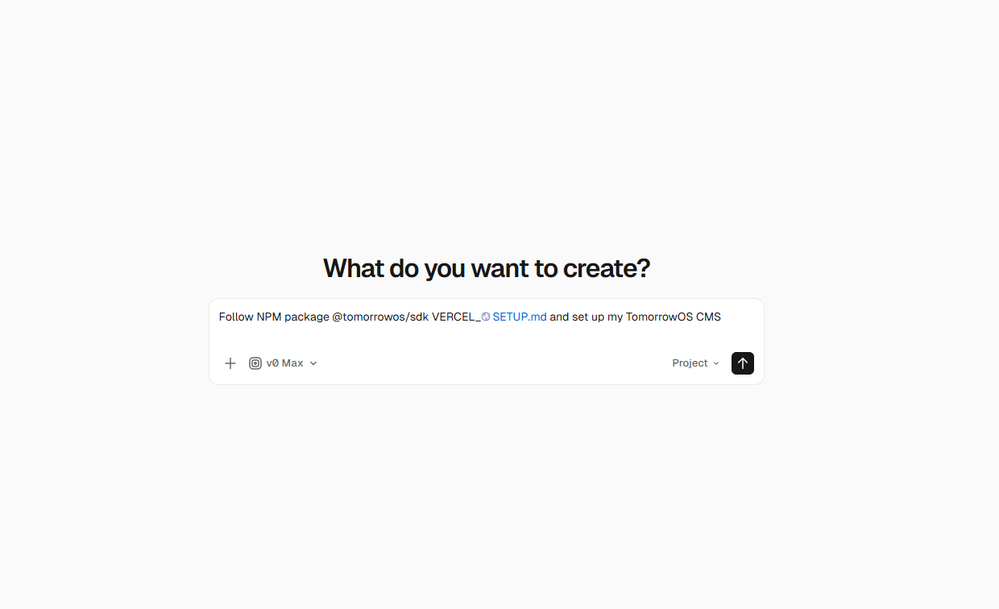
- Connect SUpbase Postgres database (recommdned) or Neon Postgres
Show click through to get Supbase Key and setup Guide for Neon Postgres too ????
- Paste the SUPBASE_URL in
- Select Cloundinary or Vercel Blob
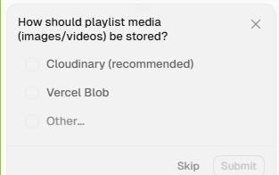
Show steps for Cloudinary
- Brand your experience, add as much as you need or skip etc.
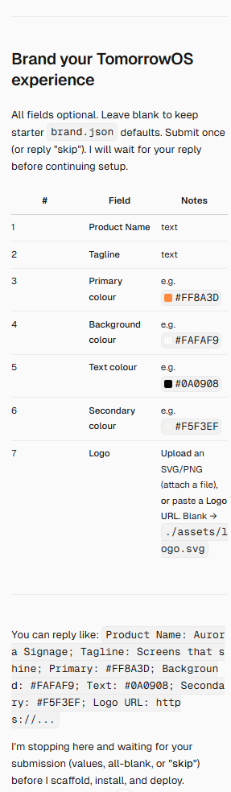
- The platform will build and connect and prepare your CMS, this can take 3 - 5 minutes as it’s a complex build. (unsure what to word here to buy time without scaring etc?
- Depending on credits used during build, you may be asked to upgrade from free to a paid version to get your CMS launched.
- Once completed you will be greeted with a CMS sample dashboard ready for your to publish and test (follow steps similar to replit at this stage, publish CMS etc.)

