Upload Media and Create and Deploy a Playlist in TomorrowOS sample CMS.

- In the top left click on the Orange + button next to Playlist.
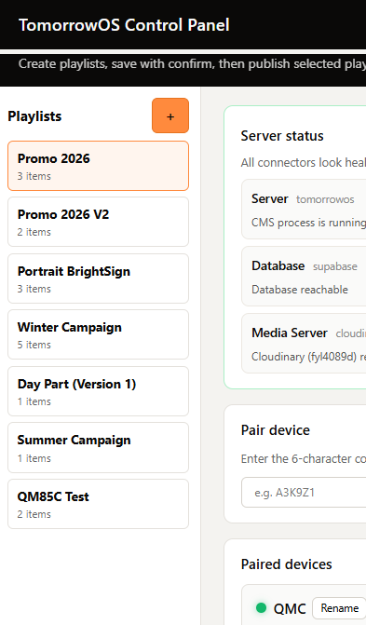
- Give your playlist a name, and add a schedule if required, if you jsut want itto run 24.7 leave this area blank.
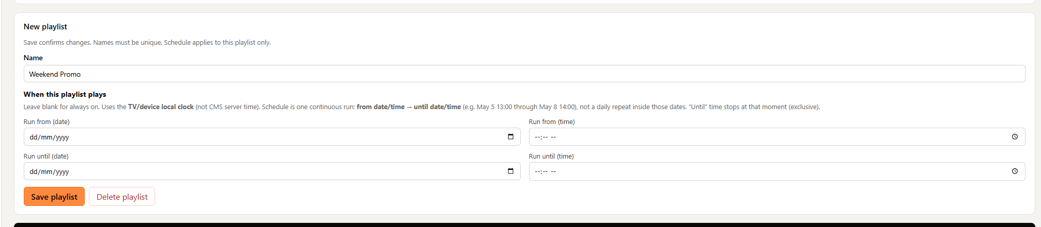
- Before saving, add your media in the top right by clickjing on the orange + button next to assets. Add any assets from your computer. Note, cloudinary free plan hs a max upload of 100mb per file. Anything above this will fault
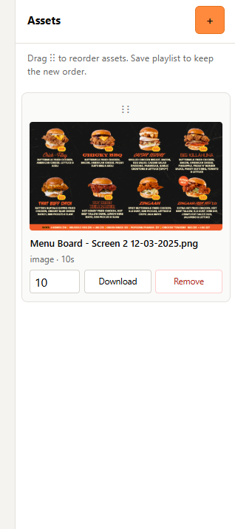
- Add as many assets in the playlist as you need, and drag and drop to reorder them,. Video files will paly for hte length of the video, image files can be edideted from a timing perspctive to alter how long they show for in the playliust.
- Once done, press on “Save Playlist” at the bottom of the page near the scheduling area.
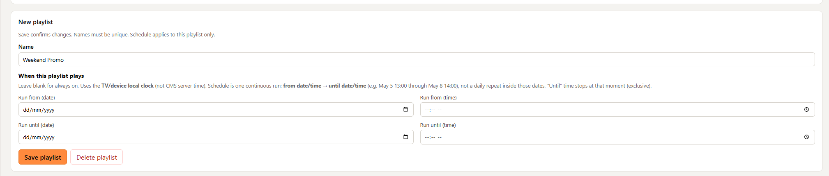
- Your playlist will load into the playlist area in the top left, ready for use:
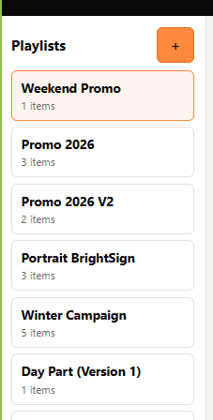
- Click on any device you want to publish to and press the orange Publish button, select the playlist of your choiceto publish, and press “Publish Selected” note, you can publish multiple playlists to a singe player if you have multiple shducledes.
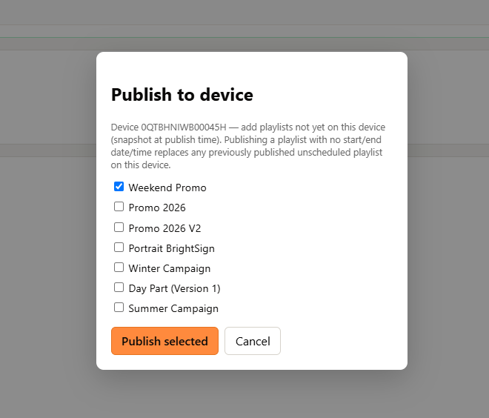
Once published you can see which playlist are attached to the device, and what is the playlist that is currently showing with the green icon next to the playlist.
- You can remove a playlist at any stage by simply clicking on remove
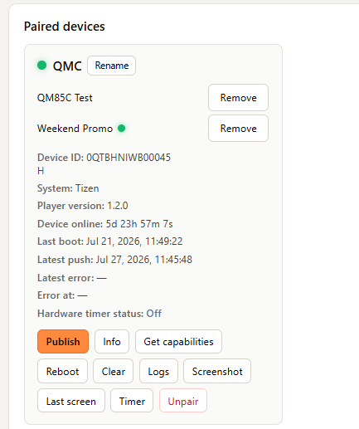

Create and publish your first playlist
Upload media, arrange it into a playlist and assign it to a connected screen using the TomorrowOS sample CMS.

Before you begin
You will need:
- A published TomorrowOS sample CMS
- Supabase and Cloudinary connected
- At least one paired screen showing online in your CMS
- An image or video file to upload
- Approximately 2–5 minutes

Important
This guide demonstrates the interface included with the TomorrowOS sample CMS.
A custom CMS built with TomorrowOS may organise playlists, media and publishing differently.

Part 1 — Create your playlist

1. Open Playlists
From your CMS dashboard, find the Playlists section.
Select the orange + button beside Playlists.

2. Name your playlist
Enter a clear name that explains where or how the playlist will be used.
Example:
Reception — Welcome Content
Good playlist names could include:
- Location
- Screen purpose
- Campaign
- Time period
Avoid generic names such as:
Playlist 1

3. Upload your media
In the Assets section, select the orange + button.
Choose the images or videos you want to upload from your computer.

Wait for each upload to complete
Do not close the page while an upload is still in progress.
The asset should appear in the Assets area once it has uploaded successfully.

Upload limits
Upload limits depend on the asset type and your Cloudinary plan. Check your current Cloudinary limits when a file does not upload. The currently listed Free-plan limits are 10 MB for images and 100 MB for videos.

When an upload fails
Check:
- The file is within your Cloudinary plan limit.
- The file type is supported by the TomorrowOS Runtime and target screen.
- Cloudinary is still connected.
- The internet connection is stable.
- The filename does not contain unusual unsupported characters.
Actions:
- View Cloudinary connection guide
- Check media compatibility
- Try the upload again

4. Add media to the playlist
Select the assets you want to include and add them to the playlist.
Add only a small number of assets for your first test.
Recommended first playlist:
- One image
- One short video
This makes it easier to confirm that both media types play correctly.

5. Arrange the playback order
Drag and drop the playlist items into the order you want them to play.
The item at the top plays first.

Video duration
Video items play for their natural video duration unless the CMS explicitly provides another playback option.

Image duration
Set how long each image should remain on screen.
Example:
10 seconds

Recommended first test
Use:
- Images: 10 seconds
- Short test videos
- A simple sequence of two or three items
This makes the first playback result easy to recognise.

6. Configure the schedule

Play continuously
Leave the schedule empty to make the playlist available at all times.

Use a schedule
When the playlist should only run during certain times:
- Select the required days.
- Choose the start time.
- Choose the end time.
- Confirm the correct timezone.
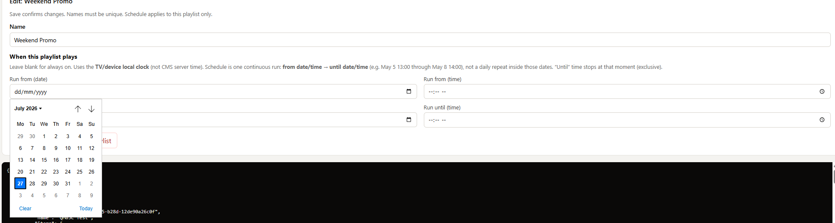

Important
The playlist schedule should use the timezone configured for the CMS or venue.
For the first onboarding test, recommend one continuously available playlist rather than overlapping scheduled playlists.

7. Save the playlist
Review:
- Playlist name
- Media order
- Image durations
- Schedule
Then select:
Save Playlist

Expected result
The saved playlist appears in the Playlists section.

Completion action in the onboarding guide
I created and saved my playlist
Supporting note:
This only updates your onboarding progress. TomorrowOS.org does not inspect your CMS or verify the playlist.

Part 2 — Publish the playlist to a screen

8. Select a screen
Select the screen that should receive the playlist.
Before continuing, confirm the screen:
- Appears in the device list
- Is paired with this CMS
- Is marked online or connected by the CMS
- Matches the physical screen you intend to update

Screen offline?
You may still be able to assign content, but the player may not receive the update until it reconnects.

9. Open Publish
From the selected device, select the orange:
Publish
button.

Expected result
A playlist-selection panel opens.

10. Choose the playlist
Select the playlist you created.
For your first deployment, choose one playlist only.
Then select:
Publish Selected

What publishing does
Publishing assigns the selected playlist to the screen through your CMS.
The TomorrowOS onboarding guide does not publish the playlist itself.

11. Wait for the screen to update
Keep the CMS and physical screen visible.
The update may take a short time depending on:
- Network connection
- Media size
- Whether the media is already cached
- Whether the player is currently online
Do not refresh or republish repeatedly while the first update is still processing.

Expected result
The selected playlist begins playing on the screen.

12. Confirm playback
Check the physical display—not only the CMS.
Confirm:
- The correct playlist is playing.
- Assets appear in the correct order.
- Images use the expected duration.
- Videos play to completion.
- The display orientation is correct.
- There are no black screens or media errors.
- The content continues through at least one full playlist cycle.

Completion action
My playlist is playing correctly
Supporting note:
This status is based on your confirmation. TomorrowOS.org does not currently inspect the physical screen through this guide.

Understanding playlist status
Once published, the CMS may display the playlists assigned to the screen.

Green indicator
Use final copy only after engineering confirms what the green icon represents.
Recommended placeholder:
The green indicator next to the playlist shows what playlist is currently active.
Possible meanings that must not be confused:
- Currently scheduled
- Currently assigned
- Requested by the CMS
- Confirmed as playing by the Runtime
Do not publish “currently playing” unless it is based on actual device telemetry.
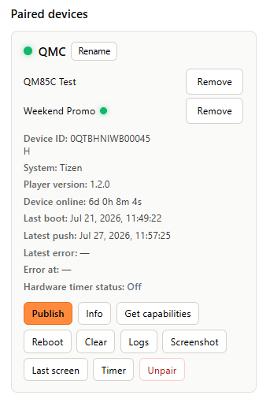

Change or remove a playlist

Replace the current playlist
To change what the screen plays:
- Select the screen.
- Open Publish.
- Select the replacement playlist.
- Select Publish Selected.
- Confirm the new content appears on the screen.

Remove a playlist
Select Remove beside the playlist assignment.
Removing a playlist will revert to the next in line playlist, or your branded splash screen if nothing is scheduled to play.

Troubleshooting

My asset will not upload
Check:
- Cloudinary is connected.
- The file is within the current plan limit.
- The file format is supported.
- Your internet connection is stable.
Actions:
- Open Cloudinary guide
- Check media compatibility
- Try again

My playlist will not save
Check:
- A playlist name has been entered.
- At least one asset has been added.
- Image durations are valid.
- Schedule fields are complete.
- No upload is still in progress.

The playlist does not appear in Publish
Check:
- The playlist was saved.
- You are viewing the correct CMS environment.
- The browser has refreshed the playlist list.
- The playlist has not been archived or removed.

The screen is offline
Check:
- The display has power.
- The TomorrowOS Runtime is running.
- The network is connected.
- The screen is still paired to this CMS.
Action:
Open device troubleshooting

The playlist was published but does not play
Check:
- The physical screen is online.
- The playlist is assigned to the correct screen.
- The schedule is currently active.
- The CMS changes were saved.
- The media format is supported.
- The screen has had enough time to download the content.

The screen is black
Check:
- The assigned playlist contains valid media.
- The assets uploaded successfully.
- The media format is compatible.
- The schedule is active.
- The display orientation and resolution are correct.
Action:
Open media playback troubleshooting

