

Development of an Intelligent System for Effective Intersection Traffic Management Using Computer Vision Technologies
Students: Kassymova Tomiris, Kuanyshbek Aisana, Kentay Aida
Supervisor: Shyryn Tutkushbayeva
Github : https://github.com/Tompi-dev/intelligent-intersection-management
YouTrack: https://tomiris.youtrack.cloud/projects/IIM/issues
The proposed system estimates intersection demand from video and evaluates constrained adaptive signal decisions in simulation. This package defines the project, evidence needs, architecture, requirements, prototype and evaluation procedure. The research question is whether camera-derived demand improves traffic outcomes under realistic sensing errors.
Team profiles: github.com/akentay, github.com/Tompi-dev and github.com/Aiisana. Full names and supervisor details are to be completed by the team. Role allocations and numeric acceptance targets require confirmation.

OVERVIEW
Contents
01 Project proposal and scope 4
02 Evidence of relevance and stakeholder research 6
03 Literature review 7
04 Existing system comparison 9
05 Technology comparison and architectural decisions 10
06 Requirements and acceptance criteria 12
07 Architecture and data contracts 15
08 Prototype and user scenarios 19
09 Verification and evaluation plan 23
10 Project management and risks 25
11 Supervisor review and submission procedure 28
A References 29
COMMITTEE CRITERIA
How this package maps to the criteria
Each of the eleven committee components has a dedicated section. Seven are fully prepared in this package; four depend on real-world input that the team still has to supply, and they are labelled as such rather than shown as complete.
№ | Committee component | Section | What this package provides | Status
1 | Project proposal | §1 | Problem, users, aim, objectives, outcomes, scope, team roles. Full names and supervisor still to be supplied. | Input needed
2 | Evidence of relevance | §2 | Interview plan, evidence register and decision rule. No interview or client agreement is completed yet. | Input needed
3 | Literature review | §3 | 12 scientific works in a structured analysis table plus 6 official documents; 9 of the 12 date from 2022–2025. | Prepared
4 | Existing system comparison | §4 | 4 platforms compared on 8 shared criteria; unconfirmed features are not treated as absent. | Prepared
5 | Technology comparison | §5 | 5 technical decisions, each with alternatives, a proposed choice and trade-offs; 4 ADRs. | Prepared
6 | Requirements specification | §6 | 10 functional and 6 non-functional requirements with priorities, acceptance criteria and test traceability. | Prepared
7 | Architecture and diagrams | §7 | System context, Use Case and draft Component diagrams with data contracts and transition model. | Prepared
8 | UX / prototype | §8 | 3 screen mockups, 3 user scenarios and a runnable command-line controller. | Prepared
9 | Verification and evaluation plan | §9 | Three evaluation layers, metrics, conditions, fixed-time baseline and 12 verification cases. | Prepared
10 | Project management and risks | §10 | 14 work items, milestones M1–M5 and 12 risks. Repository and YouTrack links still to be confirmed. | Input needed
11 | Supervisor feedback | §11 | Review procedure and submission record. Actual supervisor feedback is still to be recorded. | Input needed
SECTION 01

Project proposal and scope
We propose a camera-based traffic monitoring and adaptive signal research system for one four-arm intersection. It will estimate vehicle demand, recommend bounded signal phases, and evaluate the recommendations against a fixed-time controller in simulation. The engineering contribution is the integration and measurable evaluation of perception, demand estimation, constrained control, and reproducible experiments.
The problem is that a predetermined signal plan cannot react within an experiment to changing directional demand. Camera observations may provide useful demand information, but their errors can also produce poor control decisions. The project therefore asks whether camera-derived demand can improve simulated delay without unacceptable queue growth, starvation, or invalid phase transitions. This is a research hypothesis, not a measured local finding.

1.1 Users and expected outcomes
The primary intended user is a traffic engineer comparing signal strategies. A research operator configures camera regions and runs scenarios. A supervisor or committee inspects requirements, results, and traceable decisions. Vehicle occupants benefit indirectly; they do not operate the software.
AIM
The aim is to develop and evaluate an intelligent system that estimates intersection traffic using computer vision and adapts signal timing under explicit constraints.
OBJECTIVES
- Define user needs
- Prepare annotated clips
- Compare detectors and trackers
- Estimate per-approach queues
- Implement a constrained controller
- Integrate a simulator
- Assess transport outcomes with paired experiments

Expected outputs are a documented perception pipeline, a bounded control module, a monitoring interface prototype, a reproducible simulation benchmark, test evidence, and a limitations analysis. No improvement percentage is claimed before experiments.

1.2 Minimum scope
IN SCOPE  - One synthetic four-arm junction  - One through movement per incoming arm  - Two mutually exclusive green groups: NS and EW | OUT OF SCOPE  - Turning and pedestrian movements  - Public-road deployment  - Emergency priority  - City-wide coordination  - Plate recognition and facial identification  - Certified controller integration

Opposing through movements can share a green. Turning and pedestrian movements must be absent from the scenario.
For recorded video, monitoring may operate independently. A closed-loop transport claim requires a simulator with synchronized camera observations, or a clearly labelled sensor-error injection experiment calibrated from video. Replaying a real clip while changing an unrelated SUMO junction is not a valid closed-loop experiment.

1.3 Team responsibilities proposed for confirmation
Member | Account | Proposed responsibility
Student A | https://github.com/akentay | Perception, annotation and queue estimation
Student B | https://github.com/Tompi-dev | Architecture, controller and integration
Student C Aiisana | https://github.com/Aiisana | Prototype, evaluation and project coordination

Every member contributes documentation, implementation and peer review. These allocations are proposed and require team agreement. Full names, supervisor name, institution, selected site and hardware remain to be supplied.
SECTION 02

Evidence of relevance and stakeholder research
COMMITTEE CHECKS What evidence informs the requirements, and whether verified findings are distinguished from assumptions.
REQUIRED 3–5 discussions with user representatives, or a substantive agreement with the actual client.
The literature establishes technical interest in camera-based signal control [S09] and cooperative control [S11, S12]. It does not verify that a specific city or client needs this project. Local relevance will be established through three to five actual discussions with intended users, or a substantive agreement with an actual client.

2.1 Proposed participants and procedure
Recruit a traffic engineer, a transport researcher, a signal operator, and optionally a municipal analyst and a road user representative. Use a 20 to 30 minute semi-structured interview. Explain the academic purpose and record only consented notes. Keep contact details and recordings outside the repository; commit anonymized summaries.
Ask how timing plans are selected, which congestion situations matter, what data exist, what camera failures occur, which delay and queue measures are trusted, and what output would be useful for a controlled pilot. Ask participants to rank monitoring, recommendations, comparison reports, and failure alerts. Ask what would make the system unsuitable.

2.2 Evidence register
Item | Current basis | Validation needed
Queue information can support control | Research rationale S09 and S10 | Confirm which measures users need
A camera is available at a target site | Unverified assumption | Site and permission evidence
Local queues vary enough for adaptation | Unverified assumption | Consented counts or client data
Simulation reports are useful to an engineer | Unverified assumption | Interview or client agreement
A two-phase junction is a useful first case | Engineering scope choice | Supervisor and user feedback

■ literature rationale ■ unverified assumption ■ engineering decision
For each discussion capture date, participant role, consent, actual observations, requirement implications, contradictory evidence and follow-up. Use interview-record.md for the raw structure. No interview or client agreement is represented as completed in this package.
DECISION RULE
Retain a requirement as a verified user need only when its evidence record supports it. Label engineering necessities separately. If interviews favour monitoring rather than autonomous decisions, prioritize the monitoring and decision-support scope and document that decision in an ADR.
SECTION 03

Literature review
COMMITTEE CHECKS What approaches exist, what is already known, and which limitations the project takes into account.
REQUIRED Critical review and structured analysis table; at least 12 sources, at least 8 scientific; core sources from the last five years.
The review separates perception, tracking, traffic control, and the interface between sensing and control. Twelve scientific works are appraised below. Nine date from 2022 to 2025; YOLOX and the two 2019 control works are retained as foundations. Preprints and author versions are labelled explicitly. Official documentation S13 to S18 supports implementation and system comparisons and is not counted as scientific literature.

3.1 Critical synthesis
Detector papers [S01, S04, S05, S08] provide alternative detection designs, but generic object-detection performance is not a queue measurement. The project must evaluate approach-level count and queue errors on separated intersection clips. This motivates FR03 and NFR01.
Tracking work [S02, S03, S06, S07] suggests that association failures and occlusion are material design concerns. A stable identity supports line-crossing counts, but stopped traffic and long occlusions can still bias queues. Our inference is to assess unique crossings, queue count error and recovery after occlusion rather than optimize a tracking score alone. Online decisions must not use observations from the future.
PressLight [S10] motivates pressure-informed control, while CoLight and SocialLight [S11, S12] address multi-intersection cooperation. Their methods do not justify calling a local longest-queue heuristic an RL or max-pressure controller. For the minimum implementation, an interpretable queue-based policy provides a tractable baseline; RL is optional after the baseline and evaluation pipeline work.
The camera co-simulation study [S09] directly motivates testing imperfect observations. Its reported setting does not establish local effectiveness. We will therefore separate ideal state, estimated state, and faulty state, and report transport outcomes under all three. This sensing-to-control evaluation is the project's main integration question.

3.2 Structured publication analysis
ID and year | Approach or contribution | Project limitation or transfer concern | Use in this project
S01  2021 | Anchor-free detector with decoupled head and SimOTA. | General object detection does not establish queue estimation accuracy at a fixed roadside camera. | Keep as an older reproducible detector baseline; benchmark locally.
S02  2022 | Associates lower-confidence detections with existing tracks. | Reported MOT benchmarks cannot establish vehicle counting accuracy for this intersection. | Preferred initial tracker; measure duplicate crossings and missed vehicles.
S03  2022 | Combines motion and appearance with camera-motion compensation. | Pedestrian evaluation and added appearance processing require validation on stationary-camera traffic. | Alternative if identity continuity fails with ByteTrack.
S04  2024 | RT-DETR provides an end-to-end transformer detection design. | Published throughput uses particular hardware and workloads. | Detector alternative; measure end-to-end latency on the project machine.
S05  2023 | Training and architecture improvements target real-time detection. | Generic detection results do not resolve night-time occlusion and camera perspective. | Compare a practical YOLO-family model with RT-DETR rather than assuming a family winner.
S06  2023 | Uses observations to reduce accumulated motion errors through occlusion. | Tracking speed without detector cost is not complete pipeline speed. | Third tracking alternative for occlusion stress tests.
S07  2023 | Improves a tracking baseline and studies association and interpolation. | Global linking and interpolation variants need an online-causality check before use in a controller. | Use online-only alternatives in live feedback; reserve retrospective repair for analysis.
S08  2024 | Introduces programmable gradient information and GELAN. | Architecture improvements do not remove the need for site-specific annotation. | Candidate when detector errors dominate the queue estimate.
S09  2025 | Connects camera-based sensing with CARLA and SUMO and investigates imperfect sensing. | A co-simulation result is not evidence of performance at the selected real site. | Direct motivation for ideal-sensing versus noisy-sensing ablation.
S10  2019 | Uses pressure-based state and reward design in reinforcement learning. | Network experiments and learned policy design differ from a two-phase local heuristic. | Foundational rationale; do not label longest-queue control as max-pressure without downstream queues.
S11  2019 | Uses graph attention to exchange information between intersections. | Coordination adds topology and communication requirements outside a one-junction scope. | Foundational justification for deferring network-wide coordination.
S12  2023 | Uses distributed cooperative learning and evaluates in SUMO and CityFlow. | A network-learning approach brings training and attribution costs beyond the minimum prototype. | Future extension; retain explicit baselines before adopting MARL.

SECTION 04

Existing system comparison
COMMITTEE CHECKS Why the proposed solution is needed, and whether claims about existing systems are supported by evidence.
REQUIRED 3–5 systems compared on 6–10 consistent criteria.
Four relevant platforms are compared on eight shared criteria. These are research or engineering alternatives for building and evaluating signal-control systems, not four interchangeable roadside controllers. The proposed system adds a defined camera-to-demand-to-evaluation workflow; it is not claimed to replace mature commercial products. Entries are based on primary project or vendor material [S13 to S16]; an unconfirmed feature is not treated as absent.
Criterion | SUMO S13 | CityFlow S14 | PTV Vissim S15 | Aimsun Next S16
Primary use | Multimodal traffic research | City-scale traffic research | Microscopic traffic engineering | Transport modelling at multiple scales
Access model | Open-source project | Open-source project | Commercial; verify access | Commercial; verify edition
External control | TraCI | Python engine interface | Verify available API and edition | Python or C++ API; verify licence
Signal experiments | Documented traffic-light control | Signal-control research | Product-supported modelling; verify workflow | Product-supported modelling; verify workflow
Camera CV pipeline included in reviewed material | Not established | Not established | Not established | Not established
Suitability for one-junction baseline | Direct research fit | Feasible; larger-scale focus | Feasible if available | Feasible if available
Team reproducibility | Freeze open config and version | Freeze open config and version | Requires matching access and configuration | Requires matching access and configuration
Key project dependency | Geometry and TraCI integration | Engine build and scenario format | Licence and integration verification | Licence and integration verification

SUMO is the proposed evaluation environment because its documented external-control interface fits the limited junction experiment. CityFlow is a credible research alternative. Commercial platforms may offer useful modelling workflows but cannot be assumed available to all team members. No price, accuracy ranking, or unsupported absence of functionality is asserted.
The project gap is an openly inspectable integration and evaluation study for the chosen scope, with traceable estimation error and controller decisions. Claims of novelty should concern the implemented integration and evaluation question, rather than the invention of object detection or adaptive signal control.
SECTION 05

Technology comparison and architectural decisions
COMMITTEE CHECKS Whether technology choices are justified by the project requirements.
REQUIRED At least 3 key technical decisions, each with 2–3 reasonable alternatives.
Five technical decisions are compared. Choices are proposed until benchmark results and supervisor feedback confirm them.
Decision | Alternatives | Proposed choice | Requirement-based rationale and trade-off
Detection | YOLOX S01; YOLO-family candidate S05 or S08; RT-DETR S04 | Benchmark a YOLO candidate against RT-DETR before freezing weights | FR02 and NFR02 require target-hardware measurement; model and licence remain to be selected
Tracking | ByteTrack S02; BoT-SORT S03; OC-SORT S06 | ByteTrack initially | FR03 needs unique counts with modest complexity; change if occlusion tests fail
Service boundary | Python CLI; FastAPI worker service; Flask service | CLI now; FastAPI later S17 | Current prototype needs no service deployment; future API fits typed run records and separate inference work
Storage | JSON plus files; SQLite S18; PostgreSQL | JSON now; SQLite for local integrated MVP | Small local experiments; postpone server database until concurrent writers require it
Component interaction | In-process calls; HTTP JSON; message broker | In-process core and future HTTP boundary | Simpler deterministic experiments; timestamps and bounded buffering precede a broker

5.1 ADR 001 Evaluation environment
Choose SUMO with a TraCI adapter for the planned benchmark [S13], with CityFlow as the principal open alternative [S14]. No adapter is claimed implemented at this stage. Freeze simulator version, network, route files, seed and signal programs in each run manifest.

5.2 ADR 002 Control method
Start with a constrained queue-based heuristic and fixed-time reference. Serve NS or EW; once minimum green expires, choose the higher queued demand with a hysteresis margin, force a phase change at maximum green and enforce clearance stages. This is not a max-pressure policy because downstream occupancy is not modelled. Add max-pressure only if downstream demand can be measured; add RL only after the reproducible benchmark is established [S10 to S12].

5.3 ADR 003 Sensing validity
A recorded clip is suitable for offline CV validation. The integrated closed-loop experiment must use synchronized synthetic imagery, or calibrated error injection into simulator ground truth. This restriction follows the sensing gap highlighted in S09. In the error-injection experiment, state explicitly that a real camera is not in the loop.

5.4 ADR 004 Data boundaries
Store aggregate observations, configuration and decision logs; keep raw clips external unless licence and consent permit redistribution. Do not add plate or face recognition. Configuration examples contain placeholders. Raw timestamps must be monotonic within a run and camera freshness must be checked before adaptive decisions.
SECTION 06

Requirements and acceptance criteria
COMMITTEE CHECKS Whether the fulfilment of each mandatory requirement can be verified.
REQUIRED Functional and non-functional requirements, priorities and acceptance criteria.
Traceability links a requirement to its component, T-series verification case, and a planned work item in 10-project-plan.md. No requirement with an unexecuted acceptance test is marked fulfilled.

6.1 Functional requirements
FR01  MUST | Create a run and validate its configuration  Component: Config loader Verified by: T01  Reject unknown arms, invalid timing and malformed observations with a clear error; leave configuration unchanged.
FR02  MUST | Detect vehicles in a video source  Component: Perception worker Verified by: T02  On a versioned held-out annotated clip, produce timestamp, class, confidence and bounding box records; report precision and recall at IoU 0.5.
FR03  MUST | Estimate per-approach queues and crossing counts  Component: Demand estimator Verified by: T03  Use calibrated ROIs and tracks; count each unique forward crossing once; report queue MAE and crossing error against manual annotations.
FR04  MUST | Generate constrained adaptive phase decisions  Component: Controller Verified by: T04  Only NS or EW may be green; apply min/max green, yellow and all-red; emit a reason for every decision.
FR05  MUST | Handle stale or invalid observations  Component: Validity guard and controller Verified by: T05  Flag stale after 2 s; complete required transition stages and use a deterministic fixed-time plan; never authorize both greens.
FR06  MUST | Run paired baseline and adaptive experiments  Component: Experiment runner Verified by: T06  Use the same geometry, demand, vehicle model and seed for each paired run; store metrics and manifests.
FR07  SHOULD | Present monitoring and failure status  Component: Operator UI Verified by: T07  Show run ID, source, freshness, each approach queue, signal stage and decision reason; indicate demonstration data when used.
FR08  MUST | Export reproducible run evidence  Component: Run store and exporter Verified by: T08  Export configuration, input hashes, model/commit versions, seed, decision log and outcome summary with units.
FR09  SHOULD | Request manual control in simulation  Component: UI and controller Verified by: T09  Validate requested phase and pass it through the same transition guard; log operator action; reject conflicting movement sets.
FR10  MUST | Inspect and stop a run  Component: Experiment runner Verified by: T10  Stop accepting new decisions, close the simulator cleanly and save completed records; mark partial runs as incomplete.

6.2 Non-functional requirements
NFR01  MUST | Perception quality target  Component: Evaluation Verified by: T03  Target queue MAE <= 2 vehicles per visible approach and crossing error <= 10 percent on held-out nonempty clips; report day/night and occlusion strata separately.
NFR02  MUST | Observation latency target  Component: Telemetry Verified by: T11  On the declared machine and 720p single-source workload, target p95 capture-to-state latency <= 1 s over 10 min after warm-up; report dropped frames and throughput.
NFR03  MUST | Transition invariants  Component: Controller Verified by: T04  No conflicting green and no omitted yellow/all-red in property tests and each simulation log; toy timings do not constitute road certification.
NFR04  MUST | Reproducibility  Component: Run manifest Verified by: T08  Repeat a seeded run with frozen inputs and versions; compare decision log and summary, documenting any nondeterministic inference variance.
NFR05  MUST | Data minimization  Component: Data process Verified by: T12  Repository scan contains no working credentials or raw identifiable footage; documentation records source permissions and retention.
NFR06  SHOULD | Recoverable failure  Component: Runtime Verified by: T10  Terminate and restart a worker in a controlled test; preserve completed run records and record a failed/incomplete state.

6.3 Operational definitions
QUEUE
A queue is the number of visible tracked vehicles inside an approach ROI whose image-plane displacement stays below the calibrated stop threshold for at least 2 seconds. The threshold must be calibrated per camera; image pixels are not metres. Vehicles hidden by occlusion or beyond the ROI require an explicit uncertainty note. Use bottom-centre box positions for ROI membership.
CROSSING
A crossing is a directed passage of one track across a configured virtual line. Suppress repeated counts for the same track and direction within a run. Track fragmentation can still cause overcounting and must be measured.
STALE FRAME
A frame is stale when current run time minus observation time exceeds 2 seconds. Future, nonfinite and decreasing timestamps are invalid. NS and EW are the only allowed green groups for the simplified through-only junction.
SECTION 07

Architecture and data contracts
COMMITTEE CHECKS Whether requirements, components, data and scenarios are aligned.
REQUIRED System context diagram, Use Case Diagram, draft Component Diagram and an architectural description.
The proposed integrated design uses a perception worker, demand estimator, constrained controller, simulator adapter, run store and operator interface. Only the controller CLI and observation validation are currently executable. Diagram source files and readable SVG exports are in diagrams; the diagrams describe the target architecture, not a claim that every component is implemented.

7.1 Processing sequence
The operator defines a run and ROI calibration. A video adapter timestamps frames. The perception worker detects and tracks vehicles. The estimator builds a TrafficState with per-arm queues, measurement time and confidence metadata. The validity guard rejects invalid or stale state. The controller produces a bounded phase decision with its reason. The simulator adapter advances only through permitted transitions. The store persists the manifest, decisions and metrics. The operator inspects freshness and experiment status.

7.2 Contracts and entities
Entity | Key fields | Purpose
Run | run_id, commit_sha, seed, input_hashes, model_hash, simulator_version | Reproduction and attribution
CameraConfig | source_id, ROI polygons, crossing lines, stop threshold, calibration version | Consistent observations
TrafficState | observation_time_s, N, S, E, W, validity, source | Per-approach queued vehicle counts
PhaseDecision | time_s, stage, group, mode, reason | Inspectable controller output
MetricSummary | completed, unfinished, delay_s, queue_vehicles, seed | Comparable outcomes

The CLI prototype reads N, S, E, W and timestamps from JSON; it does not accept arbitrary controller commands or operate cameras. The future API may expose POST /runs, GET /runs/{id}/state, POST /runs/{id}/stop and GET /runs/{id}/report. These are interface designs, not live endpoints. A state response should carry source freshness and units, not only a green indicator.

7.3 Transition model
NS_GREEN | → | NS_YELLOW | → | ALL_RED | → | EW_GREEN
and symmetrically in the other direction (EW_GREEN → EW_YELLOW → ALL_RED → NS_GREEN)
10 s  minimum green | 45 s  maximum green | 3 s  yellow | 2 s  all-red | 20 s  fallback green (stale data)

Proposed laboratory constants are minimum green 10 s, maximum green 45 s, yellow 3 s and all-red 2 s. A switch requires clearance. On stale data, adaptive selection gives way to fixed-time alternation using a 20 s green. These values define a synthetic test fixture and require redesign for a real geometry.
Use a monotonic run clock. A delayed call must not skip clearance by jumping directly to a new green. A downstream adapter must preserve the stage actually applied; GUI refresh rate is not the controller clock.

7.4 Diagram consistency
The context diagram shows operator, camera and simulator boundaries. The Use Case Diagram shows configuration, monitoring, experiments, exports and manual requests. The draft Component Diagram maps the same responsibilities to interfaces and persistent evidence. The external simulator and media source are adapters; they do not bypass the validity or phase guard.

7.5 System context diagram
Editable source and readable export in diagrams/context.puml and diagrams/context.svg. Target architecture and implementation status are distinguished in the diagram.
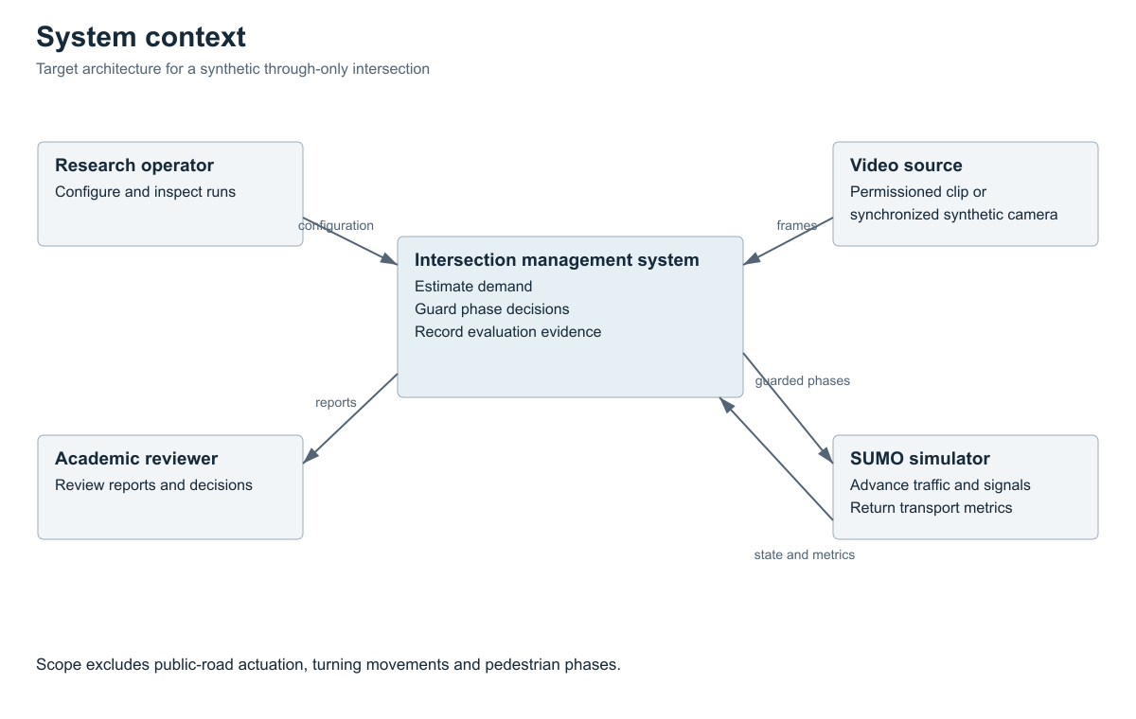
Figure 1 System context diagram

7.6 Use Case Diagram
Editable source and readable export in diagrams/use-cases.puml and diagrams/use-cases.svg. Target architecture and implementation status are distinguished in the diagram.
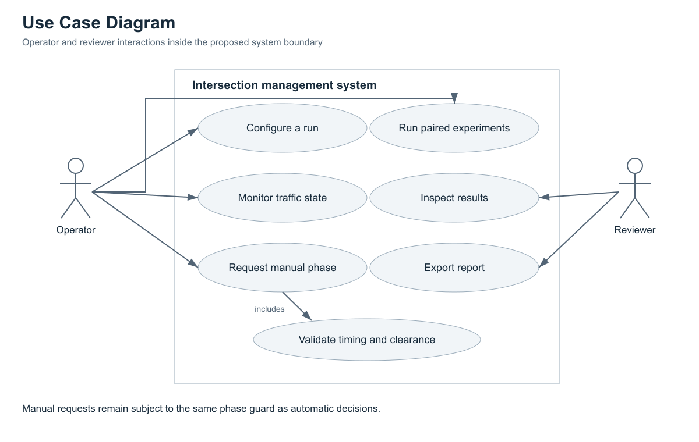
Figure 2 Use Case Diagram

7.7 Component Diagram draft
Editable source and readable export in diagrams/components.puml and diagrams/components.svg. Target architecture and implementation status are distinguished in the diagram.
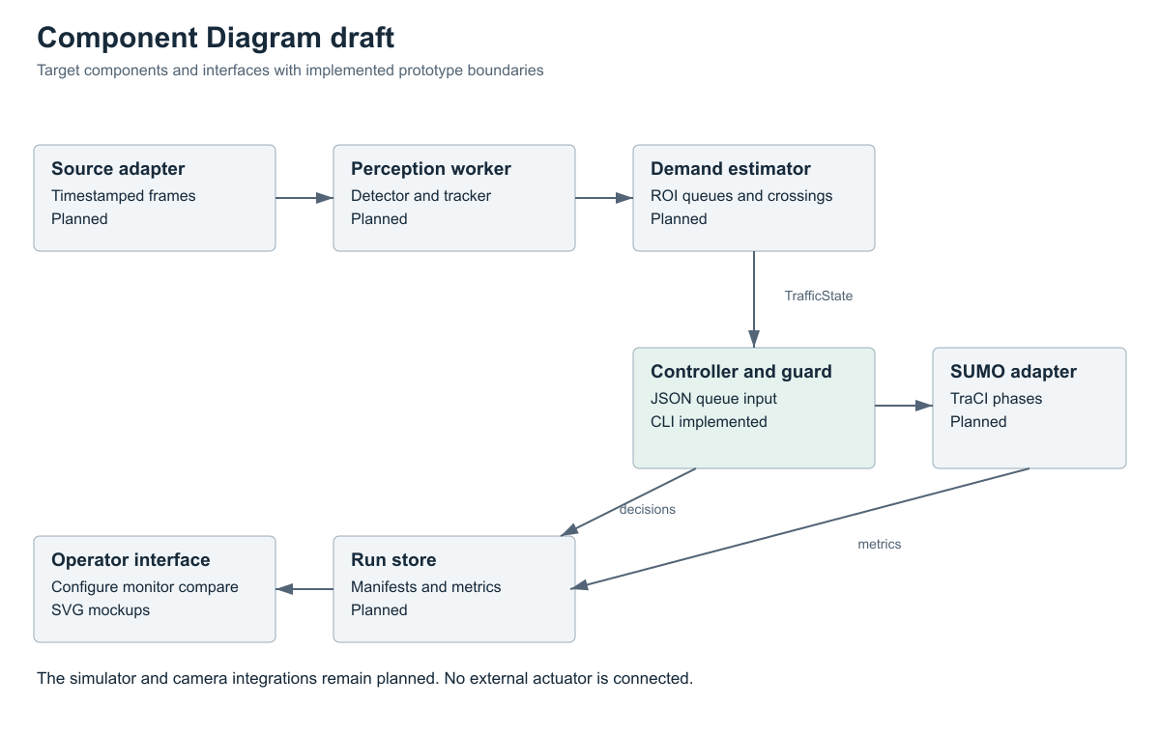
Figure 3 Component Diagram draft
SECTION 08

Prototype and user scenarios
COMMITTEE CHECKS Whether it is clear how users or external systems will interact with the solution.
REQUIRED Mockups of key user scenarios; for projects without a UI, examples of commands, APIs or data.
The prototype package has two parts: three editable SVG screen mockups and a runnable Python command-line controller. All displayed queue values in the mockups are illustrative. No camera inference, web service, real traffic-light interface or SUMO adapter is represented as implemented.

8.1 Scenario 1 — Configure observation
The operator selects a video source, identifies the junction geometry and defines approach ROIs and directed counting lines. Validation highlights missing arms, overlap and missing calibration. The configuration screen is prototype/01-configuration.svg. For the current CLI, a JSON file supplies precomputed queue observations.

8.2 Scenario 2 — Inspect a decision
The monitor shows approach queues, active signal stage, observation age and the reason for holding or switching. The operator must be able to distinguish demonstration input from real measurements. The screen is prototype/02-monitor.svg. The CLI outputs the same core concepts in JSON: time, stage, group, mode and reason.

8.3 Scenario 3 — Compare and review
The engineer selects paired runs and reviews waiting time, queue, throughput, unfinished vehicles and failures with explicit units and conditions. The comparison screen is prototype/03-comparison.svg; it deliberately contains no fabricated improvement result. Exported manifests must link to the exact input and code version.

8.4 Run the executable prototype
From the repository root execute python3 -m src.controller --input prototype/sample_observations.json. It uses only Python's standard library. Execute python3 -m unittest discover -s tests -v to check observation validation, timing bounds, clearance and fallback. The file prototype/expected_output.json records a deterministic sample result.
$ python3 -m src.controller --input prototype/sample_observations.json
$ python3 -m unittest discover -s tests -v

8.5 Configuration screen
Editable mockup in prototype/01-configuration.svg. Displayed queue counts are demonstration values; comparison results await experiments.

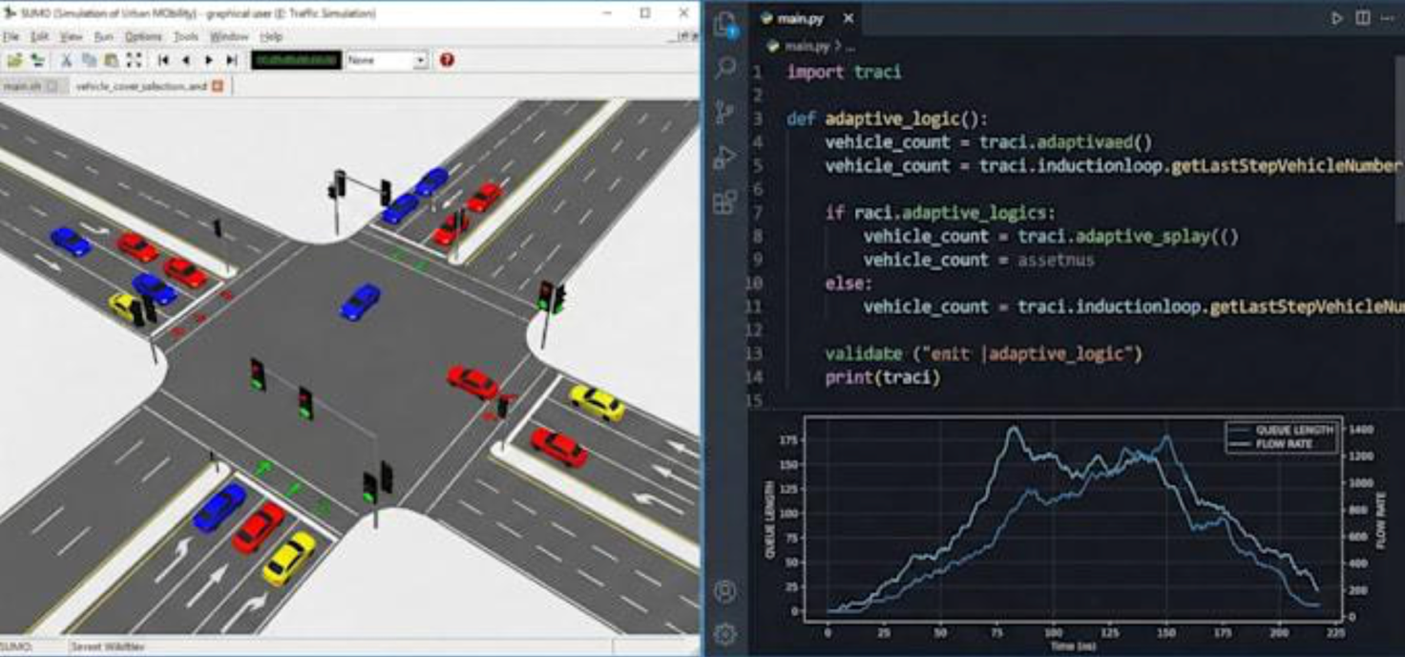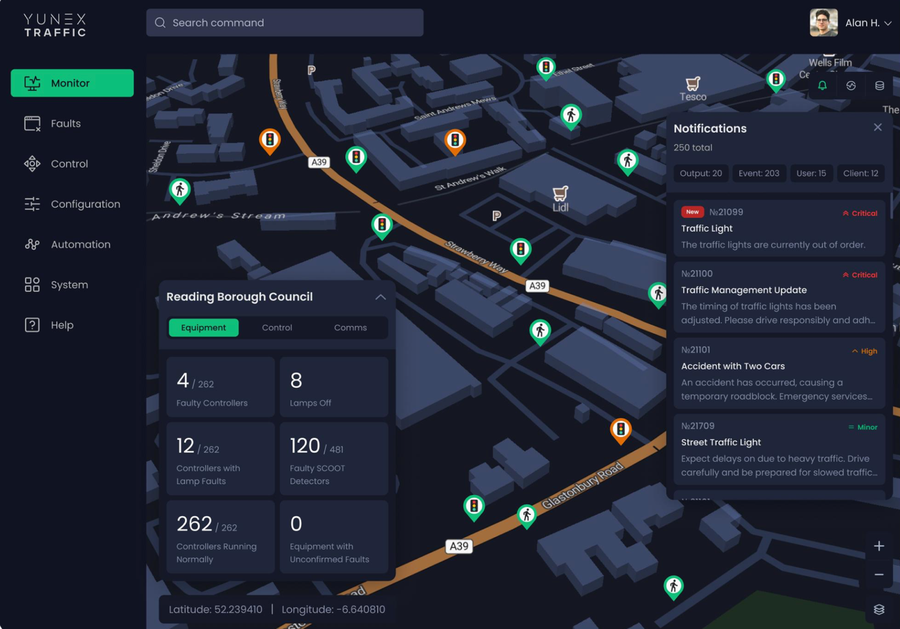
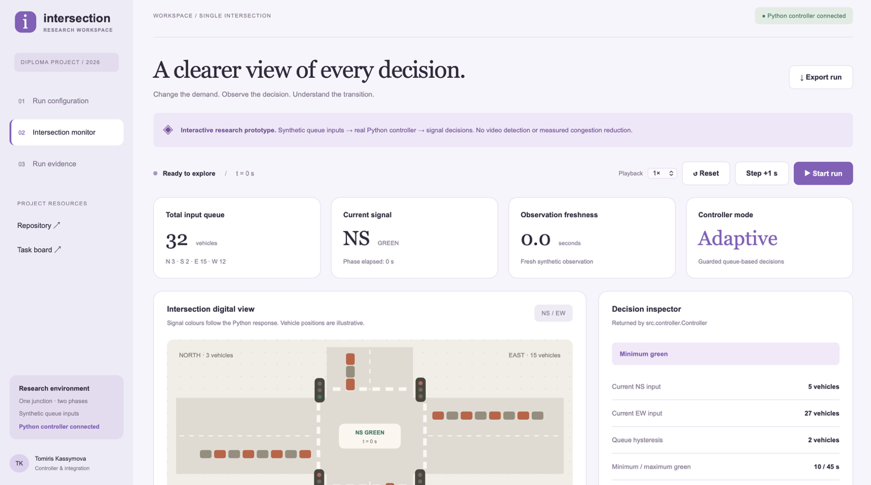
Figure 4 Configuration screen

8.6 Monitoring screen
Editable mockup in prototype/02-monitor.svg. Displayed queue counts are demonstration values; comparison results await experiments.
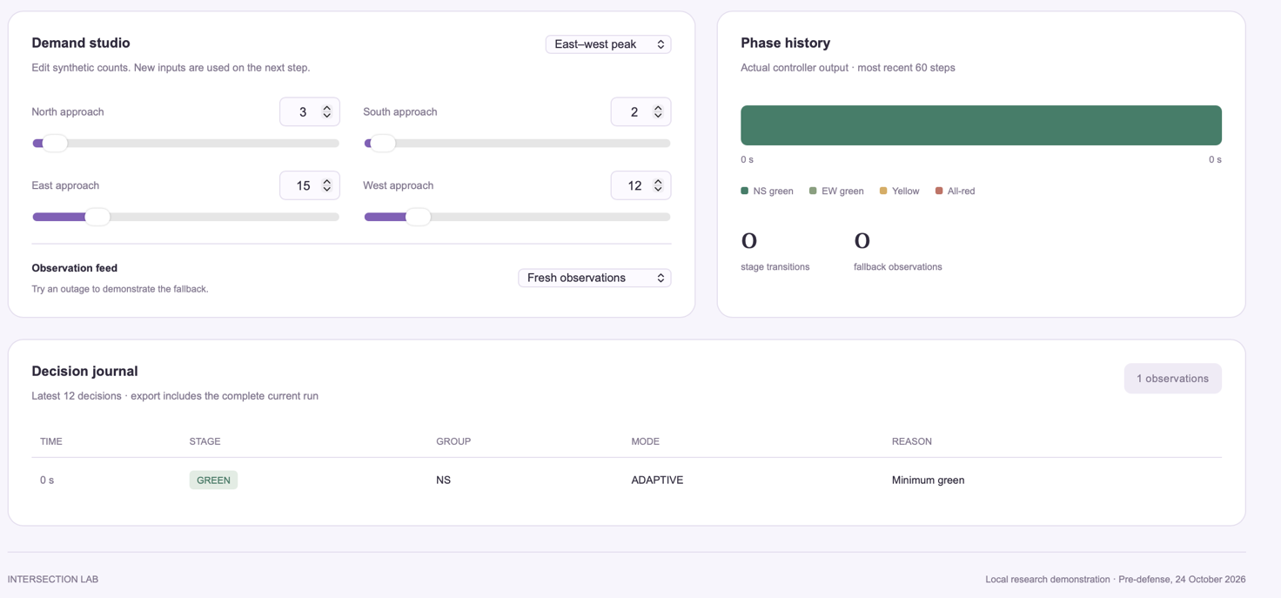
Figure 5 Monitoring screen

8.7 Comparison screen
Editable mockup in prototype/03-comparison.svg. Displayed queue counts are demonstration values; comparison results await experiments.
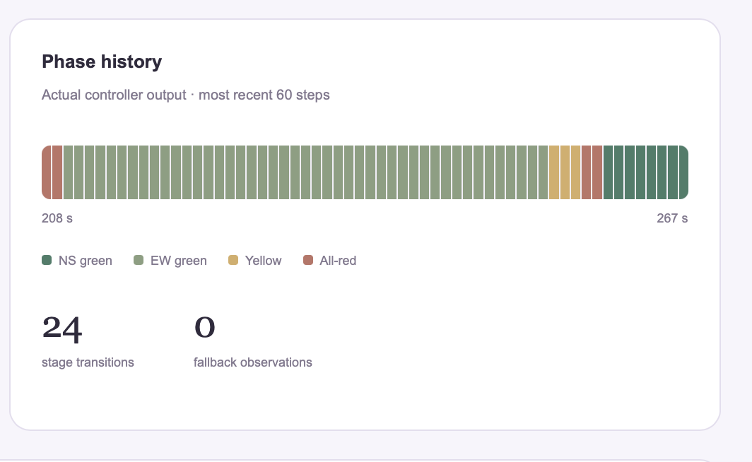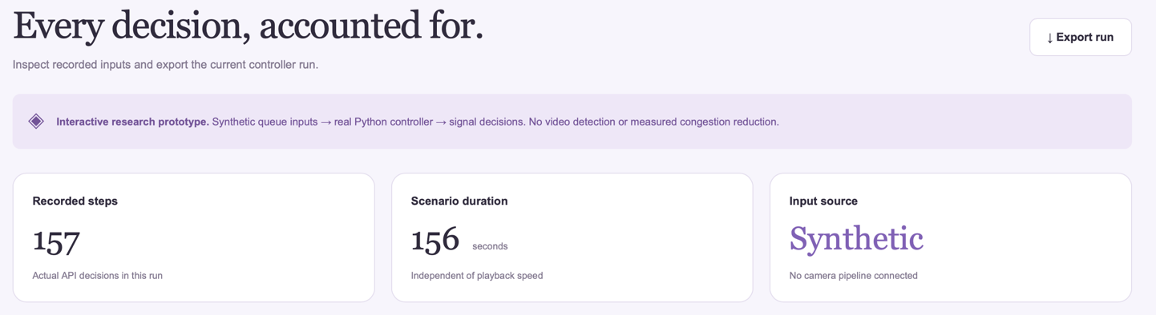
Figure 6 Comparison screen
SECTION 09

Verification and evaluation plan
COMMITTEE CHECKS How the achievement of the project aim will be demonstrated.
REQUIRED Testing plan, outcome metrics, measurement conditions and a baseline solution for comparison.
The evaluation has three layers: perception accuracy on annotated clips, controller correctness on synthetic observations, and traffic outcomes in simulation. Do not use the CLI demonstration as evidence of traffic improvement.
1  Perception accuracy on annotated clips | 2  Controller correctness on synthetic observations | 3  Traffic outcomes in paired simulation

9.1 Perception protocol
Collect permissioned footage from one chosen camera or an appropriately licensed traffic dataset. Preserve source and licence metadata. Split by recording session or camera; do not distribute neighbouring frames between training and test. Reserve held-out clips across daylight, low light, occlusion and high demand where available. Start with at least 12 one-minute clips across three available strata, and 300 carefully selected annotated frames for a pilot; revise sample size after variance inspection. Two students independently annotate a 10 percent subset and reconcile disagreement.
Measure detector precision and recall at IoU 0.5, class errors, per-approach queue MAE in vehicles and unique crossing count error. MAE is the mean absolute difference between predicted and manual queues. Crossing error is the absolute predicted-versus-reference difference divided by the nonzero reference count. For a zero-reference interval, report false crossings as a count rather than divide by zero. Evaluate selected detector/tracker combinations on the same held-out data and hardware. Never use test clips for threshold tuning.

9.2 Paired simulation experiment
Use a through-only four-arm network and a frozen 1 s simulation step. Compare a fixed-time plan tuned only on development demand, a queue-adaptive controller using ideal state, and the same adaptive controller using calibrated observation errors. A later synchronized image-in-loop experiment can replace error injection. For each method, keep routes, vehicle parameters, network and seed identical.
COMPARED POLICIES (BASELINE FIRST)
Fixed-time  Baseline plan tuned only on development demand | Adaptive · ideal  Queue-adaptive controller with ideal state | Adaptive · errors  Same controller with calibrated observation errors

5  demand cases | 10  paired seeds per case and policy | 600 s  warm-up | 3600 s  demand measurement window | 1800 s  drain period cap

Use five demand cases: balanced moderate, NS-heavy, EW-heavy, a demand surge and near-saturation. Begin with 10 paired seeds per case and policy. Each run has a 600 s warm-up, a 3600 s demand measurement window, and a drain period capped at 1800 s. Retain all vehicles entering during the measurement window as the cohort, including those unfinished at the cap. Report incomplete trips and remaining queues; do not claim lower delay by silently excluding stranded vehicles.
Primary outcome is mean cohort waiting time in seconds. Also report mean travel time, p95 completed-trip delay with unfinished counts alongside it, average and maximum queues, throughput, stop counts and maximum red duration. Use SUMO timeLoss as a separately labelled measure if collected; do not conflate it with stopped waiting time. Compare paired seed differences, their mean and 95 percent bootstrap interval. Report scenario-level results and failure cases rather than only an aggregate.

9.3 Verification cases
Case | Method and expected evidence | Requirements
T01 | Invalid configuration and negative, missing or nonfinite counts rejected | FR01
T02 | Timestamped detections checked against held-out boxes | FR02
T03 | Manual queues and crossings compared; duplicate track scenario inspected | FR03 NFR01
T04 | Adversarial demand sequences and transition logs show all timing invariants | FR04 NFR03
T05 | Stale feed, future timestamps and lost source trigger explicit fallback | FR05
T06 | Paired manifest equality for all fixed experimental factors | FR06
T07 | Walkthrough of three operator scenarios with 3 users and recorded issues | FR07
T08 | Export and rerun with matching hashes and recorded version | FR08 NFR04
T09 | Conflicting manual requests rejected; accepted requests retain clearance | FR09
T10 | Stop and worker-failure tests preserve partial run status | FR10 NFR06
T11 | Declared hardware, warm-up and 10 min p95 latency record | NFR02
T12 | Secret scan, dataset permission review and retention check | NFR05

The delivered unit tests cover the narrow CLI implementation only. Dataset evaluation, user walkthroughs and simulation runs remain scheduled work. Store future measured results separately from this plan, with run IDs and evidence links.
SECTION 10

Project management and risks
COMMITTEE CHECKS Whether project activities are traceable and the next steps are clearly defined.
REQUIRED Git repository, YouTrack project, responsibilities, milestones, risks and dependencies.

10.1 Task backlog
The proposed repository name is intelligent-intersection-management. The three supplied GitHub URLs are personal profiles, not a confirmed project repository. One team member must create or identify the shared repository and add the other members, supervisor and committee. A YouTrack URL and project prefix have not been supplied.
Roles A, B and C follow the proposal; C refers to Aiisana. The work item keys below are local planning keys, not real YouTrack IDs. Create each item in YouTrack, assign its actual user account, and replace the local key with the service-issued ID in branches, commits and pull requests. The proposed near-term plan uses 16 to 24 October 2026 and must be adjusted to the team's availability. Future milestones remain relative to the approved schedule.
Key | Owner | Priority | Due | Deliverable and acceptance | Depends on
W01 | B | Critical | 17 Oct | Shared Git repository, member access and YouTrack URL verified | None
W02 | C | Critical | 18 Oct | Full names, supervisor and scope confirmed in README | W01
W03 | C | High | 20 Oct | 3 to 5 real user discussions or substantive client agreement; anonymized evidence | W02
W04 | A | High | 19 Oct | 12 scientific works appraised, cited and method/licence details checked | W02
W05 | C | High | 20 Oct | Four analogues on eight criteria; evidence and unknowns preserved | W04
W06 | B | High | 20 Oct | Technology decisions and benchmark protocol reviewed | W04
W07 | B | Critical | 21 Oct | Requirements reviewed with measurable acceptance and T-case mapping | W03 W06
W08 | B | High | 21 Oct | Context, use case and component sources and exports consistent | W07
W09 | C | High | 21 Oct | Three user-scenario mockups reviewed; issues logged | W07
W10 | B | High | 22 Oct | CLI timing and invalid-input checks pass in team environment | W07
W11 | A | High | 22 Oct | Dataset permission, split and annotation pilot plan recorded | W04 W07
W12 | C | High | 22 Oct | Evaluation plan, risks and named owners reviewed | W07 W11
W13 | A | Critical | 23 Oct | Actual supervisor feedback on key artefacts and linked revisions | W08 W09 W12
W14 | B | Critical | 24 Oct | Reviewed submission SHA, tag, open tasks and committee access verified | W10 W13

10.2 Later milestones
Milestone | Outcome | Timing
M1 | Reviewed analysis and design package | First checkpoint
M2 | Permissioned video and measured detector/tracker baselines | Weeks 1–2 after scope approval
M3 | State estimation integrated with a constrained simulator adapter | Weeks 3–4
M4 | Paired scenarios and sensing ablations executed | Weeks 5–6
M5 | Evaluation failures addressed, report completed, final demonstration rehearsed | Per the university calendar

10.3 Review and contribution process
YouTrack task | → | Branch with task ID | → | Meaningful commits | → | Pull request | → | Peer review | → | Merge to main

Use a real YouTrack task, a branch bearing its ID, meaningful commits, a reviewed PR and a reverse link in the task. Each PR states the requirement or document changed and the checks actually run. Another team member reviews before merge; the author resolves comments with linked revisions. Ask the supervisor to review scope, requirements, architecture and evaluation at substantive checkpoints. Maintain one repository and preserve previously submitted tags.
On pre-defense day, show one actual user finding traced to a requirement, task, implementation or design, review comment, revision and test. Show each student's substantive contribution; do not manufacture a historical sequence from this generated package.

10.4 Risks, dependencies and mitigations
Risk | Likelihood and impact | Mitigation and trigger | Owner
Footage or permission unavailable | High · High | Secure permission first; use licensed footage and synthetic evaluation if denied | A
Occlusion and low light bias queues | High · High | Annotated strata, confidence flags and error-injection ablation; narrow operational conditions if targets fail | A
Limited hardware misses latency target | Medium · High | Benchmark early; reduce model size or sampled frame rate while reporting staleness | A
Simulation does not represent chosen scope | Medium · High | Review geometry and demand; label synthetic conclusions; no public-road claim | B
Controller starves an approach | Medium · High | Maximum green and red-duration monitoring; adversarial demand tests | B
Invalid or stale camera state | High · High | Freshness guard and fixed-time fallback with clearance | B
Dataset leakage inflates accuracy | Medium · High | Session-level split and held-out configuration before tuning | A
Low completed throughput hides delay | Medium · High | Cohort accounting, unfinished counts and drain cap | C
Team or supervisor feedback delayed | Medium · High | Named review owners and 23 Oct checkpoint; log unresolved comments | C
Scope expands to RL and networks | High · Medium | Freeze one-junction heuristic MVP; approve changes through ADR | B
Model or dataset redistribution restricted | Medium · High | Check licence before download or commit; store permitted references only | A
Git or YouTrack not configured | Medium · High | W01 access check before workflow claims | B

Dependencies are a usable camera dataset, agreed geometry, a declared target machine, simulator access and the supervisor's availability. A risk becomes an issue when its trigger occurs; the owner records a revised scope or mitigation task, date and evidence.
SECTION 11

Supervisor review and submission procedure
COMMITTEE CHECKS Whether the supervisor reviewed the substance of the work and whether the review led to meaningful improvements.
REQUIRED Supervisor feedback on key deliverables and decisions on how to address the comments.
The supervisor is asked to review whether the single-junction scope has sufficient engineering complexity, whether stakeholder evidence supports the requirements, whether timing and phase assumptions fit the test geometry, and whether the evaluation can establish the stated aim.
Provide the proposal, literature synthesis, requirements, three diagrams, prototype and verification plan together. Record the actual review date, document version, substantive comment, owner, planned revision and link to the change. Do not fill the feedback journal with invented approval or an assumed supervisor identity.
Before submission confirm team identities, the supervisor, repository and YouTrack links, dataset permission, actual stakeholder evidence and review outcomes. Complete the submission record with the exact commit, immutable stage tag, completed work, limitations and outstanding tasks. Use pre-defense-1 for the first stage, pre-defense-2 for the second and final-pre-defense for the final checkpoint. Do not create a submission tag until the intended reviewed version is selected.

APPENDIX

References

A.1 Scientific literature (S01–S12)
S01 | Ge Z et al. YOLOX Exceeding YOLO Series in 2021. 2021. Scientific report arXiv.  https://arxiv.org/abs/2107.08430
S02 | Zhang Y et al. ByteTrack Multi Object Tracking by Associating Every Detection Box. 2022. ECCV 2022 arXiv version.  https://arxiv.org/abs/2110.06864
S03 | Aharon N Orfaig R Bobrovsky B. BoT SORT Robust Associations Multi Pedestrian Tracking. 2022. Scientific preprint arXiv.  https://arxiv.org/abs/2206.14651
S04 | Zhao Y et al. DETRs Beat YOLOs on Real time Object Detection. 2024. CVPR 2024 arXiv version.  https://arxiv.org/abs/2304.08069
S05 | Wang C Y Bochkovskiy A Liao H Y M. YOLOv7 Trainable bag of freebies sets new state of the art for real time object detectors. 2023. CVPR 2023 preprint 2022.  https://arxiv.org/abs/2207.02696
S06 | Cao J et al. Observation Centric SORT Rethinking SORT for Robust Multi Object Tracking. 2023. CVPR 2023 arXiv version.  https://arxiv.org/abs/2203.14360
S07 | Du Y et al. StrongSORT Make DeepSORT Great Again. 2023. IEEE Transactions on Multimedia accepted 2023 arXiv version.  https://arxiv.org/abs/2202.13514
S08 | Wang C Y Yeh I H Liao H Y M. YOLOv9 Learning What You Want to Learn Using Programmable Gradient Information. 2024. Scientific paper arXiv version.  https://arxiv.org/abs/2402.13616
S09 | Azfar T et al. Traffic Co Simulation Framework Empowered by Infrastructure Camera Sensing and Reinforcement Learning. 2025. Journal of Intelligent Transportation Systems arXiv v2.  https://arxiv.org/abs/2412.03925
S10 | Wei H et al. PressLight Learning Max Pressure Control to Coordinate Traffic Signals in Arterial Network. 2019. KDD 2019 author implementation.  https://github.com/wingsweihua/presslight
S11 | Wei H et al. CoLight Learning Network level Cooperation for Traffic Signal Control. 2019. CIKM 2019 arXiv version.  https://arxiv.org/abs/1905.05717
S12 | Goel H et al. SocialLight Distributed Cooperation Learning towards Network Wide Traffic Signal Control. 2023. AAMAS 2023 arXiv version.  https://arxiv.org/abs/2305.16145

A.2 Official documentation (S13–S18)
S13 | Eclipse SUMO contributors. TraCI and traffic light control documentation. accessed 16 Oct 2026. Official technical documentation.  https://eclipse.dev/sumo/docs/TraCI/index.html
S14 | CityFlow project. CityFlow project documentation. accessed 16 Oct 2026. Official technical documentation.  https://cityflow-project.github.io/
S15 | PTV Group. PTV Vissim product documentation. accessed 16 Oct 2026. Official vendor documentation.  https://www.ptvgroup.com/en/products/ptv-vissim
S16 | Aimsun. Aimsun Next transport modelling software. accessed 16 Oct 2026. Official vendor documentation.  https://www.aimsun.com/aimsun-next-transport-modelling-software/
S17 | FastAPI contributors. FastAPI documentation. accessed 16 Oct 2026. Official technical documentation.  https://fastapi.tiangolo.com/
S18 | SQLite contributors. Appropriate Uses For SQLite. accessed 16 Oct 2026. Official technical documentation.  https://www.sqlite.org/whentouse.html

