Tulkošanas spēle

Risinājums

**DIZAINS / LIETOTĀJA SASKARNE**

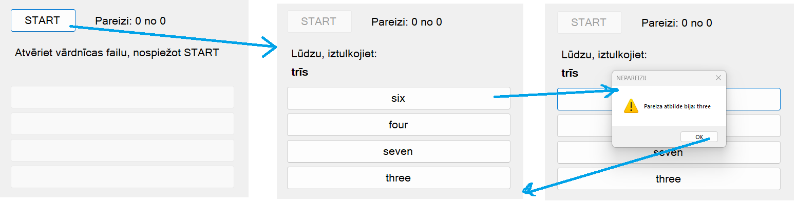

**IZEJAS KODS**

**Form1.cs**

using System;

using System.Collections.Generic;

using System.IO;

using System.Security;

using System.Windows.Forms;

using static System.Windows.Forms.VisualStyles.VisualStyleElement;

namespace TOMS_M_projekts_RTVSK

{

public partial class Form1 : Form

{

private OpenFileDialog openFileDialog1;

private List<string> lv = new List<string>();

private List<string> en = new List<string>();

private int correctAnswer = 0;

private int correctAnswerCount = 0;

private int totalAnswerCount = 0;

private int correctTranslationIndex = 0;

public Form1()

{

InitializeComponent();

}

private void buttonSTART_Click(object sender, EventArgs e)

{

//MessageBox.Show("Spēle ir uzsākta!", "DEBUG", MessageBoxButtons.OK, MessageBoxIcon.Exclamation);

openFileDialog1 = new OpenFileDialog();

if (openFileDialog1.ShowDialog() == DialogResult.OK)

{

try

{

using (StreamReader read = new StreamReader(openFileDialog1.FileName))

{

string line;

while ((line = read.ReadLine()) != null)

{

//MessageBox.Show(line, "DEBUG", MessageBoxButtons.OK, MessageBoxIcon.Exclamation);

string[] words = line.Split('=');

lv.Add(words[0]);

en.Add(words[1]);

}

}

}

catch (SecurityException ex)

{

MessageBox.Show($"Security error.\n\nError message: {ex.Message}\n\n" +

$"Details:\n\n{ex.StackTrace}");

}

//MessageBox.Show(lv[2], "DEBUG", MessageBoxButtons.OK, MessageBoxIcon.Exclamation);

buttonSTART.Enabled = false;

labelCommand.Text = "Lūdzu, iztulkojiet:";

correctAnswerCount = 0;

totalAnswerCount = 0;

updateCounter();

buttonVAR1.Enabled = true;

buttonVAR2.Enabled = true;

buttonVAR3.Enabled = true;

buttonVAR4.Enabled = true;

nextTask();

}

}

private void updateCounter()

{

labelCounter.Text = "Pareizi: " + correctAnswerCount + " no " + totalAnswerCount;

}

private void nextTask()

{

totalAnswerCount++;

Random rnd = new Random();

int newTask = rnd.Next(0, lv.Count);

correctTranslationIndex = newTask;

labelTask.Text = lv[newTask];

correctAnswer = rnd.Next(1, 5);

//MessageBox.Show(lv[lv.Count-1], "DEBUG", MessageBoxButtons.OK, MessageBoxIcon.Exclamation);

int wrongAnswer1, wrongAnswer2, wrongAnswer3;

wrongAnswer1 = newTask;

while (wrongAnswer1 == newTask)

{

wrongAnswer1 = rnd.Next(0, en.Count);

}

wrongAnswer2 = newTask;

while ((wrongAnswer2 == newTask) || (wrongAnswer2 == wrongAnswer1))

{

wrongAnswer2 = rnd.Next(0, en.Count);

}

wrongAnswer3 = newTask;

while ((wrongAnswer3 == newTask) || (wrongAnswer3 == wrongAnswer1) || (wrongAnswer3 == wrongAnswer2))

{

wrongAnswer3 = rnd.Next(0, en.Count);

}

switch (correctAnswer)

{

case 1:

buttonVAR1.Text = en[newTask];

buttonVAR2.Text = en[wrongAnswer1];

buttonVAR3.Text = en[wrongAnswer2];

buttonVAR4.Text = en[wrongAnswer3];

break;

case 2:

buttonVAR2.Text = en[newTask];

buttonVAR1.Text = en[wrongAnswer1];

buttonVAR3.Text = en[wrongAnswer2];

buttonVAR4.Text = en[wrongAnswer3];

break;

case 3:

buttonVAR3.Text = en[newTask];

buttonVAR1.Text = en[wrongAnswer1];

buttonVAR2.Text = en[wrongAnswer2];

buttonVAR4.Text = en[wrongAnswer3];

break;

case 4:

buttonVAR4.Text = en[newTask];

buttonVAR1.Text = en[wrongAnswer1];

buttonVAR2.Text = en[wrongAnswer2];

buttonVAR3.Text = en[wrongAnswer3];

break;

default:

break;

}

}

public void showCorrectAnswer()

{

string answer = "Pareiza atbilde bija: " + en[correctTranslationIndex];

MessageBox.Show(answer, "NEPAREIZI!", MessageBoxButtons.OK, MessageBoxIcon.Exclamation);

}

private void buttonVAR1_Click(object sender, EventArgs e)

{

if (correctAnswer == 1)

{

correctAnswerCount++;

} else

{

showCorrectAnswer();

}

updateCounter();

nextTask();

}

private void buttonVAR2_Click(object sender, EventArgs e)

{

if (correctAnswer == 2)

{

correctAnswerCount++;

}

else

{

showCorrectAnswer();

}

updateCounter();

nextTask();

}

private void buttonVAR3_Click(object sender, EventArgs e)

{

if (correctAnswer == 3)

{

correctAnswerCount++;

}

else

{

showCorrectAnswer();

}

updateCounter();

nextTask();

}

private void buttonVAR4_Click(object sender, EventArgs e)

{

if (correctAnswer == 4)

{

correctAnswerCount++;

}

else

{

showCorrectAnswer();

}

updateCounter();

nextTask();

}

}

}