Student Name: SIU Kin Sang

Student ID:22425349

1. Please describe the architecture of the current chatbot system. Identify the components and

check where are they running now.

Ans: In main, the code has connected to the telegram bot and run the code in Redis. The configuration is read from config.ini, and the API token is taken. In echo, the telegram chat bot will reply what the user input. The help_command, add and hello are fucntions response to users. Redis is running the python code to provide the chatting service to the telegram.

2. Explain how do your chatbot handle the special command. You need to trace the code and

explain that.

Ans: Applying /add, /help,/hello will trigger the function help_command, add and hello.

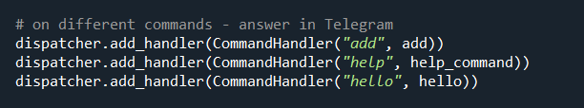

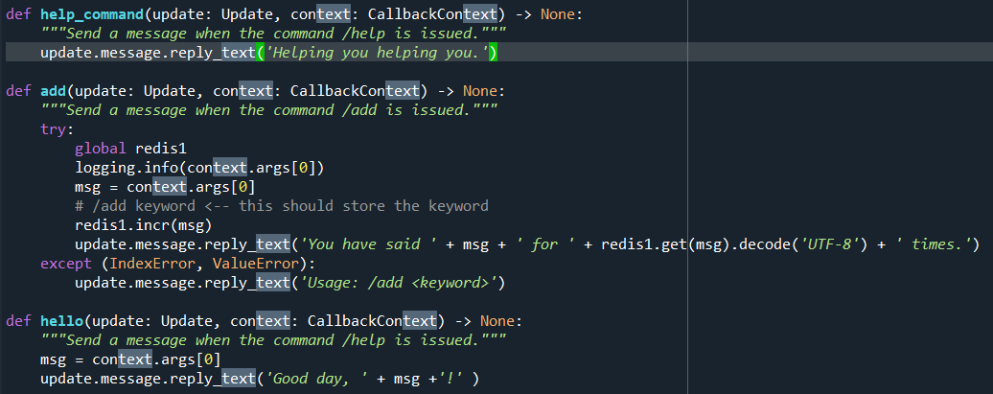

3. Update your code so that when user type /hello Kevin , it will reply Good day, Kevin! . Write

down the change you have made.

Ans:

1. “dispatcher.add_handler(CommandHandler("hello", hello))” added in main()
2. A new function is added.

def hello(update: Update, context: CallbackContext) -> None:

"""Send a message when the command /help is issued."""

msg = context.args[0]

update.message.reply_text('Good day, ' + msg +'!' )

4. Make a few screen caps to prove that you have applied your own Redis account, used it in your

chatbot, and push the code on GitHub (at least 2 commits - lab3/lab4).

Ans:

