edit {NotesMangement}/sites/all/models/bills_billing/bills_billing_check.tpl.php

myCheckPreview(t); 替换成myCheckDesign(t);

提交一个支票，以设计模式打开

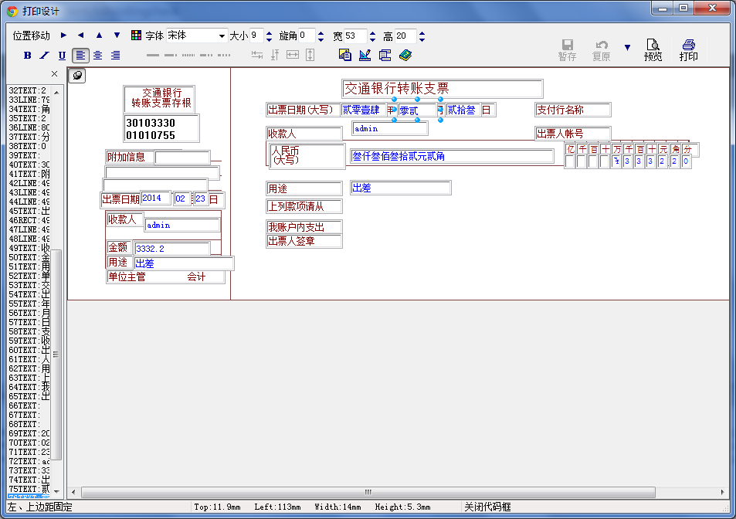

 选择第二个图标，生成代码项：

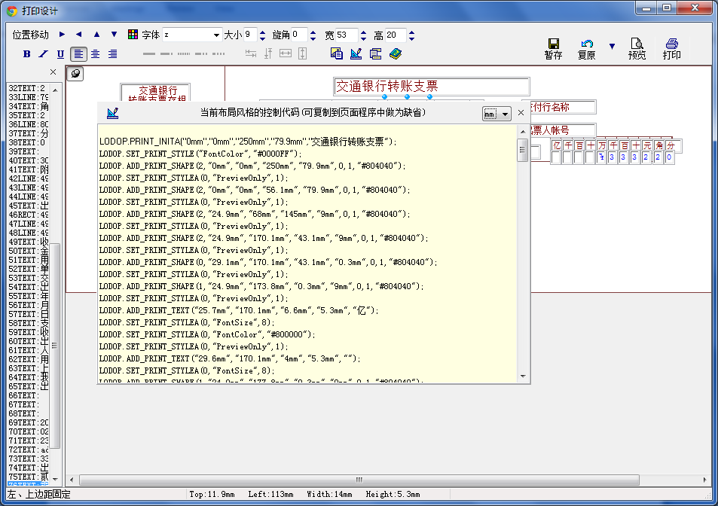

将单位换成mm

拷贝内容

修改 {NotesMangement}/sites/all/models/bills_billing/ print_js/ print_js.js

CheckCreateFullPage 替换对应内容。

备注

LODOP.ADD_PRINT_TEXT("28.3mm","29.6mm","19.6mm","5.3mm",jsonobj.attach1);

LODOP.ADD_PRINT_TEXT("33.6mm","12.7mm","39.7mm","5.3mm",jsonobj.attach2);

LODOP.ADD_PRINT_TEXT("37.8mm","11.9mm","36.5mm","5.3mm",jsonobj.attach3);

LODOP.ADD_PRINT_TEXT("42.1mm","24.9mm","10.8mm","5.3mm",jsonobj.year);

LODOP.ADD_PRINT_TEXT("42.3mm","36.2mm","6.4mm","5.3mm",jsonobj.month);

LODOP.ADD_PRINT_TEXT("42.3mm","43.1mm","5.6mm","5.3mm",jsonobj.day);

LODOP.ADD_PRINT_TEXT("51.3mm","26.2mm","26.5mm","5.3mm",jsonobj.name);

LODOP.ADD_PRINT_TEXT("59.5mm","22.8mm","26.5mm","5.3mm",jsonobj.amount1);

LODOP.ADD_PRINT_TEXT("64.5mm","22.5mm","35mm","5.3mm",jsonobj.pop);

LODOP.ADD_PRINT_TEXT("11.9mm","93.4mm","16.4mm","5.3mm",jsonobj.year1);

LODOP.ADD_PRINT_TEXT("11.9mm","113.1mm","14mm","5.3mm",jsonobj.month1);

LODOP.ADD_PRINT_TEXT("11.9mm","129.4mm","12.7mm","5.3mm",jsonobj.day1);

LODOP.ADD_PRINT_TEXT("18.3mm","97.4mm","26.5mm","5.3mm",jsonobj.name);

LODOP.ADD_PRINT_TEXT("27.8mm","96.8mm","70mm","5.3mm",jsonobj.amount2);

LODOP.ADD_PRINT_TEXT("38.6mm","96.8mm","35mm","5.3mm",jsonobj.pop);

LODOP.ADD_PRINT_TEXT("28.3mm","29.6mm","19.6mm","5.3mm","");

LODOP.ADD_PRINT_TEXT("33.6mm","12.7mm","39.7mm","5.3mm","");

LODOP.ADD_PRINT_TEXT("37.8mm","11.9mm","36.5mm","5.3mm","");

LODOP.ADD_PRINT_TEXT("42.1mm","24.9mm","10.8mm","5.3mm","2014");

LODOP.ADD_PRINT_TEXT("42.3mm","36.2mm","6.4mm","5.3mm","02");

LODOP.ADD_PRINT_TEXT("42.3mm","43.1mm","5.6mm","5.3mm","23");

LODOP.ADD_PRINT_TEXT("51.3mm","26.2mm","26.5mm","5.3mm","admin");

LODOP.ADD_PRINT_TEXT("59.5mm","22.8mm","26.5mm","5.3mm","3332.2");

LODOP.ADD_PRINT_TEXT("64.6mm","22.5mm","34.9mm","5.3mm","出差");

LODOP.ADD_PRINT_TEXT("11.9mm","93.4mm","16.4mm","5.3mm","贰零壹肆");

LODOP.ADD_PRINT_TEXT("11.9mm","113mm","14mm","5.3mm","零贰");

LODOP.SET_PRINT_STYLEA(0,"FontName","z");

LODOP.ADD_PRINT_TEXT("11.9mm","129.4mm","12.7mm","5.3mm","贰拾叁");

LODOP.ADD_PRINT_TEXT("18.3mm","97.4mm","26.5mm","5.3mm","admin");

LODOP.ADD_PRINT_TEXT("27.8mm","96.8mm","70.1mm","5.3mm","叁仟叁佰叁拾贰元贰角");

LODOP.ADD_PRINT_TEXT("38.6mm","96.8mm","34.9mm","5.3mm","出差");