# Let’s get startet with ToMartin- Customer Application

## Installation

* Install the application by dragging the folder to a folder on your computer

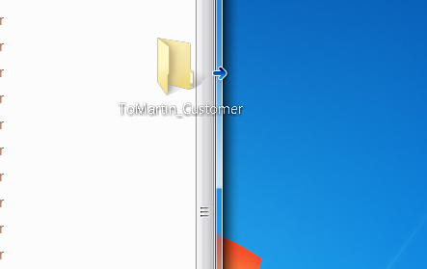

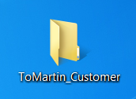

🡪

* Start the application by double-click the ‘FrmMain_LoginForm_PartPachler’



* Every startup you have to enter your password. Please be aware to watch out that your password is not stolen or spied by anyone.

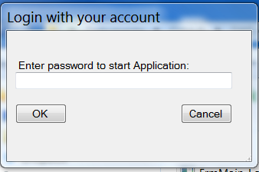

When you have entered your password correctly you can see the database. Now you can add and edit your customer database. For existing Customers you can change balance.

If you stuck you can drag your mouse over a control (e.g. a button). This shows you the **tooltips** which may help you.

## Database

Your database is stored in the same folder as the application. It is a .csv file named ‘cDB’ you can backup and restore your customer database with this file.