Analysis and Design Document

Student:Tomuș Alexandra

**Group:30234**

Revision History

|  |  |  |  |
| --- | --- | --- | --- |
| **Date** | **Version** | **Description** | **Author** |
| 26/04/2017 | 1,0 | Design Model, Data Model | Tomuș Alexandra |
|  |  |  |  |
|  |  |  |  |
|  |  |  |  |

Table of Contents

I. Project Specification 4

II. Elaboration – Iteration 1.1 4

1. Domain Model 4

2. Architectural Design 4

2.1 Conceptual Architecture 4

2.2 Package Design 4

2.3 Component and Deployment Diagrams 4

III. Elaboration – Iteration 1.2 4

1. Design Model 4

1.1 Dynamic Behavior 4

1.2 Class Design 4

2. Data Model 4

3. Unit Testing 4

IV. Elaboration – Iteration 2 4

1. Architectural Design Refinement 4

2. Design Model Refinement 4

V. Construction and Transition 5

1. System Testing 5

2. Future improvements 5

VI. Bibliography 5

# Project Specification

*[Present the project specification]*

# Elaboration – Iteration 1.1

# Domain Model

In cadrul proiectului vor exista doua tipuri de utilizatori, fiecare avand obtiunile pe care le poate realiza in functie de tipul acestuia. Cei doi posibili utilizatori sunt:

Administrator-ul: - utilizatorul principal

* poate sa vizualizeze rapoarte despre camera
* poate sa vizualizeze si sa stearga rezervari
* poate sa vizualizeze comentariile clientilor

User-ul normal: - poate realiza rezervari

* acces la o serie de fotografii
* poate vizualiza camerele
* poate adauga comentarii

# Architectural Design

## Conceptual Architecture

In ingineria software, arhitectura multi-tier este o arhitectura client-server. Modelul este bazat pe 3 nivele:

* + **Presentation tier:** este reprezentat de interfata utilizator expusa de program.
  + **Business Logic tier:** este reprezentat de codul aplicatiei, implementeaza funcționalitatea de baza a sistemului și încapsulează logica.
  + **Data tier:** include mecanisme de persistenta a datelor (servere de baze de date, fisiere, etc) si stratul de acces la date care incapsuleaza mecanisme de persistenta si expune datele.

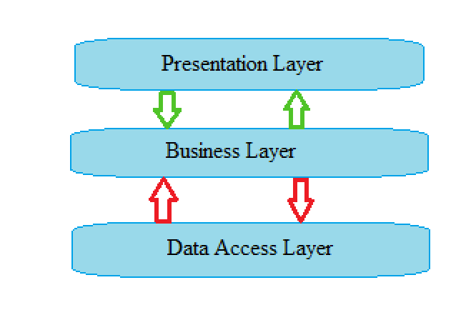

## Package Design

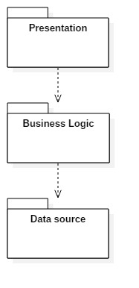

## Component and Deployment Diagrams

# Deployment.jpg

# Elaboration – Iteration 1.2

# Design Model

## Dynamic Behavior

**Administrator:**

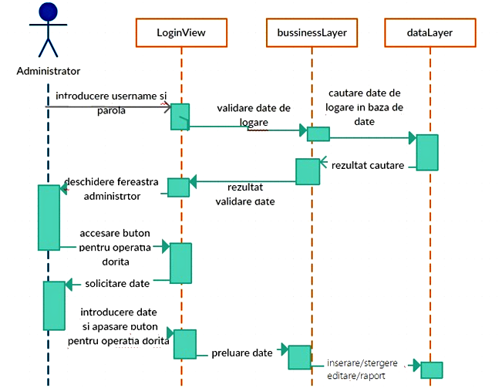

## Class Design

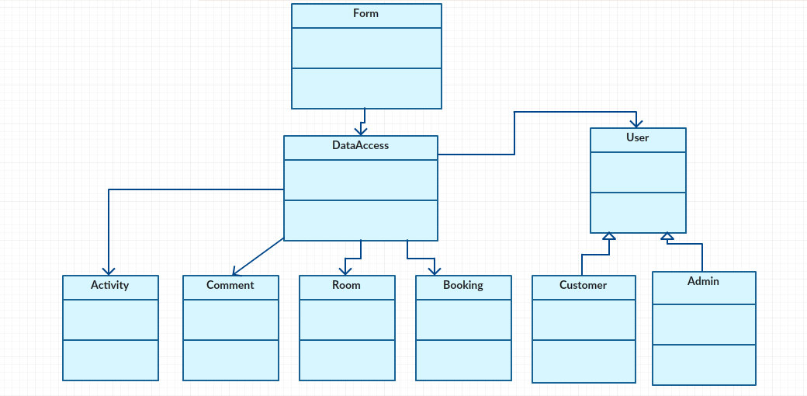

# Data Model

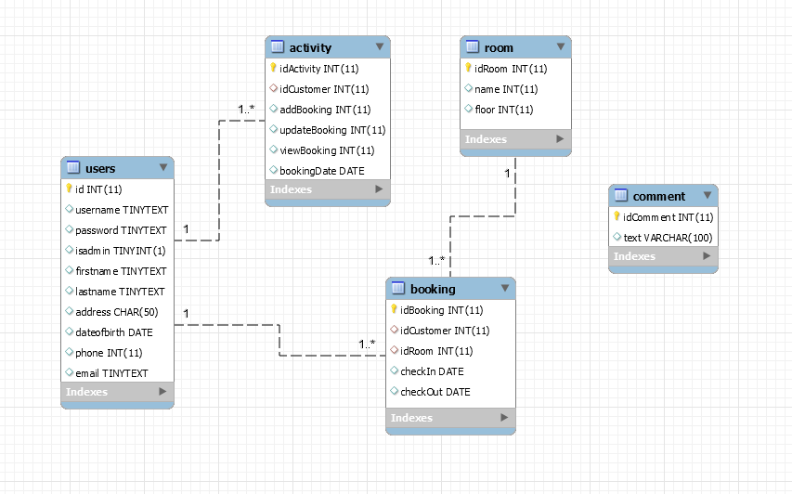

# Unit Testing

*[Present the used testing methods and the associated test case scenarios.]*

# Elaboration – Iteration 2

# Architectural Design Refinement

*[Refine the architectural design: conceptual architecture, package design (consider package design principles), component and deployment diagrams. Motivate the changes that have been made.]*

# Design Model Refinement

## *[Refine the UML class diagram by applying class design principles and GRASP; motivate your choices. Deliver the updated class diagrams.]*

# Construction and Transition

# System Testing

*[Describe how you applied integration testing and present the associated test case scenarios.]*

# Future improvements

*[Present future improvements for the system]*

# Bibliography