Neuromod Toolbox

Fully Interactive Ephys Data Analysis
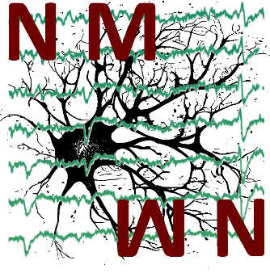
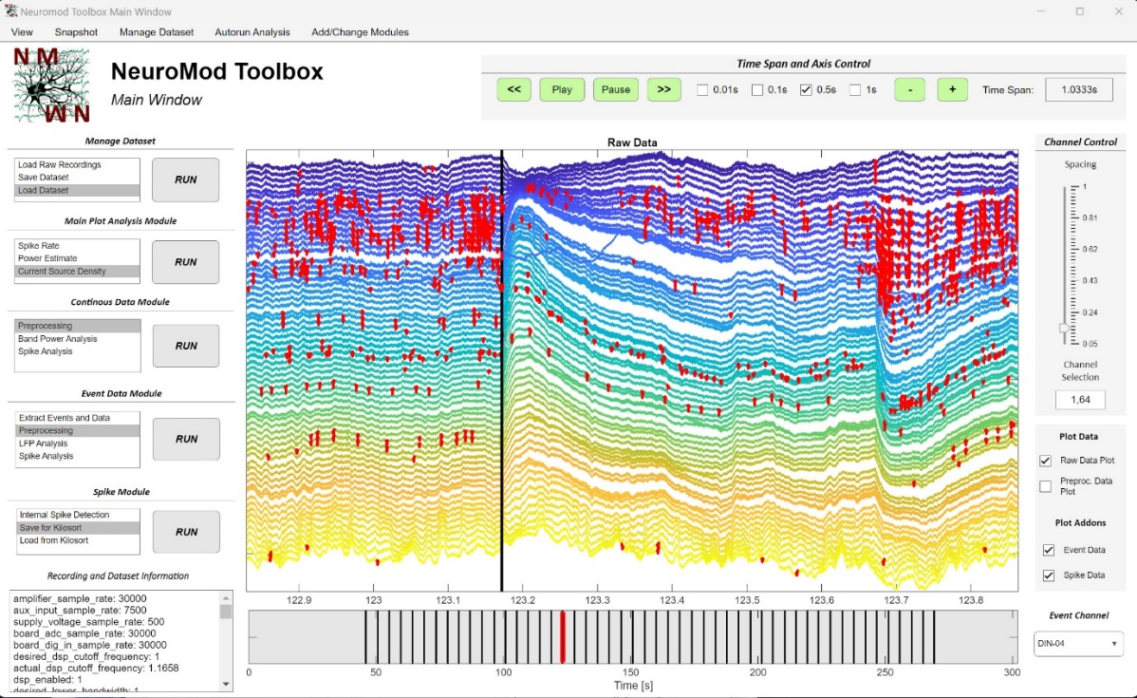
and Visualization for Matlab

Contact: Tony de Schultz
Leibniz Institute for Neurobiology Magdeburg
Email: tony.schultz@lin-magdeburg.de

- General structure of the user interface

NeuroMod is divided into a range of different modules, each responsible for a different aspect of data analysis or general data management. The modules are listed on the left side of the main window and split into several different functionalities that can be executed by clicking on the respective name and the ‘RUN’ button. While data analysis has to be conducted in a certain general order of operations (extracting data, preprocessing, analysis, plot), the exact order and operation depends on the type of analysis. Therefore, every functionality of every module can be selected at any time, while some of them are dependent of each other. The order of modules listed on the left already suggests a general order what functionality can be used when, but this does not hold true for every analysis type. In doubt, clicking on an analysis without having executed the necessary steps before that will just open a message in Matlab, explaining what is missing.
The toolbox is designed in a way, that it holds a standardized data structure that can be easily accessed and understood. This means, you can create an extension of the toolbox with your own app window and full access to all data in just a few lines of code and a minute of work. The data structure will be shortly explained in the following as it will be referred to in the explanation of each individual module. After the module explanations, a more detailed description along with the possibilities to create your own app window and access the data structure will be given.

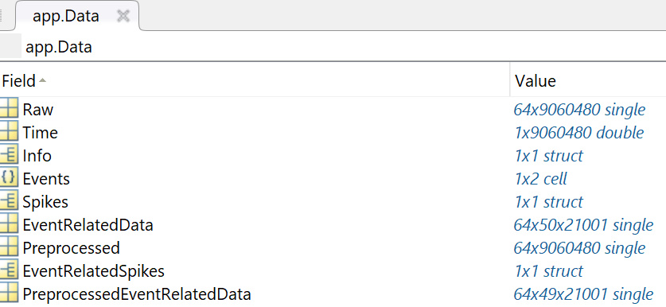
  - Data Structure

Data Components accessible as app.Data. :
- Raw: Contains raw data extracted from your recording as a channel by time matrix.
- Time: Contains time points (in seconds) for each recording sample.
- Info: Structure containing the header information from your recording along with additional information about what was done to your recording (which preprocessing was applied, what events were loaded etc.). The contains can be seen in the recording information text area on the bottom left of the main window.
- Events: Cell array, where each cell holds a 1 x Nr. Events vector, saving the time points of each event/TTL signal to your recordings system (in samples). If you have two TTL streams to your recording system, this will be a 1x2 cell array.
- Spikes: Structure holding either the loaded Kilosort spike data or spike data from the internal spike detection. Spike times are saved as Data.Spikes.SpikeTimes in a vector. The information about which channel or depth the spike occurs is saved in Data.Spikes.SpikePositions vector with the same length. This holds true for all the other spike parameters, like cluster identity or amplitude. This means, spikes of a specific cluster, depth and/or ampitude can be easily accessed with logical indexing.
- EventRelatedData: Three-dimensional matrix with dimensions: channel x events x time. This saves your event related data.
- Preprocessed: Contains preprocessed data, with same dimensions as the raw data. This means, that each time you apply a new preprocessing pipeline, the old preprocessed data will be overwritten.
- EventRelatedSpikes: Structure holding either the loaded Kilosort spike data or spike data from the internal spike detection within the range of your event related data, to analyze event related spike activity (just some fields of the original Data.Spikes are used here). This is the only dataset component calculated ‘on the fly’ every time when you start an event related spike analysis window.
- PreprocessedEventRelatedData: Three-dimensional matrix with dimensions: channel x events x time. Event related data can further be preprocessed by deleting specific events, rejecting artefacts and/or rejecting channel. If you have 50 events in your recording and delete 2 trials, the EventRelatedData variable is a channel x 50 x time matrix, while PreprocessedEventRelatedData is a channel x 48 x time matrix.

- Module Descriptions

  - Main Window

The main window is the central hub containing all functionalities, the toolbox provides. The biggest part is this window is made up of two plots. The upper one shows a data trace for each data channel in a certain time window of your recording. The second plot below it shows the time range of the recording with a red rectangle indicating the time range of the plot above. Clicking on the time plot can be used to jump in time, meaning the plot above will automatically show the data traces at the time point you clicked on.
To have more fine control over this plot, there are several panels arranged around them.

- Time Span and Axis Control Panel

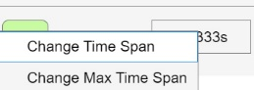
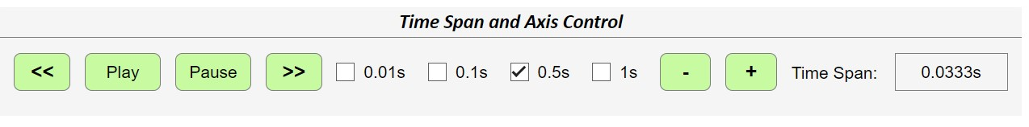
First, the time range plotted can be controlled using the panel on the upper right named ‘Time Span and Axis Control’. In the middle of this panel, you will see four checkboxes labeled with a time in seconds. This indicates the amount of time you modify the plot time range by when clicking on the << , >> , + or – button. These buttons are used to jump forwards or backwards in time by clicking on the << and >> button or to increase/decrease the amount of time data is plotted in with the + and – buttons. The minimal amount of time that is shown is 0.0333s. The max value is around 3 seconds, however it can be changed by right clicking on them time span info field on the right of the panel. This depends on how much data your PC can comfortably plot. Lastly, your dataset can be viewed in a movie mode by clicking on the Play or Pause button. Pressing the Play button will automatically jump in time by a small amount (independent of the four checkboxes) and update the data plot accordingly until you click on Pause.
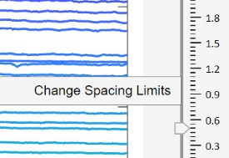
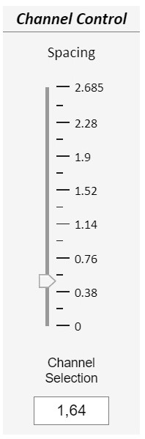
- Channel Control Panel

The second panel named ’Channel Control’ is used to control the main window plot channel range being plotted. There you can specify the spacing of each channel data trace to have a better overview of scale using the slider. The limits of the slider can be modified by right clicking on it and depend on the scale of your dataset. The last option in this panel is to select the range of channel shown in the main plot. The format of the input has to consist of two numbers, divided by a comma. When this format is violated, it will be automatically corrected to standard values.

- Plot Panel
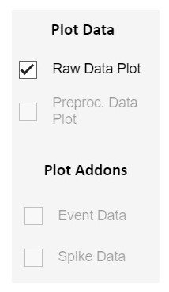
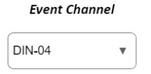
The third and last panel named ‘Plot Data’ and ‘Plot Addons’ gives several options what is shown in the data trace plot. At standard, you can view the data traces of your raw data. When you preprocessed your data and want to see the result, you can click on ‘Preproc. Data Plot’ to show the respective data traces. You can switch between them at any time. Addons are additionally extracted aspects of your data that can be visualized. If your data contains events at which a certain thing happened, you can extract the time points of those events and show them in the data trace - and time plot respectively. The same holds true for extracted spike time points. Enabling this will indicate the spikes found by coloring the data traces at these time points in red or show the exact time point with a red circle. How they will be shown can be selected in the main window menu under the menu point ‘View’ (see next point).
Lastly, there is a ‘Event Channel’ dropdown menu which can be used to select which event
you want to visualize in case your data contains more than one.

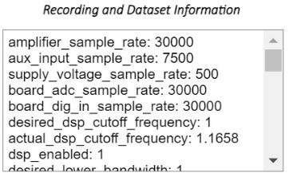
- Recording Information Text Area

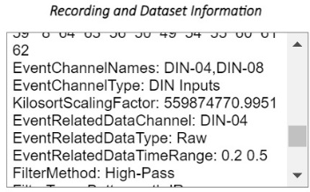
This text area in the lower left corner of the main window shows all information about your recording saved in the app.Data.Info structure. This includes standard header information native to your recording system as well as additional information like the path the data was extracted from and what was done to the dataset.

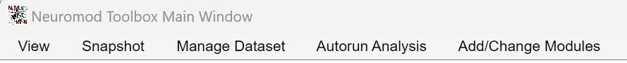
- Main Window Menu

In the main window you have several additional options in the menu strip on top.

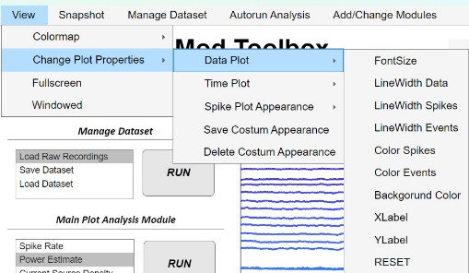
4.1: View:
This menu offers customizations options to the GUI window and plots. It can be used to switch between windowed and Fullscreen mode as well as change plot appearances. Plot appearances are at standard changed temporarily, meaning when you open the GUI again or extract/load a new recording, they will be reset to the standard appearances. However, you can save your customized appearance, which will automatically be the new standard to load when you restart the GUI. The ‘RESET’ option will reset only the plots in the main window (or of the window you have this option), while ‘Delete Costum Appearance’ will reset
all appearances of all GUI plots to standard and delete the costume appearance you saved earlier.

4.2.: Snapshot:
Take a snapshot of the app window in the selected format.

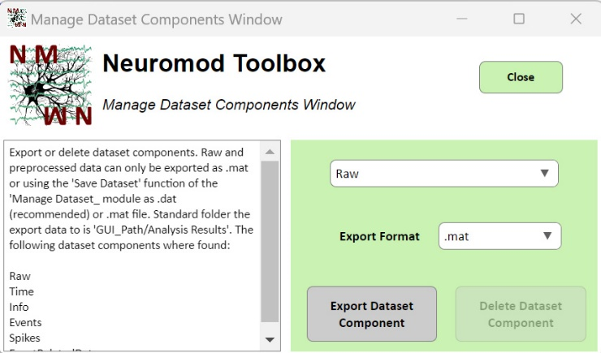
4.3.: Manage Dataset:
This opens a window in which you can either delete a dataset component or export it in the selected format (.mat, .txt. or .csv). Some actions are only allowed on specific dataset components. For example, deleting raw data is not allowed. To properly export raw and preprocessed data, it can only be saved as a .mat file in this window or as a .dat file (way faster and more memory efficient) in the ‘Save Dataset’ option of the Manage Dataset module.

4.4.: Autorun Analysis:
Say you have 20 recordings, for all of which you want to run the same kind of analysis pipeline. Instead of loading and clicking through each recording in the GUI one after another, you can instead use the autorun functionality to automatically loop through all recordings and apply your pipeline without manual labor. This depends on a config file, which consists of a variable saving all parameters available and necessary in the GUI too. You can change the parameter to your liking and select between different config files and recording files in the window opening when clicking the Autorun Analysis menu. For a deeper explanation see the dedicated section for the autorun function.

  - : Add/Change Modules
- Not implemented yet. Allows to create a completely new module and switch between modules shown in the GUI main window.

- Manage Dataset Module
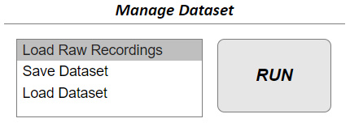
This module contains all functionalities to load a new recording, save the current dataset or load a previously saved dataset. Each functionality is explained separately:

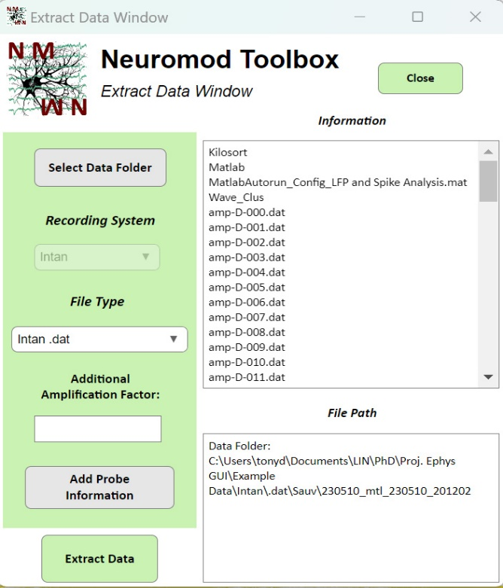
  - Load Raw Recording

This app window allows you to extract raw data from your recording. The supported formats are…
First, you have to select a folder containing your recording using the ‘Select Data Folder’ button. NOTE: Folder hat to contain ONLY ONE recording. For multiple recordings use the Autorun functionality.
Whether you selected a folder with a supported data format and whether all expected files are present is auto checked when you select the folder. If a suitable recording is found, you will see the folder contents in the upper text area of this window (in this case an Intan recording with .dat files). Also, the recording system and file type information of the window are autofilled. While you cant edit the recording system dropdown since its autodetected, you can use the File Type Dropdown menu for Open Ephys recordings to select the recording node you want to extract your data from.
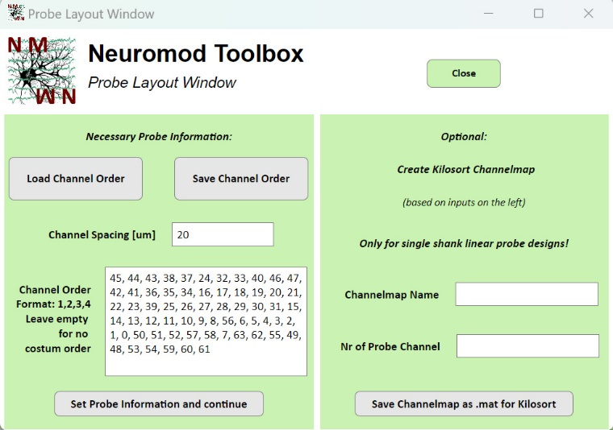
If no suitable recording was found you will be informed in the upper text area too.
When extracting your data, it is automatically converted into mV based on the A/D bit conversion values obtained from the original recording headers. However, there can be additional signal amplifications in your system not saved in the recording header that can be specified in the ‘Additional Amplification Factors’ text field. If non empty, your recording data will be multiplied by this factor to account for the additional amplification.
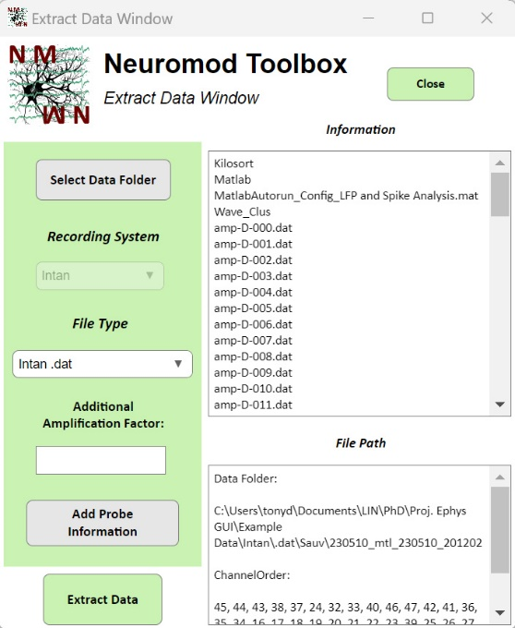
The next step is to specify your Probe Layout. This can be done cklicking on the ‘Add Probe Information’ button, opening a separate window. This newly opened Probe Layout Window contains of two sides. The left side is to specify your probe information for the Neuromod Toolbox dataset, while the right side allows you to create channel maps based on your inputs for Kilosort. The necessary information is your channel spacing. Optionally you can also specify a certain channel order in case your recording channel have a different order than on the probe itself (leave empty if you have no deviating channel order). This will reorder your channel x time data matrix, switching the channel dimensions according to your input. The channel order can also be saved as a .mat file and loaded for the next recording. The standard folder with some example channel orders along with Kilosort channel maps can be found in the ‘Path_to_GUI/ ChannelMaps’ folder. Click on the ‘Set Probe Information and Continue’ button to proceed to extract your data.
This brings you back to the original data extraction window. The channel order will be shown in the lower text are when specified. If no channel order was specified it will show an ‘NaN’. Now you can extract your data by clicking the corresponding button.
You will see a green bar showing you the percentage of data extracted and see additional information during the data extraction in the upper text area (depending on the recording filetype). If data was successfully extracted, this window will close and you will see your data traces in the main window data plot, giving you access to all other modules.
This also creates your dataset variable ‘app.Data’ containing the fields ‘Raw’, ‘Time’ and ‘Info’.

