NeuroMod Toolbox
Manual

Matlab toolbox for fully interactive analysis
of electrophysiological data
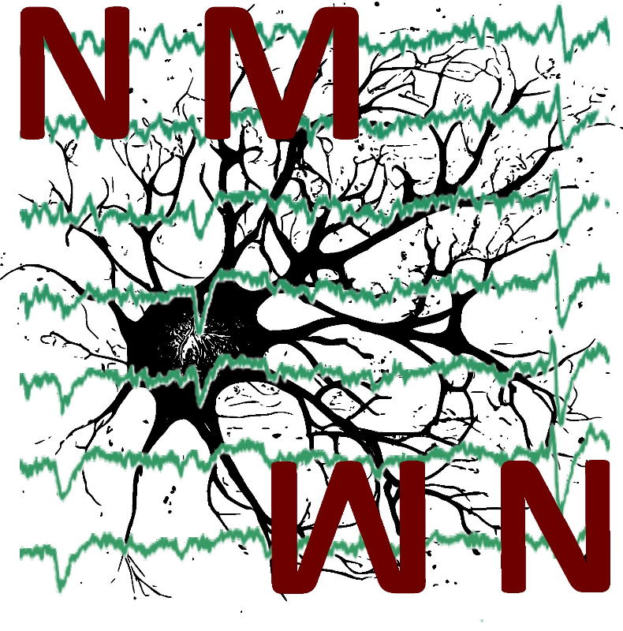

Contact: Tony de Schultz
Leibniz Institute for Neurobiology Magdeburg
Email: tony.schultz@lin-magdeburg.de

NEUROMOD
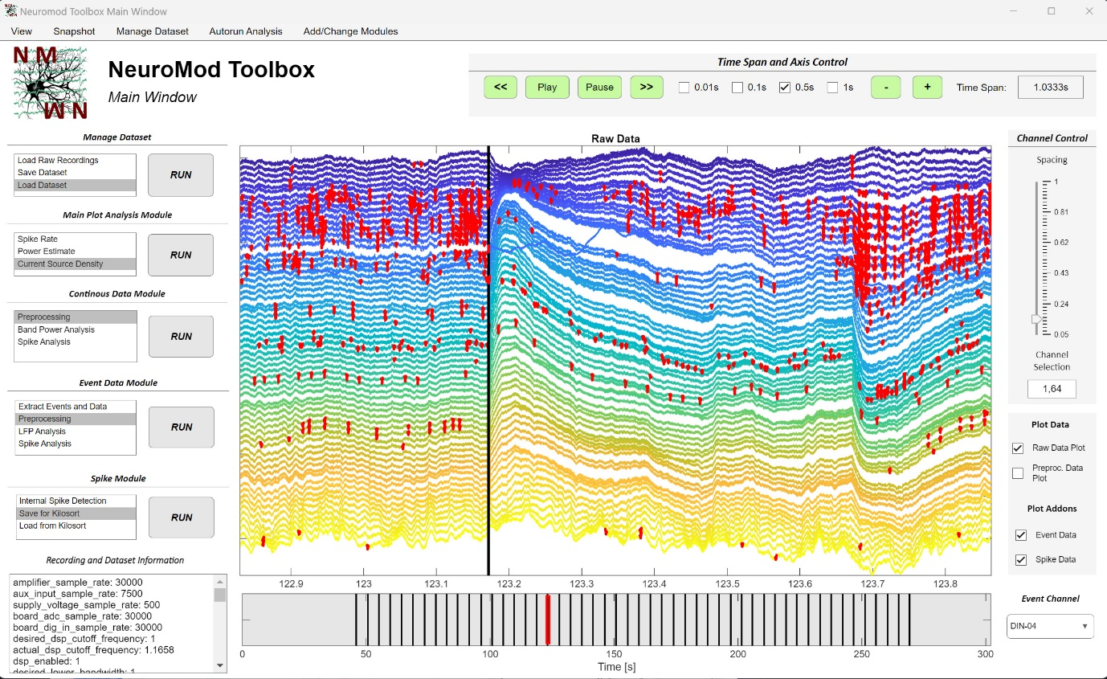
Neuromod is an interactive toolbox for analyzing and visualizing electrophysiological data from linear probe recordings. It seamlessly integrates established methods and toolboxes, such as Kilosort and Fieldtrip, to offer a wide range of analyses and support for various data formats, all without reinventing the wheel. Neuromod is designed to offer a comfortable and user-friendly experience, providing clear instructions and feedback on actions taken, rather than hard-to-interpret error messages or opaque processes that leave users uncertain about what was done to their data.
The toolbox currently supports recordings from linear probes across all Intan systems formats (.dat and .rhd), all Open Ephys formats (.dat, .nwb, .continuous), as well as Spike2 (.smrx), Neuralynx (.ncs), and Plexon (.plx) files. In addition to raw data, the GUI also supports event data (e.g., TTL signals to the recording system), enabling not only the preprocessing, analysis, and visualization of continuous data but also event-related data using a variety of methods.
Available types of analysis include current source density analysis, static power spectrum analysis, time-frequency power analysis, and event-related potentials for low-frequency signal components. Additionally, the toolbox fully supports Kilosort 4, allowing users to save data, create channel maps, and load Kilosort result files for interactive spike data visualization within the GUI. If Kilosort can’t be used, the toolbox also offers spike detection using different thresholding methods
Nearly all parameters related to data extraction and analysis are automatically set, but can still be adjusted within the GUI. This design ensures a smooth, code-free user experience, offering helpful guidance and full control over the analysis. Besides the analysis of a single recording with the user interface, this toolbox includes an autorun functionality that applies selected methods to all recordings in a file, automatically saving all possible visualizations based on a single Config file with a few options to specify. As a result, Neuromod is not only ideal for teaching and evaluating recording quality before or after sessions but also for comprehensive data analysis of one or multiple recordings.

How to use
There are two ways to use this toolbox: Either you download all the files as they are, unpack them and double click in the windows file explorer on the app file (or right click in matlab current folder window and click on run). However, this requires a valid Matlab license. Or you download the standalone version of this app, which you can execute without a valid Matlab license by just installing the Matlab runtime.
The code was tested with Matlab versions down to 2020. For versions before that there is no guarantee that all modules will work. It requires the following Matlab addons: Signal Processing Toolbox
To extract Spike2 .smrx files and use Kilosort you need to install the respective libraries /toolboxes yourself. However, once you done that the integration in this toolbox is seamless.
Disclaimer
This toolbox was created and is maintained by a single person as part of a PhD Project and Hobby. There is no guarantee for any of the analysis and results but dedication to fix bugs and evolve this. Feel free to contact me for tips and requests or pull a request/open an issue on Github. I try to get around all of them and provide guidance and help.
Rules and Philosophie of the toolbox:
- First off: this toolbox is not trying the reinvent the wheel. Rather it takes already established and proven analysis solutions like Kilosort and integrates them into a central hub aiming to bring LFP and spike analysis as well as signal quality measures together in a way, that everyone with (almost) every recording type can use it.
- All relevant analysis and data parts are saved in a single structure with a limited and clear amount of fields that every window shares. Changes in one window are automatically available in another window.
- All interactive parts like buttons, checkboxes and so on that are disabled (grey and cant be clicked on) can be activated by conducting the necessary analysis step before. For example, to enable to ‘Event Data’ checkbox on the right of the main window, you first have to extract events.
- If the user tries to do an analysis without proper preprocessing or enters a wrong format into any field requiring user input, values are either autocorrected and/or the user gets a message why the operation is not possible. The aim is to give an explanation of what to do when an error occurs, not only throw out an error nobody understands.
- In every window were you select a folder to load and some information about folder or data contents are shown, the folders were autosearched for the expected contents. If no expected contents were found, the user gets a message that nothing was found and has to select himself. This means that when you see information there, everything goes well.
- All functions are designed in a way that they can be easily used outside of the user interface with just a few support functions, including all visualizations. This enables the Autorun functionality of the GUI, where you can apply all analysis and plots in a loop to several recordings.

- General structure of the user interface

NeuroMod is divided into a range of different modules, each responsible for a different aspect of data analysis or general data management. The modules are listed on the left side of the main window and split into several different functionalities that can be executed by clicking on the respective name and the ‘RUN’ button. While data analysis has to be conducted in a certain general order of operations (extracting data, preprocessing, analysis, plot), the exact order and operation depends on the type of analysis. Therefore, every functionality of every module can be selected at any time, while some of them are dependent of each other. The order of modules listed on the left already suggests a general order what functionality can be used when, but this does not hold true for every analysis type. In doubt, clicking on an analysis without having executed the necessary steps before that will just open a message in Matlab, explaining what is missing. In the following, each module will be explained in detail

- Main Window

The main window is the central hub containing all functionalities, the toolbox provides. The biggest part is this window is made up of two plots. The upper one shows a data trace for each data channel in a certain time window of your recording. The second plot below it shows the time range of the recording with a red rectangle indicating the time range of the plot above. Clicking on the time plot can be used to jump in time, meaning the plot above will automatically show the data traces at the time point you clicked on.
To have more fine control over this plot, there are several panels arranged around them.
First, the time range plotted can be controlled using the panel on the upper right named ‘Time Span and Axis Control’. In the middle of this panel, you will see four checkboxes labeled with a time in seconds. This indicates the amount of time you modify the plot by with a certain action. Those actions can be to jump forwards or backwards in time by clicking on the << and >> button or to increase/decrease the amount of time data is plotted in with the + and – buttons. The minimal amount of time that is shown is 0.0333s. The max value is around 3 seconds, however it can be changed by right clicking on them time span info field on the right of the panel. This depends on how much data your PC can comfortably plot. Lastly, your dataset can be viewed in a movie mode by clicking on the Play or Pause button. Pressing the Play button will automatically jump in time by a small amount and update the data plot accordingly until you click on Pause.
The second panel named ’Channel Control’ to control the main window plots is to their right. There you can specify the spacing of each channel data trace to have a better overview of scale using the slider. The limits of the slider can be modified by right clicking on it and depend on the scales of your dataset. The last option in this panel is to select the range of channel shown in the main plot. The format of the input has to consist of two numbers, divided by a comma. When this format is violated, it will be automatically corrected to standard values.
The third and last panel named ‘Plot Data’ and ‘Plot Addons’ gives several options what is shown in the data trace plot. At standard, you can view the data traces of your raw data. When you preprocessed your data and want to see the result, you can click on ‘Preproc. Data Plot’ to show the respective data traces. You can switch between them at any time. Addons are additionally extracted aspects of your data that can be visualized. If your data contains events at which a certain thing happened, you can extract the time points of those events and show them in the data trace - and time plot respectively. The same holds true for extracted spike time points. Enabling this will indicate the spikes found by coloring the data traces at these time points in red.
Lastly, there is a ‘Event Channel’ dropdown menu which can be used to select which event you want to visualize in case your data contains more than one.

