Group members

Alena rAspopa

Tanya Beth Rosaldo

Anthony Delgado

Paula olariu

**FUNDAMENTAL BUSINESS ANALYSIS Group 8**

2018

Table of Contents

1 Responsibilities 3

2 Introduction 4

3 Project Plan 5

3.1 Microsoft Project 5

3.2 Trello 6

4 Description of the Techniques 7

4.1 Triple Constraint 7

4.1.1 Definition 7

4.1.2 Usage 7

4.2 Root Cause Analysis 8

4.2.1 Definition 8

4.2.2 Usage 8

4.3 Prototyping/Wireframe 8

4.3.1 Definition 8

4.3.2 Usage 8

4.4 Wireframe 8

4.4.1 Definition 8

4.4.2 Usage 9

4.5 Interface Analysis 9

4.6 Observation 9

4.6.1 Purpose: 9

4.6.2 Usage 10

4.7 Use-Case 10

4.7.1 Definition 10

4.7.2 Purpose: 10

4.8 User Story 10

4.8.1 Definition 10

4.8.2 Usage 11

4.9 User Acceptance Testing 11

4.9.1 Definition 11

4.9.2 Usage 11

5 Foundings of the techniques 12

5.1 Triple constraint 12

5.1.1 Scope 12

*5.1.1.2* *Project Deliverables* 12

5.1.1.4 Project Acceptance 12

5.1.2 Time 12

5.1.3 Budget 17

5.1.4 Risk Register 18

5.2 Root Cause Analysis 19

5.2.1 Investigative Team 19

5.2.2 The Problem occurred 19

5.2.3 Sequence Event 19

5.2.4 Methods Used 19

5.3 Prototyping/Wireframe 19

5.3.1 Throw away prototype 19

5.3.2 Feedback from Users: 20

5.3.3 Wireframe documentation 20

5.3.4 Mobile Website Wireframe 24

5.3.5 Wireframe Documentation: 24

5.4 Interface Analysis 27

5.4.1 Identified interfaces that are involved in the system: 27

5.4.2 4.2 CONTEXT DIAGRAM 31

5.5 OBSERVATION 32

5.5.1 Purpose 32

5.5.2 Description 32

5.5.3 Elements 32

5.5.4 Usage Considerations 34

5.6 USE CASES AND SCENARIOS 34

5.6.1 Purpose 34

5.6.2 Description 34

5.6.3 Elements 35

5.6.4 Use Case Diagrams 35

5.6.4.2 Use case Description 36

5.6.5 Use Case Flow of Events 37

5.6.6 Usage Considerations 40

5.7 User Story 40

5.7.1 Purpose: 40

5.7.2 Description: 41

5.7.3 Elements: 41

5.7.4 Usage Considerations: 44

5.8 User acceptance testing 44

5.8.1 Purpose: 44

5.8.2 Description: 45

5.8.3 User Acceptance Testing Planning: 45

5.8.4 Alpha User Acceptance Testing: 45

5.8.5 Beta User Acceptance Testing: 45

5.8.6 Form-Based Testing: 46

5.8.7 UAT Action Testing 47

5.8.8 User Acceptance Testing Test Execution: 48

5.8.9 User Acceptance Testing Business Objectives Met Confirmation: 48

5.8.10 Strengths of User Acceptance Testing 48

5.8.11 Limitations of User Acceptance Testing 49

6. Requirements List 49

6.1 Root Cause Analysis 49

6.2 Triple Constraint 49

6.3 User story: 49

6.4 User acceptance testing: 50

6.5 Prototyping/Wireframes 50

Home Page 50

Course Page 50

Library Page 50

6.6 Interface Analysis 51

6.7 Observation 51

6.8 Use Case 51

7 References 52

**Resource elicitation**

# Responsibilities

**Alena Raspopa – Project leader**

* Triple Constraints
* Root Cause Analysis

**Anthony Delgado – Document Manager**

* Prototyping/Wireframe
* Interface Analysis

**Tanya Rosaldo – Moodle Captain**

* Observation
* Use Case

**Paula Olariu – Trello Coordinator**

* User Story
* User Acceptance Testing

# Introduction

National College of Ireland decided to redevelop their website. Our group project task is to make a Requirements Elicitation report that is needed for the new website.

As group project we have decided to use business analysis techniques which will help for success project. After group meeting, we came up with ten techniques:

•         Observation/Shadowing

•         Use case diagram

•         User story

•         User Acceptance/Testing

•         Prototyping/Wire framing

•         Interface Analysis

•         Triple Constraint

•         Root Couse Analysis

•         Document Analysis

•         Non-functional requiring analysis

# Project Plan

## Microsoft Project

Before our team started to work on the project, we created a project plan which describes the tasks each team member had to conduct for delivering the concluded project at the accurate deadline. For planning the responsibilities of each team member, we as a group decided to use Microsoft Project where we set the amount of time required to successfully conduct the necessary work for each project deliverable. Below is included a screenshot of the Microsoft Project document, displaying a step by step description of the tasks done. project deliverable. Below is included a screenshot of the 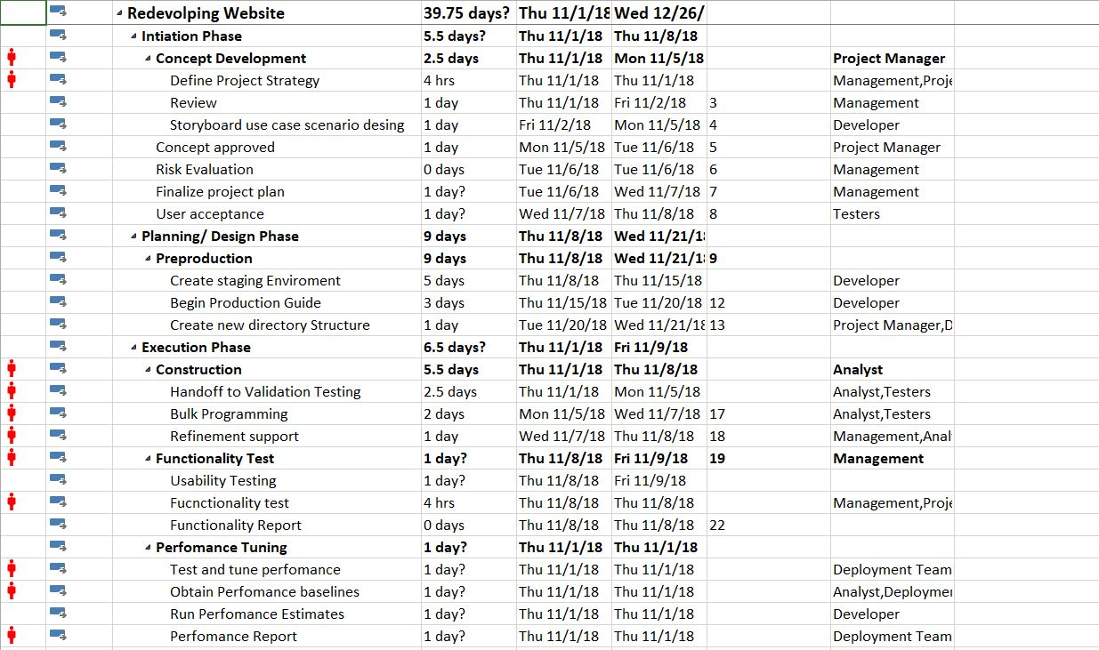Microsoft Project document, displaying a step by step description of the tasks done.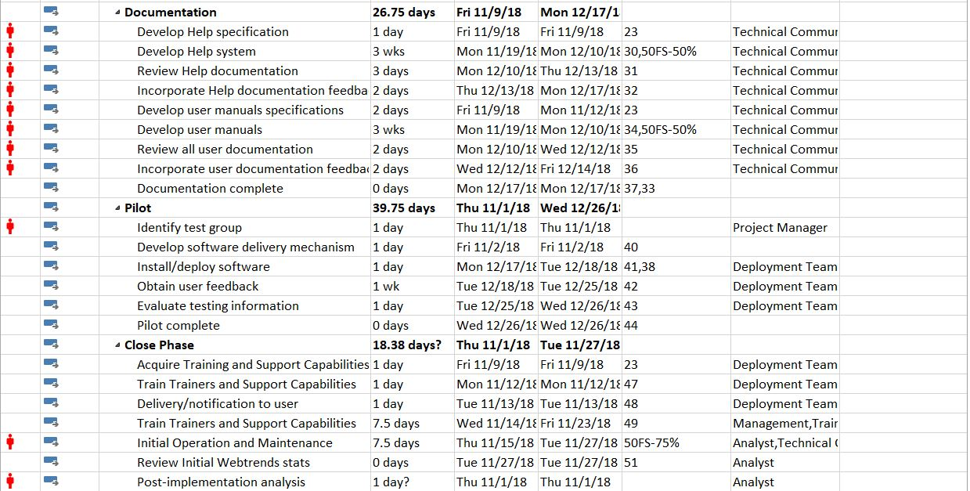

## Trello

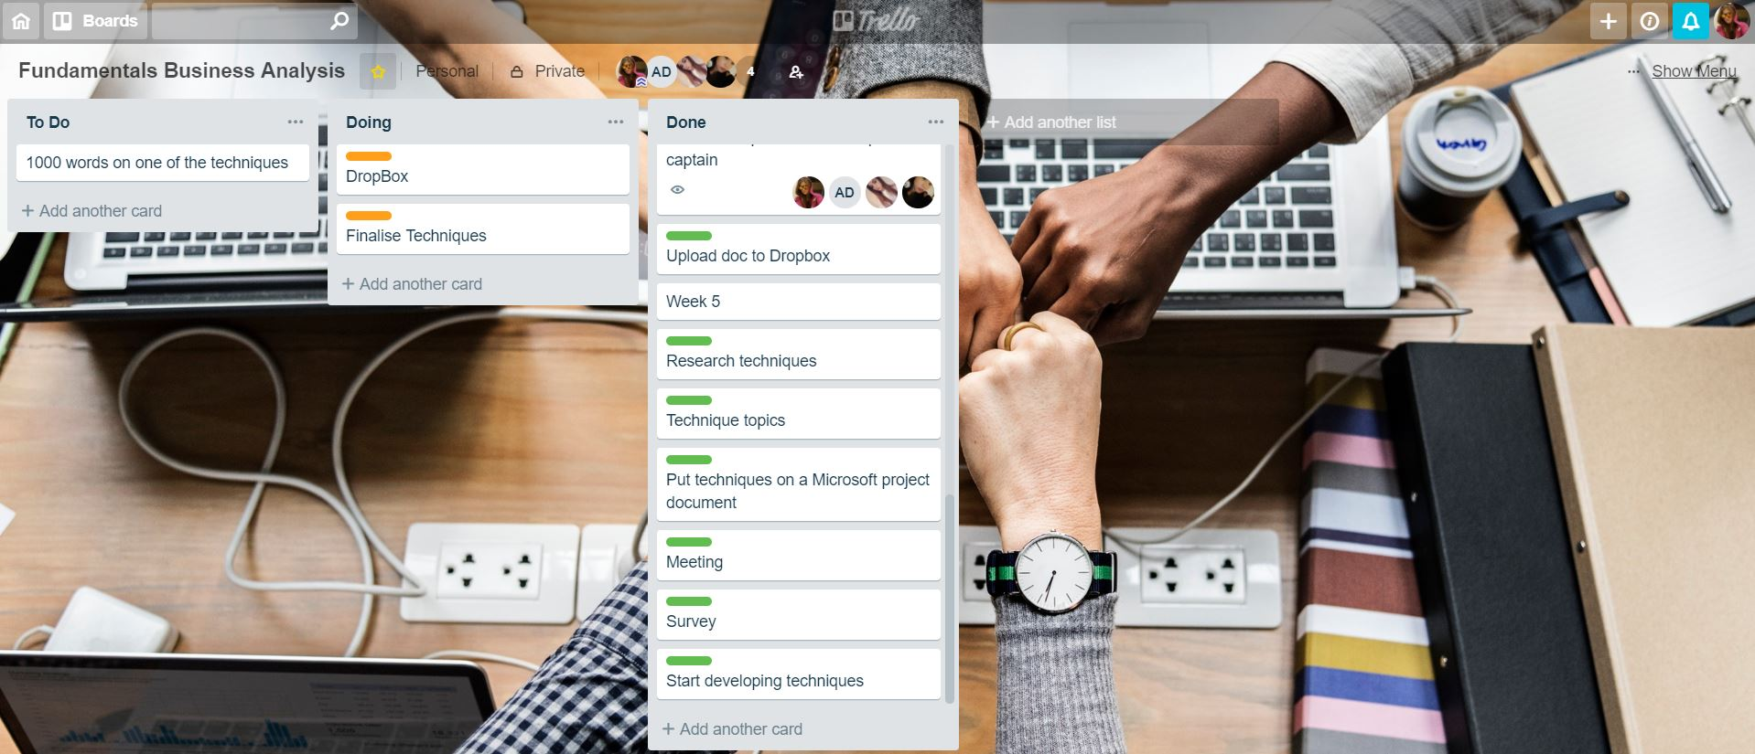The second program that we used is Trello. The program was implemented to keep track of the weekly and monthly requirements of the project. We created a dashboard where all team members were included and allowed to check the tasks which were yet to be started located in the “To Do” section, the tasks that were conducted at that moment were located in the “Doing” section, and the tasks that were fully completed could be found in the “Done” section. When a task from the “To Do” section begins to be developed, it is moved to the “Doing” section. And when a task from the “Doing” section is completed it is moved to the “Done” section. Tasks were also labelled with the name of the person by who they must be completed.

# Description of the Techniques

|  |  |
| --- | --- |
|  |  |

## Triple Constraint

### Definition

* This technique is to determine the project cost, scope and time for the team.  With this technique is possible to see the main idea of the project and from where to start. For a successful project, those three factors are always at play in the project. The triple constraint provides a framework that everyone in the project can agree on.

### Usage

* The technique is going to be used in the project for investigating how much time is going to be taken to make the changes in the website, how much budget will be needed for the changes and how big is going to be the project. The costing process including cost estimate to figure out if needed financial commitment for the project. The scoping process is a key factor in managing and establishing the scope for stakeholder’s expectations. The time process is for maintaining the time to complete the project on time. (Services, E. (2018))

## Root Cause Analysis

### Definition

* This technique helps to find issues in the project. It seeks to identify the origin of a problem using a specific set of steps. The primary goal of using RCA (Root Cause Analysis) is to analyse the problems or events. To be able to use the technique we will have three main questions, first question will be what happen in the project, second question is how it happen and the final question why it happen. After all those three questions will be answered the finial step of the technique is to make an actions for preventing the problem. (Westland, J. (2018))

### Usage

* The techniques are going to be used in the project in case if there will be any issues in the project that we are going to work on. For example, if there are any physical causes, human causes or organizational causes. It will be helpful to underline the problems that contribute to a problem event. This process will be focused on investigation and analysis through problem identification and whys the problem accrued. (Westland, J. (2018))

## Prototyping/Wireframe

### Definition

This technique is used to build a base model of a required software or product. It is basically an early version of a product which helps the designers and users see the flaws of the system and how to eliminate those, as well as, improve it. Clouting, J. (2013) The product prototype only has the features that are essential for it to work or serve its intended purpose. Developers then can eventually add features that aren’t essential, but will make the product convenient to users. (Sauter, V., Mcclendon, M., Regot, L. and Akers, G. (2012))

### Usage

Prototyping can provide huge assistance with the process of requirements elicitation as it provides an actual “view” of a product or system, although limited, and its corresponding problems. Developers will have a solid idea and solutions to these complications. Prototyping is also used to deliver a working product to stakeholders so that they can determine if that product is on track based on what they needed. (Sauter, V., Mcclendon, M., Regot, L. and Akers, G. (2012))

## Wireframe

### Definition

A wireframe is basically a blueprint for a website as it dictates how the layout of the page will look like and what content it would contain. A wireframe would include a structure of a page and information about the objects that will be put to make it easier for stakeholders to visualise it. ..., (G. (2017))

### Usage

As the description suggest, we aim to use this technique to provide a sample of a new and improved version of the NCI Website. A suitable wireframe will be constructed from data and solutions gained from variable stakeholders. Making a wireframe for the website is essential to the development and what would be the most ideal wireframe will be brought into prototyping then into fruition.

## Interface Analysis

This technique helps determine the requirements for a successful interaction between a system and user, an application to another application, or hardware to a system. Interface analysis helps build the necessary components to ensure links between all of these are successful. (Famuyide. S,(2014))

A system can contain a lot of interfaces that are used and can be individually different from each other depending on which stakeholders it is for e.g. User or Admin. Interface analysis makes sure that each of these interfaces within the same system works successfully and suit the user it is tailored to. (Weese, S. (2011))

There are general steps involved in interface analysis: (Weese, S. (2010))

* **Preparation**
  + - Prepare and determine both interfaces involved and its requirements
* **Identification**
  + Identify the purpose of each interfaces and function for their corresponding stakeholders as well as how they would interact with the system.
* **Definition**
  + Description of how the interfaces function such as its input and output.

With the NCI website, there are a lot of application interfaces interacting with each other such as Moodle and Office 365. If we are to build a new and improved version of the website, analysis of the interactions of these systems and its interfaces are very important as all stakeholders are affected.

## Observation

Observation also known as job shadowing is a technique used by business analyst who in general watch how people interact and behave in a business under natural conditions. It is designed to show an exact detail and information on how people interact with given tasks and to gain some understanding of its flow. (Sonego D (2018)).

### Purpose:

Observation’s main purpose is to record details about the task and anything to be improved or analysed.

There are 2 types of approaches: (Sonego D (2018)).

* Passive: during observation the observer don’t interrupt and only raise any concerns when observation is over.
* Active: while observing the analyst asks any questions if there is any, this type of approach the analyst can quickly understand the process of the underlying activity.

### Usage

For a successful observation, analyst should follow 3 steps: prepare for observation, observe and present observation results (Sonego D (2018)). Objectives of the observation must be understood to identify any opportunities for improvement before planning questions to be asked from the user. However, business analysts consider the skills and experience levels of the participants.

## Use-Case

### Definition

Use-case is a list of actions/steps that describes the interactions between an actor and a system to achieve its goal.

### Purpose:

Use-case describes the system’s behaviour under several conditions. It is a visual representation of the key functions that a system can perform showing the use cases, actors, the system and their interactions between each other.

It is also a list of steps defining the interactions between a role known as the actor in UML and a system.

Use-case involves: (www.tutorialspoint.com (2018))

* Actor: interacts with the system and performs to accomplish the tasks. Actor could be a human or an external system.
* Description: provides a brief description of the reason and outcome of the use-case
* Preconditions: a list of activities that must take place before use-case happens
* Post condition describes the state of the system – giving a result of the use case execution
* Termination: a list of successful and unsuccessful ways this use case might end.

## User Story

### Definition

A User Story is a tool used to gain the opinion of an end-user regarding a new software feature. It helps to obtain crucial details from an end-user and a simplified description of the requirements as well as describing what the user wants and why. (COHN, M. 2018)

A solid User Story should consist of the characteristics of the INVEST acronym:

* Independent: user stories must be independent from one another for flexibility of development.
* Negotiable: the user story should not contain too much detail, so it will be flexible for the team when adjusting how much of the story to implement.
* Value to users or customers: both the users who use the software and the customers who purchase the software get some value from the story.
* Estimating: the created user stories should be useful to the development team when planning and prioritizing.
* Small: user stories should be short as long user stories are harder to plan and estimate.
* Testable: non-testable user stories are usually vague requirements.

(TheAdaptivePM, 2018)

### Usage

The technique will be implemented in the project by asking an end-user of the website what changes should be made and why. As a result, a User Story will be created containing the information gathered from the user. (Docs.ca.com. 2018)

## User Acceptance Testing

### Definition

A User Acceptance Test is the final phase of the software testing process. The improved version of the software is tested by end-users to verify that the new software can handle and perform required tasks in real-world scenarios. (SETTER, M. 2018)

### Usage

User Acceptance testing is needed for directly gaining user requirements and identifying problems which may had been missed by the integration test, and for providing an overview of how well the system is operating. (SETTER, M. 2018)

Types of User Acceptance Testing:

* Alpha Testing: is usually done by internal staff and carried out in the development environment long before the product is presented to customers or external testers.
* Beta Testing: tested by the group of customers outside of the development environment.
* Contract Acceptance Testing: the newly designed software is tested against certain specifications agreed upon in the contract.
* Regulation Acceptance Testing: checks if the software follows the governmental ang legal regulations.
* Operational Acceptance Testing: ensures that workflows are present to allow the system to be used. (Peham, 2018)

The technique will be applied by having an end-user test the new website’s prototype and verify how the updated version works for the user along with any other desired updates. (SETTER, M. 2018)

## 

# Foundings of the techniques

## Triple constraint

### Scope

#### Product Scope Description

National College of Ireland (NCI) has decided to redevelop their website and student portal (Moodle). Our team has created a feedback link where users can give their opinion about the website. After summarizing the answers, we prepared a list of objectives that could be changed in the website to make it easier for usage as for the students and lectures.

#### **Project Deliverables**

* Update Course menu bar in NCI website
* Update Location Section in the NCI website
* Update Information Section in the NCI website
* Change fonts of the website
* Make update on the text size when using tablet or phone
* Add more pictures to the website
* Create a new tab when clicking any sections in the website
* Create responsive website when using tablet or phone
* Categories the courses in Site Home page
* Create a new tab when clicking on any buttons in the Moodle
* Create drop-down list on Course Overview Tab
* Update design in the Moodle
* Create a Moodle Button in NCI website

#### Project Exclusions

Since Student Success is the most important value of National College of Ireland and all areas of the College have a direct or indirect effect on student’s success, all employee will be expected to support their time and expertise.

#### **Project Acceptance** Criteria

* Successful Update of the NCI website
* Successful Update of Moodle

#### Project Constraints

* Time/resources/personnel limitation
* The website redeveloping should be represented by September 2019
* College Leadership will support the project and provide timely responses to request
* Project staff will be dedicated to this project and will not be reassigned

### Time

To create planning for the Project the Microsoft Project has been used. In the table above is included the task that is must be done in for successful project. All the task is sorted step by step for successful closing the project. In the planning table is included Task name, Duration for each task in days. The rows with the Start Date and Finish date are just approximate. As the project doesn’t have start date yet.

|  |  |  |  |  |
| --- | --- | --- | --- | --- |
| Task Name | Duration | Start | Finish | Resource Names |
| **Redevolping Website** | **39.75 days?** | **Thu 11/1/18** | **Wed 12/26/18** |  |
| **Intiation Phase** | **5.5 days?** | **Thu 11/1/18** | **Thu 11/8/18** |  |
| **Concept Development** | **2.5 days** | **Thu 11/1/18** | **Mon 11/5/18** | **Project Manager** |
| Define Project Strategy | 4 hrs | Thu 11/1/18 | Thu 11/1/18 | Management,Project Manager |
| Review | 1 day | Thu 11/1/18 | Fri 11/2/18 | Management |
| Storyboard use case scenario desing | 1 day | Fri 11/2/18 | Mon 11/5/18 | Developer |
| Concept approved | 1 day | Mon 11/5/18 | Tue 11/6/18 | Project Manager |
| Risk Evaluation | 0 days | Tue 11/6/18 | Tue 11/6/18 | Management |
| Finalize project plan | 1 day? | Tue 11/6/18 | Wed 11/7/18 | Management |
| User acceptance | 1 day? | Wed 11/7/18 | Thu 11/8/18 | Testers |
| **Planning/ Design Phase** | **9 days** | **Thu 11/8/18** | **Wed 11/21/18** |  |
| **Preproduction** | **9 days** | **Thu 11/8/18** | **Wed 11/21/18** |  |
| Create staging Enviroment | 5 days | Thu 11/8/18 | Thu 11/15/18 | Developer |
| Begin Production Guide | 3 days | Thu 11/15/18 | Tue 11/20/18 | Developer |
| Create new directory Structure | 1 day | Tue 11/20/18 | Wed 11/21/18 | Project Manager,Developer |
| **Execution Phase** | **6.5 days?** | **Thu 11/1/18** | **Fri 11/9/18** |  |
| **Construction** | **5.5 days** | **Thu 11/1/18** | **Thu 11/8/18** | **Analyst** |
| Handoff to Validation Testing | 2.5 days | Thu 11/1/18 | Mon 11/5/18 | Analyst,Testers |
| Bulk Programming | 2 days | Mon 11/5/18 | Wed 11/7/18 | Analyst,Testers |
| Refinement support | 1 day | Wed 11/7/18 | Thu 11/8/18 | Management,Analyst |
| **Functionality Test** | **1 day?** | **Thu 11/8/18** | **Fri 11/9/18** | **Management** |
| Usability Testing | 1 day? | Thu 11/8/18 | Fri 11/9/18 |  |
| Fucnctionality test | 4 hrs | Thu 11/8/18 | Thu 11/8/18 | Management,Project Manager |
| Functionality Report | 0 days | Thu 11/8/18 | Thu 11/8/18 |  |
| **Perfomance Tuning** | **1 day?** | **Thu 11/1/18** | **Thu 11/1/18** |  |
| Test and tune perfomance | 1 day? | Thu 11/1/18 | Thu 11/1/18 | Deployment Team,Testers |
| Obtain Perfomance baselines | 1 day? | Thu 11/1/18 | Thu 11/1/18 | Analyst,Deployment Team |
| Run Perfomance Estimates | 1 day? | Thu 11/1/18 | Thu 11/1/18 | Developer |
| Perfomance Report | 1 day? | Thu 11/1/18 | Thu 11/1/18 | Deployment Team |
| **Documentation** | **26.75 days** | **Fri 11/9/18** | **Mon 12/17/18** |  |
| Develop Help specification | 1 day | Fri 11/9/18 | Fri 11/9/18 | Technical Communicators |
| Develop Help system | 3 wks | Mon 11/19/18 | Mon 12/10/18 | Technical Communicators |
| Review Help documentation | 3 days | Mon 12/10/18 | Thu 12/13/18 | Technical Communicators |
| Incorporate Help documentation feedback | 2 days | Thu 12/13/18 | Mon 12/17/18 | Technical Communicators |
| Develop user manuals specifications | 2 days | Fri 11/9/18 | Mon 11/12/18 | Technical Communicators |
| Develop user manuals | 3 wks | Mon 11/19/18 | Mon 12/10/18 | Technical Communicators |
| Review all user documentation | 2 days | Mon 12/10/18 | Wed 12/12/18 | Technical Communicators |
| Incorporate user documentation feedback | 2 days | Wed 12/12/18 | Fri 12/14/18 | Technical Communicators |
| Documentation complete | 0 days | Mon 12/17/18 | Mon 12/17/18 |  |
| **Pilot** | **39.75 days** | **Thu 11/1/18** | **Wed 12/26/18** |  |
| Identify test group | 1 day | Thu 11/1/18 | Thu 11/1/18 | Project Manager |
| Develop software delivery mechanism | 1 day | Fri 11/2/18 | Fri 11/2/18 |  |
| Install/deploy software | 1 day | Mon 12/17/18 | Tue 12/18/18 | Deployment Team |
| Obtain user feedback | 1 wk | Tue 12/18/18 | Tue 12/25/18 | Deployment Team |
| Evaluate testing information | 1 day | Tue 12/25/18 | Wed 12/26/18 | Deployment Team |
| Pilot complete | 0 days | Wed 12/26/18 | Wed 12/26/18 |  |
| **Close Phase** | **18.38 days?** | **Thu 11/1/18** | **Tue 11/27/18** |  |
| Acquire Training and Support Capabilities | 1 day | Fri 11/9/18 | Fri 11/9/18 | Deployment Team |
| Train Trainers and Support Capabilities | 1 day | Mon 11/12/18 | Mon 11/12/18 | Deployment Team |
| Delivery/notification to user | 1 day | Tue 11/13/18 | Tue 11/13/18 | Deployment Team |
| Train Trainers and Support Capabilities | 7.5 days | Wed 11/14/18 | Fri 11/23/18 | Management,Trainers |
| Initial Operation and Maintenance | 7.5 days | Thu 11/15/18 | Tue 11/27/18 | Analyst,Technical Communicators |
| Review Initial Webtrends stats | 0 days | Tue 11/27/18 | Tue 11/27/18 | Analyst |
| Post-implementation analysis | 1 day? | Thu 11/1/18 | Thu 11/1/18 | Analyst |

*Table 1*

#### Charts

By summarizing the entire task, I have created a charts bellow for easier understanding of the planning the project. The charts will show how much time will need for each task to be done, how much hours each department will spend to finish their tasks. And how many hours will be needed for whole project

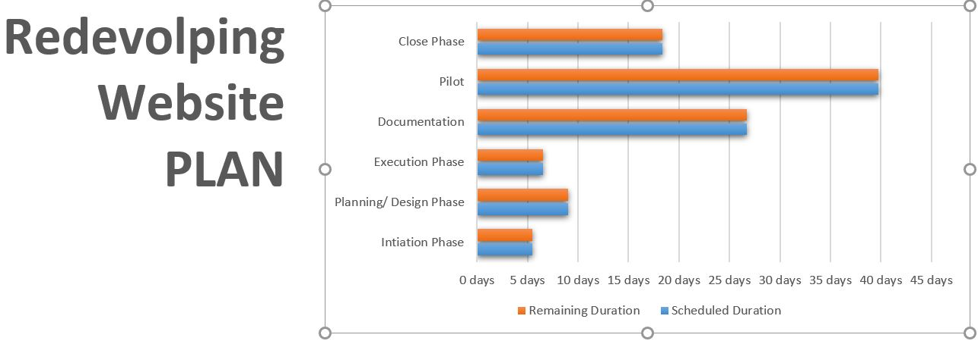

*Figure 1*

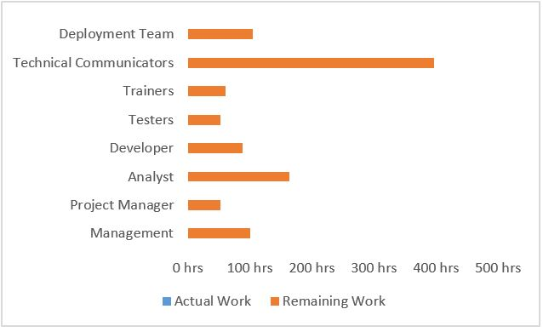

In Figure1 above shows how many days need for the project to be completed. In total need 40 to 45 days to redevelop the website.

 First step before to create a project need to split the work between departments. As you can see on Figure 2 there are 8 departments which will be involved to redevelop the website. In this chart shows how hours will spend each department for the project.

*Figure 2*

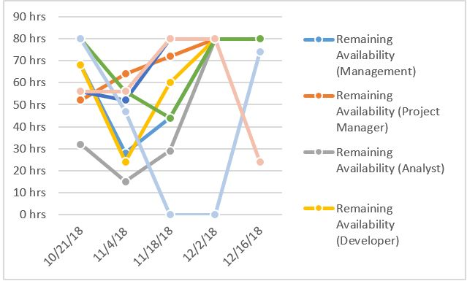

Figure 3 shows remaining availability for all work resources.

*Figure 3*

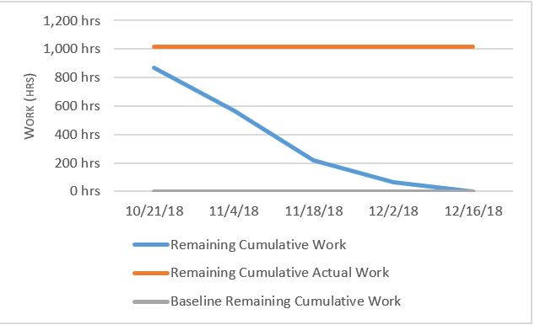In Figure 4 shows how much work has been completed and how much have left. If the remaining cumulative work line is steeper, then the project may be late.

*Figure 4*

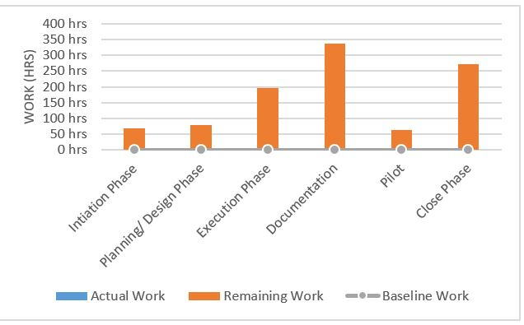

The Figure 5 Shows how much hours need to be spent on each of the tasks and Shows work stats for all top-level tasks.

*Figure 4*

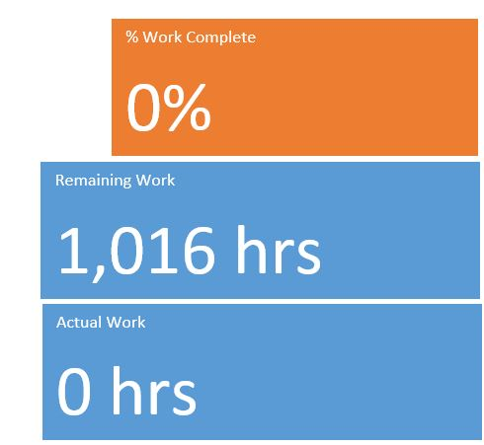

Figure 6 calculating how much in total hours is going to be spent for the website project how many hours took actual work and how many percentages of the project is done. As the project haven’t been started and it is just a planning of the whole work actual work and work complete will be on zero.

### Budget

In this section all the figures bellow will be approximate estimating. The salary for each department are set as minimum wage based on Irelands minimum salaries. The purpose for the budgeting is show total amount of money that will be needed for redeveloping a national college of Ireland website.

#### Budget Estimating by hours

|  |  |  |  |  |
| --- | --- | --- | --- | --- |
| Team Members | Salary Rate | Salary Rate | Estimated Hours | Subtotal |
| (Monthly) | (Hourly) |
| Deployment Team | € 3,472.00 | € 14.40 | 100 | € 1,440.00 |
| Technical Communicators | € 4,000.00 | € 16.60 | 380 | € 6,308.00 |
| Trainers | € 3,333.00 | € 13.80 | 80 | € 1,104.00 |
| Testers | € 4,083.00 | € 17.00 | 60 | € 1,020.00 |
| Developers | € 5,583.00 | € 23.20 | 130 | € 3,016.00 |
| Analysis | € 3,916.00 | € 16.30 | 180 | € 2,934.00 |
| Project Manager | € 4,416.00 | € 18.00 | 70 | € 1,260.00 |
| Management | € 4,000.00 | € 16.60 | 110 | € 1,826.00 |
| Total Budget |  |  |  | € 18,908.00 |

*Table 2*

The above table is a worksheet outlining hourly rates for each team member involved in the project. The figure above is approximate calculating is not actual. The purpose of this table is to show approximately how much budget will be needed for the members.

#### Budget Estimating charts

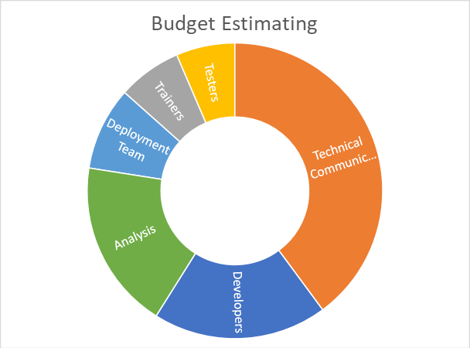

The Figure 1 represents a visual budget estimating of the team project. As there are six departments for the project team is showing in how much budget will need each department.

*Figure 1*

### Risk Register

The purpose of the risk register is to define an event that might occur while working on a project. The risks might occur in different environments for example team work or file management. The risk management document is helping to prevent the risks to occur in the project.

|  |  |  |  |  |
| --- | --- | --- | --- | --- |
| **Risk Factor** | **Risk Statement** | **Likelihood**    **(H/M/L)** | **Impact**    **(H/M/L)** | **Mitigation Strategy &/or Contingency Plan** |
| Team Management | There might be different opinions and conflict of working style | Low | High | To make sure that the work is going as has been planned. To respect each other’s opinions and learn to work with different styles of work |
| Information and File Sharing | Too many people working on one project and at a time my cause inconsistent or receiving non-updated information and files | High | High | To make sure to have a shared folder and also to compile codes frequently so as to ensure it is in good working order |
| Lack of testers | Difficulty to find testers for User Acceptance | Medium | High | To create User Acceptance, it easy and short to complete for tester. To find Testers |
| Lack of experience | Lack of person who has technical knowledge to handle the project as a part of the team. | High | High | All member needs to learn and practice on it. |

## Root Cause Analysis

The purpose of this technique is to show if any problems or faults occurred in the project. Information below provides key stages of a Root Cause Analysis (RCA) technique. During doing the technique we have got only one problem.

### Investigative Team

Anthony Delgado

Tanya Beth Rosaldo

Paula Olairu

Alena Raspopa

Date 19/10/2018

### The Problem occurred

While doing the feedback form with the team our idea was to distribute the link for all the students and lectures in the national college of Ireland. The problem was that we did not had all the emails of college students and Lectures. Our idea was to ask the student union to send the link to all the students and lectures.

### Sequence Event

We have sent a formal letter to the NCISU (National College Student Union) by asking them if they could send the link, but they have refused as they couldn’t post a link on their webpage as they would need to send it to everybody.

After we have read the refused email we been struggling again, and we make a group meeting to try to fix the problem

### Methods Used

During the meeting we have decided to put the feedback form in the Fundamentals Business Analysis course in the Open Forum Link. But as it wasn’t sure how many students are going to answer the feedback form, we have decided to put the feedback form on the tablet and walking around the college and asking students and lectures face to face to answer the feedback form.

After asking in about ten people including students and lectures, we make a summarize of all the answers from the feedback.

## Prototyping/Wireframe

Our group decided that prototyping would be included in the techniques that should be done because it is essential to the process of building and improving the NCI website.

### Throw away prototype

For prototyping, the group has to have knowledge of what the stakeholders need and want for a new NCI website. Surveys were used by the group to gather data from these stakeholders.

Based on the data that was taken using a survey on various stakeholders, we have constructed a wireframe for the NCI website. This wireframe has taken into account the changes the stakeholders needed and a general streamlining as well.

Based on the Observation of our group member, these are the common complaints:

* Access to Moodle contains unnecessary steps/clicks.
* Library page is not straightforward.
* News and events are not eye-catching and needs to be up-front to users including students and staff.
* Location and contact info are not in the same place

### Feedback from Users:

#### Change logs

Home page

* Top menu bar with Courses, Campus, etc goes down with the screen as the user scrolls down the web page
* Add an NCI Calendar on the home page
* Add NCI360 quick link access on the home page
* Make NCI website eye catching in terms of colours

Library page

* Add info in addition to the titles of the book

Course page

* Separate Full time, Night time, and Part time courses into these categories: Undergraduate, Postgraduate, CIPD, International and Professional Courses.
* Put sub categories under these category headings. The sub categories should include: Finance, Business, Management, and I.T.

### Wireframe documentation

Included in the wireframes are the following:

#### Home page

* Clarity of the homepage; straightforward interface for students and other users alike.
* An area where articles can be put as well as an accompanying photo.
* A link for Moodle for easy access in the homepage as requested.
* A quick access link for Student Apps e.g. Outlook.
* A quick access link for NCI360
* A side bar navigation menu that opens a “pop up” menu beside it when highlighted. The pop up menu contain links that is associated to that content e.g. Careers.
* An easy access to Courses in the side bar navigation menu and when clicked, goes into a page with all courses further categorised into: Undergraduate, Postgraduate, CIPD, International and Professional Courses.
* News and events are made easier to notice by making a large area where current events with photos are located as well as news next to it.
* NCI Calendar on at the bottom of the web pages
* NCI location and contact info are put at the very bottom of the page for easy access and no more clicking of a link required.
* Social media of NCI located at the bottom of page.
* Additional NCI information and advertisement can be put after the News section.
* Home link for a quick homepage access.

#### Course page

* All courses are split into: Undergraduate, Postgraduate, CIPD, International and Professional Courses. There is also a Category section which includes: Finance, Business, Management, and I.T.
* These are links which can be clicked and will bring the user to each of the respective pages of the chosen link.
* A Search bar where users can quickly find a course (if there is one).
* An “Apply for a course” button.
* An easy-to-notice area can be found where important information about CAO, courses, or any general notes about the courses.
* This page retains the Ad, NCI information, Location and Contact info, and the social media links from the home page.
* Home link for a quick homepage access.

#### Library page

* A search bar is included at the top right of the page to allow users to quick search a book if they know the name of the book. Entering a word will display all the books that is remotely relevant to that word or if the title of the book contains that word.
* A Catalogue heading with A – Z links where the user can click to just browse books starting with the respective letter or narrow down their search.
* Page show popular books that users read/use.

Clicking the book image or title would bring the user to a page and show all the information about that book.

* A Categories section and a drop-down bar where users can choose a category and narrow down books according to the chosen category e.g. Choosing Web Development category will only show books that are tagged/ relevant to Web Development. Clicking the book image or title would bring the user to a page and show all the information about that book.
* This page retains the Ad, NCI information, Location and Contact info, and the social media links from the home page.
* Home link for a quick homepage access.

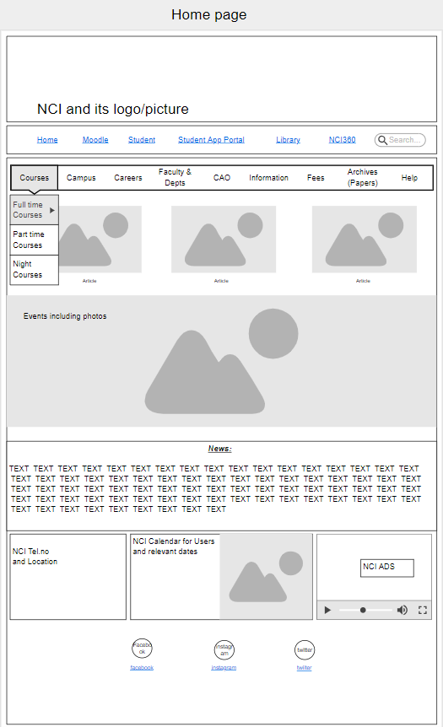

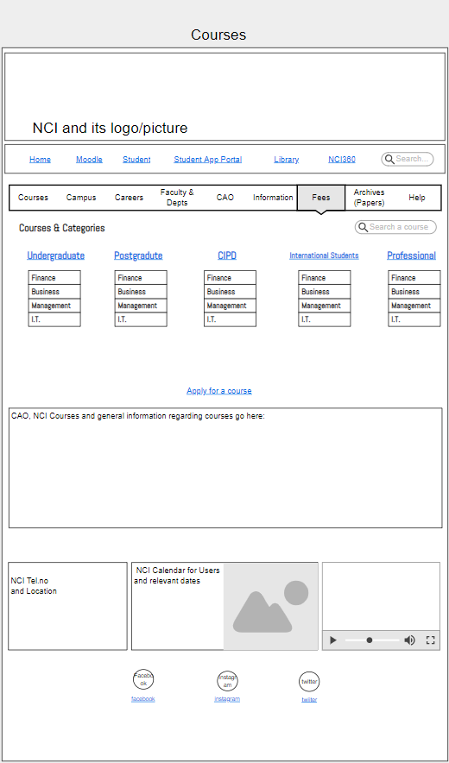

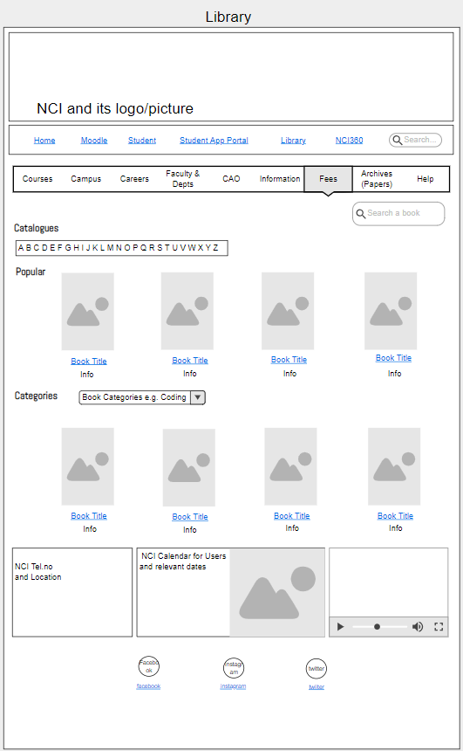

### Mobile Website Wireframe

* The content of the mobile site is identical to the desktop website

although the mobile one is more compact. The top bar only contains what

the users consider the most important headings based on our group’s survey

on various stakeholder. The secondary Menu bar is instead put onto a drop

down menu that users have to click to access the menu content.

**Feedback from Users**

**Change Logs**

Home Page

* Too much pictures and taking too much space
  + Remove pictures in the Calendar Section
  + Minimised the photo block on the Article Section

### Wireframe Documentation:

Included in the wireframes are the following:

#### Home Page

* Secondary menu bar from the desktop website is removed. It is placed on a

Drop down menu that users can click. The dropdown menu icon looks like this:



* Main top menu bar only contains the most important links or main headings such as

Moodle, Student, etc. to avoid cluttering the user interface.

* The Article Section now only contains one article with its accompanying photo

and its title. The user can swipe left or right / press the arrow keys on each side to see other featured

articles

* NCI Calendar for users and relevant dates are kept after the article section as per

the feedback from users.

* Additional info can be put into the next section which also contains the NCI Telephone number and a brief description of the location coupled with a small photo of the map.
* Social media links are found at the very bottom

#### Course Page

* Identical to the Mobile Home Page, the Mobile Course Page also has the “compacted” top menu bar that contains the main headings or links that the Users are asking for, while the secondary menu bar on the desktop version of the website is made into a drop down menu the Users can click.  It was made this way to reduce clutter on the user interface of the Mobile Course Page.
* Heading label “Courses & Categories” is displayed at the top just below the top bar, and under the label are the Link headings such as Undergraduate, Postgraduate, etc. These link headings are then followed by 4 categories of courses which are Finance, Business, Management, and I.T.
* A link for applying for a course, important information regarding courses and FAQs
* The page retains the NCI Calendar section, NCI Telephone number section and the social media links.

#### Library Page

* Following the layout of the previous mobile pages, this also has the compact top menu bar that has the necessary Links that the Users are requesting. The drop down menu that contains the secondary menu bar on desktop version is also present in this page.  This reduces the cluttering of the user interface.
* There are 3 main headings / section on this page: Catalogues, Categories, and Browse.
* The Catalogue section has an A – Z clickable links. When a user clicks on one of the letter, they will be brought to a separate page that contains all the books that starts with that letter.
* The Browse section allows users to browse books that are available. This section contains a middle “container” that shows the image of the book, its title, and info about it. Users can swipe left or right until it reaches the end or the scope of the search and just browse all available books. When a category is chosen, this “container” will only show the books that are relevant to that category e.g. Coding is chosen, so only coding books will be shown. Users can then swipe left or right to look at all the books that is included in that category.
* Category section only allows users to narrow down their search or find a book that is specifically in that category.
* A search bar is included at the top right of the page to allow users to quick search a book if they know the name of the book. Entering a word will display all the books that is remotely relevant to that word or if the title of the book contains that word.
* This page also contains the NCI calendar and telephone number section from the homepage as well as the social media links

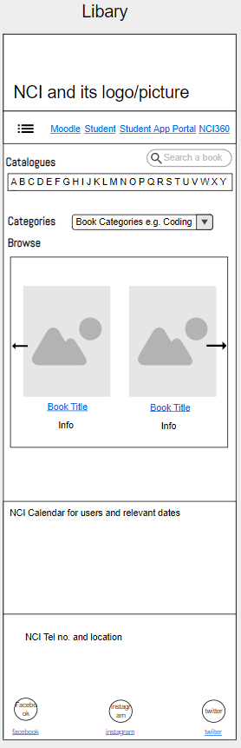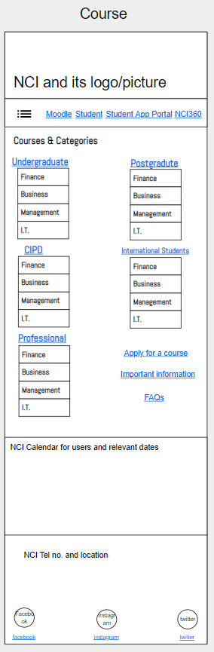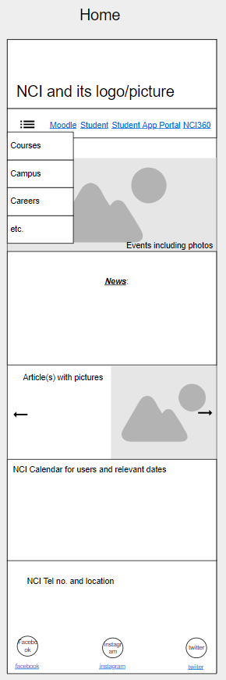

## Interface Analysis

During our group’s investigation, we have identified that the following interfaces involved are essential for the NCI website to work with the different components or solutions involved as well as the various stakeholders that interacts with this system.

* Includes graph for all interfaces
* Specific interactions
* Factors to all interfaces
* Input output graph

### Identified interfaces that are involved in the system:

* Human to Website
* Website to Application
* Human to Application
* Application to Application
* Hardware to Website
* Hardware to Application

#### Human to Website e.g. Student and Website

* This interface is all about how users and including external users interact with the website. Data is exchanged between these two interfaces when the user logs in or enter their details and this happens often. This is probably the most important interface regarding this project.

Interaction between these two components happens when stakeholders access and use a function of the website.

|  |  |  |
| --- | --- | --- |
| Input/Interaction | Process | Output |
| User enters data/details into a form on the website | Website processes and accepts the data | Website informs users that their data is accepted and sends this data to NCI Database |
| User Actions e.g. clicking a link, article, or web page within the website | Website accepts action input of user. (eventHandlers) | Website bring users to the web page from the link they have clicked |
| User uses search bar | Website searches/looks for the input word | Website displays all relevant topics to the input |

Factors included:

* Internet connection
* Working web pages
* Proper forms connected to database / accepts user input
* Appropriate data input
* Page links are working
* User knowledge of how website works
* Device that meets the minimum website requirements / is able to run the website
* Web related components (javascript,xml, etc.) are working

#### Website to Application e.g. Website and Moodle

* Interface between these two involves a lot of data exchange. Staff and Student details are the main data that are exchanged between these two components. Interaction between these two components triggers when a user uses the website to access Moodle, Student Mail / Outlook, etc.

**Website and Moodle**

|  |  |  |
| --- | --- | --- |
| Input/Interaction | Process | Output |
| Students/Staff Details that the website accepted is connected to Moodle | Website sends data to Moodle. Moodle processes this data | Moodle displays topics relevant to the Student/staff depending on the details entered |
| Necessary connections such as link for Moodle page | Website brings user to Moodle page | Moodle page is showing instead of the NCI Website |
| Website/Organisation details entered | Moodle processes this data | Moodle contains details and custom-fit for NCI staff and students |

Factors included:

* Appropriate details entered
* Correct link between the website and Moodle (HTML)
* Website data for Moodle is proper and accepted

**Website and NCI360**

|  |  |  |
| --- | --- | --- |
| Input/Interaction | Process | Output |
| Data that the user entered in the NCI360 web page form is entered | Website processes and accepts the data | NCI360 application shows details based on the entered data or details on the website |
| Website link for NCI360 is clicked | Website connects the user and brings them to the NCI360 Application page | Website brings the user to NCI360 application. NCI360 Application page is displayed |

Factors included

* Correct NCI360 data entered
* Proper link from website to NCI360 application page
* Data entered corresponds to a user account

#### Website and Student Mail/ Outlook

|  |  |  |
| --- | --- | --- |
| Input/Interaction | Process | Output |
| User clicks Student Mail link on the website. | Website accepts the action input | Website bring users to the home page of Student Mail/ Outlook |
| User entered their account details on the website correctly and clicks the Student Mail/ Outlook link. | Website accepts and processes the account details entered | Website brings the user directly to their account in Student Mail/ Outlook |
| Details entered on website is incorrect and user clicks link to Student Mail/ Outlook link | Website processes the details entered | Website brings user to the log – in page of Student Mail/ Outlook |

Factors included:

* Correct Student Mail/ Outlook details entered on the website
* Link of Student Mail/ Outlook from website works
* Details entered through the website corresponds to an account on Outlook

#### Human to Application e.g. Lecturer and Moodle

* User interacting with the application such as using the application’s functions and to perform tasks with it.

|  |  |  |
| --- | --- | --- |
| Input/Interaction | Process | Output |
| User clicks a function on the application e.g. Submit a file | Application accepts the input and processes it | The application does the function, in this case, the file is accepted and is put on the application’s database and can be displayed |
| User accesses a course available on Moodle | Application identifies all available courses based on the user details entered | The application then displays all the identified available courses and its topics to the user. |
| User setting up a forum | Application creates a forum and a link to it on the home page | Forum is created and the application provides a link which different users can access by clicking |
| User logging in to the application | Application determines if details entered is correct and contains an account | If details are correct, user is brought to the application home page. If incorrect, an error message would pop – up and require the user to either enter details again or make an account |

Factors included

* User log – in details are correct
* Application is working correctly
* User knowledge of how the application works
* Application is setup properly based on the organisation

#### Application to Application e.g. Moodle and Office 365

* Two applications interacting and transferring data between each other. The interaction between these two components triggers when data is transferred from either application to another one, a user accesses an application using another application, or both applications are used to perform a task.

|  |  |  |
| --- | --- | --- |
| Input/Interaction | Process | Output |
| Data input from an application | Second application will process this data | The second application brings the user to their home page or show details based on the details entered on the first application |
| User accesses an application through another application | First application determines if account data is correct and will pass this data to the second one. | Second application brings user to its home page if account data is correct |

Factors included

* Both applications interacts properly with each other
* Both applications are working properly
* User details are correct for both applications

#### Hardware to Website e.g. Computer and website

* Hardware is used to view, use and manage the website. Interface interaction between these two components triggers when a user is using a hardware to access the website

|  |  |  |
| --- | --- | --- |
| Input/Interaction | Process | Output |
| User action input through hardware navigating the website | Hardware I/O handles user action | Hardware displays the outcome of user input on the website e.g. Monitor displays the website pages |

Factors included

* + Internet connection
  + Proper web browser version
  + System requirements met

#### Hardware to Application e.g. Computer and Moodle

* Hardware is used to view, use and manage the application. Interface interaction between these two components triggers when a user is using a hardware to access and perform tasks using the application

|  |  |  |
| --- | --- | --- |
| Input/Interaction | Process | Output |
| User action input through hardware accessing, using, and managing the application | Hardware I/O handles user action | Hardware displays the outcome of user input on the applications e.g. Using the mouse to navigate the application and clicking a function |

Factors included

* System requirements met
* Drivers installed
* Necessary components installed

### 4.2 CONTEXT DIAGRAM

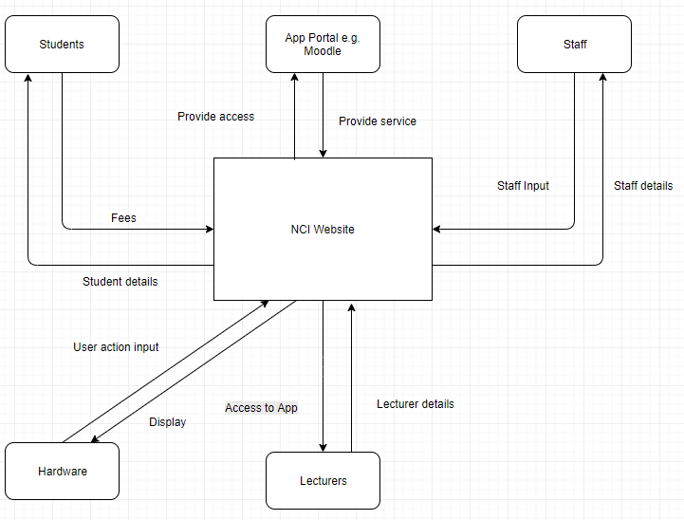

## OBSERVATION

### Purpose

Observation’s main purpose is to record details about the task and anything to be improved or analysed.

There are 2 types of approaches: (Sonego D (2018)).

* Passive: during observation the observer doesn’t interrupt and only raise any concerns when observation is over.
* Active: while observing the analyst asks any questions if there is any, this type of approach the analyst can quickly understand the process of the underlying activity.

### Description

Observation also known as job shadowing is a technique used by business analyst who in general watch how people interact and behave in a business under natural conditions. It is designed to show an exact detail and information on how people interact with given tasks and to gain some understanding of its flow. (Sonego D (2018)).

### Elements

#### Observation Objectives

Having a defined purpose of the observation and understanding and this may include:

* Understanding what is needed on this observation such as tools and interaction
* Identifying if there are any opportunities for improvements and lastly,
* The solutions or requirements required after identifying the possible weakness.

#### Prepare for Observation

When doing an observation, it involves a lot of planning on how to approach, the steps needed to be done and deciding who could be the participant on this task. When preparing for an observation the analyst should consider the skills and the level of experience of the participant, the possibilities and the outcome of the observation.

#### Conduct the Observation Session

Before the observation begins:

* Inform the participant in advance when and where observation will take place
* Explain why observation is being held
* Inform the participant what type of observation you will be doing, and they can ask help if needed and
* Reassure the participant that their performance is not going to be judged and that results of the observation will be assessed as a whole.

During observation:

* Observer watch the person perform the task given with concentration and
* Record what is seen, the time taken to accomplish task, the participant’s/observer’s questions and concerns related to the task.

#### Confirm and Present Observation Results

After having the observation session, I have the notes and data recorded reviewed and analysed. After having it analysed and had an understanding of the observation, I have everything summarised and through my research I was able to find the needs and opportunities for improvement that needs to be discussed to other stakeholders.

With the results of the observation I found out that the NCI website and Moodle in general provides good information among students, staffs and others outside NCI. However, there are problems encountered and things needed to be changed.

* Course Section: Part-Time, Full-Time, Undergraduate, Postgraduate, CIPD and Professional Courses needs categorised based on Finance, Business, IT courses etc.
* Location: location is well described however it took a long time to find as you need to click into few buttons to know the NCI’s exact location. As a solution location should be at the bottom of the page with the map location, address and contact number.
* Important Information and headings should be in a bigger font.
* Fonts should not all be the same
* Text size on the website is not relevant because it does not make the font bigger but makes the website bigger/zoom out.

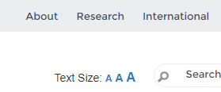

* More pictures should be added so people searching for NCI website would get an idea about NCI College itself.
* New tabs should be opened when clicking into any sections of the website instead if drag and drop of clicking the back button all the time.
* NCI website should be responsive to any devices.
* Menu button when using tablets/phones should have a drop-down list instead of hovering the mouse as it is found to be annoying when user accidentally hover through a section.

Moodle Section has a couple of things to be considered after the observation

* Site Home for Moodle should be categorised depending on the courses.
* Headings should be in a bigger font
* New tab should be opened instead of drag and drop or clicking the back button
* Course Overview must have a drop-down list instead of showing every module a student has, because dashboard/ button on the upper left already shows every module.
* Moodle Button should be added on the NCI website, so staffs and students could be directed straight to Moodle.

### Usage Considerations

#### Strengths

* Recommendations for improvements are supported with documents and evidence to be provided if asked
* Observers can gain more understanding and knowledge about the tasks as they might not be able to see what participants can see and
* Can provide an information on the participant’s knowledge, experience and skills

#### Limitation

* Participant could feel pressure and can lead to inaccurate representations.
* Requires computer literacy and
* Time-consuming when comparing with other methods of data collection.

## USE CASES AND SCENARIOS

### Purpose

Use-case describes the system’s behaviour under several conditions. It is a visual representation of the key functions that a system can perform showing the use cases, actors, the system and their interactions between each other.

### Description

Use-case is a list of actions/steps that describes the interactions between an actor and a system to achieve its goal. Use cases usually starts with the main actor but can also be a different system or an external event.

A use case describes the possibilities that can happen when goal is being executed. It gives a detailed path that can be followed by the main flow and alternative flows. The main flow represents the interaction between the actor and the system when everything goes as planned in other word main flow represents the direct way of accomplishing a goal of the use case. With some exceptions and circumstances to accomplish the said goal or results in a failure Alternative and Exceptional Flows arises this means a back-up plan when supposed goal did not go to plan.

Use Cases are graphical representation of the relationship between the actor and the system and is defined by different types of use cases that each represents a specific goal to obtain result.

With use cases there is always a scenario that describes how the actor can accomplish the task given, scenarios can be written as a series of steps with the actors or solution that enables them to achieve task.

### Elements

There is no fixed format on how to do use cases, but the following elements is mostly followed in a use case description.

### **Use Case Diagrams**

Use case diagrams are a graphical representation of the interaction among the elements of a system such as the actors who interact on the system and the type of use cases they interact with. UML (Unified Modelling Language) gives a visual description for a use case diagram

#### Relationships

“Associations” is the name called between the relationship between the actors and the use cases. Association lines means that an actor has access to the use case functionality however associations do not represent input, output, time or dependency.

There are 2 mostly used relationships in use cases:

* Extend: is used when a use case adds steps to another first class use case. This relationship can be used to show that an alternate flow has been added to an existing use case. Extended relationship is shown as a broken line with an arrowhead directed from the extending use case to the base use case, the arrow is also labelled with a keyword <<extend>>
* Include: is a relationship between two use cases which is used to show that addition use case is inserted into the base use case. This type of relationship is mostly used when there is shared functionality by some use cases or complex piece of logic.

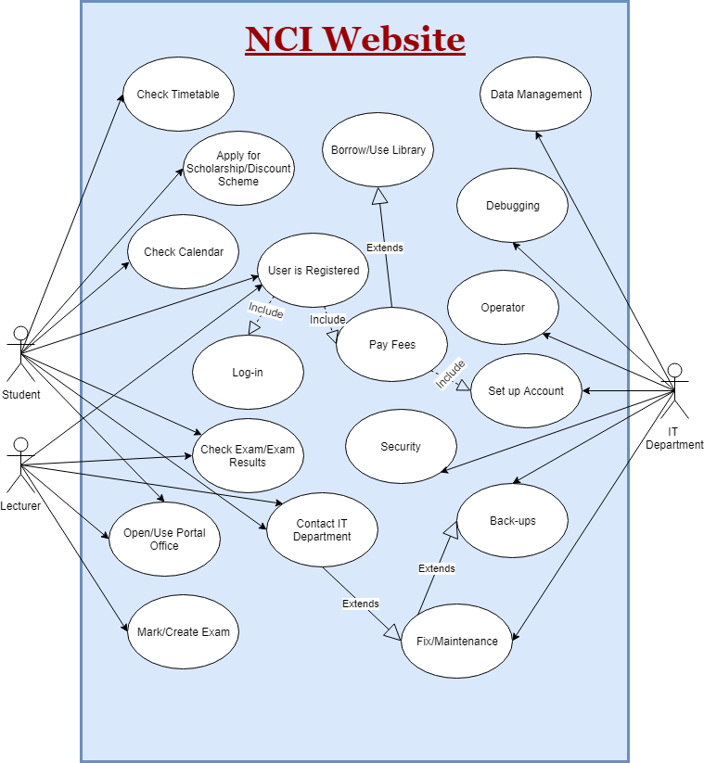

Figure .1.1 Use Case Diagram

#### **Use case Description**

Name

Each use cases must have a unique name. The name should have a verb that gives a description of what action is taken from the actor and a noun that gives a description of what is being done.

Goal

Goal is a clear description of a successful result of the use case that is performed by the main actor.

Actors

Actors are individual that interacts and are involved with the system that is defined according to their roles on the system. Actors of the system is also given a unique name to represent the role they play also, use case always starts by an actor. There are two types of actors:

Primary Actor: it is mainly the primary actor that interacts on the system to achieve a successful goal.

Secondary Actor: are actors that the system needs assistance from to be able to achieve the primary actor’s goal.

In this research we have our primary actors are: Students and Lecturers because they are the individuals that interact on the NCI website. Secondary actor will be the IT Department as they are the ones that make the NCI website to work at its best function as possible.

Preconditions

Precondition is a list of activities that must take place before use-case happens. It is not somehow tested, but it acts as a restriction on its execution.

Trigger

Trigger is a type of event that starts the flow of events on a use case. The main trigger for a use case is the primary actor.

On our research the primary actors i.e. Students and Lecturers are the triggers on our use case as they are the ones that start the flow of events.

Flow of Events

The flow of event is steps that are performed by the actor and the solution during the execution of the use case. Mostly use cases are separated by basic, primary or main and all this represents the success path that concludes the actors’ goals.

Use cases may also include alternative and exception flows. Alternative flows describe other steps/paths to be taken so actor can continue to successfully achieve the goal without any delay. Exceptional Flow represents an undesirable path for the actor, however although exception flow has occurred it can still react in a way that it recovers the flow of events and can still provide some information to the actor.

Post-conditions

A post-condition is a list of possible cases that the system can be after use case runs. it must also be true for all possible flows throughout the use case and this includes exceptional and alternative flows. If something could fail during the flow of events, it is covered in post condition by saying that action has been completed or action was not performed.

Termination

Is a list of successful and unsuccessful ways the use case might end.

### Use Case Flow of Events

USE CASE 1:

**ACTOR:** Student

**DESCRIPTION:** Student opening/using NCI website and Moodle

**MAIN FLOW:**

1. Student opens search engine and clicks into NCI website
2. Clicks into student sections/button
3. Clicks into Moodle and Student Portal
4. Student signs in with the Student ID and password
5. Scrolls and choose any module or any contents in Moodle (A1)(A2)
6. Log out in Moodle and Student Mail
7. Exit NCI website
8. Log out account in Citrix

**ALTERNATE FLOW**

**(A1)**

1. Student opens and Downloads lecture
2. Opens the document downloaded
3. If there’s a class tasks, student uploads lab and submit
4. Continue to step 6.

**(A2)**

1. If Moodle is down Student contact IT Department
2. Opens Portal Office
3. Signs in with their student ID and password
4. Save each work either Portal Office - One Drive or Student Drive – Citrix.
5. Continue to step 6.

**TERMINATION:**

* Student successfully opens the website and Moodle without any delays.
* Uploaded labs, homework and project without any delays.

USE CASE 2:

**ACTOR:** Lecturer

**DESCRIPTION:** Lecturer using/opening NCI website and Moodle

**MAIN FLOW:**

1. Lecturer opens search engine and clicks into NCI website
2. Clicks into staff sections/button
3. Clicks into Moodle and Staff Portal
4. Lecturer signs in with the ID and password
5. Scrolls and choose any module or any contents in Moodle
6. Upload any lectures/projects/homework for students
7. Make the file visible for students
8. Create Exam
9. Log out in Moodle and Mail
10. Exit NCI website
11. Log out account in Citrix

**ALTERNATE FLOW**

**(A1)**

1. If Moodle is down Lecturers contact IT Department
2. Opens Portal Office
3. Signs in with their ID and password
4. Save each work either Portal Office - One Drive or Drive – Citrix.
5. Continue to step 9.

**TERMINATION:**

* Lecturers successfully uploaded any projects and labs to be done by the students
* Successfully uploaded any lectures to be done in class
* Uploaded graded marks to certain modules to be visible for the students

USE CASE 3:

**ACTOR:** I.T. Department

**DESCRIPTION:** IT Department taking care of any front-end and end-user problems and operates system

**MAIN FLOW:**

1. IT Department Login to account (A1)
2. IT approves registration made by the student
3. Manage Databases to enable user and apps to store, modify and analyse
4. Manage back-ups to restore files if necessary. (A2)
5. Check any errors or block any intruders
6. Fix problem reports
7. Debug system errors made

**ALTERNATE FLOW:**

**(A1)**

1. If student changes course or any information, IT Department updates Student information
2. Continue to step 2

**(A2)**

1. If there’s an intruder alert or problems arise IT Department fix the errors, manage databases and backups
2. Continue to step 5.

**TERMINATION:**

* Debugs any problems faced by the IT Department and made the system to load faster than before

### Usage Considerations

#### Strengths

* Use Case diagrams can clarify scope and provides a high-level understanding of the use case requirements.
* It helps manage complexity since it only focuses on one specific usage at a time.
* Use case descriptions can be easily understood by shareholders due to use cases narrative flow.
* Provides a basic groundwork for the requirements document, user manual and test cases.
* Use cases descriptions clarify the functional behaviour of a system.
* It requires an identification of exceptional scenarios which helps discover the alternate requirements in the system

#### Limitations

* Time consuming to prepare a complete set for an application depending on the size of the system.
* Use case description format can be taken better using other techniques such as non-functional requirements, interface interactions and business rules
* Could have a learning curve for the developer and/or specially the client in using these use cases
* Not easy to read for a non-UML user and this can result for the diagrams to be confusing for users.
* Good UML software costs money and takes a lot of time to master perfectly.
* As there are no fully definition of use cases, it can result on its own interpretation

## User Story

### Purpose:

A User Story is a description of tasks. It is a short succinct statement of the quality and functionality required in order to deliver value to the product. User stories are slim and prominent requirements for a given product. The descriptions are usually written in a short form describing a new innovation or an update to for an existent feature as described through a user’s perspective.

User Stories are normally used as starting points for meaningful talk and collaboration with the product owners, developers and analysts regarding what the application should be able to do for its users hence the team can approximately estimate the work and permit the product owner to efficiently prioritize. They also serve as starting points for further specifications and enhancements by the development team. (Cohn, 2018)

### Description:

Through means of simple, brief documentation, user stories can capture the specific needs and allow teams to define features of value to stakeholders. User stories should describe who would benefit by the issue addressed in the story, what the user desires to obtain, along with any supplementary information from which the team may benefit when attempting to understand the goal of a particular story. The length of a user story should preferably not surpass two sentences. User stories are typically used to define the needs of stakeholders and order development solutions. Stories are usually written based on the following criteria: who describing a user role, what defining a required action or desired feature, and why describing the value gained by the user after the implementation of the story. (Cohn, 2018)

### Elements:

#### User Stories for the NCI website: (Babok v3, 2015)

#### Title: Rearrangement of the course details.

Statement of Value: As a new user, I want the courses section to be organised based on Part-Time and Full-Time courses, so that I can access the wanted information more easily.

Conversation: The user attempted to search for course details, however the task proved to be rather difficult as the ‘Courses’ section is displayed on the website under various categories making the course search hard to conduct a user who is not completely familiar with the website.

Acceptance Criteria: For an easier course search the courses section should be presented under two main categories ‘Part-time and Full-Time’ and from then the user will be permitted to click on the wanted category and henceforth to access the course in question.

#### Title: Location.

Statement of Value: As an unfamiliar user, I want the location details to be effortlessly seen on the homepage, then I will not need to search for the information for too long. on an unacquainted website.

Conversation: The new user wanted to find the campus location details, however the user reached the conclusion that in order to find the wanted information several steps had to be followed. Firstly, the ‘Campus’ section had to be accessed and then followed by clicking into the ‘Location and Transportation’ subsection.

Acceptance Criteria: The user suggested that placing the address and other relevant contact details on the homepage of the website will help the new user in obtaining the wanted information faster. Any additional location information should be added to the ‘Location and Transportation’ section of the website for the users searching for any extensive information.

#### Title: Variety of fonts.

Statement of Value: As a user, I would prefer the font to have a greater diversity, so that then the website will look more sophisticated.

Conversation: The user noticed that the website is not displaying information on its webpages based on the relevance of the text and that the text shown on the pages did not contain a diversity of fonts and font sizes.

Acceptance Criteria: The website’s user would like the fonts used for the writing within the webpages to be displayed in a variety of different fonts and font sizes based on the relevance of the text, and in doing so the webpages of the website will have a nicer look and make the displayed information more accessible to the user.

#### Title: Slideshow with college and student life pictures.

Statement of Value: As a new user, I want more pictures showing the college and student life on the campus, so that I can get a clearer view of the college.

Conversation: The new user checked the website to find pictures taken in the college and college’s campus along with pictures of students going about their student lives.

Acceptance Criteria: The user wanted to get a cleared and more concise view of that student life is at NCI by searching the college’s website to see pictures taken around the campus, however the user found that there are insufficient pictures on the website at the moment and requested for more pictures to be added and shown on the website.

#### Title: Responsive Design.

Statement of Value: As a user, I need the website to be made responsive on both tables and mobile phones, so that it will be more accessible.

Conversation: The users who access the NCI website found that it is not completely responsible when opened via mobile phone or tablet as some users do not have access to computers outside of college.

Acceptance Criteria: The users of the website stated that it would be extremely beneficial if the website would be made completely responsible for both mobile phones and tablets so that it could be easily accessed.

#### Title: Dropdown menu.

Statement of Value: As a user, I want the menu to be displayed as a fixed dropdown menu, so that I could access the information easily.

Conversation: The user noticed that the menu is not displayed as a dropdown menu which would provide greater accessibility to the website pages and information rather than scrolling up and down the page to gain access to the menu.

Acceptance Criteria: User requested the menu to be redesigned and presented as a dropdown menu which will stay fixed when scrolling up and down the page for easy access to the user.

#### User Stories for Moodle: (Babok v3, 2015)

Title: Moodle homepage arranged in categories.

Statement of Value: As a user, I want the Moodle homepage to be arranged in categories, so that I can find each course faster.

Conversation: The user saw that the Moodle homepage is displaying courses on their own rather than showing the main categories and adding the courses under each category for a neater arrangement.

Acceptance Criteria: The user wants the Moodle homepage to be rearranged and shown under the categories to which each course belongs so that it would look cleaner and also make it easier to find the wanted course.

#### Title: Direct link between Moodle and NCI website.

Statement of Value: As a user, I want a link for accessing Moodle directly from the NCI website, so that the log in process will be faster.

Conversation: The user wants a link to be placed on the NCI website’s homepage which will bring the user directly to the Moodle log in instead of logging in via Office 365.

Acceptance Criteria: The user suggested that a link connecting the NCI website and Moodle together would be extremely beneficial since the user found that logging into Office 365 via the link provided on the website and from there to Moodle is slightly time consuming.

#### Title: New tab

Statement of Value: As a user, I want the website to open each clicked element in a new tab, so that then I will not have to click the return button to access the main page.

Conversation: The user found that clicking the return button to navigate around the website is somewhat of an inconvenience as at the moment, the website opens each clicked element on the same page instead of opening new tabs.

Acceptance Criteria: The user declared that it will be a huge improvement and is a major necessity for the clicked elements to open in new tabs as opposed to loading the new page on the existing page so that the user can keep viewing the content on the main page as well as view other pages at the same time.

### Usage Considerations:

#### Strengths:

* User stories were clearly described and easily understood by the stakeholders of the project.
* The user stories can be carried out through prototyping, use cases, root cause analysis, user acceptance testing, all of which are elicitation techniques.
* The user stories are short, implementable, testable and solvable sets of functionalities which assists fast delivery along with regular customer feedback.
* Focus on delivering high-quality, valuable solutions to the stakeholders.
* User stories help in reaching an agreement between developers and stakeholders. (Babok v3, 2015) (Cohn, 2018)

#### Limitations:

* User stories may be challenging for the team as stories do not contain detail and can be vague.
* Stories can be difficult to understand, not testable and impracticable for the product owner and team.
* The ‘Acceptance Criteria’ section of the user story can be frequently misunderstood by the development team. (Babok v3, 2015)

## User acceptance testing

### Purpose:

The purpose of user acceptance testing is to enable users or customers to determine whether or not to accept the system. It helps the business stakeholder to make an unbiased decision about whether or not to accept the system. The decision is unbiased since more than just checking if the system is faulty is taken into account. The system will have faults but they should be balanced against if it will be beneficial to the business.

The user acceptance testing is not simply about engaging with the system but a contained exercise in determining what is wanted from the system for the business, checking the system and then making a balanced decision. (Coleyconsulting.co.uk, 2018)

### Description:

User acceptance testing is the final phase of the software testing process, and is then followed by the instalment of the software on the client site. User acceptance tests are carried out for real software users to determine if the software can execute tasks according to real-life scenarios.

User acceptance testing can be conducted by making the test version available for downloading and testing over the web. The feedback from the users who have tested the software is forwarded to the development team who will afterwards make any required changes before the software is released commercially. User acceptance testing is also known as application testing or end user testing. (Coleyconsulting.co.uk, 2018)

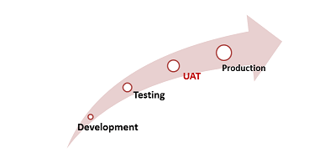

### User Acceptance Testing Planning:

Planning and time management are important for user acceptance testing because it allows the development team and project stakeholders to gather all the necessary documentation and arrange the testing environment, select the testers, roles and responsibilities, result analysing process, communication protocols etc. (Guru99.com, 2018)

### Alpha User Acceptance Testing:

Alpha testing is performed to identify all the potential issues prior to releasing the product to the public. The purpose of this testing aims to reproduce real users by using Black Box and White Box methods which focus on carrying out the tasks of a real user. Alpha user acceptance testing provides a deeper understanding of the consistency of the software at an earlier stage and also allows early detection of design and functionality errors. (Sharma, 2018)

### Beta User Acceptance Testing:

The second stage of Software Testing is Beta Testing. During beta testing a small number of the anticipated audience checks how the product works. Beta testing of the software is implemented by real users of the product in a real software environment. The purpose of this stage of testing is to allow the real client a chance to contribute to the design, usability, and functionality of the software. Beta testing provides increased value to the product due to user validation and reduces product collapse hazards. It is the last test prior to the release of the product to real users. Beta testing lessens product crash threats through customer endorsement. (Sharma, 2018)

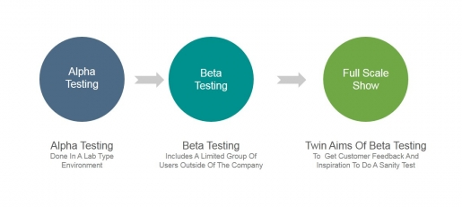

### Form-Based Testing:

The Form-based testing process must be completed by an intended user of the system. The testing usually happens at the user location.

#### Form Based Testing Components

|  |  |  |  |
| --- | --- | --- | --- |
| Form Based Testing Components | Pass/Fail | Date | Comment |
| 1. Are the colours, fonts, and toolbars coherent with standards and project guidelines? |  |  |  |
| 1. Are the appropriate courses displayed under the Part-Time section? |  |  |  |
| 1. Are the appropriate courses displayed under the Full-Time section? |  |  |  |
| 1. Is the online help section available on the homepage of the website? |  |  |  |
| 1. Is the format of each date displayed as (DD-MON-YYYY)? Are the dates edited correctly? |  |  |  |
| 1. Is the location displayed clearly on the home page of the website? |  |  |  |
| 1. Are all the elements present on website responsive? Are the images, fonts, text segments, navigation bars increasing and decreasing in size efficiently? |  |  |  |
| 1. Is a scroll bar present on every page? |  |  |  |
| 1. Is it easy to get an impression of what student life is at the college? |  |  |  |
| 1. Are the headings corresponding with the data displayed? |  |  |  |
| 1. Do all the initial ‘window display’ fit entirely on the screen? |  |  |  |
| 1. Is the Moodle’s homepage content arranged under the appropriate sections? |  |  |  |
| 1. Are webpages shrinking and enlarging to fit different screen sizes as required? |  |  |  |
| 1. Is a dropdown menu present at all time? |  |  |  |
| 1. Are defaults appropriate? |  |  |  |
| 1. Is the navigation bar present on each page of the website? |  |  |  |
| 1. Are all appropriate buttons enabled? |  |  |  |
| 1. Are element labels appropriately displayed? |  |  |  |
| 1. Is there a direct link from the website’s home page to Moodle? |  |  |  |
| 1. Is the link between from the homepage to Moodle working properly? |  |  |  |
| 1. Are the web pages appropriately labelled? |  |  |  |
| 1. Are elements and buttons displayed in the correct order? |  |  |  |
| 1. Are all element labels consistent throughout the application? |  |  |  |
| 1. Is each clicked element on Moodle opening in a new tab? |  |  |  |
| 1. Are warning, error and information messages precise and comprehensible? |  |  |  |

### UAT Action Testing

#### Acceptance Testing Functionality

|  |  |  |  |
| --- | --- | --- | --- |
| Acceptance Testing Functionality | Pass/Fail | Date | Comment |
| 1. Does every button navigate to the right element? |  |  |  |
| 1. Does the accurate element name, date show at the top of the windows? |  |  |  |
| 1. Are all the appropriate buttons available? |  |  |  |
| 1. Do all the text boxes display content correctly? |  |  |  |
| 1. Is the navigation bar visible at the top of each page? |  |  |  |
| 1. Is the dropdown navigation bar accessible on relevant each page? |  |  |  |
| 1. Are graphics presented clearly and suitably? |  |  |  |
| 1. Is the vertical navigation bar displayed properly? |  |  |  |
| 1. Does the navigation bar navigate to the correct page? |  |  |  |
| 1. Is each section of the navigation bar working correctly? |  |  |  |
| 1. Does the “search” bar introduce the wanted results? |  |  |  |
| 1. Does the “search” bar sort and display results correctly? |  |  |  |
| 1. Are any errors present when accessing the navigation and search bars? |  |  |  |

### User Acceptance Testing Test Execution:

During this process test cases are executed, after the execution, if any bugs were detected, bugs must be reported to the development team. Tests are required to be carried out again once the problems reported to the development team have been solved. Test cases allow the test team to successfully check the software in a setting suitable for user acceptance testing. It is usually carried out in a conference room where the users and the QA team agents sit together and work through all the acceptance test cases. After all the tests are fully run and the test results are available, acceptance decisions are prepared. This is also called Go/No-Go decision which means that if the users are satisfied with the software it’s a “Go”, and if the users are not completely satisfied it’s a “No-Go”. (Sharma, 2018)

### User Acceptance Testing Business Objectives Met Confirmation:

User Acceptance Testing testers are required to send an email stating that the User Acceptance Testing was successfully conducted and that the product is ready to be released to the public. However, before moving on to production, the development team and the UAT testers need to confirm that no serious flaws are present, the business process operates adequately. (Sharma, 2018)

### Strengths of User Acceptance Testing

#### Provides a deeper satisfaction to the clients as through conducting user acceptance testing’s the clients reach the conclusion that the requirements are met without having to worry if whether the product is truly prepared for the real world.

#### After conducting the user acceptance testing, the stakeholders use the information received to better understand the needs of the user. (Community.dynamics.com. 2018)

### Limitations of User Acceptance Testing

#### The end user does not clearly understand the precise purpose of the system. The users may not grasp if the product they are testing meets the conditions and solves the essential issues.

#### User acceptance testing should be carried out during the earlier stages of testing for gathering any new requirements for the product before they can trust the system to operate accordingly. (Techopedia.com, 2018)

6. Requirements List

# 6.1 Root Cause Analysis

1. Gather and Manage Evidence
2. Identify the problem
3. Analyze Cause and Effect
4. What Happen
5. How it Happen
6. Why it Happen
7. Solutions
8. Report
9. Closing

## 6.2 Triple Constraint

1. Time
   1. Plan Schedule Management
   2. Estimate Durations
   3. Control Schedule
2. Cost
   1. Identify the apps that are going to be used in the project
   2. Identify the total cost for the project
3. Scope
   1. Identify the requirements
   2. Identify the task necessary to complete the project
   3. Create a plan for each task

# 6.3 User story:

1. Stories should be independent from other stories
2. Stories should be easy to change for the development team
3. Stories should provide clear business value to the user of the solution and be written in appropriate language
4. Stories must be clear to launch without being too detailed.
5. Must be small enough to estimate
6. Should be worded clearly
7. Specific enough for testing
8. List new functions that need to be added
9. Gather user requirements
10. Test user stories

# 6.4 User acceptance testing:

1. Business requirements are available
2. Application code should be fully developed
3. Plan for user acceptance testing
4. Gather staff requirements
5. Plan for user acceptance testing execution
6. Conduct alpha testing
7. Conduct beta testing
8. UAT documentation
9. UAT evaluation
10. UAT reporting

# 6.5 Prototyping/Wireframes

## Home Page

1. Easy to navigate user interface
2. Easier access to Moodle, NCI 360, Student apps e.g. Microsoft outlook, and Library
3. Library to be more straightforward; show catalogues and display brief description about books
4. Attractive appropriate colours/eye-catching colours
5. Easy to see calendar and events section
6. Easy to see News section
7. Clear way too see NCI directions/map and their Telephone number

## Course Page

1. Categorise courses into types and departments to make it easier for users to search a course

## Library Page

1. Library to be more straightforward; show catalogues and display brief description about books

## 6.6 Interface Analysis

1. Correct connection and proper handling of interactions between two components involved with the system in hand
2. Connections such as the physical ones between hardware and users and online connections for software to another software as well as internal and external systems

6.7 Observation

1. Announce and prepare for the presentation
2. Decision on what type of Approach to be taken when doing the observation
3. When observation takes place, observer explains it to the person the objectives of this observation
4. Notes has to be taken during observation – these notes can help define what needs to be changed on Moodle and NCI website
5. After observation asks the participant anything what changes needed to be done if there is any
6. After observation the notes taken down needs to be summarised and revised for full clarification
7. Propose the observation to the other team and check for feedbacks

6.8 Use Case

**UML Diagram**

1. Identify who the actors that interacts with the system
2. How the actors interact on the system – actor's goals
3. Identifying the functionality, the start points and the end point of each use case
4. Identify any problems when actors interact with the system eg when system shuts down, it must show a diagram that IT Department will be contacted and that it extended as IT Department needs to fix or run maintenance.

**USE CASE**

1. Identify the definition of use case
2. Identify the scope
3. The steps/ flow description of each actors – precondition, activation, main flow, exceptional flow and alternate flow and termination should be fully described.
4. Problems encountered when actors are interacting with NCI website and Moodle are explained on the alternate flow, this is when an interruption to the normal flow itself didn’t go as planned and this keeps the normal flow going even with some interruption happening.
5. Identifying the problems that can occur and finding the solution, this technique can then be proposed to the other groups to get their feedbacks.

## 7 References

Glenn A. Bowen. WESTERN CAROLINA UNIVERSITY. (August 2009) Document Analysis as a Qualitative Research Method. [online]Available at <https://www.researchgate.net/profile/Glenn_Bowen/publication/240807798_Document_Analysis_as_a_Qualitative_Research_Method/links/59d807d0a6fdcc2aad065377/Document-Analysis-as-a-Qualitative-Research-Method.pdf> (Accessed 11/10/2018 19:30)

IIBA. (December 12, 2013) Non-Functional Requirements Analysis [online] Available <https://www.iiba.org/Learning-Development/Vendor-Showcase/2013/2013-12-12-non-functional-requirements-analysis.aspx> (10/10/2018 16:15)

Srvices, E. (2018). *Root Cause Analysis*. [online] Department of Enterprise Services. Available at: <https://des.wa.gov/services/risk-management/about-risk-management/enterprise-risk-management/root-cause-analysis> [Accessed 10 Oct. 2018].

Westland, J. (2018). *The Triple Constraint in Project Management: Time, Scope & Cost*. [online] ProjectManager.com. Available at: <https://www.projectmanager.com/blog/triple-constraint-project-management-time-scope-cost> [Accessed 10 Oct. 2018].

Cohn, M. (2018). User Stories and User Story Examples by Mike Cohn. [online] Mountain Goat Software. <https://www.mountaingoatsoftware.com/agile/user-stories>

TheAdaptivePM. (2018). Six attributes of good user stories. [online] https://theadaptivepm.wordpress.com/2013/05/31/six-attributes-of-good-user-stories/

Docs.ca.com. (2018). Write a Great User Story - CA Agile Central - CA Technologies Documentation. [online]https://docs.ca.com/en-us/ca-agile-central/saas/writing-great-user-story

Setter, M. (2018). What is User Acceptance Testing (UAT Testing)? - Usersnap. [online] Usersnap Blog. Available at: https://usersnap.com/blog/user-acceptance-testing-right/

Peham, T. (2018). The 5 Types of User Acceptance Testing! - Usersnap. [online] Usersnap Blog. <https://usersnap.com/blog/types-user-acceptance-tests-frameworks/>

Sonego, D. (2018). *Observation*. [online] BABOK Page. Available at: https://babokpage.wordpress.com/techniques/observation/ [Accessed 11 Oct. 2018].

www.tutorialspoint.com. (2018). *Business Analysis Use-Case Diagrams*. [online] Available at: https://www.tutorialspoint.com/business_analysis/business_analysis_usecase_diagrams.htm [Accessed 11 Oct. 2018].

Clouting, J. (2013). *What Every BA Practitioner Should Know About Prototyping*. [online] Thebacoach.com. Available at: http://www.thebacoach.com/prototyping-for-ba-practitioners/ [Accessed 11 Oct. 2018].

Sauter, V., Mcclendon, M., Regot, L. and Akers, G. (2012). *Prototyping*. [online] Umsl.edu. Available at: http://www.umsl.edu/~sauterv/analysis/prototyping/proto.html [Accessed 11 Oct. 2018].

.., G. (2017). *Wireframe vs Mockup vs Prototype, What's the Difference?*. [online] Mockplus.com. Available at: https://www.mockplus.com/blog/post/basic-uiux-design-concept-difference-between-wireframe-prototype [Accessed 11 Oct. 2018].

Sonego, D. (2015). *Interface Analysis*. [online] BABOK Page. Available at: https://babokpage.wordpress.com/techniques/interface-analysis/ [Accessed 11 Oct. 2018].

Weese, S. (2010). *Business Analysis Technique: Interface Analysis | Learning Tree Blog*. [online] Learning Tree Blog. Available at: https://blog.learningtree.com/business-analysis-technique-interface-analysis/ [Accessed 11 Oct. 2018].

Weese, S. (2011). *Recommended Elicitation Technique: Interface Analysis*. [online] Cbapccba.blogspot.com. Available at: http://cbapccba.blogspot.com/2011/04/recommended-elicitation-technique.html [Accessed 11 Oct. 2018].

Famuyide, S. (2014). *What is Interface Analysis?*. [online] Business Analyst Learnings. Available at: https://businessanalystlearnings.com/ba-techniques/2014/5/31/interface-analysis [Accessed 11 Oct. 2018].

Babok. (2015). 3rd ed. Toronto, Ontario, Canada: International Institute of Business Analysis, p.Chapter 10: Techniques.

Goto, K. (n.d.). *Planning a Web Development Project*. [online] Gotomedia.com. Available at: https://www.gotomedia.com/downloads/goto_stage.pdf [Accessed 6 Nov. 2018].

Template Lab. (2018). *40+ Effective Root Cause Analysis Templates, Forms & Examples*. [online] Available at: http://templatelab.com/root-cause-analysis/ [Accessed 6 Nov. 2018].

Uddin, A., Khan, M. and Campean, F. (2015). *DEVELOPMENT OF AN INTERFACE ANALYSIS TEMPLATE FOR SYSTEM DESIGN ANALYSIS*. [online] DEVELOPMENT OF AN INTERFACE ANALYSIS TEMPLATE FOR SYSTEM DESIGN ANALYSIS. Available at: https://www.researchgate.net/publication/282853195_DEVELOPMENT_OF_AN_INTERFACE_ANALYSIS_TEMPLATE_FOR_SYSTEM_DESIGN_ANALYSIS [Accessed 15 Nov. 2018].

COHN, M. User Stories and User Story Examples by Mike Cohn (Cohn, 2018) Cohn, M. (2018). User Stories and User Story Examples by Mike Cohn. Mountain Goat Software.

https://www.mountaingoatsoftware.com/agile/user-stories [Accessed 8 Nov. 2018].

THE PURPOSE OF USER STORIES IN SCRUM – THE LIBERATORS – MEDIUM (Medium, 2018) Medium. (2018). The purpose of User Stories in Scrum – The Liberators – Medium. [online] https://medium.com/the-liberators/the-purpose-of-user-stories-in-scrum-840db325e8e3 [Accessed 8 Nov. 2018].

COHN, M. User Story Template Advantages (Cohn, 2018) Cohn, M. (2018). User Story Template Advantages. [online] Mountain Goat Software. https://www.mountaingoatsoftware.com/blog/advantages-of-the-as-a-user-i-want-user-story-template [Accessed 8 Nov. 2018].

COHN, M. Non-functional Requirements as User Stories (Cohn, 2018) Cohn, M. (2018). Non-functional Requirements as User Stories. [online] Mountain Goat Software. https://www.mountaingoatsoftware.com/blog/non-functional-requirements-as-user-stories [Accessed 8 Nov. 2018].

5 COMMON USER STORY MISTAKES BY ROMAN PICHLER (Roman Pichler, 2018) Roman Pichler. (2018). 5 Common User Story Mistakes by Roman Pichler. [online] www.romanpichler.com/blog/5-common-user-story-mistakes/ [Accessed 8 Nov. 2018].

BABOK V3 (Babok v3, 2015) Babok v3. (2015). Toronto: IIBA.

SETTER, M. What is User Acceptance Testing (UAT Testing)? - Usersnap (Setter, 2018) Setter, M. (2018). What is User Acceptance Testing (UAT Testing)? - Usersnap. Usersnap Blog. https://usersnap.com/blog/user-acceptance-testing-right/ [Accessed 20 Nov. 2018].

ANON (Guru99.com, 2018) Guru99.com. (2018). https://www.guru99.com/user-acceptance-testing.html [Accessed 20 Nov. 2018].

USER ACCEPTANCE TESTING (UAT) DEFINITION (Coleyconsulting.co.uk, 2018) Coleyconsulting.co.uk. (2018). User Acceptance Testing (UAT) definition. https://www.coleyconsulting.co.uk/uatdefinition.htm [Accessed 20 Nov. 2018].

SHARMA, L. What are the Difference between Alpha Testing And Beta Testing (Sharma, 2018) Sharma, L. (2018). What are the Difference between Alpha Testing And Beta Testing. [online] Toolsqa.com. http://toolsqa.com/software-testing/difference-between-alpha-testing-and-beta-testing/ [Accessed 20 Nov. 2018].

BENEFITS OF USER ACCEPTANCE TESTING (UAT) - MICROSOFT DYNAMICS AX COMMUNITY (Community.dynamics.com, 2018) Community.dynamics.com. (2018). Benefits of User Acceptance Testing (UAT) - Microsoft Dynamics AX Community. [online] https://community.dynamics.com/ax/b/meritmatters/archive/2011/10/03/benefits-of-user-acceptance-testing-uat [Accessed 20 Nov. 2018].

4 REASONS WHY END USERS NEED TO PARTICIPATE IN TESTING BEFORE UAT (Techopedia.com, 2018) Techopedia.com. (2018). 4 Reasons Why End Users Need to Participate in Testing Before UAT. [online] https://www.techopedia.com/4-reasons-why-end-users-need-to-participate-in-testing-before-uat/2/32435 [Accessed 20 Nov. 2018].

Websites used for wireframe and context diagram:

Wireframes: <https://moqups.com/>

Context Diagram: <https://www.draw.io/>