From Pix to Care Rails: A Common Architectural Core for Prescriptions, Lab Orders, Reports, and Dispensing

Bruno Henrique Aragão Konig
Departamento de Engenharia Biomédica do Centro de Tecnologia e Geociências da Universidade Federal de Pernambuco
Recife, Brasil
bruno.konig@ufpe.br

Karla Amorim Sancho
Departamento de Engenharia Biomédica do Centro de Tecnologia e Geociências da Universidade Federal de Pernambuco
Recife, Brasil
karla.sancho@ufpe.br

Júlia Biscontini Koury
Departamento de Engenharia Biomédica do Centro de Tecnologia e Geociências da Universidade Federal de Pernambuco
Recife, Brasil
julia.bkoury@ufpe.br

Wellington Pinheiro dos Santos
Departamento de Engenharia Biomédica do Centro de Tecnologia e Geociências da Universidade Federal de Pernambuco
Recife, Brasil
wellington.santos@ufpe.br

Élen Karolayne do Nascimento Santos
Departamento de Engenharia Biomédica do Centro de Tecnologia e Geociências da Universidade Federal de Pernambuco
Recife, Brasil
elen.karolayne@ufpe.br

Fabiano Tonaco Borges
Departamento de Engenharia Biomédica do Centro de Tecnologia e Geociências da Universidade Federal de Pernambuco
Recife, Brasil
fabiano.borges@ufpe.br

Abstract— Brazil's Unified Health System (SUS) has advanced interoperability through the National Health Data Network (RNDS) and HL7 FHIR; however, traceability remains fragmented: prescriptions, lab orders, reports, appointments, referrals, and dispensing events still lack complete audit trails, and custody often remains implicit. This study proposes a traceable sanitary object, an architectural pattern that endows each care object with seven invariant properties: a global identifier (UUID), immutability after issuance, an append-only ledger, explicit and granular custody, a finite state machine, a canonical document with a cryptographic hash, and ownership from creation. Heterogeneous clinical objects share this core, dispensing is modeled as an act within the prescription flow, and derived objects are linked through referential lineage, mirroring Brazil's Pix payment rails. A reference implementation (Python/FastAPI, PostgreSQL/SQLite, AGPL) yields a tamper-evident audit trail and neutral public endpoints under the Brazilian General Data Protection Law (LGPD). Reproducible checks verify the pattern: 11 state machines (78 states, 99 transitions) are exhaustively checked; the SHA-256 digest of the canonical document is deterministic over 1,000 recomputations and changes with any of its 13 fields; all 96 authorization scenarios pass on PostgreSQL; and none of the six public endpoints expose a clinical field. An independent pass reproduced the reported results. The proof of concept implements server-side ICP-Brasil signing of issued PDFs; client-side signing and an external event-publishing layer are left for future work.
Keywords: append-only ledger, audit trail, chain of custody, electronic prescription, health information interoperability.

Introduction
Brazil's Unified Health System (SUS) has invested heavily in the digital exchange of health data. The National Health Data Network (RNDS) adopts the HL7 FHIR standard to consolidate records from heterogeneous institutions into a distributed national interoperability layer [1]– [3]. However, empirical assessments show that integration across national health information systems is still partial and fragmented [4], [5], and reviews of electronic health records (EHR) in Brazil repeatedly identify interoperability and security as the dominant open problems [6], [7]. These initiatives focus on the exchange of clinical data rather than the traceability of the clinical objects involved in the provision of care.
A prescription, lab order, report, appointment, referral, counter-referral, diagnostic circulation, or dispensing event is more than just data. It is an artifact. Someone issues it. Someone transfers it. Someone holds it. Someone acts on it. Someone closes it. Without end-to-end traceability and explicit custody, accountability is weakened [8]. We cannot easily determine who issued the object, who held it at each moment, what happened to it, or whether anyone altered its content. These questions are important for clinical safety and also for regulation. The Brazilian Federal Council of Medicine Resolution CFM 2.299/2021 requires ICP-Brasil signatures for digitally issued medical documents. These signatures guarantee authorship, integrity, and authenticity [9].
Brazil offers a striking precedent already in the public domain. Pix, the instant-payment system operated by the Central Bank, was designed from the outset as an open public infrastructure with standardized APIs, common rules, and equal access for banks, fintechs, governments, and new entrants. In Pix, the object (the transfer) is global and neutral, addressed by a portable key, while the regulated settlement rails are the shared substrate on which any participant operates. The model has drawn international attention as an example of payments treated as public infrastructure [10], [11]. We argue that the public health system lacks equivalent open rails for its own objects: there is no shared, neutral substrate on which a sanitary object can be issued once and then traced, audited, and acted upon across institutions.
This study proposes a traceable sanitary object as an architectural pattern that supplies such a substrate at the application-architecture level. The pattern defines an object that carries its own identity, immutability, ledger, custody chain, state machine, canonical document, and ownership independent of any single institution.
Our contribution is the pattern itself (the core), not the product. We demonstrate it through an open-source reference implementation, PicSaúde (Plataforma de Integração do Cuidado em Saúde in Portuguese), available at https://github.com/Tonaco-13/PicSaude. We do not merely demonstrate this; we verify it through reproducible robustness checks: exhaustive state-machine verification over 78 states and 99 transitions, 96/96 authorization scenarios, 13/13 tamper-evident document fields, and zero clinical leakage on public endpoints. An independent process was used to reproduce the reported figures. PicSaúde is a proof-of-concept, not a system deployed at a clinical scale.
The remainder of this paper is organized as follows. Section II reviews the relavant literature. Section III defines the conceptual model and its seven properties. Section IV details the architecture of the traceable sanitary object. Section V demonstrates the generalization across clinical objects. Section VI describes the implementation and guarantees of the model. Section VII reports the reproducible robustness checks that verify these guarantees. Section VIII discusses the trade-offs, ethics, and limitations of the study, and Section IX concludes the paper.

Related Literature

National health-data infrastructure
The dominant line of work in Brazil concerns the semantic and syntactic interoperability of clinical information. The RNDS standardizes exchanges using HL7 FHIR resources and controlled terminologies [1], [2]. Studies of the e-SUS Primary Care strategy have quantified how national information systems remain only partially integrated, with persistent fragmentation across the care and surveillance domains [4]. Broader reviews of Electronic Health Records (EHR) development in Brazil conclude that interoperability is considered essential by most authors, while also flagging access control and data security gaps [6]. Comparative analyses across Latin America emphasize governance continuity as a recurring weakness [7]. This body of work is centered on moving data between systems, not on providing each clinical artifact with an auditable lifecycle.

Electronic prescription and digital signature
Resolution CFM 2.299/2021 and related norms govern the digital issuance of medical documents. They mandate the signing of the ICP-Brasil to guarantee authorship, integrity, and authenticity [9]. However, they specify only what a valid signed document must contain—not how to trace the object after issuance or how to transfer custody between actors.

Event sourcing and append-only ledgers
Outside healthcare, event sourcing is an established pattern in which state changes are captured as immutable events in an append-only store that doubles as a complete audit trail [12]. We adopt this pattern internally as the ledger property of the proposed sanitary object.

Track-and-trace and chain of custody
In the pharmaceutical supply chain, blockchain-based and serialization-based approaches provide a tamper-evident chain of custody from the manufacturer to the dispensing point, often motivated by regulations such as the U.S. DSCSA and EU FMD [13]– [15]. These approaches trace physical product units across different organizations. The proposed pattern traces clinical objects (and their items) across clinical roles and does not require a distributed ledger or a shared consensus.

Positioning and Comparative Analysis
Prior studies separately addressed data interoperability, signed-document compliance, generic event sourcing, and supply chain track-and-trace. To bridge these gaps, the main contribution of this study proposes a unifying domain pattern for heterogeneous clinical objects. This pattern combines seven invariant properties: global identity, immutability with referential lineage, an append-only ledger, explicit and granular custody, a finite state machine, a canonical document with a cryptographic hash, and ownership from the creation. Because it is expressed at the application architecture level, it can be seamlessly instantiated in a conventional relational infrastructure. To demonstrate the architectural contribution of this study, we distinguished traceable sanitary objects from four established technical paradigms:
a) Data Interoperability Frameworks (HL7 FHIR/RNDS): Efforts such as the RNDS concentrate on semantic and syntactic standardization of the information being exchanged. However, they lack strict enforcement of a deterministic life cycle or a verifiable chain of custody (tracking the current holder and object state). The proposed pattern serves as a structural complement to FHIR; where FHIR supplies the vocabulary for clinical data, this architecture establishes the state machine and custody management layer. The same boundary applies to openEHR archetypes and IHE integration profiles, which standardize clinical content models and cross-enterprise document sharing but likewise leave lifecycle enforcement and custody to each implementation.
b) Distributed Ledger Technologies (Blockchain): While recent studies favor blockchain for establishing trust in decentralized settings, a national health system possesses an inherent central anchor in the state. Consequently, the pattern adopts an append-only relational ledger combined with cryptographic hashing to achieve tamper evidence. This approach avoids the significant computational costs and latency associated with the distributed consensus mechanisms.
c) Proprietary Electronic Prescription Platforms: Existing commercial solutions often trap custody within proprietary silos, leading to vendor lock-in, where private firms control the clinical history. By defining the sanitary object as a neutral, AGPL-licensed public rail, this architecture protects citizen sovereignty and prohibits the monetization of health records, operating as an open infrastructure, rather than a closed ecosystem.
d) Healthcare Traceability Frameworks (DSCSA/EU FMD): Regulatory track-and-trace regimes such as the U.S. The DSCSA and EU Falsified Medicines Directive mandate the serialization and verification of physical drug packages across the supply chain [13]-[15]. These frameworks locate a unit of product; they do not record who holds a clinical decision or in what state it stands. The proposed pattern operates at this clinical-object layer and is complementary to them: a dispensing event recorded under this architecture can anchor the care-level endpoint of such product-level chain.

The Traceable Sanitary Object
We define a traceable sanitary object as any artifact of care that has its own clinical identity and an auditable lifecycle. This pattern is characterized by seven invariant properties (Fig. 1).
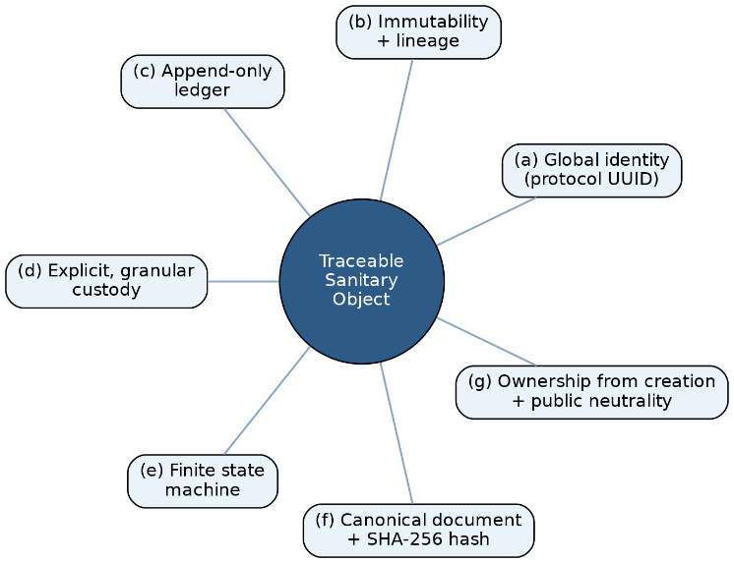
- The traceable sanitary object and its seven invariant properties (a)–(g): global identity, immutability with lineage, an append-only ledger, explicit and granular custody, a finite state machine, a canonical document with hash, and ownership from creation.

Global identity: Every object carries a protocol (a UUID) that is unique, immutable, and independent of any institution: the primary handle through which the object is referenced, audited, and shared, in direct analogy to a portable Pix key.

Immutability with lineage: An object is never edited after issuance. Any correction, renewal, or re-issuance produces a new derived object that points back to its predecessor through an origin reference, forming an explicit lineage chain. Therefore, audits never lose their history.

Append-only ledger: Every business-relevant event is recorded as an insertion into an events table that never receives updates or deletions. This internal event-sourcing log is the backbone of the auditability.

Explicit granular custody: Each object has a single custodian at every moment, and every transfer is recorded in a custody chain. Custody can be held over an entire object or over an individual item, which is what makes partial flows (e.g., partial dispensing) traceable.

Finite state machine: Each object type has an explicit set of states and valid transitions, with terminal states distinguished by clinical meaning.

A digital flow is kept separate from a purely physical flow (paper issuance that never enters the digital cycle), avoiding category errors between, for instance, a clinical revocation and a paper-only closure.

Canonical document with hash: The object is serialized deterministically into a canonical document from which a SHA-256 digest is computed—the integrity anchor and the basis for ICP-Brasil signing under the PAdES profile; in the current proof-of-concept, the signing step is a stub (Section VIII).

Ownership from creation and public neutrality: Access control and inline identity assertion are enforced on every private endpoint from the moment the object is created. Public endpoints are kept neutral (carrying no clinical data) so that verification can be offered without exposing sensitive information, consistent with the LGPD Art. 11 [16].

Architecture
The architecture materializes the seven properties on a conventional relational stack. Fig. 2 shows the prescription life-cycle state machine, and Fig. 3 shows the custody chain and derivation lineage.
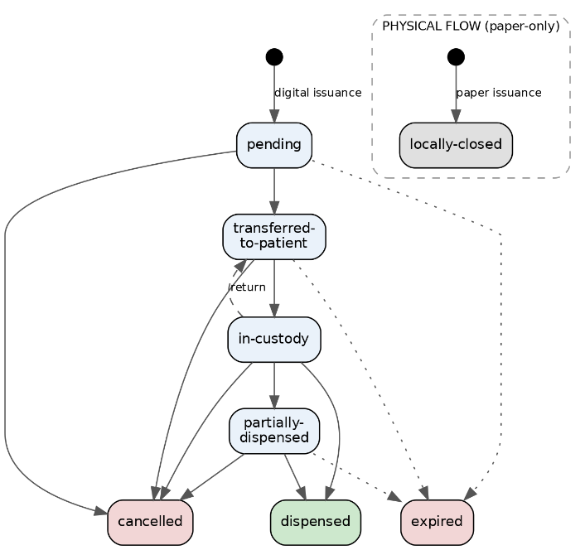
- Prescription life-cycle state machine. A digital flow (pending through dispensed, with cancellation and expiry) is kept disjoint from a physical, paper-only flow whose single terminal state is locally-closed, preventing a clinical cancellation from being conflated with a paper-only closure.

Immutable ledger
Each object family has a table of events which admits only insertions. A controlled vocabulary of events—issuance, renewal, correction, custody transfer, dispensing, partial dispensing, and item return—is recorded with the actor, timestamp, and payload. Because no update or deletion is permitted, the ledger provides a non-destructive, append-only history that underpins all audit queries.
Because the ledger is the source of truth, a regulatory report is not a separate stateful artifact but a deterministic projection of that ledger, and two properties of this projection are already enforced and verified. Reproducibility: recomputing a closed period yields a byte-identical result, because each line reflects the running balance as of its own movement date, so events recorded after the period boundary never alter earlier lines. Identifier uniqueness: each movement—a dispensing or a reversal—appears exactly once, a property we treat as a falsifiable fraud invariant and enforce with a permanent guard-rail check in the continuous-integration gate; accordingly, every sanitary-object mutation is idempotent and protected against double submission by a row-level lock. Two further rules are adopted as invariants with implementation underway: every derived object resolves to a visible root protocol through the origin-reference chain, and external surveillance identifiers (for example, a medication's ANVISA registry number) are snapshotted onto the movement at write time rather than fetched live on the clinical path.

Granular custody
A custody table records the current holder and all transitions. Valid transitions are declared explicitly (e.g., prescriber to patient on digital issuance, patient to dispenser on presentation at the counter, and dispenser to patient on return). Custody may be recorded for an entire object or for individual items.

Finite state machine
The allowed states and transitions are declared in a single domain module that serves as the source of truth, which is mirrored in the database schema. Digital states (pending, transferred-to-patient, in-custody, partially dispensed, dispensed, and cancelled) are separated from the physical terminal state used for paper-only issuance.

Canonical document and integrity
A dedicated module produces canonical serialization and its SHA-256 digest. The digest is stored with the object and exposed through a document-integrity endpoint, allowing any holder to verify that the content has not changed and is the intended input for ICP-Brasil PAdES signing.

Ownership, RBAC and public neutrality
Every private endpoint enforces role-based access control and an inline identity assertion so that ownership is checked at creation and at each subsequent act. Public endpoints expose only non-clinical confirmation data [16].

Institutional scope
Operations are made contextual through optional organization and unit identifiers. The clinical object remains global and neutral—identified by its protocol—while these identifiers act as query scope, access filter, and operational context, never as the primary key. A NULL value denotes the absence of an institutional link (not a sentinel), and the fields are rolled out incrementally only when a real use case requires them. Where an organization identifier is present, queries in an institutional context must include it as a filter, enforced as an architectural guardrail.

Generalization of the Core
The pattern is a core, not an exception: the same seven properties instantiate multiple clinical objects (Table I).
Dispensing is not a standalone object but an act within the prescription flow, governed by the invariant “sum of dispensed quantities does not exceed the prescribed quantity.” Its hospital variant follows prescriber → hospital pharmacy → (nursing unit) → patient.

- Instances of the Traceable-Sanitary-Object Core
Object | Typical states (digital flow) | Terminal states | Custody chain
Prescription | pending → transferred-to-patient → in-custody → partially-dispensed → dispensed | dispensed; cancelled; expired; locally-closed (physical) | prescriber → patient → dispenser → (patient | prescriber)
Lab order | issued → scheduled → collected → under-analysis → result-available → closed | closed; cancelled; expired; physically-closed | prescriber → patient → lab provider → patient
Report | in-production → signed → released → acknowledged (patient/prescriber) → closed | closed; cancelled; expired; physically-closed | lab provider → (patient | prescriber)
Appointment | created → confirmed → carried-out | carried-out; cancelled; no-show | none (bilateral commitment; documented exception)
Diagnostic circulation | selected → sent-to-lab → proposal-received → patient-confirmed → performed | performed; patient-unmarked; lab-unmarked; lab-archived; expired | patient → lab (token-mediated)
Referral | issued → (under-regulation) → scheduled → attended → counter-referred → closed | closed; cancelled; expired; denied; physically-closed | prescriber (origin) → patient → prescriber (destination) → patient
Counter-referral (derived) | Registered | Cancelled | destination → origin (origin-referral reference)

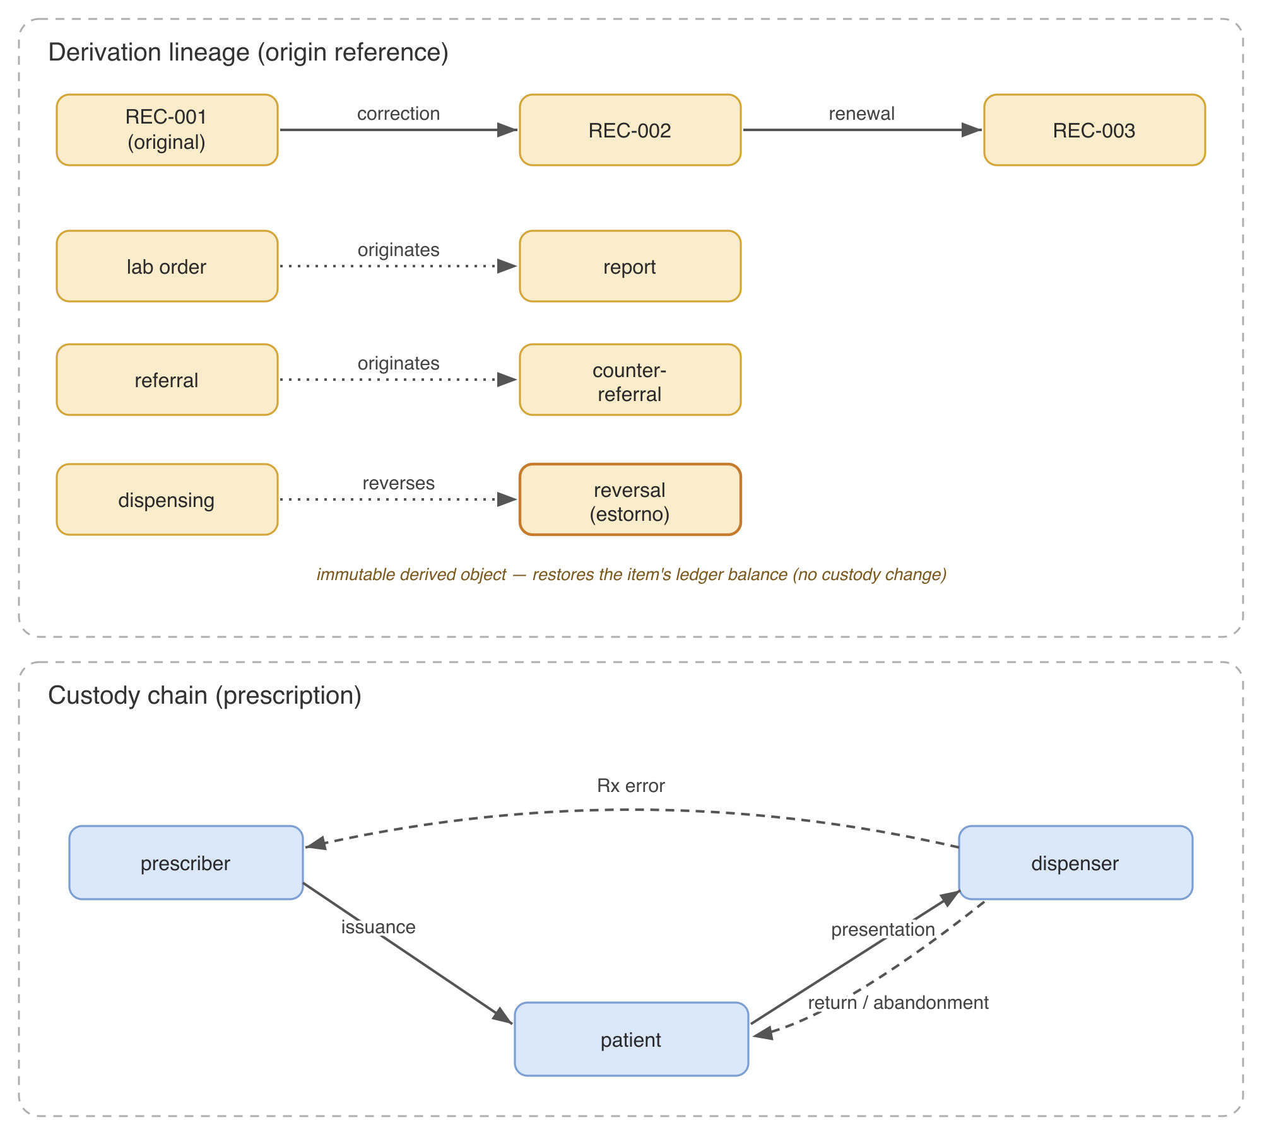
- Custody chain (a single custodian at each moment, with explicitly declared transitions) and derivation lineage (corrections and renewals chained by an origin reference, and cross-object derivations such as report-from-lab-order and counter-referral-from-referral).

Derived objects
The derivation generalizes beyond corrections and renewals. A report is a derived object of a lab order, and a counter-referral is a derived object of a referral. Each derivation has a distinct author, its own canonical document and hash, and a referential link to its origin. Thus, the lineage chain spans not only versions of one artifact but also causally related artifacts across the care pathway.

Documented exceptions
Some objects intentionally relax one property, and recording the exception is part of the discipline. Appointments are lightweight objects with identity, states, and a ledger but no custody chain because they represent a bilateral commitment rather than a held artifact. Acknowledgement of a report operates at the level of the entire report rather than per item. Diagnostic circulation authorizes the act through a presentation token, rather than a custody transfer. Naming these exceptions explicitly is what keeps the core coherent and stable.

Implementation and Guarantees
This section describes the reference implementation of the traceable sanitary object and the guarantees the pattern entails.

Stack and scale
The reference implementation uses Python with FastAPI for the API layer and a relational store that runs on PostgreSQL in production and SQLite in development, under a single Alembic-managed schema. It comprises approximately 36,142 lines of application code across 33 routers and 47 ORM models, exposing 156 endpoints over 20 schema migrations. Seven sanitary-object families each carry their own finite state machine; across object- and item-level machines, they declare 78 states and 99 valid transitions in single source-of-truth modules, and a unified ledger helper records the controlled event vocabulary for all subdomains. Seven of these families maintain their own append-only event ledgers (alongside an internal publication outbox), and five maintain explicit custody chains. The test suite comprises 1,557 test functions across 103 files; a continuous-integration gate, the unit suite together with a selected integration subset executed against an ephemeral PostgreSQL instance, runs on every change and gates merges.

Dual-database test gate
A dual-database gate executes the suite against ephemeral PostgreSQL instances in addition to SQLite. This is not redundant: SQLite's permissive typing (e.g., accepting an integer literal for a Boolean column or lax NULL handling) silently masks defects that surface only under PostgreSQL's strict typing. In our development, this gate repeatedly caught latent defects invisible on SQLite; for instance, a Boolean column written with an integer literal passed every SQLite test yet raised a type-mismatch error on PostgreSQL, meaning that a code path that appeared fully tested was in fact broken under production-equivalent conditions. The methodological claim is narrow but practical: for dual-database clinical systems, the production database must be inside the test gate—a green bar on the development database is necessary but insufficient.

Guarantees from the model
Several safety properties follow directly from the pattern rather than from ad-hoc checks. Partial dispensing cannot exceed the prescription because the sum of dispensed quantities for an item is constrained to not exceed the prescribed quantity. An item that cannot be paid for simply returns to a pending state and remains dispensable elsewhere without cancelling the prescription. Immutability, together with the append-only ledger, yields a tamper-evident audit trail: history is never overwritten, only extended; full non-repudiation follows once ICP-Brasil signing is integrated. Terminal-state semantics are kept distinct; therefore, a clinical cancellation is never conflated with a paper-only closure. Access control is enforced from creation, and public endpoints are neutral by construction; consequently, verification never discloses clinical content. Table II maps each guarantee to the mechanism that enforces it and a representative test from the suite that exercises it.

- Model guarantees, enforcing mechanism, and a representative test
Guarantee | Enforcing mechanism | Representative test
Dispensed ≤ prescribed | per-item balance check before insert | test_supera_saldo (HTTP 422)
Append-only audit trail | insert-only event ledger (no update/delete) | test_retorna_eventos_inseridos
Immutability with lineage | correction issues a new derived object | test_correcao_aceita_novos_campos
Valid transitions only | single source-of-truth transition tables | test_transicao_invalida (HTTP 409)
Ownership from creation | inline RBAC + identity assertion | test_dispensador_sem_custodia (HTTP 403)
Public neutrality | public endpoint projects no clinical field | test_publico_neutro

Regulatory and licensing posture
The design targets compliance with ANVISA RDC 1.000/2025, which governs the electronic prescription of medications under special control, emphasizing traceability, mandatory digital signature, and integration with the National Controlled-Prescription System (SNCR), which amends Ordinance SVS/MS 344/98 and CFM 2.299/2021 [9], [17]. The reference implementation was released as open source under the AGPL, on the principle that the infrastructure for a public health system should be public. The architecture is the subject of a Brazilian INPI filing (BR 51 2026 002267-3).

Robustness Evaluation
This section discusses the claims made by the proposed pattern. The evaluation was architectural rather than clinical; a real-setting study is required in the future. Therefore, we subject each invariant property to a structural or behavioral robustness check and ask whether it holds in the implementation, not only in the design. Every check is scripted, seeded, and released with the open-source code, so each number below is reproducible; the headline figures were additionally re-derived by an independent verification pass that reproduced 14 of 15 and caught one author measurement error, since corrected to the 13/13 reported here. Table III summarizes the results.

Formal verification of the state machines
The seven families comprised 11 object- and item-level machines (78 states and 99 transitions). We exhaustively checked four structural properties: every transition target is a declared state, the terminal set is a subset of the states, no non-terminal state is a dead end, and terminal states are absorbing. The first three are universally applicable. The absorbing-terminal check surfaced two terminal states with a declared outgoing transition—a dispensed item that may be reversed, and an item with an available result that may be explicitly closed—revealing a tension between “terminal as clinically complete” and “terminal as absorbing.” Instead of concealing it, we report it as a finding that is currently being refined. For the dispensing case in particular, the reversal is modeled as an immutable derived object that restores the effective ledger balance of the item rather than mutating the terminal item. Therefore, dispensability follows from the ledger balance rather than from the state label, while the declared dispensed-to-reversed transition remains dormant scaffolding that the check correctly surfaces. Surfacing such cases is precisely the benefit of treating the state machine as a verifiable artifact.
A guard-rail check confirmed that no movement identifier recurred in the dispensing report, and a concurrency test shows that two simultaneous identical dispensings each recorded a single movement, exercising the idempotency invariant under a race.

Document integrity (tamper-evidence)
For the canonical document, the SHA-256 digest was identical across 1,000 recomputations of the same input (determinism), and a single-field mutation altered the digest for all 13 document fields (eight headers and five per item); that is, any content change is tamper evident.

Authorization and anti-leak
Across nine authorization suites, 96 scenarios were executed against PostgreSQL, and all passed, each exercising the ordering 404 (not found), 403 (not owner), and 409 (state conflict) that prevents disclosure of an object's existence or state to a non-owner. These are functional checks of the intended access-control behavior, not a security audit; adversarial and penetration testing remain future work.

Dual-database divergence
The dual-database gate-caught defects are invisible on SQLite: in two concrete instances, a Boolean column written with an integer literal passed every SQLite test yet raised a type-mismatch error on PostgreSQL—a defect class that example-based testing on the development database alone does not reveal.

Public-endpoint neutrality (LGPD)
A static audit of all six public endpoints confirmed that none projected a clinical field (only protocol, status, issuance type, and per-item order/status), and tests confirmed that no seeded clinical values appeared in any public response.

- Robustness evaluation results
Check | Result
State-machine verification | 11 machines, 78 states, 99 transitions; 3/4 properties universal; 2 non-absorbing terminals found and tracked
Hash tamper-evidence | deterministic over 1,000 runs; 13/13 fields alter the digest
Authorization / anti-leak | 96/96 scenarios pass on PostgreSQL (404→403→409)
Dual-database gate | 2 boolean-as-integer defects caught on PostgreSQL, invisible on SQLite
Public neutrality (LGPD) | 0/6 public endpoints project a clinical field

Discussion, Limitations, and Ethics

Trade-offs
Physical (paper-only) issuance uses a fire-and-forget call: the front-end prints without waiting for the back end to confirm persistence. This favors the availability of the clinical act over guaranteed central registration—if the back end is offline, printing still succeeds, and the record may remain only on the client. The trade-off is accepted and documented; full traceability requires the back end to be reachable. Similarly, a mathematically invalid sentinel identifier is reserved for unidentified patients in paper flows and must be excluded from analytics, and the institutional scope is rolled out incrementally rather than imposed on every table at once.

Ethics
A non-negotiable goal of the project is that patient health data are never monetized. The aim is citizen sovereignty over health objects through auditable grants of access, never the sale of data. This principle is treated as a design constraint, rather than a policy statement.

Limitations and Challenges for Large-Scale Adoption
This work is currently a proof-of-concept and has not yet been deployed at clinical scale. Moving from an architectural core to a national or municipal deployment introduces several practical challenges that must be addressed:
a) External Integration and Interoperability: While the system is event-sourced internally, it is not yet event-driven externally. Because there is currently no event-publishing layer, external adapters (such as legacy HIS, TISS, HL7, and e-SUS) lack a native integration point. Real-world adoption will require developing these robust interfaces to orchestrate workflows without demanding the complete replacement of existing hospital and pharmacy systems. The planned mitigation is an event-publishing layer over the append-only ledger—cursor-based polling endpoints scoped by organization, per-organization webhook registration, and a canonical external event format—so that adapters consume official endpoints and never write directly to clinical tables, enabling incremental coexistence with legacy hospital information systems rather than wholesale replacement.
b) Cryptographic Implementation and Ledger Security: Server-side ICP-Brasil PAdES-B signing is fully implemented for issued PDF documents (e.g., prescription forms and lab orders). The PDF is signed with a certificate held in an encrypted server-side vault, and each signing act is recorded in the ledger. However, client-side signing of the object's canonical document remains future work, as it requires a deterministic serialization that is identical across client and server implementations. Furthermore, the append-only ledger is currently enforced as an application-level invariant; implementing cryptographic hash-chaining or external anchoring to make the ledger tamper-evident—even against a privileged database actor—is a necessary next step.
c) Performance under Real Clinical Workflows: Operating at the scale of the SUS means tracing millions of daily objects and their derivations. This poses significant database growth and query-performance challenges, which will require advanced data engineering (e.g., database sharding, asynchronous queues, and cold-storage archiving for physically closed objects) to maintain low latency during peak clinical hours. The relational design admits horizontal partitioning of the event and custody tables by time or organization, read replicas serving deterministic projections, and archival of terminally closed objects to cold storage; the absence of distributed consensus removes a major latency source by construction.
d) Governance and Orchestration: The Pix analogy raises a fundamental governance question beyond this paper's architectural scope. Just as Pix depends on the Central Bank as a central operator, shared health rails would require a designated public operator (such as the Ministry of Health or DATASUS) and a robust governance model to manage credentialing, access control, and cross-jurisdictional coordination. A federated operating model—central specification and auditing combined with regionally operated instances—could balance national consistency with local autonomy, but operator accreditation and dispute resolution across jurisdictions remain open institutional questions.

Conclusion and Future Work
We have argued that the objects of care—prescription, lab order, report, appointment, referral, counter-referral, diagnostic circulation, and dispensing—share a single architectural contract, which was formalized as the traceable sanitary object: a pattern defined by global identity, immutability with lineage, an append-only ledger, explicit and granular custody, a finite state machine, a canonical document with hash, and ownership from creation. Treating these artifacts as instances of one core is what yields traceability, auditability, and the basis for cross-institution interoperability. Crucially, this contract is not merely proposed but verifiable and verified: its state machines, canonical hashing, authorization ordering, and public-endpoint neutrality are all exercised by reproducible, seeded scripts shipped with the AGPL-licensed code, and the reported figures were reproduced by an independent pass—so the architecture's claims can be re-audited rather than taken on trust. The same discipline keeps us honest, having surfaced two real state-machine inconsistencies that we report rather than hide. Future work includes full ICP-Brasil signing, an event-publishing layer with webhooks to enable external adapters, a municipal pilot, and empirical validation in a real care setting.

References
[1] Ministério da Saúde, “Rede Nacional de Dados em Saúde (RNDS): Guia de Integração,” 2020. Accessed: Jun. 17, 2026. [Online]. Available: https://rnds-guia.saude.gov.br/
[2] Ministério da Saúde, “RNDS — HL7 FHIR Implementation Guide,” 2022. Accessed: Jun. 17, 2026. [Online]. Available: https://rnds-fhir.saude.gov.br/
[3] Brasil, Ministério da Saúde, Secretaria-Executiva, Departamento de Informática do SUS, “Estratégia de Saúde Digital para o Brasil 2020–2028,” Brasília, DF, Brasil, 2020. [Online]. Available: https://bvsms.saude.gov.br/bvs/publicacoes/estrategia_saude_digital_Brasil.pdf
[4] G. C. C. Neto, R. Andreazza, and A. Chioro, “Integration among national health information systems in Brazil: the case of e-SUS Primary Care,” Rev. Saúde Pública, vol. 55, p. 93, 2021, doi: 10.11606/S1518-8787.2021055002931.
[5] M. Fernandez et al., “Interoperability in universal healthcare systems: insights from Brazil’s experience integrating primary and hospital health care data,” Front. Digit. Health, vol. 7, 2025, doi: 10.3389/fdgth.2025.1622302.
[6] I. M. P. Barbalho et al., “Electronic health records in Brazil: prospects and technological challenges,” Front. Public Health, vol. 10, Nov. 2022, doi: 10.3389/fpubh.2022.963841.
[7] L. F. Conrado et al., “Digital health: context and challenges in Brazil with focus on public health,” in Proc. IEEE Int. Conf. Ind. Appl. (INDUSCON), 2025, pp. 1153–1160, doi: 10.1109/INDUSCON66435.2025.11241578.
[8] M. Ahmed, A. R. Dar, M. Helfert, A. Khan, and J. Kim, “Data provenance in healthcare: approaches, challenges, and future directions,” Sensors, vol. 23, no. 14, 2023, doi: 10.3390/s23146495.
[9] Conselho Federal de Medicina, “Resolução CFM nº 2.299/2021,” Brasília, DF, Brasil, 2021. Accessed: Jun. 17, 2026. [Online]. Available: http://www.portalmedico.org.br
[10] A. Duarte, J. Frost, L. Gambacorta, P. Koo Wilkens, and H. S. Shin, “Central banks, the monetary system and public payment infrastructures: lessons from Brazil’s Pix,” SSRN Electron. J., Mar. 2022, doi: 10.2139/ssrn.4064528.
[11] Bank for International Settlements, “III. The future monetary system,” in BIS Annual Economic Report 2022, Basel, Switzerland, Jun. 2022. [Online]. Available: https://www.bis.org/publ/arpdf/ar2022e3.htm
[12] M. Fowler, “Event Sourcing,” martinfowler.com. Accessed: Jun. 17, 2026. [Online]. Available: https://martinfowler.com/eaaDev/EventSourcing.html
[13] F. Díaz, N. Cerna, R. Liza, B. Motta, and S. Rojas-Flores, “Blockchain-enabled traceability in pharmaceutical supply chains: a mapping review of evidence for visibility, anti-counterfeiting, and chain-of-custody control,” Logistics, vol. 10, no. 4, Apr. 2026, doi: 10.3390/logistics10040085.
[14] U.S. Food and Drug Administration, “Drug Supply Chain Security Act (DSCSA),” Accessed: Jun. 17, 2026. [Online]. Available: https://www.fda.gov/drugs/drug-supply-chain-integrity/drug-supply-chain-security-act-dscsa
[15] “Directive 2011/62/EU of the European Parliament and of the Council of 8 June 2011 amending Directive 2001/83/EC on the Community code relating to medicinal products for human use, as regards the prevention of the entry into the legal supply chain of falsified medicinal products (Falsified Medicines Directive),” Off. J. Eur. Union, L 174, Jul. 2011.
[16] Brasil, “Lei nº 13.709, de 14 de agosto de 2018 (Lei Geral de Proteção de Dados Pessoais — LGPD), Art. 11,” 2018. Accessed: Jun. 17, 2026. [Online]. Available: http://www.planalto.gov.br/ccivil_03/_ato2015-2018/2018/lei/l13709.htm
[17] Agência Nacional de Vigilância Sanitária (ANVISA), “Resolução da Diretoria Colegiada — RDC nº 1.000, de 11 de dezembro de 2025,” Brasília, DF, Brasil, 2025.

