Split MNIST Continual Learning Project
Full explanation with all generated graphs
Repository: https://github.com/Tonagame/splitmnist-continual-learning-report
Main code path: code/from_scratch/
Main report page: index.html

1. Project Goal
The project studies catastrophic forgetting in continual learning. In normal supervised learning, the model can train on all data at once. In continual learning, the model receives data in stages. When it learns a new stage, it can overwrite knowledge from earlier stages. This failure is called catastrophic forgetting.
We reproduced the Split MNIST setting from the paper "Three types of incremental learning" by van de Ven, Tuytelaars, and Tolias. We also implemented our own experimental LSR-lite variants as a bonus direction.

2. Dataset And Scenarios
Split MNIST divides MNIST into five contexts: (0,1), (2,3), (4,5), (6,7), and (8,9). The model sees these contexts sequentially.
Scenario | Meaning | Difficulty
Task-CL | Task identity is known during evaluation; outputs are restricted to the active digit pair. | Easiest
Domain-CL | The label space is shared, but data arrives in different contexts. | Medium
Class-CL | No task identity is given; the model must classify among all 10 digits. | Hardest

3. Methods Implemented
Method | Idea
None | Sequential fine-tuning with no forgetting protection.
Joint Training | Upper-bound reference trained on all contexts together.
EWC | Protects important parameters using a Fisher-based quadratic penalty.
LwF | Uses a frozen teacher model and logit distillation.
A-GEM | Uses replay memory and projects gradients to reduce interference.
Separate Networks | Uses one network per task; mainly valid for Task-CL.
Generative Classifier | Simple diagonal Gaussian class-conditional classifier.
LSR-lite | Our prototype: real replay samples + labels + teacher logits + feature anchoring.
LSR-lite + Fourier | Adds a Fourier feature-spectrum auxiliary loss.
LSR-lite + ASW | Adds Adaptive Stability Weighting for KD and feature losses.
LSR-lite + Fourier + ASW | Combines Fourier auxiliary loss and ASW.

Important correction: LSR-lite is related to replay methods such as A-GEM and to LwF-style distillation. It is not truly a Generative Classifier because it does not generate old samples or learn a generative model; it stores real training examples.

4. Implementation Structure
The final submission code is independent and lives under code/from_scratch/. It does not import the GMvandeVen repository. The code was refactored so every method family has its own file.
File | Purpose
splitmnist_cl.py | CLI entry point, argument parsing, method dispatch, result writing.
core.py | Dataset construction, MLP model, replay buffer, evaluation, CSV/JSON helpers.
methods/joint.py | Joint Training.
methods/sequential.py | Shared sequential loop for None, EWC, LwF, A-GEM, and LSR-lite.
methods/ewc.py | EWC Fisher estimation and penalty.
methods/lwf.py | LwF teacher snapshot and KD loss.
methods/agem.py | A-GEM gradient projection.
methods/lsr_lite.py | LSR-lite, Fourier, and ASW losses.
methods/generative.py | Generative Classifier.
methods/separate.py | Separate Networks.

5. Experimental Settings
Setting | Value
Dataset | Split MNIST
Contexts | 5
Iterations | 2000 per context for main runs
Batch size | 128
Intermediate accuracy sample | acc-n = 1024
GPU | NVIDIA GeForce RTX 3070
Memory budget | 100 samples per class for A-GEM and LSR variants
Class-CL evaluation | No task identity; evaluate over all 10 classes
Task-CL evaluation | Task identity / allowed classes according to the protocol

6. Main 2000-Iteration Results Including LSR Variants
Scenario | Method | Accuracy | Status
Class-CL | None | 19.82% | success
Class-CL | EWC | 27.42% | success
Class-CL | LwF | 20.27% | success
Class-CL | A-GEM | 55.80% | success
Class-CL | LSR-lite | 92.43% | success
Class-CL | LSR-lite + Fourier | 92.64% | success
Class-CL | LSR-lite + ASW | 92.41% | success
Class-CL | LSR-lite + Fourier + ASW | 92.84% | success
Class-CL | Joint | 98.15% | success
Domain-CL | None | 54.35% | success
Domain-CL | EWC | 64.64% | success
Domain-CL | LwF | 78.63% | success
Domain-CL | A-GEM | 88.19% | success
Domain-CL | LSR-lite | 96.51% | success
Domain-CL | LSR-lite + Fourier | 96.27% | success
Domain-CL | LSR-lite + ASW | 95.74% | success
Domain-CL | LSR-lite + Fourier + ASW | 95.93% | success
Domain-CL | Joint | 98.79% | success
Task-CL | None | 87.65% | success
Task-CL | EWC | 99.52% | success
Task-CL | LwF | 99.78% | success
Task-CL | A-GEM | 99.04% | success
Task-CL | Separate Networks | 99.74% | success
Task-CL | LSR-lite | 99.33% | success
Task-CL | LSR-lite + Fourier | 99.26% | success
Task-CL | LSR-lite + ASW | 99.19% | success
Task-CL | LSR-lite + Fourier + ASW | 99.40% | success
Task-CL | Joint | 99.81% | success

7. From-Scratch Classic Method Results
Scenario | Method | Accuracy | Runtime
class | None | 19.64% | 320.0s
class | EWC | 19.68% | 351.0s
class | LwF | 26.76% | 322.2s
class | A-GEM | 55.56% | 360.5s
class | Generative Classifier | 72.66% | 17.9s
class | Joint | 98.08% | 311.2s
domain | None | 56.72% | 313.5s
domain | EWC | 57.80% | 352.3s
domain | LwF | 77.53% | 323.4s
domain | A-GEM | 90.01% | 357.9s
domain | Generative Classifier | 78.60% | 17.4s
domain | Joint | 98.97% | 320.3s
task | None | 67.14% | 346.1s
task | EWC | 64.75% | 377.2s
task | LwF | 99.16% | 317.8s
task | A-GEM | 97.61% | 351.5s
task | Generative Classifier | 94.91% | 17.4s
task | Separate Networks | 99.81% | 310.3s
task | Joint | 99.78% | 310.9s

8. All Generated Graphs
This section includes all PNG graphs currently stored in the assets folder. These are the graphs used in the GitHub report and documentation.

Paper vs GMvandeVen Code vs Our From-Scratch Code
This is the most important reproduction graph. It separates published paper results, our earlier local run of the original GMvandeVen code, and our independent from-scratch implementation.
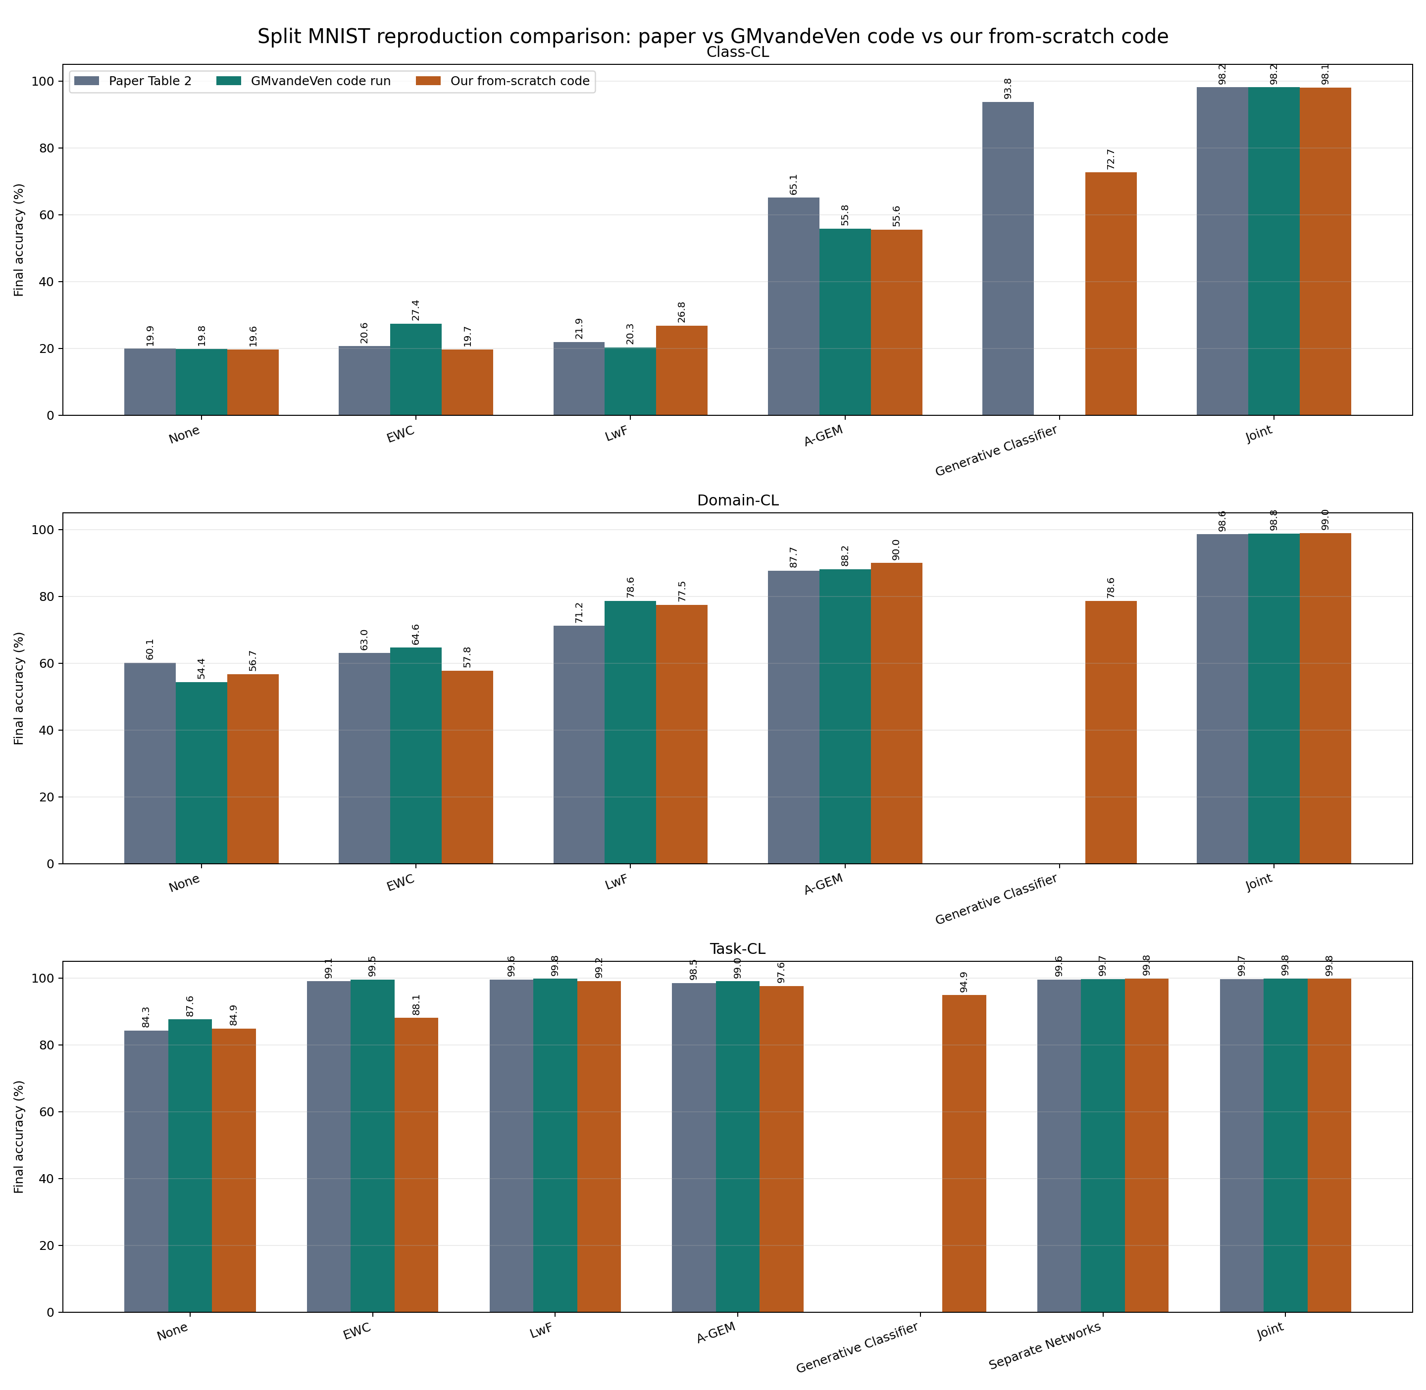
Figure: paper_vs_gmvandeven_vs_from_scratch.png

Paper Results vs Our Local Reference Results
This compares the paper values with our earlier local reproduction of the shared methods.
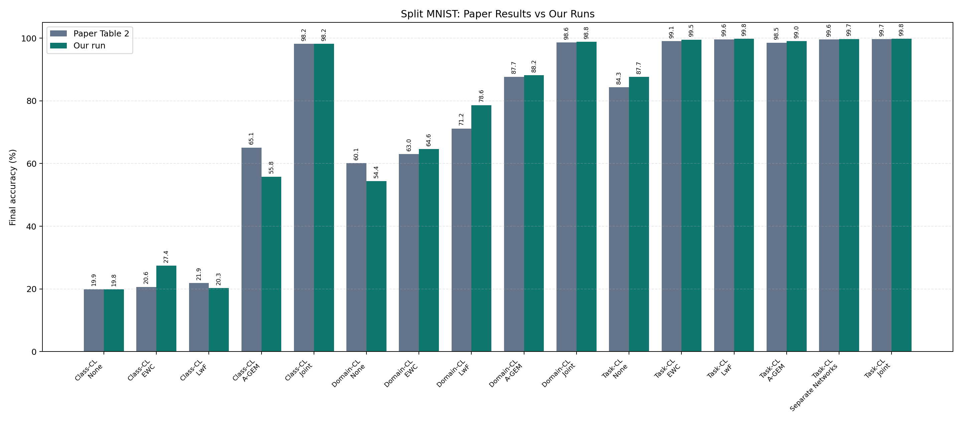
Figure: paper_vs_ours_splitMNIST_common_methods.png

All Methods By Scenario
This graph compares the final accuracy of all tested methods across Class-CL, Domain-CL, and Task-CL.
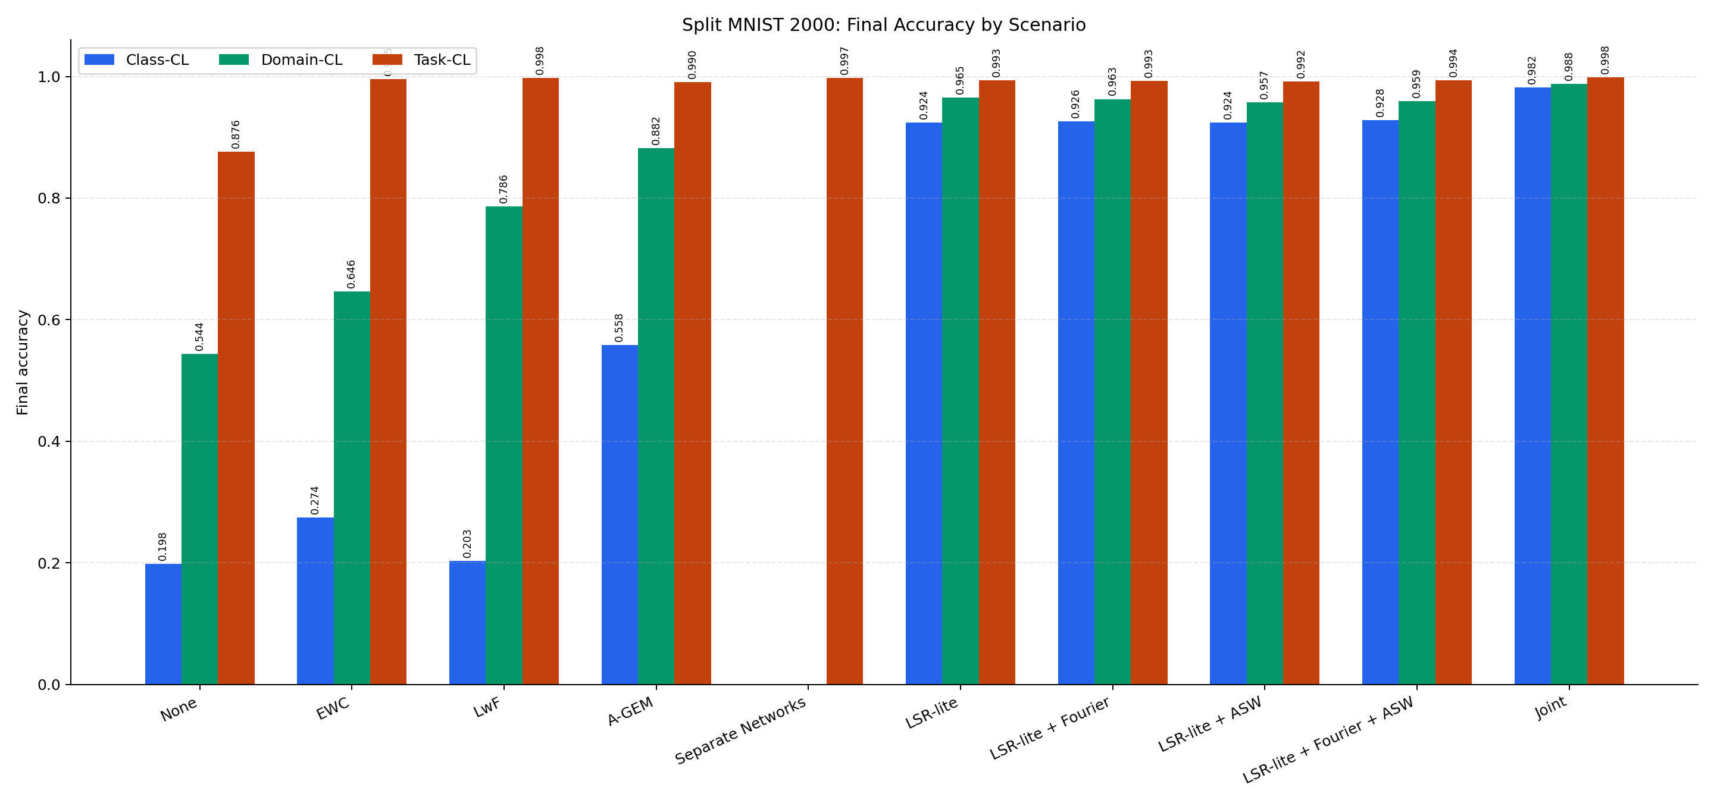
Figure: all-methods-by-scenario.png

Accuracy Heatmap
The heatmap gives a compact visual view of which methods work best in each continual-learning scenario.
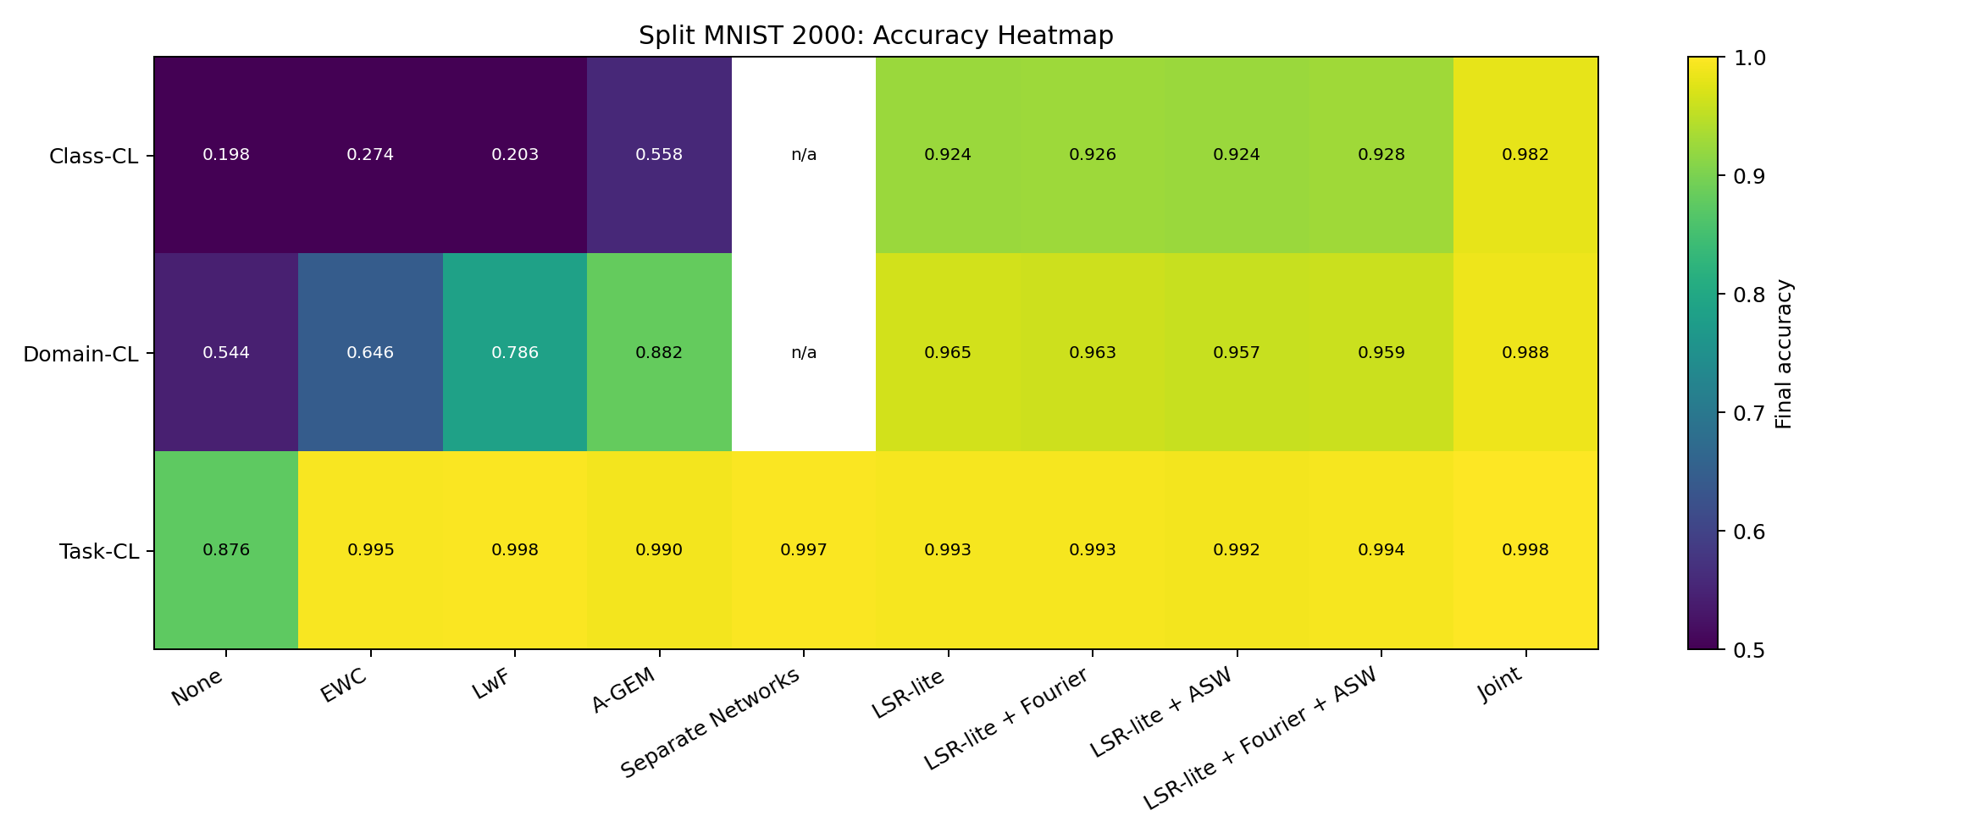
Figure: accuracy-heatmap.png

LSR-lite Ablation Results
This graph isolates the LSR-lite variants and shows the effect of Fourier and ASW compared with the base LSR-lite method.
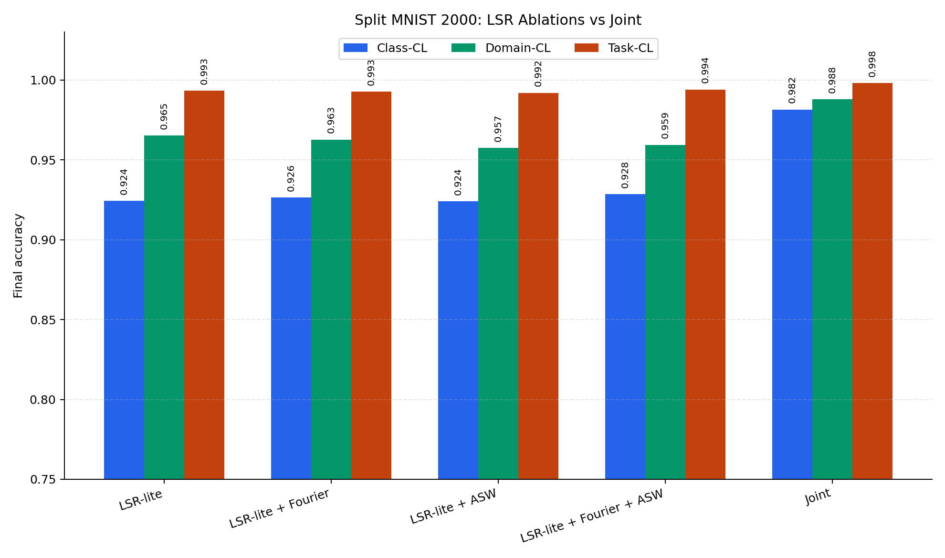
Figure: lsr-ablation-by-scenario.png

Selected Learning Curves
This graph shows how selected methods evolve during training, not only their final accuracy.
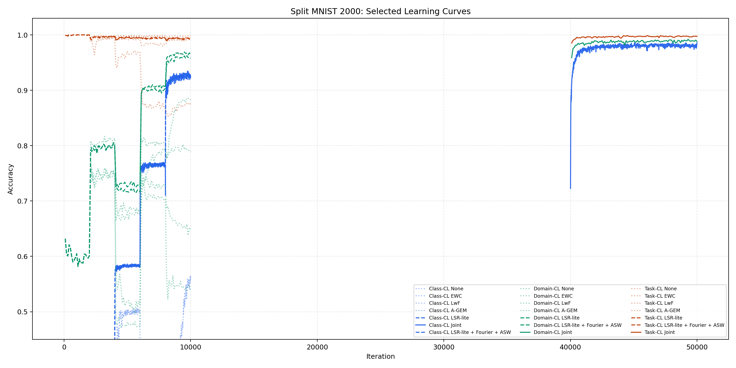
Figure: selected-learning-curves.png

From-Scratch Classic Methods Final Accuracy
This graph summarizes the final accuracy from the independent clean-room implementation for the classic non-LSR methods.
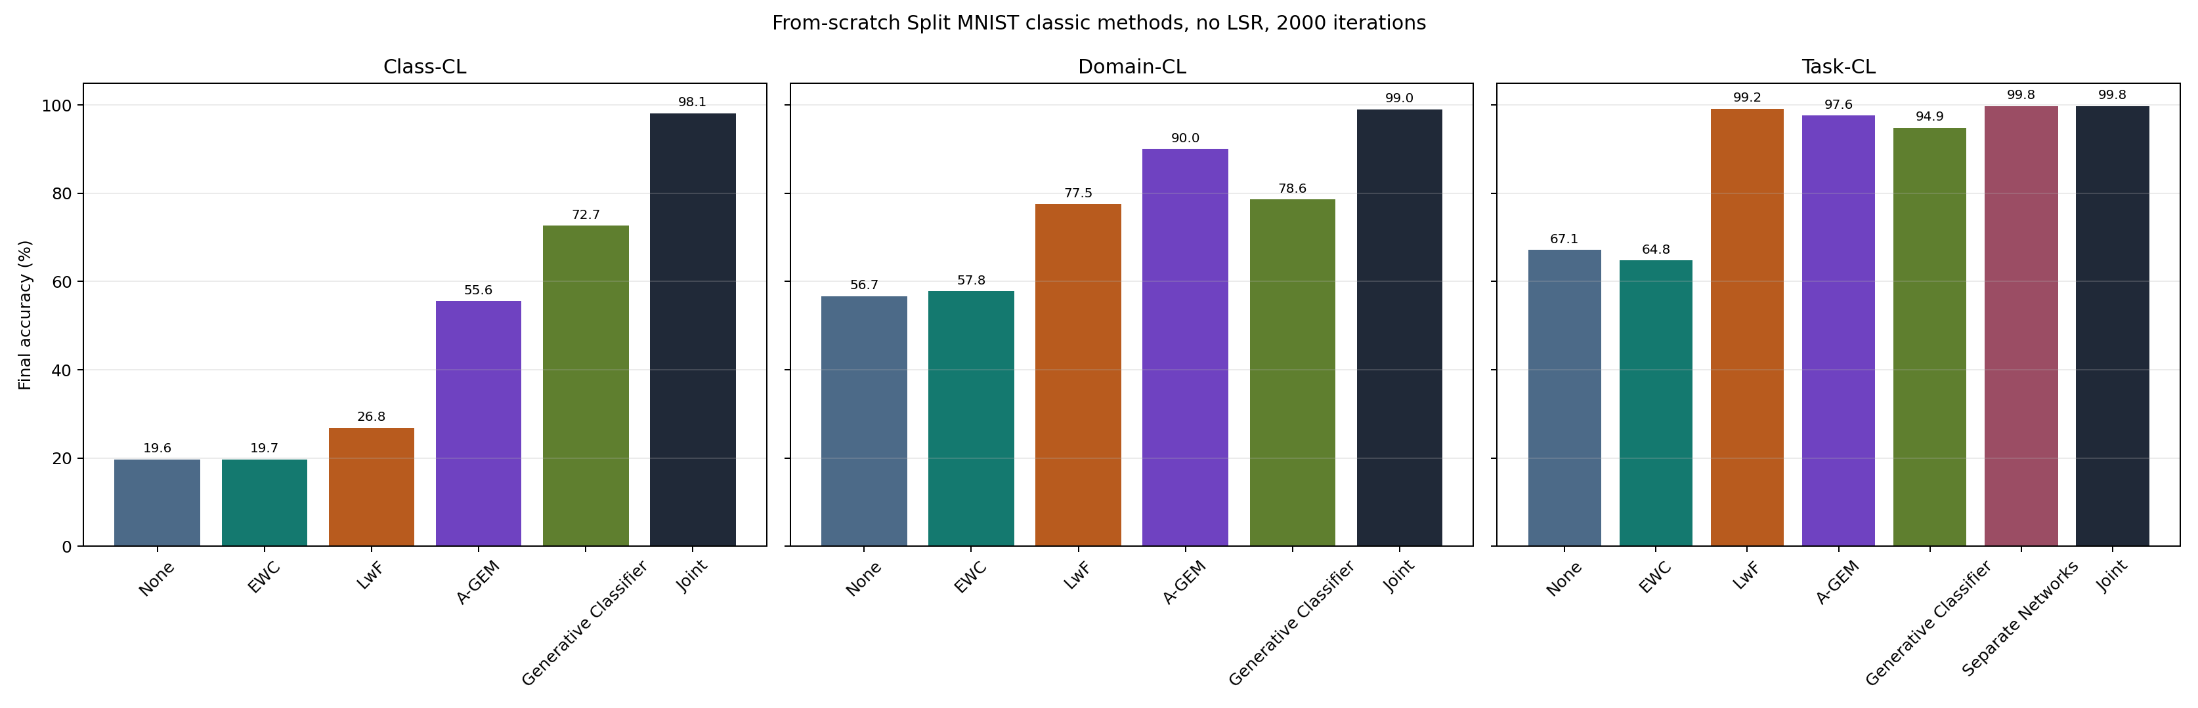
Figure: from_scratch_classic_no_lsr_2000_final_accuracy.png

From-Scratch Classic Methods Learning Curves
This graph shows learning progress over time for the independent clean-room implementation.
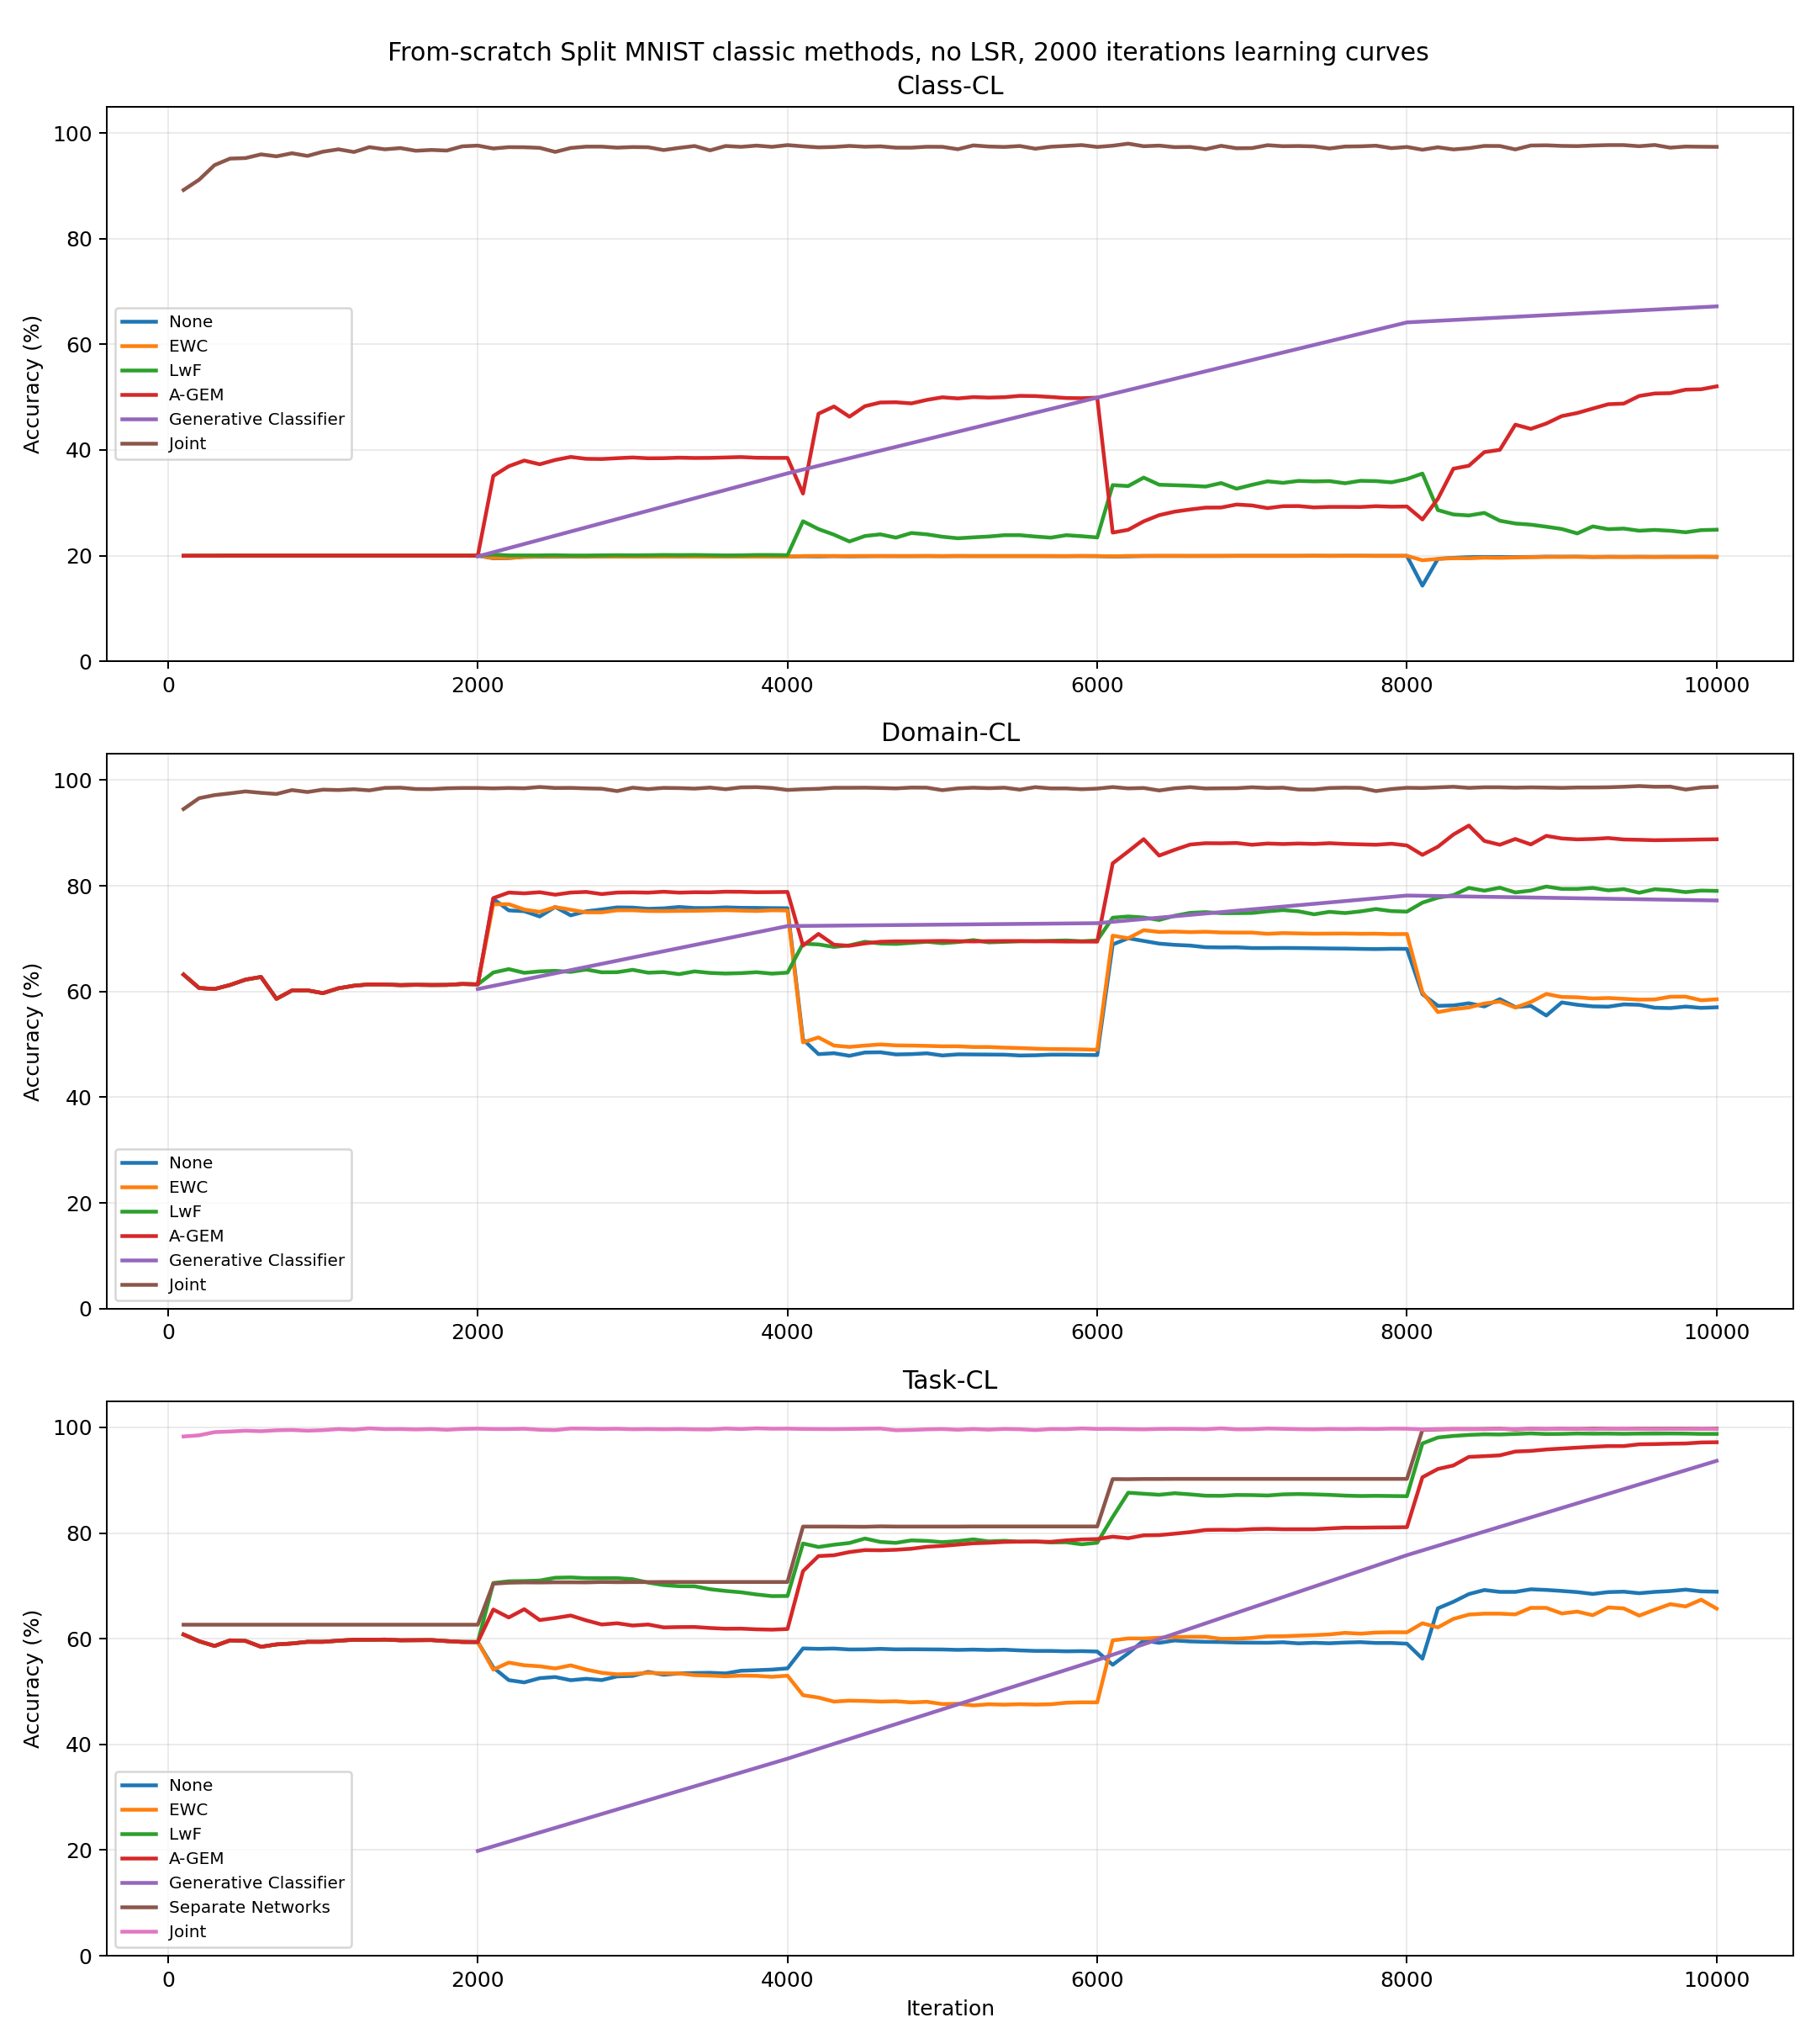
Figure: from_scratch_classic_no_lsr_2000_learning_curves.png

9. Main Conclusions
- Class-CL is the hardest scenario because the model receives no task identity and must classify among all 10 digits.
- None demonstrates catastrophic forgetting clearly, especially in Class-CL.
- Joint Training is the upper bound, not a true continual-learning method.
- Replay and distillation-based methods reduce forgetting compared with simple sequential training.
- LSR-lite performs strongly in Class-CL because it combines real replay, teacher logits, and feature anchoring.
- Fourier and ASW are useful ablations, but the core LSR-lite mechanism is replay plus distillation plus feature anchoring.
- EWC is implemented, but our clean-room version remains a partial reproduction in Task-CL compared with the original reference implementation.
Final defense message: the repository contains both transparent reference results and an independent from-scratch implementation. The report clearly separates paper results, original-code reference runs, and our own implementation.

