Assignment 5: Effect of ad-variety and session-level history on customer response to mobile advertising
Tondreka Robles
Spring B 2026, MKT 472
library(rpart)
library(rpart.plot)
library(xgboost)
library(knitr)
load("C:/Users/tondr/OneDrive/Desktop/Marketing Management Analytics/week 7/variety_train.RData")
load("C:/Users/tondr/OneDrive/Desktop/Marketing Management Analytics/week 7/variety_test.RData")
within_vars <- c("variety", "rep", "adimpsession")
pre_vars <- c("imptotal", "ctruser", "varietytotal", "adimptotal")
full_vars <- c("timeofday", "imptotal", "ctruser", "varietytotal",
"adimptotal", "variety", "rep", "adimpsession")

1. Descriptive analysis

1(a)
observed_ctr <- mean(variety_train$click)
average_past_ctr <- mean(variety_train$ctruser)
kable(data.frame(
Measure = c("Observed CTR", "Average user's past CTR"),
Value = c(observed_ctr, average_past_ctr)
), digits = 4)
Measure | Value
Observed CTR | 0.1134
Average user’s past CTR | 0.1165
The observed CTR is 0.1134, and the average of users’ past CTR is 0.1165. These numbers are close, which makes sense because users with higher past click rates are also more likely to click in the current session. They are not exactly the same because the current data is for one specific EA ad impression.

1(b)
hist(variety_train$variety,
main = "Histogram of In-Session Variety",
xlab = "Variety",
col = "lightblue")
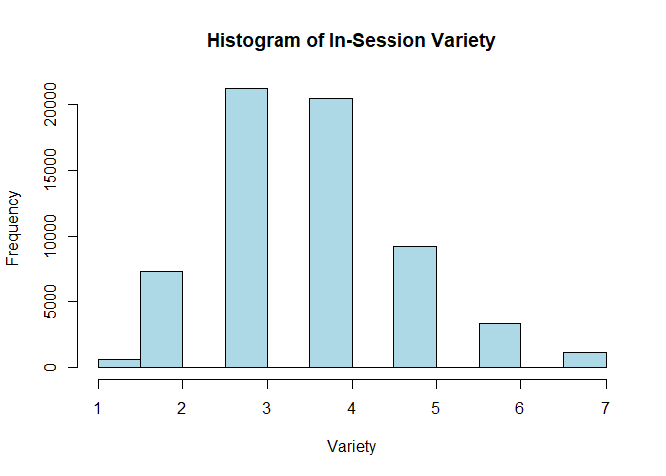
hist(variety_train$varietytotal,
main = "Histogram of Pre-Session Variety",
xlab = "Variety Total",
col = "lightgreen")
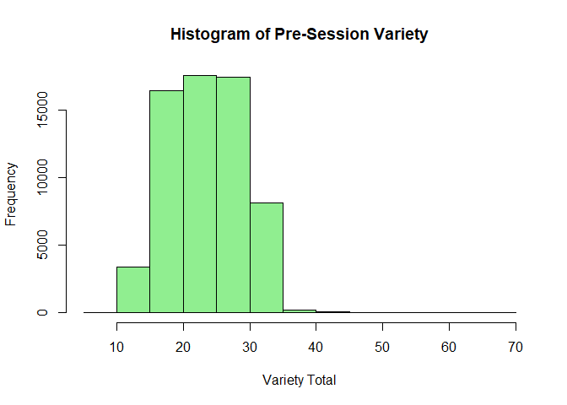
In-session variety is limited because it only comes from the first seven ads in the session. Most users saw around 3 or 4 different ads. Pre-session variety has a wider spread because it is based on the user’s entire past history before the session.

1(c)
cor.test(variety_train$variety, variety_train$rep)
Pearson's product-moment correlation
data: variety_train$variety and variety_train$rep
t = -247.39, df = 63281, p-value < 2.2e-16
alternative hypothesis: true correlation is not equal to 0
95 percent confidence interval:
-0.7051143 -0.6971927
sample estimates:
cor
-0.7011752
The correlation is about -0.70, which is a strong negative relationship. This is expected because if a user sees more different ads, there is less repetition.

1(d)
avg_ctr <- tapply(variety_train$click, variety_train$variety, mean)
plot(as.numeric(names(avg_ctr)), avg_ctr,
type = "b",
xlab = "In-session variety",
ylab = "Average CTR",
main = "Average CTR by In-Session Variety",
col = "blue",
pch = 19)
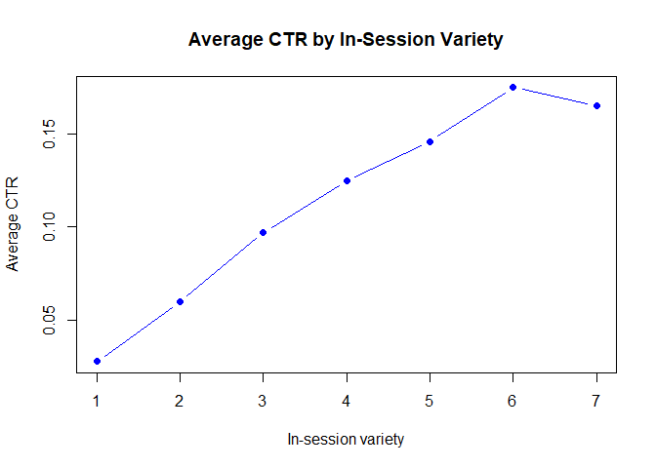
avg_ctr
1 2 3 4 5 6 7
0.02782324 0.05978930 0.09697543 0.12449839 0.14577007 0.17463617 0.16497462
CTR increases as in-session variety increases. Users are less likely to click when they saw only one or two different ads earlier in the session, and more likely to click when they saw more variety.

1(e)
This effect can be interpreted as causal because the ads shown before the eighth impression were randomly assigned. Since the variety was created by the experiment, the change in CTR is not only a regular correlation.

2. Within-session models

2(a) and 2(b): CART model
cart_within <- rpart(click ~ variety + rep + adimpsession,
data = variety_train,
cp = 0.00032)
rpart.plot(cart_within)
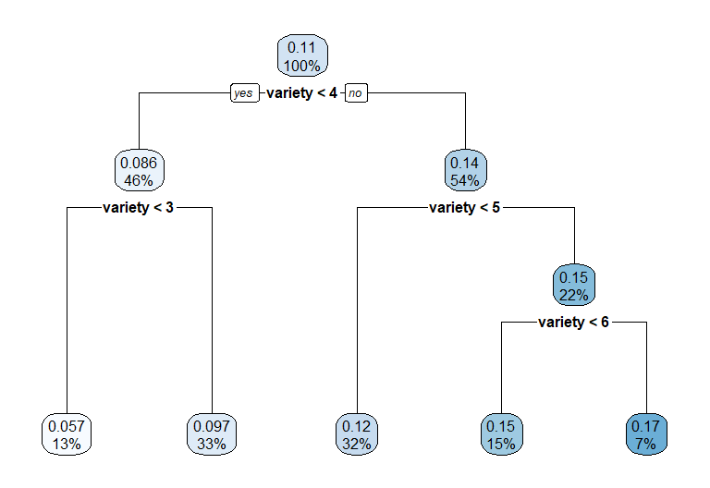
sum(cart_within$frame$var == "<leaf>")
[1] 5
cart_within$variable.importance
variety adimpsession rep
58.47956 27.44992 24.91667
This tree has 5 leaves. It splits mainly on variety, so in-session variety is the most important variable. The tree shows higher predicted CTR for higher levels of variety. rep and adimpsession are omitted from the final splits.

2(c): CART prediction
variety_test$withinsession.CART.pred <- predict(cart_within, newdata = variety_test)
head(variety_test$withinsession.CART.pred)
[1] 0.14577007 0.14577007 0.09697543 0.09697543 0.17212574 0.12449839

2(d) and 2(e): XGBoost model and prediction
xgb_within <- xgb.train(
params = list(
objective = "binary:logistic",
eval_metric = "logloss",
eta = 0.1,
max_depth = 6,
subsample = 1,
colsample_bytree = 1,
min_child_weight = 5,
gamma = 5
),
data = xgb.DMatrix(as.matrix(variety_train[, within_vars]), label = variety_train$click),
nrounds = 100,
verbose = 0
)
variety_test$withinsession.xgb.pred <- predict(
xgb_within,
xgb.DMatrix(as.matrix(variety_test[, within_vars]))
)
head(variety_test$withinsession.xgb.pred)
[1] 0.14495757 0.14495757 0.09321380 0.08561089 0.15697894 0.12501225

3. Pre-session models

3(a) and 3(b): CART model
cart_pre <- rpart(click ~ imptotal + ctruser + varietytotal + adimptotal,
data = variety_train,
cp = 0.00032)
rpart.plot(cart_pre)
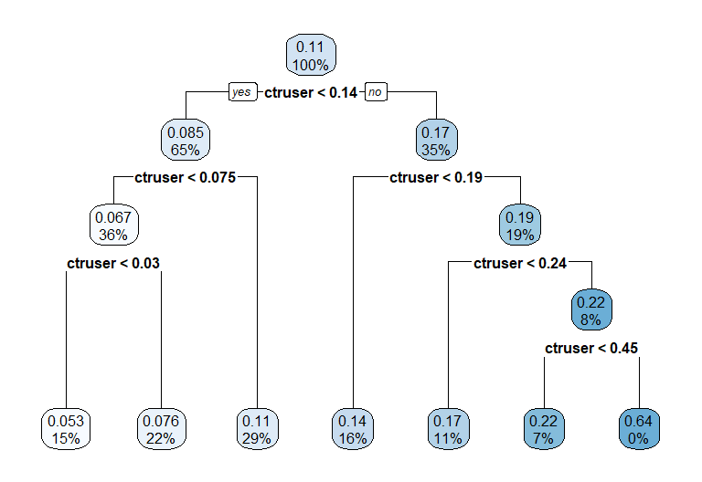
sum(cart_pre$frame$var == "<leaf>")
[1] 7
cart_pre$variable.importance
ctruser imptotal adimptotal varietytotal
139.19964023 0.03095487 0.01391436 0.01296443
This tree has 7 leaves. It splits mainly on ctruser, meaning the user’s past CTR is the most important pre-session predictor. Users with higher past CTR have higher predicted click rates. Other pre-session variables are less important or omitted.

3(c): CART prediction
variety_test$presession.CART.pred <- predict(cart_pre, newdata = variety_test)
head(variety_test$presession.CART.pred)
[1] 0.13584757 0.07644658 0.17446571 0.13584757 0.13584757 0.21657528

3(d) and 3(e): XGBoost model and prediction
xgb_pre <- xgb.train(
params = list(
objective = "binary:logistic",
eval_metric = "logloss",
eta = 0.1,
max_depth = 6,
subsample = 1,
colsample_bytree = 1,
min_child_weight = 5,
gamma = 5
),
data = xgb.DMatrix(as.matrix(variety_train[, pre_vars]), label = variety_train$click),
nrounds = 100,
verbose = 0
)
variety_test$presession.xgb.pred <- predict(
xgb_pre,
xgb.DMatrix(as.matrix(variety_test[, pre_vars]))
)
head(variety_test$presession.xgb.pred)
[1] 0.1344489 0.0796999 0.1660018 0.1344489 0.1344489 0.2124128

4. Full models

4(a) and 4(b): CART model
cart_full <- rpart(click ~ timeofday + imptotal + ctruser + varietytotal +
adimptotal + variety + rep + adimpsession,
data = variety_train,
cp = 0.00032)
rpart.plot(cart_full)
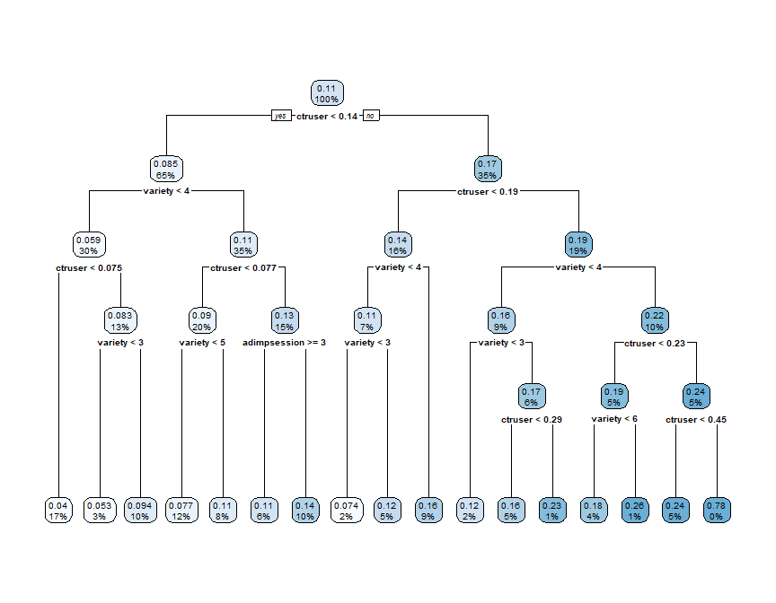
sum(cart_full$frame$var == "<leaf>")
[1] 17
cart_full$variable.importance
ctruser variety adimpsession rep varietytotal imptotal
137.79190320 54.78474214 28.83567313 24.26878740 0.08067593 0.06598887
adimptotal
0.02878702
The full CART model has 17 leaves. It uses both past behavior and within-session behavior. The most important variables are ctruser and variety. This means past CTR is important, but in-session variety still adds useful information.

4(c): CART prediction
variety_test$full.CART.pred <- predict(cart_full, newdata = variety_test)
head(variety_test$full.CART.pred)
[1] 0.1584520 0.1089337 0.1623750 0.1226303 0.1584520 0.2413793

4(d) and 4(e): XGBoost model and prediction
xgb_full <- xgb.train(
params = list(
objective = "binary:logistic",
eval_metric = "logloss",
eta = 0.1,
max_depth = 4,
subsample = 1,
colsample_bytree = 1,
min_child_weight = 5,
gamma = 5
),
data = xgb.DMatrix(as.matrix(variety_train[, full_vars]), label = variety_train$click),
nrounds = 100,
verbose = 0
)
variety_test$full.xgb.pred <- predict(
xgb_full,
xgb.DMatrix(as.matrix(variety_test[, full_vars]))
)
head(variety_test$full.xgb.pred)
[1] 0.1701629 0.1204491 0.1521814 0.1140546 0.1739496 0.2506135

5. Model evaluation
auc_calc <- function(actual, pred) {
r <- rank(pred, ties.method = "average")
n1 <- sum(actual == 1)
n0 <- sum(actual == 0)
(sum(r[actual == 1]) - n1 * (n1 + 1) / 2) / (n1 * n0)
}
rig_calc <- function(actual, pred) {
pred <- pmin(pmax(pred, 1e-15), 1 - 1e-15)
base <- mean(actual)
model_loss <- -mean(actual * log2(pred) + (1 - actual) * log2(1 - pred))
base_loss <- -mean(actual * log2(base) + (1 - actual) * log2(1 - base))
1 - model_loss / base_loss
}
model_columns <- c("withinsession.CART.pred", "withinsession.xgb.pred",
"presession.CART.pred", "presession.xgb.pred",
"full.CART.pred", "full.xgb.pred")
model_names <- c("Within CART", "Within XGBoost",
"Pre-session CART", "Pre-session XGBoost",
"Full CART", "Full XGBoost")
performance <- data.frame(
Model = model_names,
AUC = sapply(model_columns, function(x) auc_calc(variety_test$click, variety_test[[x]])),
RIG = sapply(model_columns, function(x) rig_calc(variety_test$click, variety_test[[x]]))
)
kable(performance, digits = 4)
 | Model | AUC | RIG
withinsession.CART.pred | Within CART | 0.5763 | 0.0122
withinsession.xgb.pred | Within XGBoost | 0.5835 | 0.0134
presession.CART.pred | Pre-session CART | 0.6385 | 0.0348
presession.xgb.pred | Pre-session XGBoost | 0.6430 | 0.0355
full.CART.pred | Full CART | 0.6569 | 0.0445
full.xgb.pred | Full XGBoost | 0.6658 | 0.0508
The best model is the full XGBoost model because it has the highest AUC and RIG. The pre-session models perform better than the within-session models alone, but the full model performs best because it combines both sources of information.

6. Main findings
Pre-session history is more valuable than within-session history by itself, especially because ctruser is a strong predictor. However, within-session history still matters. The best results come from using both pre-session and within-session variables together.
Within-session variety has a positive effect on click behavior. Users who saw a higher variety of ads earlier in the session were more likely to click the EA ad.

7. Business implications

7(a) and 7(b)
best_model <- "full.xgb.pred"
top5000 <- variety_test[order(variety_test[[best_model]], decreasing = TRUE), ][1:5000, ]
kable(data.frame(
Measure = c("Actual CTR for top 5000", "Average predicted CTR for top 5000"),
Value = c(mean(top5000$click), mean(top5000[[best_model]]))
), digits = 4)
Measure | Value
Actual CTR for top 5000 | 0.1954
Average predicted CTR for top 5000 | 0.1872
The actual CTR for the top 5000 impressions is 0.1954, and the average predicted CTR is 0.1872. These are fairly close, so the model does a reasonable job of identifying high-value impressions.

7(c)
cost_per_impression <- 0.05
value_per_click <- 2
baseline_spend <- nrow(variety_test) * cost_per_impression
baseline_gain <- sum(variety_test$click) * value_per_click
baseline_roi <- (baseline_gain - baseline_spend) / baseline_spend
top_spend <- nrow(top5000) * cost_per_impression
top_gain <- sum(top5000$click) * value_per_click
top_roi <- (top_gain - top_spend) / top_spend
kable(data.frame(
Strategy = c("Buy all impressions", "Buy top 5000 impressions"),
Spend = c(baseline_spend, top_spend),
Gain = c(baseline_gain, top_gain),
ROI = c(baseline_roi, top_roi)
), digits = 4)
Strategy | Spend | Gain | ROI
Buy all impressions | 1054.75 | 4752 | 3.5053
Buy top 5000 impressions | 250.00 | 1954 | 6.8160
Buying all impressions gives an ROI of 3.5053. Buying only the top 5000 impressions gives an ROI of 6.8160, which is much better.

7(d)
ordered_test <- variety_test[order(variety_test[[best_model]], decreasing = TRUE), ]
allocation <- data.frame(impressions = seq(500, 20000, by = 500))
allocation$clicks <- sapply(allocation$impressions, function(n) sum(ordered_test$click[1:n]))
allocation$ad_revenue <- allocation$clicks * value_per_click
allocation$ad_cost <- allocation$impressions * cost_per_impression
allocation$ad_profit <- allocation$ad_revenue - allocation$ad_cost
allocation$price_promo_spend <- 1000 - allocation$ad_cost
allocation$price_promo_profit <- allocation$price_promo_spend * 5
allocation$total_profit <- allocation$ad_profit + allocation$price_promo_profit
best_allocation <- allocation[which.max(allocation$total_profit), ]
kable(best_allocation, digits = 4)
 | impressions | clicks | ad_revenue | ad_cost | ad_profit | price_promo_spend | price_promo_profit | total_profit
11 | 5500 | 1060 | 2120 | 275 | 1845 | 725 | 3625 | 5470
The best allocation is to buy the top 5,500 ad impressions. This costs $275 and produces $2,120 in advertising revenue. EA should spend the remaining $725 on price promotions. This gives the highest total profit among the options checked.

