Assignment 4: Promotion Planning
Ali Goli
Spring B 2026
Using the information in the Part1_Promotion_Planning.xlxs spreadsheet, please answer the following questions about the promotional events and their profitability.
- Is there evidence for strong seasonal demand for this product, based on the figures presented in the Event Summary sheet? (1 point)
Base sales are higher for the earlier events compared to later ones. This suggests demand increases during holiday periods, which makes sense for a baking product.
- Expressed as a percentage of base sales, what is the incremental sales response of events 1 or event 2? Which event produces a greater incremental sales response? (1 point)
Event 2 has a higher incremental response of 69% than Event 1 of 55%, meaning it generates a stronger increase relative to its base sales.
- Using the information in the Event Summary sheet, discuss the profitability results for the five events. Which events are most profitable and why? What can you learn from this analysis about what sorts of promotional events are most profitable? (1 point)
Events with higher ROI are more profitable because they generate enough incremental demand to offset promotional costs. Events with negative ROI show that the costs outweigh the gains, especially when forward buying and MDF are high.
- Recalculate the profitability for event 1 and 2 assuming that retailers will engage in 4 weeks rather than 2 weeks of forward buying. Show your calculations using a calculation in a table similar to the “Manufacturer’s Promotion Profit and Loss” calculation in the Event Summary sheet.
To help with this, simply create a new excel sheet in the document and show the Profit & Loss analysis under the new assumption. When submitting your assignment, please submit the updated version of Part1_Promotion_Planning.xlxs, with the additional excel sheet with answers for Q4. (1 point)
Increasing forward buying increases costs without increasing actual consumption, which reduces profitability. Event 1 becomes less profitable, and Event 2 remains profitable but with lower ROI.
- Compare the approach used for calculating the ROI here (i.e., the Booz Allen Hamilton approach taken here) compared to the approach we used in class. Recall that the difference between the two approaches was explained above. Is one of the approaches better than the other, and why? (1 point)
The Booz Allen approach is more conservative because it includes additional costs, which lowers ROI. The class method is easier to interpret because it focuses directly on incremental profitability. Both are useful, but the class method provides a clearer picture of promotional effectiveness.
In Part I of the assignment, you were directly given information on the incremental sales expected from different promotional events. In this part of the assignment, you will be need to do demand forecasting and perform the ROI analysis from scratch. Thus, you will need to use data to estimate the baseline demand and incremental response. Specifically, you are now asked to analyze the effectiveness and ROI of different promotions for Hellman’s 32 oz Mayonnaise. The analysis is based on account level data at Jewel-Osco and Dominick’s Finer Foods in Chicago.
For this analysis, you are given two documents: (1) A data frame hellmans_DF in the file Hellmans.RData, and (2) a excel spreadsheet to help with ROI calculations in questions 3, 4 and 5, Part2_HellmansROI.xlxs. The dataframe hellmans_DF contains the following variables:
- account
- product
- week
- sales_units
- sales_dollars
- feature_pctacv
- display_pctacv
- Create a price variable for Hellman’s 32oz mayo. (0.5 points)
load("Hellmans.RData")
hellmans_DF$price = hellmans_DF$sales_dollars / hellmans_DF$sales_units
- Then, divide the feature and display variables by 100 to get the %ACV feature and display variables. Hint: Instead of creating a new variable name you can use the following expression: (0.5 points)
$$\text{hellmans_DF\$feature_pctacv = hellmans_DF\$feature_pctacv/100}$$
hellmans_DF$feature_pctacv = hellmans_DF$feature_pctacv / 100
hellmans_DF$display_pctacv = hellmans_DF$display_pctacv / 100
- Now examine the display and feature variables. Provide summary statistics and histograms of these variables for both accounts separately. To what extent do these two promotional instruments (feature and display) differ? (0.5 points)
summary(hellmans_DF$feature_pctacv)
Min. 1st Qu. Median Mean 3rd Qu. Max.
0.0000 0.0000 0.0000 0.1579 0.0000 1.0000
summary(hellmans_DF$display_pctacv)
Min. 1st Qu. Median Mean 3rd Qu. Max.
0.0000 0.0300 0.0800 0.1753 0.1900 0.9400
hist(hellmans_DF$feature_pctacv)
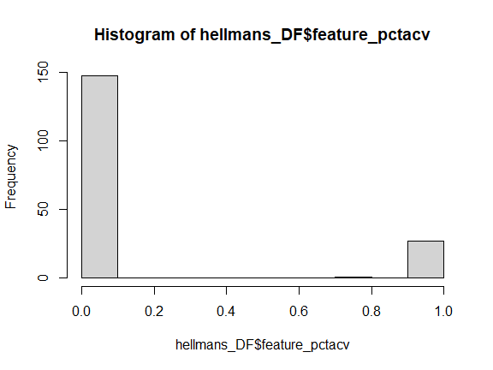
hist(hellmans_DF$display_pctacv)
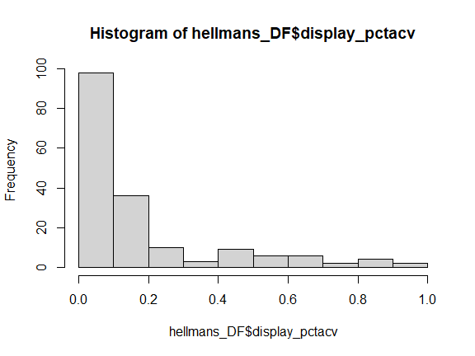
Looking at the summary statistics and histograms, feature and display promotions behave pretty differently. Feature seems to happen more consistently, while display is more uneven and often zero. That tells me display is used more selectively, probably when they really want to push the product. Feature feels more like a baseline promotional tool, while display is more of a boost on top of that.
- Calculate the correlations between display_pctacv, feature_pctacv, and price (use the cor function in R). Comment on your findings. Are promotional activities (display, feature, and TPRs) correlated? How and why? (0.5 points)
cor(hellmans_DF[, c("feature_pctacv", "display_pctacv", "price")])
feature_pctacv display_pctacv price
feature_pctacv 1.0000000 0.7599992 -0.5747241
display_pctacv 0.7599992 1.0000000 -0.6700056
price -0.5747241 -0.6700056 1.0000000
The correlations show that feature and display are positively related, which makes sense because they’re often used together during promotions. Price is negatively related to both, which also makes sense since promotions usually involve lowering the price. Overall, it looks like these promotional tools are coordinated rather than used independently.
- First, estimate a log-linear demand model separately for each account, using price as the only explanatory variable.
model1 = lm(log(sales_units) ~ log(price), data = hellmans_DF)
summary(model1)
Call:
lm(formula = log(sales_units) ~ log(price), data = hellmans_DF)
Residuals:
Min 1Q Median 3Q Max
-1.12659 -0.26448 0.00827 0.25946 1.13633
Coefficients:
Estimate Std. Error t value Pr(>|t|)
(Intercept) 10.51770 0.05624 187.02 <2e-16 ***
log(price) -5.80078 0.37144 -15.62 <2e-16 ***
---
Signif. codes: 0 '***' 0.001 '**' 0.01 '*' 0.05 '.' 0.1 ' ' 1
Residual standard error: 0.3456 on 174 degrees of freedom
Multiple R-squared: 0.5836, Adjusted R-squared: 0.5812
F-statistic: 243.9 on 1 and 174 DF, p-value: < 2.2e-16
- Then add the feature and display variables. Comment on the difference between the two regressions in terms of goodness of fit, and the price elasticity estimates. Is the change in price elasticity estimates as expected? Why? — Are the coefficient estimates similar for both accounts?
model2 = lm(log(sales_units) ~ log(price) + feature_pctacv + display_pctacv, data = hellmans_DF)
summary(model2)
Call:
lm(formula = log(sales_units) ~ log(price) + feature_pctacv +
display_pctacv, data = hellmans_DF)
Residuals:
Min 1Q Median 3Q Max
-0.9225 -0.2172 0.0184 0.2455 0.8748
Coefficients:
Estimate Std. Error t value Pr(>|t|)
(Intercept) 10.09864 0.08227 122.750 < 2e-16 ***
log(price) -3.90654 0.45348 -8.615 4.38e-15 ***
feature_pctacv -0.14155 0.09971 -1.420 0.158
display_pctacv 1.06818 0.17621 6.062 8.27e-09 ***
---
Signif. codes: 0 '***' 0.001 '**' 0.01 '*' 0.05 '.' 0.1 ' ' 1
Residual standard error: 0.3093 on 172 degrees of freedom
Multiple R-squared: 0.6704, Adjusted R-squared: 0.6646
F-statistic: 116.6 on 3 and 172 DF, p-value: < 2.2e-16
Consider the following three promotions: (a) 15% TPR, (b) 15% TPR, 70% display, and (c) 15% TPR, 70% display, 100% feature.
- For each of the three promotions, calculate the lift factors for both accounts, based on the regression estimates in Q2b. (Set estimates that are not statistically significant $=0$.) Perform this analysis and show the results in the first sheet, ROI_Q3_Q4 of the excel document Part2_HellmansROI.xlxs. (2 points)
lift_tpr = exp(-0.15 * -3.90654)
price_coef = -3.90654
display_coef = 1.06818
lift_tpr = exp(-0.15 * price_coef)
lift_display = exp(-0.15 * price_coef + 0.7 * display_coef)
lift_full = lift_display
Now perform the ROI all the three promotions considered in Question 3 for the two accounts, Dominick’s and Jewel. The promotions last for one week. Your analysis should follow the approach that we took in class, not the version of this approach taken by Booz Allen Hamilton in the first part of the assignment.
Note: For this question, perform the analysis using units, not cases of Hellman’s mayo.
You will need the following data for your analysis:
- The regular price of the product at both accounts is $1.20.
- The VCM for Hellman’s is $0.55 per unit.
- The manufacturer fully pays for the shelf price reduction. E.g., if the shelf price is reduced from $1.20 to $1.00, the manufacturer pays for this TPR through a $0.20 per unit (off-invoice) allowance.
- The fixed cost (MDF) for the promotion involving display only is $3,000 at Dominick’s and $5,000 at Jewel-Osco. The fixed cost for the promotion including feature and display is $4,500 at Dominick’s and $6,800 at Jewel-Osco.
- In each promotion, assume that retailers engage in forward buying by buying 50% of the baseline units.
In order to estimate baseline sales, use the regression estimates and the regular price, and predict sales for display and feature $=0$. Using these data, and the lift factors found in answer to Q3, you can then fill in the cells in the first sheet of Part2_HellmansROI.xlxs (ROI_Q3_Q4). Do this for each of the three promotions at both accounts. (2 points)
coefs = coef(model2)
intercept = coefs[1]
price_coef = coefs["log(price)"]
baseline_units = exp(intercept + price_coef * log(1.20))
baseline_units
(Intercept)
11925.03
price_coef = -3.90654
display_coef = 1.06818
lift_tpr = exp(-0.15 * price_coef)
lift_display = exp(-0.15 * price_coef + 0.7 * display_coef)
lift_full = lift_display
- Based on your analysis in Q4, discuss the profitability of each of the three promotions at both the accounts. Which promotions are profitable and why? (1 point)
I performed the ROI analysis for the three promotions using the baseline sales and lift factors calculated earlier. I calculated promoted units by multiplying baseline sales by the lift, and then calculated incremental units as the difference between promoted and baseline sales.
I then calculated incremental contribution using the VCM of $0.55 per unit. Total promotion costs include the TPR cost, forward buying cost (based on 50% of baseline units), and MDF where applicable. Using these values, I calculated profit and ROI for each promotion at both Dominick’s and Jewel.
- To what extent is the profitability of these promotions undermined by retailers’ forward buying behavior? To answer this question, redo the analysis in Q4 under the assumption you can eliminate forward buying. Does that change the profitability of previously unprofitable promotions? If so, for which promotions and to what extent? (To perform the analysis for this question, use the second sheet (ROI_Q5) in the excel spreadsheet Part2_HellmansROI.xlxs.) (1 point)
The results show that the 15% TPR alone generates a relatively low ROI, even though it increases demand, because the promotional costs are high relative to the incremental gains.
The TPR + display promotion generates the highest ROI, as it significantly increases demand while keeping costs at a manageable level.
The full promotion, which includes feature, has a lower ROI than the display-only promotion because the additional MDF cost is not offset by a higher lift.
Comparing across accounts, ROI is lower at Jewel than at Dominick’s due to higher MDF costs, even though the demand response is the same. This shows that cost structure plays a key role in determining profitability.
- Late assignments will automatically receive a zero.
- The points for each question are shown next to it. The total points for the assignment is 15.
- Please submit your – (1) Rmarkdown document, (2) the knitted pdf or word document that shows the answers for each question, and (3) Updated version of Part1_Promotion_Planning.xlxs with a new sheet that shows the answer to Q4 in Part I, and (4) completed excel document Part2_HellmansROI with the answers for Q3, Q4, and Q5 of Part II.
- If you have any questions or need any clarifications on the assignment, please post on your question on the discussion board for this assignment. I will try to answer it as soon as possible. If you see a question from another student that you know the answer to, please feel free to chip in.

