PORTFOLIO PROJECT BLOG POST

- INTRODUCTION OF MY

- Screenshot of the banner in my application
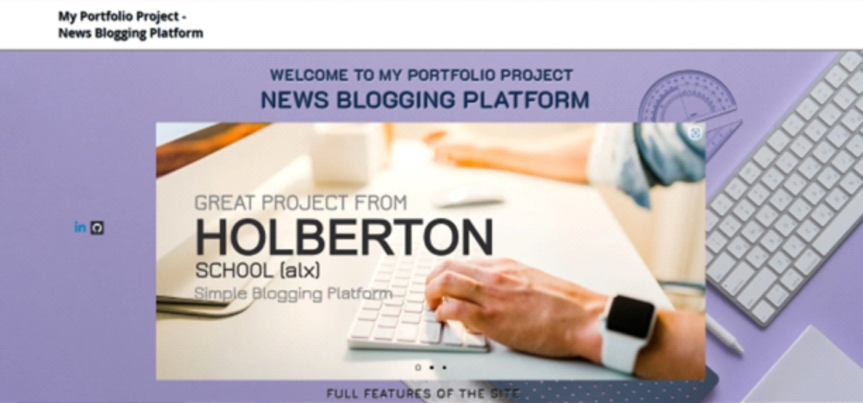

- The Purpose Of My Project
As a Developer, the main Purpose, l embarked on this Project (Blogging Platform) is to showcase expertise and provide a space for developers in various Programming languages or technologies. Blogging platforms can also create a community of other developers who share similar interests, and exchange knowledge and ideas.
Engaging in Blogging regularly will improve one’s writing skills, which is an essential skill in the technology industry and the world generally. Furthermore, it has become imperative for every sector to engage technologists to provide networking opportunities for developers and air out their views and opinions, by way of helping them to connect with other professionals in the tech industry.
More essentially, Blogging Platform Web Application will promote building a personal brand, by aiding Bloggers to create a blog under any name, which in turn assists them to build their personal brand and establish themselves as a leading brand in their different field of endeavours.
In summary, I am developing this Project (Blogging Platform) to help the world showcase their expertise, build their personal brand, improve their writing skills, connect with other professionals, and build a community of like-minded individuals.

- Share your team members, roles and timeline
I embarked on the journey of my Portfolio Project alone. There is no team member. Every role and timeline was created and done by me and myself.

- Describe who your project was created for
My web applications (Blogging platforms) are created for anyone who wishes to publish content online. This includes individuals, businesses, organizations, and institutions. They are especially useful for individuals who want to share their thoughts, opinions, and experiences with others, as well as businesses and organizations that want to build an online presence and engage with their audience.
- Explain what your personal focus was
As a Developer, the real focus I am creating a Simple Blogging Platform is to provide a user-friendly and efficient platform for bloggers to easily create, publish and manage their content with minimum technical knowledge and hassle. The platform will also provide features like search engine optimization, social media integration, user engagement tools, and customizable themes to enhance the user experience and attract more traffic to the website. Ultimately, the focus should be on delivering a reliable and scalable platform that meets the needs of bloggers and their readers.

2. A STORY ABOUT MYSELF THAT RELATES TO WHY I CHOSE TO WORK ON THIS PROJECT
Right from a tender age, I have always had this dream of becoming a developer so that I can contribute in solving problems. After my University degree programme in Information and Communication Technology (ICT), I’ve always had a passion for creating software that could make people's lives easier. I had always been fascinated by the power of the internet and the ability to connect people from all corners of the globe.
When ALX (Holberton School) decided to test our abilities in what we’ve been taught so far, by engaging us in a Portfolio Project in #Month 8. Since I made up my mind to embark development of this web application Project (Blogging Platform) I have encountered many challenges and obstacles that tested my learning skills and abilities. However, I persevered through all these and learned from the experiences, eventually becoming a skilled developer capable of developing complex web applications.
The main reason I chose to develop this web application is that; One day, I went to a cyber-café to search for information for my school project then, and I stumbled upon a Blogging Platform that was lacking in many crucial features, and when opportunity from the ALX (Holberton School) came for us choose Project Topics, I felt it was a good opportunity again to test my ability in creating a better Blogging Platform that could truly help people express themselves online. I knew that, I was up for the challenge, and I decreed upon myself to pour out all the skills and bits of knowledge I have so far learned from Holberton School, into creating a unique and innovative web application (Blogging Platform) that offered everything that the old Blogging Platform was missing – intuitive user interface, customizable layouts, integrated analytics, and more.
While I continue to engage myself in developing the Blogging Platform, I encountered many challenges, including coding bugs, server crashes, and compatibility issues. However, I remained determined and focused, and he eventually polished my reasoning and creativity, and I am confident that presenting it to the world in less than no time.

3. SUMMARY OF WHAT I'VE ACCOMPLISHED WITH MY PROJECT
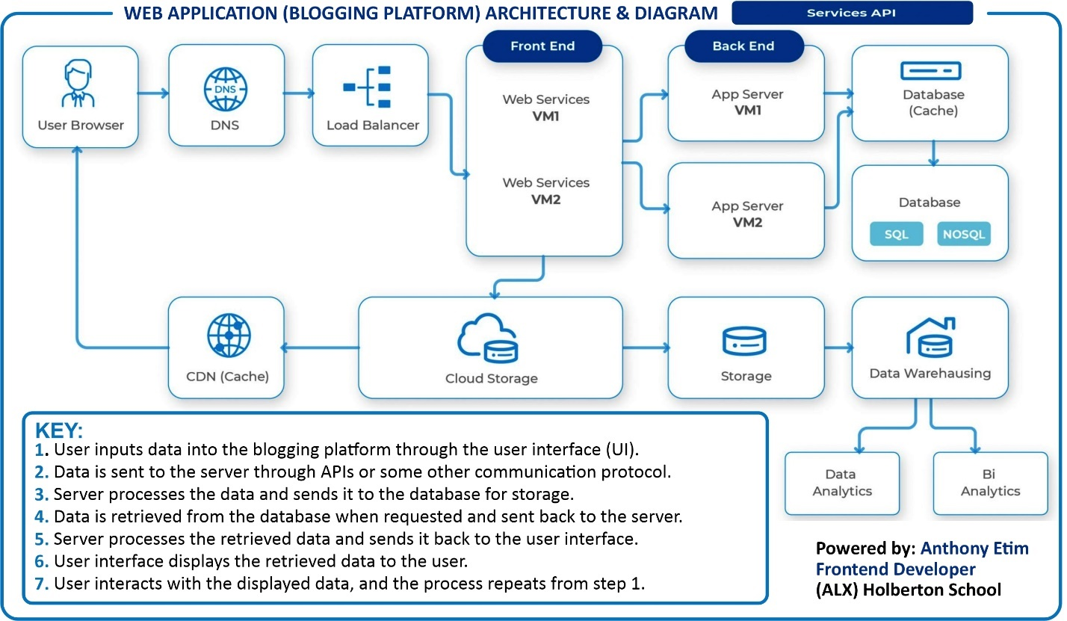

Architectures Used:
Frontend I used: HTML, CSS, react. JS
For uniqueness and beautiful user interface for promoting the brand and making it striking.
For the backend: Flask, MySQL.
This is to have a good database and also control the behaviors of the site

4. THE MOST DIFFICULT TECHNICAL CHALLENGE IN DEPTH
Developing a Blogging Platform could be very challenging, but the ability to stay focused brings success stories in the end. The most difficult technical in Blogging Platform development are numerous, as it requires a robust CMS, secure login system, efficient search engine, scalability, customization options, security measures, mobile responsiveness, external service integration, SEO optimization, and performance monitoring. Overcoming these challenges demands expertise in user experience design, backend development, database optimization, security, and performance optimization.
5. SHARE WHAT YOU'VE LEARNED:
- Technical takeaways
My technical take is the ability to rise from building a user interface to creating databases, implementing security measures, integrating third-party plugins, optimizing speed and performance, implementing SEO best practices, and adding social media integration.
- What I might do differently
As a developer, what I feel I should do differently is to understand user requirements, plan platform architecture, use a modern technology stack, focus on user experience, pay attention to the security of my web application, test thoroughly, and most importantly I will pay more attention to feedback to improve the product.
- What I learned about myself as an engineer
As an Engineer, I have several things I’ve learned about myself, but I can only outline a few: Identifying strengths and weaknesses, developing time management and communication skills, building problem-solving abilities, and maintaining personal motivation and drive.
- How this project informs your engineering path in the future
As a software engineer, there are several ways the Project could inform my path, ranging from applying theoretical knowledge, identifying strengths and weaknesses, building experience, enhancing creativity and problem-solving skills, and creating networking opportunities. It establishes a strong foundation of knowledge and builds experience that I can showcase to potential employers. This can help the upcoming software engineers improve their skills, recognize their weaknesses, and encourage them to be creative in generating innovative solutions. Finally, it can also help build professional connections leading to more opportunities in the future.

6. ADD A SHORT PARAGRAPH ABOUT YOURSELF AFTER THE CONCLUDING PARAGRAPH
- Describe yourself in a few sentences
As Software Engineer and Developer, I have always been fascinated by computers and coding. I enrolled in an Information and Communication Technology Degree programme and worked hard to excel. I progressed through my degree programme and found my love in developing apps. After graduation, I landed a job as a Technologist, where I worked on several high-profile projects. I have dedicated myself to excellent work to make me an indispensable fellow among my peer, and I will continue to inspire other developers and technologists.
- Link to my Portfolio Project Landing
Home | My Site (anthonyeetim.wixsite.com)
- Link to my LinkedIn Profile
www.linkedin.com/in/anthony-etim-09686a15a

