新建一个文件：touch download.c

xin

#include <pthread.h>

#include <stdio.h>

#include <stdlib.h>

#define NUM_OF_TASKS 5

void *downloadfile(void *filename)

{

printf("I am downloading the file %s!\n", (char *)filename);

sleep(10);

long downloadtime = rand()%100;

printf("I finish downloading the file within %d minutes!\n", downloadtime);

pthread_exit((void *)downloadtime);

}

int main(int argc, char *argv[])

{

char files[NUM_OF_TASKS][20]={"file1.avi","file2.rmvb","file3.mp4","file4.wmv","file5.flv"};

pthread_t threads[NUM_OF_TASKS];

int rc;

int t;

int downloadtime;

pthread_attr_t thread_attr;

pthread_attr_init(&thread_attr);

pthread_attr_setdetachstate(&thread_attr,PTHREAD_CREATE_JOINABL);

for(t=0;t<NUM_OF_TASKS;t++){

printf("creating thread %d, please help me to download %s\n", t, files[t]);

rc = pthread_create(&threads[t],&thread_attr,downloadfile,(void *)files[t]);

if (rc){

printf("ERROR; return code from pthread_create() is %d\n", rc);

exit(-1);

}

}

pthread_attr_destroy(&thread_attr);

for(t=0;t<NUM_OF_TASKS;t++){

pthread_join(threads[t],(void**)&downloadtime);

printf("Thread %d downloads the file%s in %d minutes.\n",t,files[t],downloadtime);

}

pthread_exit(NULL);

}

# 编译

gcc download.c –lpthread

报错！！

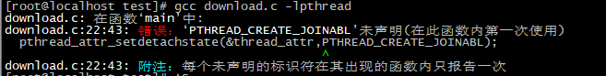

原来如此 少一个 E ，加上就行了。

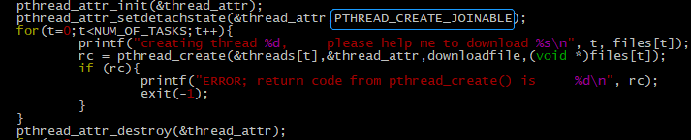

# 编译

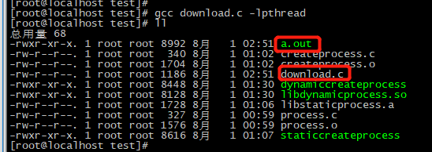gcc download.c -lpthread

执行

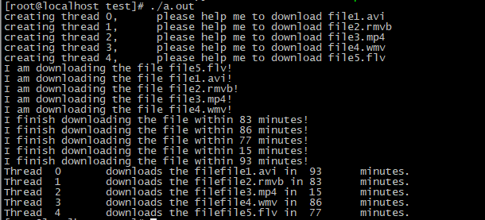./a.out