**The remote system refused the connection.**

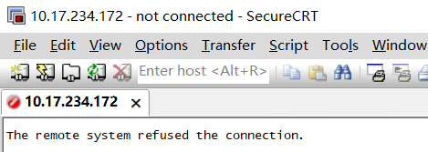

没有安装 openssh-server

sudo apt-get install openssh-server

好了。