# AutoReport

## Simple text replacement

Welcome to AutoReport, this is an introductory document. You can automatically modify this template by editing the params.json file, for example you can find me in "params.yaml", and **change all the values here**, finally *everything will be updated*. The portions automatically generated by AutoReport will be highlighted in purple for easy review and verification. It is worth mention that all the styles set in this template will be stored and stay the same in the result report, which is one of the best reasons to use Jinja2.

## Automatic Table

Table1. sample table 1

|  |  |  |  |  |
| --- | --- | --- | --- | --- |
| **A** | **B** | **C** | **D** | **E** |
| banana | capsicum | pyrite | taxi | a |
| apple | tomato | cinnabar | doubledecker | b |
| guava | cucumber | aventurine | card | c |

For the automatic table, you need to pay attention to the variable names. In this table, table_1_col_labels needs to correspond with table_1_col_labels in the data, representing the name of each column; table_1_contents needs to correspond with table_1_contents in the data, representing the data for each row. If you want to generate multiple tables, make sure the above two variable names are consistent for each table.

Table2. sample table 2

|  |  |  |  |  |  |  |
| --- | --- | --- | --- | --- | --- | --- |
| **Student** | **Class1** | **Class2** | **Class3** | **Class4** | **Class5** | **Class6** |
| a | 123 | 130 | 142 | 80 | 79 | 90 |
| b | 110 | 108 | 129 | 76 | 86 | 78 |
| c | 103 | 130 | 129 | 65 | 79 | 63 |
| d | 50 | 34 | 21 | 19 | 23 | 44 |

Table3. complex table

|  |  |  |  |  |  |  |
| --- | --- | --- | --- | --- | --- | --- |
| **HEAD** | **rate1** | | | **rate2** | | |
| **Nov** | **Dec** | **Change** | **Nov** | **Dec** | **Change** |
| area1 | 100 | 100 | 1 | 100 | 100 | 0 |
| area2 | 100 | 100 | 0 | 100 | 100 | 0 |
| area3 | 100 | 100 | 0 | 100 | 100 | 0 |

Table4. fixed header

|  |  |  |  |  |  |  |  |
| --- | --- | --- | --- | --- | --- | --- | --- |
| **H1** | **H2** | **H3** | | **H4** | | **H5** | |
| **H3_1** | **H3_2** | **H4_1** | **H4_2** | **H5_1** | **H5_2** |
| 1 | 2 | 3 | 4 | 5 | 6 | 7 | 8 |
| 1 | 2 | 3 | 4 | 5 | 6 | 7 | 8 |
| 1 | 2 | 3 | 4 | 5 | 6 | 7 | 8 |
| 1 | 2 | 3 | 4 | 5 | 6 | 7 | 8 |
| 1 | 2 | 3 | 4 | 5 | 6 | 7 | 8 |
| 1 | 2 | 3 | 4 | 5 | 6 | 7 | 8 |

## Image

Inserting images is similar to inserting text, but you need to be aware that in the code you must call *InlineImage* to create a recognizable image.

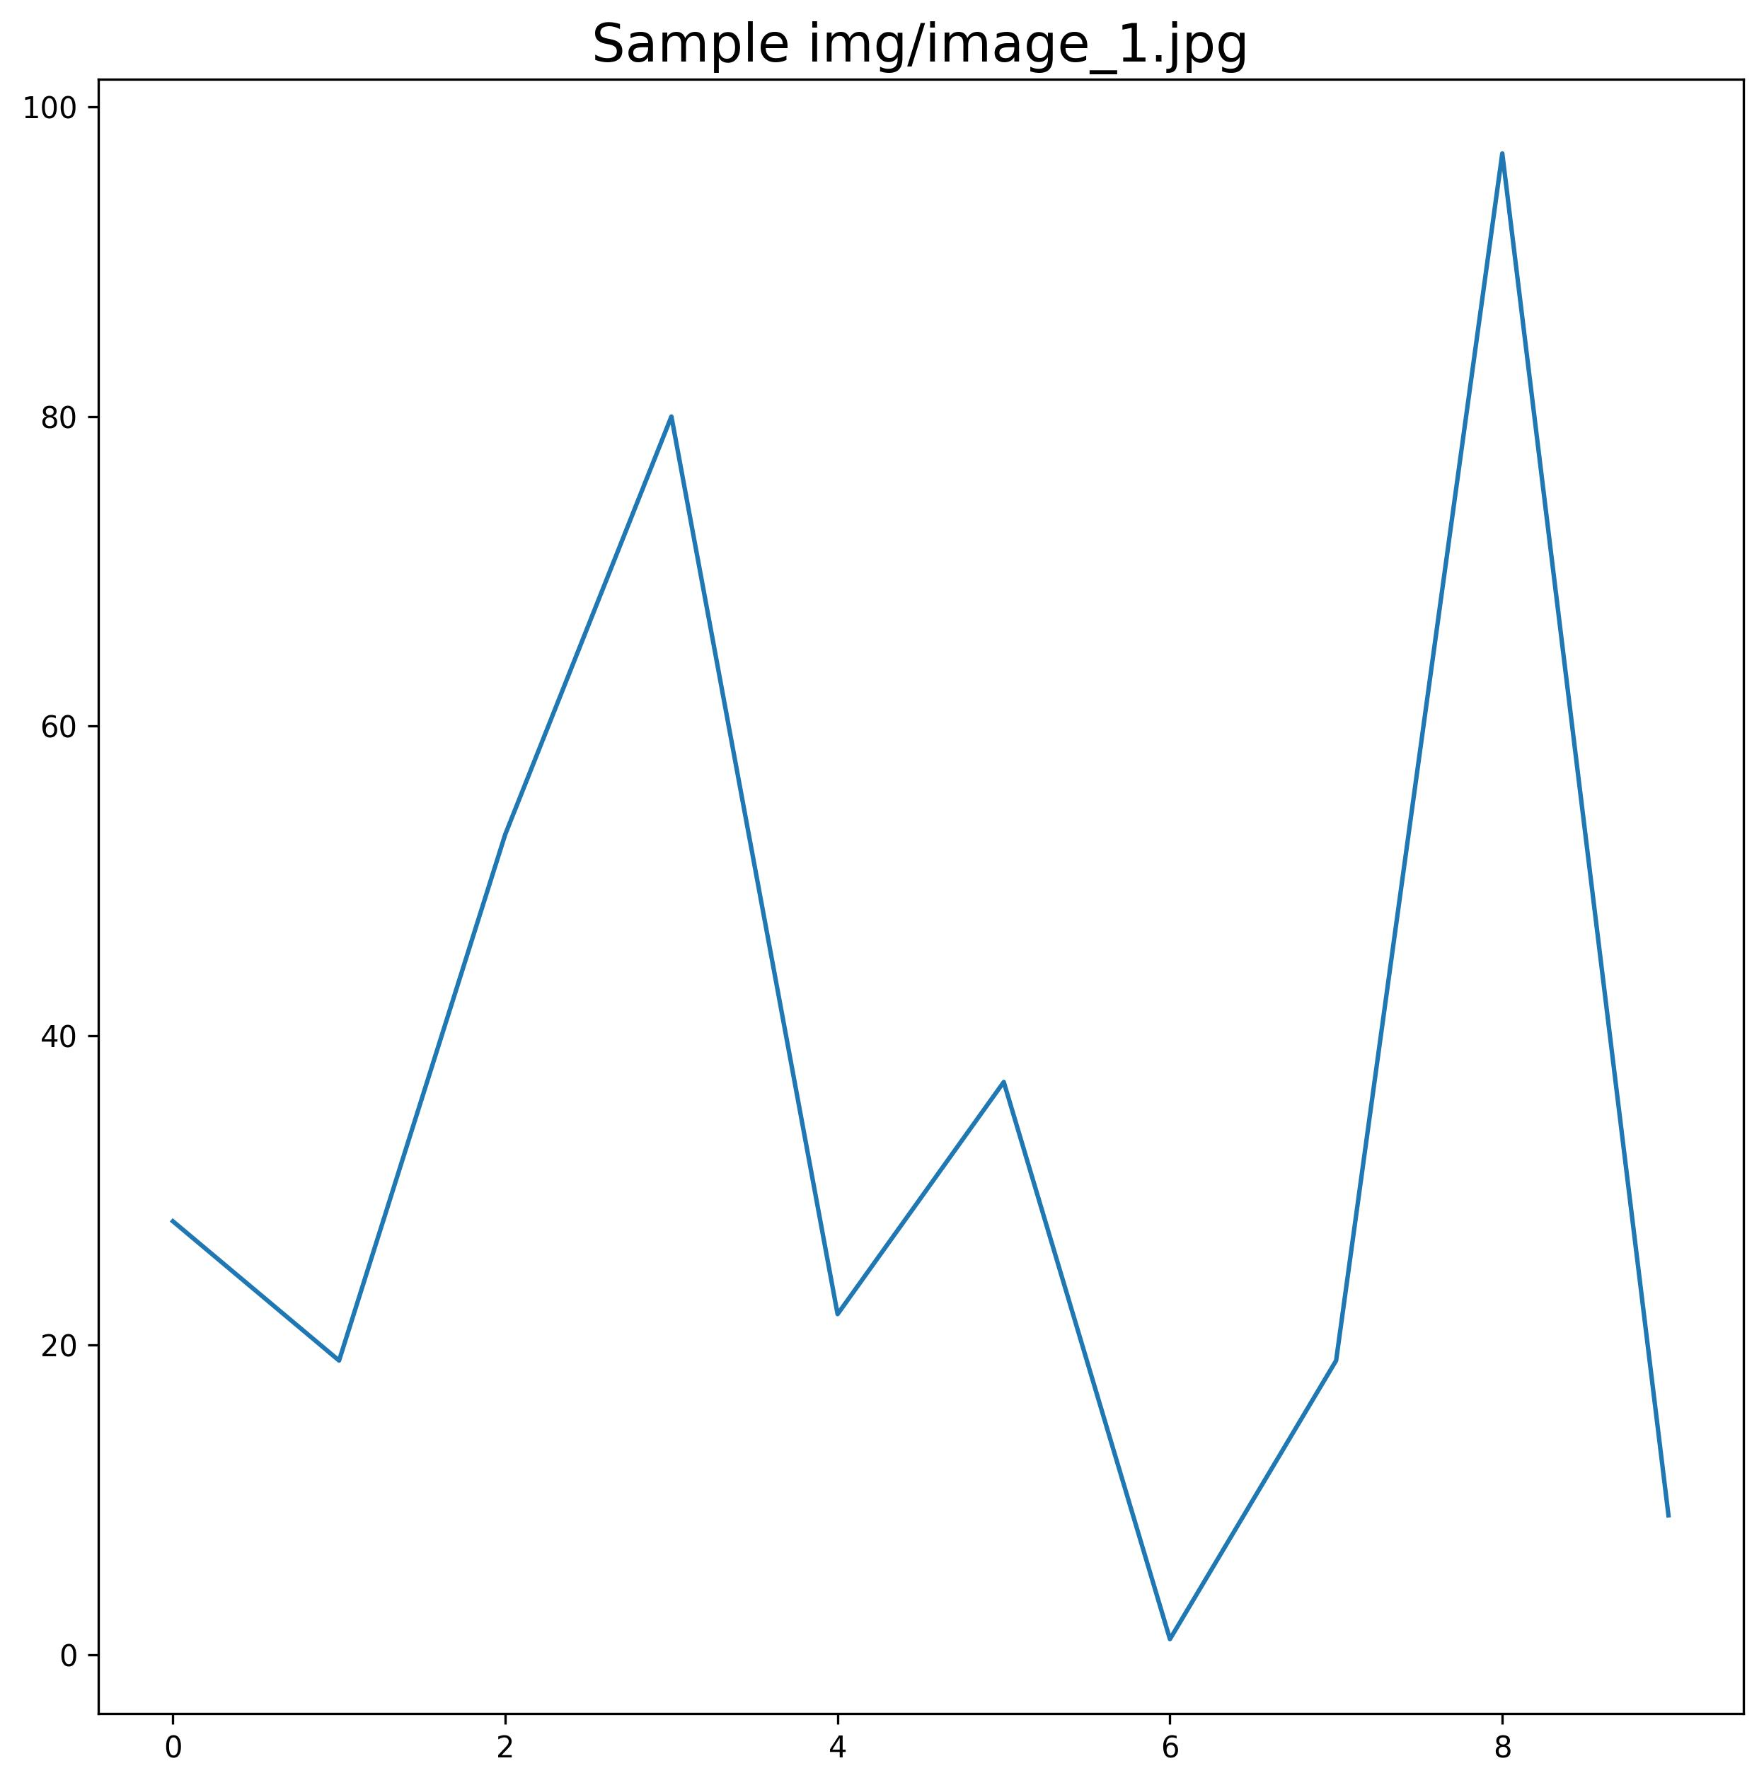

Img1

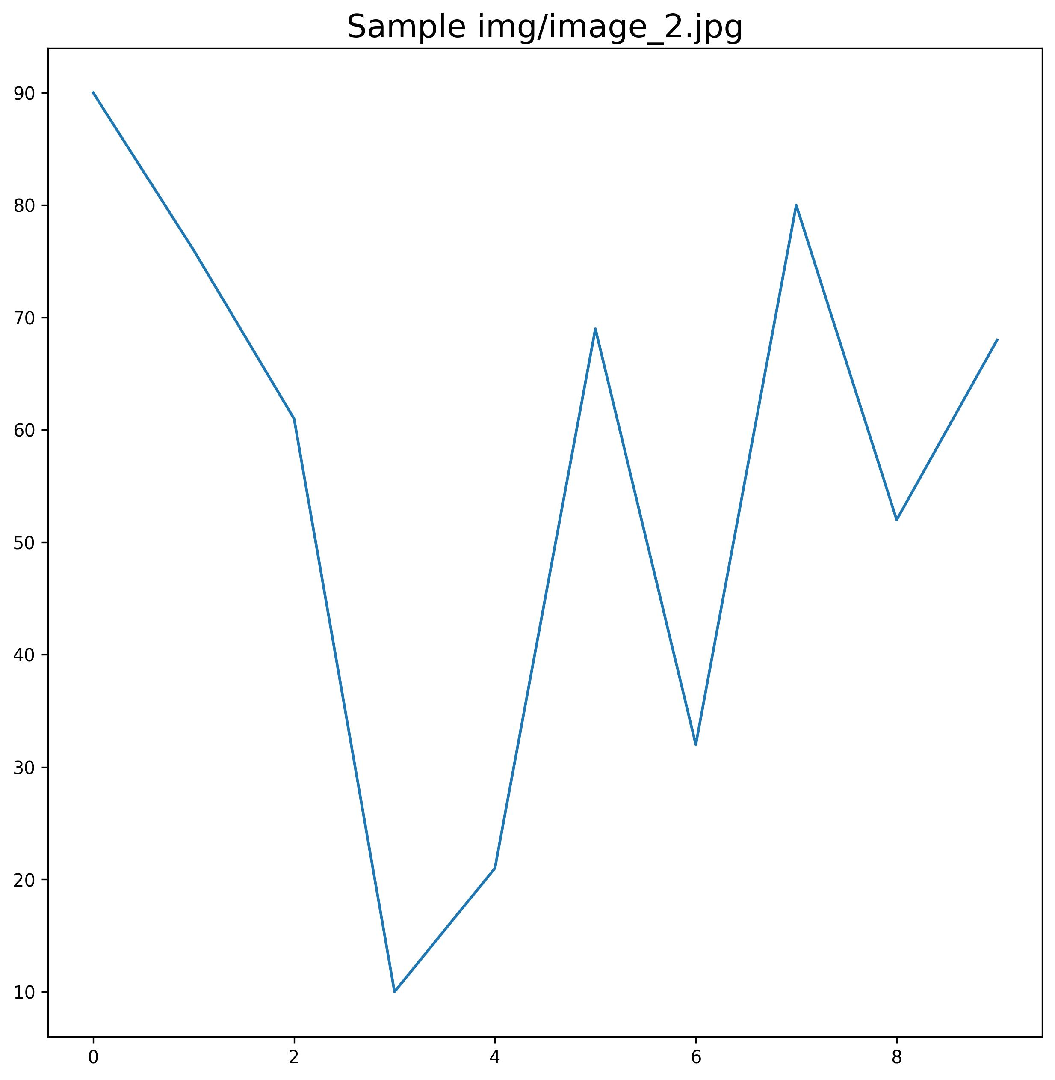

Img2



## Bullet Points

1. item 1
2. item 2