IT5005 Artificial Intelligence
Tutorial 5
Tree and Adversarial Search

- Sudoku is a popular number puzzle that works as follows: we are given a 9 × 9 square grid; some squares have numbers, while some are blank. Our objective is to ﬁll in the blanks with numbers from 1−9 such that each row, column and the highlighted 3×3 squares contain no duplicate entries (see Figure 1). Solving Sudoku puzzles is often modeled as a CSP (which we will cover later in the course). Consider, however, the problem of generating Sudoku puzzles. Consider the following procedure: start with a completely full number grid (see Figure 2), and iteratively make some squares blank. We continue blanking out squares as long as the resulting puzzle can be completed in only one way.

Questions:

- Give the representation of a state in this problem;

A state in this problem is a (partial) valid solution of the sudoku puzzle. More formally, it would be a matrix A ∈ {0,...,9}^{9×9} with 0 representing a blank square.

- Using the state representation deﬁned above, specify the initial state and goal state.

The initial state is a completely filled out grid of numbers, where the grid is valid: all rows, columns and 3 × 3 squares contain all numbers between 1,...,9.
See part d for the goal state.

- Deﬁne its actions; and
An action would be removing a number from the grid. More formally, we take as input a matrix A and a matrix E_{i,j}(a) where E_{i,j}(a) ∈ {0,...,9}^{9×9} is a matrix of all zeros except for a non-zero value a ∈ {1,...,9} in coordinate (i,j). An action would be setting A − E_{i,j}(a).

- Using the state representation and actions deﬁned above, specify the transition model/functionT (i.e., when each of the actions deﬁned above is applied to a current state, what is the resulting next state?).
The transition model would be T(A,E_{i,j}(a)) = A − E_{i,j}(a). It is important to note that as we start removing numbers it would be important to start testing for a goal node - this would be a matrix A∗ such that for any E_{i,j}(a), A∗ − E_{i,j}(a) cannot be uniquely completed. Think - how would you ensure this? It is not a trivial check to implement efficiently. In addition, it is worthwhile to think about your search strategy in this case. How would you make a good puzzle generator? It would probably make sense to randomly remove numbers rather than deterministically doing so. There are many goal nodes here, but it would be boring to use your sudoku generator if it always outputted the same puzzle on the same input.

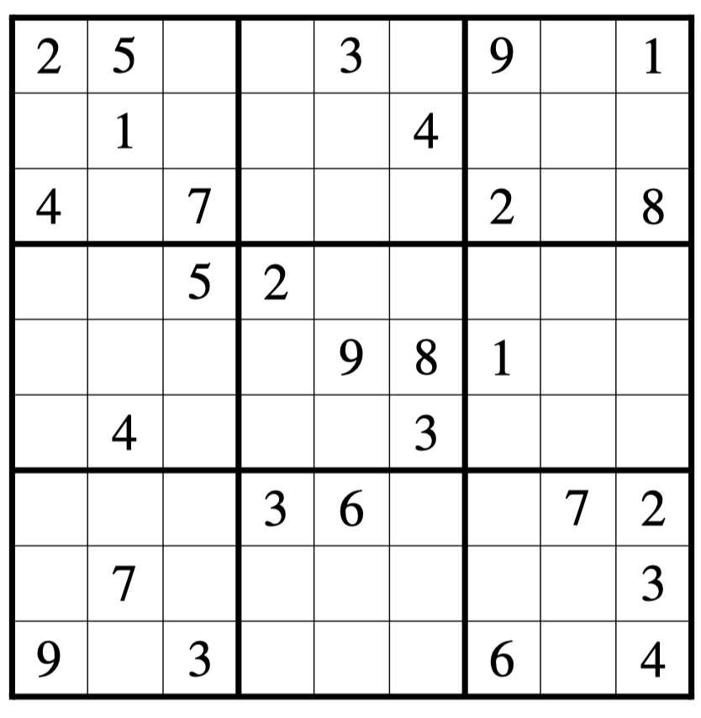
Figure 1. A simple Sudoku puzzle

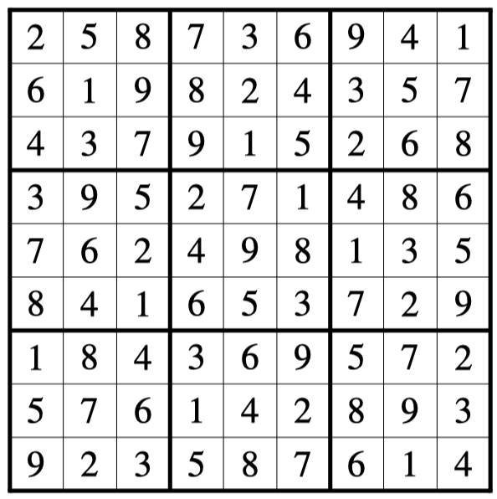
Figure 2. The solution to the puzzle in Figure 1.

- Consider a class managed by an instructor. The instructor allocates one day to meet with students to discuss a ﬁnal project; the day has t time slots in it denoted $S=\{s_{1},s_{2},…,s_{t}\}$Every student i indicates their availability denoted by a subset $A_{i} ⊆S$. Our objective is to schedule all students for a meeting, while respecting their availability constraints. Your goal is to model this as a search problem, with the state space deﬁned as a partial (valid) allocation of some of the students into the time slots.

Suppose there are three time-slots, and three students whose availability is given below. Assume that whenever you need to choose a student to add to a schedule, you do so in the order (A)lice (B)ob and then (C)laire. In addition, when choosing a time slot, ties are always broken in order of s 1≻ s 2≻ s 3.
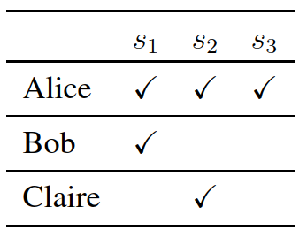

- Give a trace of the BFS algorithm in the style of Figure 3. That is, show the search tree at each stage (all repeated states are eliminated).

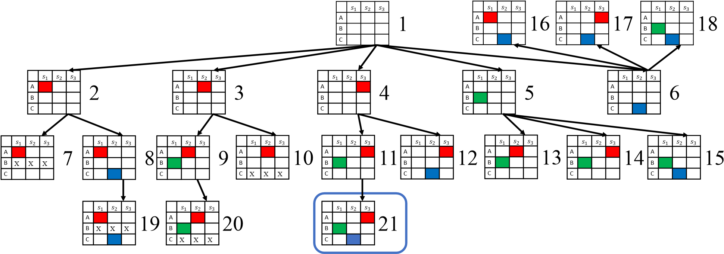
- Give a similar trace of the DFS search algorithm.

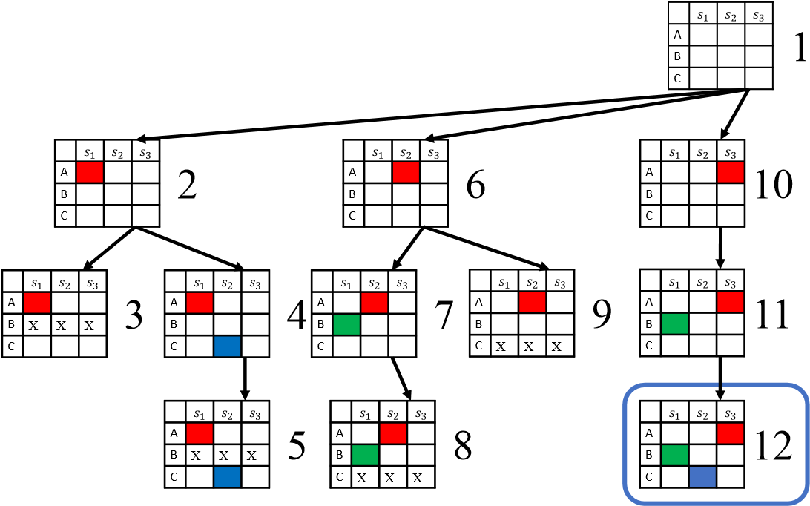
- Which of these two search algorithms is better for this problem? Why? Is one search strategy always better than the other in general?

BFS takes much longer in this case; while this is not a general truth, it is true in this case since all goal states are in the same depth, and the depth is rather low.

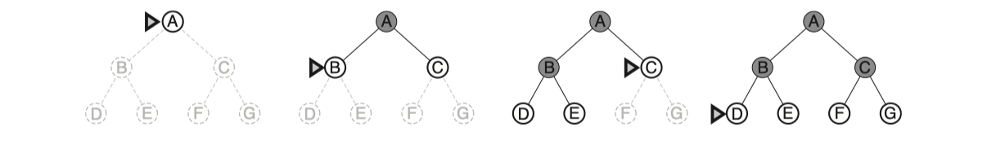
Figure 3. BFS on a simple binary tree. At each stage the node to be expanded is indicated by a marker.

- Figure 4 below shows the familir 8-puzzle where we slide tiles around until the numbers re in order when read from left to right, top to bottom:

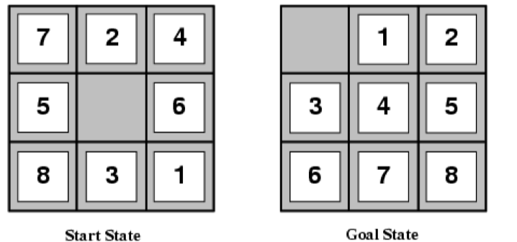

Figure 4. The 8-Puzzle

- We start with two heuristics:

h₁ = # of misplaced tiles
$$h_{2}=\sum_{i}^{n}{\left|x_{i,a}-x_{i,t}\right|}+\left|y_{i,a}-y_{i,t}\right|$$
Where $\left(x_{i,a},y_{i,a}\right)$ is the actual position of a tile, and $\left(x_{i,t},y_{i,t}\right)$ is its target position. The top left position is (1, 1) and the bottom right position is (3, 3). This is traditionally called a “Manhattan Distance”.

Are both heuristics admissible? Why or why not?

We can show that they’re both admissible by considering two “relaxed problems”, which are simplified versions of the game. The resulting optimal heuristic for such games will necessarily be admissible, since the relaxed problems allow for shortcuts.

Actual game:

A tile can move from A to B if A is adjacent to B and B is blank.

Version 1:

A misplaced tile can be placed directly into its correct position. In this case the optimal heuristic is $h_{1}$, since, if we have $n$ misplaced tiles, we place these $n$ tiles into their respective positions.

Version 2:

A misplaced tile can be moved to any horizontally or vertically adjacent tile regardless of whether it is empty.

The resulting optimal heuristic is $h_{2}$
Since both $h_{1}$ and $h_{2}$ are optimal for the relaxed problem, they are admissible for the actual problem.

As an aside, this is the main way to derive admissible heuristics.

Note that $h_{2}≥h_{1}$, i.e. $h_{2}$ dominates $h_{1}$ since version 2 does not allow for a direct placement.

- Consider two more heuristic functions:

$$h_{3}=\frac{h_{1}+h_{2}}{2}$$
$$h_{4}=h_{1}+h_{2}$$

Are $h_{3}$ and $h_{4}$ admissible? Why or why not?

$h_{3}$ is admissible. Proof:

$h_{2}≥h_{1}$, hence $h_{3}=\frac{h_{1}+h_{2}}{2}≤\frac{h_{2}+h_{2}}{2}=h_{2}$

Thus $h_{3}≤h_{2}$, and since $h_{2}$ is admissible, $h_{3}$ must also be admissible.

$h_{4}$ is not admissible. Proof:

Consider a puzzle with only one square that is directly to the left of its correct place, and its correct place is empty. Then $h_{1}=h_{2}=1$ (i.e. there is only one square out of place, and it can be moved into its proper place by sliding one position to the right).

Then $h_{4}=1+1=2>1$, thus it is not admissible.

- We consider the idea of dominance. A heuristic $h_{2}$ is said to be dominant over $h_{1}$ if $∀nh_{2}\left(n\right)≥h_{1}\left(n\right)$ if both $h_{2}$ and $h_{1}$ are admissible. Is $h_{2}$ dominant over $h_{1}$? Compare the dominance of $h_{3}$ and $h_{4}$with respect to $h_{2}$ and $h_{1}$

$h_{2}$ dominates $h_{1}$. Since $h_{3}= \frac{h_{1}+h_{2}}{2}$ and $h_{2}≥h_{1}$, $h_{3}≥\frac{h_{1}+h_{1}}{2}=h_{1}$. Thus $h_{3}$ dominates $h_{1}$. The last heuristic $h_{4}$ is not admissible and hence we do not consider its dominance.

- Consider the minimax search tree shown in Figure 5 below:

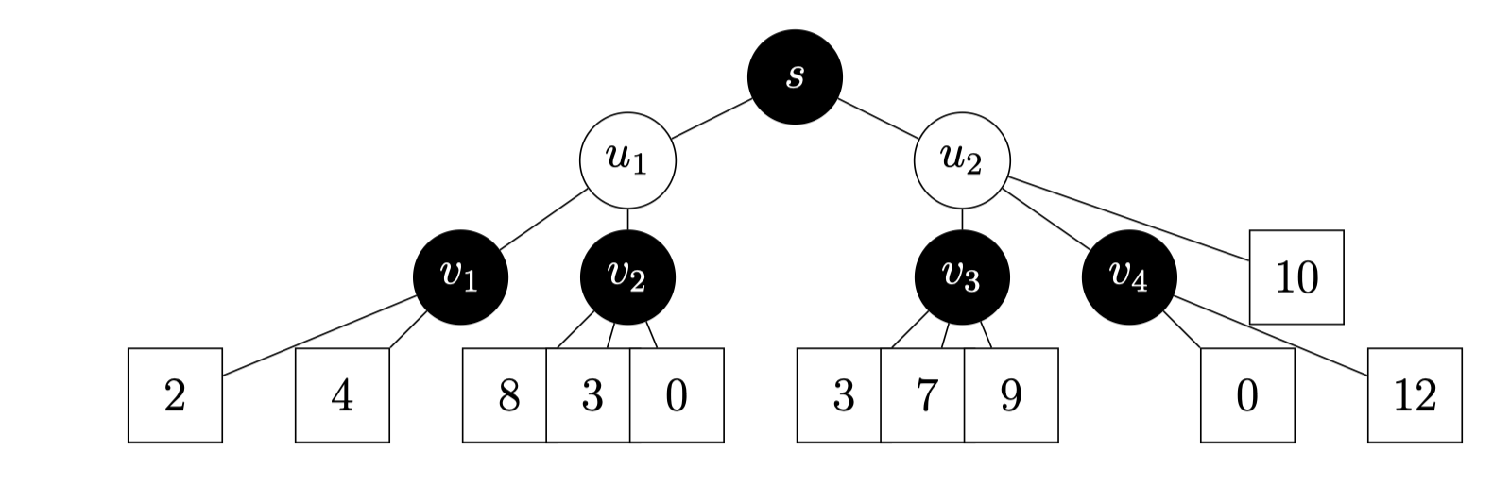
Figure 5. Minimax Search Tree

In the ﬁgure, black nodes are controlled by the MAX player, and white nodes are controlled by the MIN player. Payments (terminal nodes) are squares; the number within denotes the amount that the MIN player pays to the MAX player (an amount of 0 means that MIN pays nothing to MAX). Naturally, MAX wants to maximize the amount they receive, and MIN wants to minimize the amount they pay.

Suppose that we use the α-β pruning algorithm, reproduced in Figure 6 below.
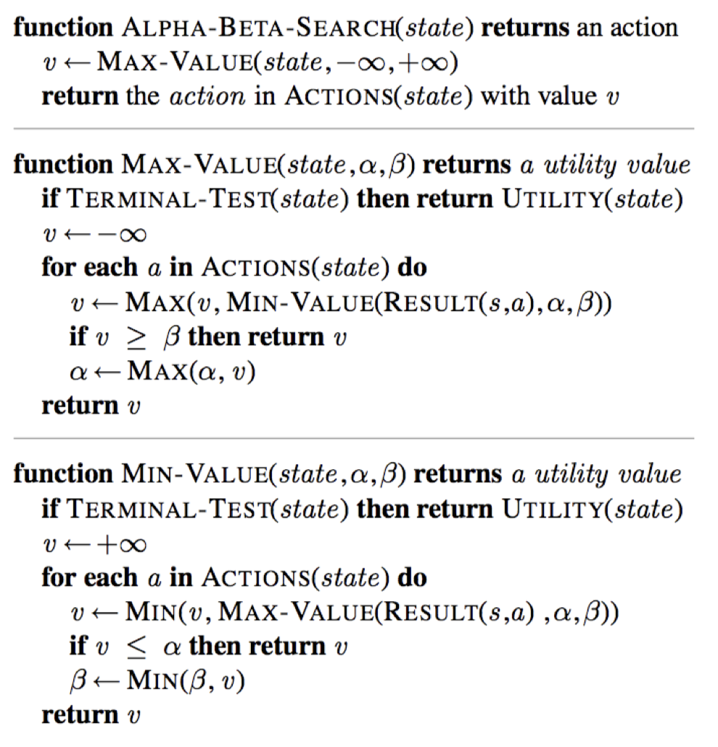

Figure 6. $α-β$ pruning search

- Assume that we iterate over nodes from right to left; mark with an ‘X’ all ARCS that are pruned by α-β pruning, if any.
b(u2) = inf
a(s) = -inf

b(u2) =10
a(s) = -inf
a(s) =-inf
v = 12 > b(u2) = 10. Stop.
b(u2)=10
a(s)=-inf
a(v3) = 9
v = 12 > b(u2) = 10. Stop.
b(u2)=10

a(v3)=9
b(u2)=9
a(s)=-inf
v = 12 > b(u2) = 10. Stop

a(v2)=8
a(v3)=9
v = 12 > b(u2) = 10. Stop
b(u2)=9
a(s)=-inf

a(s)=9
b(u2)=9
v = 8 < a(s)=9. Stop.
a(v2)=8
a(s)= 9, b(u1)=inf
a(v3)=9
v = 12 > b(u2) = 10. Stop.

- Does you answer change if we iterate over nodes from left to right?
b(u1)=inf
a(v1)=4
a(s)=-inf
a(s)=-inf

a(s)=-inf
b(u1) = 4
a(v1)=4

a(s) = -inf
v=8 > b(u1)=4. Stop.
b(u1) = 4
a(v1)=4

a(s) = 4
v=9
v2=8 > b(u1)=4. Stop
a(v1)=4
b(u2) = inf
a(u1) = 4, b(u1) = 4

a(s) = 4
b(u2) = 9
v=9
v2=8 > b(u1)=4. Stop
a(v1)=4
a(u1) = 4, b(u1) = 4

v=12
a(s) = 9
a(u1) = 4, b(u1) = 4
a(v1)=4
v2=8 > b(u1)=4. Stop
v=9
b(u2) = 9

v=10
a(s) = 4
a(u1) = 4, b(u1) = 4
a(v1)=4
v2=8 > b(u1)=4. Stop
v=9
b(u2) = 9
v=12

a(u1) = 4, b(u1) = 4
a(v1)=4
v2=8 > b(u1)=4. Stop
v=9
b(u2) = 9
v=12
a(s) = 9
v=10

