HONG KONG INSTITUTE OF INFORMATION TECHNOLOGY
Higher Diploma in Software Engineering (IT114105)
Contemporary Topics in Software Engineering (ITP4507)
Assignment One

Design and Implementation of the Smart Delivery Fleet Management System
A Short Report on the Application of the Command, Factory and Memento Design Patterns
Table 1
Programme | Higher Diploma in Software Engineering (IT114105)
Module | Contemporary Topics in Software Engineering (ITP4507)
Assignment | Assignment One (66.67% of the end-of-module assessment)
Student Number | <Student Number>
Student Name | <Student Name>

6 November 2026

Table of Contents
1 Introduction 1
2 Assumptions about the Problem Context 2
3 Application Design 3
3.1 Overall Architecture 3
3.2 The Domain Layer 3
3.3 The Command Layer 4
3.4 The Factory Layer 5
3.5 The Presentation Layer 5
3.6 Class Diagram 6
3.7 Conformance with the Open-Closed Principle 7
4 Discussion of the Design Patterns 8
4.1 The Command Pattern 8
4.2 The Factory and Abstract Factory Patterns 9
4.3 The Memento Pattern 11
4.4 Collaboration of the Three Patterns 12
4.5 Extending the System for New Fleet Types 12
5 Test Plan and Test Cases 14
5.1 Test Strategy 14
5.2 Test Case Summary 14
5.3 Test Records 15
5.4 Summary of Test Results 51
6 User Guide 53
7 Conclusion 55
References 55
Appendix A: Well-Documented Source Code 56
A.1 Domain Layer 56
A.2 Memento Types 61
A.3 Command Layer 62
A.4 Factory Layer 71
A.5 Presentation Layer 74
A.6 Entry Point and Batch File 76

1 Introduction
The Smart Delivery Logistics Company coordinates delivery work for commercial customers. Its drivers are organised into vehicle fleets, and the fleet itself, not the individual driver, decides which roles a driver may take: a delivery van fleet distinguishes van drivers from courier drivers, while a refrigerated truck fleet distinguishes refrigerated-truck drivers from cold-chain delivery drivers. The company now operates two kinds of fleet but expects to add motorcycle-delivery fleets and electric-cargo-bike fleets in the near future, so the software must be able to absorb a new fleet type without being redesigned.
The Smart Delivery Fleet Management System (SDFMS) developed for this assignment is a console application that maintains fleets and their drivers in memory. It offers twelve functions: create a fleet, set the current fleet, add a driver, modify a driver role, delete a driver, show the current fleet, display all fleets, change the fleet name, undo, redo, list the undo and redo lists, and exit the system. Five of these functions modify data and therefore have to be reversible, and the assignment requires the reversal of two of them, the driver role and the fleet name, to be implemented with the Memento pattern. The remaining structural requirements are the Command pattern for every user function and a factory family for fleets, drivers and commands.
This report explains how the system was designed and why. Section 2 records the assumptions made about the problem context. Section 3 presents the application design and the class diagram. Section 4 discusses each design pattern, the roles it plays in SDFMS and the alternatives that were rejected. Section 5 sets out the test plan, the eighteen test cases and the captured test results. Section 6 is a short user guide, Section 7 concludes, and the appendix contains the fully commented source code.

2 Assumptions about the Problem Context
The task specification fixes the twelve functions and the three patterns but leaves many details of the business context open. The following assumptions were made before the design was drawn up. Each assumption is a deliberate decision that keeps the implementation small while remaining consistent with the sample run supplied with the assignment.
Table 2 Assumptions about the problem context and their effect on the design
Ref. | Assumption | Consequence in the implementation
A1 | SDFMS is a single-user console program. Fleets, drivers and history exist only in main memory for the lifetime of one run; nothing is written to a file or a database. | The repository is an ordinary object; no persistence layer, transaction handling or file format is required.
A2 | A fleet identifier is chosen by the user and must be unique in the system. Identifiers and names are compared case sensitively and are not trimmed beyond leading and trailing blanks. | Create-fleet validates the identifier against the repository and rejects a duplicate; the identifier is the key used by set-current-fleet.
A3 | A fleet name is free text that must not be empty. Two fleets may share a name because the identifier, not the name, identifies a fleet. | Only an empty name is rejected. Names appear in the fleet header and can be changed at any time through the change-fleet-name command.
A4 | A driver identifier is unique within one fleet, but the same identifier may appear in a different fleet. A driver record belongs to exactly one fleet. | Add-driver checks the current fleet only. Delete and modify operate on the current fleet and report a driver that is not there.
A5 | Driver information is entered as one line of the form 'id, name'. The first comma separates the two fields, so a name may contain commas, blanks and any other printable character. | The reader splits the line at the first comma only and rejects a line without a comma or with an empty field.
A6 | Role codes are local to a fleet type and are numbered from one in the order the fleet type defines. A valid code for a delivery van fleet is 1 (van driver) or 2 (courier driver); for a refrigerated truck fleet 1 (refrigerated-truck driver) or 2 (cold-chain delivery driver). | The role prompt and the role names come from the fleet object, not from a constant table, so a new fleet type defines its own roles.
A7 | The user interface is line oriented: one command code, one input value or one driver record per line. A blank line carries no meaning and is ignored. | The main loop reads and discards blank lines instead of reporting them as invalid commands, which keeps the output compatible with the sample run.
A8 | Creating a fleet makes it the current fleet, because the sample run prints 'Current fleet is changed to F001.' immediately after the creation message. | The create command selects the new fleet as a side effect of executing; its undo removes the fleet and clears the current fleet.
A9 | The undo and redo lists belong to the whole session rather than to a fleet. Commands that only read or navigate - set current fleet, show fleet, display all fleets, list the histories, exit - are not recorded. | Those commands report themselves as not undoable, so the history only contains the commands that change data, exactly as the nine entries of sample case 12 show.
A10 | Executing a new undoable command discards the redo list, which is the conventional behaviour of an undo stack. | The command manager clears the redo list after a successful execution, so an old redo branch can never be replayed onto a different state.

Two further constraints come directly from the specification and are treated as assumptions throughout the design. First, the classes VehicleFleet, DeliveryVanFleet, RefridgeratedTruckFleet and Driver supplied with the assignment may be extended but their existing attributes and operations must not be removed or modified; the design therefore adds behaviour instead of rewriting it. Second, the fleet identifier and the driver identifier are the only keys the user is expected to remember, so every operation that needs a fleet or a driver asks for an identifier and reports a missing one rather than aborting the program.

3 Application Design

3.1 Overall Architecture
The program is a single Java application that the supplied run.bat compiles with 'javac *.java'. All classes therefore live in the default package and are stored in one source directory. Within that directory the code is organised into five collaborating layers, shown in Table 2. Each layer depends only on the layers below it, which keeps the console front end replaceable and the domain model free of user-interface detail.
Table 3 Layers of the SDFMS implementation
Layer | Main classes | Responsibility
Presentation | SDFMSApplication, ConsoleInput | Prints the menu and the current fleet, reads one input line at a time, parses role codes and driver records, and dispatches the command code to the factory.
Invocation | CommandManager, CommandContext | Executes command objects, keeps the undo and redo lists, and provides the shared context through which a command reaches the repository, the reader and the factories.
Application | Command, AbstractCommand and the twelve command classes | One class per user function. Each class validates its own input, performs the change, and knows how to reverse it.
Factory | SDFMSAbstractFactory, SDFMSFactory, FleetFactoryRegistry, FleetFactory and its two implementations, DriverFactory, CommandFactory | Creates fleets, drivers and commands from a code typed by the user, so that no client class needs to name a concrete product class.
Domain | VehicleFleet, DeliveryVanFleet, RefridgeratedTruckFleet, Driver, FleetRepository, Memento and the two memento classes | Holds the business data and the rules of a fleet type, and captures and restores snapshots for the undo mechanism.

3.2 The Domain Layer
VehicleFleet keeps the two attributes and the driver collection of the supplied skeleton and remains abstract. The collection is a Vector, which is one of the two concrete implementations of AbstractList that the specification allows, and the declared type remains AbstractList so that the skeleton signature is untouched. Three operations were added to the class. getDriverList() casts the raw list once, in one place, and returns a typed List<Driver>; findDriver() and hasDriver() answer the questions that the commands ask most often - does this fleet already contain a driver, and which driver object has this identifier.
The class also declares four new abstract operations: getFleetTypeDisplayName(), getRoleName(int), getRolePrompt() and showFleetSummary(). These operations express what differs between fleet types: the text in front of a fleet line, the vocabulary of roles, the prompt that offers the roles, and the single-line form used by 'display all fleets'. The concrete subclasses DeliveryVanFleet and RefridgeratedTruckFleet implement them together with the two abstract operations of the skeleton, updateDriverRole() and showFleet(). Both subclasses print the drivers of each role through one private helper that prints 'NIL' on the heading line when a role has no driver, which reproduces the sample output where an empty role appears as 'Van Driver: NIL'.
FleetRepository is a small aggregate that owns the fleets and the current fleet. It offers findFleet(), containsFleet(), addFleet(), removeFleet() and getCurrentFleet(). Keeping the current fleet in the repository rather than in a command or in the application object means that a command can change the selection without the front end knowing about it, and the menu that is printed before the next prompt can always read the selection from one place.
The Memento pattern adds the marker interface Memento and two small snapshot classes. FleetNameMemento stores the fleet identifier and the fleet name; DriverRoleMemento stores the driver identifier and the role code. Neither class exposes a setter, so the snapshot can only be read. VehicleFleet is the originator: createFleetNameMemento(), createDriverRoleMemento(), restoreFleetName() and restoreDriverRole() are its operations, and the restore operations check that the snapshot belongs to the same fleet or driver before changing anything.

3.3 The Command Layer
The interface Command declares execute(), undo(), redo(), getDescription() and isUndoable(). The description is the line that the history listing prints, so each command builds it from its own data - for example 'Change fleet name, F001, METRO EXPRESS'. AbstractCommand implements the parts that every command shares: it stores the command code and the CommandContext, leaves execute() and getDescription() abstract, provides an empty undo() for commands that need no reversal, and implements redo() as a second execution of the same change.
CommandManager is the invoker. Its execute() runs the command and, when the command reports itself as undoable, pushes it onto the undo list and clears the redo list. Its undo() pops the most recent entry, asks it to reverse itself, moves it to the redo list and prints the confirmation message; redo() performs the symmetric operation. Both operations print a short message and return when the corresponding list is empty, so the user is never left without feedback. showLists() prints the two lists in the order required by the sample output, oldest entry first, each terminated by the end marker.
CommandContext is the service object that every command receives in its constructor. It holds the repository, the ConsoleInput reader, the command manager, the abstract factory and the running flag, and it offers getCurrentFleetOrReport(), which prints 'No current fleet is set!' and returns null when no fleet has been selected. Passing the context explicitly rather than using static fields keeps the commands testable and makes the dependencies of a command visible in its constructor.
The twelve command classes are listed in Table 3. Five of them change data and are undoable; the navigation, reading and history commands are not. The undo mechanisms differ because the changes differ: a created fleet is removed again, a deleted driver is put back into the fleet it came from, an added driver is removed, and the two remaining changes are reversed from a memento.
Table 4 The twelve command classes and their undo behaviour
Code | Command class | Change | Undoable | How undo is performed
c | CreateFleetCommand | Adds a fleet to the repository and selects it | Yes | Removes the created fleet and clears the selection
s | SetCurrentFleetCommand | Changes the current fleet | No | Not recorded
a | AddDriverCommand | Adds a driver to the current fleet | Yes | Removes the driver object that was added
m | ModifyDriverRoleCommand | Changes the role of a driver | Yes | Restores the role from DriverRoleMemento
d | DeleteDriverCommand | Removes a driver from the current fleet | Yes | Inserts the saved driver object back into the fleet
sf | ShowFleetCommand | Prints the current fleet | No | Not recorded
sa | DisplayAllFleetsCommand | Prints one line per fleet | No | Not recorded
cn | ChangeFleetNameCommand | Renames the current fleet | Yes | Restores the name from FleetNameMemento
u | UndoCommand | Reverses the most recent undoable command | No | Delegates to the command manager
r | RedoCommand | Re-applies the most recently undone command | No | Delegates to the command manager
l | ShowUndoRedoListCommand | Prints both history lists | No | Not recorded
x | ExitCommand | Prints the closing message and stops the loop | No | Clears the running flag

3.4 The Factory Layer
Three product families have to be created from a code typed by the user, and each family has more than one member or is expected to grow. A single abstract factory, SDFMSAbstractFactory, declares the four operations the rest of the program needs: createFleet(typeCode, fleetID), createDriver(id, name, role), createCommand(code) and the two queries isValidFleetType(code) and getFleetTypeLabel(code). SDFMSFactory is the only implementation; it does not create objects itself but delegates to three smaller factories that it owns, and is therefore also the composition root of the object graph.
FleetFactory is the per-type factory. Each implementation publishes a type code ('v' or 'r'), a label used in messages ('delivery van fleet', 'refrigerated truck fleet') and a createFleet() operation. FleetFactoryRegistry keeps the implementations in a LinkedHashMap keyed by type code, so the order of the two fleets in the message and in the listing is stable, and a new fleet type is registered by one call without editing any other class. DriverFactory and its implementation StandardDriverFactory isolate the creation of Driver objects, and CommandFactory and SDFMSCommandFactory map a command code to one of the twelve command classes. A code that names no command returns null, which is how the front end detects an invalid command.

3.5 The Presentation Layer
ConsoleInput wraps a single Scanner and does three things. readLine(prompt) prints the prompt, reads one line, trims it and returns null at end of input; readRole(prompt) reads a role code and returns -1 when the text is not a number; readDriverInformation() reads a driver record and splits it at the first comma. Because every prompt is printed by the same method, the prompts in the output cannot drift from the prompts the commands expect.
SDFMSApplication holds the three menu lines and the command prompt as named constants and runs the read-execute loop. Before each prompt it prints the menu and, when a fleet is current, one extra line 'The current fleet is F001 CENTRAL EXPRESS.' The loop ignores blank lines, asks the factory for the command object, prints 'Invalid command!' when the factory returns null, and otherwise lets the command manager execute it. The loop stops when the exit command clears the running flag or when input ends, so a run driven by a script always terminates. Main only assembles the objects - repository, reader, context, manager and factory - and starts the loop, which keeps the wiring in one visible place.

3.6 Class Diagram
Figure 1 shows the complete class model. The upper part contains the domain classes Driver, VehicleFleet with its two subclasses, FleetRepository, and the three memento types. The right part contains the command hierarchy: the Command interface, AbstractCommand, the twelve concrete commands, and CommandManager which holds the two history lists. Associations are drawn only where an object keeps a reference to another object: a fleet manages its drivers, the repository manages the fleets, the manager uses commands, and the two commands that need a snapshot create a memento and keep it for the lifetime of the command.
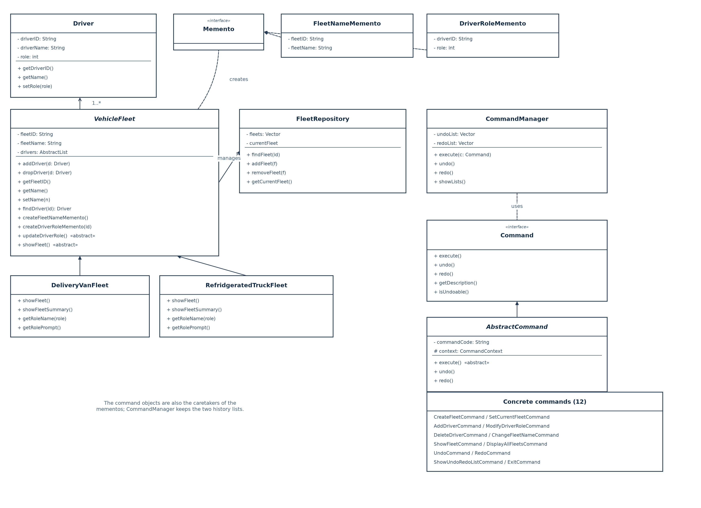
Figure 1 Class diagram of the SDFMS application
Three details of the diagram deserve comment. First, the inheritance arrows from DeliveryVanFleet and RefridgeratedTruckFleet to VehicleFleet carry the whole type-specific vocabulary of roles and headings, so no command class knows which fleet type it is working with. Second, the two memento classes depend on the marker interface Memento and on nothing else; the command that holds a memento never reads its fields, which is what keeps the snapshot opaque. Third, the command hierarchy is independent of the domain hierarchy: the only link between the two halves is the receiver, which a command reaches through the CommandContext.

3.7 Conformance with the Open-Closed Principle
The Open-Closed Principle requires that a module be open for extension but closed for modification. SDFMS respects it in three places. New fleet types extend VehicleFleet and implement FleetFactory; nothing in VehicleFleet, in the command classes, in the repository or in the front end refers to a concrete fleet class. New drivers extend Driver and implement DriverFactory. New commands add one class, one entry in SDFMSCommandFactory and one menu letter; the manager, the context and the application object are untouched because they only know the Command interface.
Table 4 lists the complete set of edits needed to support a motorcycle-delivery fleet and an electric-cargo-bike fleet. Every edit is an addition; no existing method body has to change, and the supplied skeleton classes keep their original attributes and operations.
Table 5 Effort required to add a fleet type
Step | Work for one new fleet type | Files touched
1 | Add a subclass of VehicleFleet that implements the two abstract operations and the four type-specific operations (display name, two role names, role prompt, summary line). | One new class
2 | Add a FleetFactory implementation that publishes the type code and the label. | One new class
3 | Register the new factory in FleetFactoryRegistry.createDefault() and extend the type prompt printed by CreateFleetCommand. | Two existing classes, one line each
4 | Extend the fleet type prompt text in the user guide and add test cases. | Documentation and tests only

4 Discussion of the Design Patterns

4.1 The Command Pattern
The Command pattern turns a request into a stand-alone object. Its intent, as stated by Gamma et al., is to encapsulate a request as an object, thereby letting it be parameterised, queued, logged and undone. SDFMS needs all four of those properties: the front end must treat twelve very different functions uniformly, the manager must record them in a history, the history must be replayed in both directions, and the history listing must describe each entry. A design in which the front end called a method of the domain layer for each command would need a switch on the command code, a second switch in the undo routine and a third table for the descriptions, and every new function would touch all three.
In SDFMS the client is SDFMSApplication, the invoker is CommandManager, the receiver is the fleet, the driver or the repository, and the command objects are the twelve classes of Table 3. Table 5 records the mapping. Figure 2 shows how the participants collaborate, including the path that a request takes from the command code to the domain object and the reverse path used by undo.
Table 6 Participants of the Command pattern in SDFMS
Participant | Class in SDFMS | Role in the collaboration
Client | SDFMSApplication | Reads the command code, obtains the command object from the factory and passes it to the invoker; it never calls a domain operation directly.
Invoker | CommandManager | Executes the command, keeps the undo and redo lists and decides which commands enter the history.
Receiver | VehicleFleet, Driver, FleetRepository | Owns the data that a command changes; the command calls its operations instead of manipulating fields.
Command | Command, AbstractCommand | Declares execute(), undo(), redo(), getDescription() and isUndoable(), and supplies the default behaviour shared by all commands.
ConcreteCommand | CreateFleetCommand and the other eleven classes | Validates its own input, performs one change, records everything needed to reverse it and describes itself for the history listing.

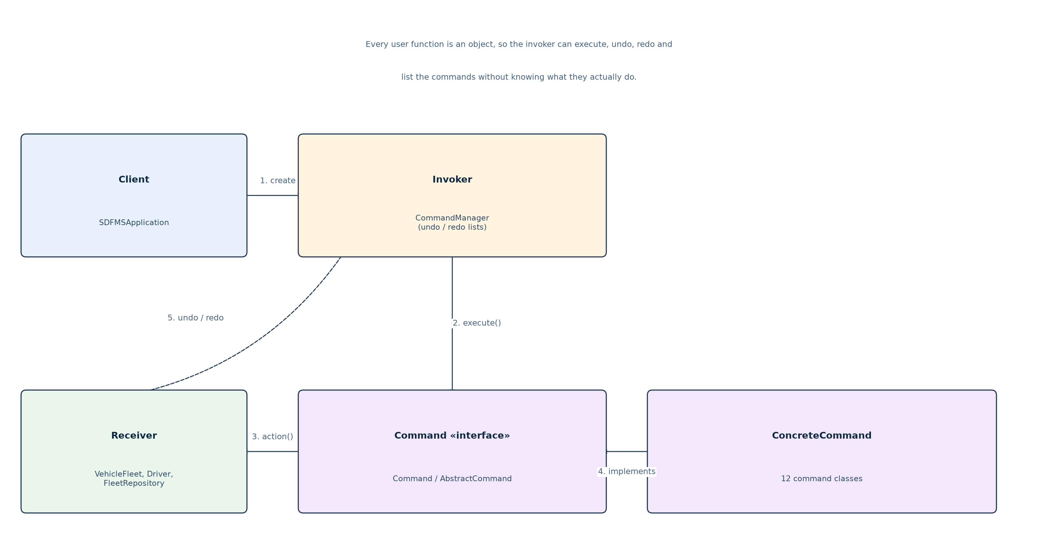
Figure 2 Collaboration of the Command pattern in SDFMS
Undo is implemented inside the command, not inside the manager, because only the command knows what it changed. A command therefore stores the minimum state needed for reversal as a field: CreateFleetCommand keeps the fleet it created, DeleteDriverCommand keeps the driver object it removed, AddDriverCommand keeps the driver it inserted, and the two remaining commands keep a memento. This choice has a useful consequence: the manager never inspects the state of the application, so the history is correct even when the current fleet has changed since the command ran.
Two commands also demonstrate that the pattern covers control operations, not only data operations. UndoCommand and RedoCommand are themselves command objects; they are created by the same factory, executed by the same manager and printed by the same listing code. They simply call the manager back, and they report themselves as not undoable so that an undo of an undo does not appear in the history. ExitCommand follows the same route: it prints the closing message and clears the running flag, which stops the loop on its next test rather than terminating the process from inside a command.
The price of the pattern is one class per function and a slightly indirect call path. For twelve functions the cost is small and it is repaid by the uniformity of the history code: showLists() prints the undo and redo lists with one statement each, because every command can describe itself. A macro command that groups several commands into one history entry, and a command that is executed asynchronously, would both be additions to the same structure rather than changes to it.

4.2 The Factory and Abstract Factory Patterns
Three kinds of object are created from a code that only the user knows at run time: the fleet, whose class depends on the type code 'v' or 'r'; the driver, which is a simple product today but may become a family of products; and the command, whose class depends on the command letter. Creating those objects with new inside the client would spread the knowledge of concrete classes across the front end and would make the type code checks and the messages that depend on them impossible to keep consistent. The factory family centralises that knowledge.
The design uses the Abstract Factory pattern for the top-level decision and the Factory pattern inside it. SDFMSAbstractFactory is the abstract factory: its four operations create the three products and answer the two questions about fleet types, so a client can build a complete set of objects that belong to the same configuration. SDFMSFactory is the concrete factory; FleetFactory, DriverFactory and CommandFactory are the per-family factories that it composes, and FleetFactoryRegistry is the table that turns a type code into the right FleetFactory. Table 6 lists the participants, and Figure 3 shows the arrangement.
Table 7 Participants of the Abstract Factory pattern in SDFMS
Participant | Class in SDFMS | Responsibility
AbstractFactory | SDFMSAbstractFactory | Declares createFleet, createDriver, createCommand, isValidFleetType and getFleetTypeLabel.
ConcreteFactory | SDFMSFactory | Implements the five operations by delegating to the registry, the driver factory and the command factory.
AbstractProduct | VehicleFleet, Driver, Command | The types that clients see; no client names a concrete product class.
ConcreteProduct | DeliveryVanFleet, RefridgeratedTruckFleet, StandardDriverFactory's Driver, the twelve command classes | The objects actually returned for a given code.
Per-family factory | FleetFactory, DriverFactory, CommandFactory and their implementations | Encapsulate one product family each, so a family can be replaced or extended without affecting the others.
Registry | FleetFactoryRegistry | Maps a type code to a FleetFactory; new types are added with one registration call.

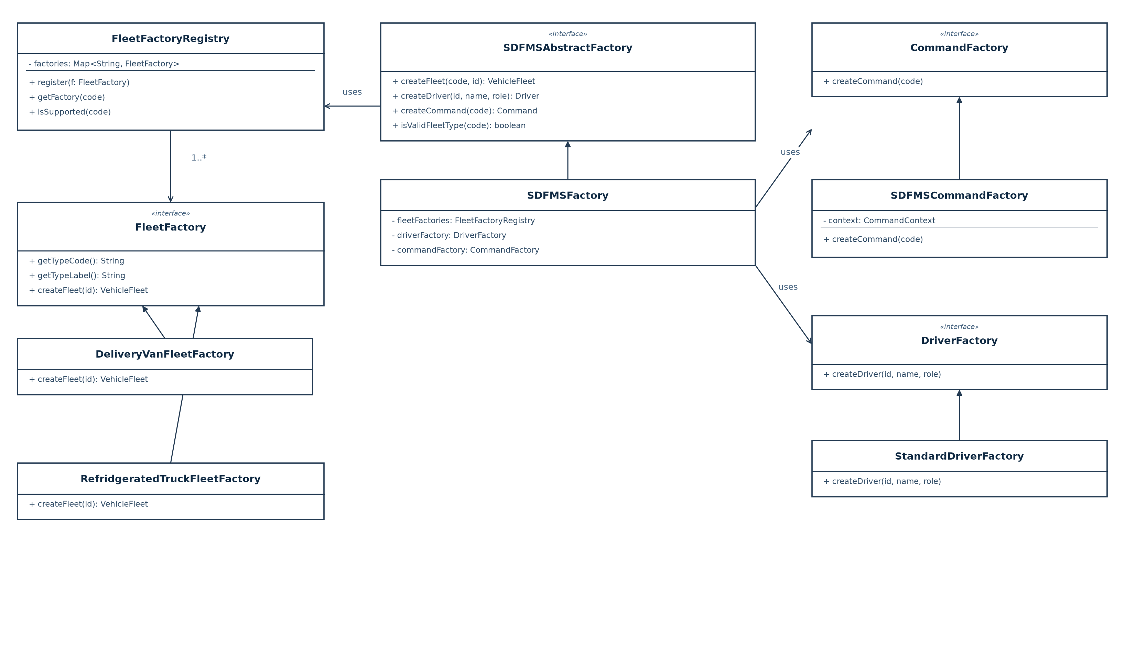
Figure 3 Factory and Abstract Factory structure of SDFMS
The abstract factory also carries two queries that a pure factory would not need. isValidFleetType() lets CreateFleetCommand reject an unknown type before it asks for the identifier and the name, and getFleetTypeLabel() produces the words of the message 'Delivery van fleet is created.' and the history entry 'Create delivery van fleet, F001, CENTRAL EXPRESS'. Because both answers come from the FleetFactory that owns the type code, the message and the history can never disagree with the object that was actually created - which would not be true if the label were a string constant in the command.
Three alternatives were considered and rejected. A simple factory with a switch would have produced the same objects but would have left the knowledge of concrete classes in one method that every new type must edit, which is exactly what the Open-Closed Principle forbids. Creating the command objects in the front end would have moved the code-to-class mapping into the presentation layer. A single factory per product without a registry would have required CreateFleetCommand to choose between two factory variables, that is, to know the fleet types by name. The registry removes that last dependency and is why a third fleet type needs no change in the command.

4.3 The Memento Pattern
The Memento pattern captures the internal state of an object so that it can be restored later, without exposing that state to the code that requests the capture. SDFMS applies it exactly where the assignment requires it, to the two changes whose previous value cannot be reconstructed from the command's own parameters: the role of a driver and the name of a fleet. In both cases the old value belongs to the domain object, and storing a copy of it in the command would duplicate a field of another object and would let the command write that field directly.
VehicleFleet is the originator. Its createFleetNameMemento() and createDriverRoleMemento() read the private fields and return a snapshot object; its restoreFleetName() and restoreDriverRole() write the fields back after checking that the snapshot belongs to the same fleet or driver. The snapshots, FleetNameMemento and DriverRoleMemento, implement the empty marker interface Memento and expose getters only. The caretaker is the command that requested the snapshot: ChangeFleetNameCommand keeps a FleetNameMemento and ModifyDriverRoleCommand keeps a DriverRoleMemento for exactly as long as the command lives in a history list. The repository and the command manager never hold a memento.
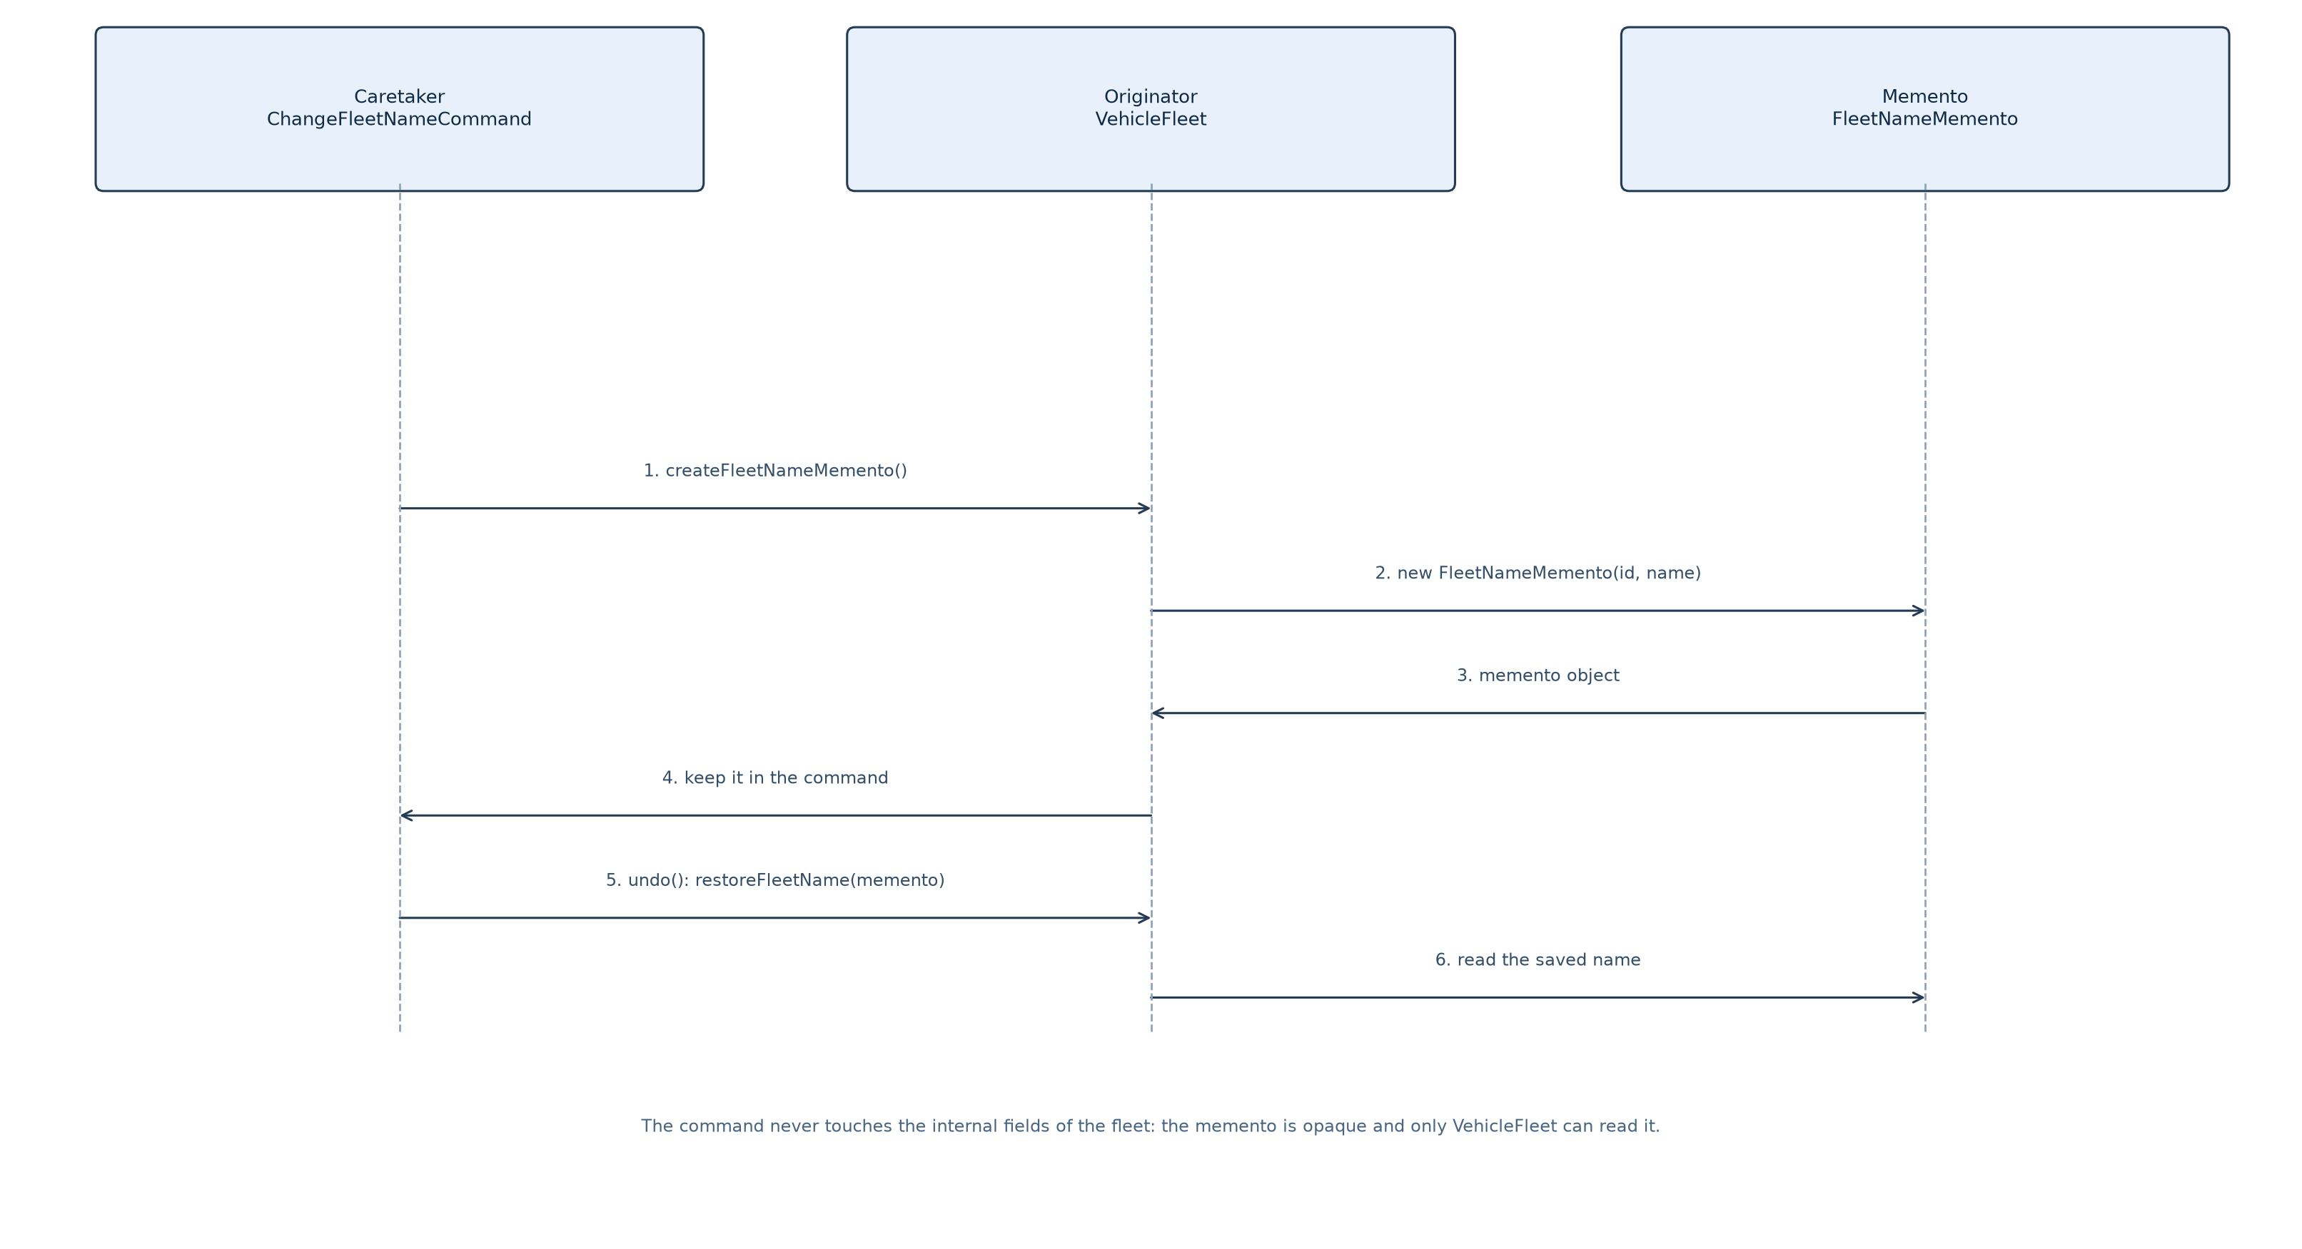
Figure 4 Capture and restore of a fleet name with the Memento pattern
The sequence in Figure 4 shows the four steps of the change and the two steps of the undo. When the command executes it first asks the originator for a snapshot, then performs the change through the originator's own operation, and then keeps the snapshot. When the manager later calls undo(), the command passes the snapshot back to the originator, which restores the field. Redo() simply executes the change again, because the new value is already part of the command; this is why no second snapshot is needed on the redo path.
The narrow interface is what makes the pattern worth its cost. Because the command only ever holds a Memento reference and never casts it to a concrete snapshot class, adding a field to a snapshot - say, the fleet name together with the selected fleet - cannot change the command's behaviour, and no client can read or forge the state of a fleet. The alternative of storing the old role as an int field in the command would have worked for today's two cases but would have broken the encapsulation rule stated in the specification, because the command would then be able to set a private field of a driver directly. The alternative of copying the whole fleet object, as a coarse undo buffer would, is expensive and would have made the identity of the driver objects ambiguous after a restore.

4.4 Collaboration of the Three Patterns
The three patterns meet in one object graph, and it is worth following a single command from keystroke to history entry. The front end prints the menu and reads 'm'. It asks SDFMSFactory for the command with that code; the abstract factory asks SDFMSCommandFactory, which returns a ModifyDriverRoleCommand built with the shared context. The front end passes that object to CommandManager.execute(). The command reaches the current fleet through the context, validates the driver identifier, reads the new role with the prompt supplied by the fleet, asks the fleet for a DriverRoleMemento, changes the role through the driver object, prints 'Driver role is updated.' and returns. The manager then checks isUndoable(), which is true, pushes the command onto the undo list and clears the redo list. Nothing else in the system is touched, and the order of these steps is what makes the history consistent.
The patterns divide the responsibilities cleanly. The factory decides what object represents a request; the command decides what the request does and how it is reversed; the memento decides how the previous state is carried between the two. None of the three needs to know the other two in detail: the factory returns a Command, the manager calls the Command interface, and the command uses the originator's memento operations. This is also why the two history lists can be printed by a single loop over Command objects and why the twelve commands require no per-command code in the front end.

4.5 Extending the System for New Fleet Types
The specification asks that the design be open to motorcycle-delivery fleets and electric-cargo-bike fleets. The following sketch shows the whole addition for one type; the second type is the same code with different words. The subclass only supplies the vocabulary of the new fleet; the factory only supplies the code and the label; the registry gains one line.
public class MotorcycleFleet extends VehicleFleet { // new file
public MotorcycleFleet(String fleetID) { super(fleetID); }
public String getFleetTypeDisplayName() { return "Motorcycle Delivery Fleet"; }
public String getRoleName(int role) {
return (role == 1) ? "motorcycle rider" : "express courier";
}
public String getRolePrompt() {
return "Role (1 = motorcycle rider | 2 = express courier) :- ";
}
public void updateDriverRole() { /* same shape as DeliveryVanFleet */ }
public void showFleet() { /* prints header, then both roles */ }
public void showFleetSummary() { System.out.println(describeHeader()); }
}
public class MotorcycleFleetFactory implements FleetFactory { // new file
public String getTypeCode() { return "m"; }
public String getTypeLabel() { return "motorcycle delivery fleet"; }
public VehicleFleet createFleet(String id) { return new MotorcycleFleet(id); }
}
// FleetFactoryRegistry.createDefault(): one added line
register(new MotorcycleFleetFactory());
After these three additions the create command accepts 'm', the new fleet appears in the listing with its own heading, its drivers are prompted with its own roles, and the history entries read 'Create motorcycle delivery fleet, F900, NIGHT LINE'. No command, no memento, no manager and no front-end class changes, which is the practical test of the Open-Closed Principle.

5 Test Plan and Test Cases

5.1 Test Strategy
Testing was black box and function oriented. Each of the twelve functions was exercised through the console exactly as a user would, with the input supplied on standard input so that a run can be repeated and compared. Four kinds of test were used, listed in Table 7. The functional tests were designed from the specification and from the sample run rather than from the source code, so that a defect in the design would not be hidden by a test written to match it.
Table 8 Levels of testing applied to SDFMS
Level | Purpose | Coverage
Functional, positive | Confirm that each function produces the specified message and the specified state. | All twelve functions, both fleet types
Functional, negative | Confirm that invalid input is reported and that no state changes. | Unknown command, unknown fleet, unknown driver, invalid role, invalid type, duplicate identifier, empty name
State-transition | Confirm that a sequence of commands leaves the data in the expected state, including undo and redo of each undoable command. | Undo and redo after create, add, modify, delete and rename; empty and exhausted histories
Regression | Confirm that the fifteen sample cases published with the assignment are reproduced exactly. | All fifteen sample cases, compared line by line with the published output

The tests ran on Windows with JDK 11 against the source directory compiled by run.bat. Each case below was driven by a script of input lines piped to the program, and the console window was captured while the case ran; the captures in Section 5.3 are the actual output of the compiled program and not retyped text. The fifteen regression cases were additionally checked mechanically: the expected lines of the published sample output were matched in order against the captured standard output, and all fifteen matched with no failure. The regression check is not part of the marks but it is the reason the messages, the capitalisation and the 'NIL' formatting can be trusted.
The cases were also chosen to cover the boundaries that the specification implies. Table 8 summarises the eighteen cases; the identifiers used in the tables refer to the records in Section 5.3. Cases TC01 to TC12 build the state that the sample run uses, so that the later cases can be read against the published output. Cases TC13 to TC15 then exercise the history in both directions and the error paths; TC16 to TC18 add the boundaries that the sample run does not reach - an operation with no current fleet, a duplicate fleet or driver identifier, an invalid fleet type and an empty history.

5.2 Test Case Summary
Table 9 Test case summary
Case | Function under test | Input (one line per value) | Expected result | Result
TC01 | Create a delivery van fleet | c, v, F001, CENTRAL EXPRESS, x | Delivery van fleet is created; current fleet is F001 | Pass
TC02 | Add two drivers | a, d001 Alex Chan, 1; a, d002 Jamie Lee, 2 | Driver is added twice; both records are stored | Pass
TC03 | Show the current fleet | sf | Header, then Van Driver with d001 and Courier Driver with d002 | Pass
TC04 | Create a refrigerated truck fleet and list fleets | c, r, F102, FROST LINE; sa | Refrigerated truck fleet is created; both fleets listed in creation order | Pass
TC05 | Add drivers to the refrigerated fleet | a, d101 Morgan Wong, 1; a, d102 Taylor Lam, 2 | Driver is added twice with the truck roles | Pass
TC06 | Show the refrigerated fleet | sf | Refrigerated-Truck Driver and Cold-Chain Delivery Driver sections | Pass
TC07 | Set the current fleet by identifier | s, F001 | Changed current fleet to F001 | Pass
TC08 | Display all fleets after switching | sa | Two fleet lines, order unchanged, no driver detail | Pass
TC09 | Modify a driver role | m, d001, 2 | Driver role is updated; d001 moves to Courier Driver | Pass
TC10 | Delete a driver | d, d002 | Driver is deleted; Courier Driver keeps only d001 | Pass
TC11 | Change the fleet name | cn, METRO EXPRESS | Fleet name is updated; header shows the new name | Pass
TC12 | List the undo and redo lists | l | Nine undo entries in execution order, empty redo list, end markers | Pass
TC13 | Undo three commands | u, u, u, sf | Name, deletion and role change reversed in reverse order; state matches | Pass
TC14 | Redo three commands | r, r, r, sf | The three undone commands re-applied in order; state matches | Pass
TC15 | Error handling and exit | s F999; d d999; q; x | Fleet not found, driver not found, invalid command, closing message | Pass
TC16 | Functions that need a current fleet | sf; a; x | No current fleet is set! for both commands; program keeps running | Pass
TC17 | Duplicate identifiers and invalid input | c F001 twice; c with type q; c with empty name; a d001 twice | Duplicate fleet rejected, invalid fleet type rejected, empty name rejected, duplicate driver rejected | Pass
TC18 | Undo and redo with an empty history | u, u, u, r, r, l | No command can be undone / redone; both lists remain empty | Pass

5.3 Test Records
Each record states the objective, the precondition, the steps and the expected result, and is followed by the screen capture of the run. A multi-page capture is split at page boundaries; the pages are shown in order.
TC01 Create a delivery van fleet
Table 10
Item | Content
Objective | Confirm that the create command accepts a type code, an identifier and a name, creates the correct fleet object, selects it and prints the two required messages.
Pre-condition | The system has just started; no fleet exists; no current fleet is set.
Test steps | Type c, then v, then F001, then CENTRAL EXPRESS.
Expected result | Delivery van fleet is created. Current fleet is changed to F001. The next menu shows the current fleet line.

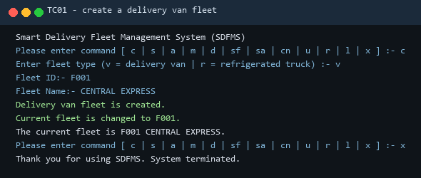
Figure 5 TC01 screen capture
TC02 Add drivers to the current fleet
Table 11
Item | Content
Objective | Confirm that a driver record is parsed from 'id, name', that the role code is validated against the fleet type, and that both drivers are stored in the fleet.
Pre-condition | Fleet F001 CENTRAL EXPRESS exists and is current; it has no drivers.
Test steps | Type a with 'd001, Alex Chan' and role 1, then a with 'd002, Jamie Lee' and role 2.
Expected result | Driver is added. for each record; the history receives two Add driver entries; the fleet now holds a van driver and a courier driver.

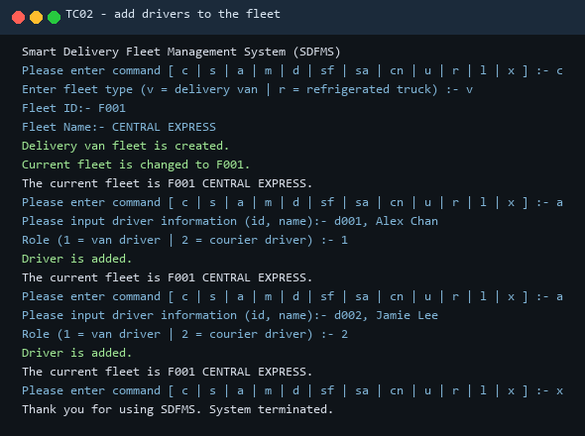
Figure 6 TC02 screen capture
TC03 Show the current fleet
Table 12
Item | Content
Objective | Confirm the header format, the role headings and the order of the drivers inside each role.
Pre-condition | F001 holds d001 as a van driver and d002 as a courier driver.
Test steps | Type sf.
Expected result | Delivery Van Fleet CENTRAL EXPRESS (F001), then Van Driver with 'd001, Alex Chan', then Courier Driver with 'd002, Jamie Lee'.

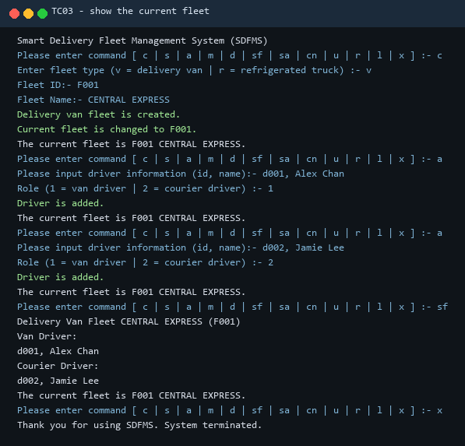
Figure 7 TC03 screen capture
TC04 Create a refrigerated truck fleet and display all fleets
Table 13
Item | Content
Objective | Confirm that the second fleet type is created through the same command and that the listing shows one line per fleet in creation order.
Pre-condition | F001 exists and is current.
Test steps | Type c, then r, then F102, then FROST LINE, then sa.
Expected result | Refrigerated truck fleet is created. Current fleet is changed to F102. The listing shows Delivery Van Fleet CENTRAL EXPRESS (F001) and Refrigerated Truck Fleet FROST LINE (F102).

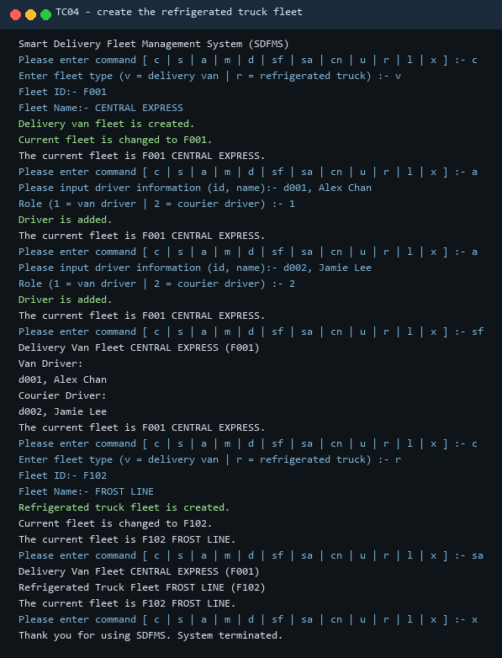
Figure 8 TC04 screen capture
TC05 Add drivers to the refrigerated truck fleet
Table 14
Item | Content
Objective | Confirm that the role prompt and the stored role codes follow the refrigerated truck fleet rather than the delivery van fleet.
Pre-condition | F102 FROST LINE is current and empty; F001 keeps its two drivers.
Test steps | Type a with 'd101, Morgan Wong' and role 1, then a with 'd102, Taylor Lam' and role 2.
Expected result | The prompt reads 'Role (1 = refrigerated-truck driver | 2 = cold-chain delivery driver)' and Driver is added. is printed twice.

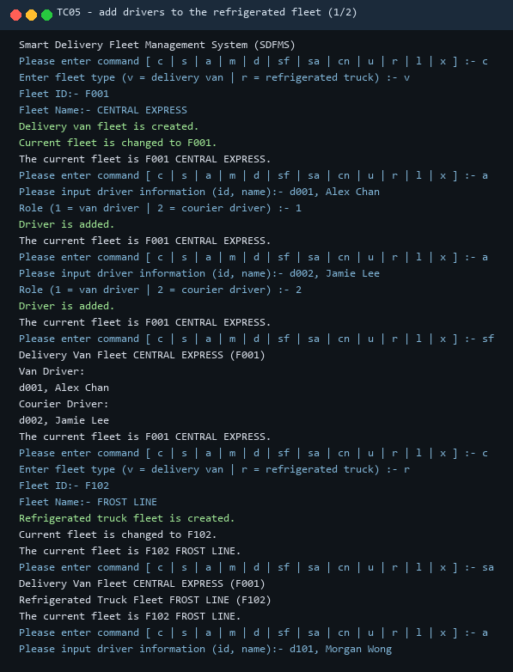
Figure 9 TC05 screen capture (page 1 of 2)
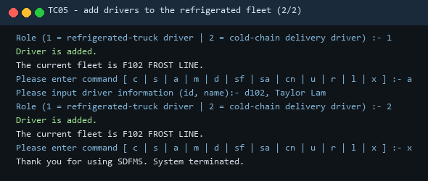
Figure 10 TC05 screen capture (page 2 of 2)
TC06 Show the refrigerated truck fleet
Table 15
Item | Content
Objective | Confirm the role headings of the second fleet type and the two-line driver format.
Pre-condition | F102 holds d101 with role 1 and d102 with role 2.
Test steps | Type sf.
Expected result | Refrigerated Truck Fleet FROST LINE (F102), then Refrigerated-Truck Driver with d101 and Cold-Chain Delivery Driver with d102.

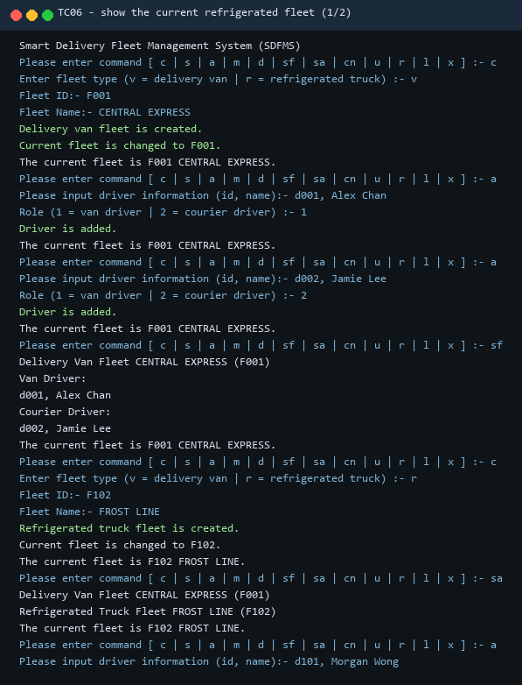
Figure 11 TC06 screen capture (page 1 of 2)
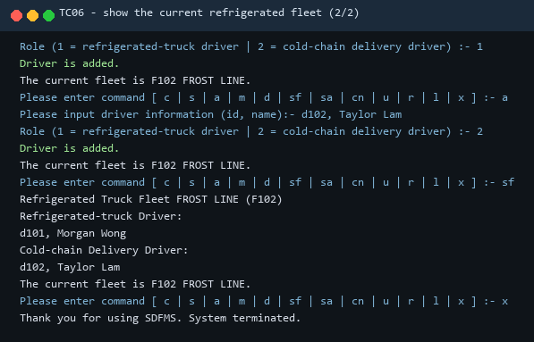
Figure 12 TC06 screen capture (page 2 of 2)
TC07 Set the current fleet by identifier
Table 16
Item | Content
Objective | Confirm that the selection changes without touching the data and that the next menu reflects the new selection.
Pre-condition | Two fleets exist; F102 is current.
Test steps | Type s, then F001.
Expected result | Changed current fleet to F001. The next menu shows 'The current fleet is F001 CENTRAL EXPRESS.'

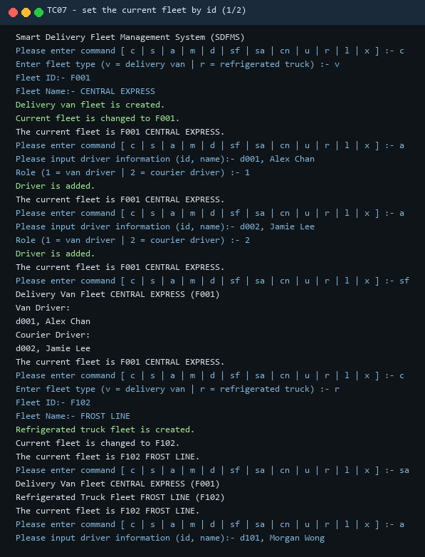
Figure 13 TC07 screen capture (page 1 of 2)
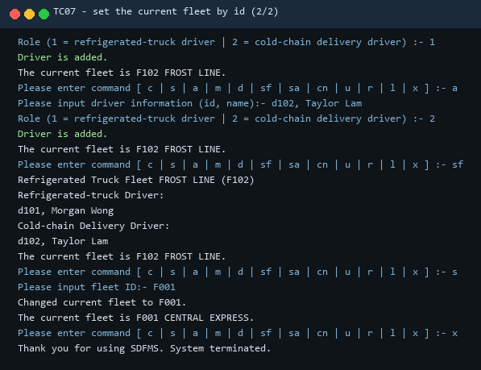
Figure 14 TC07 screen capture (page 2 of 2)
TC08 Display all fleets after switching the selection
Table 17
Item | Content
Objective | Confirm that the listing is independent of the current fleet and that the selection survives the command.
Pre-condition | F001 is current; both fleets hold drivers.
Test steps | Type sa.
Expected result | Two fleet lines in creation order; no driver detail; the menu still shows F001 as current.

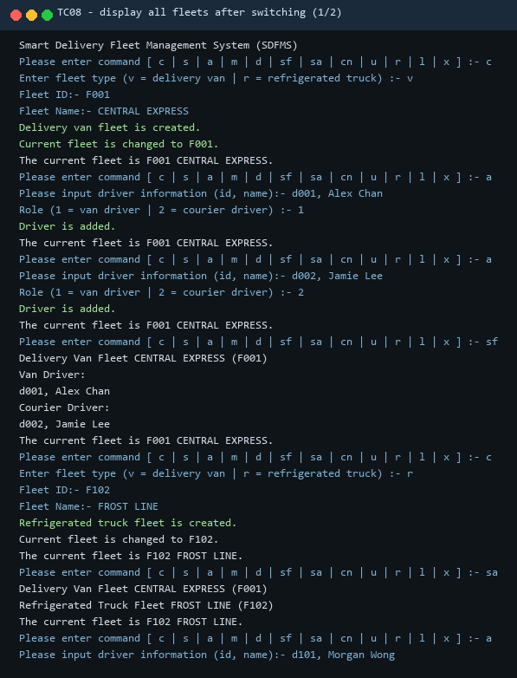
Figure 15 TC08 screen capture (page 1 of 2)
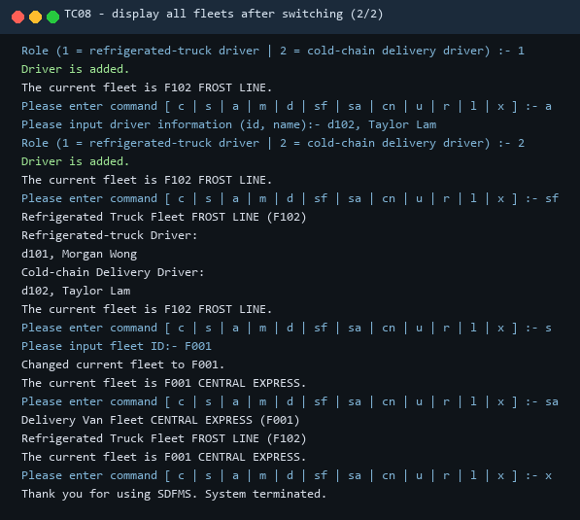
Figure 16 TC08 screen capture (page 2 of 2)
TC09 Modify the role of a driver
Table 18
Item | Content
Objective | Confirm that the role change is applied to the selected driver only, that the driver moves to the other role section, and that the history receives a Modify entry.
Pre-condition | F001 is current; d001 is a van driver and d002 a courier driver.
Test steps | Type m, then d001, then role 2, then sf.
Expected result | Driver role is updated. The next listing shows 'Van Driver: NIL' and courier drivers d001 and d002.

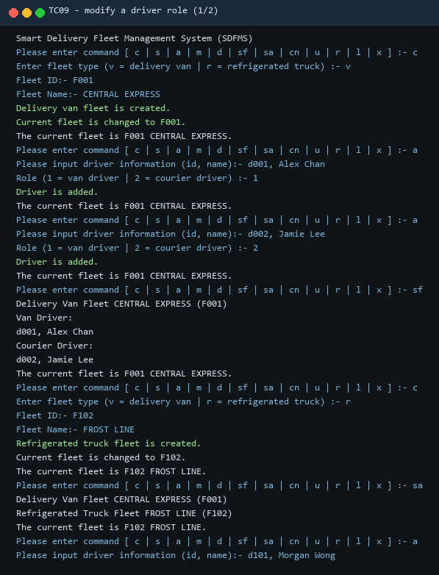
Figure 17 TC09 screen capture (page 1 of 2)
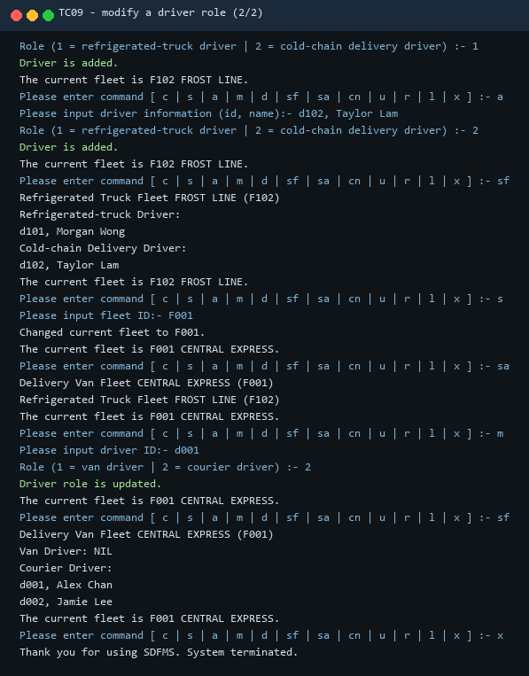
Figure 18 TC09 screen capture (page 2 of 2)
TC10 Delete a driver
Table 19
Item | Content
Objective | Confirm that the driver is removed from the current fleet, that the remaining driver keeps the correct role, and that the deletion is recorded in the history.
Pre-condition | F001 is current; d001 is a courier driver and d002 a courier driver.
Test steps | Type d, then d002, then sf.
Expected result | Driver is deleted. The listing then shows Courier Driver with d001 only.

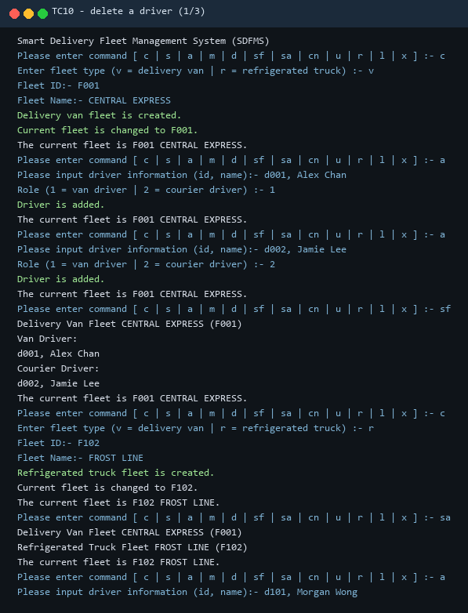
Figure 19 TC10 screen capture (page 1 of 3)
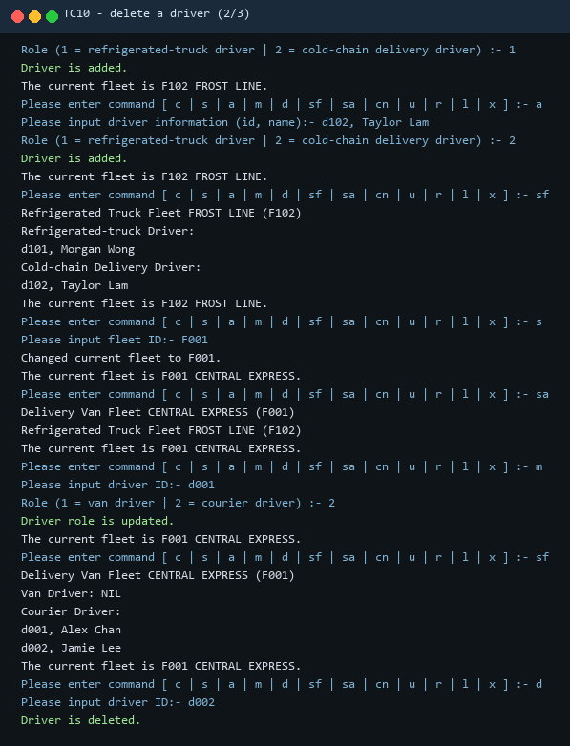
Figure 20 TC10 screen capture (page 2 of 3)
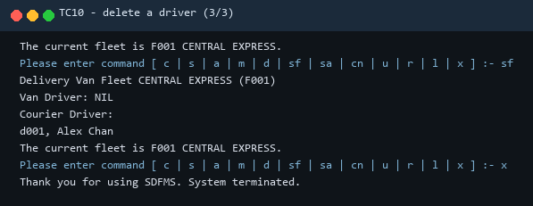
Figure 21 TC10 screen capture (page 3 of 3)
TC11 Change the name of the current fleet
Table 20
Item | Content
Objective | Confirm that the name is changed in the fleet object, that the header and the menu both show it, and that the history receives a Change fleet name entry.
Pre-condition | F001 is current and still named CENTRAL EXPRESS.
Test steps | Type cn, then METRO EXPRESS, then sf.
Expected result | Fleet name is updated. The header becomes 'Delivery Van Fleet METRO EXPRESS (F001)' and the menu line follows.

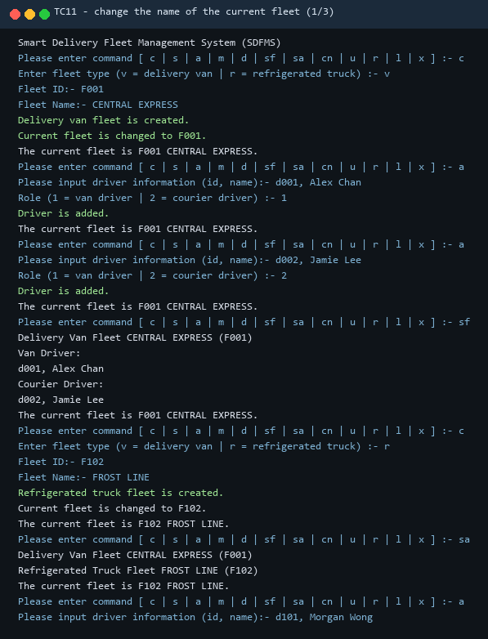
Figure 22 TC11 screen capture (page 1 of 3)
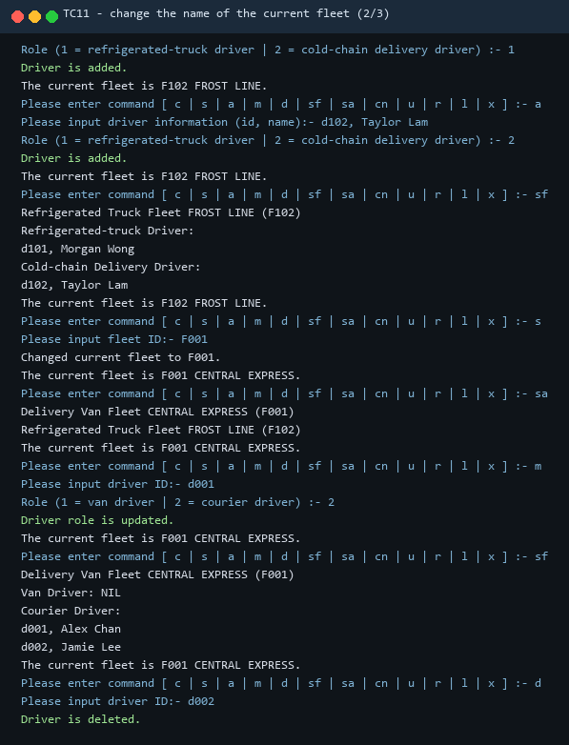
Figure 23 TC11 screen capture (page 2 of 3)
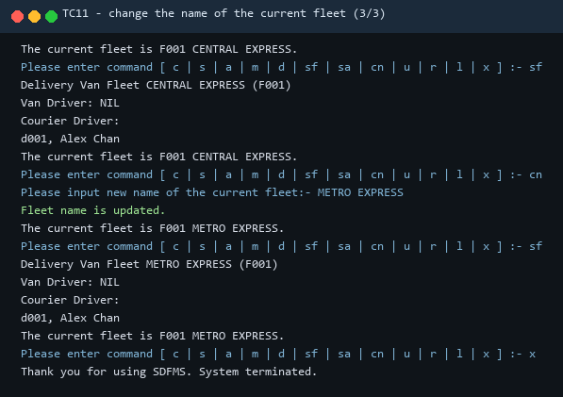
Figure 24 TC11 screen capture (page 3 of 3)
TC12 List the undo and redo lists
Table 21
Item | Content
Objective | Confirm the content, the order and the format of both lists after a sequence of nine undoable commands.
Pre-condition | The state produced by TC01 to TC11.
Test steps | Type l.
Expected result | Undo List with nine entries in execution order, the end marker, Redo List and its end marker. The redo list is empty because no command has been undone.

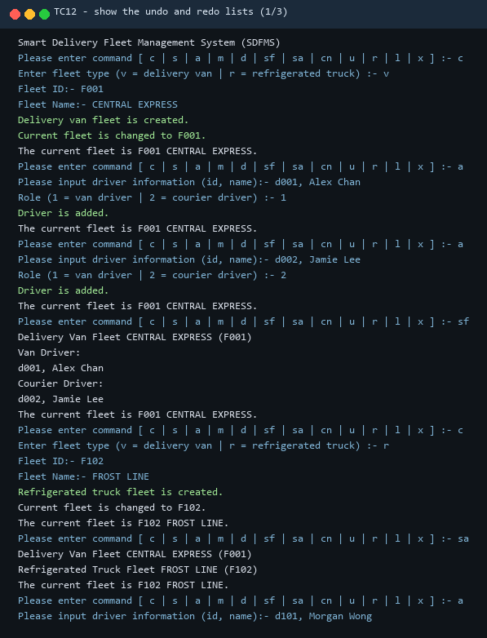
Figure 25 TC12 screen capture (page 1 of 3)
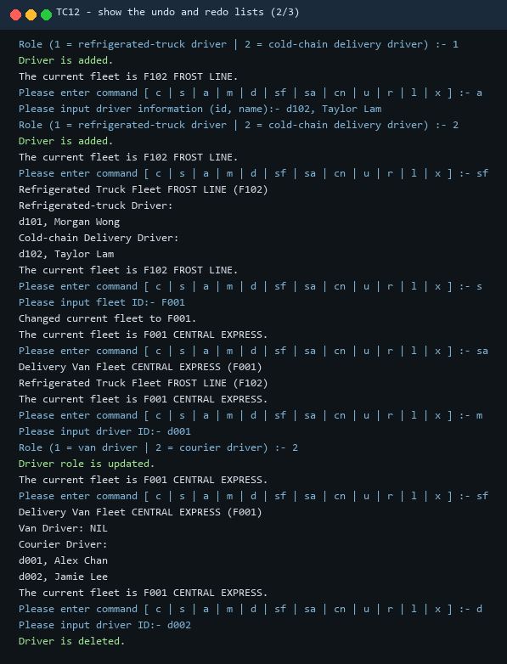
Figure 26 TC12 screen capture (page 2 of 3)
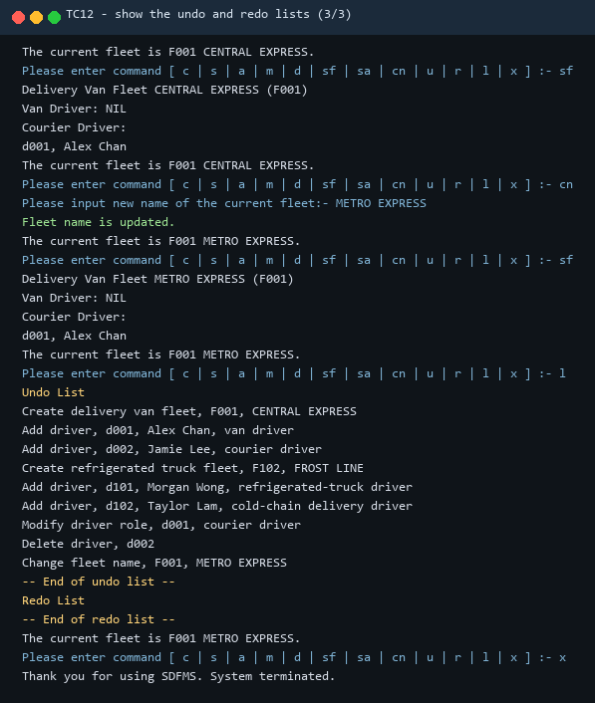
Figure 27 TC12 screen capture (page 3 of 3)
TC13 Undo three commands
Table 22
Item | Content
Objective | Confirm that undo reverses the three most recent changes in reverse order, that each reversal prints the confirmation and that the resulting state is correct.
Pre-condition | The history of TC12 with nine entries.
Test steps | Type u three times, then sf.
Expected result | Change fleet name, Delete driver and Modify driver role are undone in that order; the fleet is named CENTRAL EXPRESS again and holds d001 as a van driver and d002 as a courier driver.

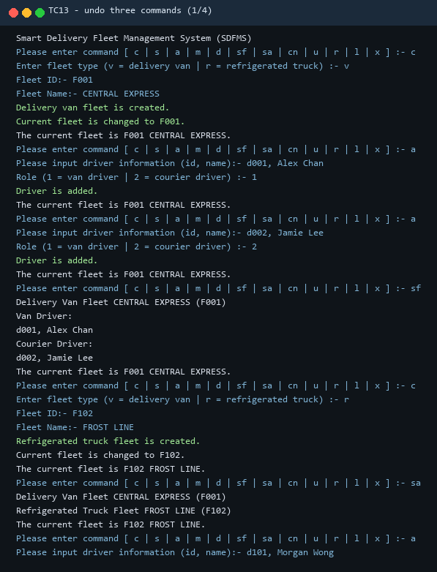
Figure 28 TC13 screen capture (page 1 of 4)
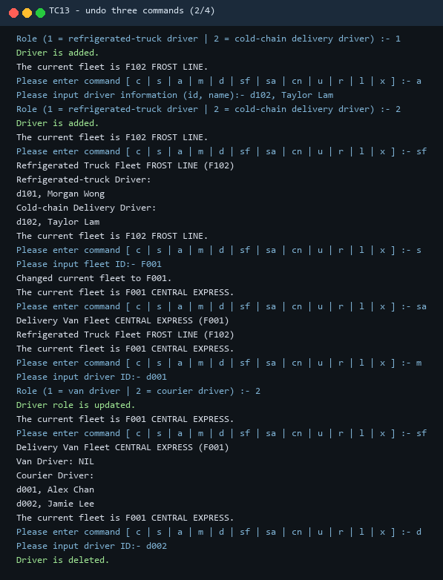
Figure 29 TC13 screen capture (page 2 of 4)
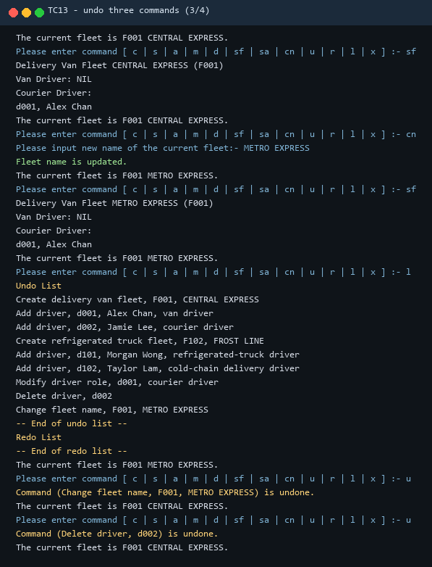
Figure 30 TC13 screen capture (page 3 of 4)
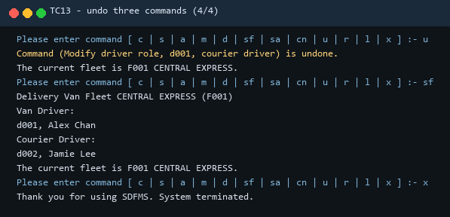
Figure 31 TC13 screen capture (page 4 of 4)
TC14 Redo three commands
Table 23
Item | Content
Objective | Confirm that redo re-applies the undone commands in the original order and restores the state that the undo had removed.
Pre-condition | The state produced by TC13.
Test steps | Type r three times, then sf.
Expected result | The three commands are redone in order; the fleet is named METRO EXPRESS and holds d001 as a courier driver.

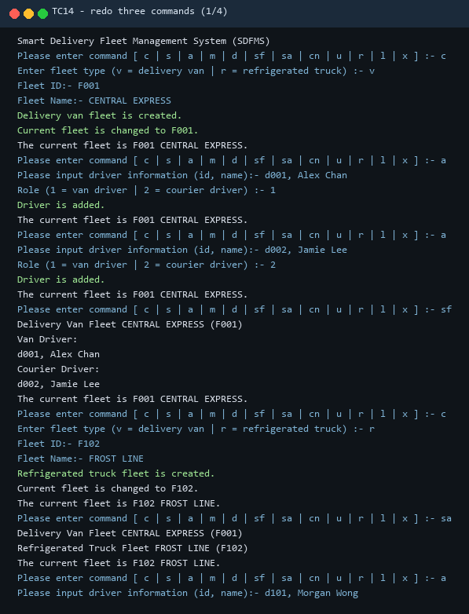
Figure 32 TC14 screen capture (page 1 of 4)
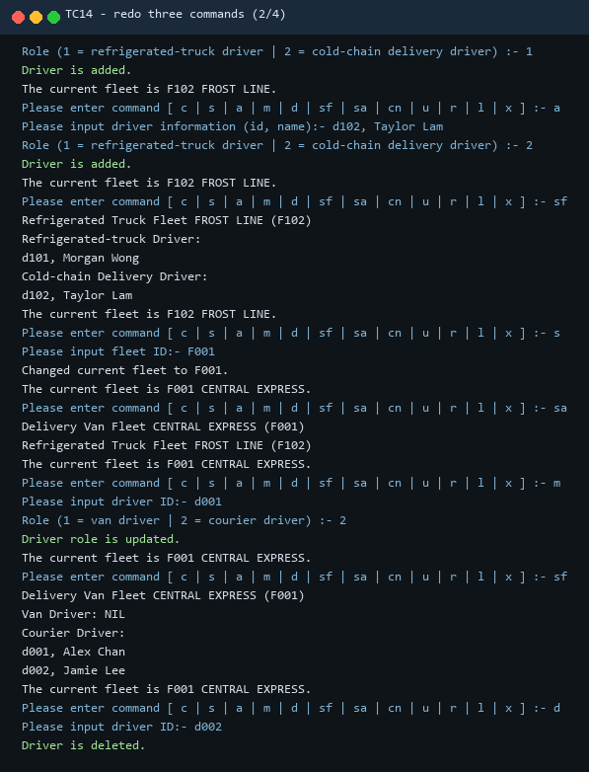
Figure 33 TC14 screen capture (page 2 of 4)
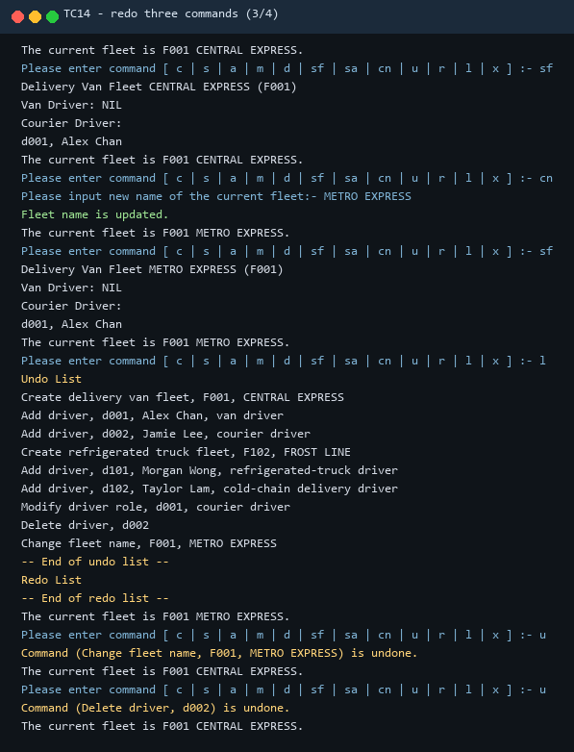
Figure 34 TC14 screen capture (page 3 of 4)
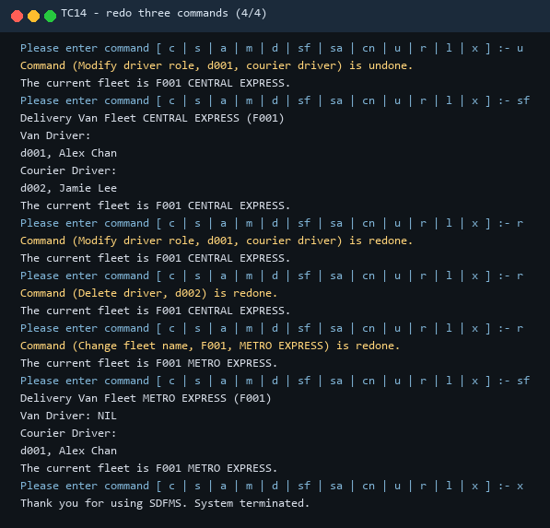
Figure 35 TC14 screen capture (page 4 of 4)
TC15 Error handling and exit
Table 24
Item | Content
Objective | Confirm that each error path prints the specified message, leaves the state unchanged and keeps the program running until the exit command.
Pre-condition | The state produced by TC14.
Test steps | Type s with F999, d with d999, q, then x.
Expected result | Fleet F999 is not found!, Driver d999 is not found in the current fleet!, Invalid command!, then Thank you for using SDFMS. System terminated. and the program ends.

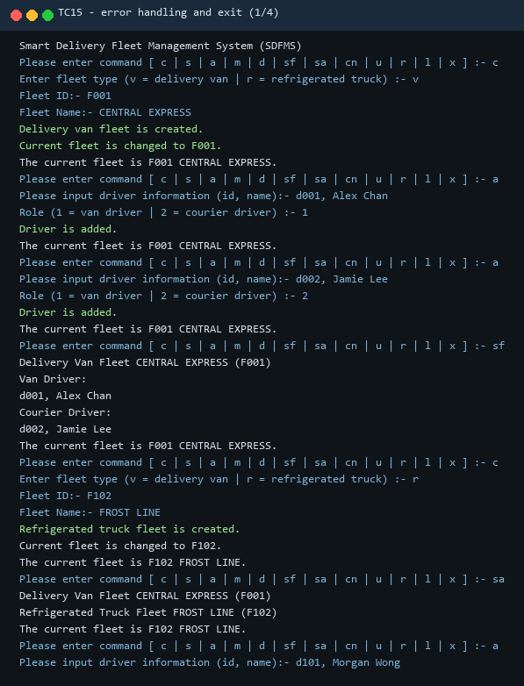
Figure 36 TC15 screen capture (page 1 of 4)
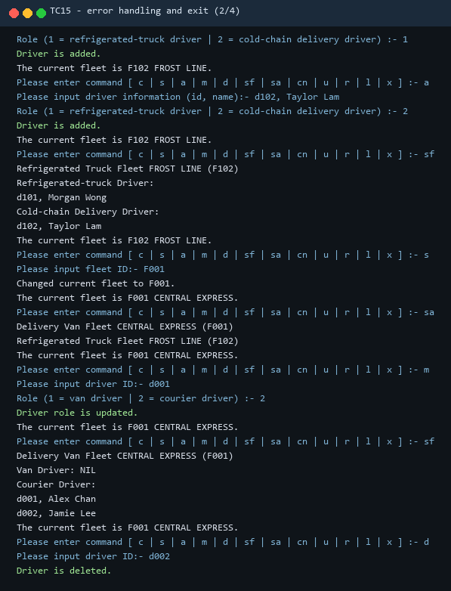
Figure 37 TC15 screen capture (page 2 of 4)
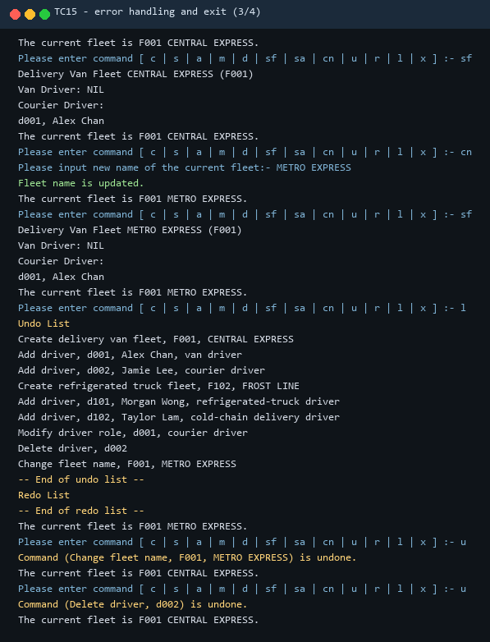
Figure 38 TC15 screen capture (page 3 of 4)
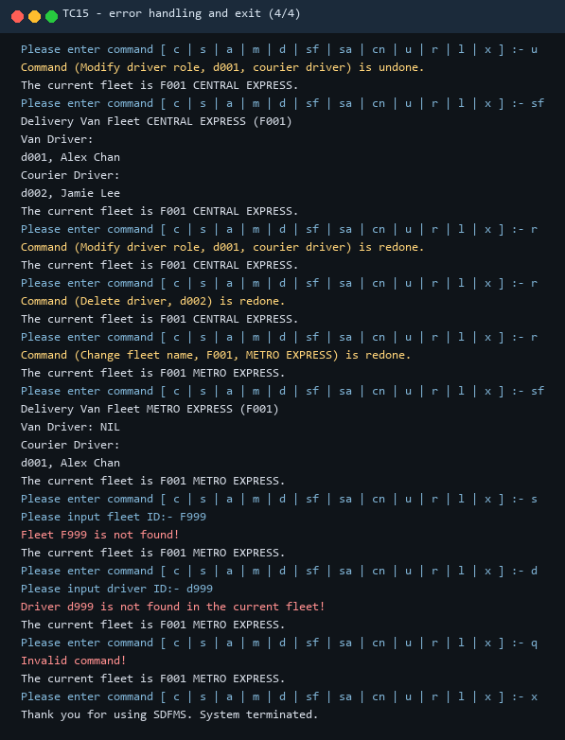
Figure 39 TC15 screen capture (page 4 of 4)
TC16 Functions that need a current fleet
Table 25
Item | Content
Objective | Confirm that a command which needs a selected fleet reports the missing selection instead of failing, and that the program continues.
Pre-condition | A fresh run with no fleet created.
Test steps | Type sf, then a, then x.
Expected result | No current fleet is set! for both commands; no exception, no data change; the exit message is still printed.

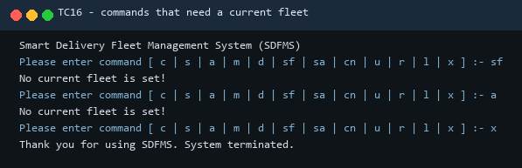
Figure 40 TC16 screen capture
TC17 Duplicate identifiers and invalid input
Table 26
Item | Content
Objective | Confirm that the create and add commands validate the identifier, the type code and the name before changing any state.
Pre-condition | F001 CENTRAL EXPRESS exists.
Test steps | Type c with v, F001, SECOND; c with type q; c with v, F900 and an empty name; c with v, F900, NIGHT LINE; a with 'd001, Alex Chan' and role 1; a with 'd001, Ben Wong' and role 1.
Expected result | Fleet F001 already exists!, Invalid fleet type!, Fleet ID and fleet name must not be empty!, then the fleet is created; the second add reports Driver d001 already exists in the current fleet!.

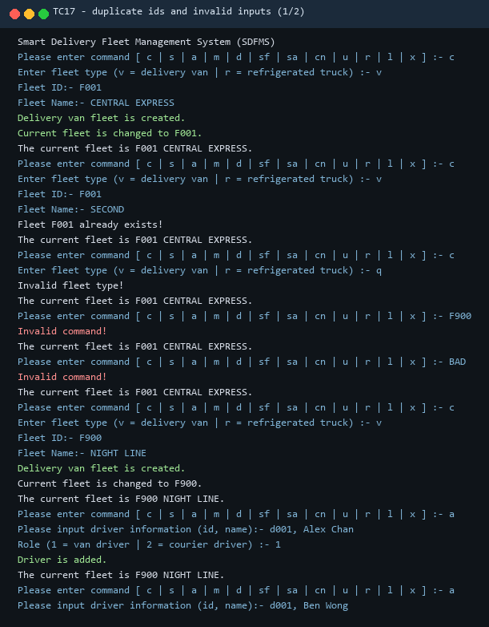
Figure 41 TC17 screen capture (page 1 of 2)
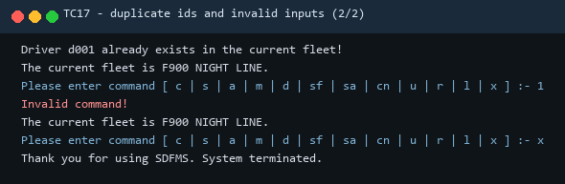
Figure 42 TC17 screen capture (page 2 of 2)
TC18 Undo and redo with an empty or exhausted history
Table 27
Item | Content
Objective | Confirm that undo and redo report an empty list instead of failing, and that the lists stay empty.
Pre-condition | One fleet created and nothing else.
Test steps | Type u three times, r twice, then l.
Expected result | No command can be undone. three times, No command can be redone. twice, then an empty undo list and an empty redo list between their end markers.

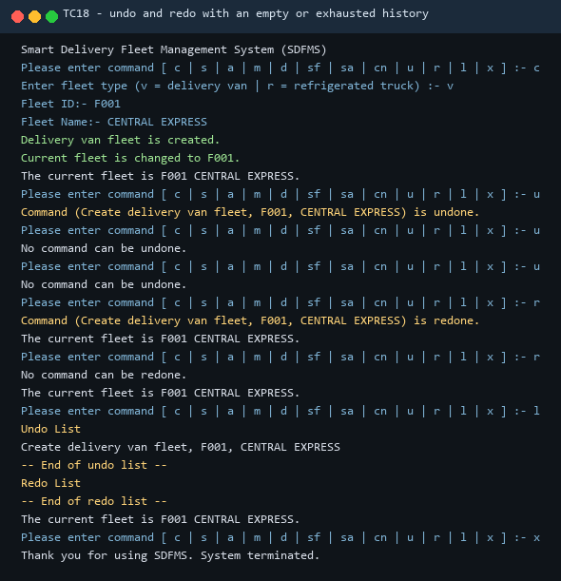
Figure 43 TC18 screen capture

5.4 Summary of Test Results
All eighteen cases produced the expected result on the first run of the compiled program; no case had to be repeated after a code change. Table 9 maps each function of the specification to the cases that cover it, and the last column records the outcome.
Table 28 Coverage of the twelve functions by the test cases
Function of the specification | Cases | Result
Create a vehicle fleet record | TC01, TC04, TC17 | Pass
Set the current fleet by Fleet ID | TC07, TC15 | Pass
Add a driver to the current fleet | TC02, TC05, TC16, TC17 | Pass
Modify the role of a driver | TC09, TC13, TC14 | Pass
Delete a driver | TC10, TC13, TC15 | Pass
Show the current fleet | TC03, TC06, TC09, TC13 | Pass
Display all fleets | TC04, TC08 | Pass
Change the name of the fleet | TC11, TC13, TC14 | Pass
Undo the last command | TC13, TC18 | Pass
Redo the last undone command | TC14, TC18 | Pass
Show the undo and redo lists | TC12, TC18 | Pass
Exit the system | TC15, TC16, TC18 | Pass

The regression run of the fifteen published sample cases was also successful. The expected lines of each case were matched in order against the captured output and every line was found in position, including the exact wording of the creation messages, the capitalisation of the fleet and role headings, the 'NIL' line for an empty role and the punctuation of the undo and redo messages.

6 User Guide
The program is compiled and started with the supplied batch file. Place run.bat in the directory that contains the Java source files and run it from there; the file calls javac to compile every source file and then java to start the Main class. The program reads commands from the console and ends when x is entered or when the input ends, so a script of command lines can also be piped to it.
@echo off
javac *.java
if errorlevel 1 goto end
java Main
:end
The menu that is printed before each prompt lists the twelve command codes. Table 10 repeats them with the input that each command expects and the message that confirms success. Every command reads one value per line; a blank line is ignored.
Table 29 Commands of SDFMS and the input they expect
Command | Meaning | Additional input | Confirmation message
c | Create a vehicle fleet | type code (v or r), fleet identifier, fleet name | Vehicle fleet is created; current fleet is changed
s | Set the current fleet | fleet identifier | Changed current fleet to <id>.
a | Add a driver | id, name; role code | Driver is added.
m | Modify a driver role | driver identifier; role code | Driver role is updated.
d | Delete a driver | driver identifier | Driver is deleted.
sf | Show the current fleet | none | Fleet header and drivers by role
sa | Display all fleets | none | One line per fleet
cn | Change the fleet name | new name | Fleet name is updated.
u | Undo the last command | none | Command (<description>) is undone.
r | Redo the last undone command | none | Command (<description>) is redone.
l | Show the undo and redo lists | none | Both lists with end markers
x | Exit the system | none | Thank you for using SDFMS. System terminated.

A short session makes the flow clear. The user creates one fleet, adds one driver, prints the fleet, changes the name and then reverses the change with u.
Please enter command [ c | s | a | m | d | sf | sa | cn | u | r | l | x ] :- c
Enter fleet type (v = delivery van | r = refrigerated truck) :- v
Fleet ID:- F001
Fleet Name:- CENTRAL EXPRESS
Delivery van fleet is created.
Current fleet is changed to F001.
...
Please enter command [ c | s | a | m | d | sf | sa | cn | u | r | l | x ] :- cn
Please input new name of the current fleet:- METRO EXPRESS
Fleet name is updated.
...
Please enter command [ c | s | a | m | d | sf | sa | cn | u | r | l | x ] :- u
Command (Change fleet name, F001, METRO EXPRESS) is undone.
Three error cases are worth remembering. An unknown command code prints 'Invalid command!' and the menu is reprinted. An operation that needs a selected fleet prints 'No current fleet is set!' when no fleet has been created or selected. An unknown identifier prints either 'Fleet <id> is not found!' or 'Driver <id> is not found in the current fleet!', and in all three cases the state of the system is unchanged.

7 Conclusion
SDFMS meets the functional requirement of the assignment: the twelve functions are implemented, the five changes that must be reversible are reversible, and the output follows the sample run for both fleet types, including the error messages and the history format. The fifteen published sample cases are reproduced line by line and the eighteen designed cases cover the twelve functions, the negative paths and the history boundaries.
The design meets the structural requirement as well. Every user function is a Command object, including undo, redo, the history listing and exit, so the invoker and the front end treat the twelve functions uniformly. Fleets, drivers and commands are created through an abstract factory whose per-type FleetFactory objects are held in a registry, so no client class names a concrete product. The previous role of a driver and the previous name of a fleet are captured as opaque mementos and restored by the originator, so the two changes required by the specification are reversed without exposing private state. Adding a fleet type requires one subclass, one factory and one registration line, which is the practical evidence that the design obeys the Open-Closed Principle.
The work also shows where the design would have to grow. Nothing is persisted, so a restart loses the fleets; undo and redo are in memory only and are not shared between sessions; and the console interface assumes one user. A persistent repository, a serialisable history and a graphical front end would each be additions behind the existing interfaces rather than redesigns of the three patterns, which is the property the assignment set out to test.

References
[1] E. Gamma, R. Helm, R. Johnson and J. Vlissides. Design Patterns: Elements of Reusable Object-Oriented Software[M]. Reading, MA: Addison-Wesley, 1994.
[2] R. C. Martin. Design Principles and Design Patterns[EB/OL]. Object Mentor, 2000. https://web.archive.org/web/20150906155800/http://www.objectmentor.com/resources/articles/Principles_and_Patterns.pdf.
[3] B. Meyer. Object-Oriented Software Construction[M]. 2nd ed. Upper Saddle River, NJ: Prentice Hall, 1997.
[4] Oracle. Java Platform, Standard Edition 21 API Specification[EB/OL]. https://docs.oracle.com/en/java/javase/21/docs/api/index.html.

Appendix A: Well-Documented Source Code
The appendix reproduces every Java source file of the implementation and the batch file that compiles and runs it. The files are grouped by layer in the order used in Section 3: the domain classes first, then the memento types, the command layer, the factory layer, the presentation layer and the entry class. Each class carries a class comment that states its responsibility, and the operations that implement a design pattern say which pattern they serve.

A.1 Domain Layer
VehicleFleet.java
import java.util.AbstractList;
import java.util.ArrayList;
import java.util.List;
import java.util.Vector;
/**
* Abstract base class of every kind of vehicle fleet.
*
* <p>The attributes and operations supplied in the assignment skeleton are
* kept unchanged. Operations that differ from one fleet type to another
* (role names, role prompt, display name, the two abstract operations) are
* declared abstract so that new fleet types can be added without touching
* this class or any command class.</p>
*/
public abstract class VehicleFleet {
private String fleetID;
private String fleetName;
private AbstractList drivers;
public VehicleFleet(String fleetID) {
this.fleetID = fleetID;
this.drivers = new Vector();
}
public String getFleetID() {
return fleetID;
}
public String getName() {
return fleetName;
}
public void setName(String fleetName) {
this.fleetName = fleetName;
}
public void addDriver(Driver driver) {
drivers.add(driver);
}
public void dropDriver(Driver driver) {
drivers.remove(driver);
}
public AbstractList getDrivers() {
return drivers;
}
/** Re-assigns every driver of this fleet to the first role of the fleet. */
public abstract void updateDriverRole();
/** Prints the fleet header followed by the drivers of every role. */
public abstract void showFleet();
/**
* Returns the drivers of the fleet as a typed list so that the rest of
* the application does not have to work with the raw AbstractList.
*/
@SuppressWarnings("unchecked")
public List<Driver> getDriverList() {
return (List<Driver>) drivers;
}
/** Returns the driver with the given id, or null when it is not in this fleet. */
public Driver findDriver(String driverID) {
for (Driver driver : getDriverList()) {
if (driver.getDriverID().equals(driverID)) {
return driver;
}
}
return null;
}
/** Returns true when a driver with the given id belongs to this fleet. */
public boolean hasDriver(String driverID) {
return findDriver(driverID) != null;
}
/** Text used in front of a fleet line, e.g. "Delivery Van Fleet". */
public abstract String getFleetTypeDisplayName();
/** Human readable name of a role code, e.g. "van driver". */
public abstract String getRoleName(int role);
/** Prompt shown when the user has to choose a role for this fleet type. */
public abstract String getRolePrompt();
/** Prints the one-line form used by "display all fleets". */
public abstract void showFleetSummary();
/** One-line header shared by showFleet() and showFleetSummary(). */
protected String describeHeader() {
return getFleetTypeDisplayName() + " " + fleetName + " (" + fleetID + ")";
}
// ------------------------------------------------------------------
// Originator operations of the Memento pattern
// ------------------------------------------------------------------
/** Captures the current name of this fleet. */
public Memento createFleetNameMemento() {
return new FleetNameMemento(fleetID, fleetName);
}
/** Restores the fleet name stored in the given memento. */
public void restoreFleetName(Memento memento) {
if (memento instanceof FleetNameMemento) {
FleetNameMemento saved = (FleetNameMemento) memento;
if (fleetID.equals(saved.getFleetID())) {
fleetName = saved.getFleetName();
}
}
}
/** Captures the current role of the given driver. */
public Memento createDriverRoleMemento(String driverID) {
Driver driver = findDriver(driverID);
int role = (driver == null) ? -1 : driver.getRole();
return new DriverRoleMemento(driverID, role);
}
/** Restores the driver role stored in the given memento. */
public void restoreDriverRole(Memento memento) {
if (memento instanceof DriverRoleMemento) {
DriverRoleMemento saved = (DriverRoleMemento) memento;
Driver driver = findDriver(saved.getDriverID());
if (driver != null && saved.getRole() >= 0) {
driver.setRole(saved.getRole());
}
}
}
}
DeliveryVanFleet.java
import java.util.ArrayList;
import java.util.List;
/**
* Fleet of delivery vans. Roles: 1 = van driver, 2 = courier driver.
*/
public class DeliveryVanFleet extends VehicleFleet {
private static final int VAN_DRIVER_ROLE = 1;
private static final int COURIER_DRIVER_ROLE = 2;
public DeliveryVanFleet(String fleetID) {
super(fleetID);
}
@Override
public void updateDriverRole() {
for (Driver driver : getDriverList()) {
driver.setRole(VAN_DRIVER_ROLE);
}
}
@Override
public void showFleet() {
System.out.println(describeHeader());
printDriversOfRole(VAN_DRIVER_ROLE, "Van Driver:");
printDriversOfRole(COURIER_DRIVER_ROLE, "Courier Driver:");
}
@Override
public void showFleetSummary() {
System.out.println(describeHeader());
}
@Override
public String getFleetTypeDisplayName() {
return "Delivery Van Fleet";
}
@Override
public String getRoleName(int role) {
switch (role) {
case VAN_DRIVER_ROLE:
return "van driver";
case COURIER_DRIVER_ROLE:
return "courier driver";
default:
return "unknown role";
}
}
@Override
public String getRolePrompt() {
return "Role (1 = van driver | 2 = courier driver) :- ";
}
/**
* Prints the drivers that hold the given role. When nobody holds it, the
* heading is printed together with "NIL".
*/
private void printDriversOfRole(int role, String heading) {
List<Driver> matches = new ArrayList<Driver>();
for (Driver driver : getDriverList()) {
if (driver.getRole() == role) {
matches.add(driver);
}
}
if (matches.isEmpty()) {
System.out.println(heading + " NIL");
return;
}
System.out.println(heading);
for (Driver driver : matches) {
System.out.println(driver.getDriverID() + ", " + driver.getName());
}
}
}
RefridgeratedTruckFleet.java
import java.util.ArrayList;
import java.util.List;
/**
* Fleet of refrigerated trucks. Roles: 1 = refrigerated-truck driver,
* 2 = cold-chain delivery driver.
*
* <p>The class name is kept exactly as supplied in the skeleton.</p>
*/
public class RefridgeratedTruckFleet extends VehicleFleet {
private static final int REFRIDGERATED_TRUCK_DRIVER_ROLE = 1;
private static final int COLD_CHAIN_DELIVERY_DRIVER_ROLE = 2;
public RefridgeratedTruckFleet(String fleetID) {
super(fleetID);
}
@Override
public void updateDriverRole() {
for (Driver driver : getDriverList()) {
driver.setRole(REFRIDGERATED_TRUCK_DRIVER_ROLE);
}
}
@Override
public void showFleet() {
System.out.println(describeHeader());
printDriversOfRole(REFRIDGERATED_TRUCK_DRIVER_ROLE, "Refrigerated-truck Driver:");
printDriversOfRole(COLD_CHAIN_DELIVERY_DRIVER_ROLE, "Cold-chain Delivery Driver:");
}
@Override
public void showFleetSummary() {
System.out.println(describeHeader());
}
@Override
public String getFleetTypeDisplayName() {
return "Refrigerated Truck Fleet";
}
@Override
public String getRoleName(int role) {
switch (role) {
case REFRIDGERATED_TRUCK_DRIVER_ROLE:
return "refrigerated-truck driver";
case COLD_CHAIN_DELIVERY_DRIVER_ROLE:
return "cold-chain delivery driver";
default:
return "unknown role";
}
}
@Override
public String getRolePrompt() {
return "Role (1 = refrigerated-truck driver | 2 = cold-chain delivery driver) :- ";
}
private void printDriversOfRole(int role, String heading) {
List<Driver> matches = new ArrayList<Driver>();
for (Driver driver : getDriverList()) {
if (driver.getRole() == role) {
matches.add(driver);
}
}
if (matches.isEmpty()) {
System.out.println(heading + " NIL");
return;
}
System.out.println(heading);
for (Driver driver : matches) {
System.out.println(driver.getDriverID() + ", " + driver.getName());
}
}
}
Driver.java
/**
* A driver that can be assigned to a vehicle fleet.
*
* <p>The attributes and operations of this class are those supplied in the
* assignment skeleton; only documentation has been added.</p>
*/
public class Driver {
private String driverID;
private String driverName;
private int role;
/**
* Creates a driver.
*
* @param driverID unique driver identifier, e.g. "d001"
* @param driverName driver name, e.g. "Alex Chan"
* @param role role code inside the fleet (1 or 2, meaning depends on
* the type of fleet the driver belongs to)
*/
public Driver(String driverID, String driverName, int role) {
this.driverID = driverID;
this.driverName = driverName;
this.role = role;
}
public String getDriverID() {
return driverID;
}
public String getName() {
return driverName;
}
public int getRole() {
return role;
}
public void setName(String driverName) {
this.driverName = driverName;
}
public void setRole(int role) {
this.role = role;
}
}
FleetRepository.java
import java.util.List;
import java.util.Vector;
/**
* In-memory store of all fleet records together with the current fleet.
*/
public class FleetRepository {
private final Vector<VehicleFleet> fleets = new Vector<VehicleFleet>();
private VehicleFleet currentFleet;
public List<VehicleFleet> getFleets() {
return fleets;
}
public VehicleFleet findFleet(String fleetID) {
for (VehicleFleet fleet : fleets) {
if (fleet.getFleetID().equals(fleetID)) {
return fleet;
}
}
return null;
}
public boolean containsFleet(String fleetID) {
return findFleet(fleetID) != null;
}
public void addFleet(VehicleFleet fleet) {
fleets.add(fleet);
}
/** Removes a fleet; the current fleet is cleared when it was that fleet. */
public void removeFleet(VehicleFleet fleet) {
fleets.remove(fleet);
if (currentFleet == fleet) {
currentFleet = null;
}
}
public VehicleFleet getCurrentFleet() {
return currentFleet;
}
public void setCurrentFleet(VehicleFleet currentFleet) {
this.currentFleet = currentFleet;
}
public boolean isEmpty() {
return fleets.isEmpty();
}
}

A.2 Memento Types
Memento.java
/**
* Marker interface for all memento objects used by the undo mechanism.
*
* <p>A memento is an opaque snapshot of the state of an originator. Only the
* originator that created it knows how to interpret it, which keeps the
* command objects independent of the internal structure of the fleet.</p>
*/
public interface Memento {
}
FleetNameMemento.java
/**
* Memento that stores the name of a fleet before it is changed.
*/
public class FleetNameMemento implements Memento {
private final String fleetID;
private final String fleetName;
public FleetNameMemento(String fleetID, String fleetName) {
this.fleetID = fleetID;
this.fleetName = fleetName;
}
public String getFleetID() {
return fleetID;
}
public String getFleetName() {
return fleetName;
}
}
DriverRoleMemento.java
/**
* Memento that stores the role of a driver before it is modified.
*/
public class DriverRoleMemento implements Memento {
private final String driverID;
private final int role;
public DriverRoleMemento(String driverID, int role) {
this.driverID = driverID;
this.role = role;
}
public String getDriverID() {
return driverID;
}
public int getRole() {
return role;
}
}

A.3 Command Layer
Command.java
/**
* A command in the sense of the Command pattern.
*
* <p>Every user function of SDFMS is represented by one command object,
* including "undo", "redo" and "show undo/redo lists". Command objects
* encapsulate the request together with everything needed to carry it out,
* so the console only has to create the object and execute it.</p>
*/
public interface Command {
/** Carries out the request, including any interaction with the user. */
void execute();
/** Reverses the effect of a previous execution. */
void undo();
/** Re-applies the effect after it has been undone. */
void redo();
/** Text used in the undo/redo lists and in the undo/redo messages. */
String getDescription();
/** Tells the command manager whether this command belongs to the history. */
boolean isUndoable();
}
AbstractCommand.java
/**
* Common behaviour shared by all SDFMS commands.
*/
public abstract class AbstractCommand implements Command {
private final String commandCode;
private final CommandContext context;
protected AbstractCommand(String commandCode, CommandContext context) {
this.commandCode = commandCode;
this.context = context;
}
public String getCommandCode() {
return commandCode;
}
protected CommandContext getContext() {
return context;
}
@Override
public boolean isUndoable() {
return true;
}
@Override
public void undo() {
// Commands that do not change persistent data override nothing.
}
@Override
public void redo() {
execute();
}
@Override
public String getDescription() {
return commandCode;
}
}
CommandContext.java
/**
* Holds the collaborators that every command needs: the fleet repository,
* the console input, the command manager (undo/redo history) and the abstract
* factory used to create fleets and drivers.
*/
public class CommandContext {
private final FleetRepository repository;
private final ConsoleInput input;
private CommandManager commandManager;
private SDFMSAbstractFactory factory;
private boolean running = true;
public CommandContext(FleetRepository repository, ConsoleInput input) {
this.repository = repository;
this.input = input;
}
public FleetRepository getRepository() {
return repository;
}
public ConsoleInput getInput() {
return input;
}
public CommandManager getCommandManager() {
return commandManager;
}
public void setCommandManager(CommandManager commandManager) {
this.commandManager = commandManager;
}
public SDFMSAbstractFactory getFactory() {
return factory;
}
public void setFactory(SDFMSAbstractFactory factory) {
this.factory = factory;
}
public boolean isRunning() {
return running;
}
public void setRunning(boolean running) {
this.running = running;
}
/**
* Returns the current fleet or prints an error and returns null when no
* fleet has been set yet.
*/
public VehicleFleet getCurrentFleetOrReport() {
VehicleFleet current = repository.getCurrentFleet();
if (current == null) {
System.out.println("No current fleet is set!");
}
return current;
}
}
CommandManager.java
import java.util.List;
import java.util.Vector;
/**
* Invoker of the Command pattern. It executes commands and keeps the two
* history lists used by Undo and Redo.
*/
public class CommandManager {
private final Vector<Command> undoList = new Vector<Command>();
private final Vector<Command> redoList = new Vector<Command>();
/** Executes a command and records it when it is an undoable command. */
public void execute(Command command) {
command.execute();
if (command.isUndoable()) {
undoList.add(command);
redoList.clear();
}
}
/** Undoes the most recent undoable command. */
public void undo() {
if (undoList.isEmpty()) {
System.out.println("No command can be undone.");
return;
}
Command command = undoList.remove(undoList.size() - 1);
command.undo();
redoList.add(command);
System.out.println("Command (" + command.getDescription() + ") is undone.");
}
/** Redoes the most recently undone command. */
public void redo() {
if (redoList.isEmpty()) {
System.out.println("No command can be redone.");
return;
}
Command command = redoList.remove(redoList.size() - 1);
command.redo();
undoList.add(command);
System.out.println("Command (" + command.getDescription() + ") is redone.");
}
/** Prints both history lists, oldest entry first. */
public void showLists() {
System.out.println("Undo List");
for (Command command : undoList) {
System.out.println(command.getDescription());
}
System.out.println("-- End of undo list --");
System.out.println("Redo List");
for (Command command : redoList) {
System.out.println(command.getDescription());
}
System.out.println("-- End of redo list --");
}
public List<Command> getUndoList() {
return undoList;
}
public List<Command> getRedoList() {
return redoList;
}
}
CreateFleetCommand.java
/**
* "Create a vehicle fleet record" command. The fleet object itself is
* created by the abstract factory from the type code typed by the user.
*/
public class CreateFleetCommand extends AbstractCommand {
private String fleetTypeCode;
private String fleetID;
private String fleetName;
private VehicleFleet createdFleet;
public CreateFleetCommand(CommandContext context) {
super("c", context);
}
@Override
public void execute() {
ConsoleInput input = getContext().getInput();
FleetRepository repository = getContext().getRepository();
SDFMSAbstractFactory factory = getContext().getFactory();
fleetTypeCode = input.readLine(
"Enter fleet type (v = delivery van | r = refrigerated truck) :- ");
if (!factory.isValidFleetType(fleetTypeCode)) {
System.out.println("Invalid fleet type!");
return;
}
fleetID = input.readLine("Fleet ID:- ");
fleetName = input.readLine("Fleet Name:- ");
if (fleetID == null || fleetID.isEmpty() || fleetName == null || fleetName.isEmpty()) {
System.out.println("Fleet ID and fleet name must not be empty!");
return;
}
if (repository.containsFleet(fleetID)) {
System.out.println("Fleet " + fleetID + " already exists!");
return;
}
createdFleet = factory.createFleet(fleetTypeCode, fleetID);
createdFleet.setName(fleetName);
applyChange();
System.out.println(capitalize(factory.getFleetTypeLabel(fleetTypeCode))
+ " is created.");
System.out.println("Current fleet is changed to " + fleetID + ".");
}
private void applyChange() {
getContext().getRepository().addFleet(createdFleet);
getContext().getRepository().setCurrentFleet(createdFleet);
}
@Override
public void undo() {
getContext().getRepository().removeFleet(createdFleet);
}
@Override
public void redo() {
applyChange();
}
@Override
public String getDescription() {
return "Create " + getContext().getFactory().getFleetTypeLabel(fleetTypeCode)
+ ", " + fleetID + ", " + fleetName;
}
private static String capitalize(String text) {
if (text == null || text.isEmpty()) {
return text;
}
return Character.toUpperCase(text.charAt(0)) + text.substring(1);
}
}
SetCurrentFleetCommand.java
/**
* "Set the current fleet by Fleet ID" command. Setting the current fleet
* changes the working context only, so it is not part of the undo history.
*/
public class SetCurrentFleetCommand extends AbstractCommand {
public SetCurrentFleetCommand(CommandContext context) {
super("s", context);
}
@Override
public void execute() {
String fleetID = getContext().getInput().readLine("Please input fleet ID:- ");
FleetRepository repository = getContext().getRepository();
VehicleFleet fleet = repository.findFleet(fleetID);
if (fleet == null) {
System.out.println("Fleet " + fleetID + " is not found!");
return;
}
repository.setCurrentFleet(fleet);
System.out.println("Changed current fleet to " + fleet.getFleetID() + ".");
}
@Override
public boolean isUndoable() {
return false;
}
@Override
public String getDescription() {
return "Set current fleet";
}
}
AddDriverCommand.java
/**
* "Add a driver to the current fleet" command. The driver object is created
* by the abstract factory and kept in the command so that undo can remove it
* and redo can add the same driver back.
*/
public class AddDriverCommand extends AbstractCommand {
private String driverID;
private String driverName;
private int role;
private VehicleFleet targetFleet;
private Driver driver;
public AddDriverCommand(CommandContext context) {
super("a", context);
}
@Override
public void execute() {
targetFleet = getContext().getCurrentFleetOrReport();
if (targetFleet == null) {
return;
}
String[] information = getContext().getInput().readDriverInformation();
if (information == null) {
System.out.println("Invalid driver information!");
return;
}
driverID = information[0];
driverName = information[1];
if (targetFleet.hasDriver(driverID)) {
System.out.println("Driver " + driverID + " already exists in the current fleet!");
return;
}
role = getContext().getInput().readRole(targetFleet.getRolePrompt());
if (!isValidRole()) {
System.out.println("Invalid role!");
return;
}
driver = getContext().getFactory().createDriver(driverID, driverName, role);
applyChange();
System.out.println("Driver is added.");
}
private boolean isValidRole() {
return role == 1 || role == 2;
}
private void applyChange() {
targetFleet.addDriver(driver);
}
@Override
public void undo() {
targetFleet.dropDriver(driver);
}
@Override
public void redo() {
applyChange();
}
@Override
public String getDescription() {
return "Add driver, " + driverID + ", " + driverName + ", "
+ targetFleet.getRoleName(role);
}
}
ModifyDriverRoleCommand.java
/**
* "Modify the role of a driver in the current fleet" command. The old role
* is captured in a memento before the change and restored on undo.
*/
public class ModifyDriverRoleCommand extends AbstractCommand {
private VehicleFleet fleet;
private String driverID;
private int newRole;
private Memento memento;
public ModifyDriverRoleCommand(CommandContext context) {
super("m", context);
}
@Override
public void execute() {
fleet = getContext().getCurrentFleetOrReport();
if (fleet == null) {
return;
}
driverID = getContext().getInput().readLine("Please input driver ID:- ");
if (!fleet.hasDriver(driverID)) {
System.out.println("Driver " + driverID + " is not found in the current fleet!");
return;
}
newRole = getContext().getInput().readRole(fleet.getRolePrompt());
if (newRole != 1 && newRole != 2) {
System.out.println("Invalid role!");
return;
}
memento = fleet.createDriverRoleMemento(driverID);
applyChange();
System.out.println("Driver role is updated.");
}
private void applyChange() {
Driver driver = fleet.findDriver(driverID);
if (driver != null) {
driver.setRole(newRole);
}
}
@Override
public void undo() {
fleet.restoreDriverRole(memento);
}
@Override
public void redo() {
applyChange();
}
@Override
public String getDescription() {
return "Modify driver role, " + driverID + ", " + fleet.getRoleName(newRole);
}
}
DeleteDriverCommand.java
/**
* "Delete a driver from the current fleet" command. The removed driver object
* is kept so that undo can put it back in the same position of the fleet.
*/
public class DeleteDriverCommand extends AbstractCommand {
private VehicleFleet targetFleet;
private String driverID;
private Driver deletedDriver;
public DeleteDriverCommand(CommandContext context) {
super("d", context);
}
@Override
public void execute() {
targetFleet = getContext().getCurrentFleetOrReport();
if (targetFleet == null) {
return;
}
driverID = getContext().getInput().readLine("Please input driver ID:- ");
deletedDriver = targetFleet.findDriver(driverID);
if (deletedDriver == null) {
System.out.println("Driver " + driverID + " is not found in the current fleet!");
return;
}
applyChange();
System.out.println("Driver is deleted.");
}
private void applyChange() {
targetFleet.dropDriver(deletedDriver);
}
@Override
public void undo() {
targetFleet.addDriver(deletedDriver);
}
@Override
public void redo() {
applyChange();
}
@Override
public String getDescription() {
return "Delete driver, " + driverID;
}
}
ChangeFleetNameCommand.java
/**
* "Change the name of the current fleet" command. The previous name is
* captured in a memento before the change and restored on undo.
*/
public class ChangeFleetNameCommand extends AbstractCommand {
private VehicleFleet fleet;
private String newName;
private Memento memento;
public ChangeFleetNameCommand(CommandContext context) {
super("cn", context);
}
@Override
public void execute() {
fleet = getContext().getCurrentFleetOrReport();
if (fleet == null) {
return;
}
newName = getContext().getInput().readLine(
"Please input new name of the current fleet:- ");
if (newName == null || newName.isEmpty()) {
System.out.println("Fleet name must not be empty!");
return;
}
memento = fleet.createFleetNameMemento();
applyChange();
System.out.println("Fleet name is updated.");
}
private void applyChange() {
fleet.setName(newName);
}
@Override
public void undo() {
fleet.restoreFleetName(memento);
}
@Override
public void redo() {
applyChange();
}
@Override
public String getDescription() {
return "Change fleet name, " + fleet.getFleetID() + ", " + newName;
}
}
ShowFleetCommand.java
/** "Show the current fleet" command. */
public class ShowFleetCommand extends AbstractCommand {
public ShowFleetCommand(CommandContext context) {
super("sf", context);
}
@Override
public void execute() {
VehicleFleet current = getContext().getCurrentFleetOrReport();
if (current == null) {
return;
}
current.showFleet();
}
@Override
public boolean isUndoable() {
return false;
}
@Override
public String getDescription() {
return "Show current fleet";
}
}
DisplayAllFleetsCommand.java
/** "Display all fleets" command. */
public class DisplayAllFleetsCommand extends AbstractCommand {
public DisplayAllFleetsCommand(CommandContext context) {
super("sa", context);
}
@Override
public void execute() {
FleetRepository repository = getContext().getRepository();
if (repository.isEmpty()) {
System.out.println("No fleet record is found.");
return;
}
for (VehicleFleet fleet : repository.getFleets()) {
fleet.showFleetSummary();
}
}
@Override
public boolean isUndoable() {
return false;
}
@Override
public String getDescription() {
return "Display all fleets";
}
}
UndoCommand.java
/**
* "Undo the last command" command. Undo is itself a command object, so the
* console treats it exactly like every other function.
*/
public class UndoCommand extends AbstractCommand {
public UndoCommand(CommandContext context) {
super("u", context);
}
@Override
public void execute() {
getContext().getCommandManager().undo();
}
@Override
public boolean isUndoable() {
return false;
}
@Override
public String getDescription() {
return "Undo";
}
}
RedoCommand.java
/** "Redo the last undone command" command. */
public class RedoCommand extends AbstractCommand {
public RedoCommand(CommandContext context) {
super("r", context);
}
@Override
public void execute() {
getContext().getCommandManager().redo();
}
@Override
public boolean isUndoable() {
return false;
}
@Override
public String getDescription() {
return "Redo";
}
}
ShowUndoRedoListCommand.java
/** "Show the undo/redo lists" command. */
public class ShowUndoRedoListCommand extends AbstractCommand {
public ShowUndoRedoListCommand(CommandContext context) {
super("l", context);
}
@Override
public void execute() {
getContext().getCommandManager().showLists();
}
@Override
public boolean isUndoable() {
return false;
}
@Override
public String getDescription() {
return "Show undo/redo lists";
}
}
ExitCommand.java
/** "Exit the system" command. */
public class ExitCommand extends AbstractCommand {
public ExitCommand(CommandContext context) {
super("x", context);
}
@Override
public void execute() {
System.out.println("Thank you for using SDFMS. System terminated.");
getContext().setRunning(false);
}
@Override
public boolean isUndoable() {
return false;
}
@Override
public String getDescription() {
return "Exit system";
}
}

A.4 Factory Layer
SDFMSAbstractFactory.java
/**
* Abstract factory of the application. It gives access to the three families
* of objects SDFMS needs: fleet objects, driver objects and command objects.
*/
public interface SDFMSAbstractFactory {
VehicleFleet createFleet(String fleetTypeCode, String fleetID);
Driver createDriver(String driverID, String driverName, int role);
Command createCommand(String commandCode);
boolean isValidFleetType(String fleetTypeCode);
String getFleetTypeLabel(String fleetTypeCode);
}
SDFMSFactory.java
/**
* Concrete abstract factory. Fleet creation is delegated to the registered
* FleetFactory of the requested type, driver creation to a DriverFactory and
* command creation to a CommandFactory.
*/
public class SDFMSFactory implements SDFMSAbstractFactory {
private final FleetFactoryRegistry fleetFactories;
private final DriverFactory driverFactory;
private final CommandFactory commandFactory;
public SDFMSFactory(CommandContext context) {
this(context, FleetFactoryRegistry.createDefault(), new StandardDriverFactory());
}
public SDFMSFactory(CommandContext context, FleetFactoryRegistry fleetFactories,
DriverFactory driverFactory) {
this.fleetFactories = fleetFactories;
this.driverFactory = driverFactory;
this.commandFactory = new SDFMSCommandFactory(context);
}
@Override
public VehicleFleet createFleet(String fleetTypeCode, String fleetID) {
FleetFactory factory = fleetFactories.getFactory(fleetTypeCode);
if (factory == null) {
throw new IllegalArgumentException("Unsupported fleet type: " + fleetTypeCode);
}
return factory.createFleet(fleetID);
}
@Override
public Driver createDriver(String driverID, String driverName, int role) {
return driverFactory.createDriver(driverID, driverName, role);
}
@Override
public Command createCommand(String commandCode) {
return commandFactory.createCommand(commandCode);
}
@Override
public boolean isValidFleetType(String fleetTypeCode) {
return fleetFactories.isSupported(fleetTypeCode);
}
@Override
public String getFleetTypeLabel(String fleetTypeCode) {
FleetFactory factory = fleetFactories.getFactory(fleetTypeCode);
return (factory == null) ? "unknown fleet" : factory.getTypeLabel();
}
}
FleetFactory.java
/**
* Factory that creates one kind of vehicle fleet.
*
* <p>A new fleet type is supported by adding one implementation of this
* interface and registering it in the registry; no existing class has to be
* changed, which is the Open-Closed Principle in practice.</p>
*/
public interface FleetFactory {
/** Single character code typed by the user, e.g. "v". */
String getTypeCode();
/** Lower case description used in messages and undo entries. */
String getTypeLabel();
/** Creates an empty fleet with the given fleet id. */
VehicleFleet createFleet(String fleetID);
}
DeliveryVanFleetFactory.java
/** Creates delivery van fleets. */
public class DeliveryVanFleetFactory implements FleetFactory {
@Override
public String getTypeCode() {
return "v";
}
@Override
public String getTypeLabel() {
return "delivery van fleet";
}
@Override
public VehicleFleet createFleet(String fleetID) {
return new DeliveryVanFleet(fleetID);
}
}
RefridgeratedTruckFleetFactory.java
/** Creates refrigerated truck fleets. */
public class RefridgeratedTruckFleetFactory implements FleetFactory {
@Override
public String getTypeCode() {
return "r";
}
@Override
public String getTypeLabel() {
return "refrigerated truck fleet";
}
@Override
public VehicleFleet createFleet(String fleetID) {
return new RefridgeratedTruckFleet(fleetID);
}
}
FleetFactoryRegistry.java
import java.util.LinkedHashMap;
import java.util.Map;
/**
* Registry of the fleet factories that are currently supported. The console
* never refers to a concrete fleet class, only to a factory found here.
*/
public class FleetFactoryRegistry {
private final Map<String, FleetFactory> factories = new LinkedHashMap<String, FleetFactory>();
/** Registers the fleet types that SDFMS supports out of the box. */
public static FleetFactoryRegistry createDefault() {
FleetFactoryRegistry registry = new FleetFactoryRegistry();
registry.register(new DeliveryVanFleetFactory());
registry.register(new RefridgeratedTruckFleetFactory());
return registry;
}
public void register(FleetFactory factory) {
factories.put(factory.getTypeCode(), factory);
}
public FleetFactory getFactory(String typeCode) {
if (typeCode == null) {
return null;
}
return factories.get(typeCode.trim().toLowerCase());
}
public boolean isSupported(String typeCode) {
return getFactory(typeCode) != null;
}
}
DriverFactory.java
/**
* Factory that creates driver objects. Keeping driver creation behind a
* factory allows the representation of a driver to change without touching
* the commands.
*/
public interface DriverFactory {
Driver createDriver(String driverID, String driverName, int role);
}
StandardDriverFactory.java
/** Creates the standard Driver objects used by SDFMS. */
public class StandardDriverFactory implements DriverFactory {
@Override
public Driver createDriver(String driverID, String driverName, int role) {
return new Driver(driverID, driverName, role);
}
}
CommandFactory.java
/**
* Factory that turns a command code typed by the user into a Command object.
*/
public interface CommandFactory {
/** Returns the command for the code, or null when the code is unknown. */
Command createCommand(String commandCode);
}
SDFMSCommandFactory.java
/**
* Creates every command object of SDFMS. Adding a new user function means
* adding one command class and one line here.
*/
public class SDFMSCommandFactory implements CommandFactory {
private final CommandContext context;
public SDFMSCommandFactory(CommandContext context) {
this.context = context;
}
@Override
public Command createCommand(String commandCode) {
if (commandCode == null) {
return null;
}
String code = commandCode.trim().toLowerCase();
switch (code) {
case "c":
return new CreateFleetCommand(context);
case "s":
return new SetCurrentFleetCommand(context);
case "a":
return new AddDriverCommand(context);
case "m":
return new ModifyDriverRoleCommand(context);
case "d":
return new DeleteDriverCommand(context);
case "sf":
return new ShowFleetCommand(context);
case "sa":
return new DisplayAllFleetsCommand(context);
case "cn":
return new ChangeFleetNameCommand(context);
case "u":
return new UndoCommand(context);
case "r":
return new RedoCommand(context);
case "l":
return new ShowUndoRedoListCommand(context);
case "x":
return new ExitCommand(context);
default:
return null;
}
}
}

A.5 Presentation Layer
ConsoleInput.java
import java.util.Scanner;
/**
* Thin wrapper around Scanner that prints the prompt before reading a line.
* A null is returned when the input stream has no more lines.
*/
public class ConsoleInput {
private final Scanner scanner;
public ConsoleInput(Scanner scanner) {
this.scanner = scanner;
}
/** Prints a prompt and returns the next input line, or null at end of input. */
public String readLine(String prompt) {
System.out.print(prompt);
if (!scanner.hasNextLine()) {
return null;
}
return scanner.nextLine().trim();
}
/** Prints a prompt and returns the next input line as a role code, or -1. */
public int readRole(String prompt) {
String line = readLine(prompt);
if (line == null) {
return -1;
}
try {
return Integer.parseInt(line.trim());
} catch (NumberFormatException ex) {
return -1;
}
}
/**
* Reads a line of the form "id, name" and returns a two element array,
* or null when the line cannot be split into exactly two parts.
*/
public String[] readDriverInformation() {
String line = readLine("Please input driver information (id, name):- ");
if (line == null) {
return null;
}
String[] parts = line.split(",", 2);
if (parts.length < 2) {
return null;
}
String id = parts[0].trim();
String name = parts[1].trim();
if (id.isEmpty() || name.isEmpty()) {
return null;
}
return new String[] {id, name};
}
}
SDFMSApplication.java
/**
* Console front end of SDFMS. It prints the menu, reads a command code, asks
* the abstract factory for the matching Command object and lets the command
* manager execute it.
*/
public class SDFMSApplication {
private static final String SYSTEM_TITLE =
"Smart Delivery Fleet Management System (SDFMS)";
private static final String MENU_LINE_1 =
"c = create fleet, s = set current fleet, a = add driver, m = modify driver role,";
private static final String MENU_LINE_2 =
"d = delete driver, sf = show fleet, sa = display all fleets, cn = change fleet name,";
private static final String MENU_LINE_3 =
"u = undo, r = redo, l = list undo/redo, x = exit system";
private static final String COMMAND_PROMPT =
"Please enter command [ c | s | a | m | d | sf | sa | cn | u | r | l | x ] :- ";
private final CommandContext context;
public SDFMSApplication(CommandContext context) {
this.context = context;
}
/** Runs the read-execute loop until the exit command or end of input. */
public void run() {
printMenu();
while (context.isRunning()) {
String commandCode = context.getInput().readLine(COMMAND_PROMPT);
while (commandCode != null && commandCode.isEmpty()) {
commandCode = context.getInput().readLine(COMMAND_PROMPT);
}
if (commandCode == null) {
break;
}
Command command = context.getFactory().createCommand(commandCode);
if (command == null) {
System.out.println("Invalid command!");
} else {
context.getCommandManager().execute(command);
}
if (context.isRunning()) {
printMenu();
}
}
}
private void printMenu() {
System.out.println(SYSTEM_TITLE);
System.out.println(MENU_LINE_1);
System.out.println(MENU_LINE_2);
System.out.println(MENU_LINE_3);
VehicleFleet current = context.getRepository().getCurrentFleet();
if (current != null) {
System.out.println("The current fleet is " + current.getFleetID() + " "
+ current.getName() + ".");
}
}
}

A.6 Entry Point and Batch File
Main.java
import java.util.Scanner;
/**
* Entry point of SDFMS. It wires the console, the repository, the command
* manager and the abstract factory together and starts the application.
*/
public class Main {
public static void main(String[] args) {
FleetRepository repository = new FleetRepository();
ConsoleInput input = new ConsoleInput(new Scanner(System.in));
CommandContext context = new CommandContext(repository, input);
context.setCommandManager(new CommandManager());
context.setFactory(new SDFMSFactory(context));
new SDFMSApplication(context).run();
}
}
run.bat
@echo off
javac *.java
if errorlevel 1 goto end
java Main
:end

