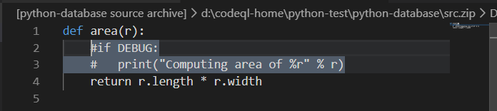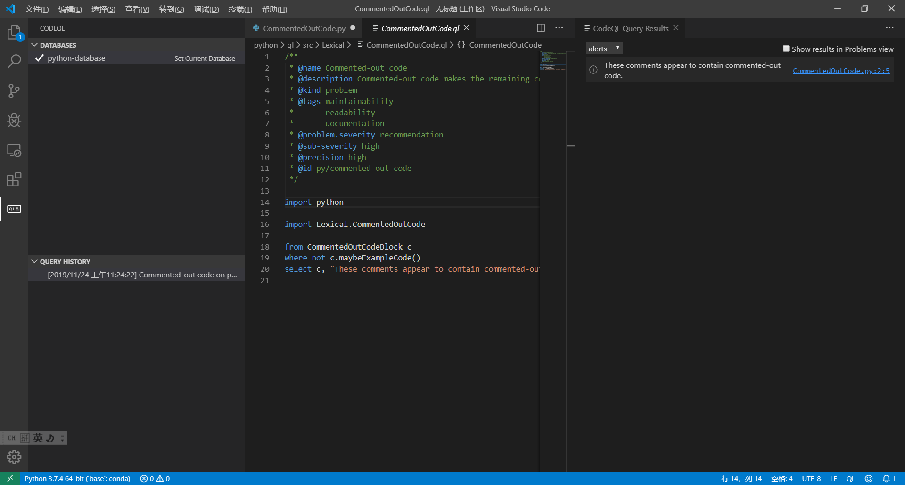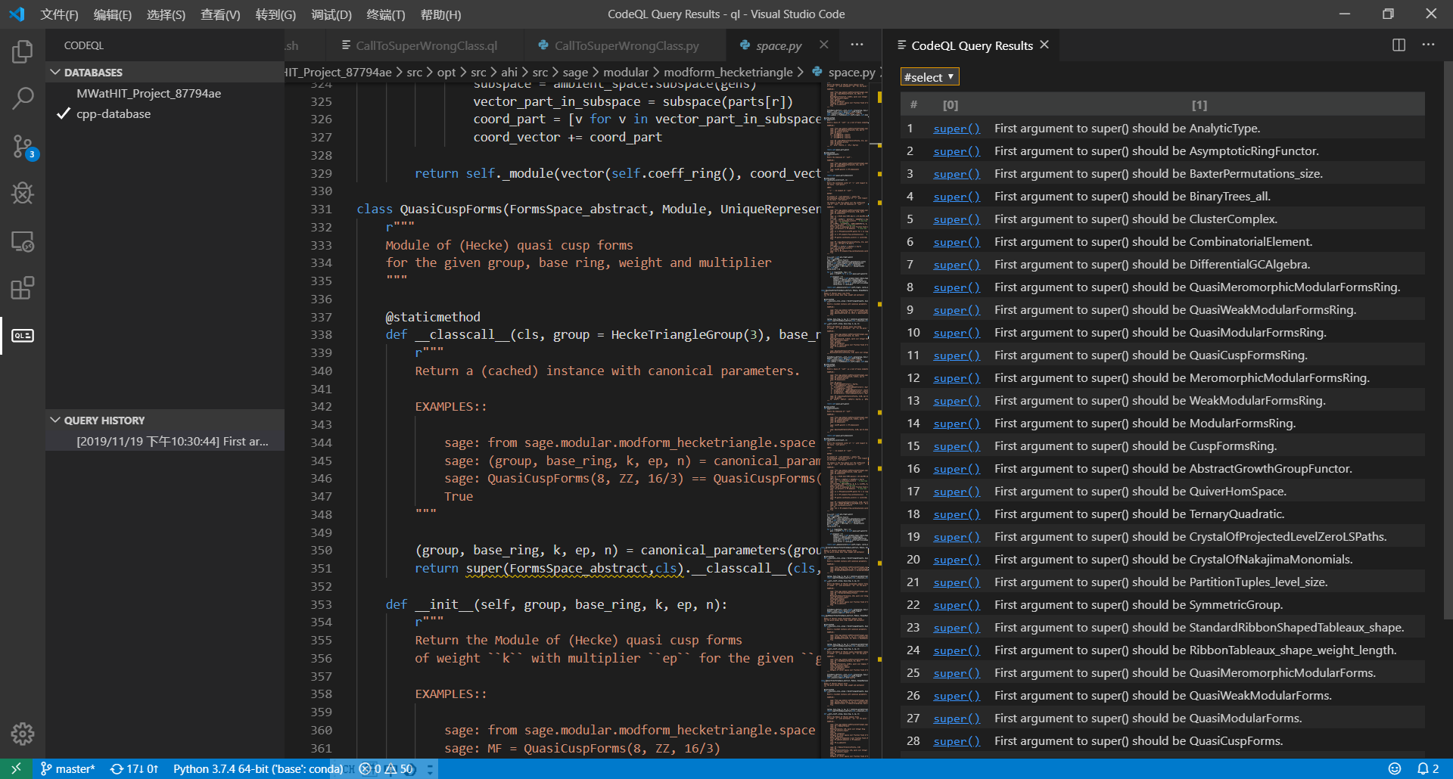Basic c/c++ query example:<https://lgtm.com/help/lgtm/console/ql-cpp-basic-example>