|  |  |  |
| --- | --- | --- |
| 12/07/2017 |  | LISTE DES CLASS |
|  |  |  |

# LISTE DES CLASS

Nom du projet

My Framework CSS

Nom du client

WEB@cademie

Responsable de projet

Jonathan GRONDIN

| CLASS | MEDIA | ACTION |  |  |
| --- | --- | --- | --- | --- |
| col-s-1~12 | -640px | Divise l’écrans en colonne |  |  |
| col-m-1~12 | 640px | Divise l’écrans en colonne |  |  |
| col-l-1~12 | 1024px | Divise l’écrans en colonne |  |  |
|  |  |  |  |  |
| m-show | 640px | Affiche à l’écrans |  |  |
| l-show | 1024px | Affiche à l’écrans |  |  |
|  |  |  |  |  |
| m-hide | 640px | Cache à l’écrans |  |  |
| l-hide | 1024px | Cache à l’écrans |  |  |
| col-s-center | -640px |  |  |  |
| col-m-center | 640px |  |  |  |
| col-l-center | 1024px |  |  |  |
| col-s/m/l-push-1~12 |  | Décale vers la droite |  |  |
| col-s/m/l-pull-1~12 |  | Décale vers la gauche |  |  |
| col-s/m/loffset-1~12 |  | Réduit |  |  |

REPONSIVE

| CLASS | ACTION |  |  |
| --- | --- | --- | --- |
| container-fluid | Créer une marge sur les coté |  |  |
| container | Prends la largeur de tous l’écrans |  |  |

CONTAINER

BUTTON

| CLASS | ACTION |  |  |
| --- | --- | --- | --- |
| btn-green | Créer un button green |  |  |
| btrn-blue | Créer un button blue |  |  |
| btn-red | Créer un button red |  |  |
| btn-white | Créer un button white |  |  |
| ~ton button~ --sm | Changer taille du button en small |  |  |
| ~ton button~ --md | Changer taille du button en medium |  |  |
| ~ton button~ --lg | Changer taille du button en large |  |  |



IMG

| CLASS | ACTION |  |  |
| --- | --- | --- | --- |
| img-responsive | Img responsive |  |  |
| img-rounded | Légère bordure |  |  |
| img-circle | Img round |  |  |
| img-thumbail | Créer un cadre |  |  |
| img-blur | Floute img |  |  |

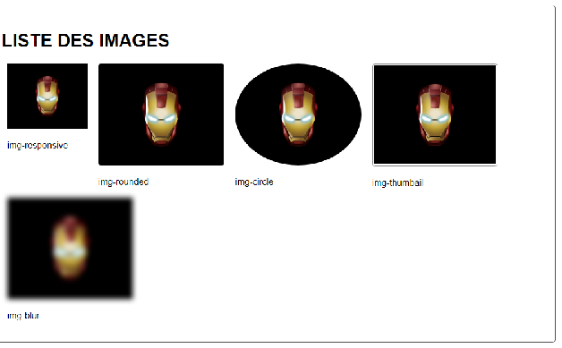

| CLASS | ACTION |  |  |
| --- | --- | --- | --- |
| text-muted | Change color text |  |  |
| text-primary | Change color text |  |  |
| text-success | Change color text |  |  |
| text-info | Change color text |  |  |
| text-warning | Change color text |  |  |
| text-error | Change color text |  |  |
| bg-muted | Change background color |  |  |
| bg-primary | Change background color |  |  |
| bg-success | Change background color |  |  |
| bg-info | Change background color |  |  |
| bg-warning | Change background color |  |  |
| bg-error | Change background color |  |  |

