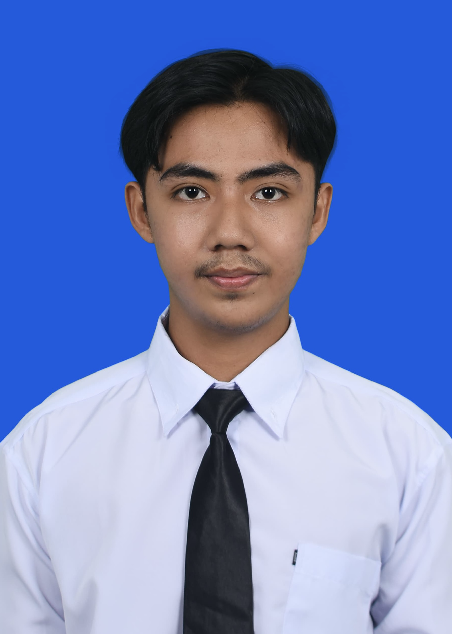
MUHAMMAD FATHONI
Address: Yogyakarta, Indonesia (open to relocation)
Phone: +6282258503481
Email: fathonimuhammad2411@gmail.com
LinkedIn: linkedin.com/in/muhammad-fathoni-038274266
Portfolio: toni2411.github.io · GitHub: github.com/Toni2411

PERSONAL PROFILE

Electrical Engineer from Universitas Islam Indonesia (GPA 3.78/4.00, full scholarship), now pursuing a Master of Electrical Engineering at the same university. I build AI and IoT systems for industry, from sensors and control panels to machine learning models, language models and the software that acts on their data. My latest project, SIAGA, is a predictive maintenance ERP for mining that warned about 25 hours before a real bearing failure and turns equipment condition into work orders and purchase requests on its own. Looking for engineering and industrial AI roles in mining, energy and manufacturing.

CORE EXPERTISE
- Industrial AI & Predictive Maintenance: Anomaly detection on vibration data with per unit Isolation Forest models, health scoring and failure lead time evaluation, connected to ERP work orders, spare parts and procurement.
- Generative AI, RAG & AI Agents: RAG pipelines built from scratch, multi agent systems, and guardrails measured with evaluation sets. Hands on with Claude, Google Gemini and local models on Ollama.
- IoT & Embedded Systems: ESP32 firmware, sensor integration, state machine control panels, MQTT telemetry and realtime dashboards, validated in simulation before touching hardware.
- Backend & Data Platforms: ERPNext, FastAPI, Flask, TimescaleDB, PostgreSQL, Supabase and Firebase, deployed with Docker.
- Electrical Engineering: Electrical wiring and troubleshooting, PID control on LabVIEW, MATLAB, VHDL/FPGA, distribution reliability (SAIDI/SAIFI) and EV electrical systems.
- Mobile & Workflow Automation: Android and iOS apps with Capacitor, plus n8n and Telegram bot automations for alerts, reports and approvals.

PROFESSIONAL SKILLS
- Programming Languages: Python, JavaScript, TypeScript, SQL (PostgreSQL), C, C++, HTML, CSS, VHDL
- AI & Machine Learning: Claude, Google Gemini, Ollama, RAG, AI agents, LLM evaluation, prompt engineering, scikit-learn, Isolation Forest, Random Forest
- IoT & Industrial: ESP32, Arduino, MQTT, sensors (vibration, PZEM-004T, MQ-135, pH, ultrasonic), control panels, PLC, PID control
- Backend & Cloud: ERPNext, FastAPI, Flask, TimescaleDB, PostgreSQL, Supabase, Firebase, REST APIs, Docker
- Electrical & Simulation: MATLAB, LabVIEW, Proteus, Quartus, FPGA, Wokwi, electrical wiring and troubleshooting
- Tools: Git, GitHub, n8n, Android Studio, Capacitor, Google Colab, Microsoft Office
- Interpersonal: Fast learner, adaptive under pressure, project management, end-to-end product ownership, teamwork, analytical thinking, leadership, problem-solving
- Spoken Languages: Indonesian, English

EDUCATIONAL HISTORY

Universitas Islam Indonesia, Yogyakarta September 2026 – Present
Master of Electrical Engineering (in progress)

Universitas Islam Indonesia, Yogyakarta August 2022 – May 2026
Bachelor of Electrical Engineering, GPA: 3.78/4.00, UII Excellent Community full scholarship

WORK EXPERIENCES

NOORA DEEN TECHNOLOGY
Part time, Full Stack / AI Engineer (Co-founder) May 2026 – Present
- Built Noora, a cross platform Islamic lifestyle app for Android and iOS: location based prayer times, the full Qur'an with Kemenag translation and per ayah audio, daily hadith, digital tasbih, sunnah fasting reminders and a streak system.
- Own the whole technical stack: offline first frontend, Supabase backend with authentication, realtime sync and row level security, the native Android and iOS release pipeline, and the company website nooradeen.com.

PT PLN (PERSERO) ULP PASIR PENGARAIAN
Internship, Technical Division September 2025 – October 2025
- Used the APKT PLN system to analyze outage data and reliability metrics like SAIDI and SAIFI, helping the technical team make better decisions.
- Documented service interruption cases and put together reliability reports for performance reviews.

UNIVERSITAS ISLAM INDONESIA
Laboratory Assistant February 2024 – January 2026
- Subjects: Electric Circuit II, Telecommunication System, Digital System, and Control System (Feb 2024 – Jan 2026).
- Ran practical sessions covering circuit analysis, signal processing, VHDL programming on Quartus with FPGA, and PID control on LabVIEW (air heater and DC motor setups).
- Built up teaching and communication skills while helping students work through tough engineering concepts.

ORGANIZATIONAL EXPERIENCES

IEEE Student Branch Universitas Islam Indonesia, Yogyakarta
Director of Academies June 2024 – May 2026
- Lead the planning and rollout of academic programs that help members grow technically and professionally.
- Handle strategic planning, lead the team, and run initiatives that expand the organization’s impact.

Ulil Albab Student Center Electric Vehicle, Yogyakarta
Head of Programming / Electrical Engineer July 2023 – March 2025
- Led the programming and electrical systems team for vehicle control, keeping execution aligned with technical and performance goals.
- Designed and troubleshot EV electrical wiring and used Proteus for circuit simulation to optimize system performance and safety.

Unisi Robotic
Electrical Division Staff May 2024 – May 2026
- Design and build electrical wiring systems for robotic projects.
- Diagnose and fix electrical issues to improve system reliability.

ACHIEVEMENTS

- 3rd Place PKM IC Community Service Scheme (2025)
- 4th Place PKM IC Karsa Cipta Scheme (2024)
- 5th Place PKM IC Innovative Work Scheme (2025)
- 1st Place in IT Centrum Startup Hackathon 2024 at Universitas Islam Indonesia (December 13 – 14, 2024)
- 1st Place in Business Idea Competition, part of the Entrepreneur Competition during Student Entrepreneur Day 2024

PROJECTS

SIAGA: Predictive Maintenance ERP for Mining (2026) · github.com/Toni2411/siaga
- Condition based maintenance on ERPNext: vibration features stream over MQTT into TimescaleDB, and per unit Isolation Forest models score each machine against its own healthy baseline.
- A sustained drop in health score raises a work order with suspected parts, reserves stock and drafts a purchase request; parts can be ordered early from the projected health trend.
- Warned about 25 hours before a real bearing failure (NASA IMS dataset), and 80 and 128 hours ahead on a second dataset. Includes a Telegram bot for mechanics and a read only LLM assistant on local Ollama.

Autonomous AI Video Studio: Multi Agent Content Pipeline (2026)
- Team of Claude based agents that writes, generates, checks, uploads and learns from an animated YouTube series; a supervisor agent scores every script against a rubric before production.
- QC agent rejects black frames, unwanted speech and titles the footage does not support; an analyst agent feeds day 1, 3 and 7 metrics back into shared memory. Controlled from Telegram with a hard monthly API budget.

Guardrailed LLM Content: RAG Chatbot and n8n Post Generator (2026)
- RAG chatbot built from scratch (chunking, embeddings, retrieval, reranking) with a calibrated relevance floor that refuses when nothing relevant is retrieved; faithfulness 1.00 across 15 evaluation cases.
- 21 node n8n workflow for weekly social media posts, with a regex gate that sends risky claims to human review.

Wastewater Treatment Control Panel (2026)
- ESP32 state machine firmware that runs 120 L treatment batches automatically, switching four pumps and a UV lamp, with level and pH sensing, fault handling and backwash reminders.
- Realtime Firebase dashboard with history charts, CSV export and an event log; logic validated in Wokwi against a written test procedure.

SEMS: Smart Energy Management System with IoT, Machine Learning and AI Recommendations (September 2025 – May 2026)
- IoT-based energy monitor for Indonesian homes, using ESP32, PZEM-004T, and DHT22 sensors paired with a responsive web dashboard backed by Firebase.
- Trained a Random Forest model that forecasts monthly consumption (R² 0.9893, MAPE 4.93%) and deployed it as a Flask REST API.
- Google Gemini 2.5 Flash gives users energy-saving tips by PLN tariff bracket (450VA to 5500VA). Buzzer alerts trigger on detected anomalies, and N8N automates Telegram chatbots, daily reports, and electrical anomaly notifications.

Mosha AirQ: Smoke Detection for a Smoke Free School (2026)
- ESP32 and MQ-135 air monitor with a rule based classifier and realtime dashboard; a 30 vs 30 reading test showed 561 PPM in clean air versus 1703 PPM during smoking, which set a 1500 PPM detection threshold.

Webhook Delivery Service (2026)
- Python and FastAPI service with durable acknowledgement, idempotency keys, per customer queues, retries with backoff, a status API and replay, covered by a pytest suite.

AromatheraWrist: Smart Bracelet with Aromatherapy and Pulse Sensor for Anxiety Relief (January 2024 – August 2024)
- Smart bracelet that combines a real-time pulse sensor with aromatherapy to help reduce anxiety, paired with a mobile app for stress tracking and aromatherapy triggers.
- Received funding from Indonesia’s Student Creativity Program (PKM-KC) 2024.

TRAINING, LICENSES, AND CERTIFICATIONS

IBM SkillsBuild September 2026
AI Fundamentals: Foundations for Understanding AI (credly.com/go/NFH2IvaK)

Google Cloud Skills September 2026
Introduction to Large Language Models; Introduction to Generative AI

MathWorks September 2026
MATLAB Onramp

Department of Electrical Engineering Universitas Islam Indonesia November 2024 and May 2025
Python Class for Data Scientist (Beginner)

Department of Electrical Engineering Universitas Islam Indonesia December 21, 2024
Basic PLC Training

Huawei Talent Online December 13, 2023
HCIA-Datacom V1.0 Course

