

Tonie Enriquez Caponpon

2000985H

**Background**

Singapore’s healthcare system has successfully met the country’s demands for the past few years, but did they do it with ease? Were they able to carry on their duties without a shortage of resources? In this report, I will be looking into our healthcare’s resources, inclusive of our healthcare workers and beds.

The dashboards in this report should be able to show you:

* Changes in our healthcare over time
* Any gaps in our healthcare system
* Significant issues or any highlights in our statistics of staff resources.

At the end, you should have a better idea of our healthcare system and find out whether our supply can cope with the healthcare demand currently and in future.

Part 1 – Narrative Framework

Part 2 – Dashboards/Graphs, and new dataset and created fields

**Part 1 – Narrative Framework**

Big Idea:

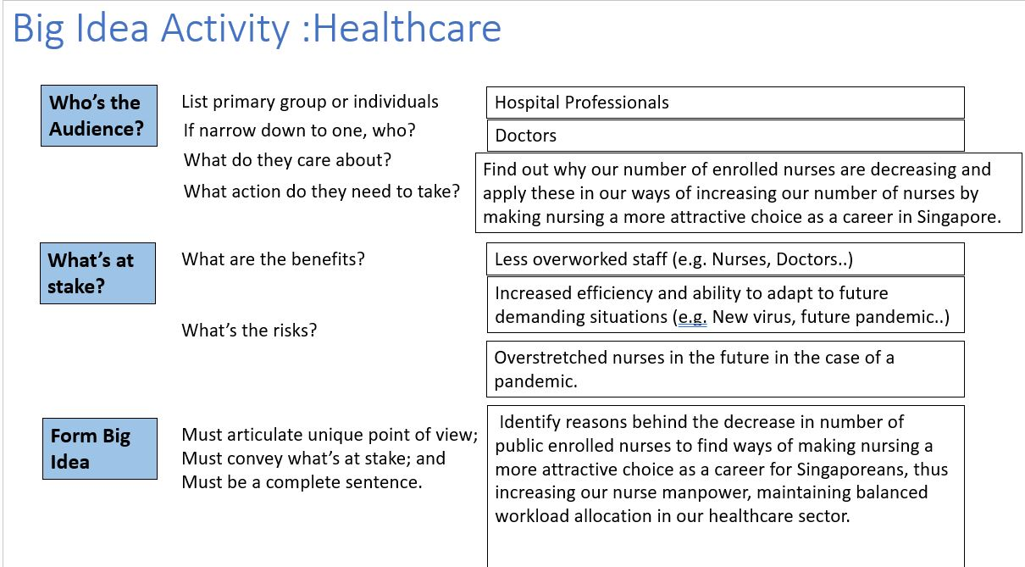

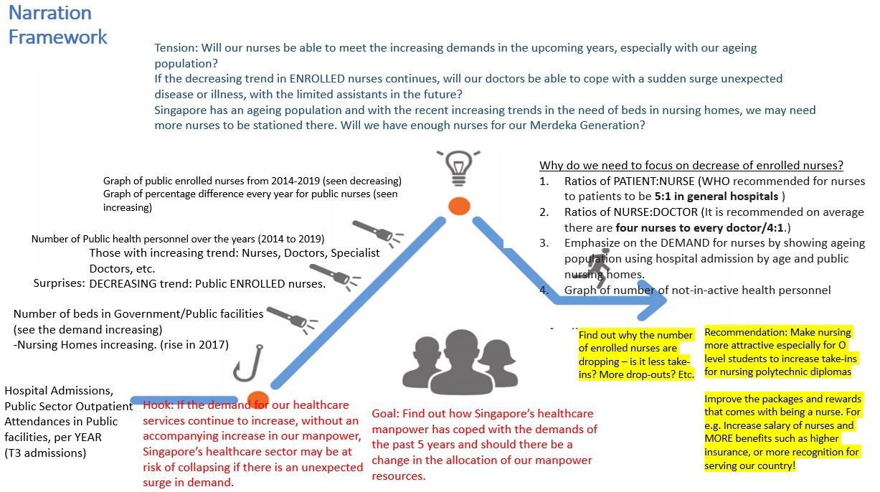

This report mainly focuses on a surprising find: a decreasing trend in our number of enrolled nurses. I will be emphasising on WHY we need more nurses in our healthcare sector, and why this is very important for our system to meet the healthcare demands of our citizens.

**Part 2 – Dashboards/Graphs, new dataset & created fields**

*a look into our healthcare sector:*

1. Hospital Admissions, Public Sector Outpatient Attendances and Day Surgeries from 2014 to 2019

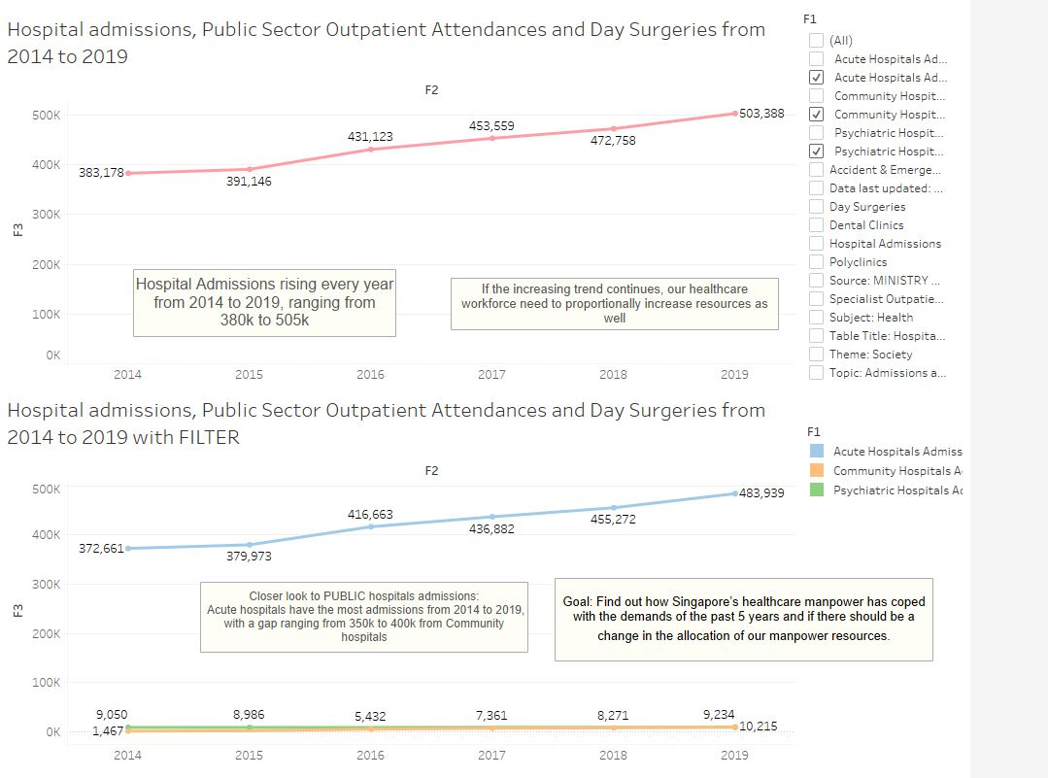

Line graphs were used to show the increase during the timeline of 2014 to 2019. I chose these five years to show the trends, excluding 2020, because 2020’s numbers in the dataset were greatly lower than the previous years. It would have ruined our trends and findings if I were to use 2020’s extremely different set of values.

From the first graph, we can see the total number of admissions and attendances in Public/Government facilities increasing over the years from 2014 to 2019. This shows the demands in our healthcare system has been increasing over the years. If this increasing trend continues, our healthcare workforce needs to proportionally increase resources as well.

From the second graph, we can see the admissions and attendances filtered to each public facility. Acute hospitals have the greatest number of hospital admissions and outpatient attendances from 2014 to 2019, with its gap above Community Hospital admissions ranging from 350,000 to 400,000.

**OUR GOAL** for this report is to find out how Singapore’s healthcare manpower has coped with the demands of the past 5 years and if there should be a change in the allocation of manpower resources.

1. Total Number of Beds in Public Inpatient Facilities from 2014 to 2019

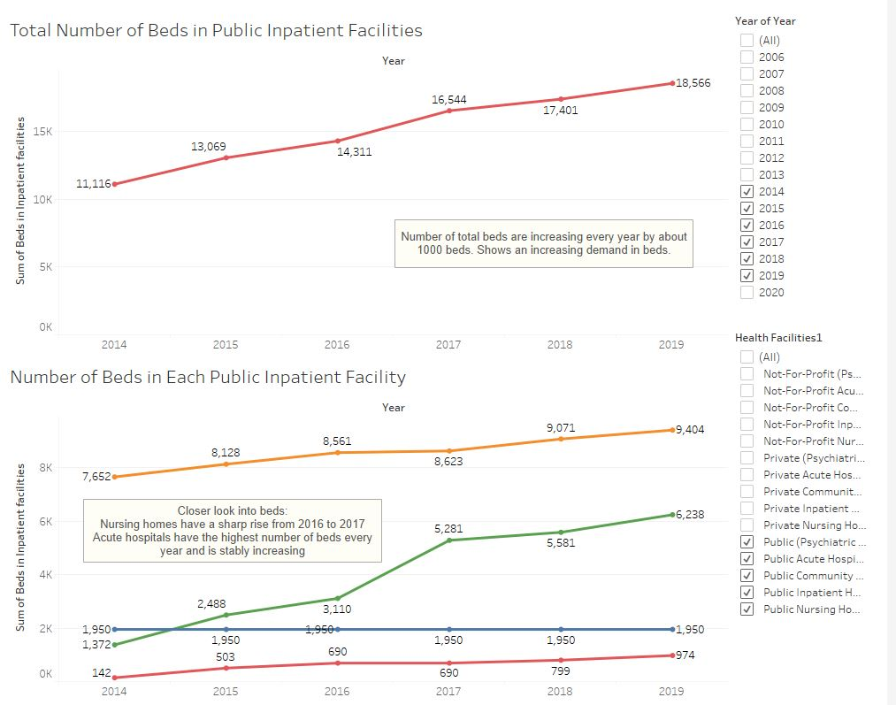

The first graph shows us an increasing number of total PUBLIC beds from 2014 to 2019. It has been stably increasing by about 1000-1500 beds every year.

However, drilling into which public inpatient facilities have high numbers of beds, in the second graph, we can see that Acute hospitals have the highest number of beds every year and is also stably increasing. In addition, Nursing homes experienced a sharp rise from 2016 to 2017 and went from 3,110 to 5,281. From then on, it has been increasing as well. This tells us that beds in nursing homes have an increasing demand!

1. Number of Public Health Personnel in our Public Facilities from 2014 to 2019

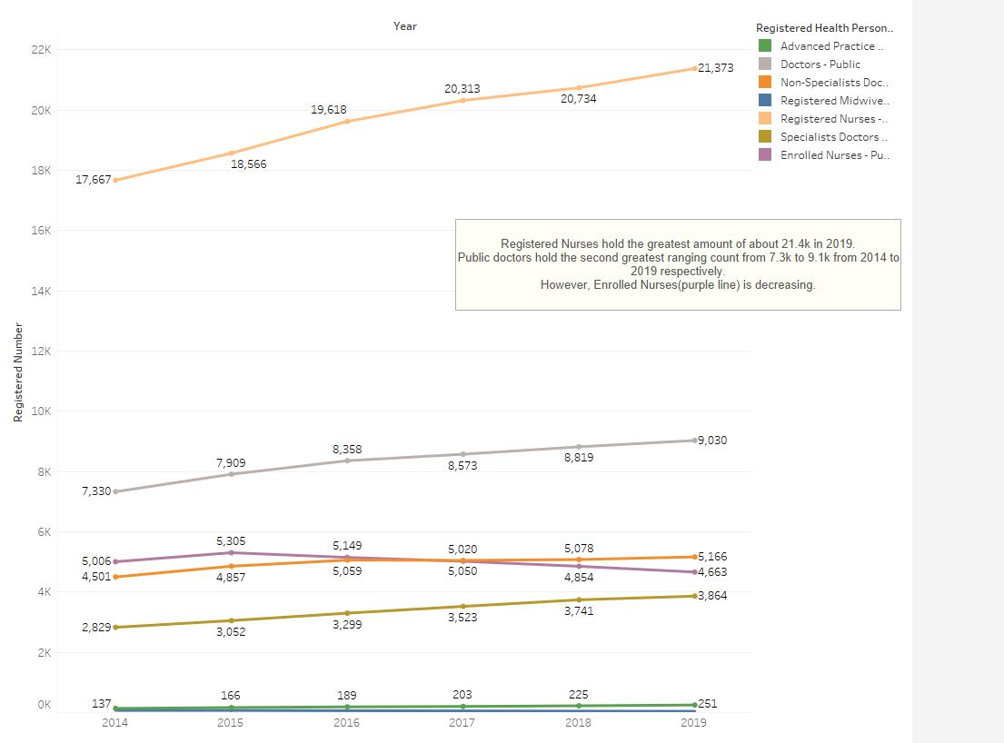

This line graph shows us clearly that Registered Nurses hold the greatest amount of about 21,400 in 2019. It has stably increased from 2014 to 2019, without showing any sharp rises in numbers. Public doctors hold the second greatest amount of about 9,000, and it has also been increasing throughout the years, but only by a small difference.

However, here we find an interesting insight. We have one group of health personnel with a decreasing trend. This is not beneficial in our journey towards a more balanced healthcare system. Our Public ENROLLED NURSES have been experiencing a decrease in numbers from 2015 onwards, after hitting a peak of 5,305 in 2015.

*a look into our decreasing number of Enrolled nurses:*

1. Number of Public Enrolled Nurses, and its percentage difference, every year from 2014 to 2019.

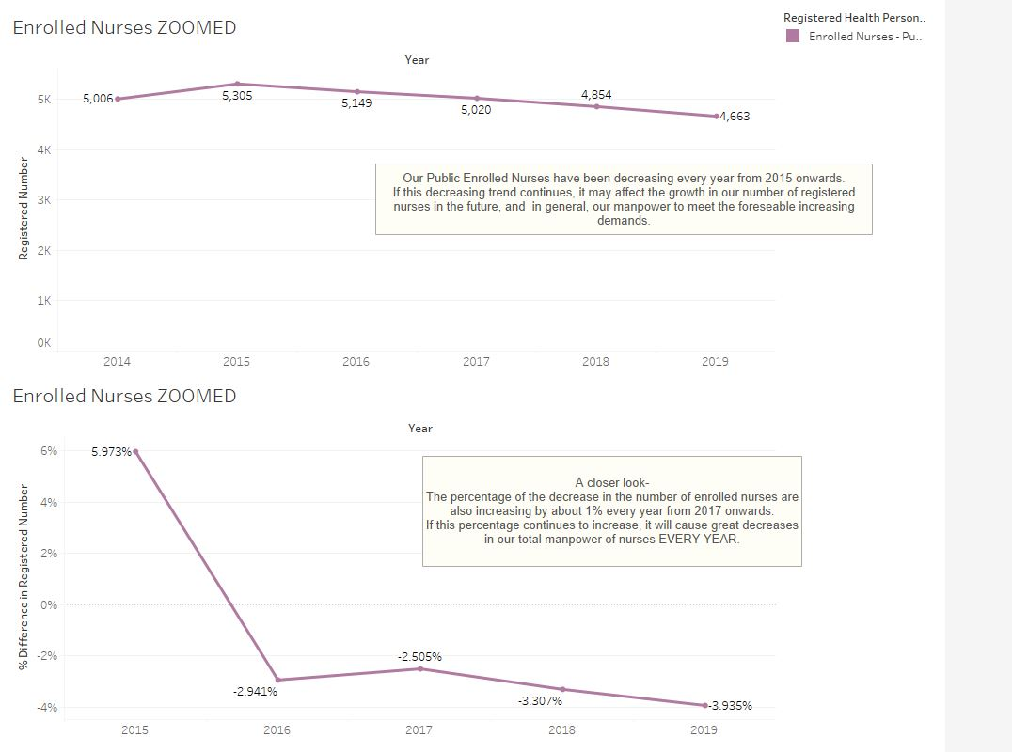

Our public enrolled nurses have been decreasing every year from 2015 onwards. If such a trend continues, it may affect our growth in our number of registered nurses in the future as well. This is because people take the route of being an Enrolled nurse for 2 years, before becoming a Registered nurse – Registered nurses are able to perform the basic job of a nurse without supervision, therefore being helpful to our services. However, enrolled nurses act as assistants to registered nurses, and can only perform under their supervision.

A closer look into the percentage differences: We can see that the percentage decrease of enrolled nurses are increasing from 2017 onwards. If this percentage continues to increase, it will cause greater decreases in our total manpower of nurses EVERY YEAR.

Now, Why should there be a need to focus on our number of enrolled nurses, or nurses in general?

NEW DATASET AND NEW CALCULATED FIELDS CREATED for the next part:

1. New dataset, uniting columns from the three different datasets using the key: YEAR.

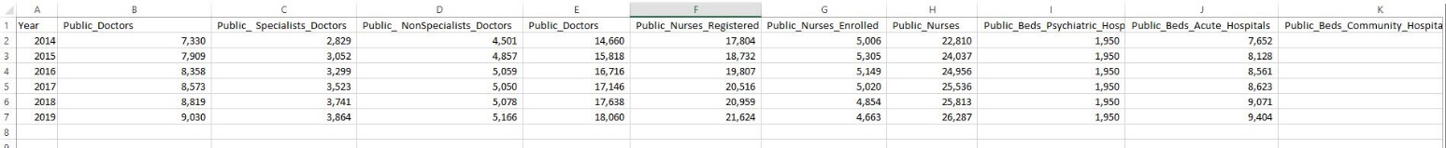

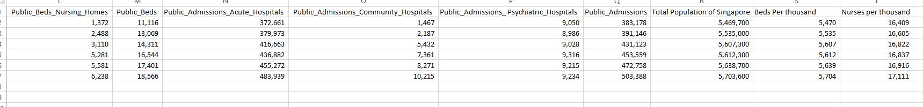

Putting these columns together made it easier for me to create new calculated fields for my graphs in the next segment. I did this on excel by matching these columns using one common key: the YEAR (2014 to 2019)

I also added new columns: Total Population of Singapore, Beds Per Thousand, Nurses per Thousand

1. New created field using new dataset: Ratio of Total Doctors to Nurses

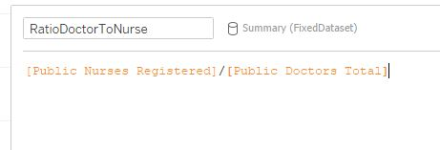

1. New created field using new dataset: Ratio of Total Admissions to Nurses

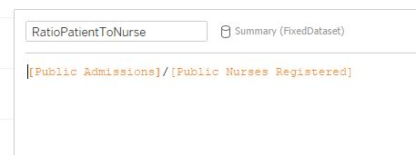

1. New created field using new dataset: Ratio of Total Doctors to Nurses STATUS

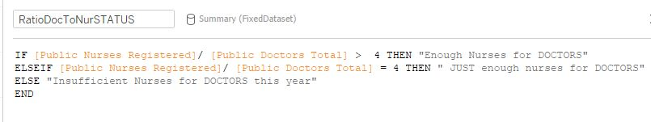

1. New created field using new dataset: Ratio of Total Admissions to Nurses STATUS

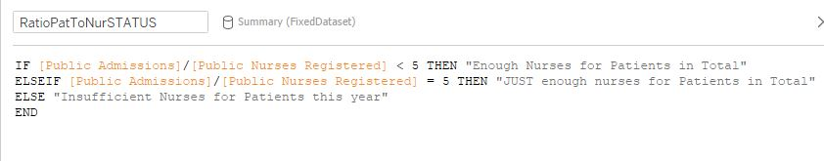

-end-

*a look into why we should be paying attention to our number of nurses:*

1. Ratio of Doctors to Nurses from 2014 to 2019

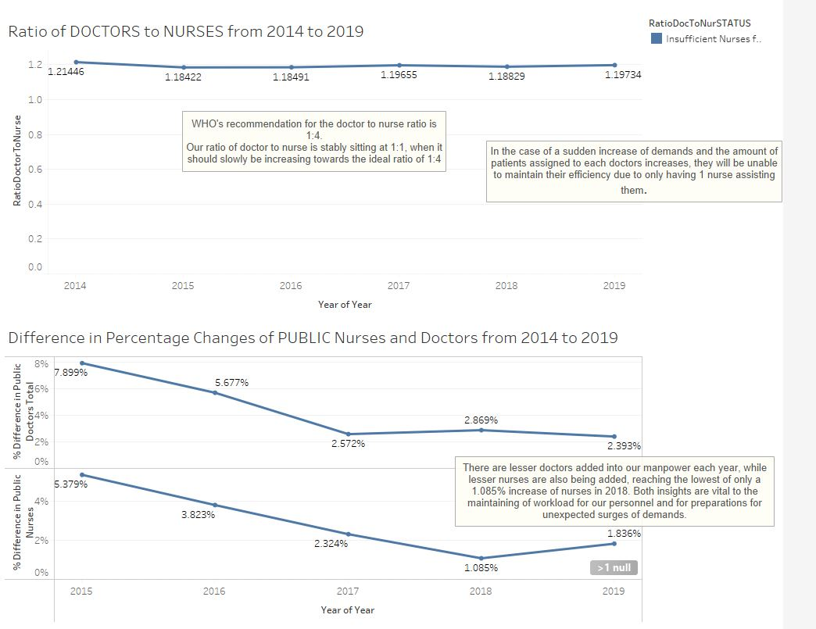

Our ratio of doctors to nurses is stably sitting at 1:1, when it should slowly be increasing towards the ideal ratio of 1:4. It also has been maintaining a status of “Insufficient Nurses for Doctors” for all years in 2014 to 2019.

Why do we need to look into the ratio of our doctors to our nurses? Firstly, WHO’s recommendation for the ideal ratio is 1:4. You may think that 1:1 is enough, but the reason for the need of 4 nurses for each doctor is this: In the case of a sudden increase of demands, such as a pandemic like COVID-19, and the amount of patients assigned to each doctor increases, they will be unable to maintain their efficiency and lessen the room of error, due to only having 1 nurse assisting them. At the same time, nurses will be stretched and they will be forced to be assigned to more than 1 doctor, and this may cause confusion and inaccurrate management of caring for the different patients.

The two graphs below are just as important. There are lesser doctors being produced each year, while lesser nurses are being added into our manpower as well, reaching the lowest point of only a 1.085% increase in 2018! These insights are vital to the maintaining of balanced workload for our staff, and preparations for unexpected surges in demands.

1. Ratio of Admissions to Nurses from 2014 to 2019

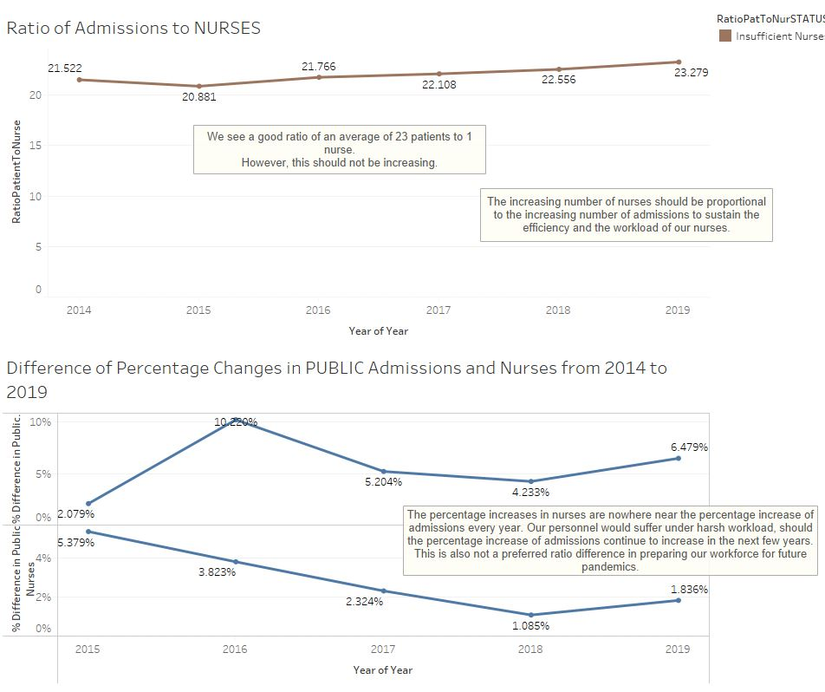

From the graph on top, we can seen increasing ratio of Admissions to Nurses, with 23:1 in 2019 However, this graph should not be showing an increasing trend. This means that the number of patients assigned to a nurse, at a time, could be increasing. The increasing number of nurses should be proportional to the increasing number of admissions to sustain their efficiency and also their workload. Similar to the case of doctors to nurses, this is important as the number of patients under the care of a nurse greatly affects their quality of work and management of responsibilities such as who to give medicine to, at certain times.

For the two graphs below the top, the percentage increases in nurses are clearly nowhere near the percentage increases of admissions every year! Our personnel would suffer under harsh workload, should the percentage increase of admissions continue to increase in the next few years. This is also not a preferred ratio difference between the two groups, in preparing our workforce for future pandemics.

1. Relating the Number of Beds in Public Nursing Homes To Hospital Admission Rates by AGE from 2014 to 2019.

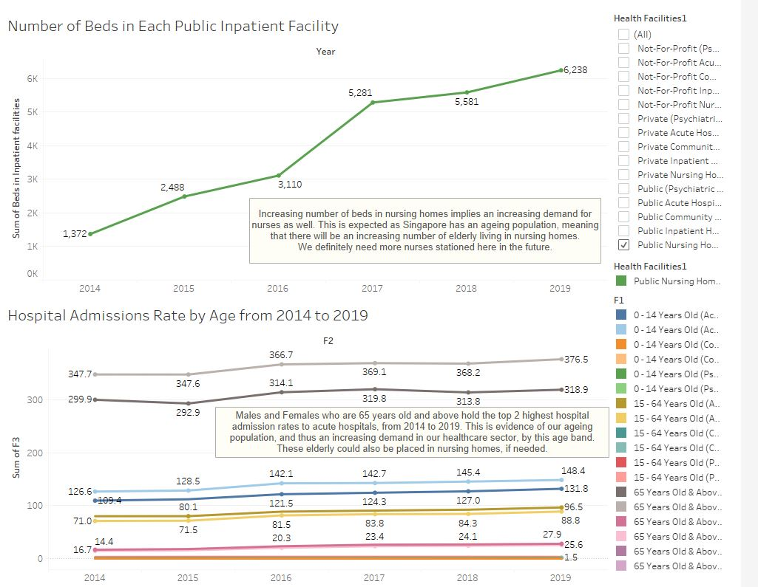

From the top graph, it is evident that there is an increasing number of beds in nursing homes, implying that there is an increasing demand for nurses there as well. This is very much expected as Singapore has an ageing population, meaning that there would definitely be an increasing number of elderly living in nursing homes. More nurses being stationed there would definitely be a decision to be made in the near future.

The graph of hospital admission rates by AGE proves our point about Singapore’s ageing population. Males and Females who are 65 years old and above, hold the top 2 highest hospital admission rates to acute hospitals, from 2014 to 2019. This further implies that there is an increasing demand in our healthcare sector, by this specific age band. These elderly, if illnesses persist and long-term medication is needed, would be placed in nursing homes, thus increasing the demand of nurses as a result.

1. Number of Not-in-active Healthcare Hospital Personnel from 2014 to 2019

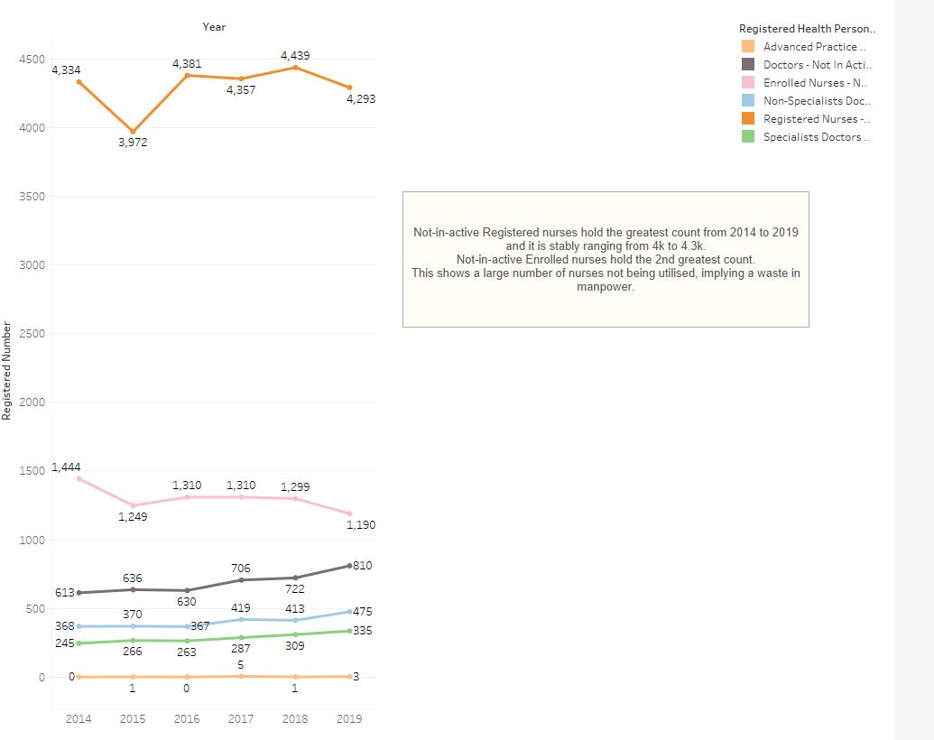

From this graph alone, we can see that registered nurses have the greatest count of not-in-active personnel from 2014 to 2019, and it is stably ranging from 4000 to 4,400. Not-in-active Enrolled nurses hold the 2nd greatest count out of all personnel. This shows a large number of nurses not being utilised by our healthcare sector, implying a waste in manpower. These nurses being added to our services would be beneficial to our workload distribution and therefore supports the cause in increasing our nurses in Singapore.

1. RECOMMENDATIONS

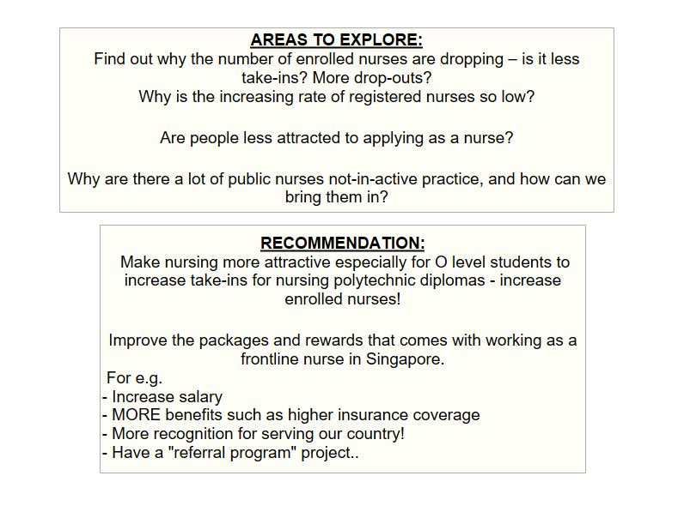

Increasing our number of nurses greatly contributes to the wellbeing of our healthcare personnel in Public hospitals. Whether be it to attending to the current number of admissions or in preparation for an unexpected surge of demand in the near future. My advice is for our directors to find ways to make Nursing a more attractive choice to our citizens, thus increasing our manpower of nurses. This is vital to creating a more balanced work environment, without overstretching any of our personnels in the healthcare sector.



Tonie

P01

Tonie Enriquez CAPONPON, 2000985H