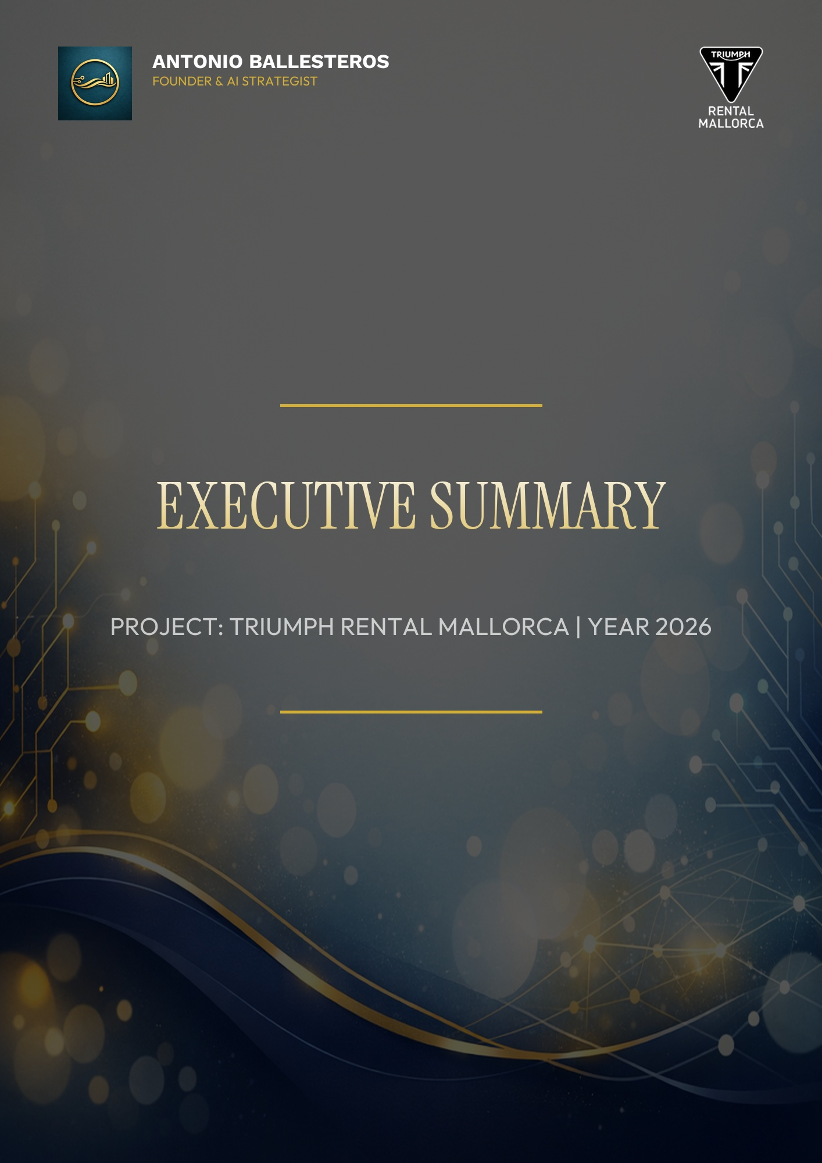

CONTENTS
1
1. Status Summary: Your Online Presence 1
1.1. Identified Issues (Immediate Impact) 1
1.2. Conclusion 1

1. Status Summary: Your Online Presence

A detailed analysis of your website has revealed several critical issues that are currently hindering your growth and allowing competitors in Mallorca to gain an advantage.

1.1. Identified Issues (Immediate Impact)

1. Mobile Access Barrier
Your website has a major flaw on mobile devices: the navigation menu does not function properly. Most tourists book via their phones; if they cannot navigate easily,
they will leave your site within seconds and look for another provider.
2. Difficulty Being Found Locally
While your brand is strong, search engines (Google) are not effectively connecting your website with searches made in Spanish or English on the island.
You are losing visibility to other services that have optimized their presence for these languages.
3. Response Speed
The page takes longer than it should to display key information. In the digital world, every second of waiting is a lost sales opportunity.

1.2. Conclusion

Your business offers an exceptional product, but your "digital storefront" has cracks that are driving away potential customers right now.
It is urgent to correct these errors to ensure the upcoming season is a resounding success.
Recommendation: Act on these points immediately before competitors further strengthen their position.

