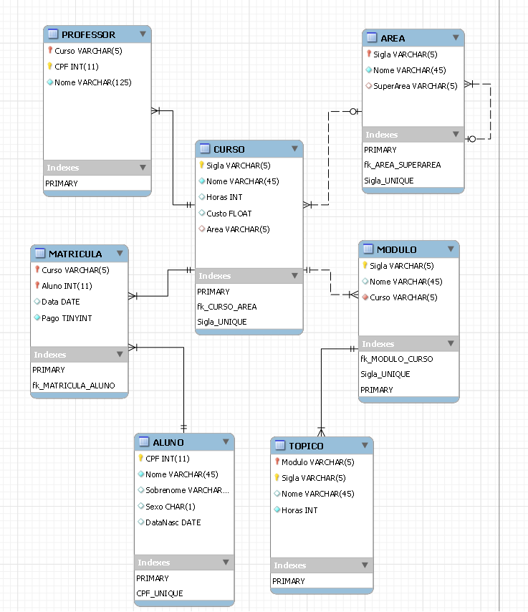

*-- MySQL Script generated by MySQL Workbench*

*-- Tue Sep  6 16:43:21 2022*

*-- Model: New Model    Version: 1.0*

*-- MySQL Workbench Forward Engineering*

SET @OLD_UNIQUE_CHECKS=@@UNIQUE_CHECKS, UNIQUE_CHECKS=0;

SET @OLD_FOREIGN_KEY_CHECKS=@@FOREIGN_KEY_CHECKS, FOREIGN_KEY_CHECKS=0;

SET @OLD_SQL_MODE=@@SQL_MODE, SQL_MODE='ONLY_FULL_GROUP_BY,STRICT_TRANS_TABLES,NO_ZERO_IN_DATE,NO_ZERO_DATE,ERROR_FOR_DIVISION_BY_ZERO,NO_ENGINE_SUBSTITUTION';

*-- -----------------------------------------------------*

*-- Schema SAM*

*-- -----------------------------------------------------*

*-- -----------------------------------------------------*

*-- Schema SAM*

*-- -----------------------------------------------------*

CREATE SCHEMA IF NOT EXISTS `SAM` DEFAULT CHARACTER SET utf8 ;

USE `SAM` ;

*-- -----------------------------------------------------*

*-- Table `SAM`.`AREA`*

*-- -----------------------------------------------------*

CREATE TABLE IF NOT EXISTS `SAM`.`AREA` (

  `Sigla` VARCHAR(5) NOT NULL,

  `Nome` VARCHAR(45) NOT NULL,

  `SuperArea` VARCHAR(5) NULL,

  PRIMARY KEY (`Sigla`),

  INDEX `fk_AREA_SUPERAREA` (`SuperArea` ASC, `Sigla` ASC) VISIBLE,

  UNIQUE INDEX `Sigla_UNIQUE` (`Sigla` ASC) VISIBLE,

  CONSTRAINT `SuperArea`

    FOREIGN KEY (`SuperArea` , `Sigla`)

    REFERENCES `SAM`.`AREA` (`Sigla` , `SuperArea`)

    ON DELETE NO ACTION

    ON UPDATE NO ACTION)

ENGINE = InnoDB;

*-- -----------------------------------------------------*

*-- Table `SAM`.`CURSO`*

*-- -----------------------------------------------------*

CREATE TABLE IF NOT EXISTS `SAM`.`CURSO` (

  `Sigla` VARCHAR(5) NOT NULL,

  `Nome` VARCHAR(45) NOT NULL,

  `Horas` INT NULL,

  `Custo` FLOAT NULL,

  `Area` VARCHAR(5) NULL,

  PRIMARY KEY (`Sigla`),

  INDEX `fk_CURSO_AREA` (`Area` ASC) VISIBLE,

  UNIQUE INDEX `Sigla_UNIQUE` (`Sigla` ASC) VISIBLE,

  CONSTRAINT `fk_CURSO_AREA1`

    FOREIGN KEY (`Area`)

    REFERENCES `SAM`.`AREA` (`Sigla`)

    ON DELETE NO ACTION

    ON UPDATE NO ACTION)

ENGINE = InnoDB;

*-- -----------------------------------------------------*

*-- Table `SAM`.`MODULO`*

*-- -----------------------------------------------------*

CREATE TABLE IF NOT EXISTS `SAM`.`MODULO` (

  `Sigla` VARCHAR(5) NOT NULL,

  `Nome` VARCHAR(45) NULL,

  `Curso` VARCHAR(5) NOT NULL,

  INDEX `fk_MODULO_CURSO` (`Curso` ASC) VISIBLE,

  UNIQUE INDEX `Sigla_UNIQUE` (`Sigla` ASC) VISIBLE,

  PRIMARY KEY (`Sigla`),

  CONSTRAINT `fk_MODULO_CURSO1`

    FOREIGN KEY (`Curso`)

    REFERENCES `SAM`.`CURSO` (`Sigla`)

    ON DELETE NO ACTION

    ON UPDATE NO ACTION)

ENGINE = InnoDB;

*-- -----------------------------------------------------*

*-- Table `SAM`.`TOPICO`*

*-- -----------------------------------------------------*

CREATE TABLE IF NOT EXISTS `SAM`.`TOPICO` (

  `Modulo` VARCHAR(5) NOT NULL,

  `Sigla` VARCHAR(5) NOT NULL,

  `Nome` VARCHAR(45) NULL,

  `Horas` INT NOT NULL DEFAULT 0,

  PRIMARY KEY (`Modulo`, `Sigla`),

  CONSTRAINT `fk_TOPICO_MODULO1`

    FOREIGN KEY (`Modulo`)

    REFERENCES `SAM`.`MODULO` (`Sigla`)

    ON DELETE NO ACTION

    ON UPDATE NO ACTION)

ENGINE = InnoDB;

*-- -----------------------------------------------------*

*-- Table `SAM`.`ALUNO`*

*-- -----------------------------------------------------*

CREATE TABLE IF NOT EXISTS `SAM`.`ALUNO` (

  `CPF` INT(11) NOT NULL,

  `Nome` VARCHAR(45) NOT NULL,

  `Sobrenome` VARCHAR(80) NULL,

  `Sexo` CHAR(1) NULL,

  `DataNasc` DATE NULL,

  PRIMARY KEY (`CPF`),

  UNIQUE INDEX `CPF_UNIQUE` (`CPF` ASC) VISIBLE)

ENGINE = InnoDB;

*-- -----------------------------------------------------*

*-- Table `SAM`.`MATRICULA`*

*-- -----------------------------------------------------*

CREATE TABLE IF NOT EXISTS `SAM`.`MATRICULA` (

  `Curso` VARCHAR(5) NOT NULL,

  `Aluno` INT(11) NOT NULL,

  `Data` DATE NULL,

  `Pago` TINYINT NOT NULL DEFAULT 0,

  PRIMARY KEY (`Curso`, `Aluno`),

  INDEX `fk_MATRICULA_ALUNO` (`Aluno` ASC) VISIBLE,

  CONSTRAINT `fk_MATRICULA_CURSO1`

    FOREIGN KEY (`Curso`)

    REFERENCES `SAM`.`CURSO` (`Sigla`)

    ON DELETE NO ACTION

    ON UPDATE NO ACTION,

  CONSTRAINT `fk_MATRICULA_ALUNO1`

    FOREIGN KEY (`Aluno`)

    REFERENCES `SAM`.`ALUNO` (`CPF`)

    ON DELETE NO ACTION

    ON UPDATE NO ACTION)

ENGINE = InnoDB;

*-- -----------------------------------------------------*

*-- Table `SAM`.`PROFESSOR`*

*-- -----------------------------------------------------*

CREATE TABLE IF NOT EXISTS `SAM`.`PROFESSOR` (

  `Curso` VARCHAR(5) NOT NULL,

  `CPF` INT(11) NOT NULL,

  `Nome` VARCHAR(125) NOT NULL,

  PRIMARY KEY (`Curso`, `CPF`),

  CONSTRAINT `fk_PROFESSOR_CURSO1`

    FOREIGN KEY (`Curso`)

    REFERENCES `SAM`.`CURSO` (`Sigla`)

    ON DELETE NO ACTION

    ON UPDATE NO ACTION)

ENGINE = InnoDB;

SET SQL_MODE=@OLD_SQL_MODE;

SET FOREIGN_KEY_CHECKS=@OLD_FOREIGN_KEY_CHECKS;

SET UNIQUE_CHECKS=@OLD_UNIQUE_CHECKS;