HEURISMIC ANALYS

Build a Game-Playing Agent

Antonio Rincon

Contents

1. Base Heuristics 3

2. Custom Heuristics 3

3. Evaluation 4

# Base Heuristics

In the starting code provided with the isolation project there are several heuristics provided:

* **open_move_score**

score equal to the number of moves open for your computer player on the board.

* **null_score**

This heuristic presumes no knowledge for non-terminal states, and returns the same uninformative value for all other states

* **center_score**

Outputs a score equal to square of the distance from the center of the board to the position of the player

* **improved_score**

outputs a score equal to the difference in the number of moves available to the two players.

# Custom Heuristics

As part to beat the improved score, new score heuristic have been tested:

* improved_score_weight

outputs a score equal to the difference in the number of moves available to the two players, weighting the opponent moves



* in_wall

score the presence of move in the wall borders

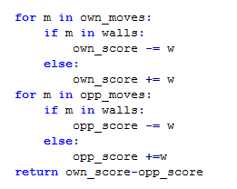

* in_border

score the presence of moves in the 4 corners:

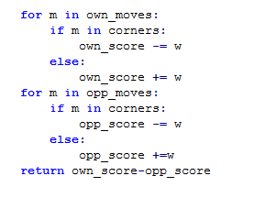

# Evaluation

While testing the tournament application, some warning related to timeouts and forfeit raised. Initialization of best move was changed to selected any available move instead of (-1,-1) to avoid the forfeit warnings. The timeout warning was related to the sleeping mode of the computer.

The was a big variability on the results in different executions, the number of matches per player was increased to 100 to have more homogeneous results in different executions.

custom_score where configured to weight 0.80, .90, 1, 1.10, 1.20 the opponent moves.

Also custom score were tuned add to add a penalty to moves positioned in the walls or corners by .025 and 0.5

Combining a weight 1.1 to opponent moves and weigth 0.25 to positions in corner or border it was possible to get 2% improvement.

