0.1 | 2025/08/13 | Initial release of report |  |  |  |  | TLP
Rev. | Issued date | Description |  |  |  |  | Made by
 | Draga AS
Project:
 | DISC DEXPI Continuation Project
Document title:  DISC DEXPI Gap Analysis |  |  |  |  |  |  |  |  | Rev:  0.1 |  | Page:  1 of 10

Table of Contents
1 Abstract 4
2 Introduction 4
3 Identified Gaps 4
3.1 Instrumentation Modelling 4
3.2 Vessel/Tank Internal Components 5
3.3 Annotations 6
3.4 Mount Type 6
3.5 Report duplicate/incorrect names and URIs 7
3.6 Off-Page Signal Modelling 7
3.7 Battery Limits and Tie-In Points 7
3.8 ProcessSafetyFunction Subtype 8
3.9 Electrical Line Type 8
3.10 Clamp-On 9
3.11 Prepare Symbols for Profile 9
3.12 Update requirements to will include with DEXPI 2.0 conceptual model updates 9
4 Out-of-Scope Gaps 10

Terms and Abbreviations
Term | Explanation
DISC | Digitalization Industrialization Standardization Collaboration; initiative between Equinor, AkerBP, Aibel & AkerSolutions.
PCA | POSC Caesar Association
P&ID | Piping and Instrumentation Diagram
DEXPI | DEXPI: Data Exchange in the Process Industry
NCS | Norwegian Continental Shelf
CAD | Computer Aided Design
NOAKA | North of Alvheim Krafla Askja
Draw.io | Free and open-source diagramming tool
pnb | Plants & Bytes: software and consulting company involved in DEXPI group.
round-trip | Export from System A, import into System B, modify in System B, export from System B, import back into System B with changes

Abstract
The DEXPI initiative, launched in 2011, aims to establish a common data exchange standard for the process industry. Historically, most DEXPI-related will work is conducted within standalone projects, with limited focus on transferring DEXPI P&ID files between different CAD vendors.
Prior to the current DISC DEXPI Continuation Project, the NOAKA DEXPI Project documents most of the requirements for DISC partners to implement DEXPI in a standardized way and addressed several gaps between the DISC requirements and the existing DEXPI specification.
Building on this foundation, the current project aims to close the remaining gaps and address integration challenges between CAD vendors, with the ultimate objective of enabling full round-trip transfers of DEXPI P&IDs. A number of these gaps can only be addressed now that the new DEXPI serialization format is approved, moving away from the Proteus schema. As a result, the solutions developed in this project and presented to the DEXPI content team for integration into the DEXPI model will be serializable exclusively using the new format.
This document outlines the outstanding gaps identified and describes how they will be addressed in the continuation project.

Introduction
At the conclusion of the NOAKA/DISC DEXPI project, several engineering elements remained either undocumented in the DISC DEXPI Requirements document and/or unmodelled. In addition, further discussions with DISC members revealed further gaps. In this document a gap is defined as any engineering drafting requirements that
Each of these gaps will be addressed in this project and where relevant included in extensions of the blueprint files made available in the earlier project. The blueprint files will be provided in both the old Proteus schema and the new DEXPI XML format where possible.
Some solutions will only be feasible using the new DEXPI 2.0 serialization, where there exist limitations due to the Proteus schema.

Identified Gaps
The following gaps have been identified as either carry-on will work from the previous DISC DEXPI project, gaps resulting from decision made during the previous project or as a direct result of implementing the previous modelling and requirements definitions.

Instrumentation Modelling
In the NOAKA/DISC DEXPI project, a simplified and pragmatic approach was adopted for modelling instrumentation and automation elements, avoiding the use of the full DEXPI instrumentation models for ProcessSignalGeneratingFunction / MeasuringSystem and ActuatingElectricalFunction / ActuatingElectricalSystem with their associated sub-component class types. The DISC project’s simplified approach classified all elements within these modelling branches under the ProcessInstrumentationFunction class type, with differentiation achieved through type attributes.
This approach was identified as a gap in the previous project, where the expectation was to resolve and remodel the DEXPI instrumentation information model to support NCS P&ID drafting for instrumentation and automation, using discrete class definitions for the various elements.
During the period between the original DISC DEXPI project and this continuation project, significant effort was invested in discussing, drafting, and revising modelling solutions to support NCS P&ID instrumentation and automation drafting. In parallel, the simplified solution was implemented in practice. Implementation results demonstrated that the simplified approach could deliver the desired connectivity and graph information.
Note: The simplified approach is also more easily applied to legacy DEXPI drawing conversion from image or unintelligent CAD tools.
Gap: This ‘gap’ can be considered closed.

Vessel/Tank Internal Components
In the DISC project, a decision was made to exclude vessel internals from the modelling and requirements definition, as these components are typically detailed in documents such as the General Arrangement drawing. It has since been determined that vessel/tank internal components are an essential part of the P&ID and must be includes in the DEXPI transfer. Consequently, these elements will be incorporated into the model and requirements will document for the continuation project.
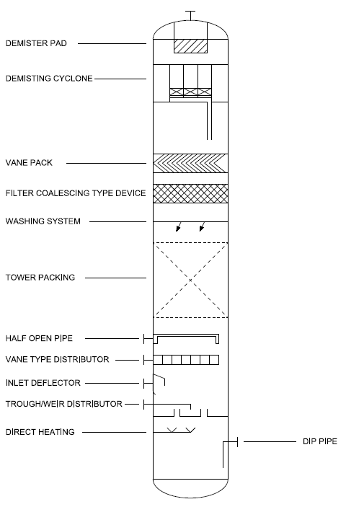
Figure : Example of Vessel/Tank Internal Components.

Gap:
- Document DEXPI will update and will present to DEXPI Content Team.
- Include updates in DISC DEXPI Requirements document
- Include updates to DISC DEXPI Profile
- Include example in Blueprint files

Annotations
Annotations (Note) class DISC proposal is part of the DEXPI standard but has not been included in any of the blueprint files for implementation testing.
This class supports note reference, text and association to other DEXPI conceptual objects.
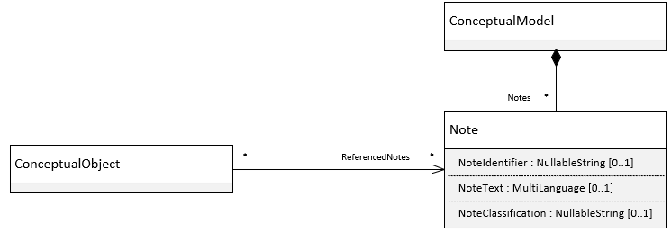
Figure : DEXPI Note class
Gap:
- Include example in Blueprint files

Mount Type
Mount class DISC proposal recently approved for addition to DEXPI specification.
This class supports the mounting connection between instrument and equipment type and can be assigned as a sensing location for the ProcessSignalGeneratingFunction.
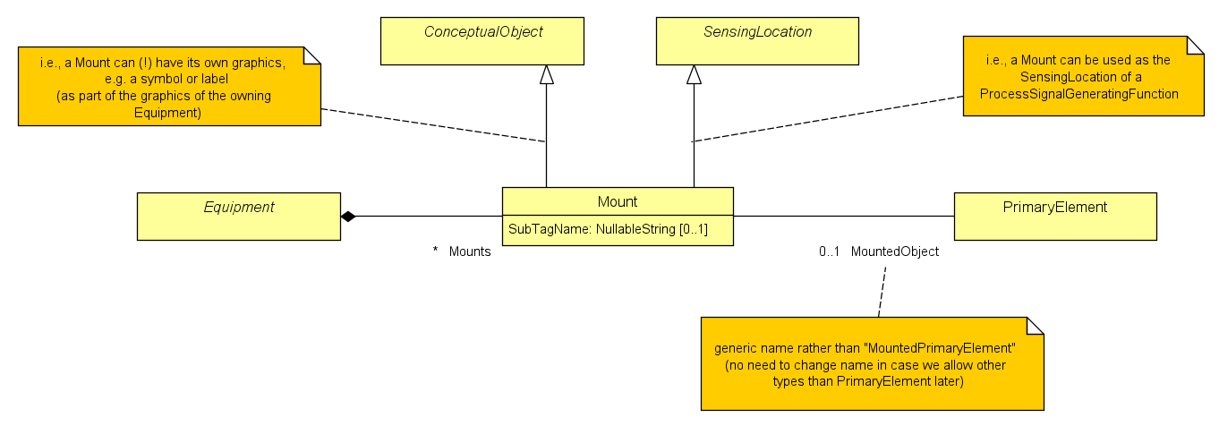
Figure : DEXPI Mount class
Gap:
- Include updates in DISC DEXPI Requirements document
- Include updates in DISC DEXPI Profile
- Include example in Blueprint files

Report duplicate/incorrect names and URIs
The following items have been identified with duplicate/incorrect names/URIs.

 | ComponentClass | ComponentClassURI | note
Fan | BlowerFan | http://sandbox.dexpi.org/rdl/BlowerFan | These two classes are the same except that they have different subtypes. Recommendation is to make a unified class and update documentation or separate them into two classes.
Blower | BlowerFan | http://sandbox.dexpi.org/rdl/BlowerFan
Bar absolute | Bar | http://data.posccaesar.org/rdl/RDS1314539 | All the PressureAbsoluteUnits and PressureGaugeUnits have the same name and URI. The guage / absolute needs to be always specified to avoid confusion. Also, it is very likely to use both guage and absolute pressures at the same P&ID sheet.
Bar guage | Bar | http://data.posccaesar.org/rdl/RDS1314539

Gap:
- Duplicate/incorrect names Fan/Blower is an error in DEXPI 1.4 – it is fixed in DEXPI 2.0
- Check and if required raise issue with DEXPI group for UoM usage of bar/barg

Off-Page Signal Modelling
Current DEXPI conceptual model and serialization do not support the transfer of signal lines that run across multiple P&IDs. In these cases, the current standard requires the use of ‘dummy’ elements to ensure the correct compositional topology in the transfer file – fix for orphan signal line. Any solution to this problem must ensure the connectivity information of the signal can be captured and transferred without the use of ‘dummy’ elements.
Gap:
- Discuss and will agree on suitable DEXPI model
- Document DEXPI suggestion and will present to DEXPI Content Team.
- Include updates in DISC DEXPI Profile
- Include will update in DISC DEXPI Requirements document
- Include example in Blueprint files

Battery Limits and Tie-In Points
Battery Limits define the boundary between plant owner responsibility and external entity responsibility. Tie-In Points defines the boundary between new and existing systems, defining the scope of a project.
Transfer of Battery Limits and Tie-In Points is identified as a gap. These designated location points/group identifiers are not currently part of the DEXPI model.
Gap:
- Discuss and will agree on suitable DEXPI model
- Document DEXPI suggestion and will present to DEXPI Content Team.
- Include updates in DISC DEXPI Profile
- Include will update in DISC DEXPI Requirements document
- Include example in Blueprint files

ProcessSafetyFunction Subtype
ProcessSafetyFunction as a discrete subtype of ProcessInstrumentationFunction allows for improved modelling for safety critical elements directly from the DEXPI file/model. The expectation is that this new subtype shall be identified as a separate class type.
- Document DEXPI suggestion and will present to DEXPI Content Team.
- Include updates in DISC DEXPI Profile
- Include will update in DISC DEXPI Requirements document
- Include example in Blueprint files

Electrical Line Type
Electrical Line additional type to support the electrical lines that are drafted on NCS P&IDs. Within the current DISC DEXPI requirements/profile definition these are modelled as SignalConveryingFunction type. The expectation is that these electrical lines shall be identified as a separate class type e.g. ElectricalLineFunction.
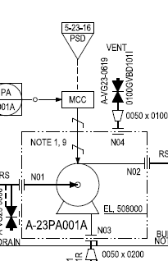
Figure : Example of electrical line between MCC and pump
Gap:
- Discuss and will agree on suitable DEXPI model
- Document DEXPI suggestion and will present to DEXPI Content Team.
- Include updates in DISC DEXPI Profile
- Include will update in DISC DEXPI Requirements document
- Include example in Blueprint files

Clamp-On
Clamp-on measuring elements are measuring instruments that are fitted externally to the pipe using clamp-on mounting. These measuring devices are not in-line as they are not in direct contact with the process fluid, however, they are often drafted as in-line elements. The current DISC DEXPI requirements models these elements as in-line. The expectation is that these elements should be identified correctly with the relationship to the piping showing that they are not in-line but rather mounted on with sensing occurring at the location they are mounted.
Gap:
- Discuss and will agree on suitable DEXPI model
- Document DEXPI suggestion and will present to DEXPI Content Team.
- Include updates in DISC DEXPI Profile
- Include will update in DISC DEXPI Requirements document
- Include example in Blueprint files

Prepare Symbols for Profile
Update symbol machine readable files to will ensure correct information is makes available to DISC DEXPI profile. Not all DISC DEXPI symbols have been drafted with correct sizing attribute-to-geometry consistency as required by the DISC DEXPI profile. Any inconsistent symbols are required to be updated.
Gap:
- Ensure each symbol is defined in a machine-readable format with correct:
  - sizing information and attribute-to-geometry consistency
  - origo placement
- Include updates in DISC DEXPI Profile

Update requirements to will include with DEXPI 2.0 conceptual model updates
A small number of name changes are introduced in DEXPI 2.0 that impact the DISC DEXPI requirement documentation.
Gap:
- Include updates in DISC DEXPI Requirements document
- Include updates to DISC DEXPI Profile

Out-of-Scope Gaps
  - Engage with PCA to take ownership of the DISC Profile.
  - Work with PCA initiative to take ownership of NCS Symbol Legend.
  - Work with company drafting standards to enhance the foundation for mapping towards DEXPI.

