Digitalization Industrialization Standardization Collaboration

DISC DEXPI

Equinor – Aker BP – Aker Solutions - Aibel
Document title:  DISC DEXPI Version Gaps | Rev:  1.0 | Page:  1 of 23

Table of Contents
1 Gaps 3
1.1 Vessel/Tank Internal Components 4
1.2 Mount Type 5
1.3 Battery Limits and Tie-In Points 6
1.4 Motor – Equipment Linking 8

Introduction
This document looks at the gaps between the plant modelling supported by DISC DEXPI Profile 0.6.x DEXPI XM 2.0 (DEXPI XML) vs DISC DEXPI Profile for DEXPI 1.3.1/1.4 (Proteus XML 4.2.1).
At a high level the change from DEXPI 1.4 to DEXPI 2.0 type profile

Gaps
The following sections detail the gaps that were identified as being within the scope of this project, including the findings from subsequent investigations and the responses or resolutions applied. These responses may have included requests to modify the DEXPI standard submitted via the Content Team issue list, issues that were resolved through the adoption of DEXPI 2.0 and are therefore no longer applicable, or cases where further analysis determined that an initially perceived issue was not, in fact, an issue.

Vessel/Tank Internal Components
In the DISC project, a decision was made to exclude vessel internals from the modelling and requirements definition, as these components are typically detailed in documents such as the General Arrangement drawing. It was then determined that vessel/tank internal components are an essential part of the P&ID and needed to be included in the DEXPI transfer.
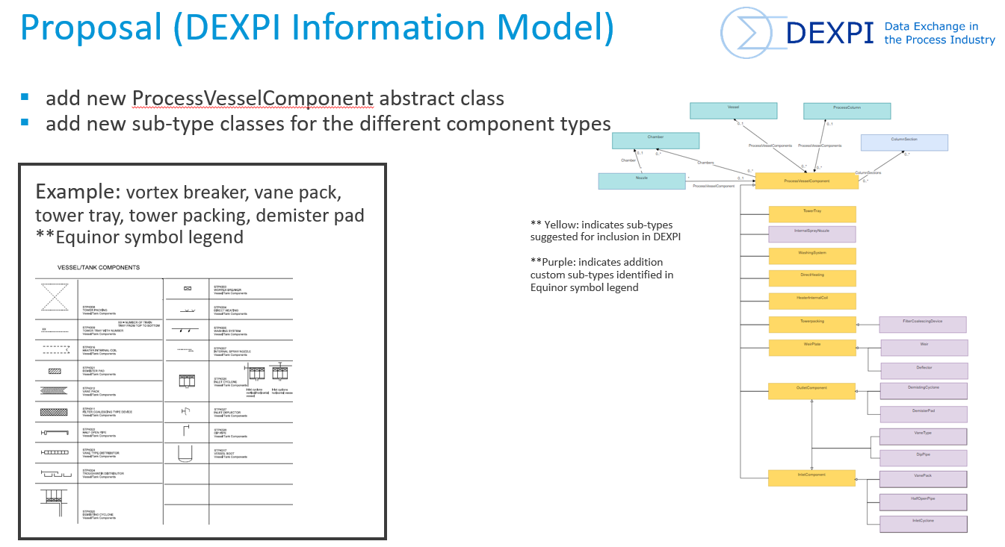
Figure 1: Proposal for Vessel/Tank Internal component modelling.
Resolution:
- The model has been added to the DISC DEXPI profile and requirements document.
- An example using the Vortex breaker was added to the Blueprint files.
- A proposal has been submitted to the DEXPI content team representing the discussions during the workshops and other technical meetings within the project.

Issue 85: https://gitlab.com/dexpi/content-team-project/-/issues/85

Mount Type
Mount class DISC proposal recently approved for addition to DEXPI specification.
This class supports the mounting connection between instrument and equipment type and can be assigned as a sensing location for the ProcessSignalGeneratingFunction. It was determined that this new class type should be used in the DISC DEXPI modelling requirements.
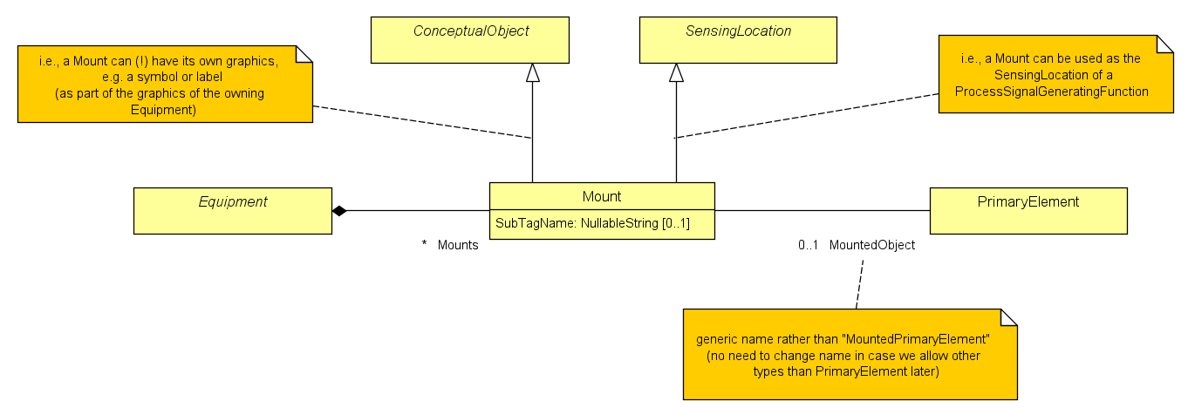
Figure 2:New DEXPI Mount class
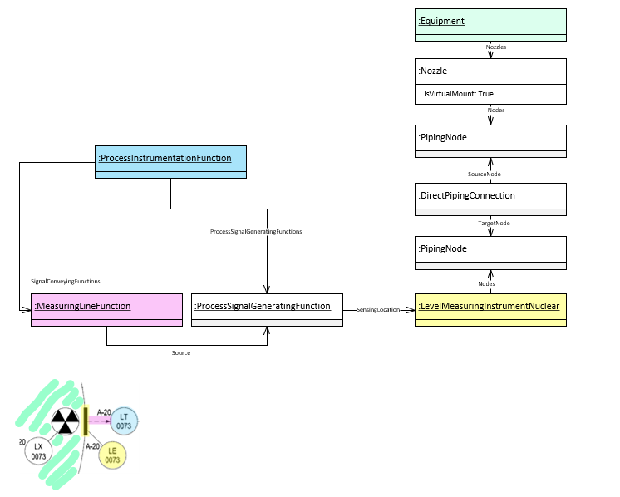
Figure 3: DISC DEXPI Mounted modelling approach
Resolution:
- The use of the new Mount type was discussed, and this class was evaluated for modelling instruments mounted directly on equipment, as shown on the P&ID. However, adopting this approach required the additional use of elements from the ProcessSignalGeneratingFunction instrument sub-model. This introduced a deviation from the overall “simplified” instrumentation modelling approach and would have resulted in a special-case solution applicable only to this specific instrumentation connection type. It was therefore decided that the previous project modelling approach would continue to be used.
- It is recommended to use the Mount class type modelling approach once the overall Instrumentation model is acceptable for use on NCS P&IDs.
- An example of this model was included in the Blueprint files.

Battery Limits and Tie-In Points
Battery Limits define the boundary between plant owner responsibility and external entity responsibility. Tie-In Points defines the boundary between new and existing systems, defining the scope of a project.
Transfer of Battery Limits and Tie-In Points information was identified as a gap.
Resolution:
The gap referred to as the Battery Limits and Tie-In Points issue was reviewed in detail, and it was determined that it actually comprises two distinct but related issues.
1. Tie-in point identification
The first issue concerns the identification of tie-in points, where there is a need to clearly define designated locations on existing pipelines or plant systems at which new piping, lines, or equipment will physically connect. These tie-in points are typically documented in dedicated lists and linked to detailed information that must be coordinated to ensure a seamless connection during installation.
It was determined that tie-in points can be considered as a type of ‘break’ inline with the existing property break of the line. It was during the discussion of a ‘break’ type solution for the tie-in that an additional challenge with how to manage multiple property breaks at the same location using a single symbol was also brought into the discussion resulting in a new overall solution for property breaks that could now be supported with the DEXPI 2.0 format.
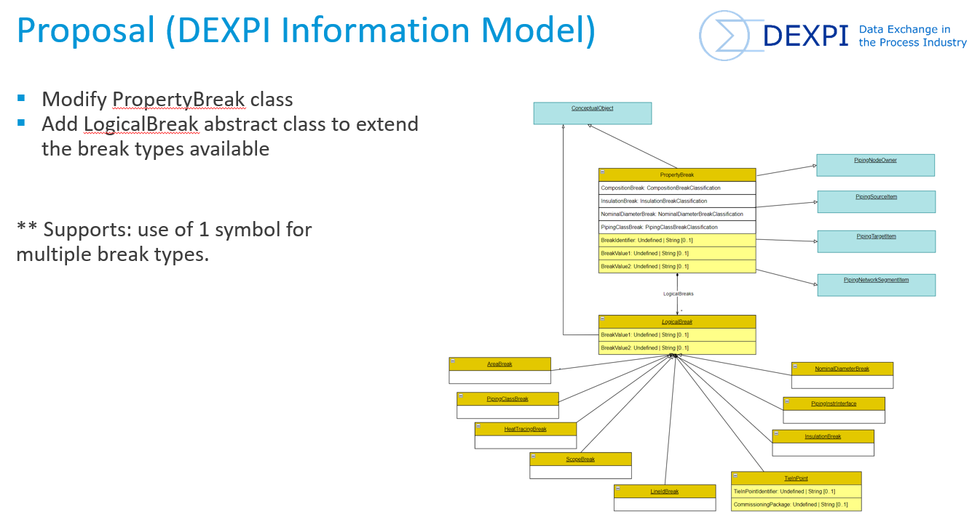
Figure 4:PropertyBreak proposal
This proposal has been raised with the DEXPI Content Team.
Issue 88: https://gitlab.com/dexpi/content-team-project/-/issues/88
The new model has been incorporated into the Blueprint files.

2. Package boundary boxes (scope / battery limits)
The second issue relates to the representation of package boundary boxes, also referred to as scope or battery limits. The key functionality that a package boundary must represent includes:
- A package identifier — typically the main package equipment name — that enables users to navigate to detailed information for the package. It is expected that the intelligent engineering tool will support hyperlinking between this identifier and all relevant sub-elements and associated documentation.
- Uniquely identifiable connection points — defining where the package boundary interfaces with existing facility systems or other owned parts of the plant. These connection points should display their identifiers and, where relevant, their sizes. The intelligent engineering tool is also expected to store information associated with each connection point, including references to vendor or sub-vendor drawings that describe the interface on the opposing side.
A DISC-specific solution has been defined to address the requirements for package boundaries. However, the full set of information that should be captured and represented by the package boundary has not yet been comprehensively defined. As such, this solution should be considered an initial implementation and revisited at a later stage to validate its completeness and to identify whether additional functionality or features are required to address any remaining gaps. In addition, the DEXPI class elements used in this temporary solution may not be fully consistent with the overall DEXPI information modelling approach and should therefore also be reviewed and reassessed.
Refer:

Motor – Equipment Linking
One of the gaps identified during this project relates to the modelling of the relationship between a driver (e.g. a motor) and the driven equipment (e.g. a pump). In the previous project, this relationship was modelled indirectly through an attribute-based approach, whereby direct connections between equipment were identified by transferring the unique ID of the secondary equipment (e.g. motor) in the ConnectedEquipment attribute of the primary equipment (e.g. pump). While functional, this approach lacks structural clarity and robustness.
The TransmissionSystem sub-model addresses this gap by explicitly modelling the connection between the driver and the associated equipment.
The requirement was to incorporate this sub-model into the DISC DEXPI requirements and replace the previous attribute-based practice of directly referencing equipment identifiers within motor or equipment data.
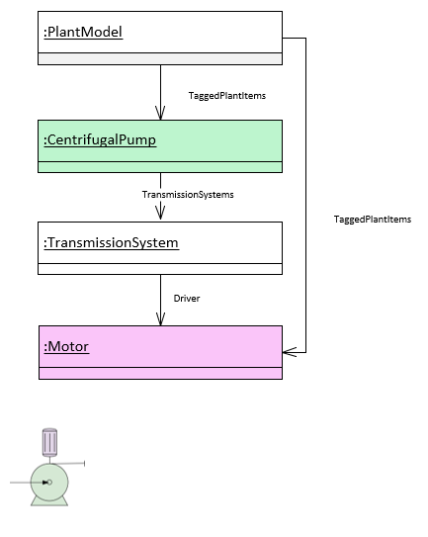
Figure 5:TransmissionSystem model
Resolution:
- The TransmissionSystem sub-model has been added to the DISC DEXPI profile and requirements document.
- An example of this model has been added to the Blueprint files.

