Digitalization Industrialization Standardization Collaboration

DISC DEXPI

Equinor – Aker BP – Aker Solutions - Aibel
Document title:  DISC DEXPI Final Report | Rev:  1.0 | Page:  1 of 23

Table of Contents
1 Project Summary 4
2 Introduction and Summary 4
3 Gaps 4
3.1 Instrumentation Modelling 5
3.2 Vessel/Tank Internal Components 6
3.3 Annotations 7
3.4 Mount Type 8
3.5 Report duplicate/incorrect names and URIs 9
3.6 Off-Page Signal Modelling 10
3.7 Battery Limits and Tie-In Points 11
3.8 ProcessSafetyFunction Subtype 13
3.9 Clamp-On 13
3.10 Electrical Line Type 14
3.11 Motor – Equipment Linking 15
3.12 Update requirements to include DEXPI 2.0 conceptual model updates 16
3.13 Prepare Symbols for Profile 16
4 Project Deliverables 17
4.1 Creation of machine-readable DISC DEXPI Profile 17
4.1.1 Machine-readable Symbol library profile for DISC 19
4.1.2 HTML Human Readable Profile 20
4.2 Blueprint File 20
4.3 Validation Method 21
5 Recommendations for further work 22
5.1 Reference Data: 22
5.2 Technical Recommendations 22
5.3 Promote Use of DEXPI: 22
5.4 Use Cases / Business Value: 22
Appendix A: Maturation of DEXPI proposal 23

Terms and Abbreviations

Term | Explanation
DISC | Digitalization Industrialization Standardization Collaboration; initiative between Equinor, AkerBP, Aibel & AkerSolutions.
PCA | POSC Caesar Association
P&ID | Piping and Instrumentation Diagram
DEXPI | DEXPI: Data Exchange in the Process Industry
NCS | Norwegian Continental Shelf
NORSOK | Norsk Sokkels Konkurranseposisjon
Draw.io | Free and open-source diagramming tool
PnB | Plants & Bytes: software and consulting company involved in DEXPI group.
Github | Platform for software development, collaboration, and security.
round-trip | Export from System A, import into System B, modify in System B, export from System B, import back into System B with changes

Project Summary
The DEXPI initiative, launched in 2011, aims to establish a common data exchange standard for the process industry. The previous DISC DEXPI project defined the first version of the DISC requirements but also identified several gaps between DISC engineering needs and the DEXPI standard. The focus of this project within the DISC collaboration was to address those gaps and further mature the DISC DEXPI implementation.
In parallel, the project updated the DISC DEXPI requirements to align with the DEXPI 2.0 serialization format. This enabled the use of new features introduced in DEXPI 2.0 and removed dependencies on the legacy Proteus format and its associated constraints.
As part of the project deliverables, a DISC DEXPI profile was developed in a machine-readable DEXPI 2.0 XML format. The profile includes a detailed symbol legend and associated mappings, providing clear configuration requirements for CAD vendors. When used in conjunction with the DEXPI standard, this profile also forms a robust basis for validation of DISC DEXPI files.
The project also delivered a modelling requirements document defining the intended modelling approach. This approach is demonstrated through updated DISC DEXPI Blueprint files, which are fully compliant with the DISC DEXPI requirements and achieve 100% DISC DEXPI compliance.

Introduction and Summary
At the conclusion of the NOAKA/DISC DEXPI project, several engineering elements remained either undocumented in the DISC DEXPI Requirements document and/or unmodelled in the associated Blueprint files. Further discussions with DISC members subsequently identified additional modelling gaps.
In the context of this document, gaps refer to differences between NCS P&ID engineering modelling requirements and the DEXPI 2.0 standard, as well as modelling requirements that had been identified but were not previously documented in the DISC DEXPI Requirements specification or incorporated into the Blueprint example files.
Each of these gaps was analysed as part of this project and, where applicable, addressed through updates to the DISC DEXPI requirements, extensions to the Blueprint files developed in the previous project, or by raising issues with the DEXPI Content Team for consideration within the standard.

Gaps
The following sections detail the gaps that were identified as being within the scope of this project, including the findings from subsequent investigations and the responses or resolutions applied. These responses may have included requests to modify the DEXPI standard submitted via the Content Team issue list, issues that were resolved through the adoption of DEXPI 2.0 and are therefore no longer applicable, or cases where further analysis determined that an initially perceived issue was not, in fact, an issue.

Instrumentation Modelling
In the NOAKA/DISC DEXPI project, a simplified and pragmatic approach was adopted for modelling instrumentation and automation elements, avoiding the use of the full DEXPI instrumentation models for ProcessSignalGeneratingFunction / MeasuringSystem and ActuatingElectricalFunction / ActuatingElectricalSystem with their associated sub-component class types. The DISC project’s simplified approach classified all elements within these modelling branches under the ProcessInstrumentationFunction class type, with differentiation achieved through type attributes.
This approach was identified as a gap in the previous project, where the expectation was to resolve and remodel the DEXPI instrumentation information model to support NCS P&ID drafting for instrumentation and automation, using discrete class definitions for the various elements.
During the period between the original DISC DEXPI project and this continuation project, significant effort was invested in discussing, drafting, and revising modelling solutions to support NCS P&ID instrumentation and automation drafting. In parallel, the simplified solution was implemented in practice. Implementation results demonstrated that the simplified approach could deliver the desired connectivity and graph information.
Note: The simplified approach is also more easily applied to legacy DEXPI drawing conversion from image or unintelligent CAD tools.
Resolution:
This ‘gap’ is currently resolved using the ‘simplified’ approach to modelling and is suffice for the current projects.
- An issue has been raised with the DEXPI content team identifying this as a large gap for NCS P&IDs. The issue raised outlines that the approach taken in DISC relies heavily on custom attributes to identify process control engineering elements and this should be replaced by a model with well defined class elements and connection points.
Issue 90: https://gitlab.com/dexpi/content-team-project/-/issues/90

Vessel/Tank Internal Components
In the DISC project, a decision was made to exclude vessel internals from the modelling and requirements definition, as these components are typically detailed in documents such as the General Arrangement drawing. It has since been determined that vessel/tank internal components are an essential part of the P&ID and must be included in the DEXPI transfer.
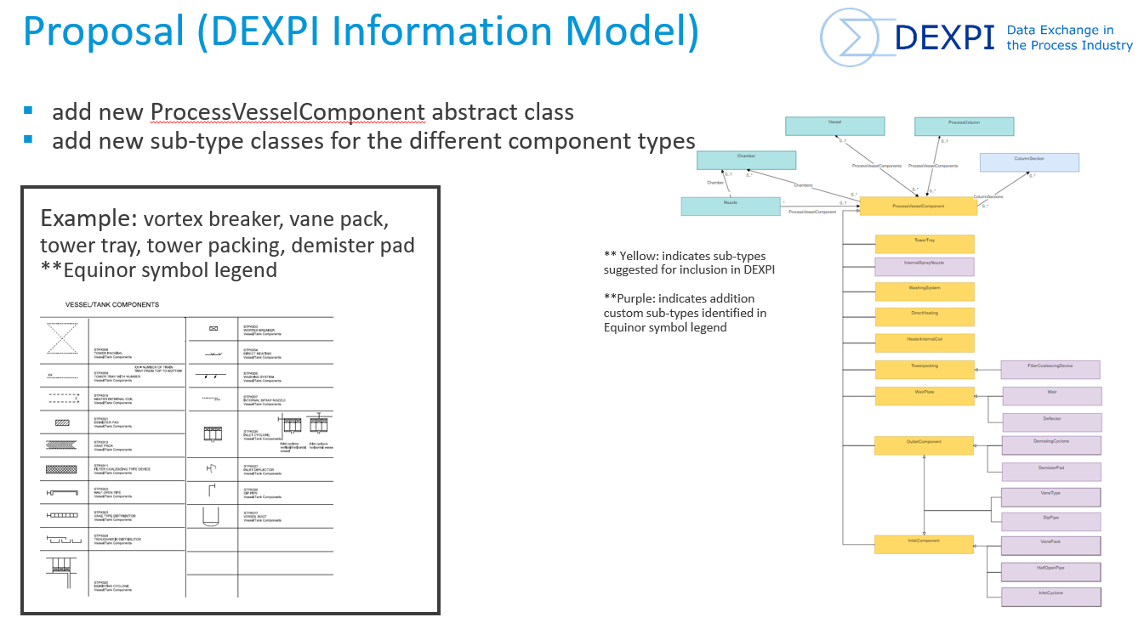
Figure 1: Proposal for Vessel/Tank Internal component modelling.
Resolution:
- The model has been added to the DISC DEXPI profile and requirements document.
- An example using the Vortex breaker was added to the Blueprint files.
- A proposal has been submitted to the DEXPI content team representing the discussions during the workshops and other technical meetings within the project.

Issue 85: https://gitlab.com/dexpi/content-team-project/-/issues/85

Annotations
Annotations (Note) class DISC proposal is part of the DEXPI standard but has not been included in any of the Blueprint files for implementation testing.
This class supports note reference, text and association to other DEXPI conceptual objects.
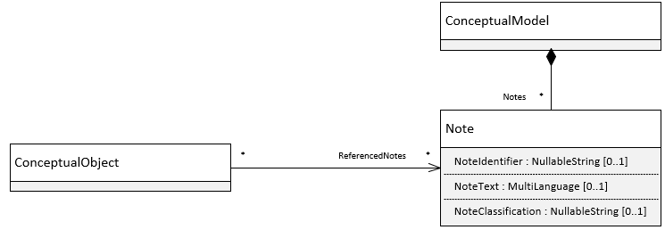
Figure 2:DEXPI Note class
Resolution:
- Included example in Blueprint files

Mount Type
Mount class DISC proposal recently approved for addition to DEXPI specification.
This class supports the mounting connection between instrument and equipment type and can be assigned as a sensing location for the ProcessSignalGeneratingFunction.
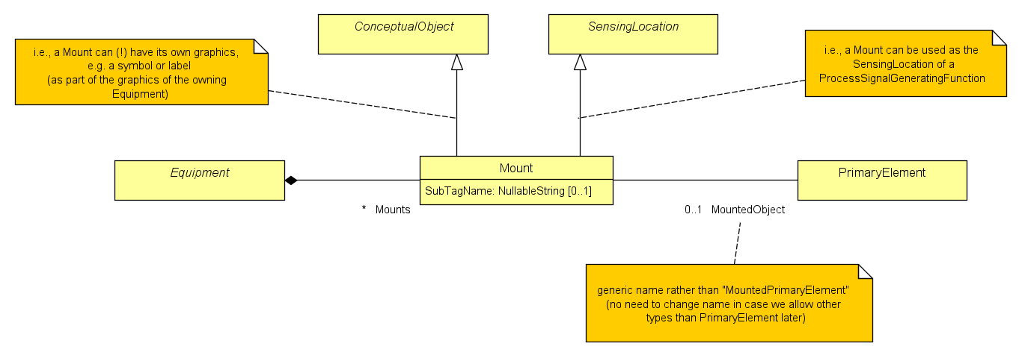
Figure 3:New DEXPI Mount class
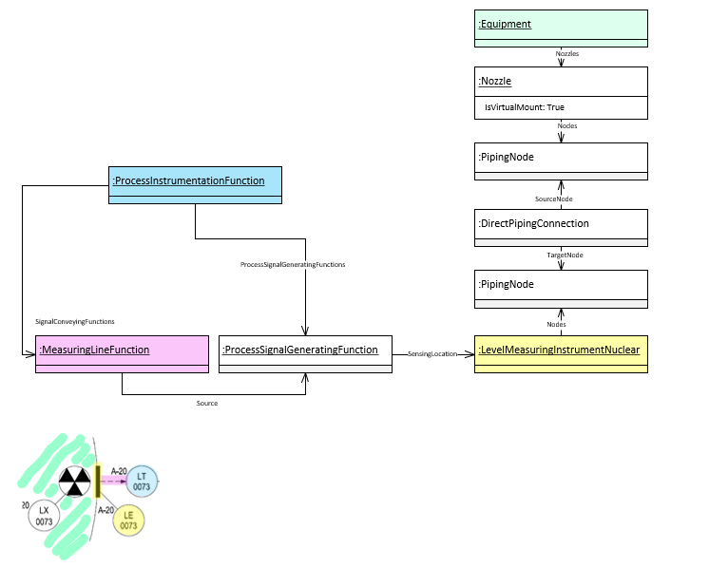
Figure 4: DISC DEXPI Mounted modelling approach
Resolution:
- The use of the new Mount type was discussed, and this class was evaluated for modelling instruments mounted directly on equipment, as shown on the P&ID. However, adopting this approach required the additional use of elements from the ProcessSignalGeneratingFunction instrument sub-model. This introduced a deviation from the overall “simplified” instrumentation modelling approach and would have resulted in a special-case solution applicable only to this specific instrumentation connection type. It was therefore decided that the previous project modelling approach would continue to be used.
- It is recommended to use the Mount class type modelling approach once the overall Instrumentation model is acceptable for use on NCS P&IDs.
- An example of this model was included in the Blueprint files.

Report duplicate/incorrect names and URIs
The following items have been identified with duplicate/incorrect names/URIs.

 | ComponentClass | ComponentClassURI | note
Fan | BlowerFan | http://sandbox.dexpi.org/rdl/BlowerFan | These two classes are the same except that they have different subtypes. Recommendation is to make a unified class and update documentation or separate them into two classes.
Blower | BlowerFan | http://sandbox.dexpi.org/rdl/BlowerFan
Bar absolute | Bar | http://data.posccaesar.org/rdl/RDS1314539 | All the PressureAbsoluteUnits and PressureGaugeUnits have the same name and URI. The gauge / absolute needs to be always specified to avoid confusion. Also, it is very likely to use both gauge and absolute pressures at the same P&ID sheet.
Bar gauge | Bar | http://data.posccaesar.org/rdl/RDS1314539

Resolution:
These items have been checked against the DEXPI 2.0 standard and have been resolved:
- Duplicate/incorrect names Fan/Blower is an error in DEXPI 1.4 – fixed in DEXPI 2.0
- UoMs bar/barg are differentiated in DEXPI 2.0 using UoM type definitions
  - PressureGauge
  - PressureAbsolute

Off-Page Signal Modelling
Current DEXPI conceptual model and serialization do not support the transfer of signal lines that run across multiple P&IDs. In these cases, the current standard requires the use of ‘dummy’ elements to ensure the correct compositional topology in the transfer file – fix for orphan signal line. Any solution to this problem must ensure the connectivity information of the signal can be captured and transferred without the use of ‘dummy’ elements.
Resolution:
This issue was discussed at length not only with regards to signal lines but also for piping lines. Both elements have a requirement imposed by the DEXPI model for a parent item to be available across drawings.
The DEXPI 2.0 XML transport format now allows multiple drawings (Diagram Models) to be supported by a single Plant Model and, at first glance, this appears to provide a solution to the off-page signal modelling gap. However, when attempting to model multiple drawings using a shared Plant Information Model, issues were identified with the handling of off-page connectors. Off-page connectors are inherently a drawing-boundary concept and not a construct of the engineering information model, and their use creates inconsistencies within the Plant Model.
An issue has been raised with the DEXPI Content Team to address this limitation.
Issue 89: https://gitlab.com/dexpi/content-team-project/-/issues/89
In the interim, it appears that the most viable approach is to continue modelling signal lines drafted on a P&ID without a corresponding graphical representation of the parent ProcessInstrumentationFunction element. This requires each drawing to maintain its own Diagram Model and corresponding Plant Model. Under this approach, the ProcessInstrumentationFunction exists within the Plant Model but does not have an associated RepresentationTypeGroup in the Diagram Model when this element is not drafted together with the signal.
An example using this approach was added in the Blueprint files.

Battery Limits and Tie-In Points
Battery Limits define the boundary between plant owner responsibility and external entity responsibility. Tie-In Points defines the boundary between new and existing systems, defining the scope of a project.
Transfer of Battery Limits and Tie-In Points is identified as a gap. These designated location points/group identifiers are not currently part of the DEXPI model.
Resolution:
The gap referred to as the Battery Limits and Tie-In Points issue was reviewed in detail, and it was determined that it actually comprises two distinct but related issues.
1. Tie-in point identification
The first issue concerns the identification of tie-in points, where there is a need to clearly define designated locations on existing pipelines or plant systems at which new piping, lines, or equipment will physically connect. These tie-in points are typically documented in dedicated lists and linked to detailed information that must be coordinated to ensure a seamless connection during installation.
It was determined that tie-in points can be considered as a type of ‘break’ inline with the existing property break of the line. It was during the discussion of a ‘break’ type solution for the tie-in that an additional challenge with how to manage multiple property breaks at the same location using a single symbol was also brought into the discussion resulting in a new overall solution for property breaks that could now be supported with the DEXPI 2.0 format.
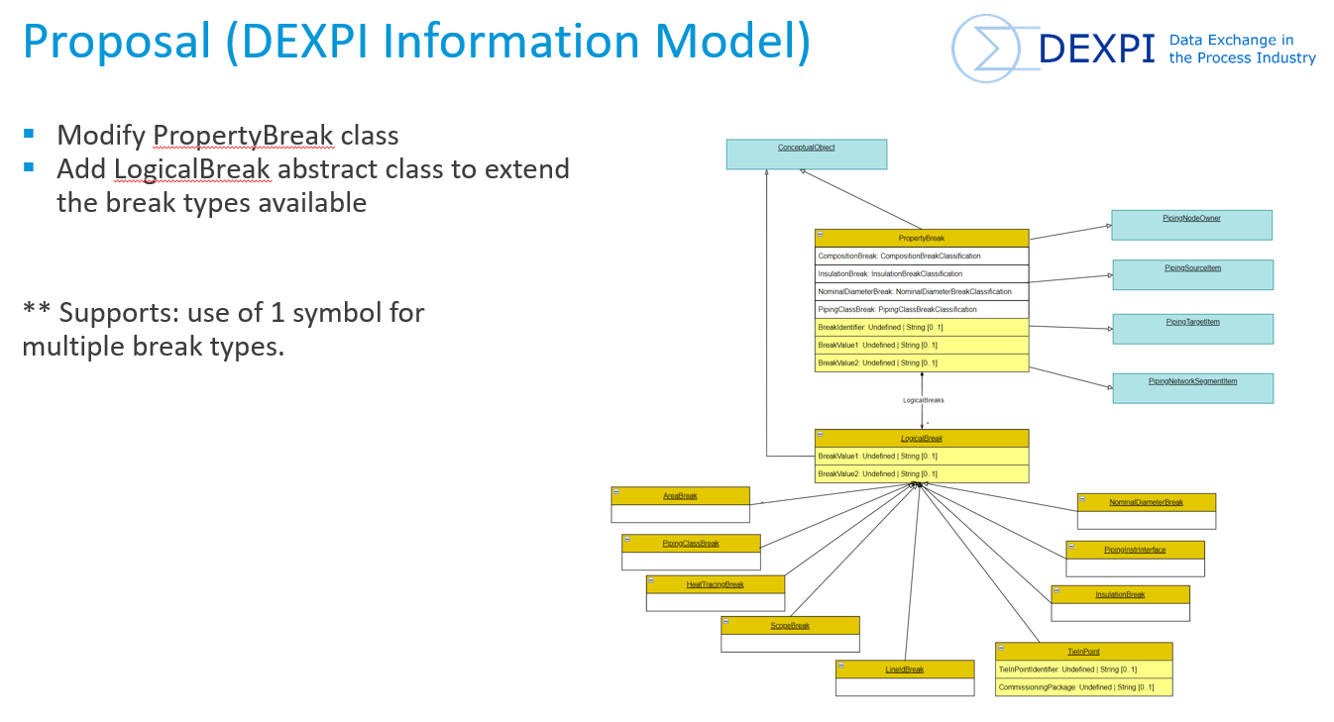
Figure 5:PropertyBreak proposal
This proposal has been raised with the DEXPI Content Team.
Issue 88: https://gitlab.com/dexpi/content-team-project/-/issues/88
The new model has been incorporated into the Blueprint files.
2. Package boundary boxes (scope / battery limits)
The second issue relates to the representation of package boundary boxes, also referred to as scope or battery limits. The key functionality that a package boundary must represent includes:
- A package identifier — typically the main package equipment name — that enables users to navigate to detailed information for the package. It is expected that the intelligent engineering tool will support hyperlinking between this identifier and all relevant sub-elements and associated documentation.
- Uniquely identifiable connection points — defining where the package boundary interfaces with existing facility systems or other owned parts of the plant. These connection points should display their identifiers and, where relevant, their sizes. The intelligent engineering tool is also expected to store information associated with each connection point, including references to vendor or sub-vendor drawings that describe the interface on the opposing side.
A DISC-specific solution has been defined to address the requirements for package boundaries. However, the full set of information that should be captured and represented by the package boundary has not yet been comprehensively defined. As such, this solution should be considered an initial implementation and revisited at a later stage to validate its completeness and to identify whether additional functionality or features are required to address any remaining gaps. In addition, the DEXPI class elements used in this temporary solution may not be fully consistent with the overall DEXPI information modelling approach and should therefore also be reviewed and reassessed.
Refer:

ProcessSafetyFunction Subtype
ProcessSafetyFunction as a discrete subtype of ProcessInstrumentationFunction allows for improved modelling for safety critical elements directly from the DEXPI file/model. The expectation is that this new subtype shall be identified as a separate class type.
Resolution:
- Issue requesting new subtype has been submitted to DEXPI content team.
- Issue 86: https://gitlab.com/dexpi/content-team-project/-/issues/86
- Included example in Blueprint files

Clamp-On
Clamp-on measuring elements are measuring instruments that are fitted externally to the pipe using clamp-on mounting. These measuring devices are not in-line as they are not in direct contact with the process fluid, however, they are often drafted as in-line elements. The current DISC DEXPI requirements models these elements as in-line. This model has been used in projects and is deemed an acceptable solution as these elements are drafted as in-line.
Resolution:
Through discussions if was found that this model has been used in projects and is deemed an acceptable solution as these elements are drafted as in-line.

Electrical Line Type
Electrical Line additional type to support the electrical lines that are drafted on NCS P&IDs. Within the current DISC DEXPI requirements/profile definition these are modelled as SignalConveryingFunction type. The expectation is that these electrical lines shall be identified as a separate class type e.g. ElectricalLineFunction.
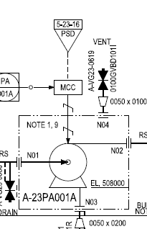
Figure 6:Example of electrical line between MCC and pump
Resolution:
- The introduction of a new electrical line type was evaluated, and several modelling approaches using the ActuatingElectricalFunction sub-model were explored. However, due to the overlap with the ProcessInstrumentationFunction sub-model, this approach would have required subsequent changes within the ProcessInstrumentationFunction model. As these changes would have had wider implications across related elements and affected the overall consistency between the two sub-models, the approach was deemed unsuitable. To maintain a consistent and simplified modelling strategy, it was therefore decided not to proceed with this approach.
- It was decided to continue using the previously defined method of identifying electrical line types via the SignalConveyingFunction type attribute.
- The issue raised for Instrumentation Modelling (Ref: Instrumentation Modelling) includes a point to look into the modelling of actuating electrical function ‘signals’.

Motor – Equipment Linking
One of the gaps identified during this project relates to the modelling of the relationship between a driver (e.g. a motor) and the driven equipment (e.g. a pump). The introduction of the TransmissionSystem sub-model as part of DEXPI 1.4/2.0 provides a formal and structured mechanism to represent this relationship. In the previous project, this relationship was modelled indirectly through an attribute-based approach, whereby direct connections between equipment were identified by transferring the unique ID of the secondary equipment (e.g. motor) in the ConnectedEquipment attribute of the primary equipment (e.g. pump). While functional, this approach lacks structural clarity and robustness.
The TransmissionSystem sub-model addresses this gap by explicitly modelling the connection between the driver and the associated equipment. This approach will be incorporated into the DISC DEXPI requirements and will replace the previous attribute-based practice of directly referencing equipment identifiers within motor or equipment data.
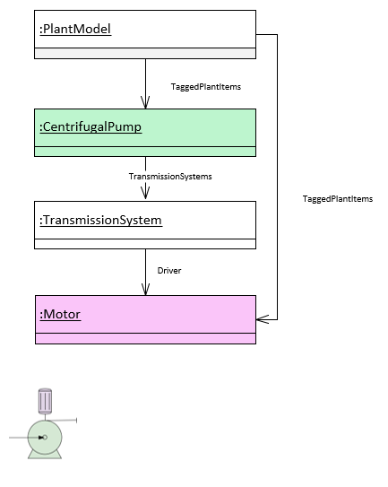
Figure 7:TransmissionSystem model
Resolution:
- The TransmissionSystem sub-model has been added to the DISC DEXPI profile and requirements document.
- An example of this model has been added to the Blueprint files.

Update requirements to include DEXPI 2.0 conceptual model updates
Ensure DEXPI 2.0 name changes and Proteus related definitions within the Blueprint files and requirement documents are updated and corrected.
Resolution:
- Naming changes introduced in DEXPI 2.0 have been reflected in the requirements documentation.
- Requirements specific to the profile have been removed from the requirements document as these are now available in a structured, machine-readable document DISC DEXPI profile.
- Entries specific to Proteus format have been removed as the DISC DEXPI profile is dependant on DEXPI 2.0 and can no longer use Proteus.
- DEXPI 2.0 changes have been reflected in the Blueprint files

Prepare Symbols for Profile
Update symbol machine readable files to ensure correct information is made available to DISC DEXPI profile. Not all DISC DEXPI symbols have been drafted with correct sizing attribute-to-geometry consistency as required by the DISC DEXPI profile. Any inconsistent symbols are required to be updated.
Resolution:
- All symbols have been revised to a machine-readable format with correct:
  - sizing information and attribute-to-geometry consistency
  - ‘intelligent’ symbol variants
  - origo placement
  - node connection placement and type (limited set of examples)
  - label placement
  - label attribute mapping
- Symbol updates in DISC DEXPI Profile

Project Deliverables

Creation of machine-readable DISC DEXPI Profile
The DISC DEXPI Profile replaces the requirements that were previously made available in the DISC DEXPI Requirements document and Symbols.xlsm excel file by a machine-readable XML file built using the DEXPI 2.0 XML schema.
This new DISC DEXPI Profile has also been extended to two new sub-profiles FL0 & FL10. These sub-profiles are configured to validate ‘fill grade’ of an object i.e. ensure the object attribute has been filled with a value.
The new DEXPI 2.0 Exchange Format (DEXPI XML) has been designed to support class extensions. For example, the following excerpt from DiscProfile.xml shows the definition of a new class type:
<ConcreteClass name="AcousticNoiseReducer" superTypes="Plant/Piping.PipingComponent">
<Data property="DexpiMeta/rdl_uri">
<String>http://noaka.org/rdl/AcousticNoiseReducer</String>
</Data>
<Data property="DexpiMeta/rdl_label">
<String>ACOUSTIC NOISE REDUCER</String>
</Data>
</ConcreteClass>
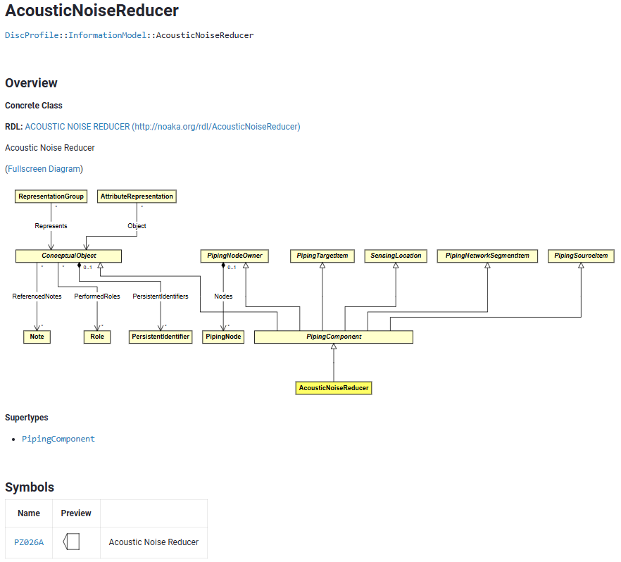
Figure 8: Excerpt of DISC DEXPI Profile (html) AcousticNoiseReducer

DEXPI does not yet provide a canonical solution for the detail requirements defined within the DISC DEXPI project. To this end, a DEXPI profile extension was developed for this project and will be submitted to the DEXPI group profile extension group – this provides the meta model for requirements definitions.
This extension supports the definition of graphical symbols with variants depending on object data (e.g., valve positions) as well as the assignment of these symbols to certain types of engineering objects.
It also supports Node definitions; position/type, LabelTemplates per symbol with links to the PlantModel Attributes.
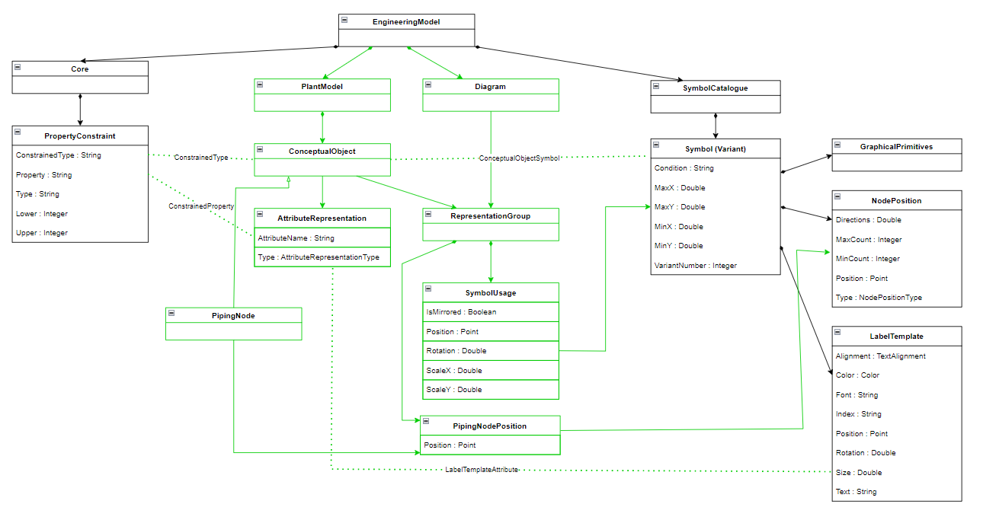
Figure 9: DISC DEXPI Profile Model Overview
The DISC DEXPI Profile is modelled using the same XML schema as the DEXPI standard (with some additions as described above). This provides a strongly defined set of elements and explicit interconnectivity, which, when applied to a final DEXPI file enables systematic verification of the file against both the DEXPI standard information model and the DISC DEXPI Profile specific requirements.

Machine-readable Symbol library profile for DISC
The previous DISC DEXPI project resulted in the delivery of a DISC DEXPI symbol library (based on NORSOK Z-004 together with several additional project symbols) drafted in Draw.io. This project has taken the draw.io symbols and converted them to DEXPI 2.0 format within the DISC DEXPI profile so that the symbol graphical data model, class mapping and label/attribute mapping can be used seamlessly with DEXPI 2.0 model to validate DISC DEXPI files.
Each symbol has been checked via the meta model for the profile and has been check for overall sizing consistency.
Each symbol incorporates details for:
  - Reference ID
  - Symbol standard sizing
  - Symbol origin point
  - Symbol connection points and types
  - Symbol label placement and attribute definitions
  - Dynamic symbols – symbol variants based on attribute values e.g. normally open/closed variants.
The meta model for the definition of these requirements is provided in the project Profile.xml file and must be used to create DISC DEXPI profile compliant symbols. Compliance is required for the explicit interconnectivity required for verification.
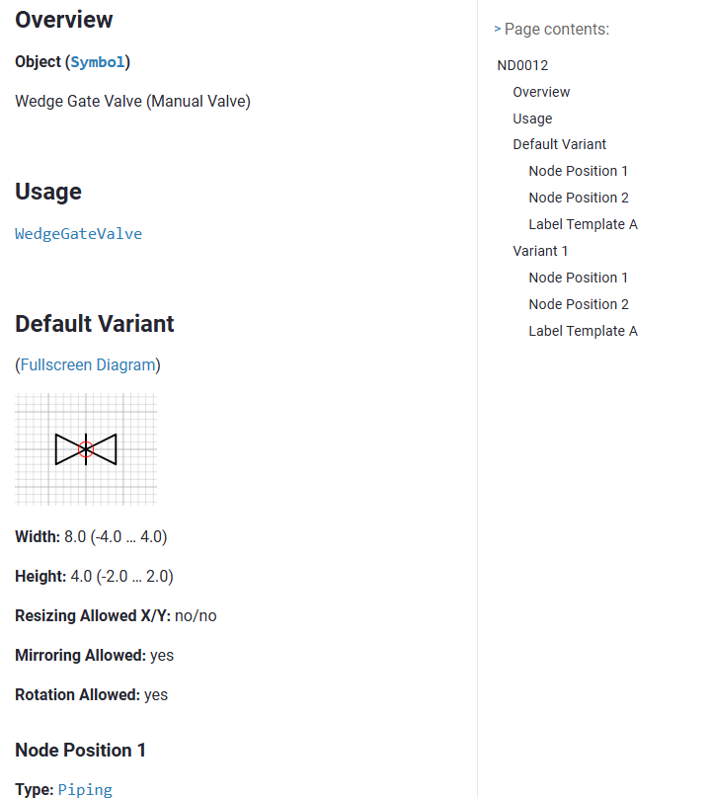
Figure 10: DISC DEXPI standardized symbol definition.

HTML Human Readable Profile
In addition to the machine-readable profile, the project also delivered an HTML version of the profile packaged together with the DEXPI standard in HTML format. This allows users to easily navigate between the DEXPI standard and the DISC DEXPI Profile and to clearly identify where the standard has been extended. The HTML version also provides a convenient way to view symbol details, including graphic variants, nodes, label placements, and associated attributes.

Blueprint File
Building on the success of the blueprint files developed during the first DISC project, it was decided to continue their use and extend them to DEXPI 2.0. In the previous project, these files proved to be an effective reference for understanding how specific P&ID patterns should be converted to DEXPI and also served as fully compliant reference files for comparison, validation, and scoring purposes.
To support the ongoing work, the blueprint files have been updated and delivered in DEXPI 2.0 format. They are included as part of the project delivery package, together with an overview document describing the changes between versions. **Blueprint file versions support testing of Persistent ID requirements by class type.
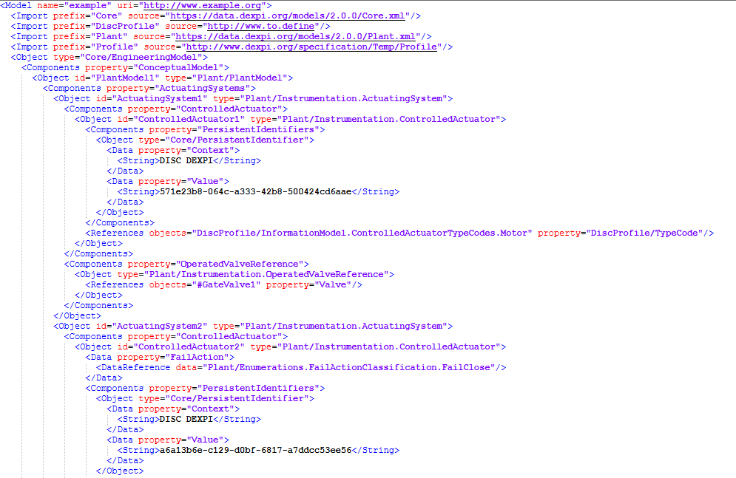
Figure 11: Blueprint file DEXPI 2.0 XML

Validation Method
A Validation method has been developed as part of this project to give a rating of compliant of a DEXPI file against the requirements of the DISC DEXPI profile in conjunction with the DEXPI standard modelling requirements. The details of this method are described in more detail in the documentation provided in the ‘PID Validation Method’ folder of the document deliverables package.

Recommendations for further work

Reference Data:
  - Engage with PCA to take ownership of the profile.
  - Work with PCA to complete DISC DEXPI Semantic references.
  - Work with PCA initiative to take ownership of NCS Symbol Legend## (format to be aligned with profile verification requirements)
  - Work with company drafting standards to enhance the foundation for mapping towards DEXPI

Technical Recommendations
  - ##Update DISC DEXPI profile to use direct pointers to PCA symbol references
  - Collaborate with Management Of Change (Persistent ID) projects
  - Work with DEXPI group to develop NCS instrumentation and actuating electrical models

Promote Use of DEXPI:
  - Support inclusion of DEXPI Deliverable as part of new project contracts.
  - Support inclusion of DEXPI deliverables as part of next DISC ‘Show and Tell’.
  - ** Secure participation of engineering tool vendors.

Use Cases / Business Value:
  - Develop uses cases to demonstrate machine-based validation.

Appendix A: Maturation of DEXPI proposal
1. Description of Activity:
Collaborate with AkerBP, Equinor, Aibel and AkerSolutions and associated process engineering tool vendors (Aucotec, Hexagon, Siemens and Aveva) to document and agree to ownership of the DEXPI DISC profile for the NCS supply chain.
The activity undertaken is to produce P&IDs in a machine-readable format with both conceptual data and graphical representation using the DEXPI standard.

2. Purpose:
The benefits of a DEXPI format are a standardized format of transfer of P&IDs between engineering tools, machine-based validation, and the possibility of machine-based engineering design. The solution will enable a ‘round-trip’ with updates of the P&ID between engineering tools and the ability to provide value through machine-based validation.

3. Success Criteria Addressed:
- All DISC DEXPI elements with valid Semantic reference
- DEXPI instrumentation models updated to NCS standards.
- Export DISC DEXPI defined P&ID
- Import DISC DEXPI defined P&ID
- Demonstrate possibility of machine-based validation

4. Objectives:
- Implement DISC DEXPI resource standardization (symbol legend, DISC DEXPI Profile) e.g. as part of PCA
- Drive completion of RDL references
- Drive improvement of DEXPI standard for NCS instrumentation models
- Drive vendor development through use of contractual or otherwise incentives e.g. ‘Show and Tell’
- Provide methods/uses cases for validating engineering design/ use of DEXPI machine-readable format for other 3rd party consumers. E.g. 3D, Simulators

5. Sub-activities and Tasks:
- Sub-activity 1:
  - Engage with PCA to take ownership of the solution.
  - Deliver and implement method for use of developed DISC DEXPI profile.
- Sub-activity 2:
  - Deliver list of RDL reference requiremenents/suggestions to PCA
  - Work with PCA to complete DISC DEXPI Semantic references
- Sub-activity 3:
  - Develop DEXPI definition(s) for NCS instrumentation models
  - Work with DEXPI Content team to include model into DEXPI standard
- Sub-activity 4:
  - Support inclusion of DEXPI Deliverable as part of new project contracts
  - Support inclusion of DEXPI deliverables as part of next DISC ‘Show and Tell’
- Sub-activity 5:
  - Develop uses cases to demonstrate machine-based validation

6. Dependencies to Other Activities:
- Dependency 1:
  - Alignment with internal initiatives / road map of standards organisations
- Dependency 2:
  - Delivery of definition how to define and use Semantic ID definitions.
- Dependency 3:
  - Availability of people with competence within modelling and instrumentation/automation.
  - Approval of updates to the DEXPI standard from the governing DEXPI content team group.
- Dependency 4:
  - Secure participation of engineering tool vendors.

7. Acceptance Criteria and Deliverables:
- Acceptance Criteria 1: Standardized references must be provided for all elements within the DEXPI transfer file.
  - Deliverable 1: PCA to confirm receipt of missing RDL references by provision of a temporary reference value.
  - Deliverable 2: References to be added to profile and included in DEXPI file deliverable.
- Acceptance Criteria 2: DEXPI standard complete with inclusion of NCS standards.
  - DEXPI standard delivered with u updated to include instrumentation modelling that supports NCS instrumentation models.
- Acceptance Criteria 3: Round trip of DEXPI P&ID
  - Deliverable 1: Export DISC DEXPI P&ID from vendor A
  - Deliverable 2: Import of Deliverable 1 into tool from vendor B
  - Deliverable 3: Update of imported P&ID in vendor B tool
  - Deliverable 4: Export of P&ID from vendor B
  - Deliverable 5: Import of P&ID into vendor A with updates
- Acceptance Criteria 4: Demonstrate machine-based validation.
  - Deliverable 1: Document use case for machine-based validation based on DEXPI
  - Deliverable 2: Demonstrate validation using data from Criteria 3

8. Expertise:
- Required Expertise: [List the specific expertise or skills required to carry out this activity successfully.]
  - DEXPI modelling expert.
  - Process Engineering engineer with modelling knowledge.
  - Instrumentation / Automation engineer with modelling knowledge

- Expert Point of Contact:
Suggested points of contact
  - Manfred Theißen : Plants And Bytes
  - Monica Hole: Aibel
  - David Cameron: UiO / Aibel
  - Ida Istre Sørensen: Equinor
  - Contacts from the different vendors:
    - Jaime Thos: Hexagon
    - Richard Zielinski: Aucotec
    - Michael List: Siemens
    - Andrew Walker: Comos
    - Johan Jotun: Aveva

