1. Найти читателей, которые родились в промежуток между '1997-08-16' и '2006-01-01', и чьи билеты активны в системе.

**select * from reader WHERE (date_of_birth between '1997-08-16' and '2006-01-01') AND status = 'active';**



1. Найти выдачи книг, которые происходили более 30 дней назад.

**select * from issue_of_book where datediff(now(), date_of_issue) > 30;**

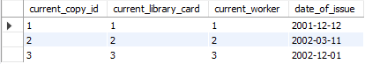

1. Вывести ФИО рабочих заглавными буквами.

**select upper(fio_worker) from worker;**

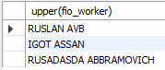

1. Вывод списка издателей с количеством копий в наличии в порядке убывания.

**select publishing_house, sum(number_of_copies) as total_books from books group by publishing_house order by total_books desc;**

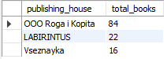

1. Вывод списка копий в наличии с названиями книг.

**select copy_of_book.id_copy, books.title FROM copy_of_book LEFT JOIN books ON books.id_book = copy_of_book.books_id_book;**

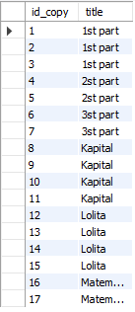

1. Вывод данных о читателях, которые брали книги после 2021-09-03.

**select * from reader where id_library_card = ANY(select reader_id_library_card from issue_of_book where date_of_issue > '2021-09-03');**



1. Вывод данных о взятии книг с ФИО читателей и датой.

**select fio, titles, date_of_issue from reader INNER JOIN (select reader_id_library_card as card_number, date_of_issue, titles from issue_of_book INNER JOIN (select copy_of_book.id_copy as copies, books.title as titles FROM copy_of_book LEFT JOIN books ON books.id_book = copy_of_book.books_id_book) as tab ON issue_of_book.copy_of_book_id_copy = copies ORDER BY card_number) as tab1 ON card_number = id_library_card;**

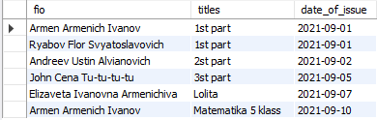

1. Количество различных степеней образования среди читателей.

**select education, count(*) from reader group by education;**

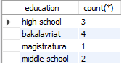

1. Вывод последнего внесенного в базу читателя.

**select fio from reader where id_library_card = any(select max(id_library_card) from reader);**



1. Вывод книг в библиотеке с более 20 копиями.

**select id_book, title, number_of_copies FROM books GROUP BY number_of_copies HAVING number_of_copies > 20;**



1. Вывод прикрепленных читателей с названием зала, в котором они прикреплены.

**select fio, name_room FROM reader INNER JOIN (select id_attachment, date_attachment, name_room, reader_id_library_card FROM attachment_in_room LEFT JOIN reading_rooms ON id_attachment = id_room) as tab ON id_library_card = reader_id_library_card;**

