Tutorial

Send an email at the following address: [samuel.rochette@epfedu.fr](http://samuel.rochette@epfedu.fr)

It must contain a HTML export of the python notebook you’ll create.

Open a new python notebook for each of the 6 sessions we will have together. Please use markdown and make it comfortable to read.

# Classic CV

1. Define in several detailed steps how a canny filter works (this must be done in a markdown cell)
2. Test a canny filter on an image of your choice, you can use the python library of your choice (display the base and filtered image side-by-side)
3. Test a gaussian blur with different sizes of kernel and different values of sigma. Explain what is the impact of those changes
4. Implement your own convolution function (you can use numpy for the element wise multiplication but should write the 2 loops to iterate over height and width). What happens if a pixel is outside the [0,255] interval?

This function must take “input_image” and “kernel” as parameters.

# Palet breton

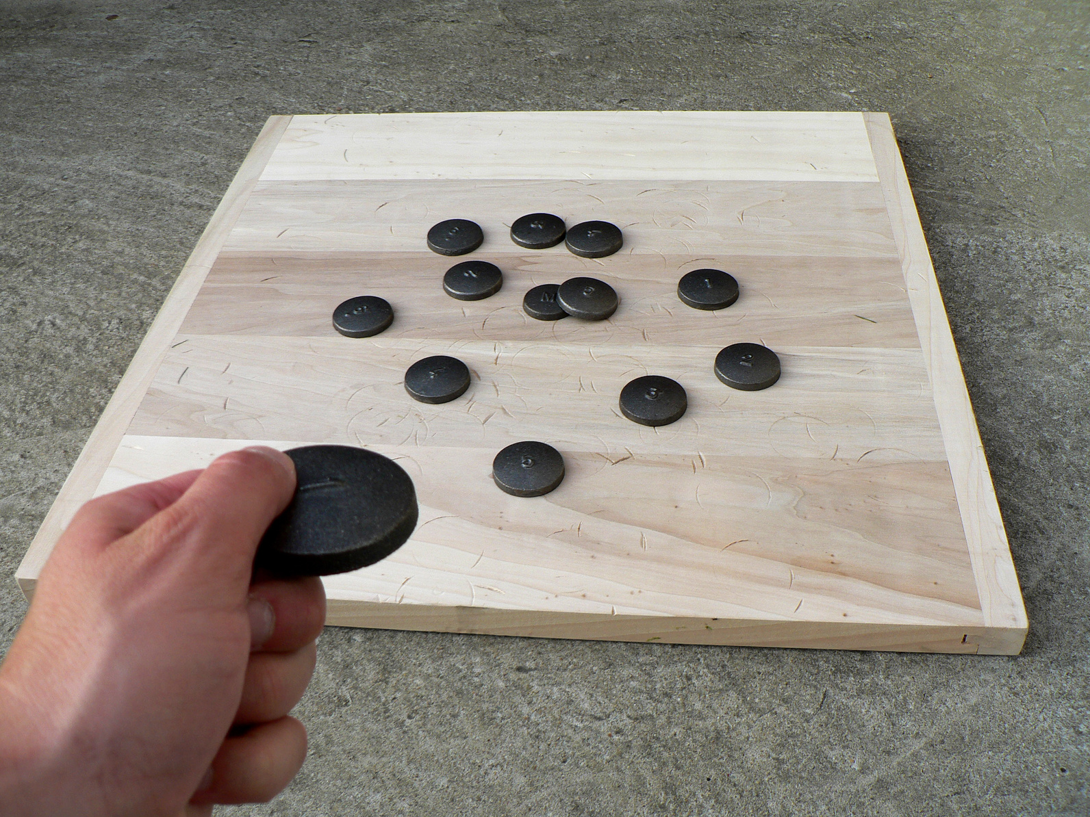

Given a set of [input images](https://epfedu-my.sharepoint.com/:f:/g/personal/samuel_rochette_epfedu_fr/EunVHVlc7n9OhPN4sXizv7YBDN_mhnhtv2Q4RnOwhV83bw?e=heomI8) taken after a game of “palet breton”, implement a classic CV solution in python that detects the nearest “palet” to the “cochonnet”.

*A friend of mine gave this exercise to me as a challenge a few years ago.*

Some guidance will be given along the tutorial but note that no obvious solution exists for this problem. It will be an occasion for me to see how each one of you tackle this problem.