SPI data export, frames from ad9361API lib

Original Data | Osciloscope Data
129 | 129 | 10000001
248 | 248 | 11111000
0 | 0 | 00000000
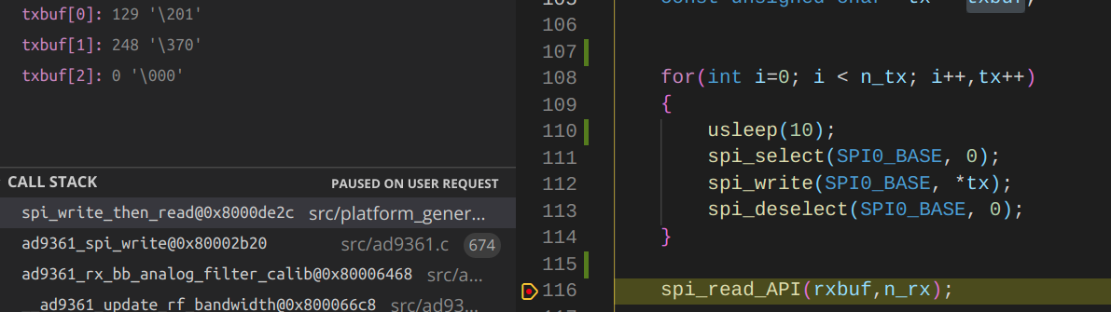

Check Data every rising edge

