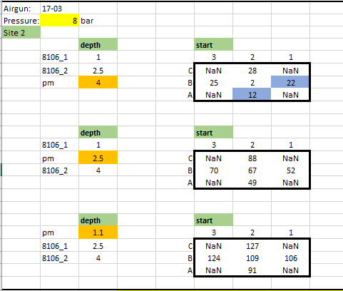

Note different depth for pressure and PM for 1 m depth.