Final Project Report: PPE Detection Pipeline

Introduction and Task Identification
Our main task is a 5 class Personal Protective Equipment detection and classification project. We aim to map images of workers into one of five categories: helmet, safety vest, no ppe, partial ppe, and full ppe. We built a pipeline using a combined dataset from the MinhNKB and Jomarkow subsets. A deep learning solution is required for this task instead of traditional machine learning methods because industrial camera feeds have extreme variety in lighting and backgrounds. When we tested handcrafted features paired with classical models like Support Vector Machines and Random Forests, the accuracy topped out at roughly 79 percent. In contrast, deep spatial algorithms like our custom Convolutional Neural Network, our Vision Transformer architecture, and our YOLO detection framework adaptively learned complex patterns. They easily distinguish a yellow safety vest from diverse industrial machinery. Deep learning is strictly required to handle overlapping objects and pinpoint multiple items in a single scene.

Custom Pipeline Development
Our comprehensive pipeline supports multiple Artificial Intelligence approaches using a unified data layer. First, we use a preprocessing and cropping script to unify two separate datasets into a standard YOLO format. This script also secures square image crops of individual workers. Second, we engineered a dynamically scaling data loader using PyTorch. This ensures our models receive images resized correctly for their specific needs, like upsampling crops for the Vision Transformer. We also apply random distortions like color jitter and horizontal flips to train the network to be resilient against poor lighting. Third, our training pipeline seamlessly runs our custom classification networks alongside larger pretrained models like Vision Transformers and YOLO object detectors.

Augmentation for Transfer Learning
To maximize performance across highly varied warehouse environments, we augmented our pipeline to use Transfer Learning with advanced pretrained models. Instead of initializing our network with random weights, our pipeline queries open source libraries to download weights that were already trained on huge datasets. We deployed an actively tuned YOLO network that dynamically maps generalized feature anchors onto specific box predictions. For classification, the system freezes the base layers of the Vision Transformer so they act strictly as a feature extractor. It strips away the original classification head and attaches our specific 5 class predictor. Our pipeline also supports custom community models directly from the Hugging Face Hub, allowing us to start our training using robust domain knowledge.

Performance Evaluation Metrics
We executed a comprehensive evaluation to compare multiple methods. The table below outlines our results.
Model Architecture | Training Paradigm | Validation Metric / Accuracy
Baseline SVM | Traditional ML | 76.31 percent
Baseline Random Forest | Traditional ML | 79.48 percent
Custom PPENet CNN | Trained from scratch | 87.33 percent
ResNet 18 Base | Trained from scratch | 79.23 percent
ResNet 18 Transfer | Frozen pretrained weights | 79.82 percent
ViT B 16 | Fine tuned pretrained weights | 93.90 percent
YOLOv8 End to End | Fine tuned Object Detection | 0.873 Precision
As the table shows, the custom Convolutional Neural Network achieved 87.33 percent, which vastly outperformed traditional machine learning models but lacked scalable depth. A blank ResNet parameter model trained strictly from scratch achieved 79.23 percent. This proved that large networks struggle heavily without pretrained generalized anchors. However, a frozen ResNet loaded with ImageNet weights efficiently achieved 79.82 percent just by training its final layer. A natively fine tuned Vision Transformer achieved state of the art pure classification precision at 93.90 percent. Finally, YOLO natively scanned raw scenes end to end and localized objects with an incredible precision mapping of 0.873.

Experimentation and Analysis
Our experimentation directly evaluated the tradeoffs between custom layouts and advanced transfer learning models. Deploying frozen backbones provided much faster convergence speeds compared to a blank model. This proved that generalized visual features easily transition to obscure safety classification tasks. However, without unfreezing the entire network for a full fine tuning process, rigid architectures struggled to untangle the visual similarity between bright yellow clothing and actual safety vests. Ultimately, integrating transfer learning via Vision Transformers established our highest global precision point at 93.90 percent. Unfortunately, its massive parameter complexity created slow processing speeds compared to our custom simple network. Conversely, deploying our YOLO framework entirely bypassed the slow cropping phase to secure top tier detection directly on raw video frames. For scalable real time inference across camera streams, this approach provides massive operational value in environments constrained by tracking speed and latency.

Appendix: Model Confusion Matrices and Heatmaps
Note: All confusion matrices and plots below were generated strictly using 20% unseen Testing Data to ensure objective evaluation.

Fine Tuned Vision Transformer Confusion Matrix (Testing Data)
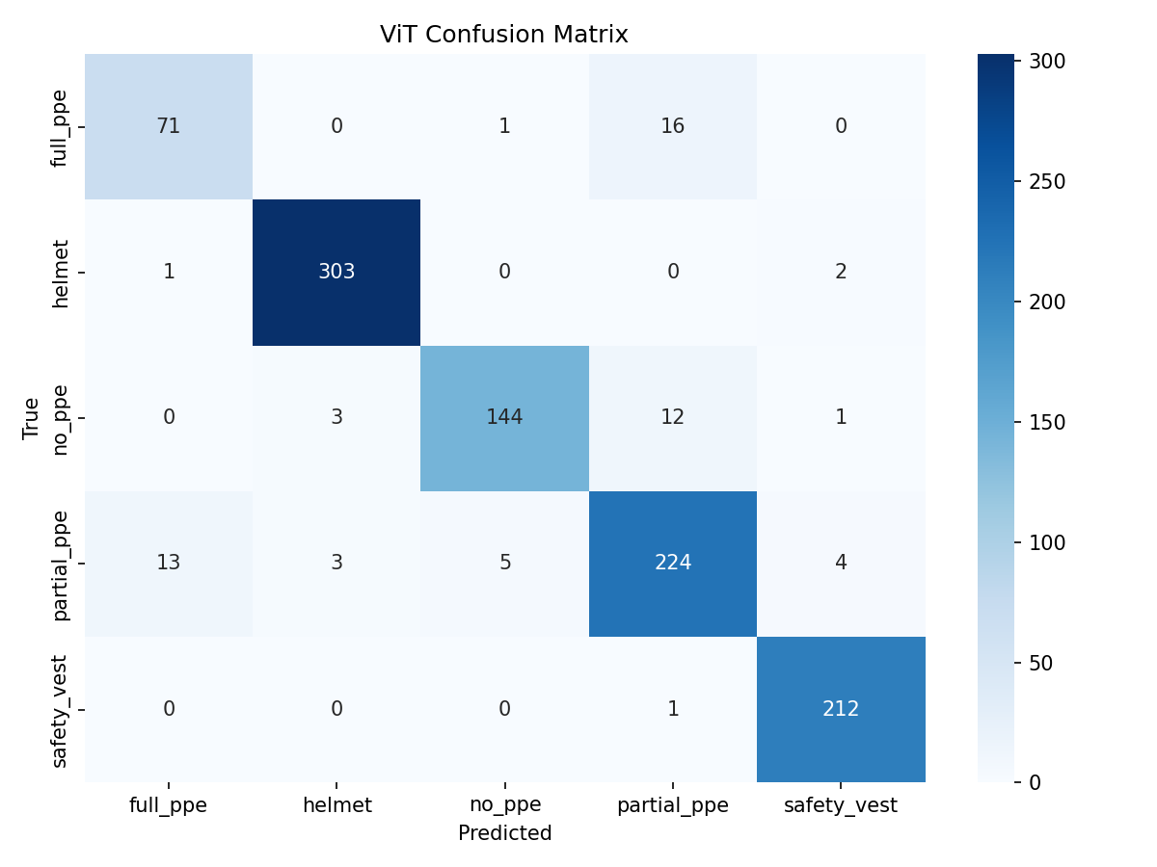

YOLOv8 End to End Object Detection Confusion Matrix (Testing Data)
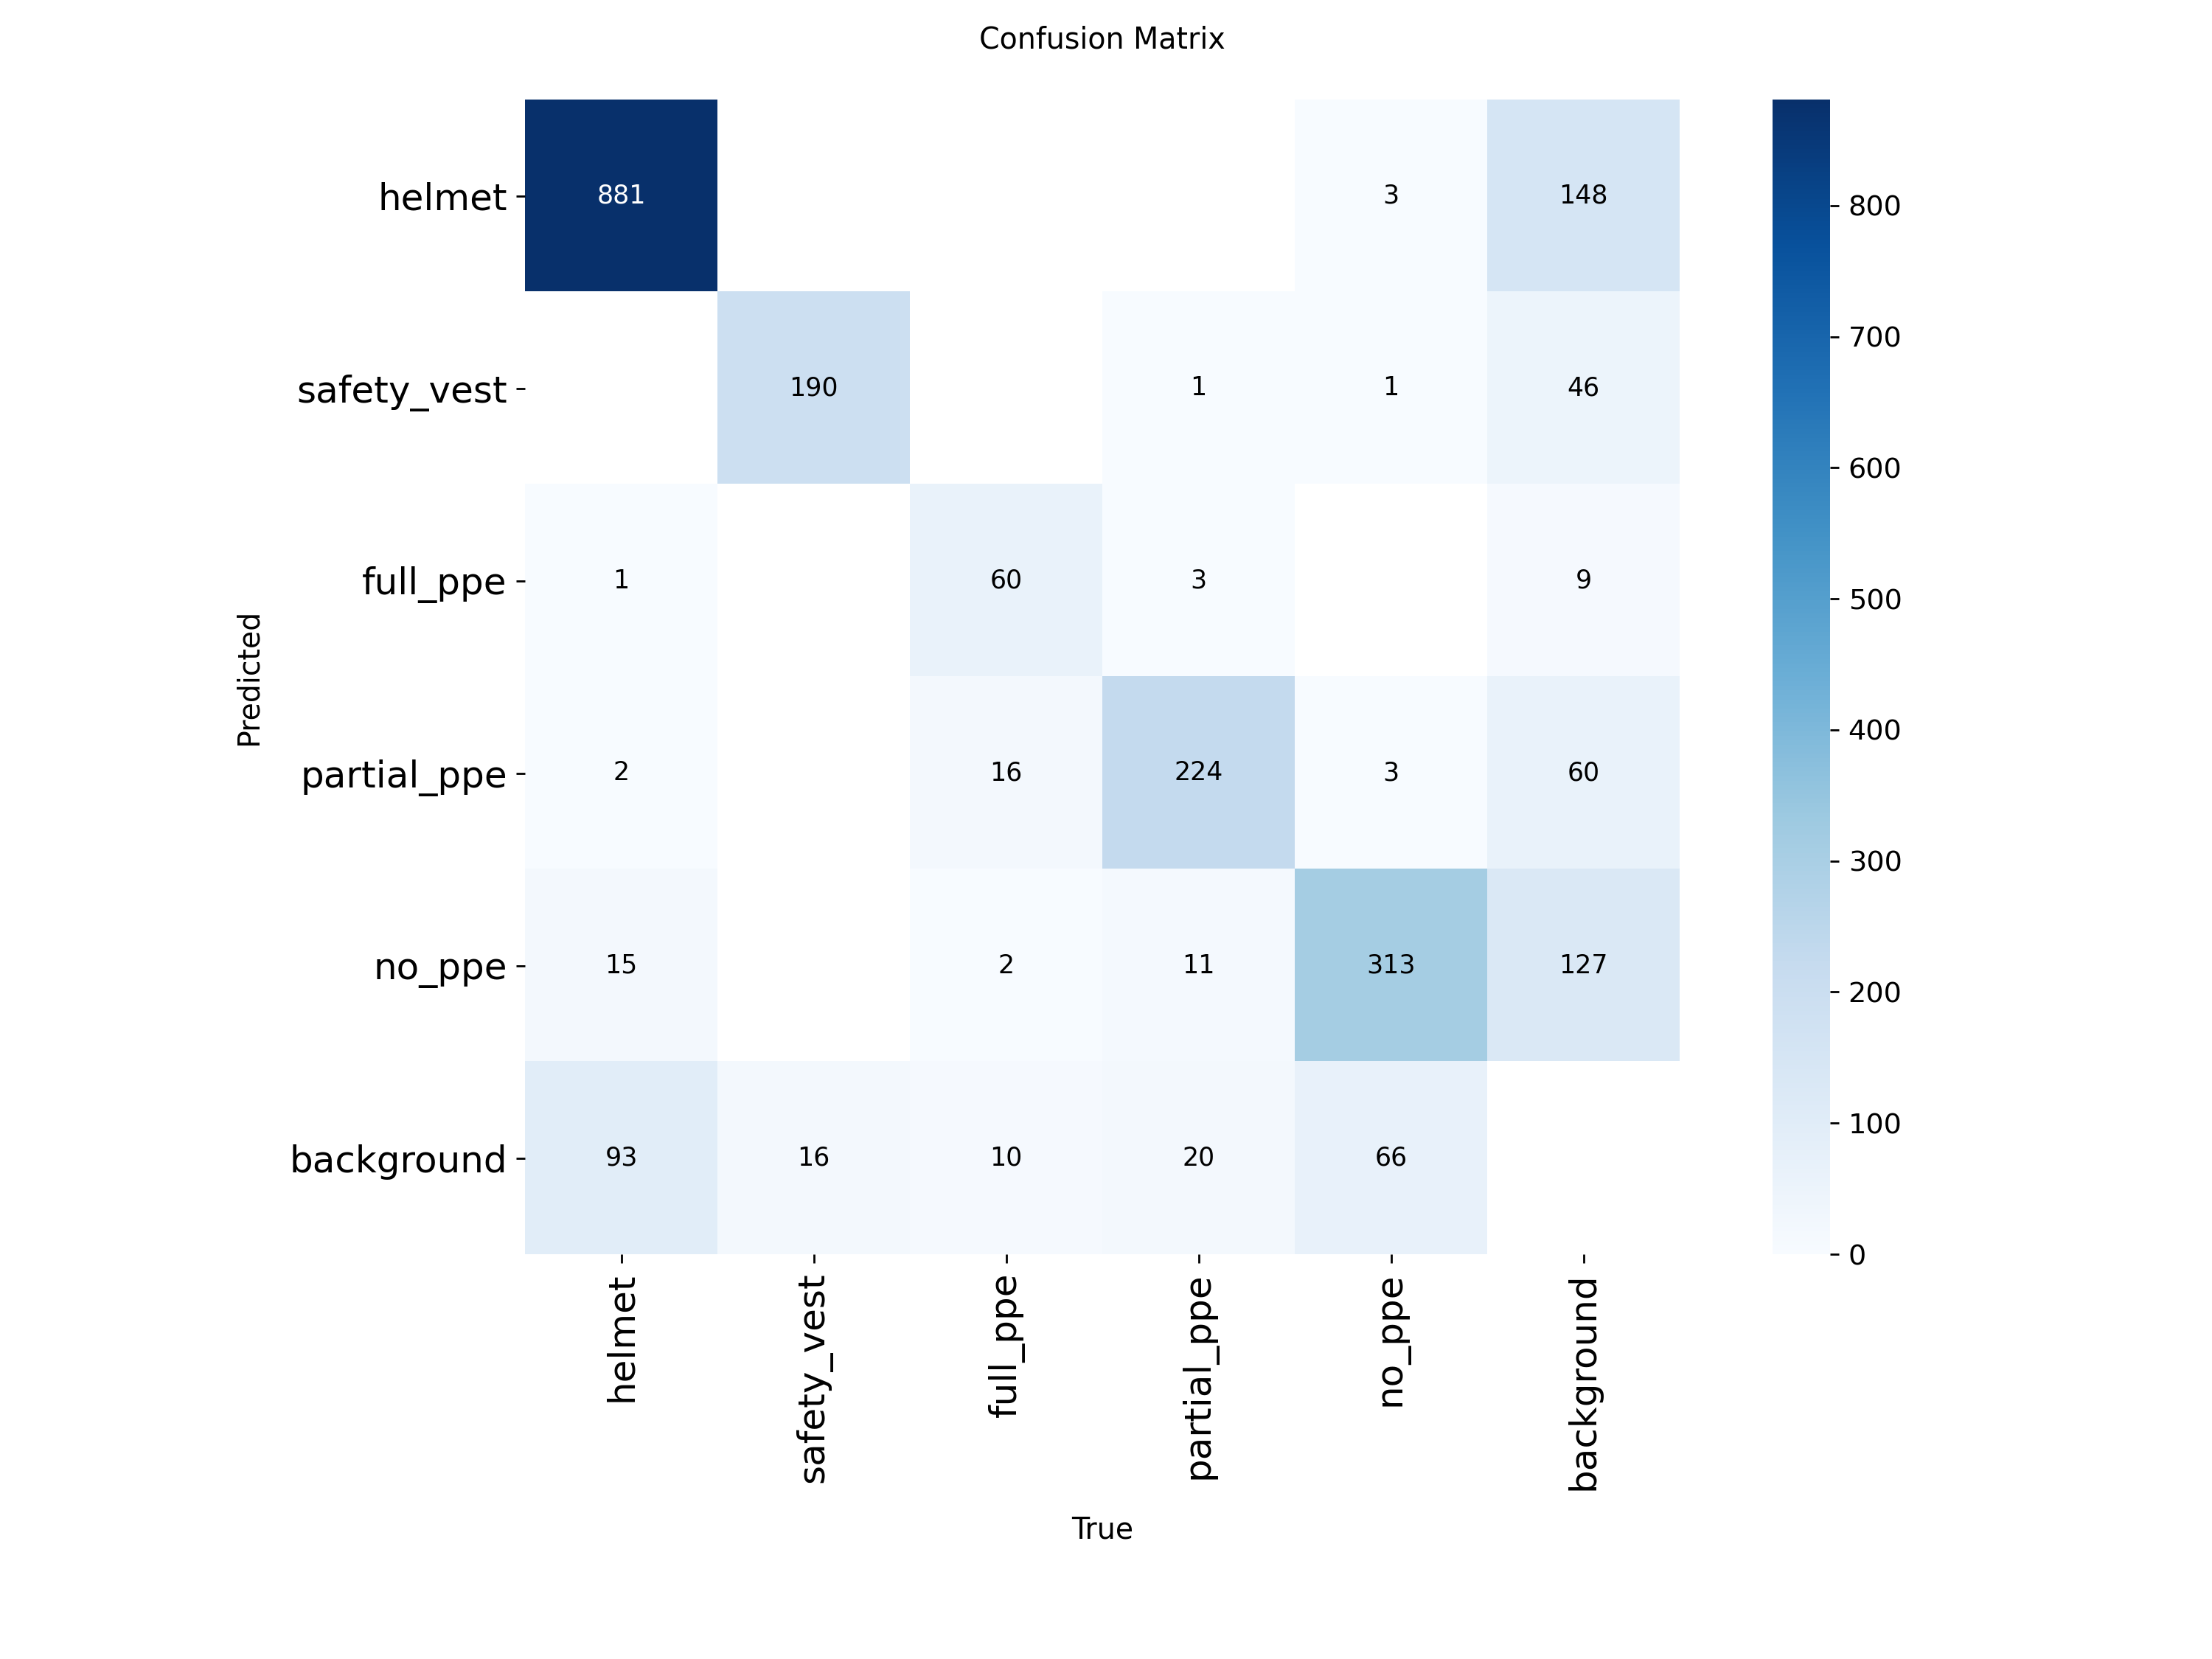

Custom Developed Model CNN Confusion Matrix (Testing Data)
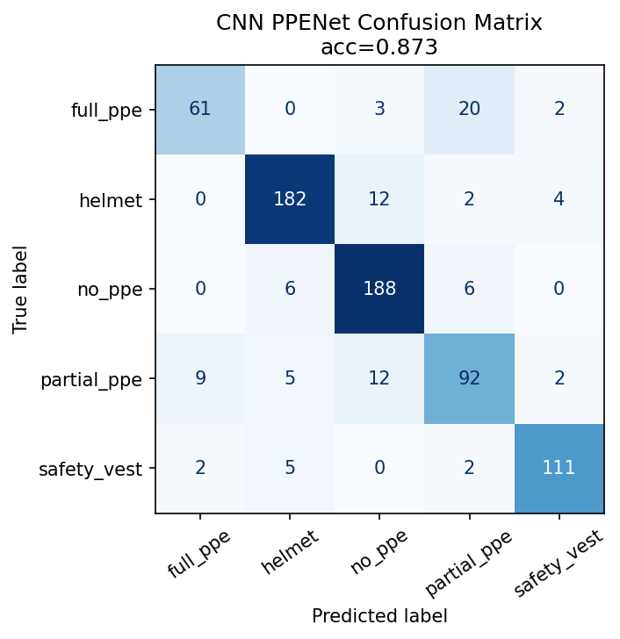

Traditional ML Support Vector Machine Confusion Matrix (Testing Data)
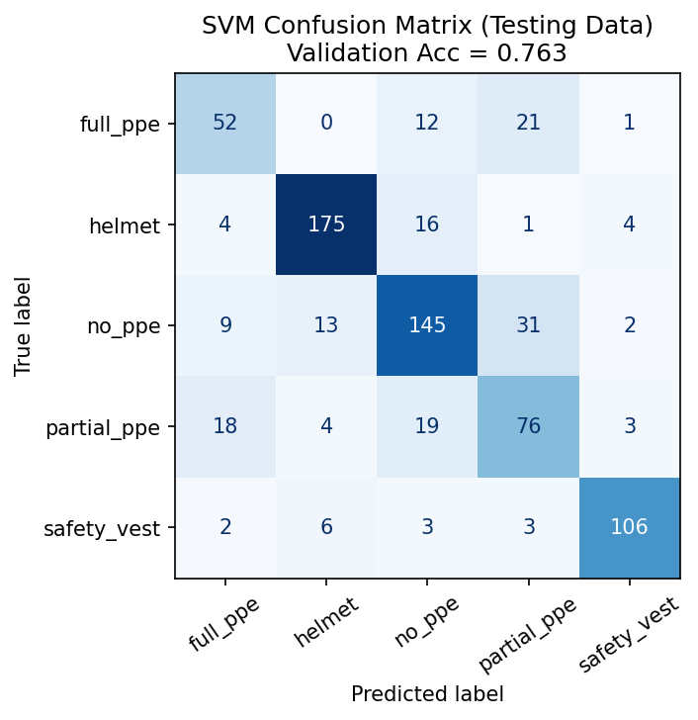

Traditional ML Random Forest Confusion Matrix (Testing Data)
