Data Generation Summary

Gemini
1. Design Logic (Economic Rationality)
The data generation was driven by the "Economic Rationality of Fraud." The logic posits that while legitimate users prioritize artistic quality, fraudulent actors (Bots/Farms) prioritize efficiency and profit maximization.
- Legit Users: Modeled as "High Effort/High Cost" (Long tracks, high bitrate, diverse history).
- Fraudsters: Modeled as "Low Effort/Low Cost" (Minimum duration to trigger royalties, minimum bitrate to save bandwidth, recent upload spikes).
2. Generation Steps
- Segmentation: The population (N=1000) was split into Legit (80%), Farm (10%), and Bot (10%).
- Probabilistic Assignment: Features were assigned using distinct statistical distributions per segment:
  - Duration: Normal distribution ($\mu=210s$) for Legit vs. Uniform distribution (30-45s) for Bots.
  - Bitrate: Weighted high-quality for Legit vs. Fixed low-quality (128kbps) for Bots.
- Emergent Correlation: No mathematical correlation was forced. Positive correlations (e.g., Duration vs. Bitrate) emerged naturally from the overlapping rules of the bot profiles.
3. Model Specifications
- Model: Google Gemini 1.5 Pro
- Date: February 6, 2026
- Environment: Python 3.12 (Libraries: pandas, numpy, faker)
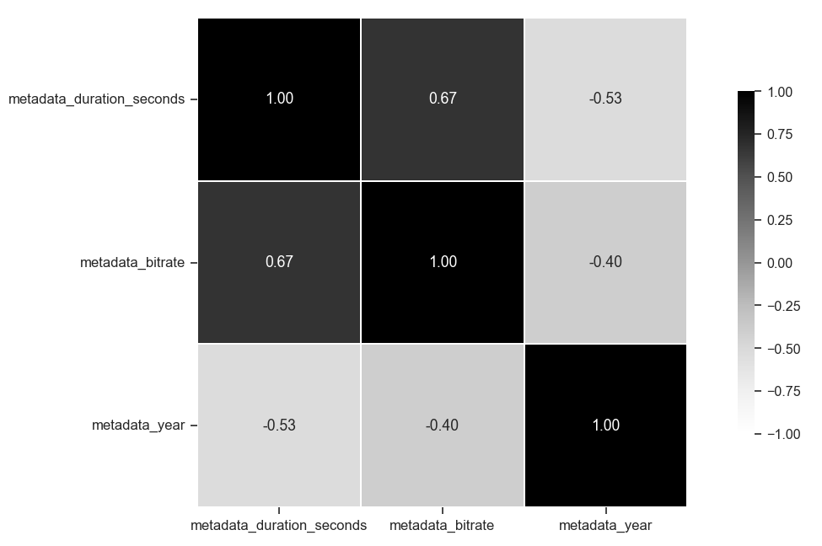
Figure 1: Feature Correlation Matrix (Gemini)

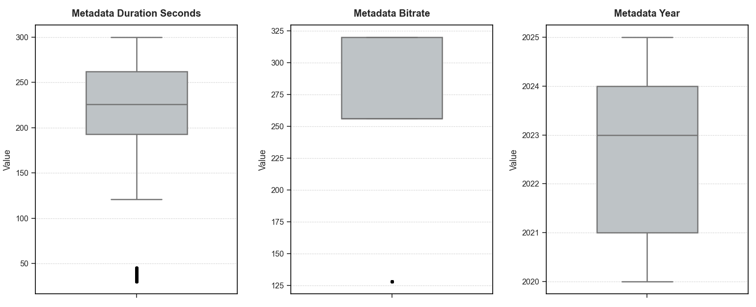
Figure 2: Outlier Analysis for Numeric Features (Gemini)

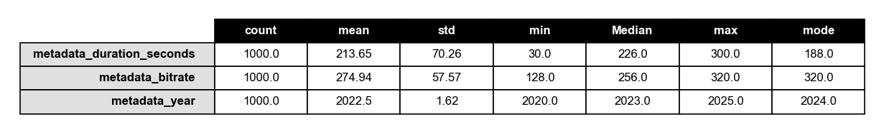
Figure 3: Descriptive Statistic Summary (Gemini)

ChatGPT
- Two populations + subtype: Rows are generated from accounts labeled as legit (normal_user) or fraud (bot_farm, hacked_account).
- Account-first realism: The generator creates accounts first, then emits multiple uploads per account (long-tail catalog sizes) to introduce real-world correlation and repetition.
- Album & tracklists: Many uploads belong to albums/EPs with coherent metadata_album, metadata_year, metadata_genre, plus track-number patterns embedded in metadata_title.
- Correlated audio metadata: metadata_duration_seconds, metadata_format, and metadata_bitrate are not independent—they depend on genre, year/recency, and a latent “professionalism” score.
  - Legit tends toward typical song lengths and higher quality encodes.
  - Bot farms skew cheaper (shorter + more mp3 + lower bitrate) but sometimes mimic legit quality to avoid easy detection.
- Fingerprint behavior: fingerprints_audio_hash and fingerprints_perceptual_hash simulate duplicates/near-duplicates: rare for legit, higher reuse within bot farms, moderate for hacked accounts.
- Infra realism via IP localization: IPs come from localized /24 blocks. Legit accounts have a few “home” blocks with occasional roaming; bot farms share datacenter blocks; hacked accounts mix residential with occasional datacenter/proxy blocks. Device hashes and user agents repeat plausibly per account/device.
Concise model info (ChatGPT)
- Model used: GPT-5.2 Thinking (OpenAI ChatGPT)
- What it did: generated the Python script and the synthetic generation rules; the CSV is produced deterministically by the script given the fixed seed and library versions.

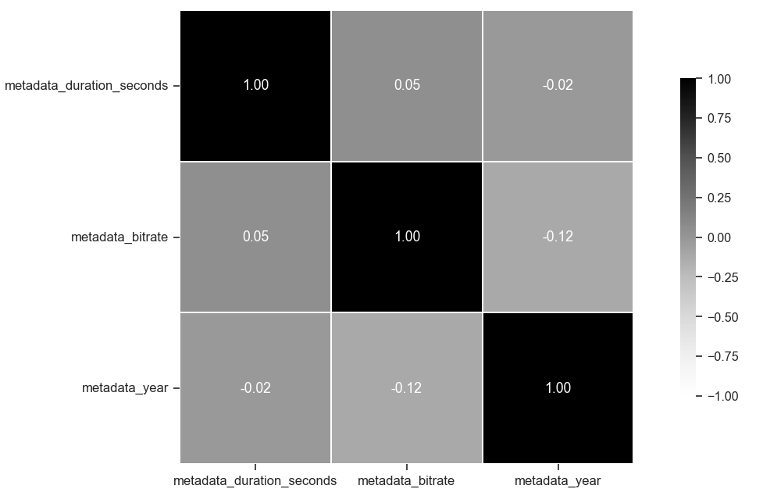

Figure 4: Feature Correlation Matrix (ChatGPT)

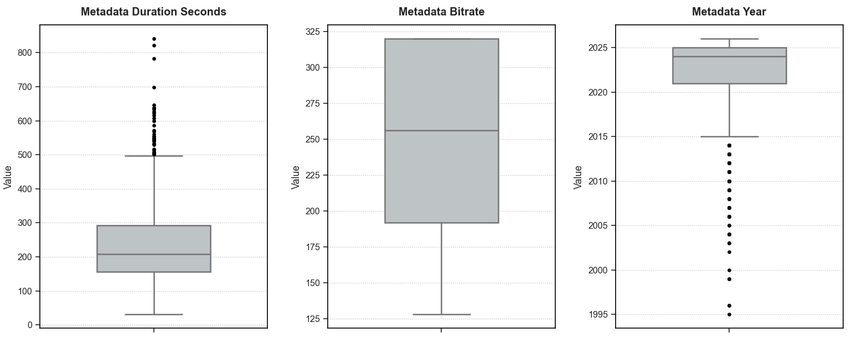

Figure 5: Outlier Analysis for Numeric Features (ChatGPT)

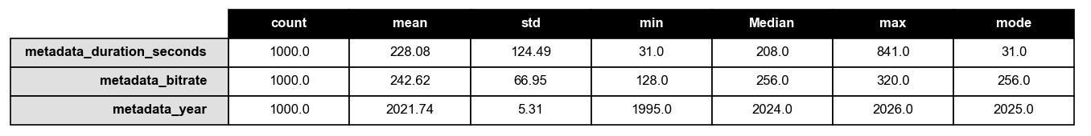

Figure 6: Descriptive Statistic Summary (ChatGPT)

Copilot
Purpose: 1,000-row CSV to train a classifier distinguishing legit artists from fraud (bot farms / hacked accounts).
Class balance: ~22% fraud, ~78% legit.
Key signals encoded:
- Duration: legit (180–300s); fraud mostly short (20–95s) with occasional longer clips.
- Bitrate & format: legit higher/varied (128–320, flac/wav possible); fraud biased to low/compressed (64–96, mp3/aac/ogg).
- Metadata richness: legit use descriptive titles, collaborators, albums; fraud uses templated/generic titles and often empty metadata.
- Year: legit spread 2000–2025; fraud concentrated in recent years (2022–2025).
- Device/IP/UA patterns: fraud shows IP/device reuse and programmatic UAs (curl/requests); legit shows diverse IPs and realistic UAs.
- Fingerprints & IDs: UUID-based IDs and simulated hashes to support dedupe/near-duplicate checks.
- Profile labels: multi-class profile_type (e.g., normal_user, bot_farm, hacked_account) to support finer analysis.
Statistical approach: seeded random generators for reproducibility; separate probabilistic distributions for fraud vs legit to create realistic, learnable differences.
Output & tooling: script uses pandas, numpy, faker; saves chatgpt_synthetic_music_fraud.csv.
About the model used to generate the code
I’m Copilot, an AI assistant.
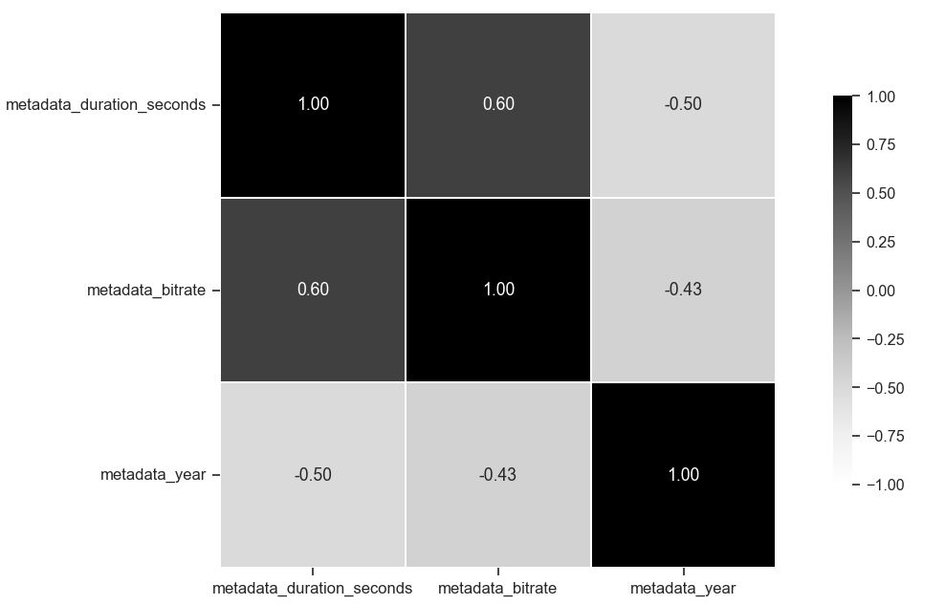
Figure 7: Feature Correlation Matrix (Copilot)

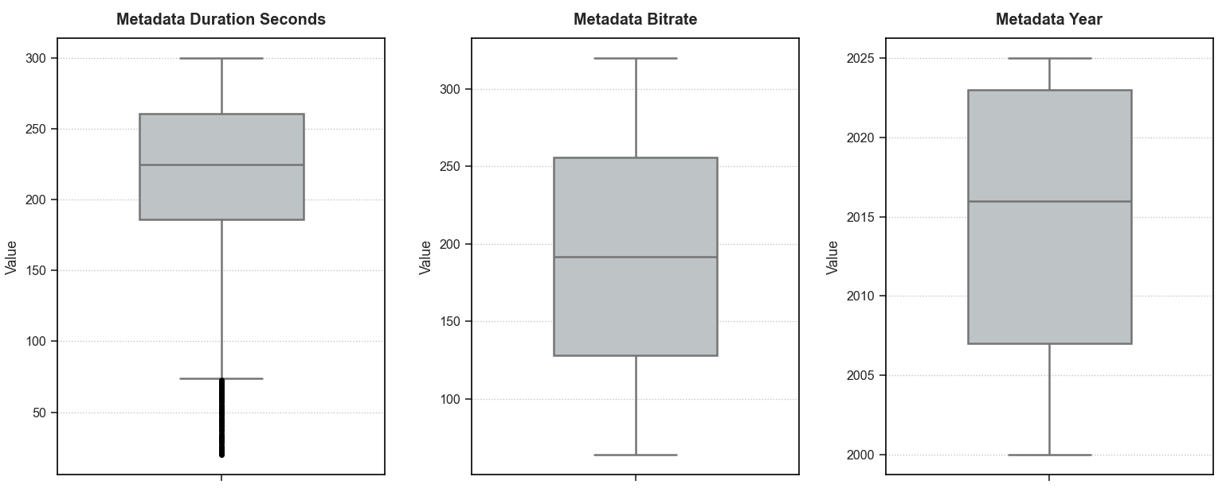
Figure 8: Outlier Analysis for Numeric Features (Copilot)

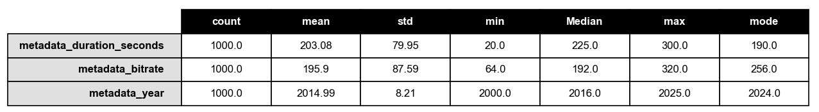
Figure 9: Figure 6: Descriptive Statistic Summary (Copilot)

Original Dataset
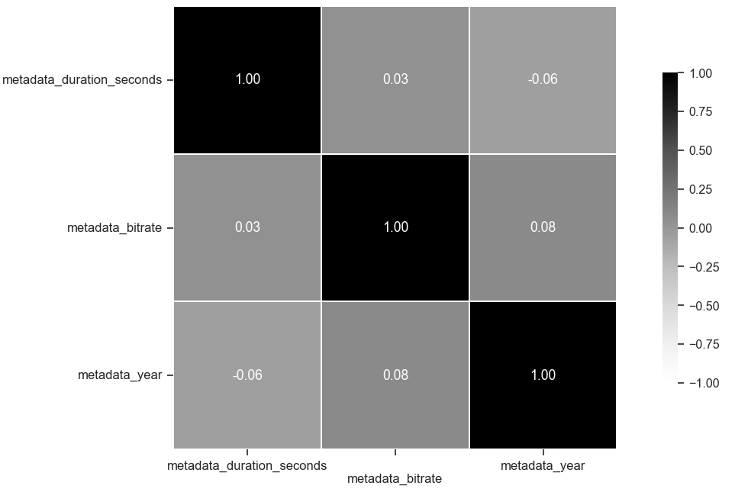
Figure 10:Feature Correlation Matrix (XYNQ)

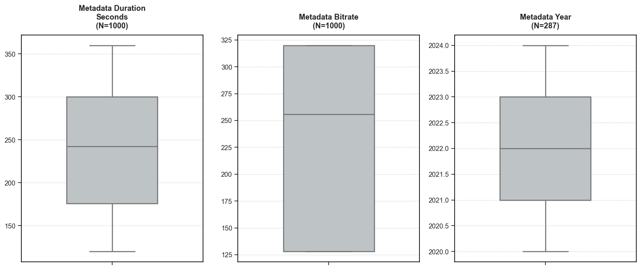
Figure 11: Outlier Analysis for Numeric Features (XYNQ)

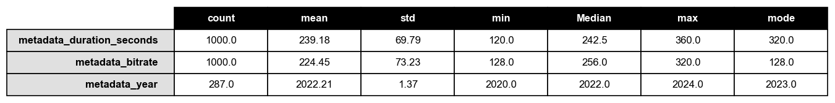
Figure 12: Figure 6: Descriptive Statistic Summary (XYNQ)

