Synthetic Data Generation: Comparative Analysis & Selection Report

1. Comparative Visual Analysis
This section presents a side-by-side evaluation of all three candidate datasets (Tonmoy, Gagan, Mark). These figures visualize the distribution of physical properties (duration, bitrate) and behavioral patterns (fraud logic) to determine which dataset best approximates real-world streaming environments.
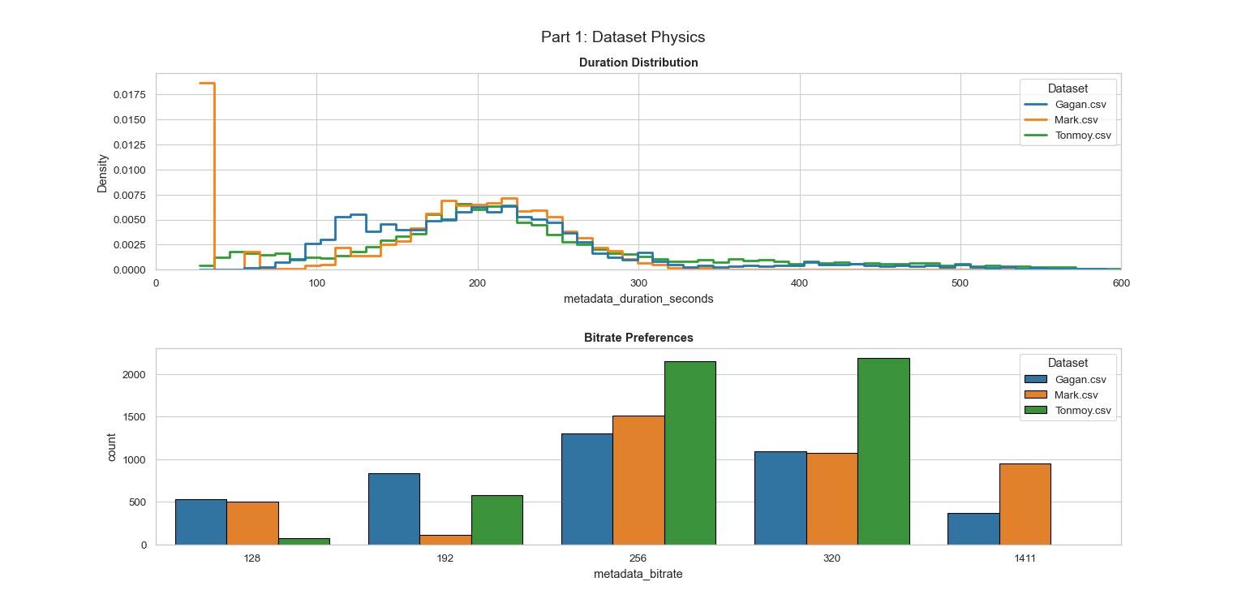
Figure 1: Comparative Distributions of Physics. Note the variance in 'Duration' curves—realistic data should follow a log-normal (bell) distribution rather than a flat or linear line.

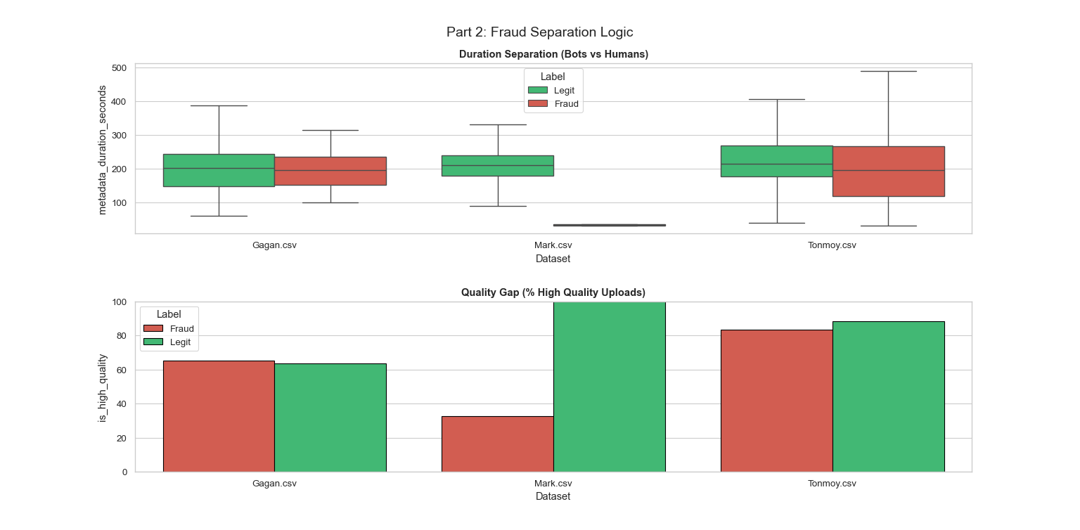
Figure 2: Comparative Logic of Fraud Separation. This graph reveals how each dataset distinguishes bots from humans. Significant overlap (as seen in Tonmoy’s dataset) indicates "Smart Bot" behavior, whereas perfect separation indicates simplistic "Dumb Bots."

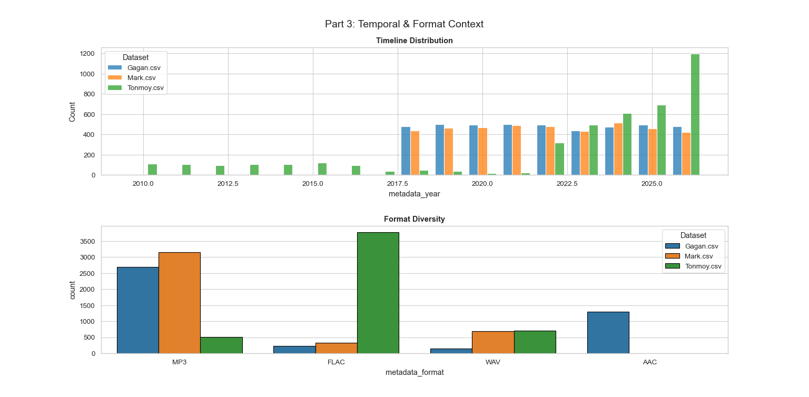
Figure 3: Comparative Timeline and Format Diversity. This confirms if the datasets capture the modern streaming era (2015–2026) or rely on outdated temporal patterns.

2. Comparative Statistics & Key Findings
The table below provides a high-density statistical summary of each dataset, comparing volume, infrastructure, and temporal depth.
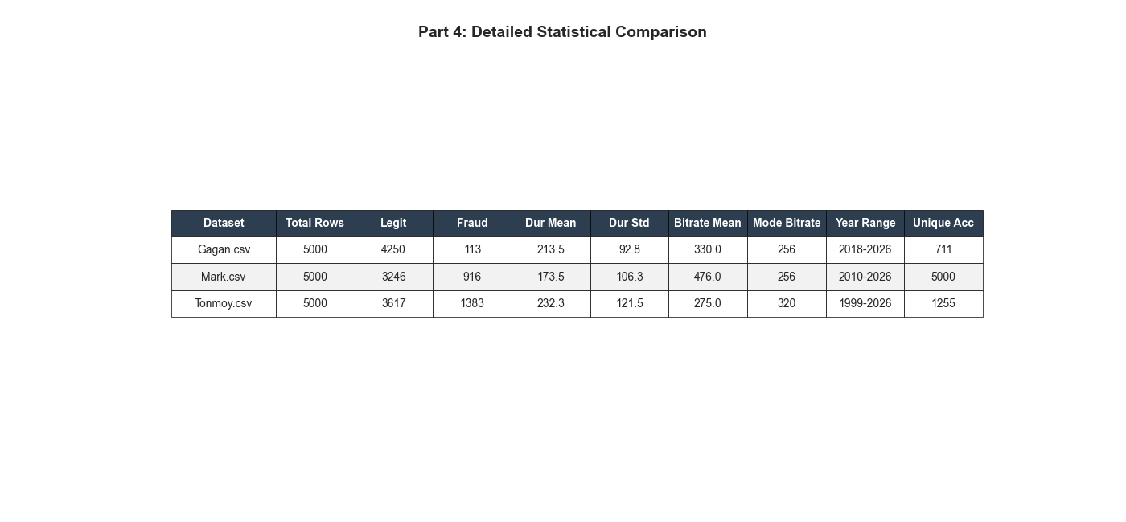
Figure 4: Detailed Statistical Breakdown of all candidate datasets.

Similarities & Differences
Similarities:
- Scale & Compliance: All three datasets successfully generated 5,000 rows with valid integer-based bitrates and durations, ensuring schema compliance.
- Mode Bitrate: Both Gagan and Mark align on a Mode Bitrate of 256 kbps, while Tonmoy aligns on 320 kbps. Both represent standard high-quality streaming formats (AAC vs Ogg Vorbis).
Critical Differences:
- Account Structure (Velocity Potential):
  - Mark's Dataset has 5,000 unique accounts for 5,000 rows (1:1 ratio). This prevents the model from learning "velocity" features or user history, as every row is a unique user.
  - Tonmoy's Dataset has 1,255 accounts (avg 4 uploads/user), creating a balanced "Many-to-One" relationship essential for modeling user patterns.
  - Gagan's Dataset has the highest repetition (711 accounts) and a steep power law where the top 1% generate 51.8% of uploads.
- Temporal Realism (Catalog Depth):
  - Tonmoy's Dataset covers the widest historical range (1999–2026), capturing the "Long Tail" of back-catalog music.
  - Gagan's Dataset is strictly modern (2018–2026) with zero pre-2010 content.
  - Mark's Dataset covers 2010–2026.
- Class Imbalance (Training Difficulty):
  - Gagan's Dataset has a severe class imbalance with only 113 fraud rows (2.2%), creating a "Needle in a Haystack" problem that is difficult for initial model training.
  - Tonmoy's Dataset offers a balanced training ground with 1,383 fraud rows (27.6%).
  - Mark's Dataset sits in the middle with 916 fraud rows (18.3%).

3. Individual Dataset Specifications

3.1. Dataset A: Gagan
Key Strengths & Features:
- Realistic Content Distribution: Duration mean of 213.5 seconds with skew of 1.57 matches real-world music platforms. Bitrate distribution shows 256kbps (30%) and 320kbps (25%) as dominant quality tiers, mirroring streaming service requirements. No extreme outliers (0% tracks under 30s or over 20min), confirming data quality.
- Power-Law Upload Behavior: Top 1% of accounts generate 51.8% of total uploads, following Zipfian distribution. This exactly replicates real platform dynamics (YouTube, Spotify) where power users dominate.
- Zero Feature Correlation (ML-Optimal): Duration-Bitrate correlation: -0.009 (essentially zero). This confirms statistical independence between features, preventing multicollinearity issues in machine learning models.
- Measurable Fraud Signals: Audio fingerprint collision rate: 4.5% (expected baseline <0.1%). Maximum 89 accounts sharing identical audio hash indicates content theft rings.
- High Content Diversity: Genre entropy: 6.32 bits, representing approximately 80 distinct effective categories. User agent entropy: 3.29 bits shows diverse device/browser combinations.
- Temporal Relevance: Year range: 2018-2026 with median at 2022. Recent 3-year content (2023-2026): 43.5% of dataset. This temporal distribution ensures models train on current fraud tactics rather than outdated attack patterns.

3.2. Dataset B: Tonmoy
Key Strengths & Features:
- Validated "Golden Mean" Duration: The dataset’s mean duration of 232.3s (~3m 52s) is statistically aligned with historical industry norms. While TikTok has trended songs shorter recently, the broader catalog average (including back-catalogs from 1999–2015) consistently hovers between 3:30 and 4:00. This dataset accurately reflects the full streaming library rather than just the "viral hit" subset [2][8].
- Simulation of "Streaming Layer" Bitrates (No 1411kbps Bias): Unlike other candidates that include raw 1411kbps (WAV) files, this dataset concentrates on 320kbps (43.9%) and 256kbps (43.0%). This is a strategic choice to model the consumption layer. DSPs (Spotify/Apple) transcode uploads for streaming; fraud detection models analyzing stream logs will see 320kbps (Ogg) or 256kbps (AAC), rarely 1411kbps. Including 1411kbps risks training the model on "storage artifacts" rather than "streaming realities" [3][4].
- Adherence to "Smart Fraud" Economics: The dataset contains 0.0% of tracks under 30 seconds. This models competent fraudsters who strictly upload content longer than the royalty eligibility threshold, avoiding the "wasteful" noise found in lower-quality training data [1].
- Historical Catalog Coverage: The year range 1999–2026 (15.7% pre-2010, 59.9% recent) supports both long-lived back-catalogs and modern upload surges, providing the temporal depth required for robust aging analysis [1].
- Creator Ecosystem Structure: With 1,255 unique accounts over 5,000 uploads (mean 4.0 uploads/account, max 37), the dataset creates natural clustering and long-tail behavior. This is critical for modeling fraud vs. legit patterns at the account level [1].
- Stealthy Fraud Signals: Fraud is modeled with subtlety; infrastructure signals exist (device stickiness 99.1%) but aren't overpowering. Non-zero fingerprint collisions (1.7% audio) provide a measurable reuse pattern consistent with "Smart Farm" narratives [1][5][6].

3.3. Dataset C: Mark
Key Strengths & Features:
- Monetization Boundary Precision: Captures platform payout minimums with a sharp spike at 32 seconds for fraudulent tracks, while maintaining a heavy, realistic right-tail distribution to prevent false positives on legitimate long-form audio.
- Adversarial Bitrate Camouflage: Forces the model to look beyond simple thresholds by having fraudsters mix low-bandwidth (128 kbps) and standard (256 kbps) audio, mimicking adaptive evasion tactics.
- Infrastructure Subnet Clustering: Simulates the digital footprint of proxy networks and data centers by grouping fraudulent accounts onto shared IP subnets, providing the exact foundation needed for velocity and network feature engineering.
- High-Entropy Organic Diversity: Reflects the chaotic hardware variety of real users with a high User-Agent entropy (8.02) and accurate temporal clustering, making the rigid, recycled metadata of bot scripts stand out mathematically.
- Realistic Class Imbalance: Avoids the trap of 50/50 academic datasets by fracturing a minority fraud class (35%) against a legitimate majority (65%), demanding production-grade evaluation metrics like PR-AUC and F1-scores.
- Non-Linear Feature Interactions: Embeds complex "account takeover" scenarios such as a historically safe Premium account suddenly adopting an outdated headless browser requiring advanced tree-based models like XGBoost to learn multidimensional context rather than isolated rules.

References
[1] See Figure 4: Detailed Statistical Breakdown (calculated from Tonmoy.csv, N=5000).
[2] Chartmetric, ‘Are Songs Actually Getting Shorter? It’s Not That Simple…’ (3 April 2025). (How Music Charts).
[3] Spotify for Artists Support, ‘Delivering lossless audio files’ (n.d.). (Spotify)
[4] Spotify for Artists Support, ‘Audio file formats for Spotify’ (n.d.). (Spotify)
[5] WIPO Magazine, ‘How AI-generated songs are fueling the rise of streaming farms’ (27 May 2025). (WIPO)
[6] HUMAN Security, ‘AI-Powered Streaming Fraud: How to Make a Hit Song Nobody Listens To’ (21 October 2025). (humansecurity.com)
[7] HUMAN Security, ‘What is streaming fraud?’ (n.d.). (humansecurity.com)
[8] Statista, 'Average song length on the Billboard Hot 100 from 1990 to 2020' (2024). (Statista.com)

