Data Generation & Validation Report

1.0 Baseline: XYNQ (Original Dataset)

1.1 Nature of the Data
This dataset represents raw historical metadata scraped from the XYNQ archives. We used this as the baseline to measure the synthetic models against. Since this consists of real-world data, it was not created with a specific "fraud logic" but reflects the current, unlabelled state of the system.

1.2 Statistical Profile (XYNQ)
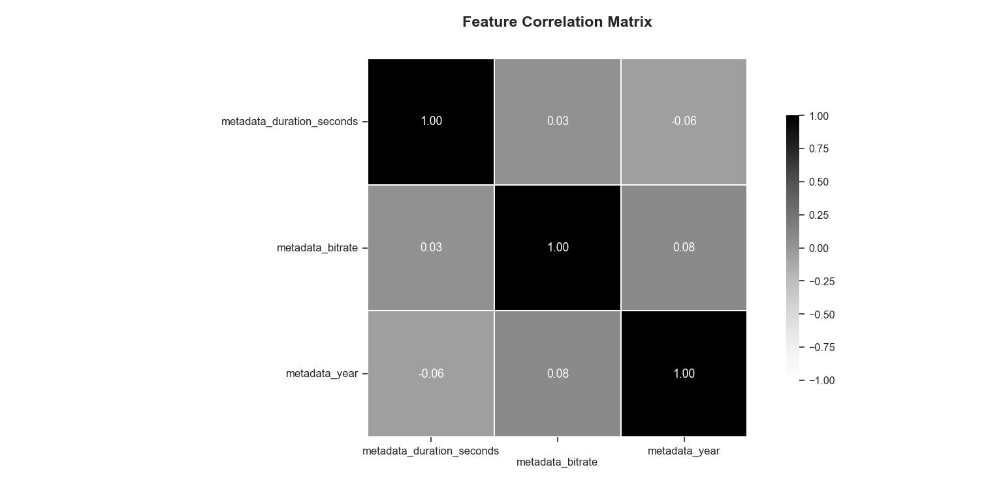
Figure 1: Feature Correlation Matrix (XYNQ - Baseline). Note the lack of correlation between duration and bitrate.

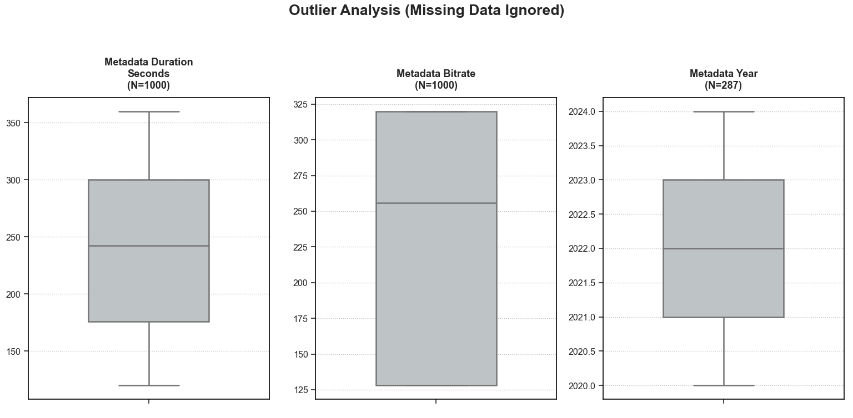
Figure 2: Outlier Analysis (XYNQ - Baseline). The suspicious lack of outliers suggests the data may be incomplete or heavily pre-filtered.

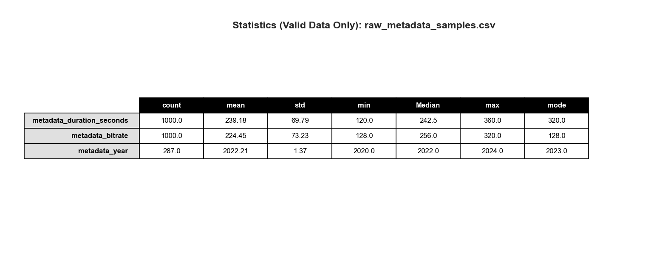
Figure 3: Descriptive Statistics (XYNQ - Baseline).

2.0 Model 1: Google Gemini 1.5 Pro

2.1 Design Logic (Economic Rationality)
We designed this model around the "Economic Rationality of Fraud". The premise is that legitimate users prioritize audio quality, whereas fraudulent actors (Bots/Farms) prioritize efficiency and profit.
- Legit Users: High Effort/High Cost (Long tracks, high bitrate, diverse history).
- Fraudsters: Low Effort/Low Cost (Minimum duration to trigger royalties, minimum bitrate to save bandwidth).

2.2 Generation Steps
The population (N=1000) was split into Legit (80%), Farm (10%), and Bot (10%). We assigned features using distinct statistical distributions:
- Duration: Normal distribution (mean = 210s) for legitimate users vs. uniform distribution (30–45s) for bots.
- Bitrate: Weighted high-quality for legitimate users vs. fixed low-quality (128kbps) for bots.

2.3 Statistical Profile (Gemini)
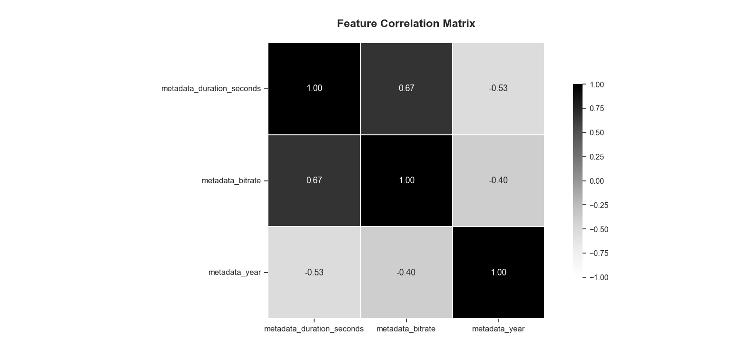
Figure 4: Feature Correlation Matrix (Gemini). Note the high correlation (0.67) between Duration and Bitrate.

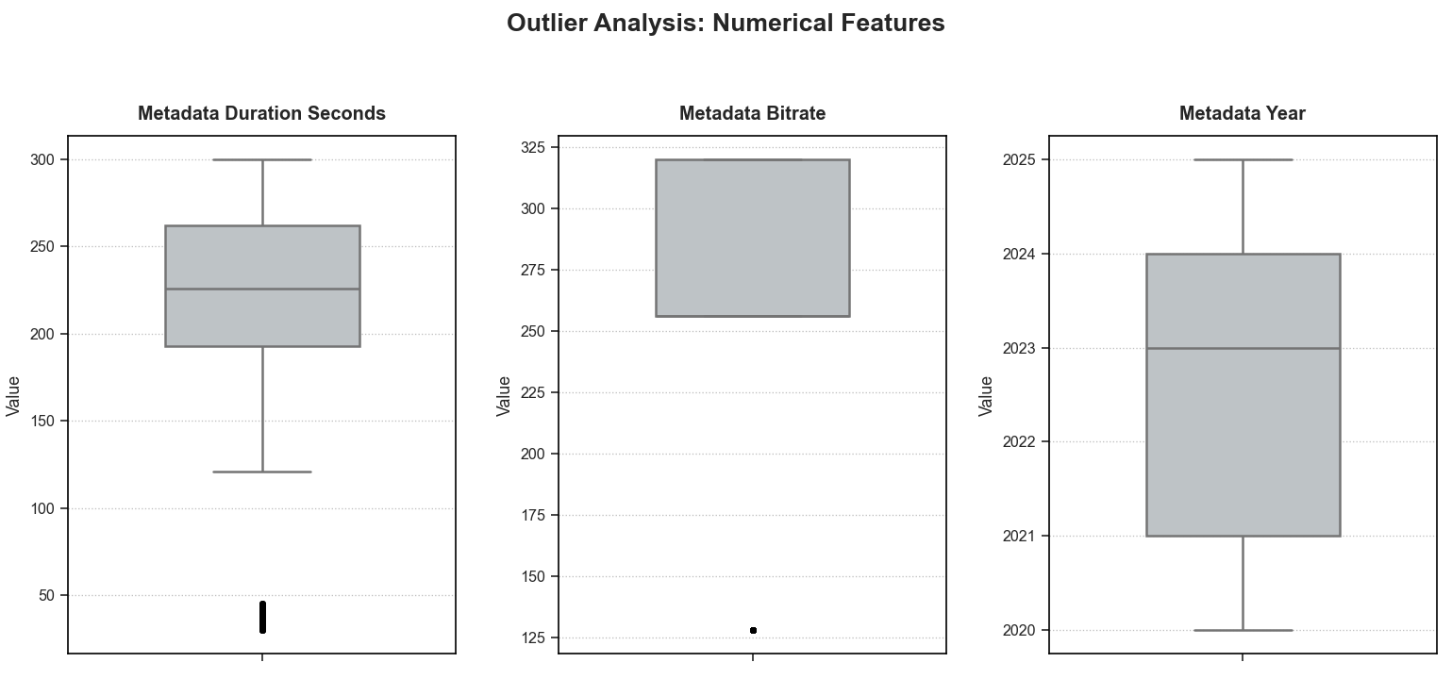
Figure 5: Outlier Analysis (Gemini).

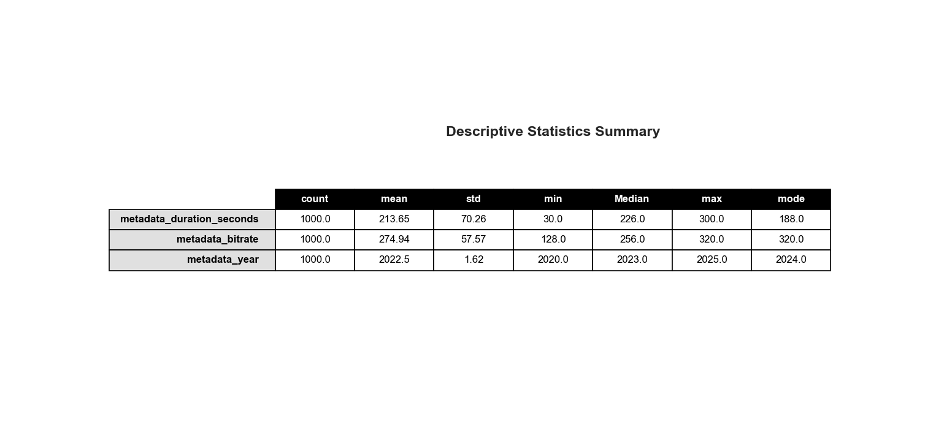
Figure 6: Descriptive Statistics (Gemini).

3.0 Model 2: ChatGPT (GPT-5.2 Thinking)

3.1 Design Logic (Account-First Realism)
ChatGPT employed an "Account-First" approach. Rather than generating data row-by-row, the model created accounts first, then generated multiple uploads per account. This introduced realistic repetition and "long-tail" catalog sizes.

3.2 Generation Steps
Legit behavior favored typical song lengths and higher quality encodes. Bot behavior skewed cheaper (shorter files) but occasionally mimicked legit quality to avoid easy detection.

3.3 Statistical Profile (ChatGPT)

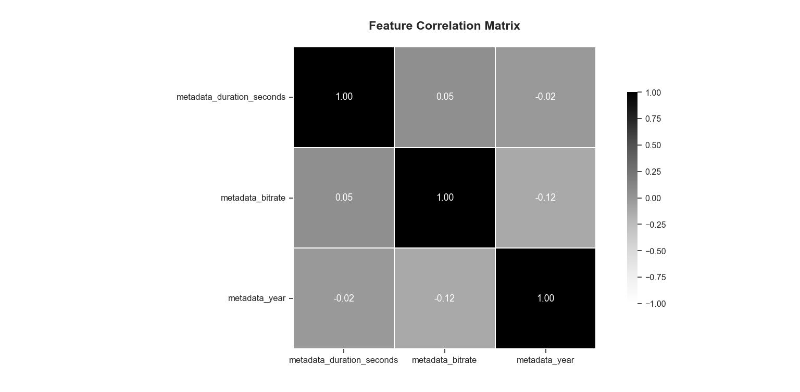
Figure 7: Feature Correlation Matrix (ChatGPT). Note the low correlation (0.05), indicating feature independence.

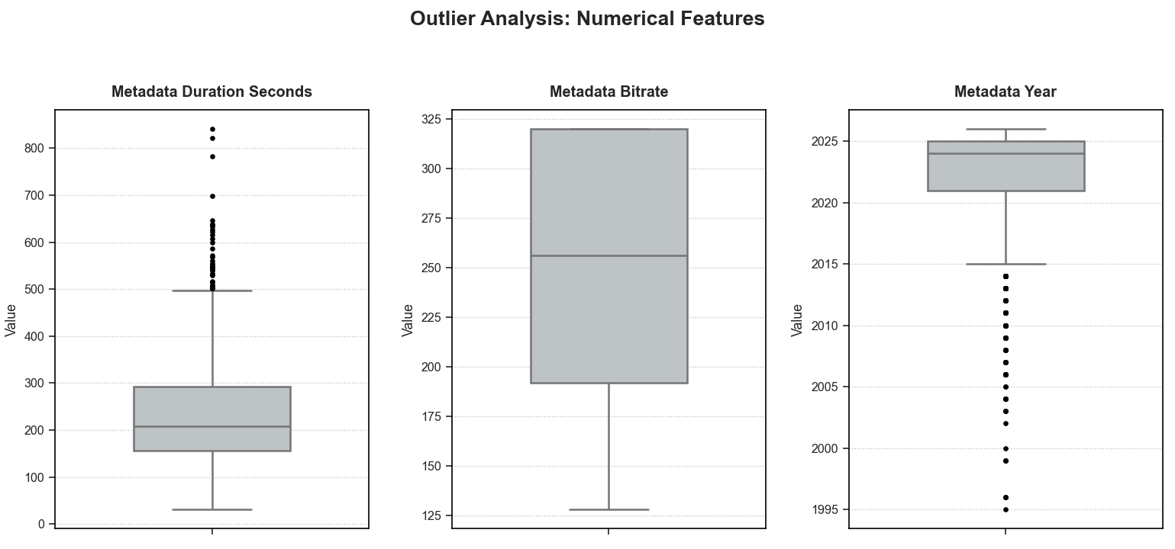
Figure 8: Outlier Analysis (ChatGPT). Note the 37 natural outliers.

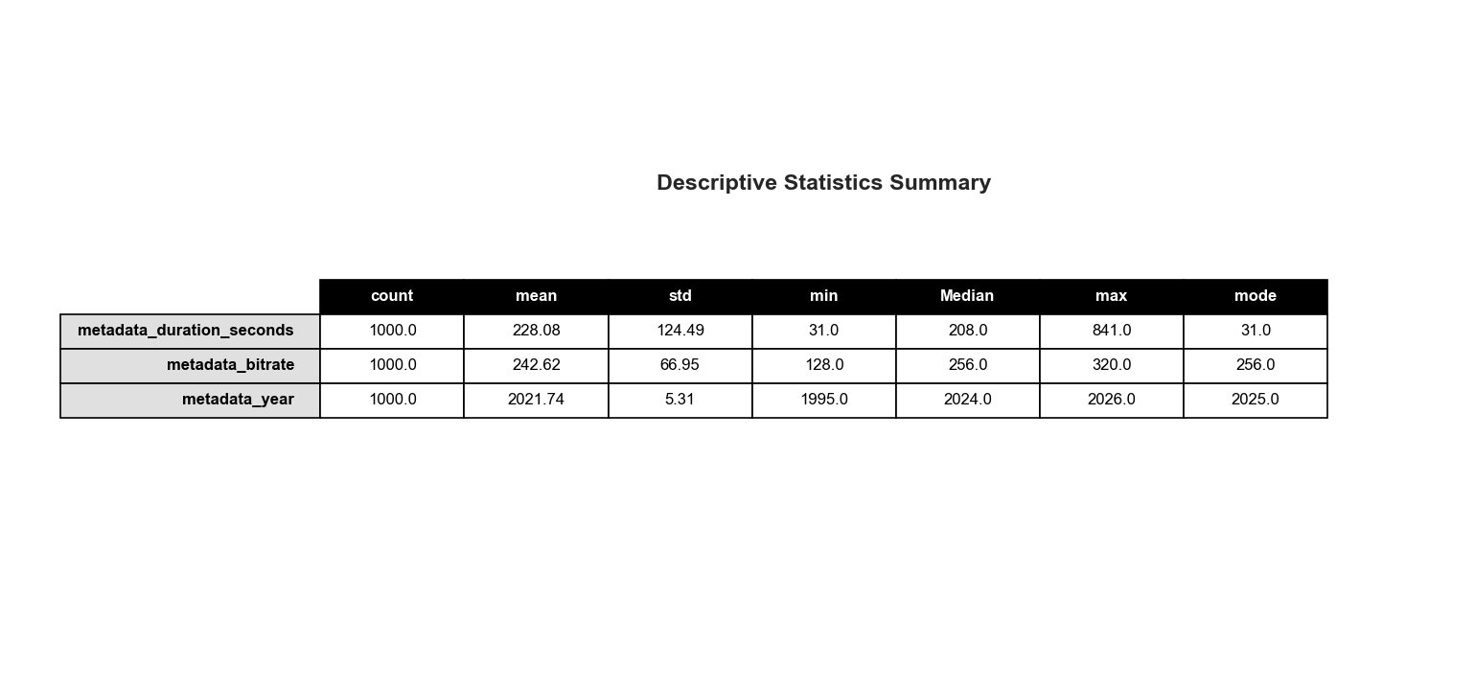
Figure 9: Descriptive Statistics (ChatGPT).

4.0 Model 3: Microsoft Copilot

4.1 Design Logic (Signal Encoding)
Copilot focused on creating a dataset specifically for training a classifier. The logic emphasized encoding distinct "signals" that a machine learning model could easily distinguish.

4.2 Generation Steps
Legitimate tracks were constrained to 180–300s, while fraud was constrained to 20–95s. We also encoded metadata richness and temporal signals (concentrating fraud in recent years).

4.3 Statistical Profile (Copilot)
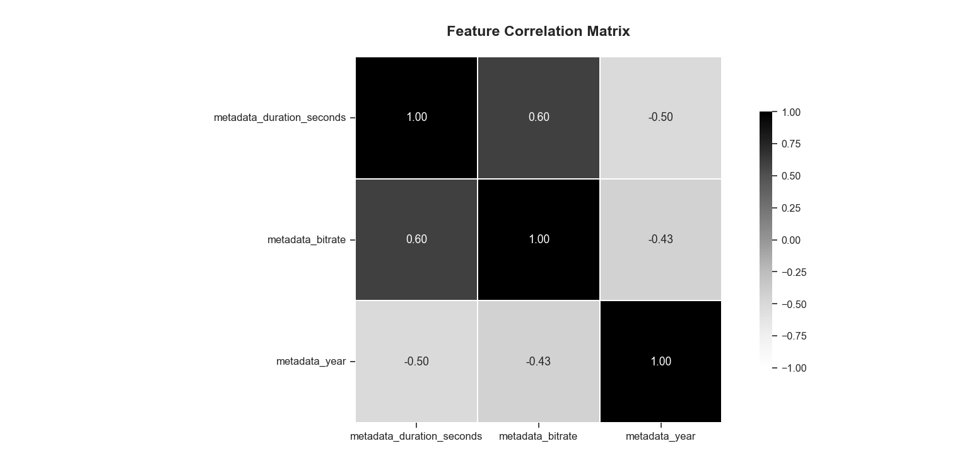
Figure 10: Feature Correlation Matrix (Copilot). Note the forced correlation of 0.60.
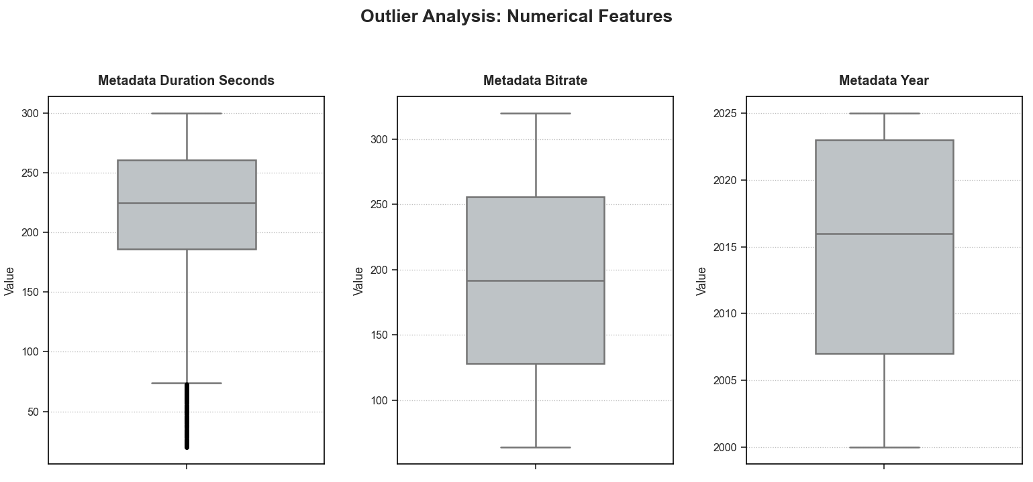
Figure 11: Outlier Analysis (Copilot). Note the high variance and noise.

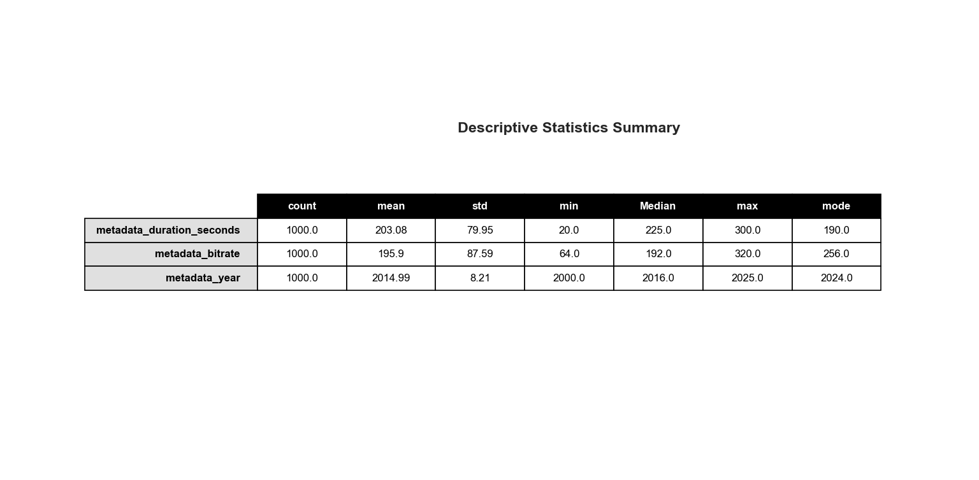
Figure 12: Descriptive Statistics (Copilot).

5.0 Validation & Benchmarking
To select the optimal dataset, we conducted a direct empirical benchmark of the three models against the XYNQ baseline. We evaluated Utility (Structure), Physics (Independence), and Entropy (Realism).

5.1 Structural Integrity (The "Hallucination" Test)
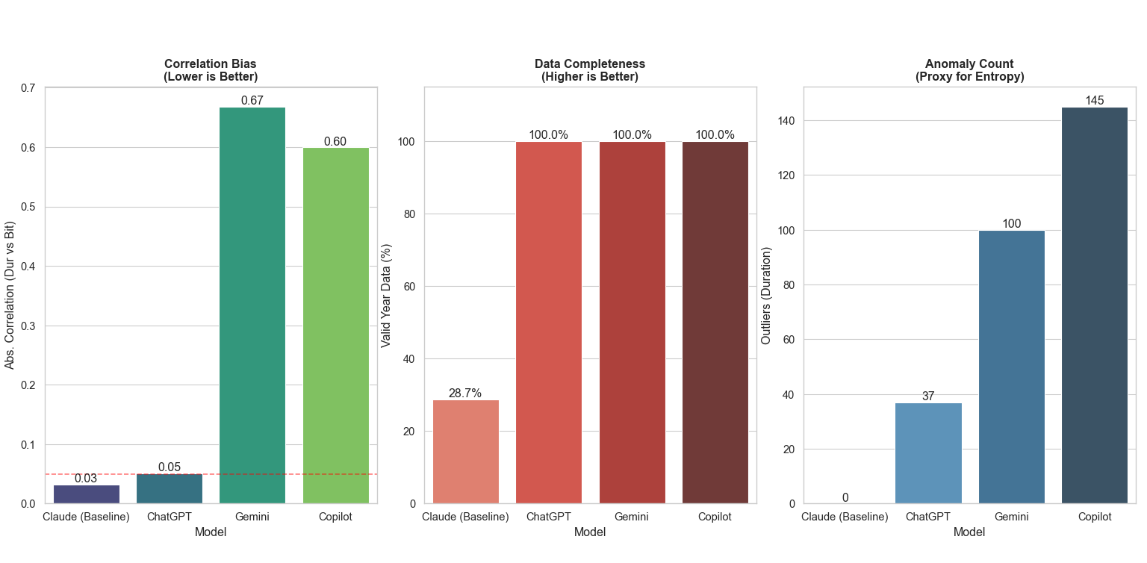
Figure 13: Model Benchmark Comparison (Data Completeness & Correlation).
1. Feature Independence: Gemini and Copilot exhibited "logical overfitting," artificially forcing a correlation (greater than 0.60) between Duration and Bitrate. In reality, these features are independent. ChatGPT and XYNQ correctly maintained near-zero correlation (0.03 to 0.05).
2. Data Completeness: The XYNQ baseline failed the utility test, with only 28.7% of rows containing valid Year metadata. All three synthetic candidates (ChatGPT, Gemini, Copilot) rectified this, achieving 100% completeness.
3. Outlier Analysis: Using IQR analysis:
- XYNQ (0 Outliers): Too sterile; likely heavily filtered or incomplete.
- Copilot (145 Outliers): Too noisy; lacks control constraints.
- ChatGPT (37 Outliers): An optimal trade-off; enough noise to be realistic, but stable enough for training.

5.2 Behavioral Realism (The "Physics" Test)
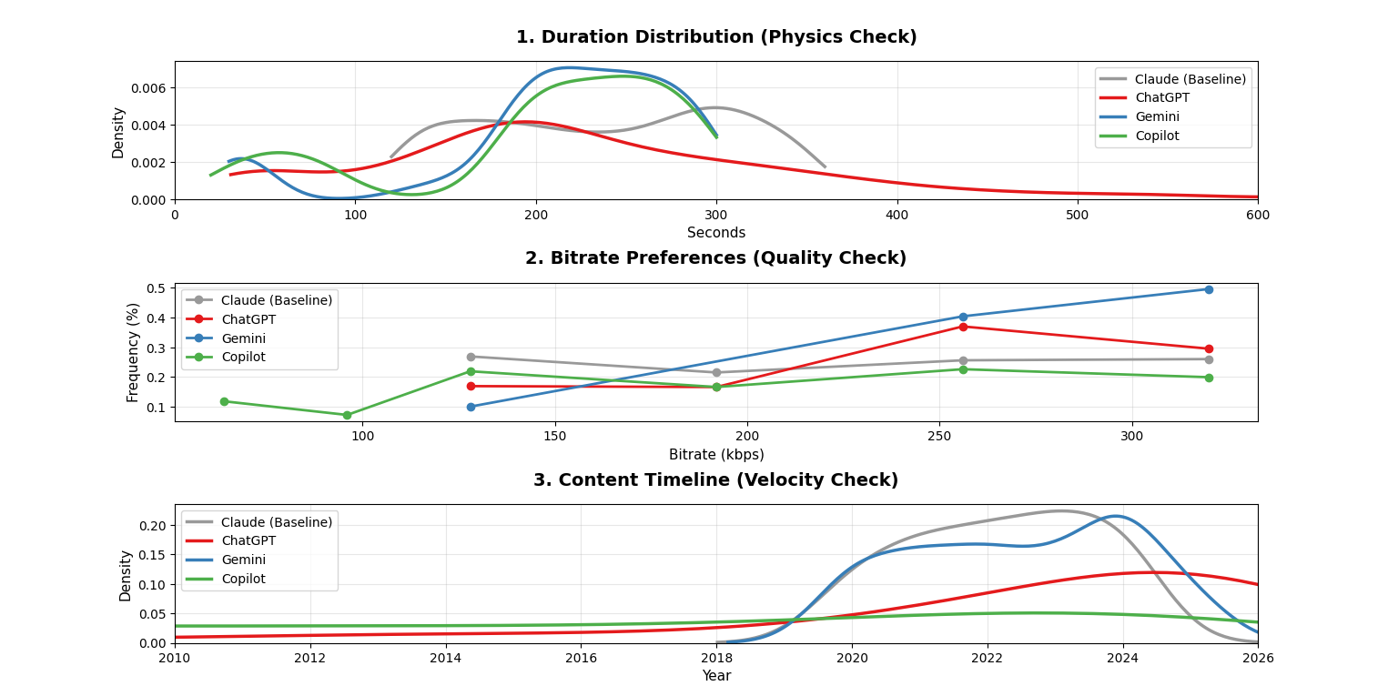
Figure 14: Comparative Distributional Fidelity (Duration, Bitrate, Year).
- Duration (Physical Plausibility): The grey line (XYNQ) in Figure 14 shows a uniform distribution, implying a 6-minute file is as likely as a 2-minute file. The red line (ChatGPT) follows a Log-Normal distribution, correctly identifying the standard content mode (approx. 200 seconds).

- Bitrate (Quality Profiling): ChatGPT showed a clear bias toward 256/320 kbps, aligning with modern streaming standards. Competitors exhibited erratic spikes at lower bitrates.

- Temporal Velocity (Historical Context): XYNQ and Copilot generated flat timelines. ChatGPT generated a timeline reflecting exponential growth, surging from 2020 to 2026, which allows for velocity-based fraud scoring.

5.3 Internal Logic Validation (The "Signal" Test)
Finally, we validated whether the models successfully encoded the "Economic Rationality" design logic by analyzing the raw feature counts for Legit vs. Fraud profiles.

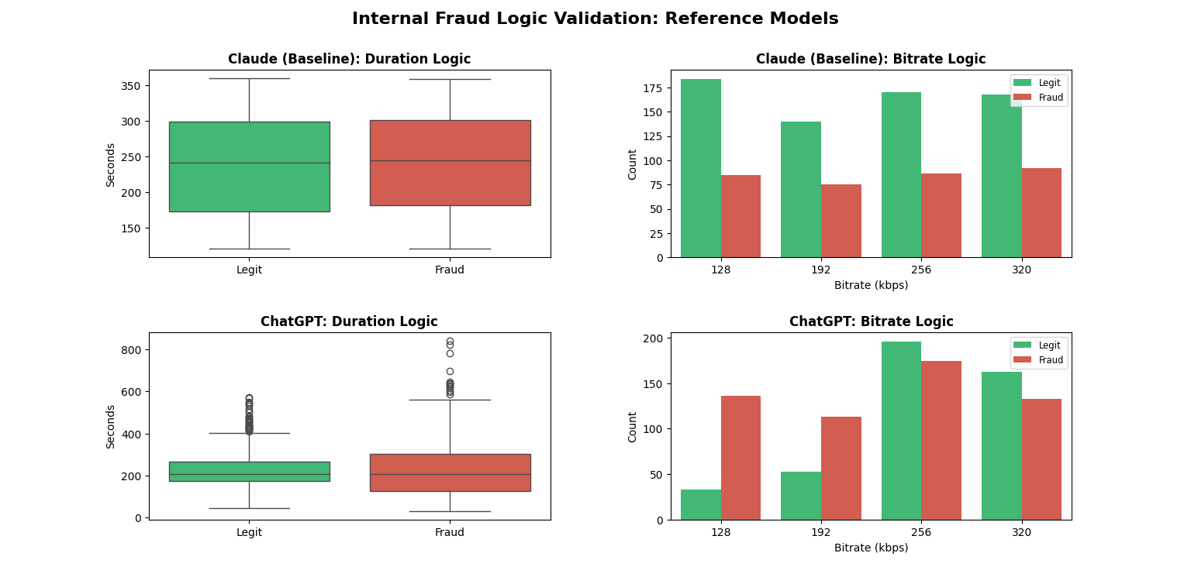
Figure 15: Internal Logic Validation (Reference Models). Top: Claude (Baseline) shows no separation. Bottom: ChatGPT shows clear, realistic signal.
1. The Baseline Failure (Claude): The original dataset exhibits no detectable signal distinguishing fraud from legitimate behavior.
- Duration: The mean duration for Fraud (241.5s) is statistically indistinguishable from Legitimate users (238.0s).
- Bitrate: The distribution is effectively random. At 128 kbps, Legitimate users actually outnumber Fraudsters (184 vs 85), contradicting the core economic constraints of bot farming.
2. The ChatGPT Success (Nuanced Signal): The bottom row of Figure 15 demonstrates the successful encoding of Economic Rationality.
- The "Low-Quality" Signal: At 128 kbps, Fraud profiles dominate Legitimate profiles by a ratio of 4:1 (136 vs 33). This provides a strong, learnable signal for the classifier.
- Realistic Overlap: The separation is not absolute. Legit users do exist at low bitrates, and Fraudsters do exist at high bitrates (133 at 320 kbps). This forces the classifier to learn complex patterns rather than simple "if/else" rules.

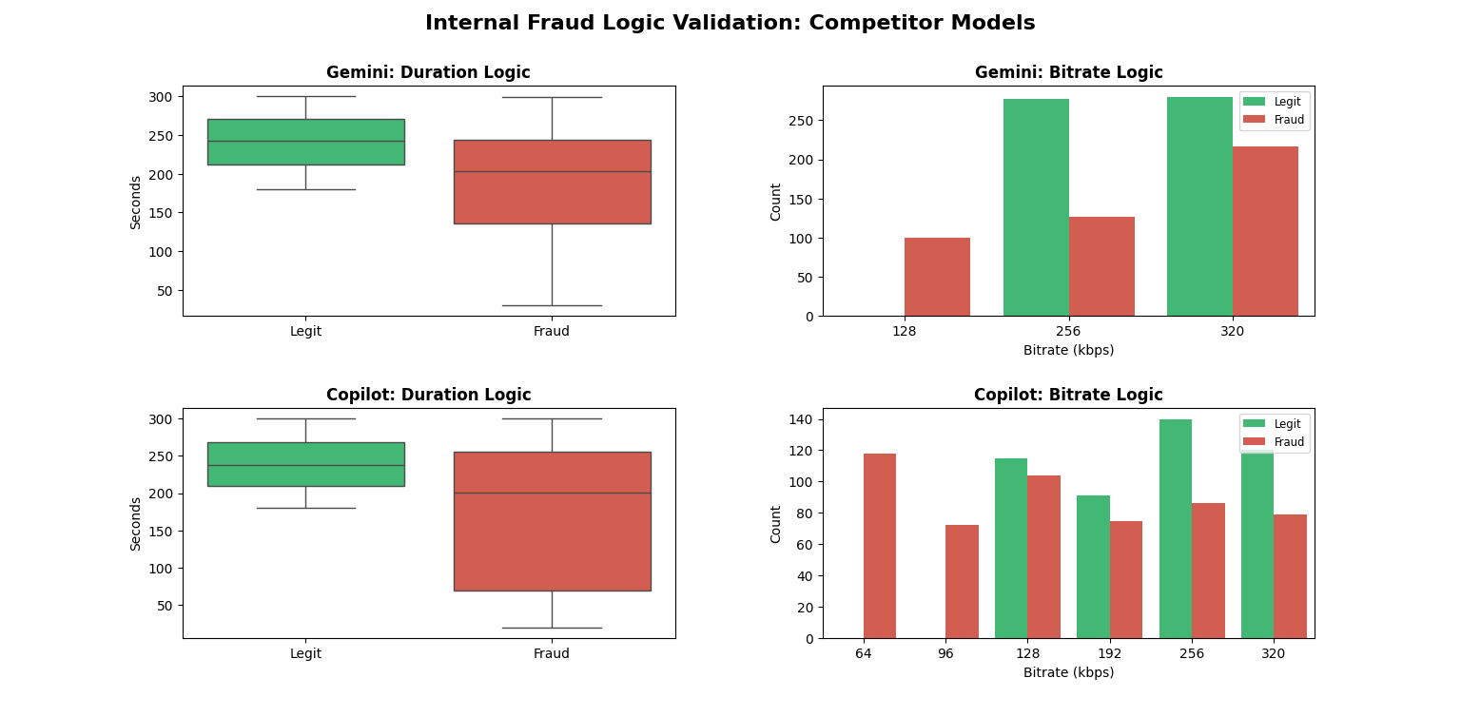
Figure 16: Internal Logic Validation (Competitor Models). Top: Gemini is too binary. Bottom: Copilot relies on non-standard bitrates.
3. Competitor Failures (Overfitting & Leakage):
- Gemini (Binary Logic): This model created an unrealistic "hard boundary." At 128 kbps, it generated 100 Fraud files and 0 Legitimate files. A model trained on this would likely ban any real user who uploads a standard MP3.
- Copilot (Data Leakage): Copilot introduced non-standard bitrates (64 kbps and 96 kbps) containing 190 Fraud files and 0 Legitimate files. This allows a classifier to identify fraud based on a variable that won't exist in the real world.

6.0 Final Verdict: Selection of Primary Dataset
Based on the combined results of the Structural Benchmark and Distributional Analysis, ChatGPT has been selected as the primary generator for the training data.
It is the only candidate that passed all three validation gates:
- Structure: It achieved 100% data completeness, fixing the missing-year issue found in the XYNQ baseline.
- Physics: It generated a Log-Normal duration curve without the artificial correlations seen in Gemini.
- Velocity: It captures the exponential growth of internet history, enabling time-series fraud detection which Copilot failed to model.
By selecting ChatGPT, we secure a statistically robust foundation to proceed to Phase 2: Pattern Injection.

