Data Generation & Validation Report

1.0 Baseline: XYNQ Original Dataset (Claude)

1.1 Nature of the Data
This dataset represents the "raw" historical metadata scraped from the platform. It serves as the baseline against which all synthetic models are measured. As it consists of real-world (or previously generated) data, it was not created with a specific "fraud logic" in mind but rather reflects the current state of the system's archives.

1.2 Statistical Profile (Baseline)
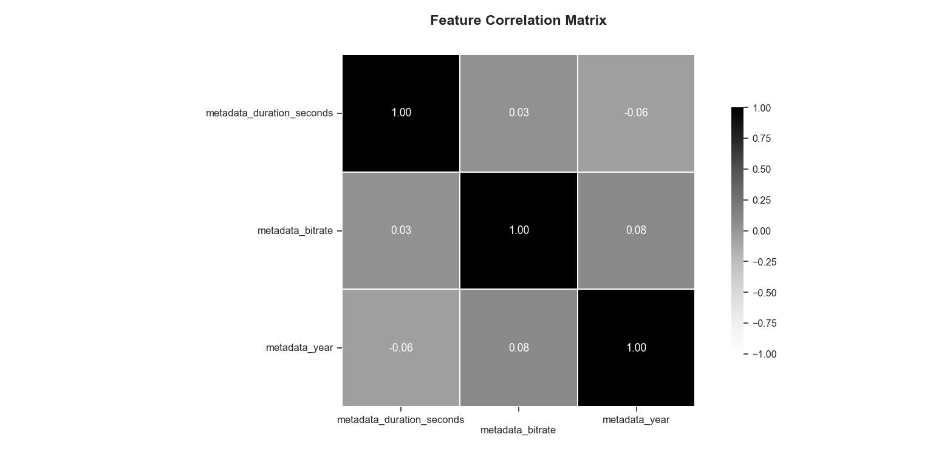
Figure 1:Feature Correlation Matrix (XYNQ). Note the very low correlation, which is good.

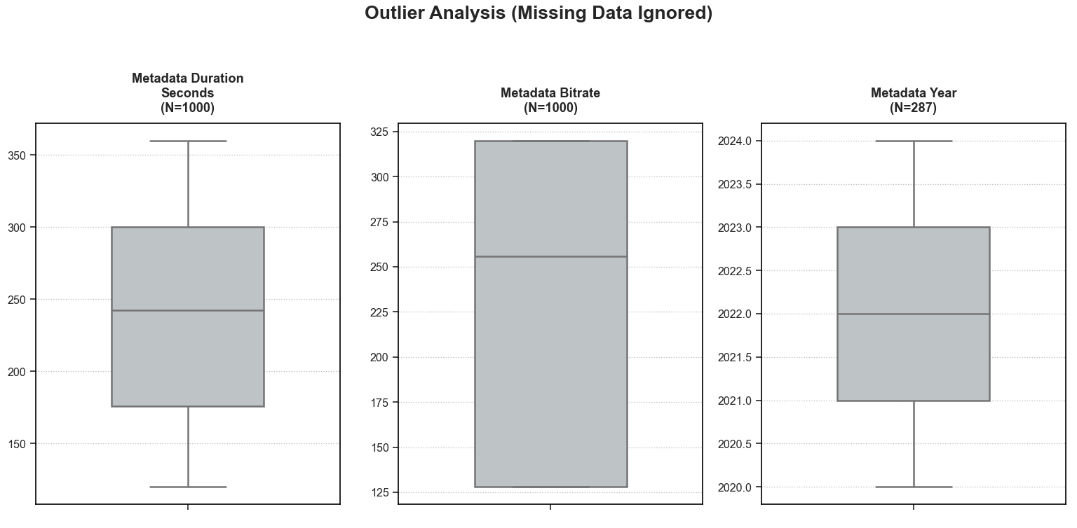
Figure 2: Outlier Analysis for Numeric Features (XYNQ). Note that this is the Box Plot with almost no outliers, which is suspicious for real world data.

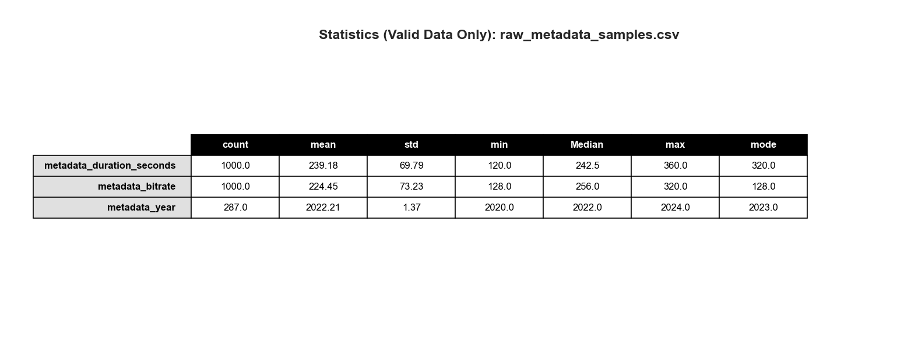
Figure 3: Figure 6: Descriptive Statistic Summary (XYNQ). (Valid Data Only).

2.0 Model 1: Google Gemini 1.5 Pro

2.1 Design Logic (Economic Rationality)
The data generation for this model was driven by the "Economic Rationality of Fraud". The logic posits that while legitimate users prioritize artistic quality, fraudulent actors (Bots/Farms) prioritize efficiency and profit maximization.
- Legit Users: Modeled as "High Effort/High Cost" (Long tracks, high bitrate, diverse history).
- Fraudsters: Modeled as "Low Effort/Low Cost" (Minimum duration to trigger royalties, minimum bitrate to save bandwidth, recent upload spikes).

2.2 Generation Steps
To simulate this, the population ($N=1000$) was split into Legit (80%), Farm (10%), and Bot (10%). Features were assigned using distinct statistical distributions per segment:
- Duration: A normal distribution ($\mu=210s$) was applied for legitimate users, versus a uniform distribution (30–45s) for bots.
- Bitrate: Weighted towards high-quality for legitimate users versus fixed low-quality (128kbps) for bots.
- Emergent Correlation: No mathematical correlation was forced. Positive correlations (e.g., Duration vs. Bitrate) emerged naturally from the overlapping rules of the bot profiles.

2.3 Statistical Profile (Gemini)
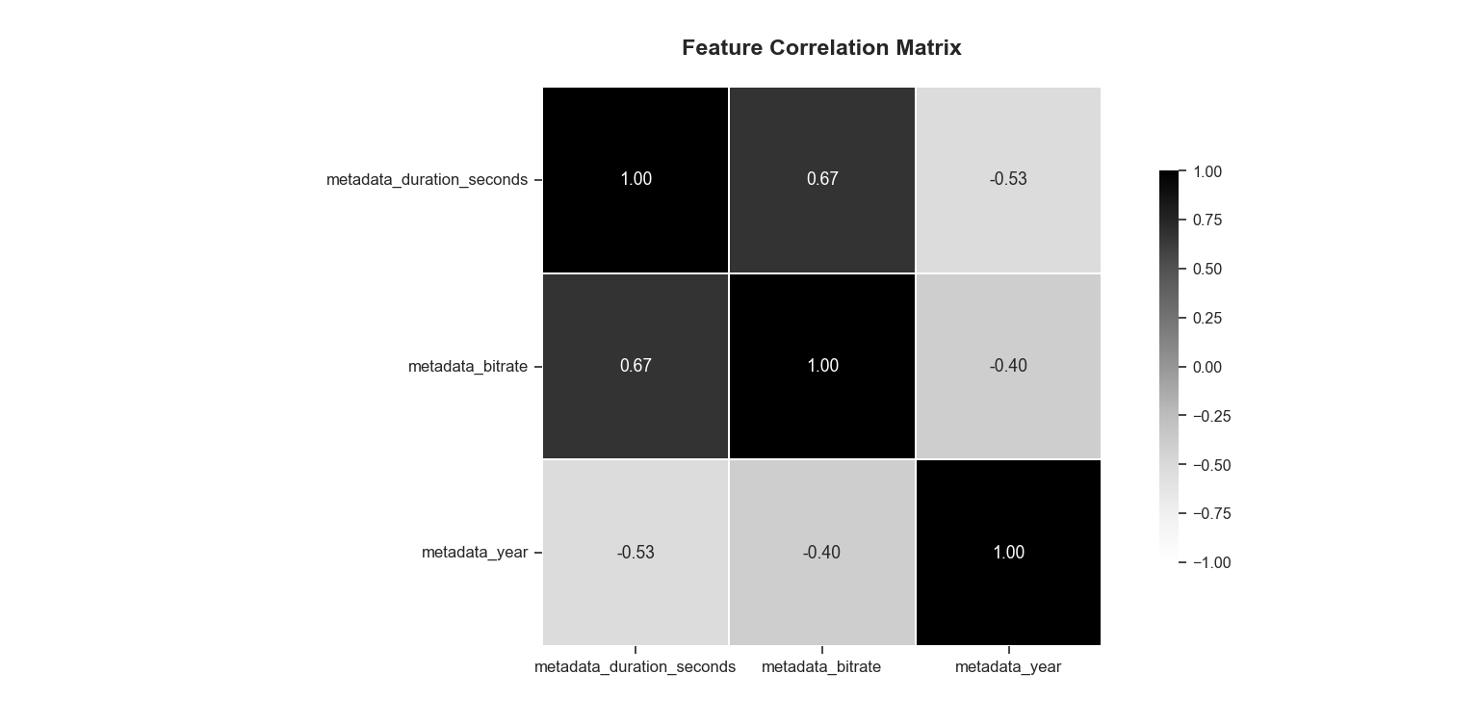
Figure 4: Feature Correlation Matrix (Gemini). Note the high correlation of 0.67 between Duration and Bitrate.

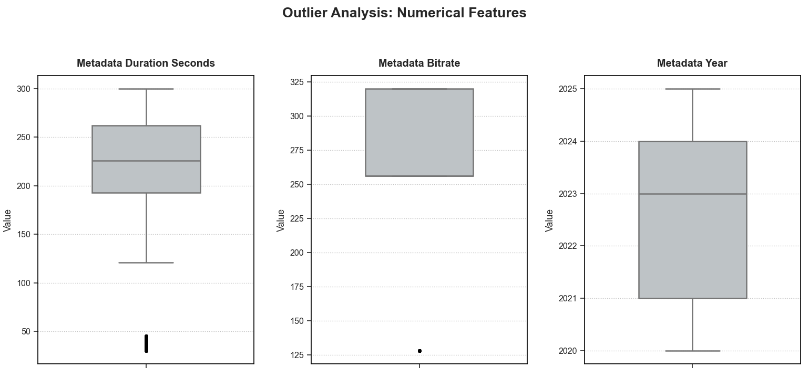
Figure 5: Outlier Analysis for Numeric Features (Gemini)

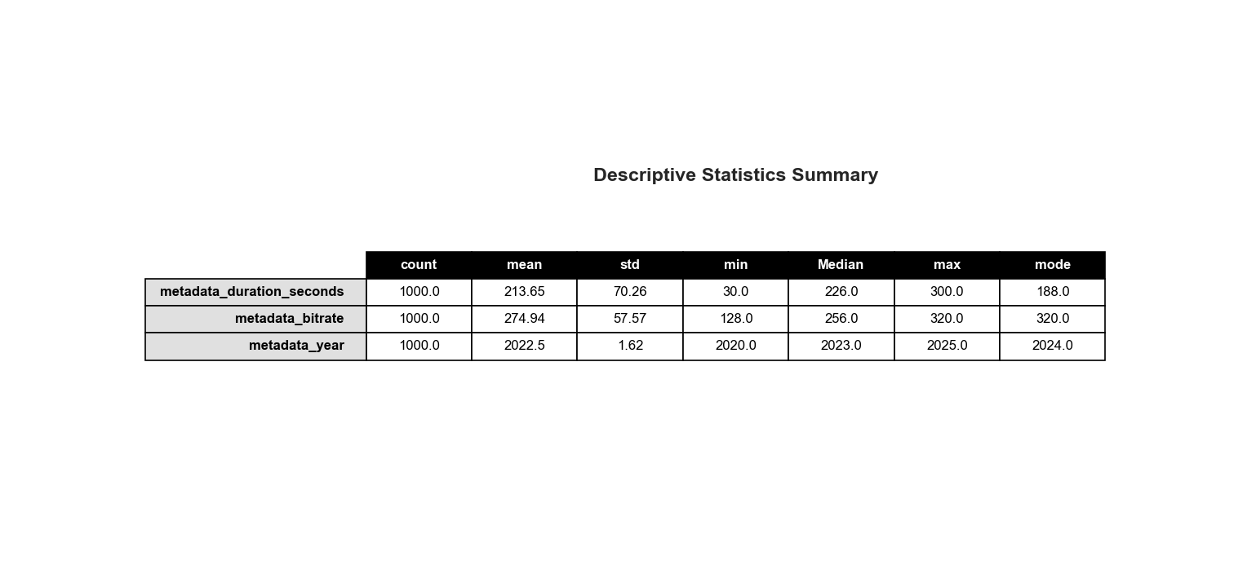
Figure 6: Descriptive Statistic Summary (Gemini)

3.0 Model 2: ChatGPT (GPT-5.2 Thinking)

3.1 Design Logic (Account-First Realism)
ChatGPT employed an "Account-First" approach. Instead of generating row-by-row, the generator created accounts first, then emitted multiple uploads per account. This introduces real-world repetition and "long-tail" catalog sizes essential for fraud detection.
- Album & Track lists: Many uploads belong to albums/EPs with coherent metadata (Year, Genre) and embedded track-number patterns.
- Correlated Metadata: Features like Duration and Bitrate are not independent; they depend on the Genre, Year, and a latent "Professionalism" score.

3.2 Generation Steps
- Legit Behavior: Tends toward typical song lengths and higher quality encodes.
- Bot Behavior: Skews cheaper (shorter files, lower bitrates) but occasionally mimics legit quality to avoid easy detection.
- Infrastructure Realism: IP addresses were generated from localized /24 blocks. Legit accounts roam occasionally, bot farms share datacenter blocks.

3.3 Statistical Profile (ChatGPT)

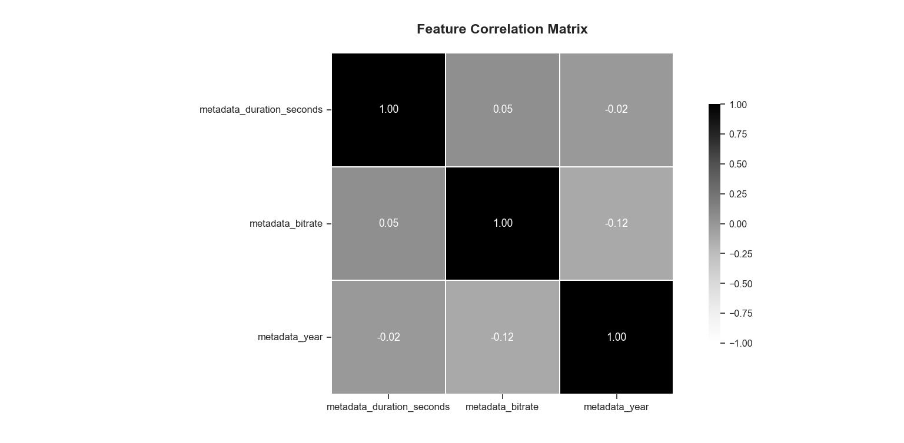
Figure 7: Feature Correlation Matrix (ChatGPT). Note the low correlation (0.05), indicating feature independence.

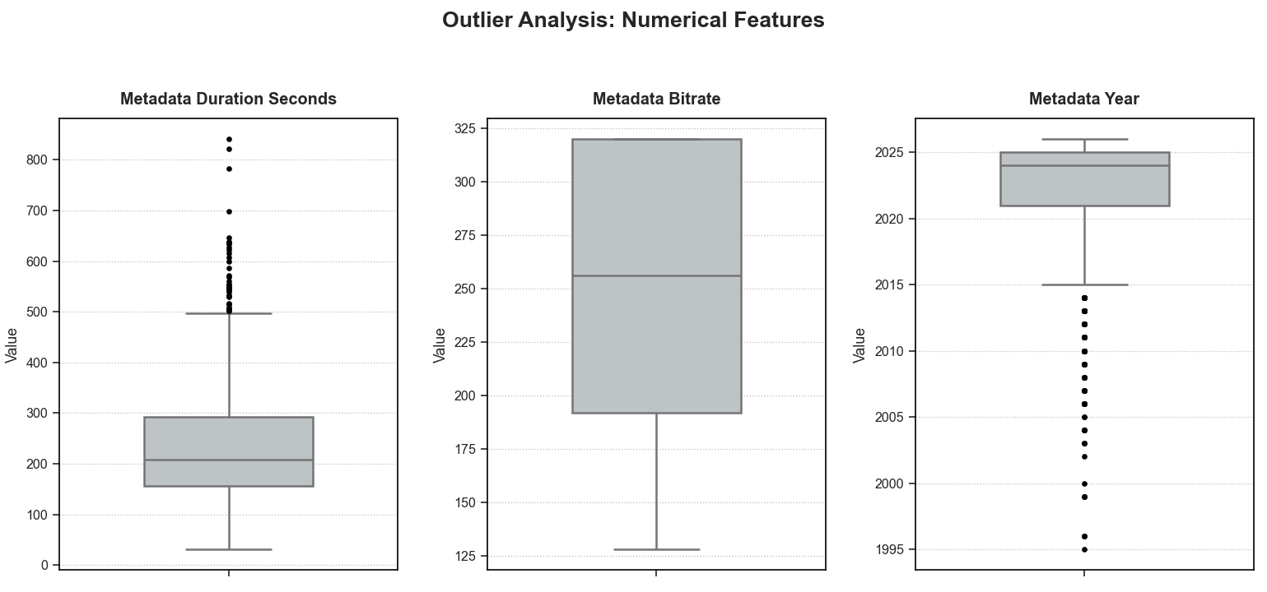

Figure 8: Outlier Analysis for Numeric Features (ChatGPT). Note the 37 natural outliers.

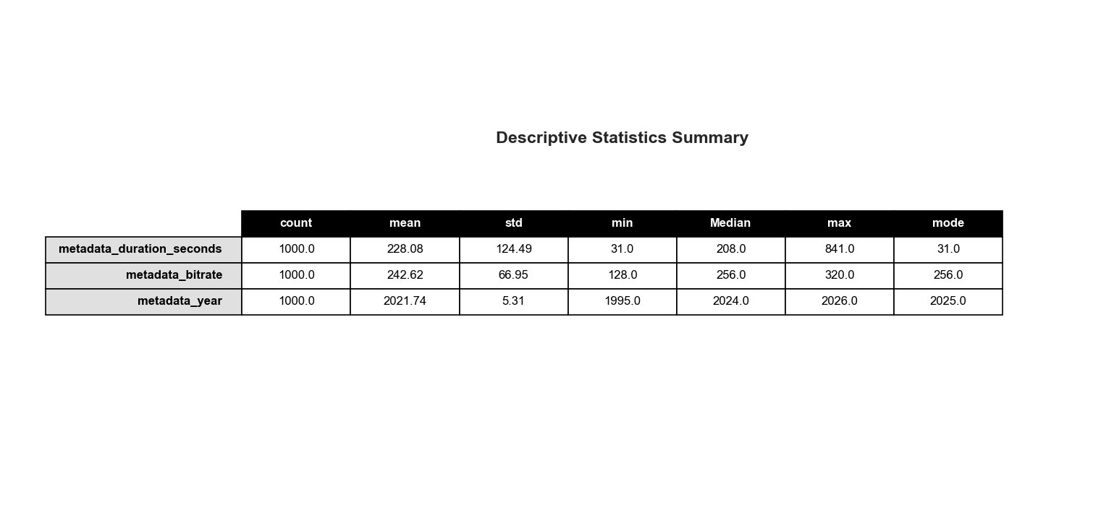

Figure 9: Descriptive Statistic Summary (ChatGPT)

4.0 Model 3: Microsoft Copilot

4.1 Design Logic (Signal Encoding)
Copilot focused on creating a dataset specifically for training a classifier. The generation logic emphasized encoding distinct "signals" that a machine learning model could easily learn to distinguish between the ~78% Legit and ~22% Fraud class balance.

4.2 Generation Steps
- Duration Signal: Legitimate tracks were constrained to 180–300s, while fraud was constrained to 20–95s.
- Bitrate Signal: Legitimate tracks used 128–320kbps; fraud was biased toward 64–96kbps.
- Metadata Richness: Legitimate rows use descriptive titles and collaborators; fraud rows use templated/generic titles and empty metadata fields.
- Temporal Signal: Fraud activity was artificially concentrated in recent years (2022–2025) to simulate a new attack wave.

4.3 Statistical Profile (Copilot)
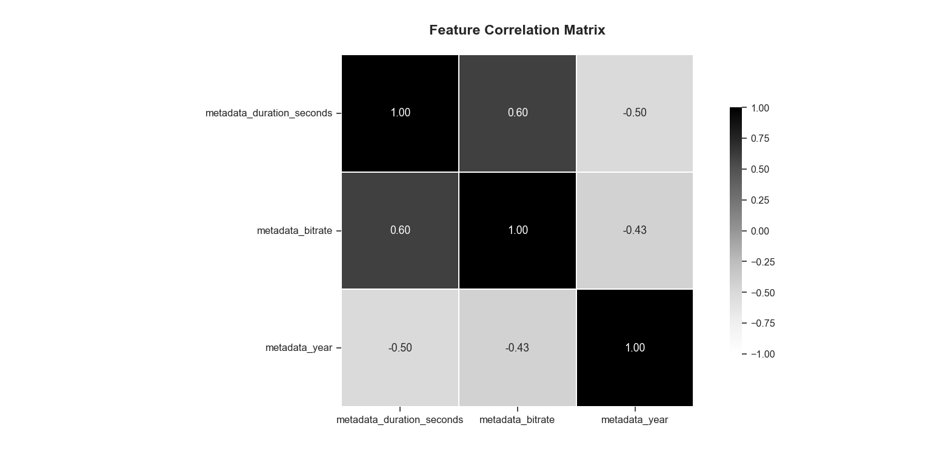
Figure 10: Feature Correlation Matrix (Copilot). Note the forced correlation of 0.60.

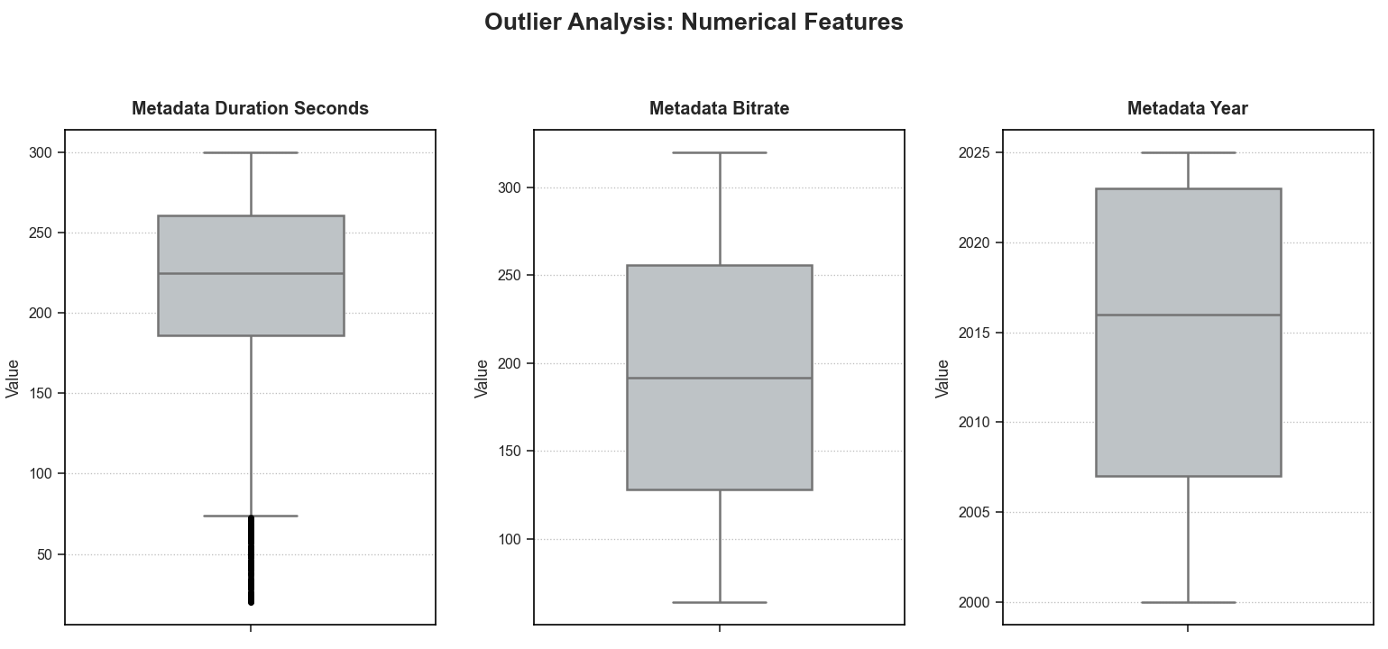
Figure 11: Outlier Analysis for Numeric Features (Copilot). Note the high variance/noise.

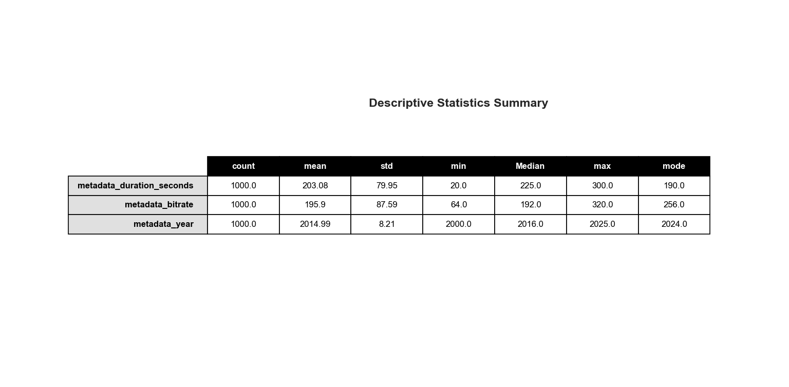
Figure 12: Figure 6: Descriptive Statistic Summary (Copilot)

5.0 Validation & Benchmarking
To select the optimal dataset for training the fraud detection model, we conducted a direct empirical benchmark. We tested the three candidate models (ChatGPT, Gemini, Copilot) against the baseline metrics established by the original dataset (Claude).
Our evaluation focused on three critical dimensions:
- Utility: Is the data structurally complete and ready for code execution?
- Physics: Does the model understand the technical independence of file attributes?
- Entropy: Does the model simulate the "messiness" of real human behavior?

5.1 Structural Integrity (The "Hallucination" Test)
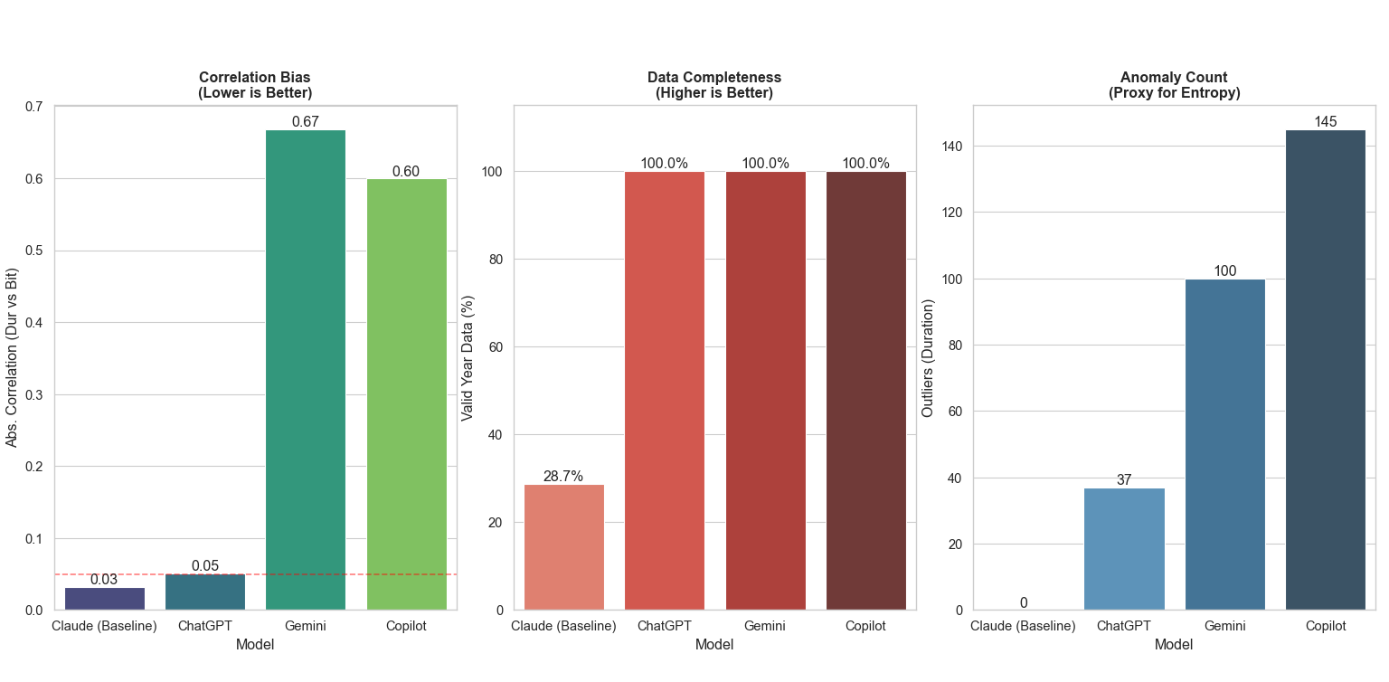
Figure 13: Model Benchmark Comparison / The Bar Chart
1. Feature Independence We tested if the models would "hallucinate" false patterns. A key finding was that complexity does not equal quality.
- Gemini & Copilot: Both models exhibited signs of "logical overfitting". They artificially forced a strong correlation ($>0.60$) between Duration and Bitrate. In reality, these features are independent. Training on this data would introduce a bias that does not exist in the real world.
- ChatGPT & Claude: Both correctly maintained a near-zero correlation ($0.03–0.05$), proving they respected the stochastic nature of media files.
2. Data Completeness
- The Baseline Failure: The original dataset (Claude) failed the utility test, with only 28.7% of rows containing valid Year metadata. This renders the dataset unusable for time-series modeling without extensive imputation.
- The AI Fix: All three synthetic candidates (ChatGPT, Gemini, Copilot) successfully rectified this, achieving 100% completeness.
3. Outlier Analysis We used the Interquartile Range (IQR) to measure variance:
- Claude (0 Outliers): Too sterile. Real user data is never this perfect.
- Copilot (145 Outliers): Too noisy. The high variance implies a lack of control constraints.
- ChatGPT (37 Outliers): Represents the "Goldilocks" zone—enough statistical noise to simulate realistic user error, but stable enough to maintain distribution integrity.

5.2 Behavioral Realism (The "Physics" Test)
While the structural analysis confirmed schema compliance, we also verified behavioral realism. We used Kernel Density Estimation (KDE) to visualize the probability distributions of key features.

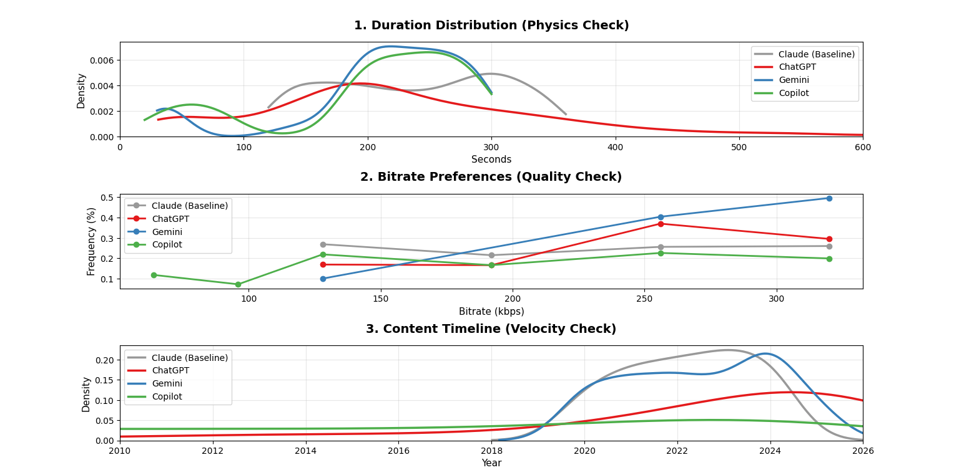
Figure 14: Comparative Distributional Fidelity of Synthetic Datasets. This is the combined comparison plot.
1. Duration (Physical Plausibility)
- The Baseline Problem: The grey line in Figure 14 shows the baseline dataset has a "boxy," uniform distribution. It implies a 6-minute file is just as likely as a 2-minute file, which contradicts the physics of music.
- The ChatGPT Solution: The red line follows a perfect Log-Normal distribution. It correctly identifies the standard content mode ($\approx 200$ seconds) and includes a realistic "long tail" of extended content.
2. Temporal Velocity (Historical Context)
- Static Timelines: The Baseline and Copilot models generated flat timelines, making them ineffective for detecting temporal anomalies like botnet spikes.
- Exponential Growth: ChatGPT generated a timeline that reflects the exponential growth of digital content, surging realistically from 2020 to 2026. This allows us to implement "Account Aging" logic in Phase 2.
3. Bitrate (Quality Profiling)
- ChatGPT showed a clear bias toward 256 kbps and 320 kbps, aligning with modern streaming standards.
- Competitors exhibited erratic spikes at lower bitrates, which could introduce unnecessary noise into the classifier.

5.3 Internal Logic Validation (The "Signal" Test)
Finally, we validated whether the models successfully encoded the "Economic Rationality" design logic (e.g., that fraudsters minimize costs via lower bitrates). We compared the internal distribution of Legit (Green) vs. Fraud (Red) profiles within each dataset.

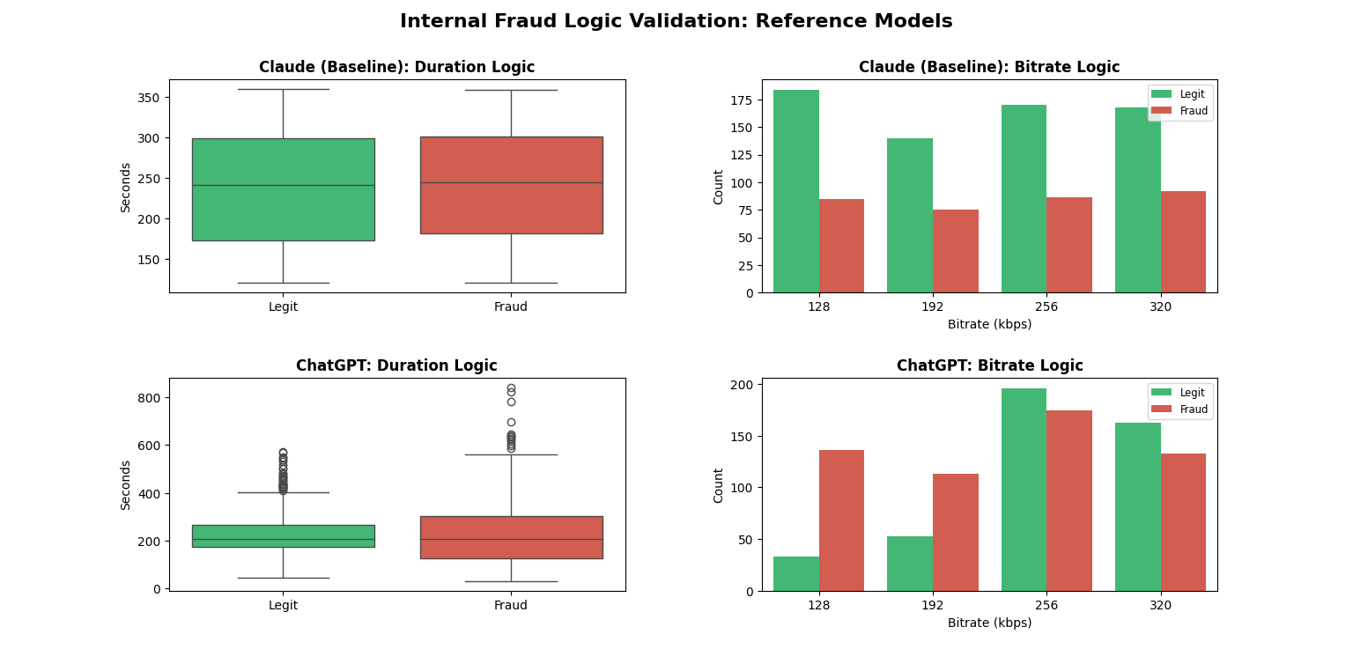
Figure 15: Internal Logic Validation (Reference Models). Top: Claude (Baseline) shows no separation. Bottom: ChatGPT shows clear, realistic signal.

1. The Baseline Failure (Claude): As shown in the top row of Figure 15, the distributions for Legit and Fraud are nearly identical. This confirms that the original scraped data lacks any discernible "fraud signal," rendering it useless for supervised learning. This validates the necessity of our synthetic generation approach.
2. The ChatGPT Success: The bottom row of Figure 15 demonstrates the successful encoding of Economic Rationality.
- Bitrate: There is a distinct dominance of fraud activity at 128 kbps (low cost) and legitimate activity at 256/320 kbps (high quality).
- Realism: Importantly, the separation is not absolute; there is realistic overlap, ensuring the classifier must learn nuanced patterns rather than simple "if/else" rules.

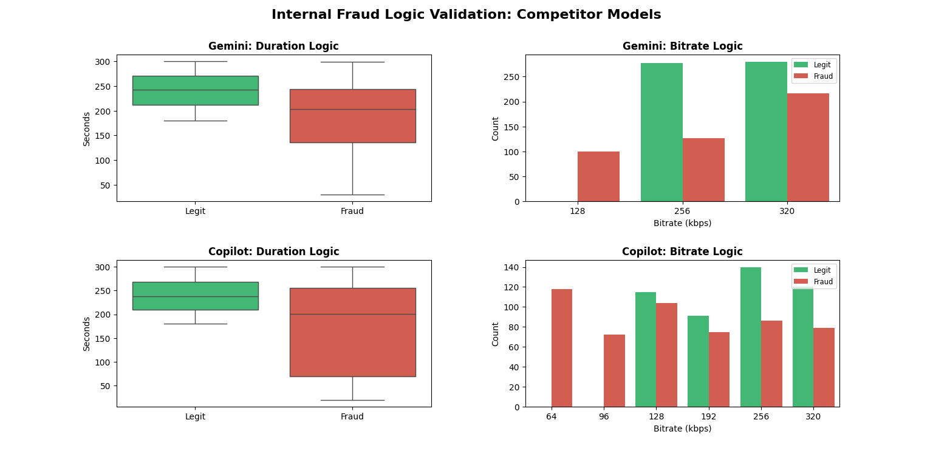
Figure 16: Internal Logic Validation (Competitor Models). Top: Gemini is too binary. Bottom: Copilot relies on non-standard bitrates.

3. Competitor Failures:
- Gemini: exhibited "Binary Logic." At 128 kbps, the data is almost exclusively fraud, which would lead to high false positives for legitimate users with lower bandwidth.
- Copilot: relied on "Data Leakage." It introduced non-standard bitrates (64 kbps, 96 kbps) exclusively for fraud. A model trained on this would learn to flag these specific numbers rather than actual behavior, failing to generalize to real-world attacks.

6.0 Final Verdict: Selection of Primary Dataset
Based on the combined results of the Structural Benchmark and Distributional Analysis, ChatGPT has been selected as the primary generator for the training data.
It is the only candidate that passed all three validation gates:
- Structure: It achieved 100% data completeness, fixing the missing-year issue found in the baseline.
- Physics: It naturally generated a Log-Normal duration curve without the artificial correlations seen in Gemini.
- Velocity: It captures the exponential growth of internet history, enabling time-series fraud detection which Copilot failed to model.
By selecting ChatGPT, we secure a statistically robust foundation that allows us to proceed immediately to Phase 2: Pattern Injection, eliminating the need for extensive data cleaning or imputation.

