MV_teamprj1_EDA

1973046 윤여름

2024-05-21

# data importing & analysis

library(tidyverse)

## ── Attaching core tidyverse packages ──────────────────────── tidyverse 2.0.0 ──  
## ✔ dplyr 1.1.4 ✔ readr 2.1.5  
## ✔ forcats 1.0.0 ✔ stringr 1.5.1  
## ✔ ggplot2 3.5.1 ✔ tibble 3.2.1  
## ✔ lubridate 1.9.3 ✔ tidyr 1.3.1  
## ✔ purrr 1.0.2   
## ── Conflicts ────────────────────────────────────────── tidyverse_conflicts() ──  
## ✖ dplyr::filter() masks stats::filter()  
## ✖ dplyr::lag() masks stats::lag()  
## ℹ Use the conflicted package (<http://conflicted.r-lib.org/>) to force all conflicts to become errors

library(ggplot2)  
library(ggmosaic)  
library(GGally)

## Registered S3 method overwritten by 'GGally':  
## method from   
## +.gg ggplot2  
##   
## Attaching package: 'GGally'  
##   
## The following object is masked from 'package:ggmosaic':  
##   
## happy

hotel = read.csv("./source/hotel_bookings.csv")  
head(hotel)

## hotel is_canceled lead_time arrival_date_year arrival_date_month  
## 1 Resort Hotel 0 342 2015 July  
## 2 Resort Hotel 0 737 2015 July  
## 3 Resort Hotel 0 7 2015 July  
## 4 Resort Hotel 0 13 2015 July  
## 5 Resort Hotel 0 14 2015 July  
## 6 Resort Hotel 0 14 2015 July  
## arrival_date_week_number arrival_date_day_of_month stays_in_weekend_nights  
## 1 27 1 0  
## 2 27 1 0  
## 3 27 1 0  
## 4 27 1 0  
## 5 27 1 0  
## 6 27 1 0  
## stays_in_week_nights adults children babies meal country market_segment  
## 1 0 2 0 0 BB PRT Direct  
## 2 0 2 0 0 BB PRT Direct  
## 3 1 1 0 0 BB GBR Direct  
## 4 1 1 0 0 BB GBR Corporate  
## 5 2 2 0 0 BB GBR Online TA  
## 6 2 2 0 0 BB GBR Online TA  
## distribution_channel is_repeated_guest previous_cancellations  
## 1 Direct 0 0  
## 2 Direct 0 0  
## 3 Direct 0 0  
## 4 Corporate 0 0  
## 5 TA/TO 0 0  
## 6 TA/TO 0 0  
## previous_bookings_not_canceled reserved_room_type assigned_room_type  
## 1 0 C C  
## 2 0 C C  
## 3 0 A C  
## 4 0 A A  
## 5 0 A A  
## 6 0 A A  
## booking_changes deposit_type agent company days_in_waiting_list customer_type  
## 1 3 No Deposit NULL NULL 0 Transient  
## 2 4 No Deposit NULL NULL 0 Transient  
## 3 0 No Deposit NULL NULL 0 Transient  
## 4 0 No Deposit 304 NULL 0 Transient  
## 5 0 No Deposit 240 NULL 0 Transient  
## 6 0 No Deposit 240 NULL 0 Transient  
## adr required_car_parking_spaces total_of_special_requests reservation_status  
## 1 0 0 0 Check-Out  
## 2 0 0 0 Check-Out  
## 3 75 0 0 Check-Out  
## 4 75 0 0 Check-Out  
## 5 98 0 1 Check-Out  
## 6 98 0 1 Check-Out  
## reservation_status_date  
## 1 2015-07-01  
## 2 2015-07-01  
## 3 2015-07-02  
## 4 2015-07-02  
## 5 2015-07-03  
## 6 2015-07-03

dim(hotel)

## [1] 119390 32

summary(hotel)

## hotel is_canceled lead_time arrival_date_year  
## Length:119390 Min. :0.0000 Min. : 0 Min. :2015   
## Class :character 1st Qu.:0.0000 1st Qu.: 18 1st Qu.:2016   
## Mode :character Median :0.0000 Median : 69 Median :2016   
## Mean :0.3704 Mean :104 Mean :2016   
## 3rd Qu.:1.0000 3rd Qu.:160 3rd Qu.:2017   
## Max. :1.0000 Max. :737 Max. :2017   
##   
## arrival_date_month arrival_date_week_number arrival_date_day_of_month  
## Length:119390 Min. : 1.00 Min. : 1.0   
## Class :character 1st Qu.:16.00 1st Qu.: 8.0   
## Mode :character Median :28.00 Median :16.0   
## Mean :27.17 Mean :15.8   
## 3rd Qu.:38.00 3rd Qu.:23.0   
## Max. :53.00 Max. :31.0   
##   
## stays_in_weekend_nights stays_in_week_nights adults   
## Min. : 0.0000 Min. : 0.0 Min. : 0.000   
## 1st Qu.: 0.0000 1st Qu.: 1.0 1st Qu.: 2.000   
## Median : 1.0000 Median : 2.0 Median : 2.000   
## Mean : 0.9276 Mean : 2.5 Mean : 1.856   
## 3rd Qu.: 2.0000 3rd Qu.: 3.0 3rd Qu.: 2.000   
## Max. :19.0000 Max. :50.0 Max. :55.000   
##   
## children babies meal country   
## Min. : 0.0000 Min. : 0.000000 Length:119390 Length:119390   
## 1st Qu.: 0.0000 1st Qu.: 0.000000 Class :character Class :character   
## Median : 0.0000 Median : 0.000000 Mode :character Mode :character   
## Mean : 0.1039 Mean : 0.007949   
## 3rd Qu.: 0.0000 3rd Qu.: 0.000000   
## Max. :10.0000 Max. :10.000000   
## NA's :4   
## market_segment distribution_channel is_repeated_guest  
## Length:119390 Length:119390 Min. :0.00000   
## Class :character Class :character 1st Qu.:0.00000   
## Mode :character Mode :character Median :0.00000   
## Mean :0.03191   
## 3rd Qu.:0.00000   
## Max. :1.00000   
##   
## previous_cancellations previous_bookings_not_canceled reserved_room_type  
## Min. : 0.00000 Min. : 0.0000 Length:119390   
## 1st Qu.: 0.00000 1st Qu.: 0.0000 Class :character   
## Median : 0.00000 Median : 0.0000 Mode :character   
## Mean : 0.08712 Mean : 0.1371   
## 3rd Qu.: 0.00000 3rd Qu.: 0.0000   
## Max. :26.00000 Max. :72.0000   
##   
## assigned_room_type booking_changes deposit_type agent   
## Length:119390 Min. : 0.0000 Length:119390 Length:119390   
## Class :character 1st Qu.: 0.0000 Class :character Class :character   
## Mode :character Median : 0.0000 Mode :character Mode :character   
## Mean : 0.2211   
## 3rd Qu.: 0.0000   
## Max. :21.0000   
##   
## company days_in_waiting_list customer_type adr   
## Length:119390 Min. : 0.000 Length:119390 Min. : -6.38   
## Class :character 1st Qu.: 0.000 Class :character 1st Qu.: 69.29   
## Mode :character Median : 0.000 Mode :character Median : 94.58   
## Mean : 2.321 Mean : 101.83   
## 3rd Qu.: 0.000 3rd Qu.: 126.00   
## Max. :391.000 Max. :5400.00   
##   
## required_car_parking_spaces total_of_special_requests reservation_status  
## Min. :0.00000 Min. :0.0000 Length:119390   
## 1st Qu.:0.00000 1st Qu.:0.0000 Class :character   
## Median :0.00000 Median :0.0000 Mode :character   
## Mean :0.06252 Mean :0.5714   
## 3rd Qu.:0.00000 3rd Qu.:1.0000   
## Max. :8.00000 Max. :5.0000   
##   
## reservation_status_date  
## Length:119390   
## Class :character   
## Mode :character   
##   
##   
##   
##

str(hotel)

## 'data.frame': 119390 obs. of 32 variables:  
## $ hotel : chr "Resort Hotel" "Resort Hotel" "Resort Hotel" "Resort Hotel" ...  
## $ is_canceled : int 0 0 0 0 0 0 0 0 1 1 ...  
## $ lead_time : int 342 737 7 13 14 14 0 9 85 75 ...  
## $ arrival_date_year : int 2015 2015 2015 2015 2015 2015 2015 2015 2015 2015 ...  
## $ arrival_date_month : chr "July" "July" "July" "July" ...  
## $ arrival_date_week_number : int 27 27 27 27 27 27 27 27 27 27 ...  
## $ arrival_date_day_of_month : int 1 1 1 1 1 1 1 1 1 1 ...  
## $ stays_in_weekend_nights : int 0 0 0 0 0 0 0 0 0 0 ...  
## $ stays_in_week_nights : int 0 0 1 1 2 2 2 2 3 3 ...  
## $ adults : int 2 2 1 1 2 2 2 2 2 2 ...  
## $ children : int 0 0 0 0 0 0 0 0 0 0 ...  
## $ babies : int 0 0 0 0 0 0 0 0 0 0 ...  
## $ meal : chr "BB" "BB" "BB" "BB" ...  
## $ country : chr "PRT" "PRT" "GBR" "GBR" ...  
## $ market_segment : chr "Direct" "Direct" "Direct" "Corporate" ...  
## $ distribution_channel : chr "Direct" "Direct" "Direct" "Corporate" ...  
## $ is_repeated_guest : int 0 0 0 0 0 0 0 0 0 0 ...  
## $ previous_cancellations : int 0 0 0 0 0 0 0 0 0 0 ...  
## $ previous_bookings_not_canceled: int 0 0 0 0 0 0 0 0 0 0 ...  
## $ reserved_room_type : chr "C" "C" "A" "A" ...  
## $ assigned_room_type : chr "C" "C" "C" "A" ...  
## $ booking_changes : int 3 4 0 0 0 0 0 0 0 0 ...  
## $ deposit_type : chr "No Deposit" "No Deposit" "No Deposit" "No Deposit" ...  
## $ agent : chr "NULL" "NULL" "NULL" "304" ...  
## $ company : chr "NULL" "NULL" "NULL" "NULL" ...  
## $ days_in_waiting_list : int 0 0 0 0 0 0 0 0 0 0 ...  
## $ customer_type : chr "Transient" "Transient" "Transient" "Transient" ...  
## $ adr : num 0 0 75 75 98 ...  
## $ required_car_parking_spaces : int 0 0 0 0 0 0 0 0 0 0 ...  
## $ total_of_special_requests : int 0 0 0 0 1 1 0 1 1 0 ...  
## $ reservation_status : chr "Check-Out" "Check-Out" "Check-Out" "Check-Out" ...  
## $ reservation_status_date : chr "2015-07-01" "2015-07-01" "2015-07-02" "2015-07-02" ...

# 소주제 1 : baby의 수/children의 수와 연관된 변수 파악

* meal type (식사타입)
* total_of_special_requests (특별 요청 수)
* 가설 1 : baby의 유무가 meal type에 영향을 미칠 것이다.
* 가설 2 : baby의 유무가 total_of_special_requests(특별 요청 수)에 영향을 미칠 것이다.
* 가설 3: baby의 유무가 meal type과 total_of_special_requests(특별 요청 수)에 영향을 미칠 것이다. (one-way manova)

#babies  
summary(hotel$babies)

## Min. 1st Qu. Median Mean 3rd Qu. Max.   
## 0.000000 0.000000 0.000000 0.007949 0.000000 10.000000

sum(is.na(hotel$babies))

## [1] 0

sum(ifelse(hotel$babies != 0, 1, 0))

## [1] 917

table(hotel$babies)

##   
## 0 1 2 9 10   
## 118473 900 15 1 1

#baby 유무로 전처리  
hotel$hasbabies = ifelse(hotel$babies != "0", 1, 0)  
hotel$hasbabies = factor(hotel$hasbabies, levels = c(0, 1), labels = c("0", "1"))  
ggplot(hotel, aes(hasbabies)) + geom_bar()

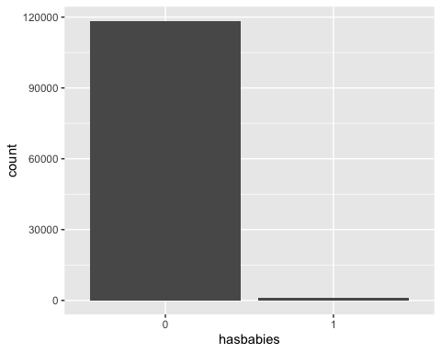

#meal type  
sum(is.na(hotel$meal))

## [1] 0

table(hotel$meal) #BB : breakfast&Bed / FB : full-board(breakfast, lunch & dinner) / HB : Half Board (Breakfast and Dinner normally) / SC : self-catering / undefined = sc로 통합하거나 삭제

##   
## BB FB HB SC Undefined   
## 92310 798 14463 10650 1169

ggplot(hotel, aes(meal)) + geom_bar()

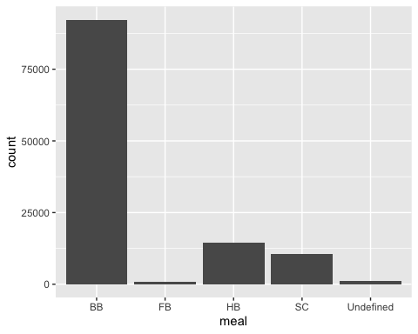

#total_of_special_requests  
summary(hotel$total_of_special_requests)

## Min. 1st Qu. Median Mean 3rd Qu. Max.   
## 0.0000 0.0000 0.0000 0.5714 1.0000 5.0000

sum(is.na(hotel$total_of_special_requests))

## [1] 0

table(hotel$total_of_special_requests)

##   
## 0 1 2 3 4 5   
## 70318 33226 12969 2497 340 40

ggplot(hotel, aes(total_of_special_requests)) + geom_bar()

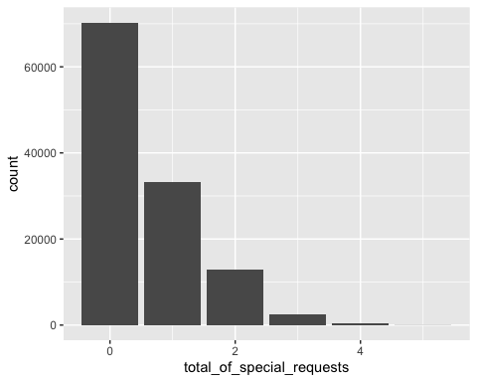

#hyp 1 : babies - meal type   
ggplot(hotel, aes(x = hasbabies, colour = meal, fill = meal)) + geom_density(alpha = 0.1) + facet_wrap(~hasbabies)

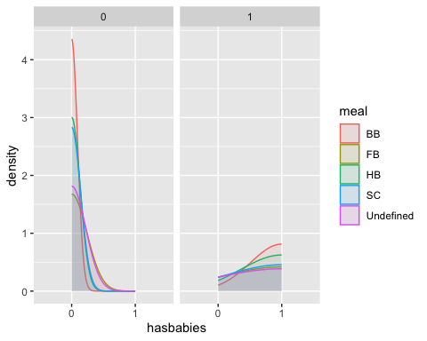

hotel %>% group_by(meal, hasbabies) %>% summarise(n=n()) %>% ggplot(aes(meal,n,fill=meal)) + geom_bar(stat = 'identity', position='dodge') + facet_wrap(~hasbabies, scales = "free_y")

## `summarise()` has grouped output by 'meal'. You can override using the  
## `.groups` argument.

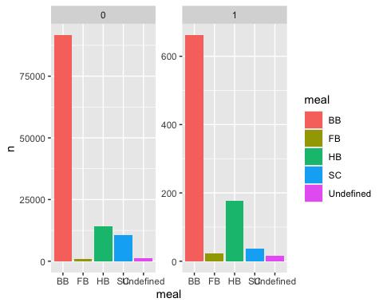

#hyp 2 : babies - total_of_special_requests  
ggplot(hotel, aes(x = factor(hasbabies), y = total_of_special_requests)) + geom_boxplot() + geom_violin(alpha = 0.3)

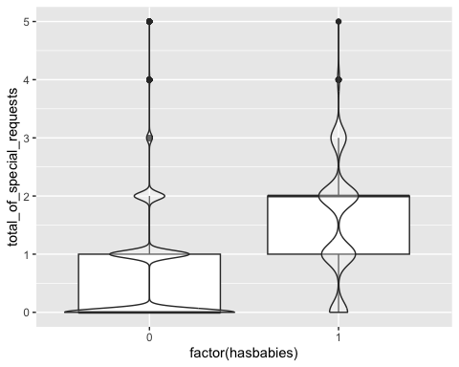

#hyp 3 : babies - meal type & total_of_special_requests  
  
ggpairs(hotel[,c(13,30,33)])

## `stat_bin()` using `bins = 30`. Pick better value with `binwidth`.  
## `stat_bin()` using `bins = 30`. Pick better value with `binwidth`.

