hw3_2229027

JiminLee_2229027

2023-09-23

install.packages('GGally',repos = "http://cran.us.r-project.org")

## Warning in readRDS(dest): lzma decoder corrupt data

##   
## The downloaded binary packages are in  
## /var/folders/zl/ljg24f_15m93w7f2rt14c2n80000gn/T//RtmpjOUgZn/downloaded_packages

library(GGally)

## Loading required package: ggplot2

## Registered S3 method overwritten by 'GGally':  
## method from   
## +.gg ggplot2

library(tidyverse)

## ── Attaching packages  
## ───────────────────────────────────────  
## tidyverse 1.3.2 ──

## ✔ tibble 3.2.1 ✔ dplyr 1.1.3  
## ✔ tidyr 1.2.1 ✔ stringr 1.4.0  
## ✔ readr 2.1.2 ✔ forcats 0.5.2  
## ✔ purrr 1.0.2   
## ── Conflicts ────────────────────────────────────────── tidyverse_conflicts() ──  
## ✖ dplyr::filter() masks stats::filter()  
## ✖ dplyr::lag() masks stats::lag()

library(ggmosaic)

##   
## Attaching package: 'ggmosaic'  
##   
## The following object is masked from 'package:GGally':  
##   
## happy

data(mpg)  
head(mpg, 5)

## # A tibble: 5 × 11  
## manufacturer model displ year cyl trans drv cty hwy fl class   
## <chr> <chr> <dbl> <int> <int> <chr> <chr> <int> <int> <chr> <chr>   
## 1 audi a4 1.8 1999 4 auto(l5) f 18 29 p compa…  
## 2 audi a4 1.8 1999 4 manual(m5) f 21 29 p compa…  
## 3 audi a4 2 2008 4 manual(m6) f 20 31 p compa…  
## 4 audi a4 2 2008 4 auto(av) f 21 30 p compa…  
## 5 audi a4 2.8 1999 6 auto(l5) f 16 26 p compa…

nrow(mpg) # num of obseration : 234

## [1] 234

names(mpg)

## [1] "manufacturer" "model" "displ" "year" "cyl"   
## [6] "trans" "drv" "cty" "hwy" "fl"   
## [11] "class"

help(mpg) # 변수의 세부적인 정보를 보기 위함

#### 1) mpg 자료중 범주형 변수는 어떤 것들이 있는가?

str(mpg)

## tibble [234 × 11] (S3: tbl_df/tbl/data.frame)  
## $ manufacturer: chr [1:234] "audi" "audi" "audi" "audi" ...  
## $ model : chr [1:234] "a4" "a4" "a4" "a4" ...  
## $ displ : num [1:234] 1.8 1.8 2 2 2.8 2.8 3.1 1.8 1.8 2 ...  
## $ year : int [1:234] 1999 1999 2008 2008 1999 1999 2008 1999 1999 2008 ...  
## $ cyl : int [1:234] 4 4 4 4 6 6 6 4 4 4 ...  
## $ trans : chr [1:234] "auto(l5)" "manual(m5)" "manual(m6)" "auto(av)" ...  
## $ drv : chr [1:234] "f" "f" "f" "f" ...  
## $ cty : int [1:234] 18 21 20 21 16 18 18 18 16 20 ...  
## $ hwy : int [1:234] 29 29 31 30 26 26 27 26 25 28 ...  
## $ fl : chr [1:234] "p" "p" "p" "p" ...  
## $ class : chr [1:234] "compact" "compact" "compact" "compact" ...

manufacturer, model, trans, drv, fl, class, year

#### 2) 1)에서 확인한 범주형 변수들 중 drv, class, fl을 수업시간에 배운 내용을 바탕으로 살펴보시오.

ggplot(mpg, aes(drv)) +   
 geom_bar() +   
 ggtitle('bar chart of drv')

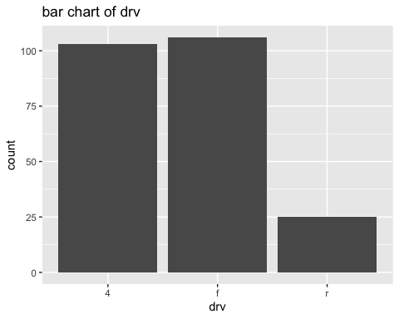

ggplot(mpg, aes(class)) +   
 geom_bar() +   
 ggtitle('bar chart of type of car(class)')

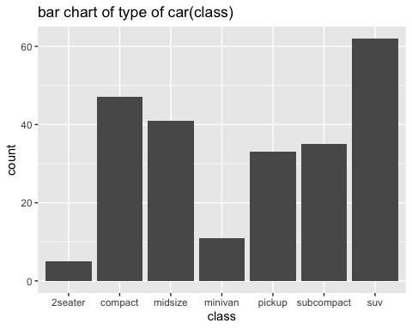

ggplot(mpg, aes(fl)) +   
 geom_bar() +   
 ggtitle('bar of fuel type')

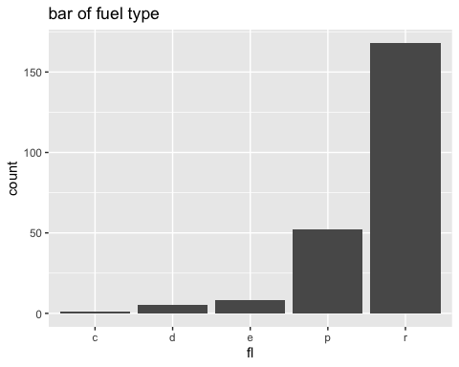 #### 3) class별 drv, fl 분포를 살펴보시오.

data1 = mpg[c('class', 'drv', 'fl')]  
df1 = as.data.frame(data1)  
ggplot(df1) + geom_mosaic(aes(x=product(class), fill=drv))

## Warning: `unite_()` was deprecated in tidyr 1.2.0.  
## ℹ Please use `unite()` instead.  
## ℹ The deprecated feature was likely used in the ggmosaic package.  
## Please report the issue at <https://github.com/haleyjeppson/ggmosaic>.  
## This warning is displayed once every 8 hours.  
## Call `lifecycle::last_lifecycle_warnings()` to see where this warning was  
## generated.

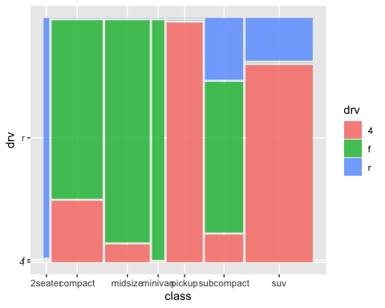

ggplot(df1) + geom_mosaic(aes(x=product(class), fill=fl))

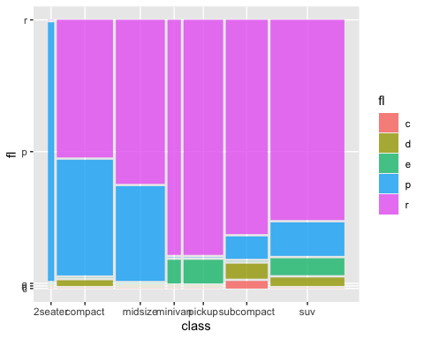 ### 2. iris자료는 R에 내장되어 있는 자료이다.

#### 1) Sepal.Length, Sepal.Width, Petal.Length, Petal.Width의 분포가 Species 별로 어떻게 다른지 알아보려고 한다. 이에 알맞은 그림을 그리고 살펴보시오.

data(iris)  
head(iris)

## Sepal.Length Sepal.Width Petal.Length Petal.Width Species  
## 1 5.1 3.5 1.4 0.2 setosa  
## 2 4.9 3.0 1.4 0.2 setosa  
## 3 4.7 3.2 1.3 0.2 setosa  
## 4 4.6 3.1 1.5 0.2 setosa  
## 5 5.0 3.6 1.4 0.2 setosa  
## 6 5.4 3.9 1.7 0.4 setosa

ggplot(iris, aes(Sepal.Length, color=Species)) + geom_boxplot()

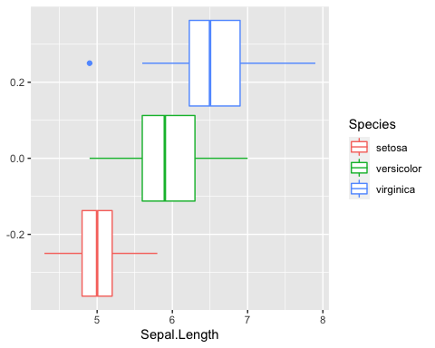

ggplot(iris, aes(Species, Sepal.Width, color=Species)) + geom_jitter()

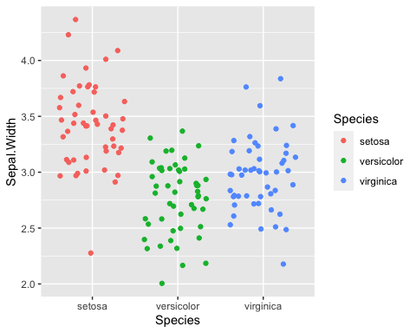

ggplot(iris, aes(Species, Petal.Length, color=Species)) + geom_violin() + geom_jitter(alpha=0.2, size=1.5)

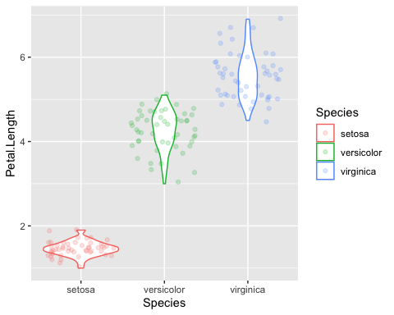

ggplot(iris, aes(Petal.Width, color=Species)) + geom_density()

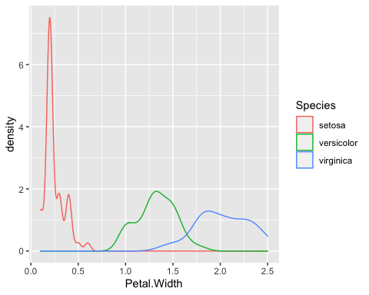

#### 2) Sepal.Length와 나머지 3개의 연속변수들 (Sepal.Width, Petal.Length,

Petal.Width)의 관계를 알아보려고 한다. 수업시간에 배운 내용을 바탕으로 살펴 보시오.

ggplot(iris, aes(Sepal.Length, Sepal.Width)) + geom_point(aes(color=Species)) + geom_smooth(method="lm")

## `geom_smooth()` using formula 'y ~ x'

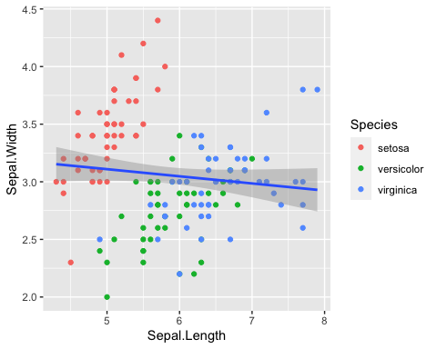

ggplot(iris, aes(Sepal.Length, Petal.Width)) + geom_point(aes(color=Species)) + geom_smooth()

## `geom_smooth()` using method = 'loess' and formula 'y ~ x'

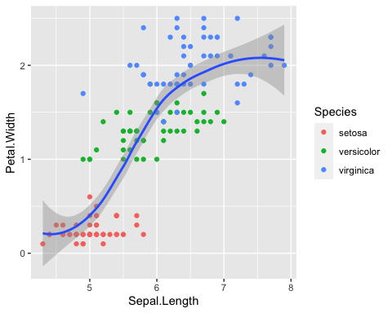

ggplot(iris, aes(Sepal.Length, Petal.Width)) + geom_point(aes(color=Species)) + geom_smooth(method="lm")

## `geom_smooth()` using formula 'y ~ x'

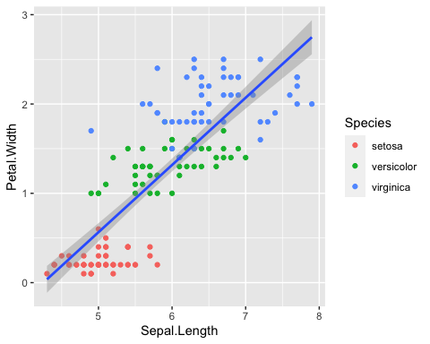

#### 3) 4개의 연속변수를 산점도 행렬을 이용하여 살펴보시오.

ggpairs(iris, columns = 1:4, aes(color=Species))

