This document has been created with Datasheet_2006.dot template version 1.00.
Author  Matti Kongas | Date  19.5.2004
Checked by  JTI | Date  17.05.2005
Approved by  JKK | Date  17.05.2005

INSTRUCTIONS OF USE
THE MANAGEMENT PAGE(S) MUST BE REMOVED BEFORE DELIVERING THE DOCUMENT OUTSIDE OUTOTEC MINERALS ORGANIZATION, OR WHEN THE DOCUMENT IS COPIED AS A PART OF ANOTHER DOCUMENT.

This template does not have macros.
Fill in all document management details in the table above.
Edit the header manually!
Fill in the revision history table below.
As an internal document record, give detailed info about the document revision history and comments about the document and possible needs to consider in future new revisions.
Save the document.
Save pictures in editable format in a subfolder to the text and pdf file folder.

Revision,  date and author | Description of revision and additional comments, info and  possible needs to be considered in future new revisions
B 3.7.2007 | Only template & logo changed

FrothMaster™ 2 Froth Analyzer System

- Vision based flotation control
Flotation plant operators have always utilized visual information about froth appearance when making operative decisions. Even though a skilful operator is able to diagnose problems, subjective factors and inconsistent opinions between operators cause problems. Judging froth appearance and making control decisions based on a variety of personal opinions results in instability and ultimately, poor results in flotation circuit. Continuous 24-hour human monitoring of froth surfaces around the plant is not practical.

- FrothMaster™ 2 system
FrothMaster is a tool for real-time froth surface analysis. FrothMaster system is able to measure several essential properties of froth appearance including froth speed, bubble size, froth stability and froth color with statistical information related to these variables. The measured froth properties together with assays from on-stream analyzer can be used for expert control of the flotation circuit.
In addition, FrothMaster provides option for convenient visual monitoring of froth characteristics anywhere through advanced web server technology.
Typical FrothMaster installation has several froth imagers mounted on top of flotation machines. The imagers are networked through intelligent connection boxes to a FrothManager station, which acts as a gateway to plant automation system and office network. FrothManager station can run optional ACT expert system applications for flotation circuit froth recovery, mass balancing and adaptive cell level controls.
The FrothMaster 2 Imager module FIS 6210 consists of a high resolution color camera, controlled light and optional sun shade. The imager module is designed for flotation plant environment and is IP65 proof (Figure 1).
The FrothMaster 2 connection box CBS 6200 consists of electronics that performs image analysis and provides connections for automation system and plant network. The enclosure is a IP65 epoxy painted stainless steel box. All imager external connections go through this box.

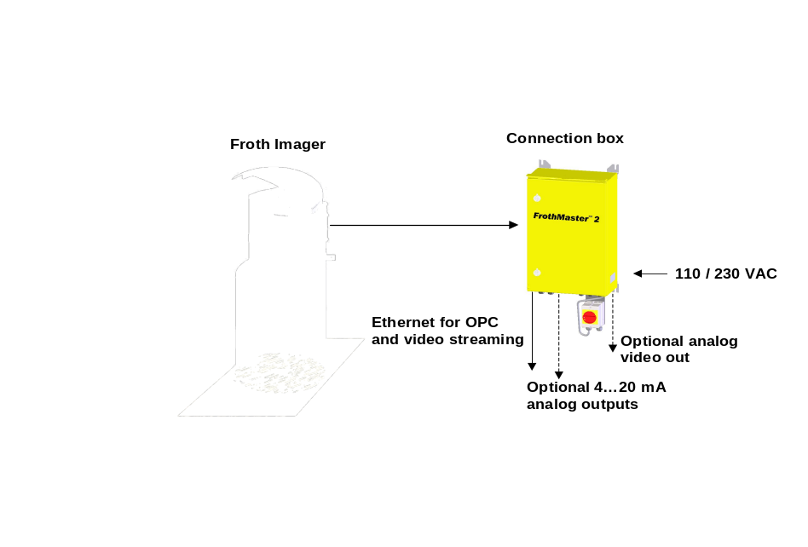
Figure 1. FrothMaster 2 Imager FIS 6210 (with optional sun shielding) and Connection box CBS 6200

- Operating principle
In order to measure the speed of froth, FrothMaster compares two images taken 20 ms apart. The algorithm calculates froth speed according to these two images at every sample instance.
Bubble size is calculated analyzing one image by bubble size algorithm. Froth stability is calculated using speed vectors calculated by the speed algorithm.
Froth color is evaluated by calculating individual color components and statistical information related to them.
Each FrothMaster Imager measures froth properties using a sample rate between 0,25 s
and1 s depending on the size of the measured area and FrothMaster setup parameters.

- Connection to automation system
There are two ways to connect FrothMaster instrument to automation system.
Currently the most common protocol is OPC (Ole for Process Control) through Ethernet. All major automation system suppliers are able to provide OPC connection for their automation systems by Currently the most common protocol is OPC (Ole for Process Control) through Ethernet. All major automation system suppliers are able to provide OPC connection for their automation systems by default or as an option.
In addition to OPC, Ethernet provides also possibility to transfer video image over plant’s network.
If OPC protocol is not available, the most straightforward way is to use optional 4…20mA analog output signals. Virtually all automation systems provide connection via 4…20 mA signals without need for updates or additional hardware.

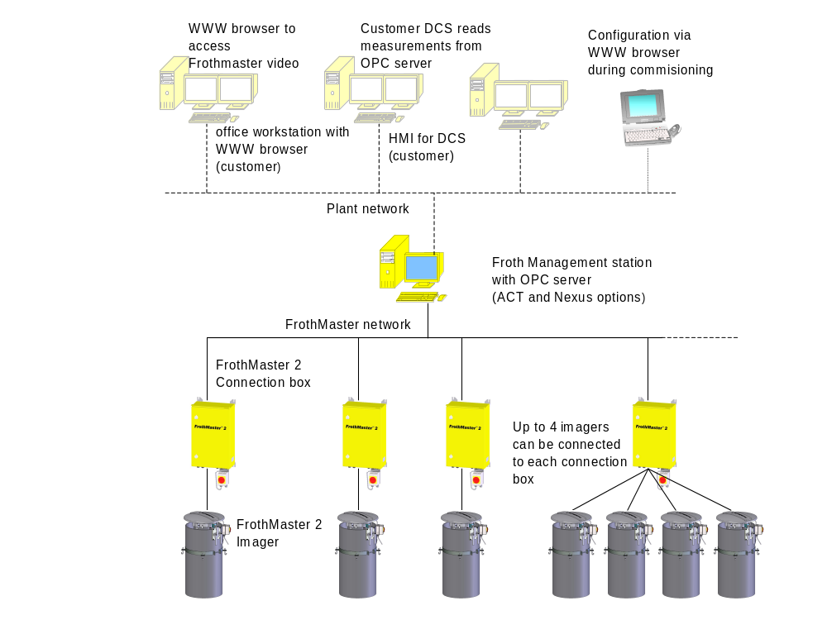
Figure 2. FrothMaster 2 network

- FrothMaster™ 2 network
Ethernet Cat 5 (or Cat 6) cable or fiber can be used as a connection media between FrothMaster 2 connection boxes (CBS) and automation system. Each FrothMaster 2 CBS in the network is able to operate independently, calculating real-time froth properties and sending measurement results to automation system. This truly distributed processing system guarantees constant sample rate and simultaneous measurement of all imager results regardless of the number of image analysis points in the plant.
Each CBS can be connected 1-4 froth imagers. Connection media between froth imagers and CBS is RG-59 coaxial cable (25m per imager included with the delivery, can be extended by customer).

- FrothMaster™ based controls
  - Froth Speed
The froth speed has been found to be one of the major factors affecting to recovery and grade. Influence of the froth speed to grade can be observed from the Figure 2. Froth speed indicates how hard the cell is “pulling”.
From the process control point of view, it is beneficial to be able to maintain a certain froth speed that gives optimal grade and recovery.
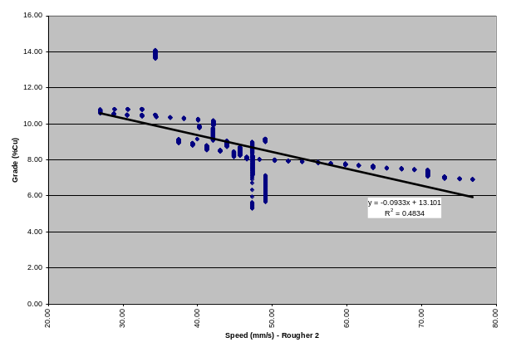
Figure 2. An XY-scatter between speed and concentrate grade over a period of 16 hours
As shown in Figure 3, there is a strong relation between froth speed and aeration rate. In practice this means that by adjusting air feed to flotation tank, froth speed can be controlled accurately to the desired setpoint. In addition to measuring the froth speed, FrothMaster system can be used to controlling the speed thus enabling grade optimization with optional ACT expert contol software.
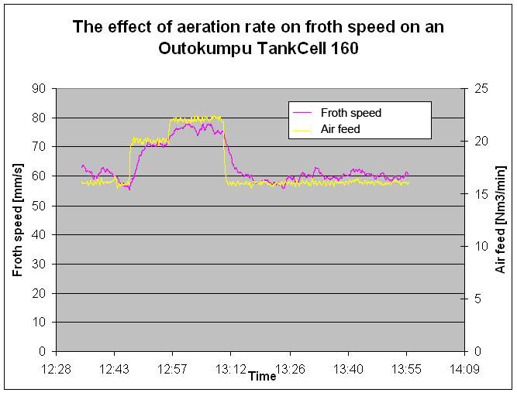
Figure 3. Relation between aeration rate and froth speed
  - Bubble size
As froth speed is quite unambiguous parameter describing the state of the process, there are also many other parameters that can be extracted from the froth surface image. Beneficiation of this information requires some data mining to find out what parameters really describe the particular process and how to manipulate these parameters by adjusting e.g. aeration rate, froth bed thickness and reagent addition.
The most important and also informative parameter describing appearance of froth surface is average bubble size. Process studies have shown that there is a relation between bubble size and reagent addition. Figure 6 shows relation between bubble size and collector addition discovered at Agnico-Eagle plant by Corem.
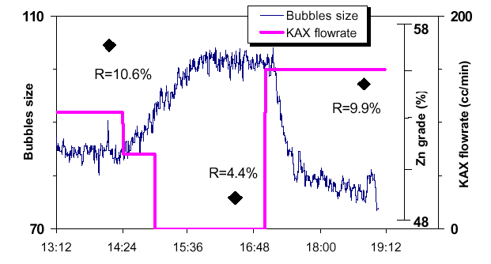
Figure 4. Relation between bubble size and reagent addition
  - Froth stability
As froth speed and bubble size are quantifiable physical measures, froth stability is an indication showing changes in the process. Stability gives an early warning signal of the froth collapsing occurrence that often is seen with reagents overdose or when the air feed to the cell is pushed up to the limit.
  - Color analysis
In certain flotation processes, color of the froth surfaces indicates mineral content in the froth. In direct flotation this information can be used to estimate content of valuable mineral. In reverse flotation processes, when there is significant color difference between valuable mineral and gangue (e.g. calcium and iron), color analysis can be used to indicate gangue in the froth.

- Specifications, Frothmaster™ 2 Imagers

- Dimensions:
- Imager with shade: height 1200 mm, Ø500 mm
- Imager alone: height 300 mm, Ø280 mm
- Connection box: 600 x 380 x 220 mm
- Max Imager to Connection box distance is 100m
- Weight:
- Imager FIS 6210 with shade tube: 40 kg
- (Imager without shade tube 15 kg)
- Connection box: 25 kg
- Operating environment:
- Imager: IP 65 / Nema 4, PEH
- Connection box: IP 65 / Nema 4X, epoxy painted AISI 304 stainless steel
- -10°C to 45°C, 5 to 85%, non-condensing
- Storage Temperature
- - 10°C to 50°C, 5 to 85%, non-condensing
- Power requirements:
- 110/230 VAC, 50/60 Hz, max 200W
- (one imager and connection box)
- Measurements
- Froth speed and direction
- Bubble size distribution
- Froth stability
- Color histogram (R, G, B)
- Statistical information
- Measurement update frequency
- 1 to 4 Hz depending on configuration
- Measurement outputs:
- User selectable number of 4…20mA analog outputs
- Video image stream
- Digital color video stream via Ethernet
- Max resolution: 768 x 576
- Max 25 frames per second (may be limited by network bandwidth or configuration)
- One video stream connection at time
- Optional analog color video via coaxial cable (RG-59)

- Imager setup and diagnostics
- WebFire web server embedded in each imager

- Specifications, Frothmaster™ 2 System
- FrothMaster 2 network
- Up to 40 instruments in one network
- Industrial grade Ethernet cabling (CAT-5e, IP65) up to 100 m
- Multimode fiber optics up to 2000 m available as an option
- Froth Management station environment
- Office or control room environment
- Froth Management station Power requirements:
- 110/230 VAC, 50/60 Hz, 400W
- Froth Management station protocol
- OPC server for plant DCS system communication
- Froth Management station options
- ACT expert system application for froth speed control
- ACT expert system application for adaptive decoupled level control
- ACT expert system application for on-line mass balance
- NEXUS self organizing map (SOM) application for froth type identification
- Video image stream display
- Standard web browser

Quality assurance

ISO 9001 quality assurance
FrothMaster™ 2 is CE marked according to the European Union Directives.

Outotec Minerals unit is ISO 9001 accredited and has a quality management policy to ensure that the expectations of customers are met.
Outotec Minerals is a leading supplier of minerals processing technologies including grinding, flotation, thickening, physical separation, and automation equipment. The company manufactures a wide range of samplers for on-line analysis, composite, and metallurgical sampling of mineral slurries, solutions and dry powders.
You can find more information at www.outotec.com

FrothMaster™ 2 is a trademark of Outotec Oyj.
© 2007 Outotec Oyj. All rights reserved. Information is subject to change without notice.

