This document has been created with the omin_at2000.dot template version 3.01.
THE MANAGEMENT PAGE(S) MUST BE REMOVED BEFORE DELIVERING THE DOCUMENT OUTSIDE THE MINTEC ORGANIZATION, OR WHEN THE DOCUMENT IS COPIED AS A PART OF ANOTHER DOCUMENT.
INSTRUCTIONS OF USE
- Depending on what type of document you are creating, do the following:
- If you are creating a document that is delivered with covers, click Document macros – Remove Header Table on the Mintec toolbar.
- If you are creating a document that is delivered without covers, click Document macros – Remove Covers on the Mintec toolbar.
Document macros must be run in normal view (View - Normal).
They do not run properly in print layout view!
You can run document macros only once in each document! Running a document macro does not remove the macro menu from the Mintec toolbar, but it disables the macros from running again in the current document. If you by accident run a wrong macro, start a new document.
- Fill in all the details in the table below.
- Double-click text fields and enter information about the product name and document title as well as the TAKO code and document revision.
DO NOT delete any fields from the table below! If you don’t need a field, fill it with a space character which will show it as being empty.
Product  FrothMaster 2 | Code  10000002554e | Revision  B , Edit Revision 6
Title  FrothMaster 2  Installation Instructions | Author  Markus Heinälä | Date  26.04.2005
Title  FrothMaster 2  Installation Instructions | Checked by  JKK | Date  17.05.2005
Title  FrothMaster 2  Installation Instructions | Approved by  JTI | Date  17.05.2005
- Click Update all fields on the Mintec toolbar. This updates all headers and fields in your document.
- Save the document.
Do not edit the headers or the document covers manually!
- Fill in the document record table below.
- As an internal document record, give detailed info about the document revision history and comments about the document and possible needs to consider in future new revisions.

Revision,  date and author | Description of revision and additional comments, info and  possible needs to be considered in future new revisions
A 02.05.2005 | First version.
B 28.06.2007 | Only template & logo changed

- If you are creating documentation for other product than Courier, change the information on the Reader Comment page to match the product.
DO NOT REMOVE THE FOLLOWING STANDARD IMAGES!
Note that the floating images can only be seen in the Print Layout view.

Note standard image

Tip standard image

Warning standard image
Check and approval details
The language validator, checker, approver and archiver should fill in the following table and sign it.

Product  FrothMaster 2 | Code  10000002554e
Title  FrothMaster 2  Installation Instructions | Author  Markus Heinälä
Language validated by | Revision validated | Date
Checked by  JKK | Revision checked  A | Date  17.05.2005
Approved by  JTI | Revision to be published  A | Date  17.05.2005
Archived by  SLT | Revision archived  A | Date  17.05.2005

THIS IS THE LAST MANAGEMENT LINE. DO NOT REMOVE IT! Pages total 35, management pages 1.

Installation Instructions
10000002554e Revision B

FrothMaster 2
Installation Instructions
Contents
1. General 3
1.1 FrothMaster 2 system 3
1.2 FrothMaster 2 structure 3
2. Preparations for the installation 5
2.1 Main principles of installation 5
2.2 Installation steps 7
2.3 Froth Imager Set location 7
2.4 Froth Imager Set daylight cover 11
Daylight cover specification 11
Daylight cover installation 12
Installation dimensions 12
Underpinning 12
2.5 Delivery packing 13
2.6 Tools needed in the installation 13
3. Imager Module installation 14
3.1 Imager Module fixing stand installation 14
3.2 Imager Module installation 15
3.3 Installation of the optional sun shade 17
4. Connection Box Set installation 18
5. Power supply and electric cabling 19
5.1 Connection Box Set power supply 19
5.2 Froth Imager Set power supply cabling 20
5.3 Video signal cabling 21
5.4 Network cabling 21
Network topology and connection media 21
Copper cable 23
Fiber optic cable 23
5.5 Analog output signal cabling 23
6. Installation of the FrothManagement Station 25
7. Scope of installation requirements 26
READER COMMENTS

General

FrothMaster 2 system
FrothMaster is a tool for real-time froth surface analysis. FrothMaster instrument is able to measure several notable properties of froth appearance including bubble size, froth stability, froth speed and froth color with statistical information related to variables. In addition, FrothMaster provides option for convenient visual monitoring of froth characteristics anywhere from plant network.
The measured froth properties together with assays from on-stream analyzer can be used for expert control of the flotation circuit.

FrothMaster 2 structure
Typical FrothMaster installation has several froth imagers mounted on top of flotation machines. The imagers are networked through intelligent connection boxes to a FrothManagement station, which acts as a gateway to plant automation system and office network. FrothManagement station can run optional ACT expert system applications for flotation circuit froth recovery, mass balancing and level control.
The FrothMaster 2 imager module FIS 6210 consists of a high resolution color camera, controlled light, daylight cover and sun shade. The imager module is designed for flotation plant environment and is IP65 proof ().
The FrothMaster 2 connection box CBS 6200 is shown in . The unit consists of electronics that performs the image analysis and I/O for automation system and network connections. The unit enclosure is IP65 stainless steel box. All external connections go through this box. Up to 4 imager modules (FIS 6210) can be connected to each connection box.

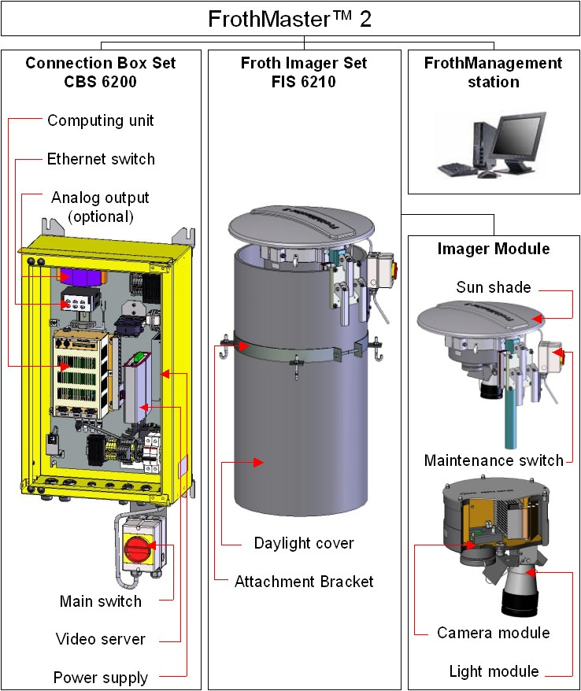

Figure 1. FrothMaster 2 structure

Preparations for the installation

Main principles of installation
Prior to delivery FrothMaster 2 has been tested and packed carefully. Operating software has been loaded into the CPU’s flash memory. The operation starts automatically after the power is turned ON.
Each FrothMaster 2 installation is individual and local circumstances have an effect on the installation layout. Careless or wrong installation may totally ruin the performance and serviceability of the FrothMaster. When planning the installation it is strongly recommended to think of needs in the various operating and maintenance situations of the system.
When installation is well designed and carried out the operation and maintenance of the system is easy and the best possible performance of the FrothMaster 2 is achieved throughout its lifetime.
The basic principle is that accesses onto the FrothMaster 2 modules are easy and safe. It is important that enough space and light is provided for maintenance and working with the equipment.
The minimum space requirement of the FrothMaster 2 Froth Imager Set is:
1100 x 1100 x 1800 mm (w, d, h),
44” x 44” x 71” (w, d, h).
The dimensions of the Froth Imager Set are as follows:
500 x 1100 mm (∅, h),
20” x 44” (∅, h).
The minimum space requirement of the FrothMaster 2 Connection Box Set is:
1000 x 1000 x 1800 mm (w, d, h),
40” x 40” x 71” (w, d, h).
The dimensions of the Connection Box Set are as follows:
375 x 250 x 750 mm (w, d, h),
15” x 10” x 30” (w, d, h).
The FrothMaster 2 modules should be located so that they are not exposed onto splashing or dipping slurry. This will make the operator access more convenient and on a long run will extend the lifetime of the equipment.
Figure 2 illustrates a typical installation layout of the FrothMaster system. It is possible to connect one to four Froth Imager Sets to a single Connection Box Set. Module locations are determined according to maximum cable lengths. It is recommended to plan installation locations for Froth Imager Sets first and then decide installation location of Connection Box Set so, that maximum cable lengths are not exceeded.
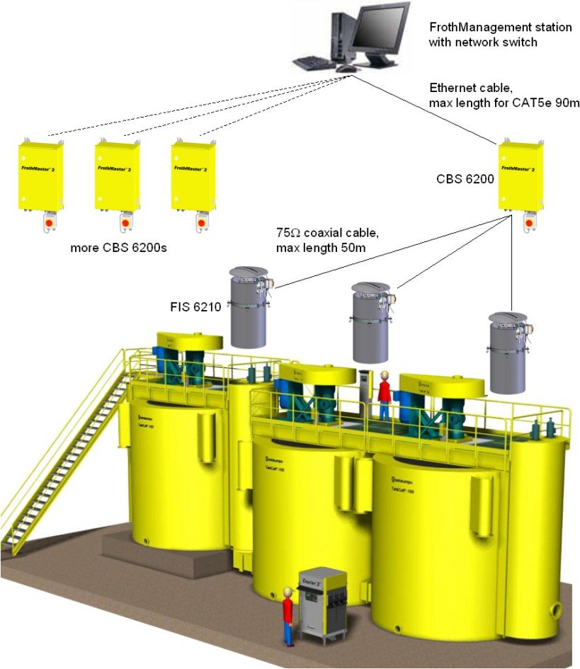
Figure 2. Typical FrothMaster 2 installation layout and maximum cable lengths between modules
FrothMaster 2 modules should not be exposed to direct sunlight. If Froth Imager Sets are installed to a sunny place, daylight cover has to be used.

Installation steps
Installation steps are described in chapters 2- and they are:
- Froth Imager Set installation location
- Installation of the daylight cover
- Imager Module installation
- Connection Box Set installation
- Power supply and electric cabling
- FrothManagement station installation
- FrothMaster 2 software configuration (see Operating Manual for instructions)

Froth Imager Set location
FrothMaster 2 is designed to fit into mill environment. Anyhow it should not be installed in area, which is liable to extreme vibration.
FrothMaster 2 Froth Imager Set is usually installed on a platform above a flotation tank so that the camera can see also the froth lip of the flotation tank, see Figure 3.
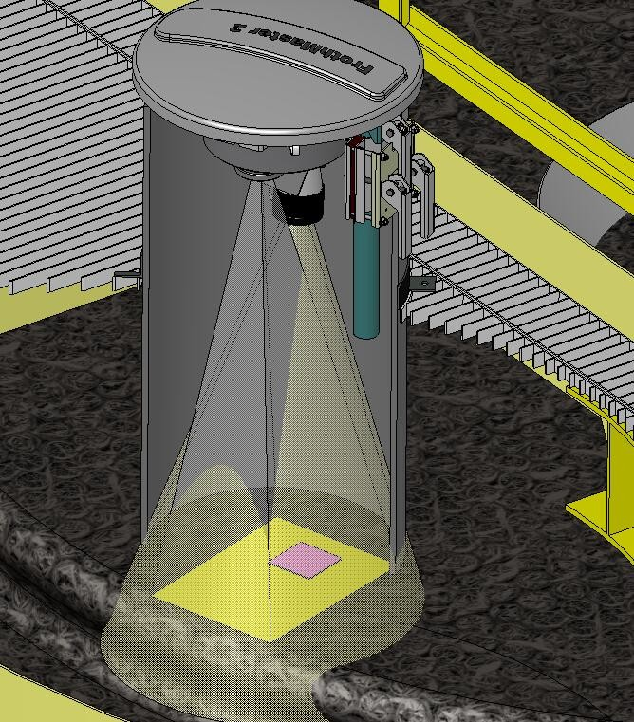
Figure 3. Froth Imager Set (FIS) location
Froth Imager Set should be installed such that x-axis of the camera view is parallel to radius of the flotation cell (assuming cylindrical flotation cell). X-axis of the camera view is indicated by the arrow with text “Froth moving direction” on the imager top.
The distance of the camera lens from the froth surface should be ~900 mm. If 1000 mm daylight cover is provided with the FIS unit, the distance between the camera lens and froth surface is automatically ~900 mm, assuming that the daylight cover is installed according to instructions in chapter 2.4.
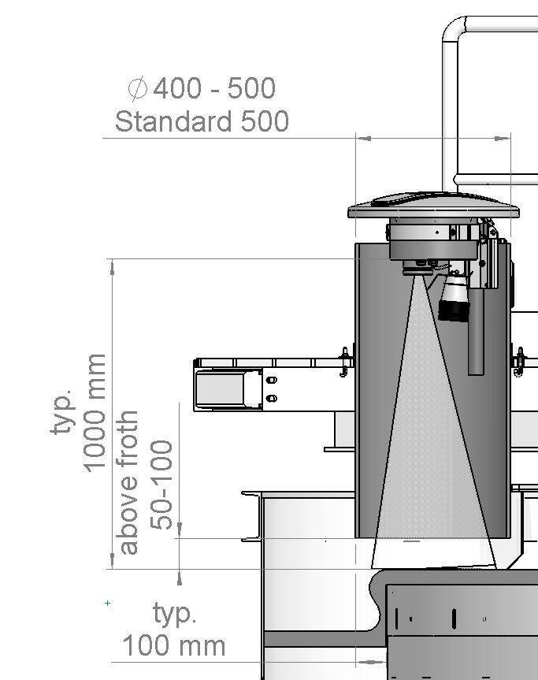
Figure 4. FIS alignment and location
When mounting FIS over the flotation cell, you should check from the camera view that it is properly located. From the video image, you see a view similar to Figure 5. In this view, you can see froth lip and launder on the left side. In the middle is shown Region-of-interest (ROI) as a green vector field. The actual measurement is taken over this region. For more information about setting ROI, see FrothMaster2 User Manual.
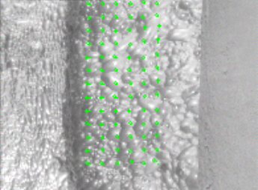
Figure 5. Camera view of the froth surface
For on site maintenance purposes it is ideal to install the Froth Imager Set (FIS) so that imager module can be accessed and cleaned when necessary by maintenance personnel, see Figure 6.
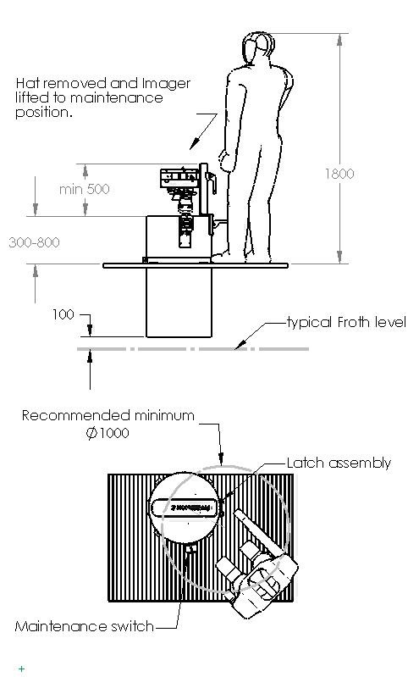
Figure 6. Required working space around the Froth Imager Set

Froth Imager Set daylight cover

Daylight cover specification
The FrothMaster 2 imager module is mounted inside a short piece of process pipe called daylight cover, see . Daylight covers can be acquired externally by contractor (or Outotec subsidiary) or they can be supplied with the complete FrothMaster 2 system.
When it is decided to acquire the daylight covers externally, they should be acquired according to following specifications:
- Material: Polythene
- Length: 1000 mm ± 20 mm / 39.5 mm ± 0.5”
- Outside diameter: 400-500 mm / 16-20”
- Thickness: 6-16 mm / 0.25-0.65” recommended, 30 mm / 1.15” maximum.

Daylight cover installation
Froth Imager Set installation begins with the daylight cover installation. Once a suitable installation place has been found the first step is to prepare the installation spot for daylight cover. The cover can be installed with the delivered attachment bracket by fixing the bracket around a hole made to a platform above flotation tank (see Figure 7 on the left) or mounting it on a stand specially made for the daylight cover (see Figure 7 on the right).
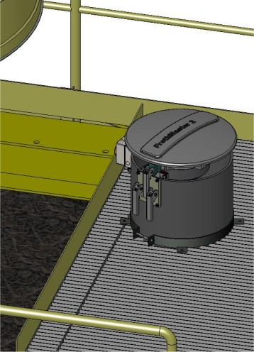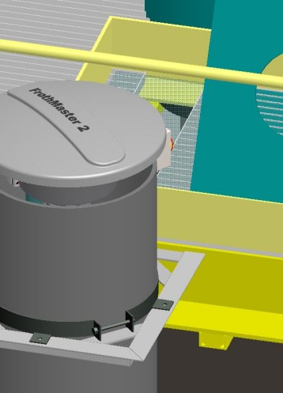
Figure 7. Daylight cover installation possibilities

Installation dimensions
The daylight cover is fastened with the attachment bracket so that the lower edge of the daylight cover is 100 mm / 4” above the average froth surface. However, if the fluctuation range of the froth surface is over ± 100 mm / 4”, the daylight cover should be installed so, that it is 50 mm / 2” above the highest possible froth level, see Figure 4.

Underpinning
The FrothMaster 2 delivery packing includes one attachment bracket per daylight cover. However, if the daylight cover has to be installed so that over 800 mm / 31” of the daylight cover length is above the attachment bracket or the cover feels shaky otherwise, some kind of underpinning should be considered. The underpinning can be done, for example, by using guy bars or guy ropes or a supporting bar. Additional attachment bracket, that can be used in underpinning, is optional and needs to be ordered separately.

Delivery packing
FrothMaster 2 system is packed into one crate. The weight and size of the crate depends on the amount of Froth Imager Sets (1-4) included in the system and whether the daylight covers of the Froth Imager Sets are included or not.

Tools needed in the installation
The installation does not require any special tools. A set of normal tools like power drill, adjustable spanners, pliers, side cutters and screwdrivers are anyhow needed. In some cases installation requires cabling tools such as BNC connector pliers, RJ-45 Ethernet connector pliers or multimode fiber optic cable tools.

Imager Module installation

Imager Module fixing stand installation
The Imager Module fixing stand is installed on to the upper edge of the daylight cover. The fixing stand should be installed to such direction that the Imager Module detachment levers can be accessed easily when necessary, see Figure 6. After the suitable installation direction has been decided, the installation is made according to following instructions:
- Attach the outside plate of the fixing stand to the inside plate from the upper corners of the plates with two bolts, see Figure 8.
- Position the fixing stand on to the upper edge of the daylight cover so that the stand rests on the edge.
- Tighten the fixing stand with the bolts so that both plates rests firmly against the flanks of the daylight cover.
- Drill ∅ 12 mm and 9 mm holes through the daylight cover by using the fixing stand as a template, see Figure 8.
- Insert Imager Module fixing bolts and detachment levers to the fixing stand as shown in Figure 9.
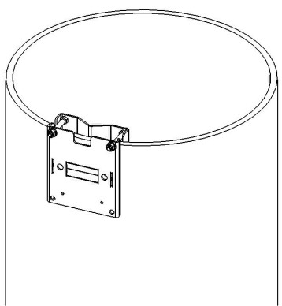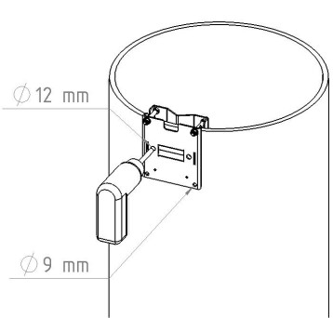
Figure 8. Installation of the imager module stand (steps 1 - 4)

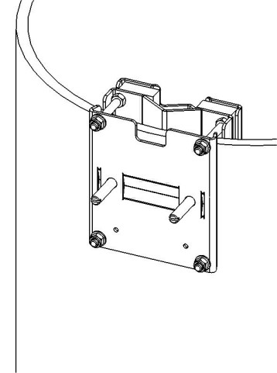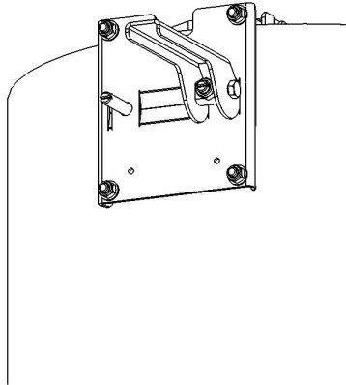
Figure 9. Installation of the imager module stand (step 5)

Imager Module installation
The Imager Module is quite heavy so be careful, when lifting it up.
The Imager Module is mounted according to following instructions:
- Open the Imager Module detachment levers, see Figure 10.
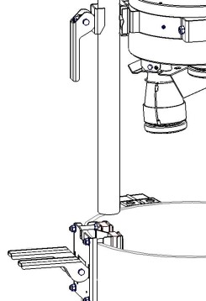
Figure 10. Imager Module installation
- Slide the module carefully down to its place and fasten the detachment levers until the Imager Module is firmly fastened to the fixing stand, see Figure 11.
- Open the Imager Module locking screws so that the module can be rotated in the bracket, see Figure 11.
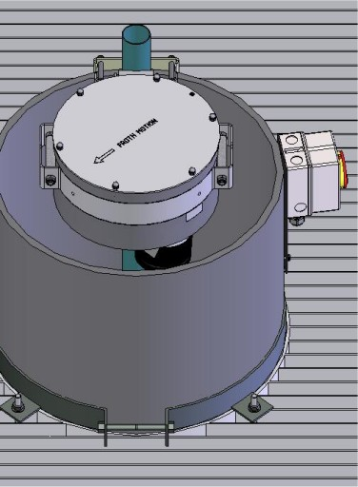
Imager module
locking screws
Figure 11. Imager module fastened to fixing stand
- Rotate the module until the arrow on the top lid points to the direction of flotation and fasten the locking screws again.
- Mount the Froth Imager Set maintenance switch to the fixing stand as in Figure 12.
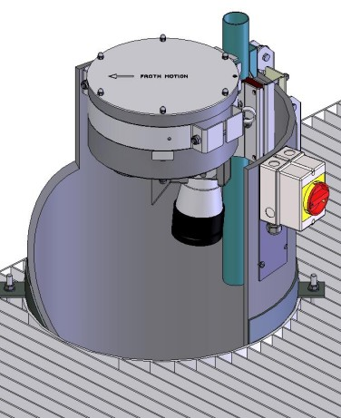
Maintenance switch
Figure 12. Imager module maintenance switch installation

Installation of the optional sun shade
Place the sun shade’s pipe on to the Imager Module pipe as in Figure 13. Secure the sun shade with butterfly nut.
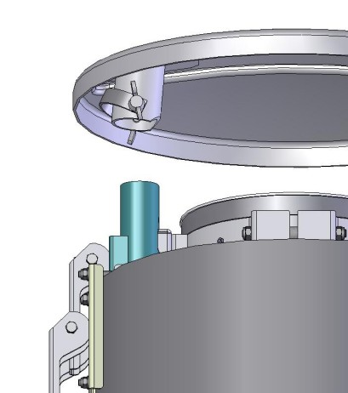
Figure 13. Sun shade installation

Connection Box Set installation
The Connection Box Set (CBS) can be mounted to a wall, a railing or other suitable vertical support. When planning the installation place of the CBS, following matters should be considered:
- The Connection Box Set should not be exposed to direct sunlight.
- The maximum distance between Froth Imager Set and Connection Box Set is limited by maximum cable length which is 50 m / 164 ft.
- The cabinet door should have enough room to be fully opened, see Figure 14.
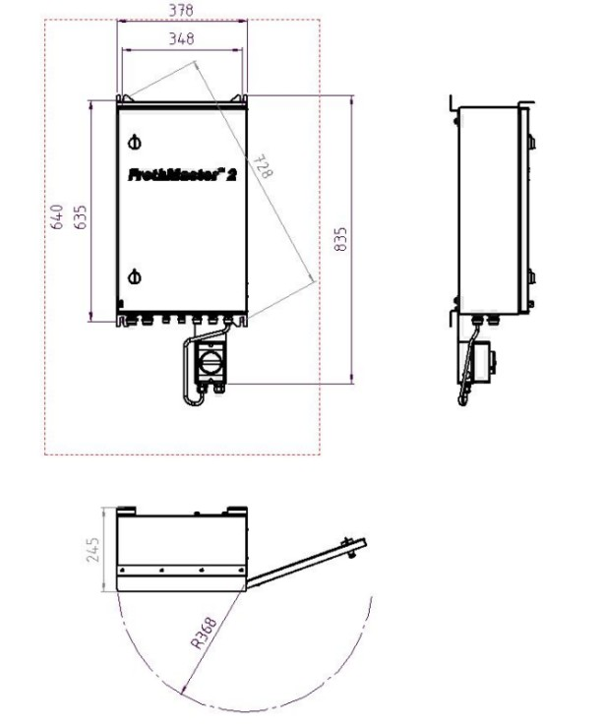
Figure 14. Connection Box Set installation layout

Power supply and electric cabling
Make sure that you follow the local safety regulations when supplying the electrical power and working with the electrical cabling.
Since cables are exposed to a rather harsh environment, it is recommended that the cables are protected by running them into a conduit or at least by using cable trays.

Connection Box Set power supply
FrothMaster 2 requires a power supply according to:
- Single phase AC, 230 V ±10% at 5A 50/60 Hz
or
- Single phase AC, 115 V ±10% at 10A 50/60 Hz
A double conversion (AC/DC/AC) UPS 1 kW / 10 min is highly recommended to secure trouble-free and stable operation.
The connection point for the FrothMaster’s electric supply is the Connection Box Set (CBS). Froth Imager Sets are supplied from the CBS. Power supply will be connected to terminal strip inside the Connection Box Set main switch (see Figure 15 a). Terminal connectors can be accessed by opening two screws of the main switch enclosure. Figure 15 b shows terminal connectors after the main switch enclosure is removed. The power supply connection will be made as follows:
Table 1. FrothMaster 2 power supply connection
Connector label |  | Wire
PE |  | PE
T1 |  | Not connected
T2 |  | L
T3 |  | N

For more detailed description of power supply connection, see document
10000002560 (previous no. 710 3369-3JE) FrothMaster 2 – CBS 6200 Power Supply Wiring Diagram.

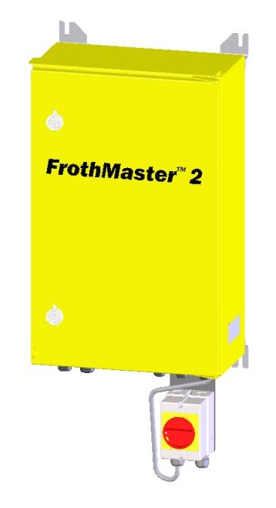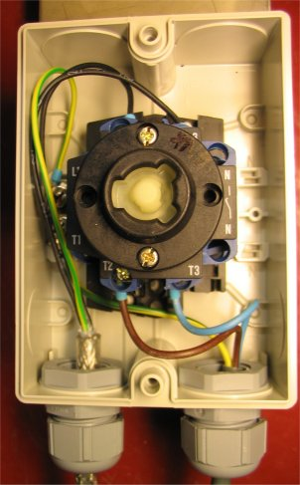
Figure 15. Connection Box Set main switch location and power supply terminal
Make sure that the Connection Box Set is properly grounded.

Froth Imager Set power supply cabling
The maximum power supply cable length between Froth Imager Set and Connection Box Set is 50 m / 164 ft.
The power supply cables between the Froth Imager Sets and the Connection Box Set are connected according to following table.

Table 2. Froth Imager Set power supply connection
FIS 6210 maintenance switch |  |  | Cable | CBS 6200
 | Connector label |  | Wire |  | Connector label
FIS #1 | PE |  | PE |  | X3 / 1
FIS #1 | L2 |  | 1 / L |  | F4
FIS #1 | L3 |  | 2 / N |  | X2 / 1
FIS #2 | PE |  | PE |  | X3 / 2
FIS #2 | L2 |  | 1 / L |  | F5
FIS #2 | L3 |  | 2 / N |  | X2 / 2
FIS #3 | PE |  | PE |  | X3 / 3
FIS #3 | L2 |  | 1 / L |  | F6
FIS #3 | L3 |  | 2 / N |  | X2 / 3
FIS #4 | PE |  | PE |  | X3 / 4
FIS #4 | L2 |  | 1 / L |  | F7
FIS #4 | L3 |  | 2 / N |  | X2 / 4

For more information about FIS power supply connection, see document
10000002561 (previous no. 710 3372-3JE) Imager Modules – CBS 6200 Cabling, FM 2 Wiring Diagram.

Video signal cabling
The maximum video signal cable length between Froth Imager Set and Connection Box Set is 50 m / 164 ft.
Video signal is connected from FIS to CBS by using 75 Ω coaxial cable. The connections are made with BNC connectors. For more detailed description of video signal connection, see document
- 10000002561 (previous no. 710 3372-3JE) Imager Modules – CBS 6200 Cabling, FM 2 Wiring Diagram.

Network cabling

Network topology and connection media
Default FrothMaster 2 system will be delivered with standard network equipment that enable network interconnection using CAT5e copper cabling. When copper cabling is considered, it must be noted that maximum distance between two nodes (i.e. CBS to CBS or CBS to FrothManagement Station / Ethernet switch) is 90 m / 295 ft.
Optionally FrothMaster 2 system can be ordered with fiber optic interface accessories that enable interconnection using 1300nm multi-mode fiber. The number of required fiber optic interfaces per each CBS is dependent on preferred network topology schema. Different network topologies are illustrated in Figure 16 and Figure 17.
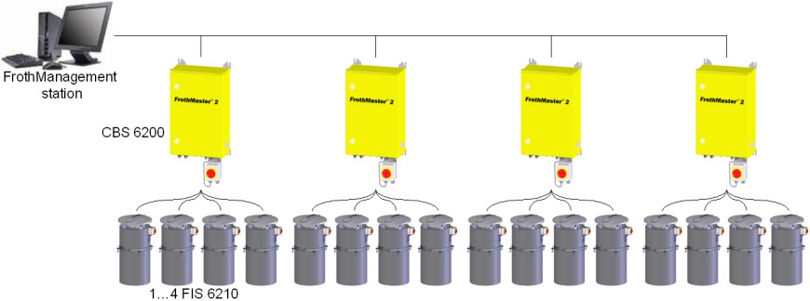
Figure 16. Daisy-chain network topology
Advantage of Daisy-chain is that it will save some cabling costs and it doesn’t require separate network switch because all required network equipment locate inside each CBS. The problem with daisy-chain is that if some of the CBSes fail, all CBSes downstream from the broken one will be out of operation.
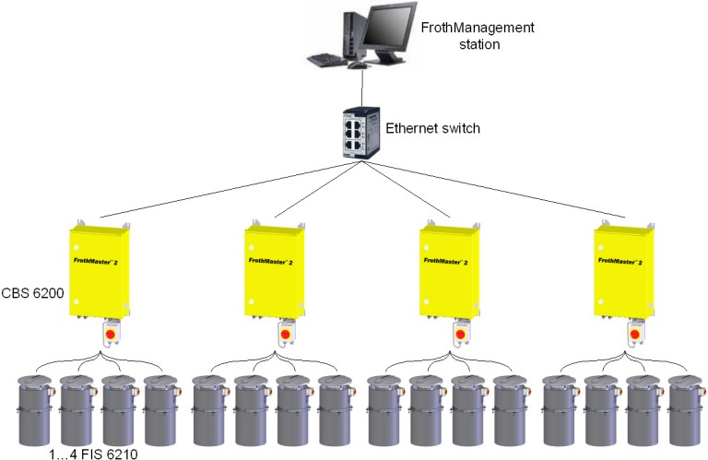
Figure 17. Star network topology
Advantage of the star topology is that rest of the system remains operational even if one CBS fails. Disadvantage of the star topology is slightly higher cabling costs.
Both connection schemas, Daisy-chain and star, apply to both CAT5e copper and fiber optics. There are four basic options regarding connection media and network topology:
- If customer prefers copper and daisy-chain, no additional network hardware is required.
- If customer prefers copper and star topology, additional Ethernet switch may be required.
- If customer prefers fiber and daisy-chain, each CBS must be ordered with two (2) optional fiber optic interfaces.
- If customer prefers fiber and star topology, each CBS must be ordered with one (1) optional fiber optic interface. In addition, one fiber optic switch is also required.

In addition to these four options, customer may wish to have copper daisy-chain that will be lead to control room using fiber optics. In this case it is possible to order one of the CBSes with one (1) optional fiber optic interface. This will reduce costs because only one fiber optic interface is required but still gives possibility to benefit long wiring distances of fiber to control room.

Copper cable
When copper is used as a interconnection media, you should use CAT5e FTP (foil twisted-pair - the extra foil shielding protects against Electro Magnetic Interference) cabling with proper armoring for industrial environment.
Network connection can be made from Connection Box Set to plant Ethernet network by using CAT5e FTP (foil twisted-pair) cable. The cable is connected to RJ-45 connector located at the Connection Box Set’s Computing Unit. The maximum length for the CAT5e network cable is 90 m / 295 ft. For distances greater than 90 m / 295 ft, a fiber optic connection is recommended. Figure 16 and Figure 17 illustrates network cabling guidelines for FrothMaster network.

Fiber optic cable
Fiber optic connection is recommended, when the distance between plant Ethernet network connection point and the Connection Box Set is over 90 m / 295 ft. With fiber optic cable it is possible to extend the cable length up to 1000 m / 3280 ft. The fiber optic cable may also be used to make the FrothMaster network less vulnerable to electric hazards such as lightning.
When fiber optic connection is used, optional fiber to copper media converters are required. The media converter can be installed inside the Connection Box Set or inside a separate connection box.

Analog output signal cabling
Up to 16 analog outputs can be connected to automation system from one Connection Box Set. The analog output signal cables are connected to the analog output modules located inside the CBS, see Figure 18. Each output module has 4 analog outputs marked as Iout0…Iout3. If more than one module is installed, the modules are numbered so that the first one is nearest to the rearward wall of the Connection Box Set.
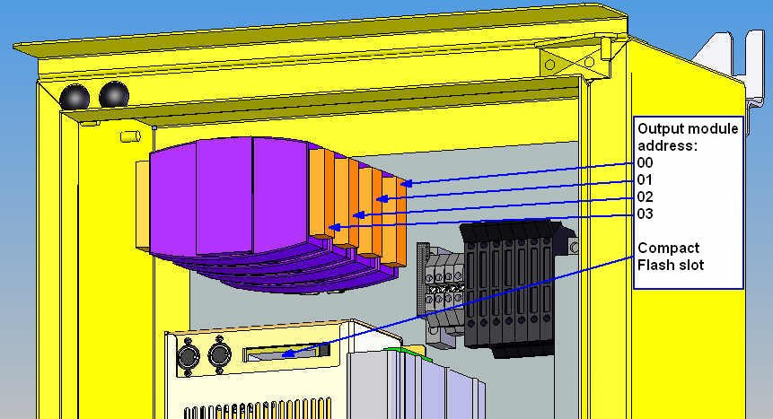
Figure 18. Analog output module
Recommended cable for analog outputs is CSA approved pair cable with proper armoring for industrial conditions, which contains as much pairs as there are outputs in the Connection Box Set. The wires are connected to the output module according to document
- 10000002564 ( previous no. 710 3376-3JE) Control Connections – Analog Output Connections (4-20mA), FM 2 Wiring Diagram.

Installation of the FrothManagement Station
The FrothManagement Station is a PC workstation including tools for configuring FrothMaster system and OPC server for connection to automation system. Optionally, FrothManagement Station can be equipped with expert system software (Outotec ACT and Nexus).
The FrothManagement Station is typically located in the control room of the plant and it should be accessible by plant operating personnel for froth measurement data and video image monitoring. However, if FrothManagement Station is equipped with expert system, it may be desired that FrothManagement Station is not available for all plant personnel. In this case, the FrothManagement Station may be installed in a restricted area with other process control hardware (PLCs etc.).
The FrothManagement Station will be delivered with all required software installed. When installing system hardware and connecting power cables, you should follow instructions by computer manufacturer (included).
There are two network interface cards in the FrothManagement Station. The other one is tagged “FrothMaster network” and the other one “Automation system network”.
Network settings are properly configured for FrothMaster network and you may connect the network cable from CBS boxes to the network interface tagged “FrothMaster network”.
Network settings for automation system network should be assigned by plant’s network administrator and the automation network cable should be connected to network interface tagged “Automation system network” only after approval from plant’s network administrator.

Scope of installation requirements

Environment requirements
Ambient temperature: 5-45 °C / 41-113 ° F (no direct sunlight). Optional FIS air cooler needed for temperatures above 35 °C / 95 °F.
Moisture: up to condensing conditions
EMC: heavy industrial environment, EN 50082-2 & EN 50081-2
Shock: 15 G equivalent / 11 ms
Vibrations: 1 G / 5-150 Hz
Mains power specifications
Requirement: 115/230 VAC ± 10%, 50/60 Hz, 320 W, UPS recommended
Fused terminal strip: 10A-115VAC and 5A 230VAC, circuit brake
Connection: Main switch / CBS 6200
T2 (L), T3 (N) and PE (PE).
Cable specifications

CABLE | TYPE | MAXIMUM LENGHT
Power supply | 3-wire, wire ∅ 1,5 mm², metallic shielding | 50 m / 164 ft between Connection Box Set and Froth Imager Set
Video signal | 75 Ω coaxial, BNC connectors | 50 m / 164 ft between CBS and FIS
Network | CAT5e, FTP (foil twisted-pair), RJ-45 connectors  or  Multimode fiber optic cable | 90 m / 295 ft between CBS and FrothManagement Station  or  1000 m / 3280 ft between CBS and FrothManagement station
Analog output | CSA approved pair-cable

Instrument air specifications and connection (optional FIS air cooling)
Pressure: 5 bar (75 psi)
Consumption: 7 Nl/min (1.8GPM)
Air inlet hose clamp: OD 12 mm / G½”

READER COMMENTS
The design team of Outotec is committed to ensure the quality and usefulness of this manual and the FrothMaster 2 analyzer system. Your comments, recommendations and suggestions will help make our continuous effort more effective.
Please take few moments to write your comments either directly on the form provided or on a photocopy of it.
Your assistance is greatly appreciated.
Thank you for choosing the FrothMaster 2 analyzer system.

Fax to: | Outotec, Analyzers  FAX: INT + 358 205 292998
or mail to: | P.O. Box 84, FI-02201 Espoo, Finland
or e-mail to: | analyzers@outotec.com
Attn: | Manager, Analyzer Sales Support
From:
Analyzer Serial Number:
Manual: | FrothMaster 2  Installation Instructions  Code 10000002554e Revision B  ( Please identify applicable software versions and individual documents )
Comments / recommendations:
 | Number of additional pages ( )

