This document has been created with the omin_at2000.dot template version 3.01.
THE MANAGEMENT PAGE(S) MUST BE REMOVED BEFORE DELIVERING THE DOCUMENT OUTSIDE THE MINTEC ORGANIZATION, OR WHEN THE DOCUMENT IS COPIED AS A PART OF ANOTHER DOCUMENT.
INSTRUCTIONS OF USE
- Depending on what type of document you are creating, do the following:
- If you are creating a document that is delivered with covers, click Document macros – Remove Header Table on the Mintec toolbar.
- If you are creating a document that is delivered without covers, click Document macros – Remove Covers on the Mintec toolbar.
Document macros must be run in normal view (View - Normal).
They do not run properly in print layout view!
You can run document macros only once in each document! Running a document macro does not remove the macro menu from the Mintec toolbar, but it disables the macros from running again in the current document. If you by accident run a wrong macro, start a new document.
- Fill in all the details in the table below.
- Double-click text fields and enter information about the product name and document title as well as the TAKO code and document revision.
DO NOT delete any fields from the table below! If you don’t need a field, fill it with a space character which will show it as being empty.
Product  FrothMaster 2 | Code  10000002555e | Revision  D , Edit Revision 13
Title  FrothMaster 2  Operating Manual | Author  AS | Date  20.03.2008
Title  FrothMaster 2  Operating Manual | Checked by  AS | Date  20.03.2008
Title  FrothMaster 2  Operating Manual | Approved by  JKK | Date  20.03.2008
- Click Update all fields on the Mintec toolbar. This updates all headers and fields in your document.
- Save the document.
Do not edit the headers or the document covers manually!
- Fill in the document record table below.
- As an internal document record, give detailed info about the document revision history and comments about the document and possible needs to consider in future new revisions.

Revision,  date and author | Description of revision and additional comments, info and  possible needs to be considered in future new revisions
A 06.05.2005 | First version.
B 25.08.2005 | Added filter/scaling settings.
C 28.06.2007 | Only template & logo changed
D 20.03.2008 | Webfire/video server images changed, algorithm settings modifed

- If you are creating documentation for other product than Courier, change the information on the Reader Comment page to match the product.
DO NOT REMOVE THE FOLLOWING STANDARD IMAGES!
Note that the floating images can only be seen in the Print Layout view.

Note standard image

Tip standard image

Warning standard image
Check and approval details
The language validator, checker, approver and archiver should fill in the following table and sign it.

Product  FrothMaster 2 | Code  10000002555e
Title  FrothMaster 2  Operating Manual | Author  AS
Language validated by | Revision validated | Date
Checked by | Revision checked | Date
Approved by | Revision to be published | Date
Archived by  SLT | Revision archived  D | Date  25.03.2008

THIS IS THE LAST MANAGEMENT LINE. DO NOT REMOVE IT! Pages total 45, management pages 3.

Operating Manual
10000002555e Revision D

FrothMaster 2
Operating Manual
Contents
1. Introduction 3
2. FrothMaster 2 network configuration 4
2.1 Setting up FrothMaster network IP-addresses 4
Default settings 4
Computing Unit 4
Separate video server 6
FrothManagement station 9
3. Image analysis configuration 10
3.1 Selecting active cameras 10
3.2 Selecting ROI area 10
3.3 Camera settings 12
Frame Grabber Channel 13
Use Testimage.ppm 13
Channel Recovery Time 13
Contrast 13
Brightness 13
3.4 Analog outputs 13
3.5 Measurement settings 13
Calculate Froth Speed 14
Calculate Bubble burst rate 15
Calculate SNE bubblesize 15
Calculate Color 15
Calculate Segmentation 15
Show Unfiltered Measurements 15
3.6 Filter settings 16
Speed Memory, Stability Memory and Size Memory 16
Speed Band, Stability Band and Size Band 17
3.7 Scaling settings 17
3.8 Algorithm settings 18
Motion Search Range X/Y 19
Search Full Scale 20
BMA Block Height / Width 20
Burst Motion/Direction Threshold 20
Mbrt 20
Image Segmentation Stride 20
4. OPC server settings and connection to DCS 21
4.1 OPC server installation 21
4.2 Using the OPC server 23
4.3 OPC server settings 24
4.4 Connection to automation system OPC client 26
Windows XP firewall settings 26
Configuring DCOM settings 30
Test OPC connection using Matrikon OPC explorer 33
5. Appendix A: description of analyzed variables 35
READER COMMENTS

Introduction
This document describes software configuration and operation of FrothMaster 2 system. Prior to software configuration, it is assumed that the system is mechanically and electrically properly installed according to document “FrothMaster 2 Installation Instructions”.

FrothMaster 2 network configuration

Setting up FrothMaster network IP-addresses

Default settings
Easiest way to set up IP addresses in FrothMaster network is to use FrothManagement station as configuration computer. By default the FrothManagement station’s network settings are following:
- IP-address: 192.168.2.1
- Subnet mask: 255.255.255.0
All other modules in FrohtMaster network have IP addresses from the same subnetwork. Connection Box Set (CBS) contains one or two components with individual IP-address depending on the CBS version. If CBS contains optional separate video server then there is two different IP-addresses. Refer to document FrothMaster 2 Final Test Report to find out which CBS version you have.
Connection Box Set default network settings are described inTable 1. Refer to document FrothMaster 2 Final Test Report to find out which network settings are factory configured to CBS. Correct settings can be tracked from the document with CBS’s serial number.
Table 1. Connection Box Set default network settings
 | COMPUTING UNIT |  | VIDEO SERVER
 | IP-ADDRESS | SUBNET MASK | IP-ADDRESS | SUBNET MASK
#1 CBS 6200 | 192.168.2.101 | 255.255.255.0 | 192.168.2.201 | 255.255.255.0
#2 CBS 6200 | 192.168.2.102 | 255.255.255.0 | 192.168.2.202 | 255.255.255.0
…
#10 CBS 6200 | 192.168.2.110 | 255.255.255.0 | 192.168.2.210 | 255.255.255.0

Computing Unit
Open Internet browser in FrothManagement station. Write Computing Unit’s IP-address to browser’s address bar, for example 192.168.2.101. Log in –page similar to Figure 1 appears on to the screen. Use following user name and password to log in:
- User name: administrator
- Password: froth
Go to the Connection Box Setting –page similar to Figure 2. To change the network settings you need to write down also Froth Master Name and Description. Click Save settings to apply new network settings.

Figure 1. WebFire login

Figure 2. Computing Unit’s network settings

Separate video server
Open Internet browser in FrothManagement station. Write video server’s IP-address to browser’s address bar, for example 192.168.2.201. Video server’s Live View –page similar to Figure 3 appears on to the screen.

Figure 3. Video server's Live View –page
Click Setup –link located on the upper right corner of the page. Write following user name and password to appearing pop up:
- User name: root
- Password: ‘root’ (or ‘pass’)
Select Basic Configuration à 2. TCP/IP from the Setup –page. TCP/IP Settings –page similar to Figure 4 appears on to the screen.

Figure 4. Video server TCP/IP Settings
Change new IP-address, subnet mask, default router and host name to fields indicated with green rounded rectangles in Figure 4. Click Save to apply new configuration.

FrothManagement station
Go to Control Panel and open Network Settings. Right click the Local Area Connection –icon and select Properties. Select Internet Protocol (TCP/IP) from the items list and click Properties. Change new IP address to appearing window similar to Figure 5. Remember to keep the FrothManagement station in same subnetwork than other FrothMaster 2 modules. If this is not possible, change subnet mask so that the station can connect to the modules from another subnetwork.

Figure 5. FrothManagement station TCP/IP settings
Remember to write down new IP-addresses of all FrothMaster network modules including FrothManagement station. It is recommended to save IP-addresses to a file which is saved to FrothManagement station’s hard disk. Use for example Notepad and save a file called IP-address.txt to folder C:\network settings.

Image analysis configuration

Selecting active cameras
Each FrothMaster 2 CBS can have up to 4 cameras (Froth Imager Set, FIS) connected. However, the CBS may also have smaller number of cameras. This means that you may have to disable some video channels from the CBS. Open an Internet browser in the FrothManagement station and type in the IP address of the CBS you want to configure to the address bar. After login, connection box settings are shown as in Figure 2. To enable or disable a video channel, you can use the “Active” checkbox for each camera.
In connection box settings page you are also able to give name (e.g. instrument tag) and description for each camera.
It is recommended that you don’t use any special characters in the camera name because some OPC clients can’t access these. Thus if you have a tag “FM-102”, you should name it “FM102”.
Click “Save Settings” to apply new settings.

Selecting ROI area
ROI (region of interest) area is selected from camera view to cut out those parts of the camera view that are insignificant for analysis purposes. Select page “Camera ROI Area” after login, see Figure 6.
If the ROI area window, doesn’t show any reasonable image, click Refresh button. Select ROI area from the window by drawing a rectangle with a mouse. Everything inside the rectangle represents the ROI area. When suitable ROI are has been drawn, select the direction of froth motion and click Save Settings button.
You are also able to adjust the resolution of the analysis calculation by selecting “768x576”, “384x288” or “192x144” from “Image size” drop list. However, it is suggested that the default “384x288” is used because it is suitable for most applications.
If more than one Froth Imager Sets (FIS) are installed to Connection Box Set, select ROI areas for them as well. Select next FIS from Camera drop list and click Refresh to get image to ROI window from the selected FIS. Select ROI area and froth moving direction and click Save Settings button. Proceed to next FIS if necessary.

Figure 6. ROI area selection

Camera settings
Each Froth Imager Set has same set of video signal related parameters that are shown in Figure 7. The Froth Imager Set that is wanted to be configured is selected from Camera drop list. A description of each parameter can be found by clicking question mark next to parameter. Click Save Configuration button to save parameters, before moving to next Froth Imager Set.

Figure 7. Camera settings

Frame Grabber Channel
This parameter describes the frame grabber channel to be used for this camera. Normal convention is to use channel 0 for the first camera, channel 1 for the second camera, channel 2 for the third camera and channel 3 for the fourth camera.

Use Testimage.ppm
If this parameter is set to 1, a test image describing copper flotation froth will be used instead of the video signal. Use only for testing / demonstration purposes.

Channel Recovery Time
This parameter can be used to give a small delay time for a frame grabber channel until it takes a new image. A delay time is required if you have enabled a camera but you don’t have a camera connected. In normal use you don’t need this parameter (because you can disable a disconnected camera).

Contrast
Use this parameter to adjust camera contrast. The default value 27648 is good for a human eye but you may adjust this parameter to get better image analysis result.

Brightness
Use this parameter to adjust camera brightness. The default value 32768 is good for a human eye but you may adjust this parameter to get better image analysis result. In some applications lower brightness give better results for froth speed algorithm.

Analog outputs
FrothMaster 2 comes optionally with analog output modules. There can be up to 4 analog outputs mapped to each camera. Each analog module gives current output from 4 to 20 mA. The measurement range is set so, that the lower limit gives 4 mA and higer llimit gives 20 mA.

Measurement settings
Using measurements settings, you can select what measurement outputs the algorithm should calculate. Generally it is a good idea to optimize algorithm and network usage such that only required measurements are calculated.
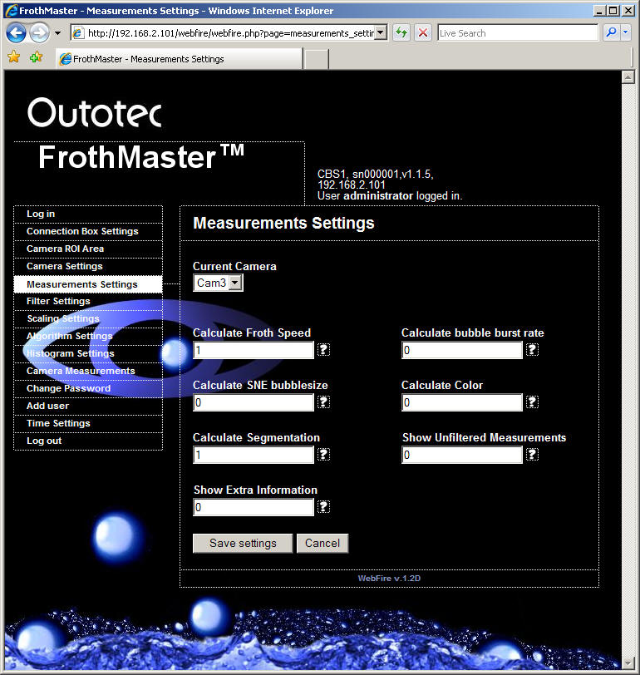
Figure 8. Measurement settings

Calculate Froth Speed
If this parameter is set to 1, the algorithm calculates froth speed. Following measurements are output to OPC server:
[FrothMaster name].[Camera name]_speed
[FrothMaster name].[Camera name]_x_speed
[FrothMaster name].[Camera name]_y_speed
* [FrothMaster name].[Camera name]_speed_unfiltered
* [FrothMaster name].[Camera name]_x_speed_unfiltered
* [FrothMaster name].[Camera name]_y_speed_unfiltered

Calculate Bubble burst rate
If this parameter is set to 1, the algorithm calculates bubble collapse ratio in the froth. (experimental)

Calculate SNE bubblesize
If this parameter is set to 1, the algorithm calculates SNE texture based average size of bubbles. This measurement is very fast to calculate and gives a good estimate about bubble size in most applications. If you want more detailed information about bubble size, consider calculating segmentation and using perimeter histograms. Following measurement is output to OPC server:
[FrothMaster name].[Camera name]_bubblesize
* [FrothMaster name].[Camera name]_bubblesize_unfiltered

Calculate Color
If this parameter is set to 1, the algorithm calculates color of the froth. The calculated measurement describes average intensity of each color component (red, green and blue). Following measurements are output to OPC server:
[FrothMaster name].[Camera name]_red
[FrothMaster name].[Camera name]_green
[FrothMaster name].[Camera name]_blue
If you need more detailed information about froth color, consider using color histograms.

Calculate Segmentation
If this parameter is set to 1, the algorithm calculates bubble based segmentation. This calculation is very CPU intensive and you should carefully consider how often you need to have updated information about segmentation. You can adjust segmentation update rate using parameter “Image Segmentation Stride” in “Algorithm Settings”.
Following measurements are output to OPC server:
[FrothMaster name].[Camera name]_number_of_bubbles
[FrothMaster name].[Camera name]_perimeter_avg
[FrothMaster name].[Camera name]_perimeter_stddev
[FrothMaster name].[Camera name]_fineFrothRatio
[FrothMaster name].[Camera name]_area

Show Unfiltered Measurements
If this parameter is set to 1, the unfiltered measurement results are sent to the OPC server.

Filter settings
There are two consecutive filters for speed, stability and size measurements. Each measurement is first filtered using exponential filter. The output of the exponential filter is fed to a dead band filter. Note that you can disable either of the filters by setting its value to 0.

Figure 9. Filter settings

Speed Memory, Stability Memory and Size Memory
The exponential filter of the FrothMaster2 is of form:
y(t) = (1-lambda^n)*x(t) + lambda^n*y(t-n)
where y(t) is the current output of the filter
x(t) is the current measurement
lambda is the memory factor
y(t-n) is the previous output of the filter
n is the number of frames between this output and the previous (see curfield measurement variable if you need to know the absolute value of n)

Speed Band, Stability Band and Size Band
Output from each exponential filter is fed to corresponding dead band filter. The dead band filter is of form:
y’(t) = y(t) if |y(t)-y’(t-1)| > epsilon
y’(t) = y’(t-1) if |y(t)-y’(t-1) | < epsilon
where y’(t) is the current dead band filter output (and final output signal)
y’(t-1) is the previous dead band filter output
y(t) is the exponential filter output (and dead band filter input)
epsilon is the dead band factor to be adjusted for each signal

Scaling settings
For measurement value scaling, there is a scaling multiplier for measurements: speed, stability, SNE bubble size and segmentation bubble size. When the scaling multiplier is 1, there is no scaling.
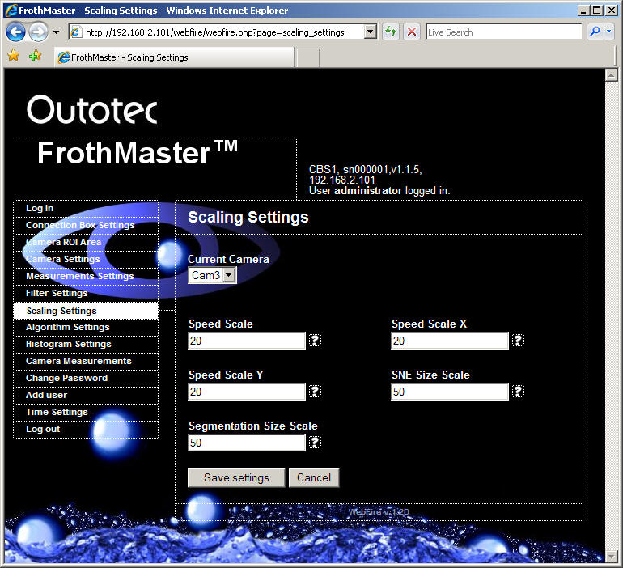
Figure 10. Scaling settings

Algorithm settings
These settings describe how the image analysis algorithm analyzes froth surface image. Adjusting these parameters is intended for trained Outokumpu service engineer only.

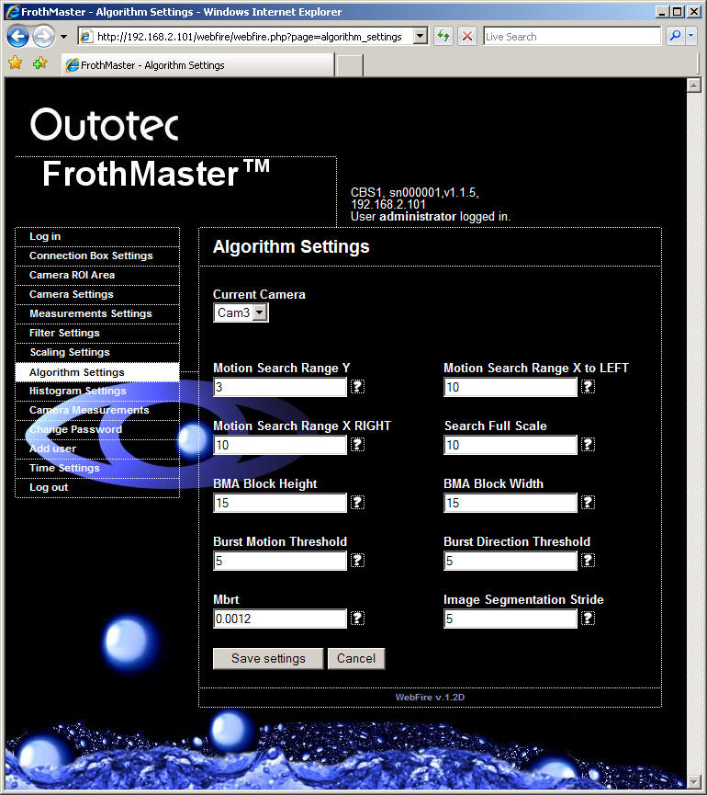
Figure 11. Algorithm settings

Motion Search Range X/Y
These parameters define how many pixels the block matching algorithm searches to x- and y-direction. In normal operation values x to left = 10, x to right = 2 and y=3 are good (assuming the primary froth movement is to x-axis direction).

Search Full Scale
Search full scale can be used to limit maximum output of speed measurement. This parameter can be used for algorithm testing. In normal operation you should set Search Full Scale same as the higher one of parameters Motion Search Range X or Motion Search Range Y.

BMA Block Height / Width
These parameters define size of each BMA (Block Matching Algorithm) block in pixels. By default each BMA block is 10 x 10 pixels. This is good for most applications. However, if bubbles in the froth are very small you may want to try bigger blocks, e.g. 20 x 20.

Burst Motion/Direction Threshold
Bubble collapse ratio related. (experimental)

Mbrt
Mbrt (Marker to Bubble Ratio Threshold) parameter defines a threshold limit between a detected bubble or fine froth.

Image Segmentation Stride
This parameter defines how often full segmentation is performed. For example, if segmentation stride is 1, segmentation is performed on every algorithm execution cycle. If segmentation stride is 10, segmentation is performed every on every 10th algorithm execution cycle.

OPC server settings and connection to DCS

OPC server installation
Each FrothManagement Station is delivered with OPC server installation. However, sometimes it may be necessary to re-install or update the OPC server to newer version.
To re-install the OPC server, follow these steps:
- Remove existing OPC server installation (control panel, Add or remove programs).
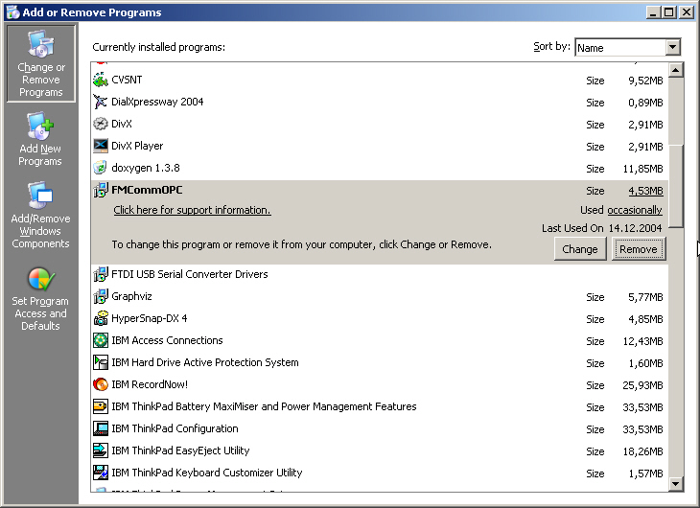
- Install new OPC server by double clicking the installation package “FMCommOPC.msi”.
- Install to default folder C:\Program Files\FMCommOPC.

- Start OPC server application by double clicking the icon on the desktop.
- From “settings” menu, check that communication setting are properly configured for FrothMaster network:

- Click “ Register OPC server”.

Using the OPC server
Figure 12 shows OPC server main window. All FrothMasters in the network are shown in “Detected FrothMasters” list. You can update the list by clicking “Refresh” or “Check for new” button.

Figure 12. OPC server main window
By clicking “Refresh” button, OPC server checks that all the defined FrothMasters respond and removes any that do not respond. It also scans the network for any new FrothMasters and updates all the properties of all the FrothMasters and the available measurements and their values. In practice, you should click “Refresh” when you have changed image analysis configuration (see Chapter 3) or network configuration (see Chapter 2) of any FrothMaster.
By clicking “Check for new” button, OPC server checks for new FrothMasters that can be found in the network during the timeout period. OPC server doesn’t remove any defined FrothMasters that do not respond. In practice, you should click “Check for new” when adding new FrothMasters to the network.
Both “Refresh” and “Check for new” actions can be set to be executed automatically on defined interval. However, when automatic “Refresh” or “Check for new” is used, there may occur some delay in measurement updating because the server continuously polls for changes in the network.
Automatic “Refresh” and automatic “Check for new” is recommended only if there are constant network failures, power failures or changes in FrothMaster image analysis configuration which require OPC server to automatically refresh the network. Normally you should refresh the network manually by clicking “Refresh” or “Check for new” buttons.
Each FrothMaster in “Detected FrothMasters” list can be added to OPC namespace by clicking the right mouse button over the desired FrothMaster and selecting “Add FM to OPC namespace”. After this, the selected FrothMaster should appear in the “OPC namespace” list. This means that measurement values of this FrothMaster can be accessed from OPC client in the automation system.
When FrothMaster is added to OPC namespace, you are able to browse measurement tags. By clicking the right mouse button over the desired measurement tag, you are able show a measurement trend of the variable.

Figure 13. Measurement trend
Status information of each FrothMaster and measurement is indicated as shown in Figure 14.

Figure 14. OPC server symbol legends

OPC server settings
Under the “Setting” menu, you can find OPC server communication settings and time out settings.
Communication settings window is shown in Figure 15. By default these settings are according to FrothMaster 2 network configuration as described in Chapter 2). You should use 192.168.2.1 for local IP address and 255.255.255.0 for subnet mask. According to these settings, OPC server automatically calculates the broadcast address 192.168.2.255. For remote port you should use 5555 and for local port 1111.

Figure 15. OPC server communication settings
Timeout settings window is shown in Figure 16. Description of each timeout setting parameter can be seen in the window. Proper configuration of these parameters is dependent on measurement update interval (and thus dependent on image analysis settings).
When adjusting these parameters, you should start with following initial values:
- Seek Timeout = 5 s
- Validity Timeout = 15 s
- Scan Time = 15 s

Next you should monitor value of the FrothMaster “Status” variable. When communication is working properly, the value of the FrothMaster “Status” should be “OK”. If you are getting value “ScanTimeTimeout” from time to time, you should add value of the “Scan Time” parameter.
If quality of some measurement variables goes “Bad”, you should add value of the “Validity Timeout” parameter.

Figure 16. OPC server timeout settings

Connection to automation system OPC client

Windows XP firewall settings
Windows XP service pack 2 turns on network firewall by default, thus you need to make some exceptions to firewall rules. Following instructions are taken from a white paper “Using OPC via DCOM with Microsoft Windows XP Service Pack 2” by OPC foundation. To get latest version of this document, please visit www.opcfoundation.org.
1. By default the windows firewall is set to “On”. This setting is recommended by Microsoft and by OPC to give your machine the highest possible protection. For trouble shooting, you may wish to temporarily turn off the firewall to prove or disprove that the firewall configuration is the source of any communication failure. You can find “Windows Firewall” settings from the control panel (assuming you have Windows XP SP2 installed).
Note: It may be appropriate to permanently turn off the firewall if the machine is sufficiently protected behind a corporate firewall. When turned off, the individual firewall settings outlined here need not be performed to allow OPC communication.

2. Select the “Exceptions” tab and add all OPC Clients (i.e. the OPC client application on DCS workstation) and Servers (i.e. the OPC server FMCommOPC.exe on the FrothMaster2 OPC server workstation) to the exception list. Also add Microsoft Management Console (used by the DCOM configuration utility in the next section) and the OPC utility OPCEnum.exe found in the Windows\System32 directory.

In the Add a Program dialog, there is a listing of most applications on the machine, but note that not all of them show up on this list. Use the “Browse” button to find other executables installed on the computer.
Note: Only EXE files are added to the exceptions list. For in-process OPC Servers and Clients (DLLs and OCXs) you will need to add the EXE applications that call them to the list instead.

3. Add TCP port 135 as it is needed to initiate DCOM communications, and allow for incoming echo requests. In the Exceptions tab of the Windows Firewall, click on Add Port.

In the Add a Port dialog, fill out the fields as follows:
Name: DCOM
Port number: 135
Choose the TCP radio button

Configuring DCOM settings
Follow these steps to configure DCOM for OPC Communications using Windows XP Service Pack 2 (from a white paper “Using OPC via DCOM with Microsoft Windows XP Service Pack 2” by OPC foundation):
1. Go to Start -> Run and type DCOMCnfg and click on OK.

2. Click on Component Services under the Console Root to expand it.
3. Click on Computers under Component Services to expand it.
4. Right click on My Computer in the pane on the right and select Properties

5. Go to the COM Security tab and note these are the four permission configurations that we will have to edit:

6. Edit the Limits for Access and Launch
a. Access Permissions – Edit Limits...
You need to check the Remote Access box for the user labeled ANONYMOUS LOGIN in this dialog.
Note: This setting is necessary for OPCEnum.exe to function and for some OPC Servers and Clients that set their DCOM 'Authentication Level' to 'None' in order to allow anonymous connections. If you do not use OPCEnum you may not need to enable remote access for anonymous users.

b. Launch and Activation Permissions – Edit Limits...
You need to check the remote boxes for the user labeled Everyone in this dialog.
Note: Since Everyone includes all authenticated users, it is often desirable to add these permissions to a smaller subset of users. One suggested way to accomplish this is to create a group named “OPC Users” and add all user accounts to this group that will execute any OPC Server or Client. Then substitute “OPC Users” everywhere that Everyone appears in these configuration dialogs.

7. Edit Default Permissions for Access and Launch
For each user (or group) that participates in OPC communication (e.g. “OPC Users”), make sure that both the Local Allow and Remote Allow checkboxes are both checked.

Test OPC connection using Matrikon OPC explorer
Install Matrikon OPC expoler on the OPC client workstation. Select “Add/Connect server…” and connect to server “Outokumpu.FMComm.1” on a remote OPC server workstation (here \\FM2STATION).

Add a group “TestGroup” to server “Outokumpu.FMComm.1” and some items to group “TestGroup”. Observe that items update to confirm that OPC connection between the client host and FrothMaster management station works.

Appendix A: description of analyzed variables

- Speed (resultant)
- Speed X
- Speed Y
- Stability (=variance of speed vectors)
- Bubble size based on SNE texture
- Red (average)
- Green (average)
- Blue (average)
- Number of bubbles
- Perimeter (average)
- Perimeter (std dev)
- Fine froth ratio
- Froth area
- Histogram min
- Histogram max
- Number of bins in histogram
- Bin 1
- Bin 2
- Bin 3
- …

Histogram can be calculated from following measurements: Perimeter, Red, Green and Blue. One histogram of ten (10) bins requires 13 variables.

READER COMMENTS
The design team of Outotec is committed to ensure the quality and usefulness of this manual and the FrothMaster 2 analyzer system. Your comments, recommendations and suggestions will help make our continuous effort more effective.
Please take few moments to write your comments either directly on the form provided or on a photocopy of it.
Your assistance is greatly appreciated.
Thank you for choosing the FrothMaster 2 analyzer system.

Fax to: | Outotec, Analyzers  FAX: INT + 358 205 292998
or mail to: | P.O. Box 84, FI-02201 Espoo, Finland
or e-mail to: | analyzers@outotec.com
Attn: | Manager, Analyzer Sales Support
From:
Analyzer Serial Number:
Manual: | FrothMaster 2  Operating Manual  Code 10000002555e Revision D  ( Please identify applicable software versions and individual documents )
Comments / recommendations:
 | Number of additional pages ( )

