This document has been created with the omin_at2000.dot template version 3.01.
THE MANAGEMENT PAGE(S) MUST BE REMOVED BEFORE DELIVERING THE DOCUMENT OUTSIDE THE MINTEC ORGANIZATION, OR WHEN THE DOCUMENT IS COPIED AS A PART OF ANOTHER DOCUMENT.
INSTRUCTIONS OF USE
- Depending on what type of document you are creating, do the following:
- If you are creating a document that is delivered with covers, click Document macros – Remove Header Table on the Mintec toolbar.
- If you are creating a document that is delivered without covers, click Document macros – Remove Covers on the Mintec toolbar.
Document macros must be run in normal view (View - Normal).
They do not run properly in print layout view!
You can run document macros only once in each document! Running a document macro does not remove the macro menu from the Mintec toolbar, but it disables the macros from running again in the current document. If you by accident run a wrong macro, start a new document.
- Fill in all the details in the table below.
- Double-click text fields and enter information about the product name and document title as well as the TAKO code and document revision.
DO NOT delete any fields from the table below! If you don’t need a field, fill it with a space character which will show it as being empty.
Product  FrothMaster 2 | Code  10000002556e | Revision  B , Edit Revision 3
Title  FrothMaster 2  Maintenance Manual | Author  MPH | Date  23.03.2005
Title  FrothMaster 2  Maintenance Manual | Checked by  JTI | Date  17.05.2005
Title  FrothMaster 2  Maintenance Manual | Approved by  JKK | Date  17.05.2005
- Click Update all fields on the Mintec toolbar. This updates all headers and fields in your document.
- Save the document.
Do not edit the headers or the document covers manually!
- Fill in the document record table below.
- As an internal document record, give detailed info about the document revision history and comments about the document and possible needs to consider in future new revisions.

Revision,  date and author | Description of revision and additional comments, info and  possible needs to be considered in future new revisions
A 03.05.2005 | First version
B 28.06.2007 | Only template & logo changed

- If you are creating documentation for other product than Courier, change the information on the Reader Comment page to match the product.
DO NOT REMOVE THE FOLLOWING STANDARD IMAGES!
Note that the floating images can only be seen in the Print Layout view.

Note standard image

Tip standard image

Warning standard image
Check and approval details
The language validator, checker, approver and archiver should fill in the following table and sign it.

Product  FrothMaster 2 | Code  10000002556e
Title  FrothMaster 2  Maintenance Manual | Author  MPH
Language validated by | Revision validated | Date
Checked by  JTI | Revision checked  A | Date  17.05.2005
Approved by  JKK | Revision to be published  A | Date  17.05.2005
Archived by  SLT | Revision archived  A | Date  17.05.2005

THIS IS THE LAST MANAGEMENT LINE. DO NOT REMOVE IT! Pages total 31, management pages 1.

Maintenance Manual
10000002556e Revision B

FrothMaster 2
Maintenance Manual
Contents
1. Introduction 3
1.1 About this document 3
1.2 FrothMaster 2 maintenance principle 3
1.3 FrothMaster 2 general safety 3
1.4 FrothMaster 2 electric safety 3
2. What is what? 4
3. FrothMaster 2 basic troubleshooting 5
Some of the analysis variables have abnormal values 5
Some / all analysis variables are not updating 5
Camera view is fuzzy 6
Camera view is dark 6
Camera view is not available 6
No connection to video server 6
No connection to FrothMaster configuring software (Webfire) 7
4. Froth Imager Set (FIS) maintenance 8
4.1 Unfixing Imager Module for maintenance 8
4.2 Cleaning camera and lamp windows 9
4.3 Changing Imager Module light bulb 10
5. Connection Box Set (CBS) maintenance 12
5.1 Fuses 12
5.2 Calibration and configuration of analog output modules 13
DCON Utility installation 13
Module connection 14
Module configuration 15
Module calibration 17
6. FrothMaster 2 software 20
6.1 Computing Unit’s software update 20
Saving CBS configuration 20
Changing the software Flash Card 20
Restoring saved configuration 21
READER COMMENTS

Introduction

About this document
The purpose of this manual is to help the end user's organisation to do logical troubleshooting and continuous maintenance of the FrothMaster 2 system. This will increase the availability of the FrothMaster 2 system.
Use of the manual provides a good starting point for contacting Outotec Minerals or local representative for more detailed troubleshooting. The instructions given on this manual aim to find the problem on module level.
This document is based on the information available at the moment of its publication. While efforts have been made to be accurate, the information does not cover all details or variations in hardware and software, or provide for every possibility in connection with installation, operation or maintenance. Outotec Minerals assumes no obligation of notice to holders of this document with respect to changes made in the FrothMaster 2 system.
Outotec Minerals assumes no responsibility for the accuracy, completeness or usefulness of the information contained in this document. No warranties or other responsibilities for any material losses or delays may cause to holder of this document shall apply.

FrothMaster 2 maintenance principle
Since the FrothMaster 2 system is rather simple and doesn’t contain any moving mechanical parts, it doesn’t require so much periodic maintenance. Therefore, it is best to perform maintenance operations only when it is necessary. Required periods for maintenance operations like camera window cleaning are case-specific and can be learned from experience.

FrothMaster 2 general safety
The FrothMaster 2 has been designed to operate reliably and safely in the harsh process environment. The construction of the analyzer has been designed to minimize the risk of injury to the operating personnel or material damage due to electricity or heat.

FrothMaster 2 electric safety
The Connection Box Set (CBS) is the connection point for the FrothMaster 2 electric power supply. The power is distributed from the CBS to the Froth Imager Sets that are connected to the CBS.
The FrothMaster 2 mains power switch is located below the CBS. Every Froth Imager Sets (FIS) have their own maintenance switches. The entire FrothMaster 2 system is de-energized by turning the mains power switch off.

What is what?

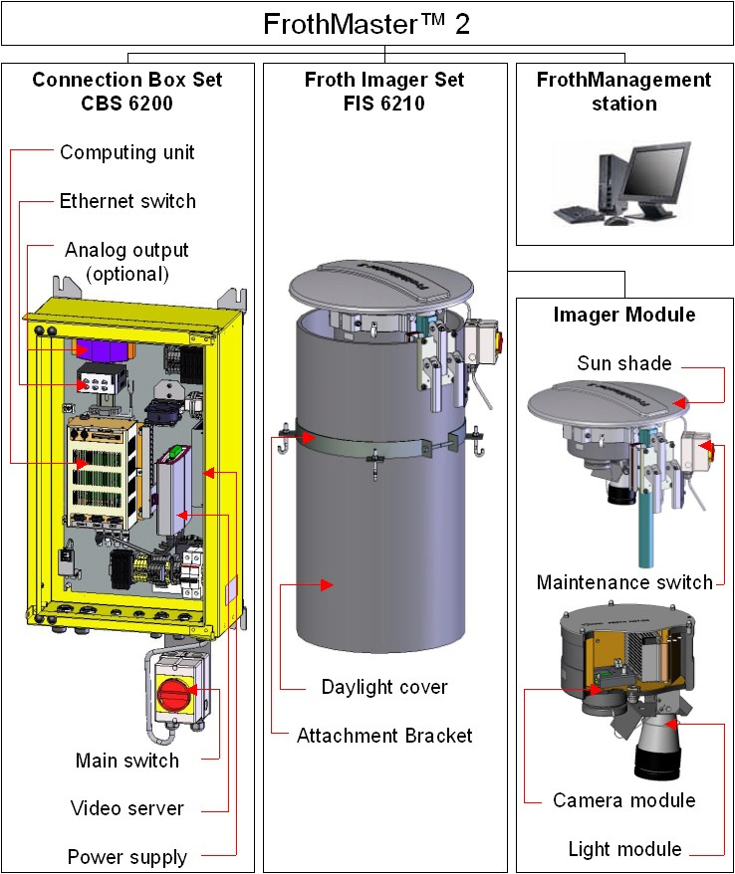
Figure 1. FrothMaster 2 modules

FrothMaster 2 basic troubleshooting
This chapter highlights trouble situations that may occur in FrothMaster 2 system and gives instructions how to solve these problems. Before looking at descriptions below, check that the problem is not caused by process conditions.
Some of the analysis variables have abnormal values
Cause:
- Imager Module lamp is broken.
- Imager Module lamp and camera windows are dirty.
- ROI area is not selected correctly.
- Analog output module calibration is adrift (if analog outputs are in use).
Action:
- Change Imager Module lamp, see chapter 4 for instructions.
- Clean Imager Module lamp and camera windows, see chapter 4 for instructions.
- Select ROI area with configuration tool, see FrothMaster 2 Operating Manual for instructions.
- Check analog output module calibration and calibrate if necessary, see chapter 5.2 for instructions.
Some / all analysis variables are not updating
Cause:
- Analog output module fuse has blown or signal cable is broken (if analog outputs are in use).
- Network connection between Connection Box Set, FrothManagement station or automation system has failed.
- FrothManagement station’s OPC server has failed.
Action:
- Check analog output module fuse and signal cable.
- Check network cable connections and devices such as switches, fiber converters etc. If cable connections and network devices are working, restart FrothMaster from Connection Box Set and restart FrothManagement station.
- Restart FMcomm OPC server. If it doesn’t help, restart FrothManagement station.
Camera view is fuzzy
Cause:
- Imager Module camera window is dirty.
- Distance between froth surface and Imager Module is wrong.
Action:
- Clean Imager Module lamp and camera windows, see chapter 4 for instructions.
- Correct the distance according to instructions given FrothMaster 2 Installation Instructions document, chapter 2.4.
Camera view is dark
Cause:
- Imager Module lamp is broken.
- Imager Module lamp and camera windows are dirty.
Action:
- Change Imager Module lamp, see chapter 4 for instructions.
- Clean Imager Module lamp and camera windows, see chapter 4 for instructions.
Camera view is not available
Cause:
- Froth Imager Set power supply switch is OFF.
- Froth Imager Set power supply fuse has blown.
- Video signal cable is broken.
Action:
- Check Froth Imager Set power supply switch status.
- Check Froth Imager Set power supply fuse, see chapter 5.1 for instructions.
- Check video signal cable connection.
No connection to video server
Cause:
- Network connection to video server has failed.
- Video server or Connection Box Set main fuse has blown.
- Video server power supply is broken.
Action:
- Check network cable connections and devices such as switches, fiber converters etc. If cable connections and network devices are working, restart FrothMaster from Connection Box Set and restart FrothManagement station.
- Check Connection Box Set main fuse and video server fuse, see chapter 5.1 for instructions.
- Check that power supply G1 output voltage for video server is 12 V DC, see document 10000002562 (previous no. 710 3374) FrothMaster 2 Power Module wiring diagram for instructions.
No connection to FrothMaster configuring software (Webfire)
Cause:
- Network connection to Computing Unit has failed.
- Computing Unit or Connection Box Set main fuse has blown.
- Computing Unit power supply is broken.
Action:
- Check network cable connections and devices such as switches, fiber converters etc. If cable connections and network devices are working, restart FrothMaster from Connection Box Set and restart FrothManagement station.
- Check Connection Box Set main fuse and Computing Unit fuse, see chapter 5.1 for instructions.
- Check that power supply G1 output voltage for Computing Unit is 5 V DC, see document 10000002562 (previous no. 710 3374 FrothMaster 2 Power Module wiring diagram for instructions.

Froth Imager Set (FIS) maintenance

Unfixing Imager Module for maintenance
Switch the Imager Module to maintenance (OFF) before any maintenance operations. The Imager Module lamp is extremely hot, when it is in use. Be careful when working with hot parts of the Imager Module.
The Imager Module is unfixed by opening three detachment levers illustrated in Figure 2.
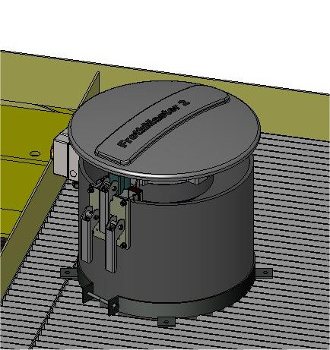
Imager Module detachment levers
Imager Module maintenance switch
Figure 2. Imager Module detachment levers and maintenance switch locations
The sun shade has to be removed before lifting the Imager Module up to maintenance position. To remove the sun shade, unfasten the butterfly screw that is holding the sun shade and lift the shade out of its place.
Lift the Imager Module up until it is above daylight cover. Turn the module on a side that has enough space to perform maintenance operations. Secure the module to maintenance position by tightening all detachment levers. Figure 3 shows an example of Imager Module in maintenance position.
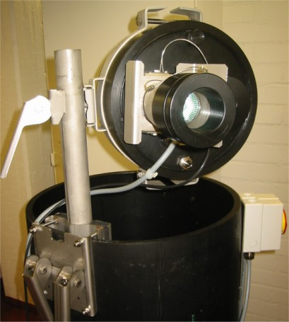
Figure 3. Imager Module in maintenance position

Cleaning camera and lamp windows
Switch the Imager Module to maintenance (OFF) before any maintenance operations. The Imager Module lamp is extremely hot, when it is in use. Be careful when working with hot parts of the Imager Module.
REQUIRED TOOLS AND ITEMS
Sprayer
Dishwashing liquid or other equivalent detergent
Micro fiber cloth
Fix the Imager Module to maintenance position as instructed in chapter 4.1. Before cleaning the windows, check that the lamp has cooled down.
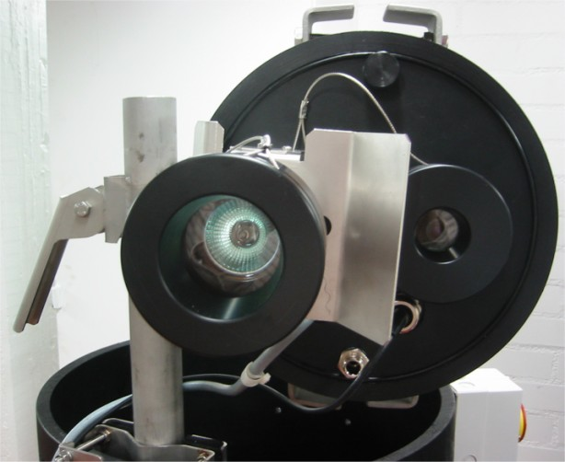
Figure 4. Imager Module lamp and camera windows
Fill the sprayer with water and mix a small amount of dishwashing liquid in it. Use the sprayer to moisten both windows with the detergent. Wait a little while for the detergent to soak in and spray again. The idea is to remove as much dirt as it is possible with the sprayer, before wiping the windows with micro fiber cloth. When all possible dirt has been removed with the sprayer, start wiping rest of the dirt off with micro fiber cloth. Wipe the whole window with one single wipe to one direction. Make every wipe with new clean spot of the cloth. Rinse the micro fiber cloth carefully after the cleaning is ready.

Changing Imager Module light bulb
Switch the Imager Module to maintenance (OFF) before any maintenance operations. The Imager Module lamp is extremely hot, when it is in use. Be careful when working with hot parts of the Imager Module.
REQUIRED TOOLS AND ITEMS | TYPE
Spare bulb  Clean gloves or micro fiber cloth | HALOGEN 12VDC 35W >30° GU5.3
Fix the Imager Module to maintenance position as instructed in chapter 4.1. Unscrew the lamp cover as illustrated in Figure 5. It is recommended to use gloves when working with Imager Module lamp. The bulb is attached to a plug type lamp-socket. Pull the bulb out of the lamp-socket by taking a firm grab from the bulb edging.
Do not touch new spare bulb with bare hands. Use clean gloves or cloth, when handling the bulb.
Check that spare bulb is the same type than the used one. Push the bulb gently to the lamp-socket with gloves or cloth. Screw the lamp cover back to its place.
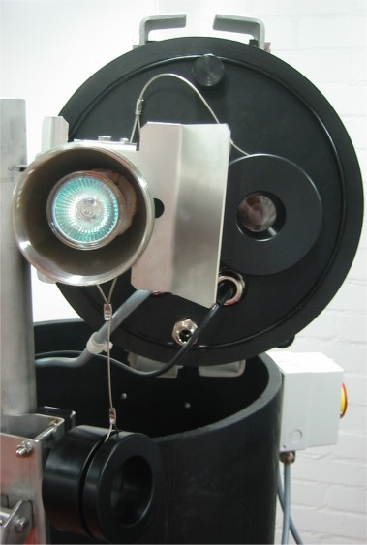
Figure 5. Removing the lamp cover

Connection Box Set (CBS) maintenance

Fuses
There are 12 fuses in Connection Box Set. Fuse F1 is 5A - 230VAC / 10A–115 VAC automatic fuse. In case of circuit break, you can reset this fuse without having to replace the fuse. However, fuses F4-F14 are normal glass tube fuses, which must be replaced when broken. Specifications for all fuses are listed on Table 1. Fuse locations are illustrated in Figure 6.
Table 1. CBS fuse specifications
FUSE | SIZE | TYPE | COMMENT
F1 | 5 A or 10A | Automatic | Mains
F4 | 2,5 A | Glass tube 5x20mm, slow | FIS 6210 #1 Power supply
F5 | 2,5 A | Glass tube 5x20mm, slow | FIS 6210 #2 Power supply
F6 | 2,5 A | Glass tube 5x20mm, slow | FIS 6210 #3 Power supply
F7 | 2,5 A | Glass tube 5x20mm, slow | FIS 6210 #4 Power supply
F8 | 3,15 A | Glass tube 5x20mm, slow | Computing Unit
F9 | 0,5 A | Glass tube 5x20mm, slow | Fiber converter
F10 | 0,5 A | Glass tube 5x20mm, slow | Analog output modules
F11-F14 | 0,5 A | Glass tube 5x20mm, slow | Optional 12VDC supplies
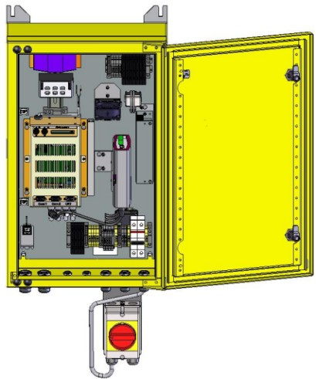
F8-F14
F4-F7
F1
Figure 6. Fuse locations

Calibration and configuration of analog output modules

REQUIRED TOOLS AND ITEMS
Flat screwdriver
Multimeter
RS-485 converter and connection cables
Laptop
FrothMaster 2 software CD
Optional analog output modules are used when DCS connection is made with 4-20 mA signals instead of OPC. The analog output modules are factory calibrated, but some times calibration may be lost due to disruptions in signal cables. Also, when new module is installed to replace a broken one or to give extra outputs, it has to be calibrated and configured. Analog output modules are located at the top left corner inside the Connection Box Set as illustrated in Figure 7.
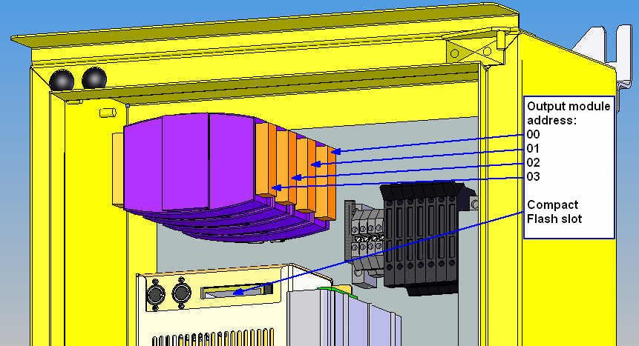
Figure 7. Analog output modules

DCON Utility installation
Configuration and calibration of the analog output module is made with DCON Utility software found from the FrothMaster 2 software CD. DCON Utility is installed to a computer, e.g. laptop, which is connected to analog output module with RS-485 connection. Follow these instructions to install DCON Utility to the computer:
- Insert FrothMaster 2 software CD to CD-drive.
- Browse the CD with My Computer and open DCON Utility folder.
- Run Setup.exe file found from the Setup folder under the DCON Utility folder.
- Choose installation folder and click Next.
- Choose start menu folder and click Next.
- When the file installation is ready, click Finish.
- DCON Utility installation is now ready.

Module connection
Configuration computer is connected to analog output module by using RS-485 converter. Connection between configuration computer and analog output module is illustrated in Figure 8. RS-485 converter is configured with following settings:
- Half duplex (single pair) transmission
- DTE
- No termination
- Enable transmitting (TxD) driver only when transmitting
- Transmit data echo suppression mode
- CTS always enabled.
Refer to RS-485 converter’s user manual for configuration instructions.
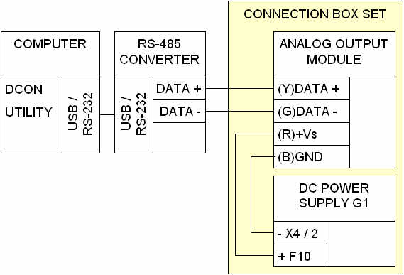
Figure 8. Analog output module connection
For analog output calibration, multimeter and external DC power source has to be connected to the output channel which is being calibrated. External power supply can be connected from automation system (DCS) or Connection Box Set (CBS), see Figure 9. Power can be supplied from DCS by using the signal cable connected to the output channel. When power is supplied from CBS, it is possible to use one of the optional Fuses, e.g. F14, to make the connection. Power can also be supplied from any other low voltage (under 36 V) DC power supply that is capable to output more than 20 mA.
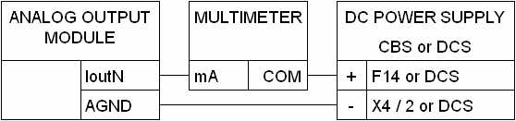
Figure 9. Calibration connection

Module configuration
Analog output module is configured with DCON Utility software. The module is configured according to following instructions:
- Start DCON Utility in a computer that is connected to the module.
- Select COM Port from the menu bar to configure COM-port settings. It is possible to use other COM-ports than COM 2, but all other settings should be made as illustrated in Figure 10. Accept the settings with OK button.
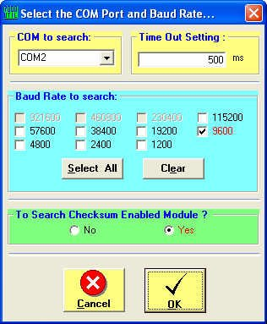
Figure 10. COM-port settings screen
- Click search button to start module search. Analog output module should appear to the search window as illustrated in Figure 11.
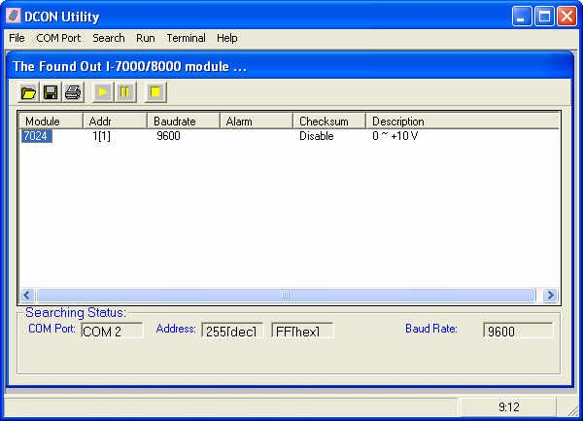
Figure 11. DCON Utility’s module search window
- Double click the module name (7024) in the search window to configure the module settings. Choose the module address according to its position in Connection Box Set (CBS). See Figure 7 for module addressing instructions. If there is only one module, its address is 0. All other settings are made according to Figure 12. Apply new settings by clicking Setting button.
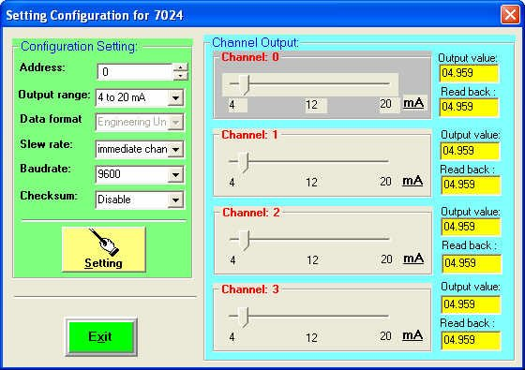
Figure 12. Analog output module configuration
- Check that new configuration is shown on the search module window.
- Close the DCON Utility software. Analog output module is now configured.

Module calibration
Analog output module is calibrated according to following instructions:
- Connect configuring computer, multimeter and external power source to module as instructed in chapter Module connection. Start calibration from the output channel Iout0.
- Switch power ON and let the output module to warm up for 30 minutes.
- Start DCON Utility in a computer that is connected to the module.
- Configure COM-port settings and search the module as instructed in chapter Module configuration.
- Double click the module name (7024) in the search window to open the configuration window. Use the channel output section of the configuration window to test that the multimeter outputs approximately same values as the output values on the configuration window.
- Change module’s output range to 0 to 20 mA as in Figure 13. Apply new settings by clicking Setting button
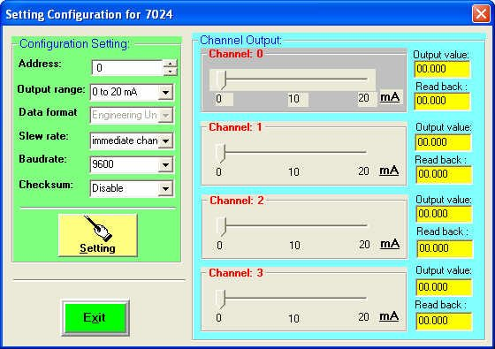
Figure 13. Analog output module configuration for calibration
- Open Single Line terminal from DCON Utility’s Terminal menu.
- Set the value of the output channel to 0 mA according to instructions given in Table 2. Figure 14 contains example of the set value command when module address is 0 and output channel is 0.
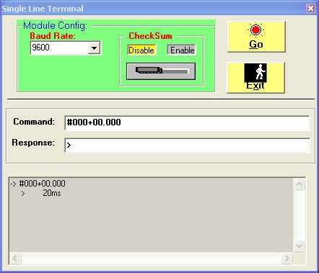
Figure 14. Output channel value setting to 0 mA
- Trim the output by apply trim command until multimeter reading is 0.00 ± 0.03 mA. See Table 2 for instructions how to use apply trim command. In Figure 15 apply trim command has been used to decrease the output current by 2,44 μA.
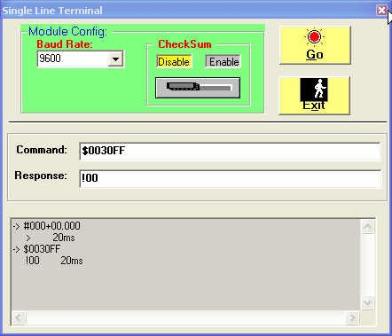
Figure 15. Output channel value trimming
- Enter 0 mA calibration command, when output has been trimmed. See Table 2 for instructions how to use 0 mA calibration command.
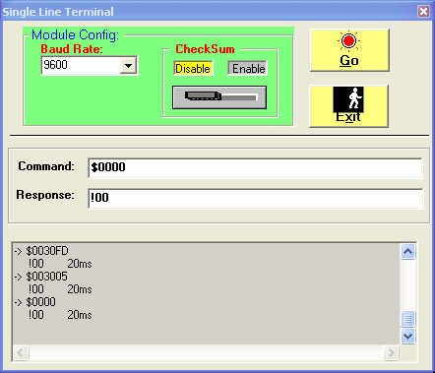
Figure 16. 0 mA calibration for module 0 output channel 0
- Set the value of the output channel to 20 mA. Refer to Table 2 for instructions.
- Trim the output by apply trim command until multimeter reading is 20.00 ± 0.03 mA. Refer to Table 2 for instructions.
- Enter 20 mA calibration command, when output has been trimmed. Refer to Table 2 for instructions.
- Repeat 1 to 13 for channels Iout1, Iout2 and Iout3.
- Analog output module is now calibrated.
Table 2. Analog output module commands
COMMAND NAME | SYNTAX
Set value | #AAN+CC.CCC
Apply trim | $AA3NVV
0 mA calibration | $AA0N
20 mA calibration | $AA1N
DESCRIPTION OF SYNTAX SYMBOLS
AA | address of output module (00 to 03)
N | number of output channel (0 to 3)
CC.CCC | output value in mA (e.g. 20.000)
VV | 2’s complement hexadecimal to trim the analog output value. 00 to 5F to increase 0 to 95 counts and FF to A1 to decrease 1 to 95 counts. Each count indicates 2.44 μA.

FrothMaster 2 software

Computing Unit’s software update

Saving CBS configuration
Before updating the software used CBS configuration should be printed or saved to a file. Log in to FrothMaster 2 configuration tool, WebFire, by writing the Computing Unit’s IP-address to the address bar of the FrothManagement station’s Internet browser. The user name and password are following:
- User name: administrator
- Password: froth
Print out following Webfire pages with a printer or print screen function:
- ROI area
- Configuration
- Network Settings
Or save CBS configuration to a file by selecting Save Configuration File -option from the Webfire. Download the configuration file called FM2SETTINGS from CBS hard-drive’s root folder to FrothManagement station by using ftp-client.
Shut down the Connection Box Set before updating the software.

Changing the software Flash Card
Computing Unit’s software is updated simply by replacing the old Compact Flash card with new one containing updated software. Compact Flash card is installed to the Computing Unit’s Compact Flash slot marked HD, see Figure 7.
Default network settings in new software Compact Flash card are following:
- IP-address: 192.168.2.101
- Subnet mask: 255.255.255.0
You may have to change FrothManagement station IP settings temporarily to same network as shown above. See Operating Manual for instructions. Temporary network settings for FrothManagement station can be following:
- IP-address: 192.168.2.1
- Subnet mask: 255.255.255.0
After that it is possible to change CBS network settings to same as they were with older software version. Change the FrothManagament station network settings back to normal as well.

Restoring saved configuration
After installation old configuration has to be restored to WebFire according to the printouts that were taken earlier or from the configuration file that was saved to FrothManagament station. When using printouts, see FrothMaster 2 Operating Manual for configuration instructions. When using saved file, use ftp-client to download the FM2SETTINGS configuration file from FrothManagament station to CBS root folder. Start the Webfire configuration tool and use Load Configuration File -option to load saved configuration to FrothMaster.

READER COMMENTS
The design team of Outotec is committed to ensure the quality and usefulness of this manual and the FrothMaster 2 analyzer system. Your comments, recommendations and suggestions will help make our continuous effort more effective.
Please take few moments to write your comments either directly on the form provided or on a photocopy of it.
Your assistance is greatly appreciated.
Thank you for choosing the FrothMaster 2 analyzer system.

Fax to: | Outotec, Analyzers  FAX: INT + 358 205 292998
or mail to: | P.O. Box 84, FI-02201 Espoo, Finland
or e-mail to: | analyzers@outotec.com
Attn: | Manager, Analyzer Sales Support
From:
Analyzer Serial Number:
Manual: | FrothMaster 2  Maintenance Manual  Code 10000002556e Revision B  ( Please identify applicable software versions and individual documents )
Comments / recommendations:
 | Number of additional pages ( )

