TITLE
FLOW SHEET and P&I D
INDEX OF THE REVISIONS
Number | Date | Description | Paragraphs updated | Pages updated
00  01  02  03 | 23/08/14  02/11/15  11/04/16  22/06/2016 | First issue  General review  General review  General review | All  All  All  All | All  All  All  All
DATE |  | by
22/06/2016 |  | Valerio Cardone – Paolo Serra – Roberto Corino – Ivano Menso
Index

1 INTRODUCTION 3
2 DIAGRAMS IN PROCESS ENGINEERING (BFD, PFD and P&ID) 3
3 BASIC RULES FOR DRAWING A DIAGRAM 3
3.1 BFD (Block Flow Diagram) 3
3.2 PFD (Process Flow Diagram) 4
3.2.1 Graphical representation and coding of equipment 5
3.2.2 Coding of equipment 5
3.2.3 Streams 8
3.2.4 Utilities 8
3.2.5 Information about streams and equipment 9
3.2.6 P&ID 9
3.2.7 Energy issues 10
3.2.8 Instrumentation Coding and Numbering 10
3.2.9 Instrument Position and connection 13

INTRODUCTION
A flow sheet is a pictorial description of a process. The level of the detail can vary from a simple block diagram to a full piping diagram, with instrumentation details.
The diagram identifies the process steps in sequence, and the level of the details shown should be appropriate for the intended use.
The symbols used in these diagrams to describe the instrumentation are sometimes conform to the standards of the Instrumentation, Systems, and Automation Society (ISA) Standard S5; however, due to the necessity to realize diagrams as much as possible close to actual plant, we tend to avoid an excessive schematization.
Other standards used for the representation of the P&ID (Piping and Instrumentation Drawing) are the BS 1646 (British Standards Institution) and DIN 28004 (Deutsches Institut für Normung).
The purpose of this document is to establish the standards to be used inside SIBELCO Europe for compiling a flow sheet (e.g. symbols, coding and description of the components, etc.) and the information to be included in the diagram, depending on the intended use.

DIAGRAMS IN PROCESS ENGINEERING (BFD, PFD and P&ID)

Diagrams provide a clear and reliable method to describe unambiguously a process,
There are three main diagrams normally used by engineers to design and describe the processes:
- Block Flow Diagram (BFD)
Starting from an input-output diagram, the process is divided in its main functional blocks (such as, for example: crushing section, washing section, drying section, etc…). Then the main streams and preliminary material balance are added.
- Process Flow Diagram (PFD)
The Process Flow Diagram, usually called “flow sheet”, is a more detailed pictorial description of the process, It included all the machines and equipment used in the process, their preliminary sizing, all the process stream and their values (usually the PFD is prepared when the detailed material balance has been completed).
- Piping and Instrumentation Diagram (P&ID)
It is also called Process and Instrumentation Diagram, or sometimes it id called Mechanical Flow Diagram, and it contains all the data required to start to design the process. It includes the specific description of the process machines and the instrumentation.
P&IDs are the “schematics” used in the field of instrumentation and control (Automation) generally. This document is used by field technicians, engineers, and operators to better understand the process and how the instrumentation is interconnected.

BASIC RULES FOR DRAWING A DIAGRAM

BFD (Block Flow Diagram)

- The operations are indicated by blocks.
- The main streams are identified by lines with arrows indicating the direction of flow.
- The flow of the streams is from left to right, if possible.
- Light streams (gas) are usually upward, heavy streams (liquid and solid) are down the blocks representing the individual portions of the plant.
- The diagram must provide basic information of the process.
- In case of intersecting lines, the process horizontal lines are kept constant while the vertical lines are interrupted.
- The diagram provides simplified material balances and reactions or interactions.

The following picture shows an example of simplified BFD: | 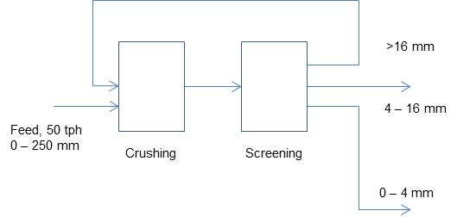
 | Image 1 – Block Flow Diagram (BFD)

PFD (Process Flow Diagram)

The Process Flow Diagram, or flow-sheet is certainly the most important and diagram used to describe an appropriate level of detail the structure of a process.
There is not a nomenclature defined and universally accepted, but in general, however, a PFD contains the following information:
- It must show all the equipment, with a brief description and indication of the most important connections.
- Each equipment is represented by a symbol (icon) and identified by a code, with a number.
- All the process streams are shown and identified with a number.
- Process streams conditions and compositions are shown (directly in the PDF, or in an attached summary table).
- All the major control loop are shown.
- All the utility equipment are shown.

in short, the PFD must provide:
- the topology of the process (location and interaction of equipment and currents),
- the description of the streams
- the description of the equipment

The following picture shows an example of PFD:
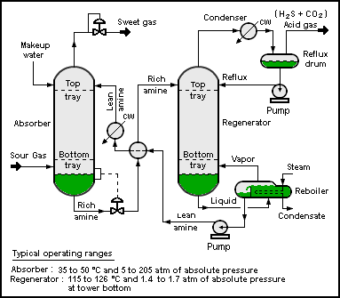
Image 2 – Process Flow Diagram (PFD)

Graphical representation and coding of equipment
Equipment and devices are represented by icons.
The ASME (American Society of Mechanical Engineers) periodically publishes a list of symbols used in the production of the PFD.
Nevertheless the use of customized symbols is widespread, and each company or engineering firm can sometimes adopt its own specific symbols that make somehow distinguishable and recognizable their PFD from those of other companies.
The graphic symbol may still differ slightly, depending on the tool utilized for drawing (i.g. flow-sheets generated through a process simulation program like USIM PAC, by Caspeo, or FSSM, or other spreadsheets) or on the engineering company that designed the PFD.
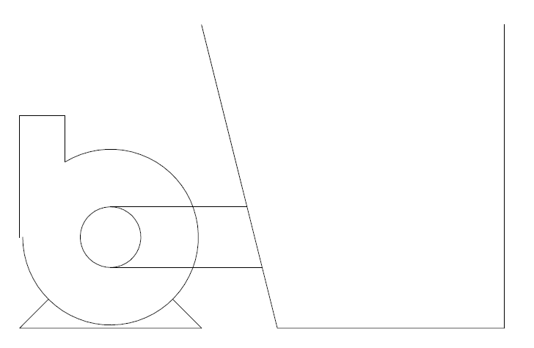 | 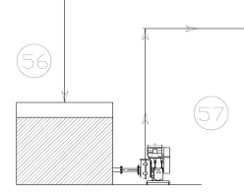 | 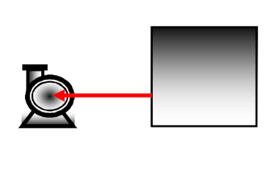
Image 3 – Graphical representation of a sump pump

We attach to these guidelines a collection, in dwg format, of the main symbols commonly used in SIBELCO, in the compilation of PFD.

Coding of equipment
For the identification of the device or equipment, it is necessary to use a “label” or “Tag Name”, that is a code consisting of two-three letters (usually the initials of the name of the device in English) followed by a number.
The following tables (Image 3) show a list of names of machines and devices commonly used:
Tag Name
  Description
  AC- | air compressor
  AD- | air dryer
  AF- | air filter
  AL- | air lift
  AS- | air slide
  AV- | automatic valve
  BC- | belt conveyor
  BE- | bucket elevator
  BL- | blower
  BN- | bin
  BU- | burner
  CO- | cooler
  CY- | cyclone
  DF- | dewatering filter
  DI- | diverter
  DR- | dryer
  DS- | density separator (hydrosizer)
  FA- | fan
  FE- | feeder
  FI- | filter
  HO- | hopper
  HV- | hand valve
  LB- | loading bellow
  MI- | mill
  MS- | magnetic separator
  MV- | motorized valve
  OH- | overhead crane
  PU- | pump
  RV- | rotary valve
  SC- | screw conveyor
  SU- | sump
  VS- | vibrating screen
  Tag Name | Description
  BW- | belt weigher (scale)
  FI- | flow indicator
  FT- | flow transmitter
  HS- | trip switch (pulpkeys)
  LA- | level alarm
  LI- | level indicator
  LSH- | level switch high
  LSL- | level switch low
  LT- | level transmitter
  PdT- | differential pressure transmitter
  PI- | pressure indicator
  PS- | pressure switch
  PT- | pressure transmitter
  SSL- | speed sensor low
  TI- | temperature indicator
  TT- | temperature transmitter
  ZS- | position switch
  ZSC- | position switch closed
  ZSO- | position switch open
 | Image 4 – Tag Names

For the device numbering, different systems can be used: or the serial number of the device, distinguished by type, or a progressive number within a section of the plant.
In the event of changes to existing plants it will be necessary, of course, to comply with the numbering system in use in the site, but in the case of new plants, we strongly recommend that you follow these rules.
In terms of coding standardization within Sibelco Europe, below a coding procedure is suggested. The machine or device is identified by a 13-digit number, according to the following coding:
- SITE: composed by 2 letters per site;
- PRODUCTION UNIT (PU): composed by 2 letters per production unit per site;
- NAME/SENSOR (SENS): composed by 4 letters per device or sensor;
- ZONE: composed by 1 number (from 1 to 9) identifying zones inside each production unit;
- NUMBER (NUM): composed by 2 numbers (from 01 to 99) identifying each device per zone and per production unit;
- SENSOR NUMBER (S. NUM): composed by 2 numbers (from 01 to 99) identifying each element connected to main device (digital sensors, digital output, analog signals, etc.) per zone and per production unit.

The following picture (image 5) explains the encoding used.
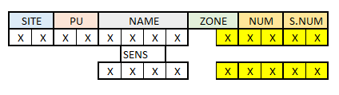Image 5 – Code numbering
The aim of the coding is to provide an unambiguous tag name relevant for P&IDs, electrical drawings, PLC blocks, SCADA tags and operator messages.

Streams
All the process streams are shown in the PFD and identified by a number, corresponding to the sequence number utilized in the mass balance calculation.
The stream direction is indicated by means of an arrow.
Someone prefers to indicate in the PFD only the number of the stream and enclose to the PFD a table extracted from the mass balance sheet, with the stream description (condition and composition).
For completeness of information and immediate understanding of the process, it is probably advisable and more appropriate to indicate these information already in the PFD itself.
Example:  For a stream we can use | or
  TPH | m³/h PULP
  % SOLIDS | m³/h WATER
  Total volume m³/h
  Stream
  #
  Sand Capacity TPH
  Water Flow m³/h | Density t/m³
For a machine/device:
Basic issues | 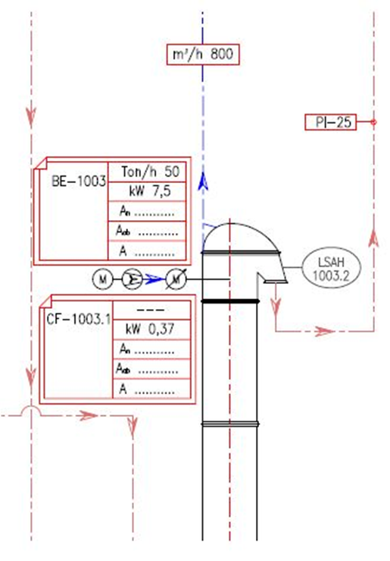
  Type | Tag Name
  Power (kW) | Tag Name
  Rated Current value(A) | Tag Name
  No Load current value (A) | Tag Name
  Full load current rating (A) | Tag Name
Image 9 – Basic issues
Please always specify in the PFD legend the convention utilized.

Utilities

The utility can be: electricity, compressed air, cooling water, chilled water, steam, condensate, inert gas, sewer chemical, water treatment and torches.
Some examples of symbols usually adopted for utilities are:

- Lps low pressure steam 3-5 barg (sat)
- Mps medium pressure steam 10-15 barg (sat)
- Hps high pressure steam 40-50 barg (sat)
- Htm heat transfer medium (organic): to 400°C
- Cw cooling water: from cooling tower 30°C returned at less than 45°C
- Wr river water: from river 25°C returned at less than 35°C
- Rw refrigerated water: in at 5*C returned at less than 15°C
- Rb refrigerated brine: in at -45°C returned at less than 0°C
- Cs chemical waste water
- Ss sanitary waste water
- El electric energy (specify 220, 380 , 440, 660V service)
- Ng natural gas
- Fg fuel gas
- Fo fuel oil
- Fw fire water

Information about streams and equipment
Further information that must be included in the PFD are:
- A summary table containing the essential data of the steams.
- A summary table with the list of equipment and their main characteristics.
These data represent the starting point for the detailed design.
Example:
Equipment type | Description of the equipment
Heat Exchangers | Type: gas-gas, gas-liquid, liquid-liquid, Condenser, Vaporizer  Process: Duty, Area, Temperature and Pressure for both streams  Number of shell and tube passes  Materials of construction: shell and tubes
Tanks, Vessels | Height, Diameter, Orientation, Pressure, Temperature, Materials of construction
Pumps | Flow, Discharge, Pressure, Temperature, ΔP, Driver type, Shaft power, Materials of construction
Compressors | Actual inlet flow rate, Pressure, Temperature, Driver type, Shaft power, Materials of construction
Others | Provide critical information

P&ID
The Piping and Instrumentation, or Process and Instrumentation Diagram, is certainly the most important and diagram used to describe an appropriate level of detail the structure of a process.
It contains the data needed to start the design and realization of the plant. For each equipment in it are given mechanical and functional data.
It is necessary to specify:
For Equipment, show every piece including: | Summary detail on each unit
For piping, include all lines including Drains, and specify: | Size (standard), Thickness, Materials of construction, Insulation (thickness and type)
For instruments, identify: | Indicators, Recorders, Controllers, Show instrument lines
For utilities, identify: | Entrance utilities, Exit utilities, Exit to waste treatment facilities

Usually the following information are not included in the P&ID:
- Operative conditions: T and P
- Streams values
- Position of equipment
- Piping: Length and filling
- Supports, structures and foundations.

Energy issues
Information contained on a flow-sheet can be further completed, adding energy data to help energy team during waste-walk.

In fact, the following information can be added manually after the kick-off of the plant:
- Rated current value
- No load current value
- Full load current rating

For an easier management of project documents, we recommend organizing various types of information on different layers.

Type | Tag Name
Power (kW) | Tag Name
Rated Current value(A) | Tag Name
No Load current value (A) | Tag Name
Full load current rating (A) | Tag Name
Energy Issues

Image 10 – Energy issues

Instrumentation Coding and Numbering
For the coding and numbering of the process instrumentation, the reference standard normally used in the Process and Instrumentation Diagram is ANSI/ISA S5.1-1984 (R 1992) "Instrumentation symbols and identification" standard.
The code consists of a combination of letters and a succeeding number as a unique identification of the actual instrument. The numbering practice varies - some use a sequential number, others use a number related to the process stream number or similar:

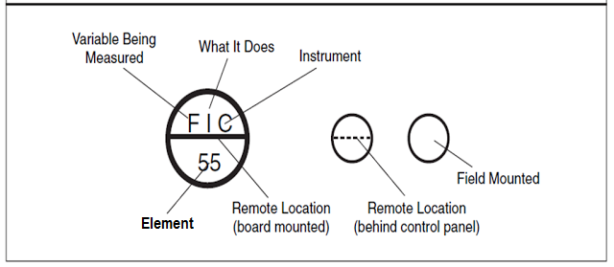

First letter indicates a measured or initiating variable, or a modifier, such as Current (I), Speed (S) or Flow (F).
Second or succeeding letters indicates a readout or passive function, output function or a modifier function.

In the following tables we list the letters used in the codes composition and their meaning.
First Letter | Second or succeeding letters
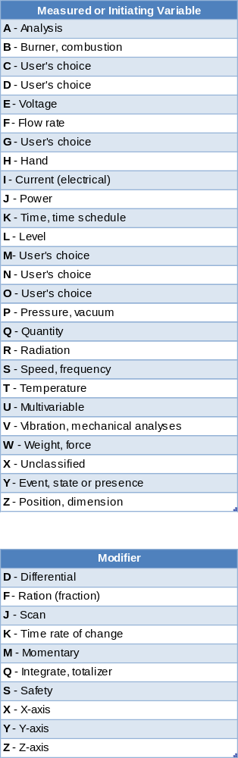 | 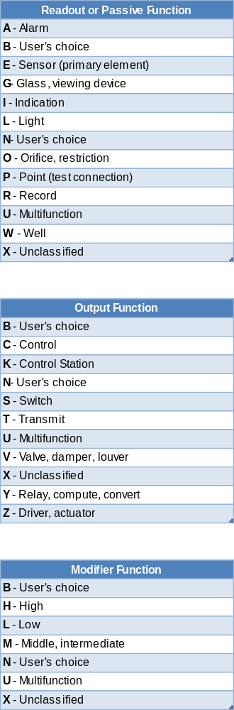

Here, in the following page are some examples of instrumentation coding.

Control instrument | PC (Pressure Controller),  PRC (Pressure Recorder Controller),  PIC (Pressure Indicator Controller)
Controller with valve | PVC (Pressure Valve Controller)
Reading devices | PR (Pressure Recorder)  PI (Pressure Indicator)
Switches | PSH (Pressure Switch High)  PSL (Pressure Switch Low)  PSHL (Pressure Switch High/Low)
Alarm Devices | PAH (Pressure Alarm High)  PAL (Pressure Alarm Low)  PAHL (Pressure Alarm High/Low)
Transmitter | PT (Pressure Transmitter)  PIT (Pressure Transmitter with Indicator)  PTR (Pressure Transmitter with Recorder)
Sensors | PE (Pressure sensor)
Actuators | PV (Pressure Actuator)

The number after the letters is usually the number of the control loop.
Numbering can be in parallel (the letter changes until a repetition):
TIC-100, FRC-100, LIC-100
or in series (the numbers are in sequence):
TIC-100, FRC-101, LIC-102

Instrument Position and connection
The graphic symbol used allows us to understand where the instrument is placed.
 | Remote location (board mounted)
 | Remote location (Behind Control Panel)
 | Field Mounted
If the instrument is integrated inside a DCS system (Distributed Control System) or a PLC (Programmable Logic Controller) the following symbols are used:
 | DCS |  | PLC

To define the type of connection or signal, we normally use the following graphics:
 | Not defined signal
 | Pneumatic signal
 | Electrical signal
 | Hydraulic signal
 | Internal connection (for example a software connection, inside the PLC)
Example:
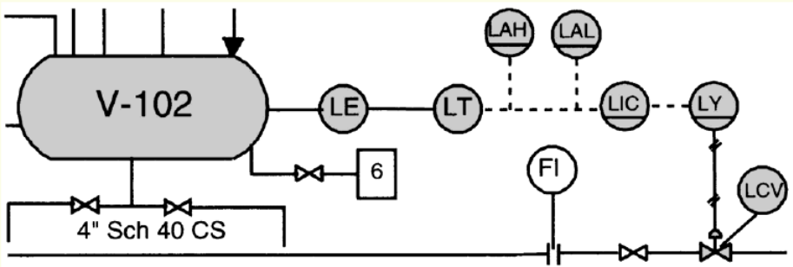
Structure of the level control loop for tank V-102:
LE level sensor positioned on the tank V-102
LT level transmitter placed on the tank V-102 (signal sent via an electrical signal to the control room)
LIC level indicator and controller in the control room (sending an electrical signal to the instrument LY)
LY instrument that can calculate the exact valve opening (Sending a pneumatic signal (solid line) to the control valve LCV)
LAH level alarm high in the control room (front panel)
LAL level alarm too low in the control room (front panel)

