- Simple Reports

TABLE OF CONTENTS

Chapter 18 Simple Reports 1
18.1 General Information 2
18.1.1 Objectives 2
18.1.2 Legend 2
18.1.3 Reference Documentation 2
18.2 Data Direct 3
18.2.1 Introduction 3
18.2.2 Set Up for Every User 3
18.2.3 User Interface in MS Excel 7
18.3 Reports 8
18.3.1 Common Controls 8
18.3.2 Reports with Process Data 9
18.3.3 Reports with Historical Data 10
18.3.4 Reports with Alarms and Events 11
18.4 Scheduled Reports 12
18.4.1 Report Templates 12
18.4.2 Scheduling Reports 13
18.4.3 Running Jobs 16

  - General Information
    - Objectives
On completion of this chapter you will be able to:
- Create simple reports based on MS Excel Data Access
- Setup a scheduled task to generate scheduled reports

    - Legend
> Indicates when you go from one menu to a sub-menu
Italic Indicates object and file names
“ “ Indicates dialog box buttons, tabs, menus etc.
Bold Indicates important topics
Indicates start/explanation of student activity

    - Reference Documentation
3BUF001094 Industrial IT 800xA – Data Access and Reports
  - Data Direct
    - Introduction
Data Direct (Excel Data Access) is an add-in for Microsoft Excel designed to retrieve data (real-time data, historical values, lab data, batch information, and event information) from System 800xA.
This functionality is one of the basic system functionalities, although it is part of the Information Management software package. This means that it can be installed along with the core system without installing IM, and that it doesn’t require additional licensing. Nevertheless when installed in systems with IM some of its features are enhanced (data access from non 800xA nodes, extended amount of historical values, etc).
Data Direct can run in any system node.
    - Set Up for Every User
      - Configuring the Add-In
The Data Direct add-in is integrated into Microsoft Excel on a user-basis. It is automatically available for the user that performed the 800xA software installation, but it must be explicitly added for any other users (on a node by node basis).
It is mandatory to perform this procedure for the service account since this account is used for scheduled reports.
- Log on as the desired user and start MS Excel.
- Select “Tools” from the menu and click on “Add-Ins”
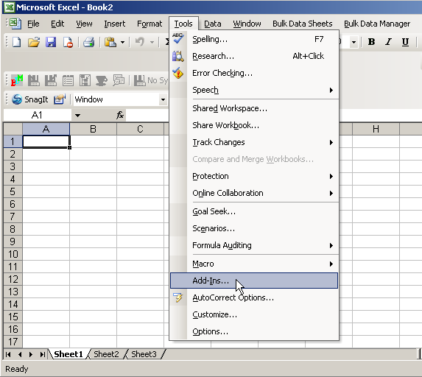
- Click “Browse” and browse to C: > Program Files > ABB Industrial IT > Inform IT > Data Direct > Bin.
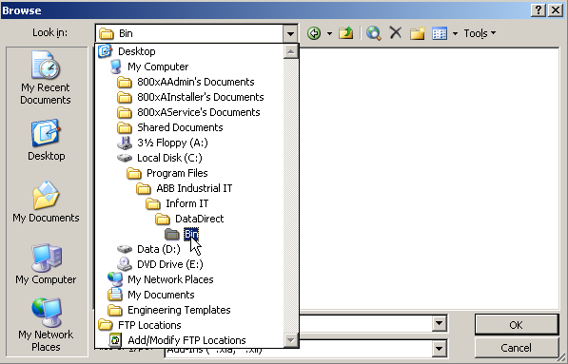
- Select the ABBDataDirect.xla add-in and click “OK”:
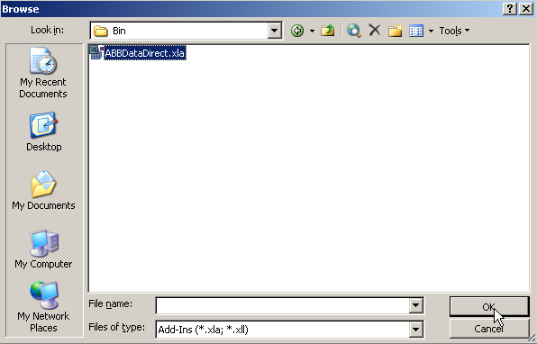
- Click on the “DataDirect” checkbox
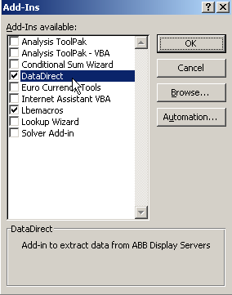
- Once the add in is enabled, the Data Direct toolbar will be available.
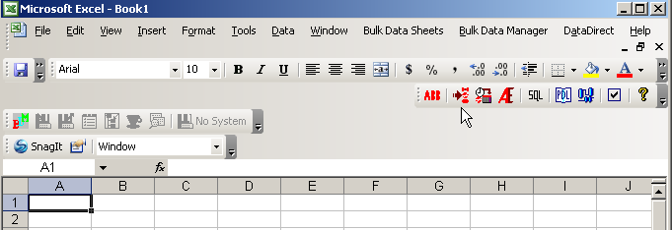

      - Security Settings
In order to enable the Data Direct macros the security level must be changed to low. This procedure has to be followed for every user and every node where Data Direct is going to be run.
- Select “Tools” from the menu and click on “Macro”.
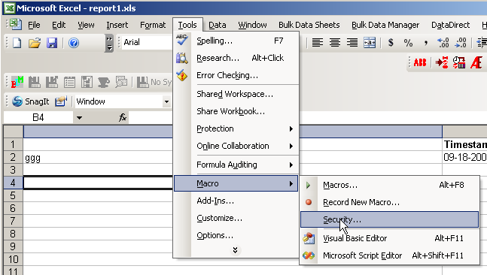
- Go to the “Security Label” tab and select “Low”
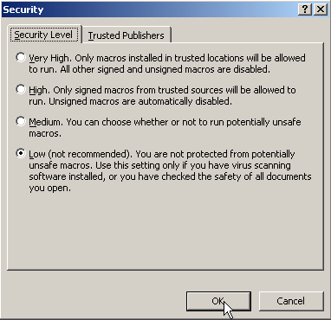
      - Calculation Strategies
The retrieval of system data is performed by executing Data Direct functions in the Excel environment. These executions are calculations and by default the system is set to calculate automatically.
In the case of Data Direct this behavior could be negative, since automatic calculation updates the contents of the tables when the file is opened. To avoid this, the calculations need to be configured as “Manual”.
- Go to “Tools > Options”
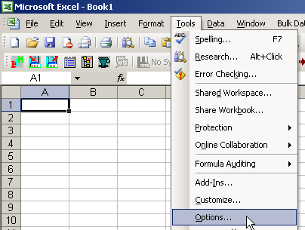
- In the Calculation tab select “Manual”
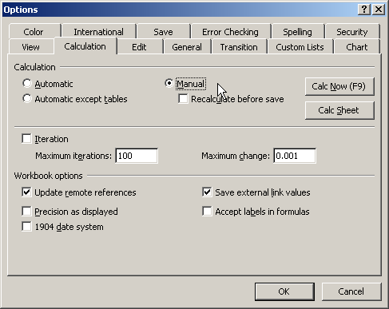
    - User Interface in MS Excel
The system information is accessed through programmable functions in MS Excel. These functions can be invoked manually or by accessing the Data Direct interactive tools. To do so open the “DataDirect” menu or click on the DataDirect Toolbar buttons.

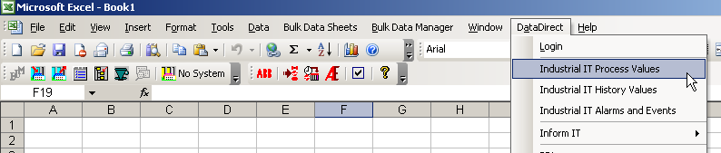

Button | Function
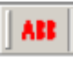 | Same as accessing the menu DataDirect > Login. Logging is only required when retrieving data remotely from a non 800xA node
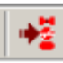 | Same as accessing the menu DataDirect > Industrial IT Process Values. It opens the real time data access dialog
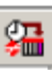 | Same as accessing the menu DataDirect > Industrial IT History Values. It opens the historical data access dialog
 | Same as accessing the menu DataDirect > Industrial IT Alarm and Events. It opens the alarm and events data access dialog
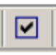 | Access the options menu to define how the data is going to be presented, or which functionalities are to be available in the menu or the toolbar.
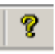 | Show the Help

  - Reports
Data Direct is mainly used to create reports. These can be created as:
- one time reports to show and store data from the instant they were created
- reusable reports to allow the user to reload the enclosed data when required
Operators can view reports from their Operator Workplaces by simply browsing report archives via the Plant Explorer. Reports can be automatically generated and sent to multiple output destinations such as printers, files etc.
    - Common Controls
Data Direct functions can be manually typed into the worksheet cells or they can be invoked by using Data Direct dialogs. Dialogs help the user find the information within the system structure and define the way the data is going to be presented.
There is one dialog for each type of report (process data, historical data and alarm & events), but they all share a set of common controls:
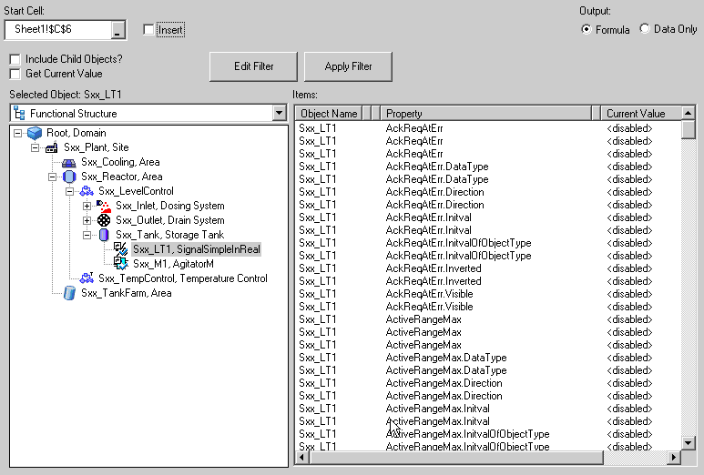
Filter Options
Item List
The “Start Cell” input field defines the cell position where the result data will be filled. If the “Insert” checkbox is selected, instead of filling the cells new rows will be inserted.
The “Output” options are used for:
- “Formula” = the destination cell will be filled with the function required to retrieve the specified data. This means that if a calculation is executed the data will be updated.
- “Data Only” = the numeric value of the property at the moment of configuration will be written in the cell, and it cannot be modified by a calculation.
The “Item List” will show the available information for the selected object. The contents of this list will change according to the data type:
- Process Data will show every OPC property
- Historical will show only the properties that are being logged by a Log Configuration aspect
- Alarm and Events Dialog will show only the Alarm & Event lists and alarm lines
It is recommended to avoid using the “Get Current Value” option, since it delays the population of the table.
    - Reports with Process Data
A Process Data report is used to get real time values from the system. The Process Data dialog can be accessed by clicking on the “IIT Process Value” button.
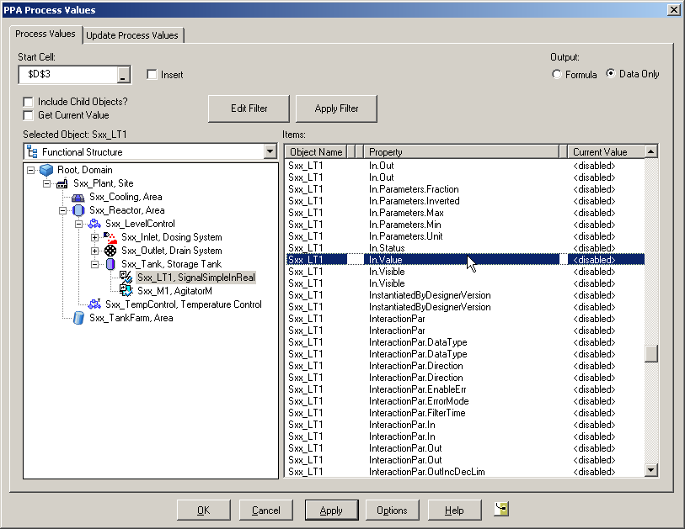
In the following example the In.Value property of the object Sxx_LT1 was selected, and in the output options the object name and timestamp were enabled.
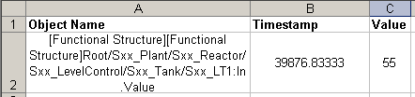
    - Reports with Historical Data
A Historical Data report is used to show historical values of a property. The Historical Data dialog can be accessed by clicking on the “IIT History Value” button.
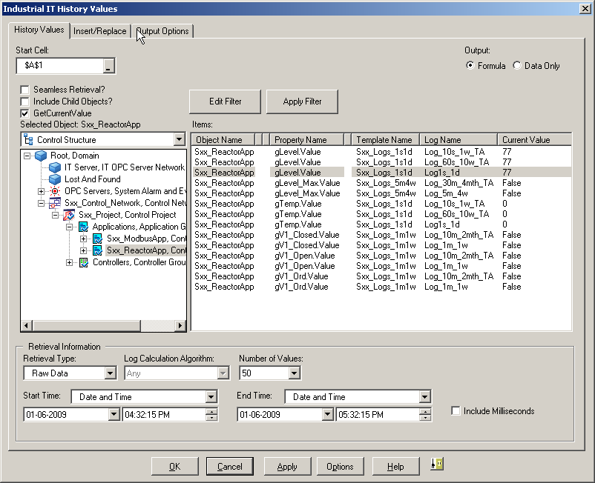
If a property is being logged using different logs they will be available to be chosen.
The “Retrieval Information” section defines how the historical data is going to be treated before being added to the report:
- “Raw Data” = only the first points in the time window will be included
- “Interpolated Data” = the user can select a calculation algorithm (for example time average) to process all the points in the time window and reduce them to the amount of points defined by “Nr of Values”
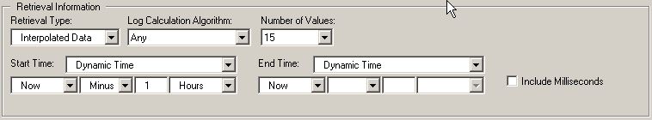
If the “Start” and “End” times are static, the report will always show data from that fixed time window. If they are dynamic the time window will be relative to the calculation time, so the data will change for every calculation.
    - Reports with Alarms and Events
An Alarm and Event report is used to show historical events from an alarm & event list or alarm line. The Alarm and Event dialog can be accessed by clicking on the “IIT History Value” button.
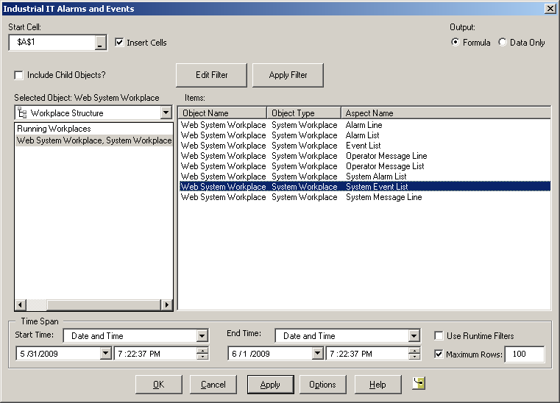
The time span needs to be specified like the time window for historical data).
- Exercise 18.1
  - Scheduled Reports
The 800xA’s scheduling functionalities can be used to execute reports, among other operations. To do so a job needs to be created. This job will execute an action which will use a report template created using Data Direct. A schedule will define when the job executes the report action.
It’s basically the same concept as scheduling a project backup, what you have learned in previous courses.

    - Report Templates
Whenever the report job is executed it searches for a report to use as template. There are two ways to use a template: as a windows file or as a system object. The first option is simpler, but the second one improves the maintenance of the template (allows versioning, saves the template in the Full Backup), etc.
The report templates are generic type objects located in the Scheduling Structure under the Reports object.
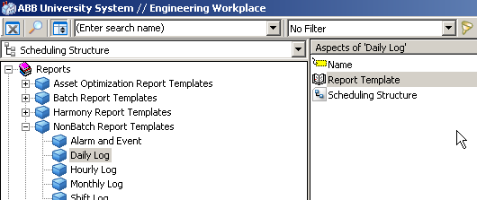
Each report has a File Viewer aspect that attaches the 800xA system object with windows files.
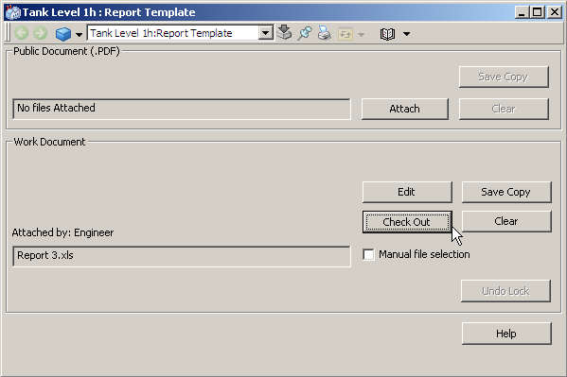
The “public document” is the file shown by the File Viewer’s “Main View”, while the work document is the file that is going to be linked to the report template object.
    - Scheduling Reports
Scheduling of reports is implemented as Job Description objects which are created in the Scheduling Structure (one schedule per job). Every report job description must contain an Action and a Scheduling Definition aspect to define what to do and when to do it.
- Add a new object to the Scheduling Structure under Schedules and Jobs.
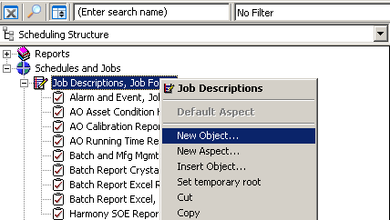
- Add an Action aspect to the newly created job.
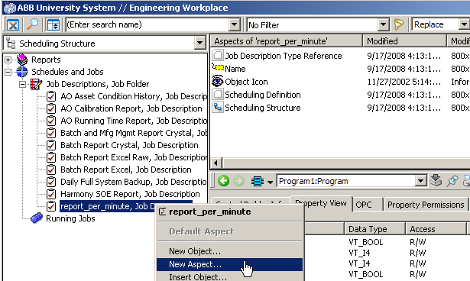
- The Action aspect has to be configured to execute a report.
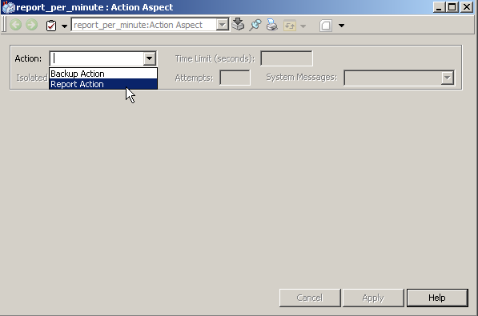
- Define the report template path and choose “Windows files”:
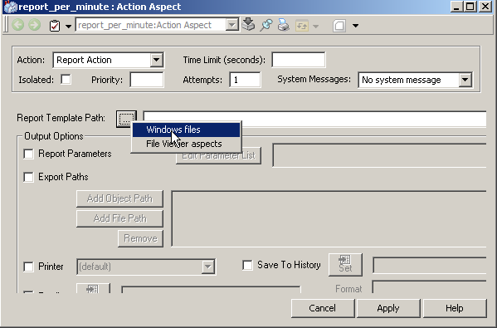
- Browse to the report template and click “Open”.
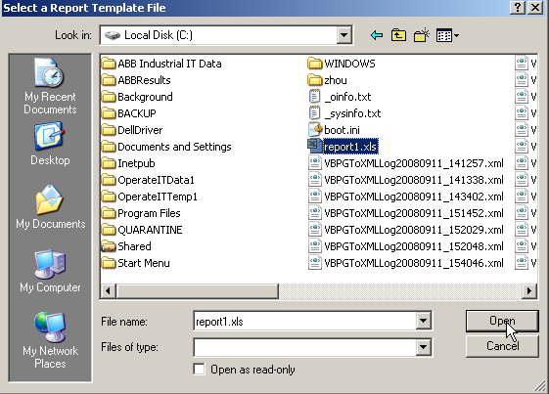
- Define the output options: save the reports as files, sent them directly to a printer or send them as e-mails.
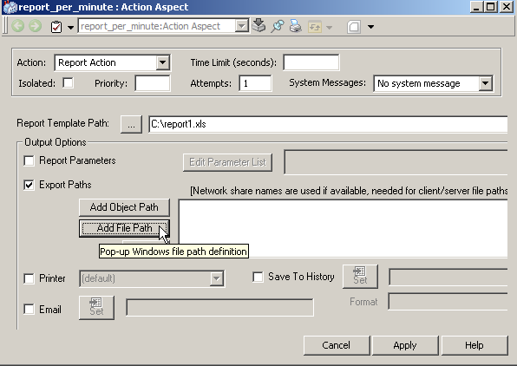
- Define report files paths and the max. number of files. The path can be defined to include the timestamp in the format C:\filename <TimeStamp>.xls.
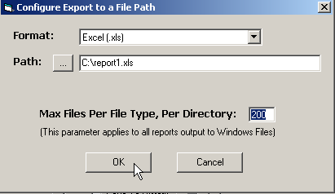
The path is the local disk on the node where the Scheduler Service is running.
- Select the Scheduling Definition aspect of the job object.
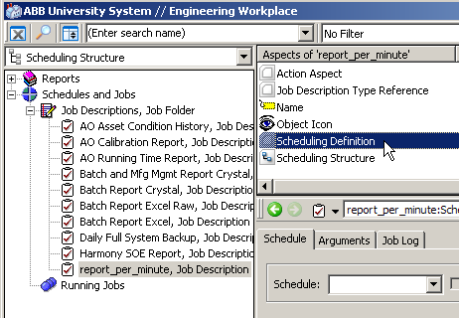
- The job can be configured to run with any frequency or to be triggered by an expression. A time window can also be set up to be the only moment in which the job can run. The schedule must also be assigned to a Scheduler Service Group.
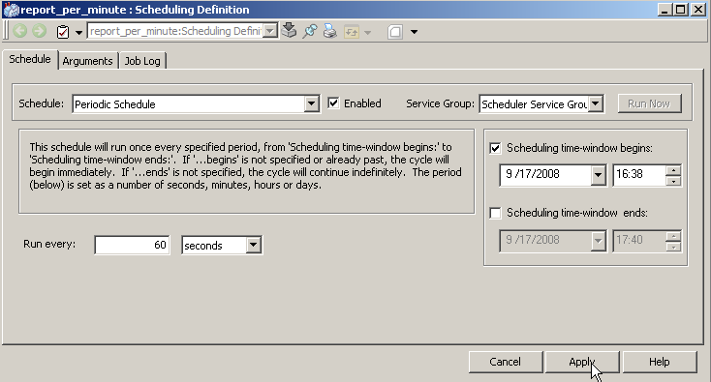
    - Running Jobs
Jobs run when they are scheduled to do so or when they are manually run by pressing the “Run Now” button on the Scheduling Definition aspect.
When a job is running a Running Job object is automatically created under Running Jobs in the Scheduling Structure. When the job is finished this object disappears.
The status of the job can be identified by its icon color:
- Green: Running / Paused
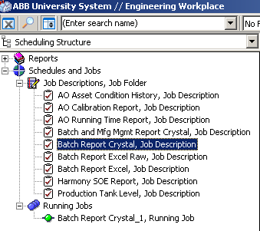
- Blue: waiting to be executed
- Red: failed
(if a job fails a log is available to find out the reason)
