6/06/2012 14:27
De DAT sheet is niet bijgehouden.
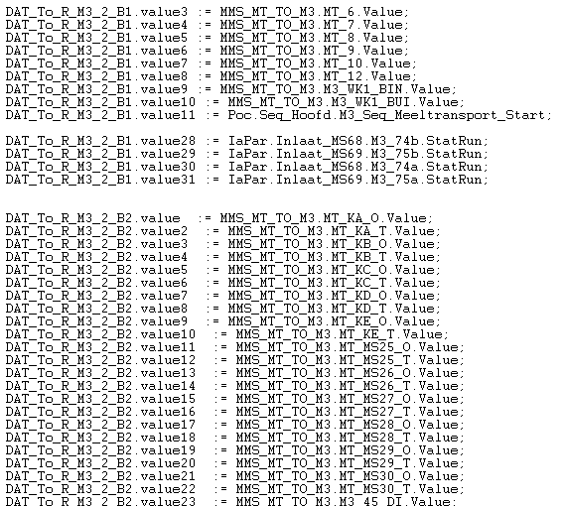
M3 AC800M | Sibelco AC450 | R_M3_2 | DS29 | DAT129 | B1.val | pc14.7.9.1:1
M3 AC800M | Sibelco AC450 | R_M3_2 | DS29 | DAT129 | B1.val2 | pc14.7.9.1:2
M3 AC800M | Sibelco AC450 | R_M3_2 | DS29 | DAT129 | B1.val3
M3 AC800M | Sibelco AC450 | R_M3_2 | DS29 | DAT129 | B1.val4
M3 AC800M | Sibelco AC450 | R_M3_2 | DS29 | DAT129 | B1.val5
M3 AC800M | Sibelco AC450 | R_M3_2 | DS29 | DAT129 | B1.val6
M3 AC800M | Sibelco AC450 | R_M3_2 | DS29 | DAT129 | B1.val7
M3 AC800M | Sibelco AC450 | R_M3_2 | DS29 | DAT129 | B1.val8
M3 AC800M | Sibelco AC450 | R_M3_2 | DS29 | DAT129 | B1.val9
M3 AC800M | Sibelco AC450 | R_M3_2 | DS29 | DAT129 | B1.val10
M3 AC800M | Sibelco AC450 | R_M3_2 | DS29 | DAT129 | B1.val11
M3 AC800M | Sibelco AC450 | R_M3_2 | DS29 | DAT129 | B1.val12
M3 AC800M | Sibelco AC450 | R_M3_2 | DS29 | DAT129 | B1.val13
M3 AC800M | Sibelco AC450 | R_M3_2 | DS29 | DAT129 | B1.val14
M3 AC800M | Sibelco AC450 | R_M3_2 | DS29 | DAT129 | B1.val15
M3 AC800M | Sibelco AC450 | R_M3_2 | DS29 | DAT129 | B1.val16
M3 AC800M | Sibelco AC450 | R_M3_2 | DS29 | DAT129 | B1.val17
M3 AC800M | Sibelco AC450 | R_M3_2 | DS29 | DAT129 | B1.val18

6/06/2012 16:01
Niveaumetingen zitten nog in programma Bunkers_M5
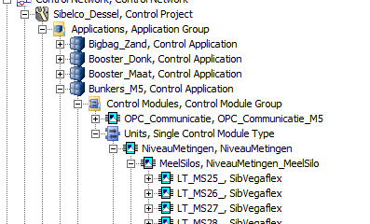

6/06/2012 16:06
Documentatie sequenties niet gevonden in public Elektrische dienst. Ook niet in 800xA. Enkel te bekijken via SFC.

6/06/2012 16:18
M3_46, M3_47, M3_48 nog in Advant ? Zitten nog wel onder Advant in 800xA.

