Feedback / Questions / Suggestions: ProcurementCOE@Sibelco.com

SAP – Default settings for users (Procurement)
This work instruction will instruct you on how to set defaults for your Purchase requisition creation so that you don’t need to fill in the information each time you raise a PR. This is especially beneficial when you create requisitions with more lines.
It will also ensure, when you buy from price agreements / catalogues (Internal or Supplier Hosted: punch out) that when you have selected what you need and in addition have the correct defaults set – you could submit your purchase requisition immediately. We always recommend that you check on delivery date.
Defaults are making your requisitioning easier, and you can always overwrite a default value when it is to be changed for a certain purchase requisition, e.g. plant or cost center – anything can be changed.
Please note: when you have a default like cost center, and you want to order some stocked items: then please review and change a PR to avoid they are immediately costed against your cost center.
- Using the app – Default Settings for Users (Procurement)
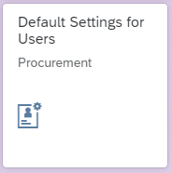

- First you will be asked to enter your User ID (Your user ID is what you normally log in with e.g. KOVANG00)



- Then you need to select the User ID that is found by clicking on the arrow (highlighted red below)

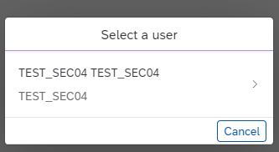

- You are then taken to the page where you can set your default information. First you will need to select ‘Edit’ in the bottom right hand corner to enable you to add the information you want to.
Defaults that maybe useful to set:
- Plant (you order mainly for)
- Company code
- Currency (if you always use a common currency for your purchases)
- Purchasing Group (if you frequently buy for the same purchasing group)
- Purchasing Organisation
- Account Assignment Category (often K for cost centre)
- Cost Centre (the one you use most. You can overwrite if needed during requisitioning)
Here is an example of a user with default settings:
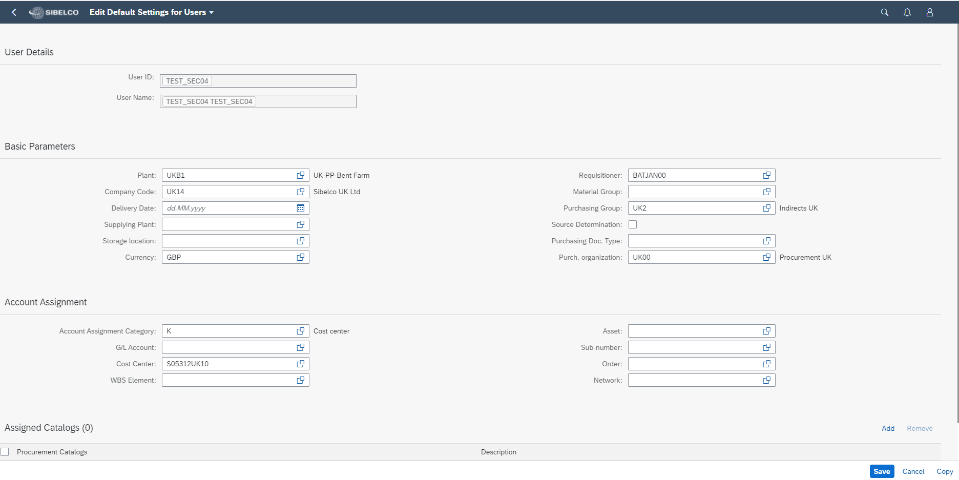
Please note: you can enter your default Requisitioner details but this is currently not working to carry through to your PR creation.
If you enter this information, once the default setting is corrected for this field you will notice your Requistioner details defaulting to your PR lines.
Requisitioner details is no longer a mandatory field BUT with this information provided it can be used for reporting purposes.
- When you create a PR you will see your default information populated in the fields:
- Plant was defaulted to UKB1
- Account Assignment Category was defaulted to K

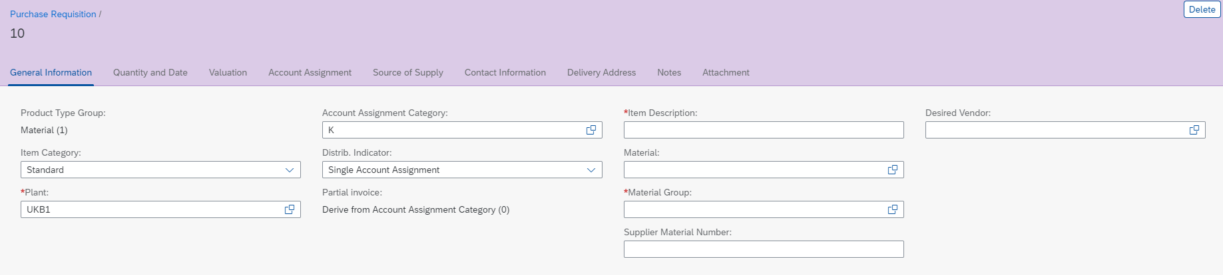

CREATE PR FROM A PUNCHOUT
Only for NON stocked materials – online platform supplier ‘webshop’
- Open Manage Purchase Req Professional

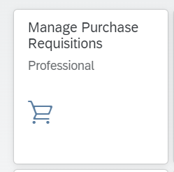

- Create

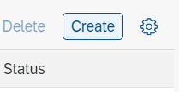

- Change your settings

We click on the icon settings (you only need to do this one time). And change the view /add more columns

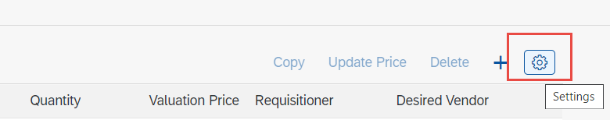

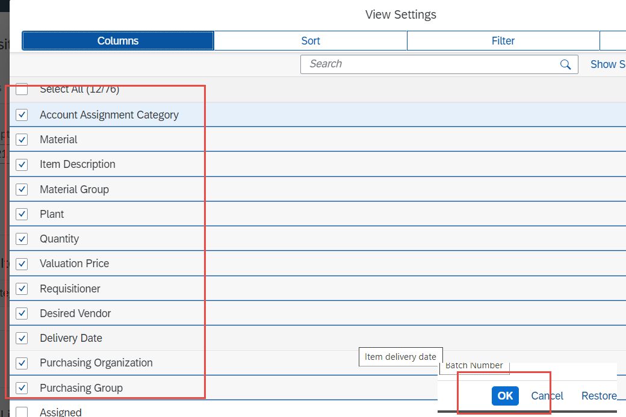

- Click on ‘+’ and Items from External Catalogs

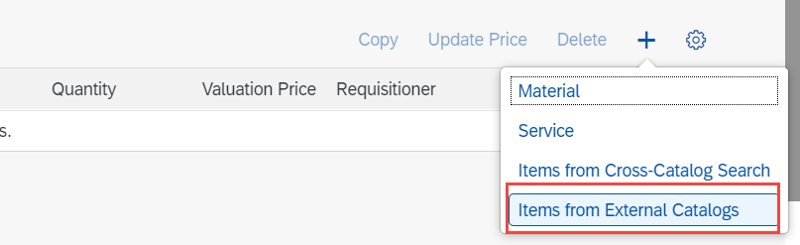

- Search for the catalogue + move the items in your basket (every punchout view is different)
- Transfer your basket to SAP
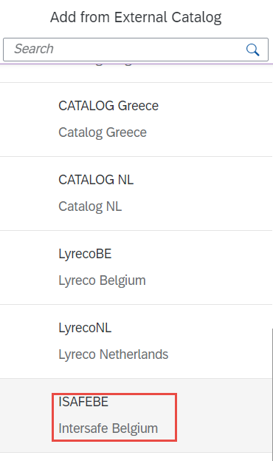
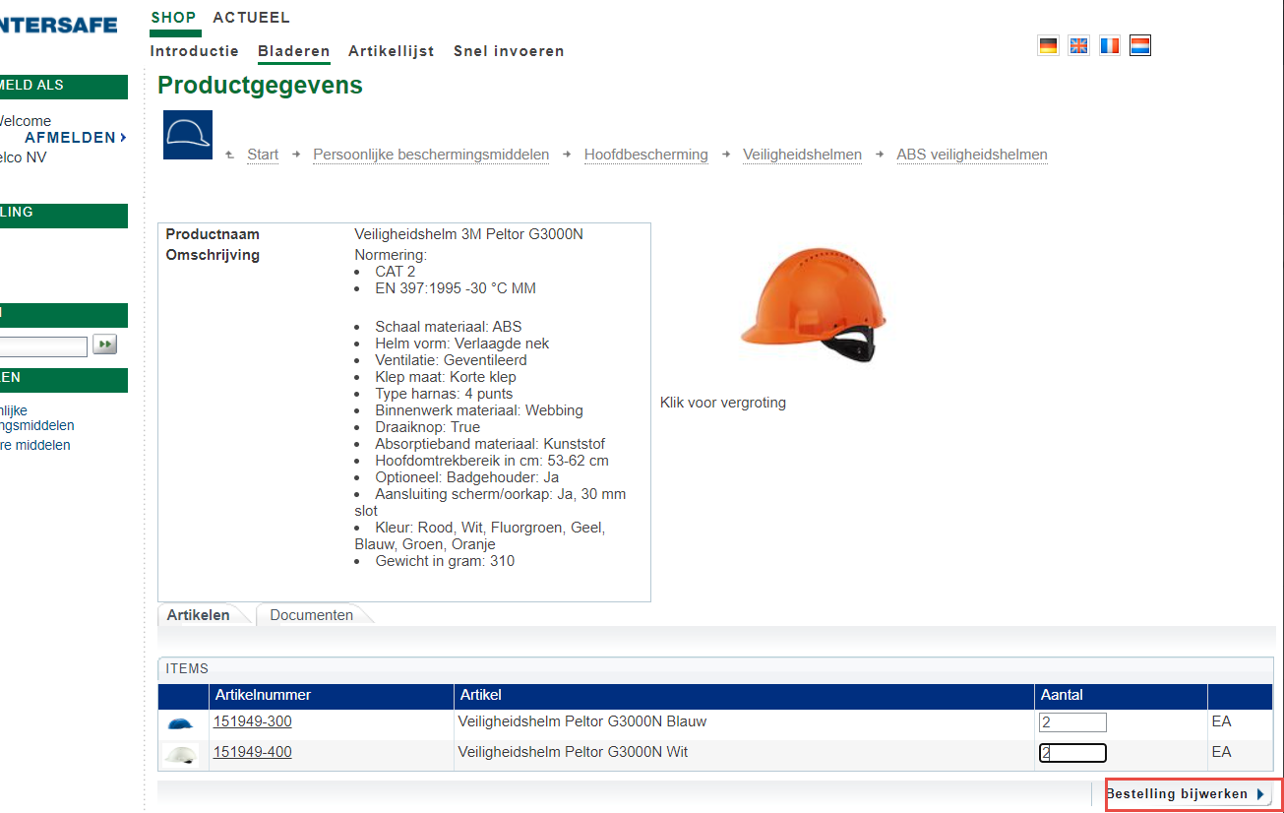

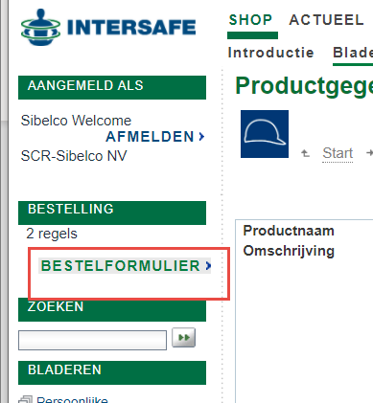

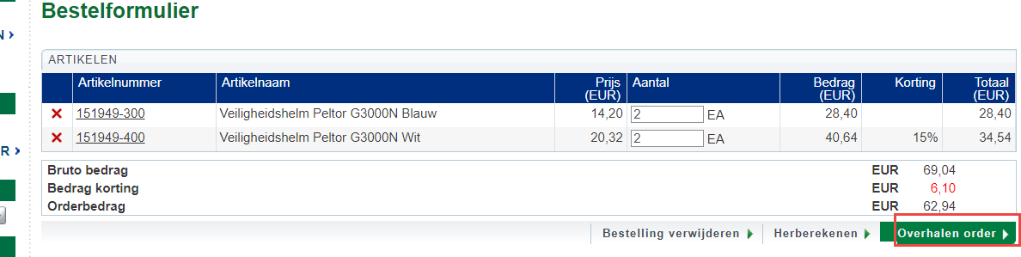

- Complete the order
Do not fill in the field of ‘Material’!
Purchase Request is filled with info of punchout + default settings
Requisitioner field is not mandatory
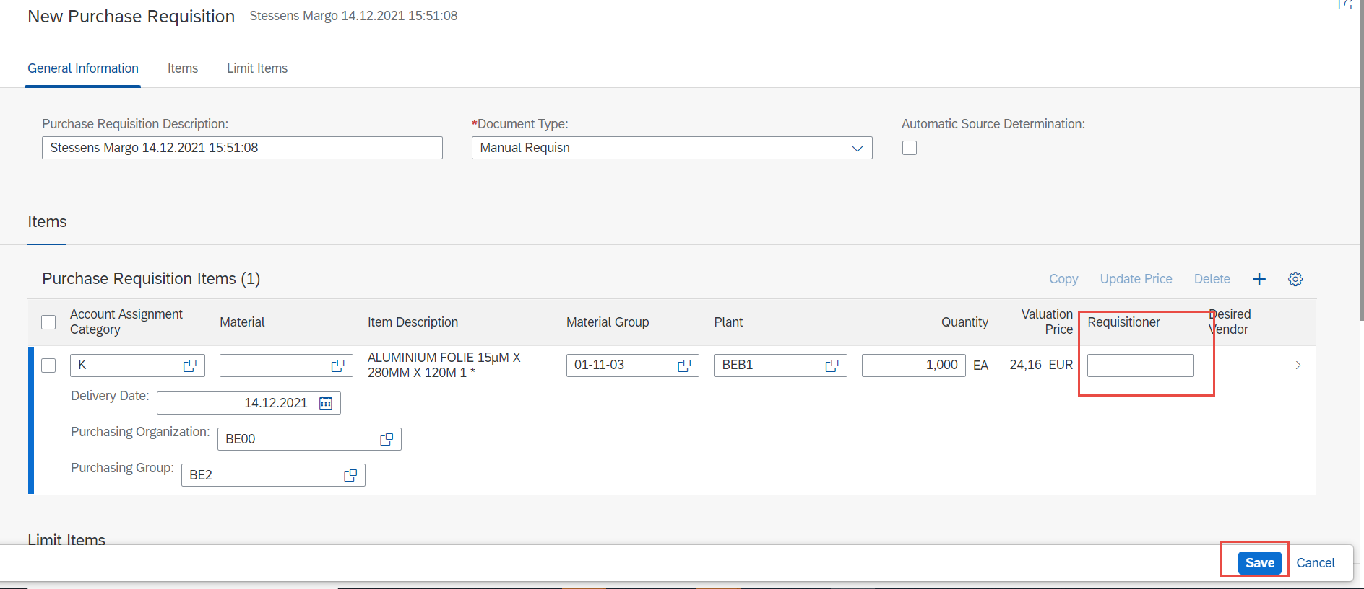

- Apply & Save

How to order via Pucnhout out, starting from a workorder?

- Check if you need to change your default settings
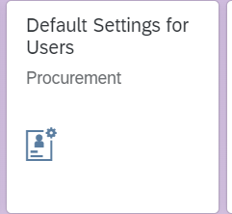
- Go to app & complete the necessary fields
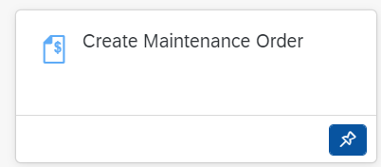
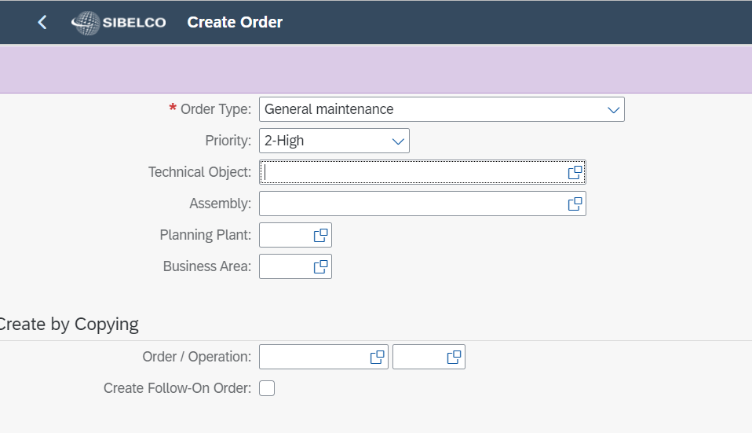

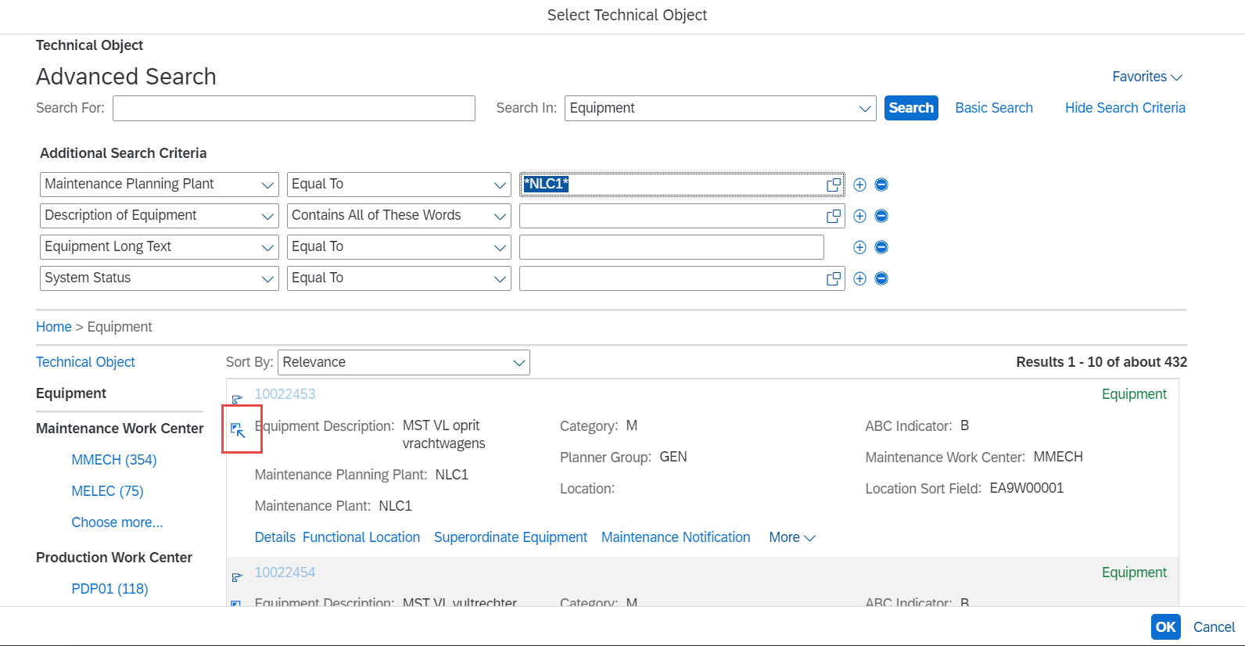

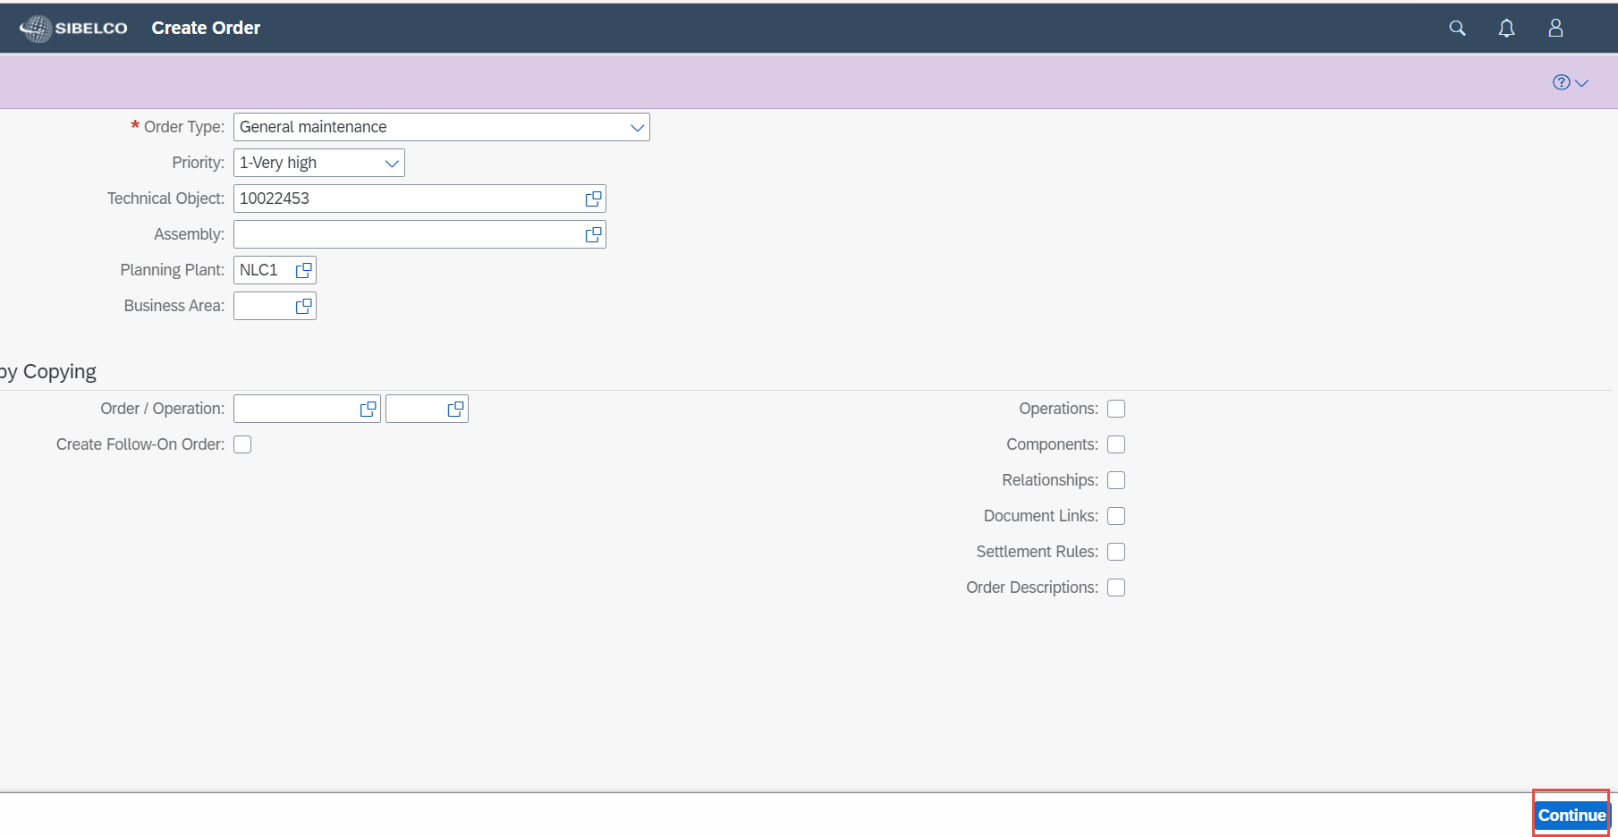
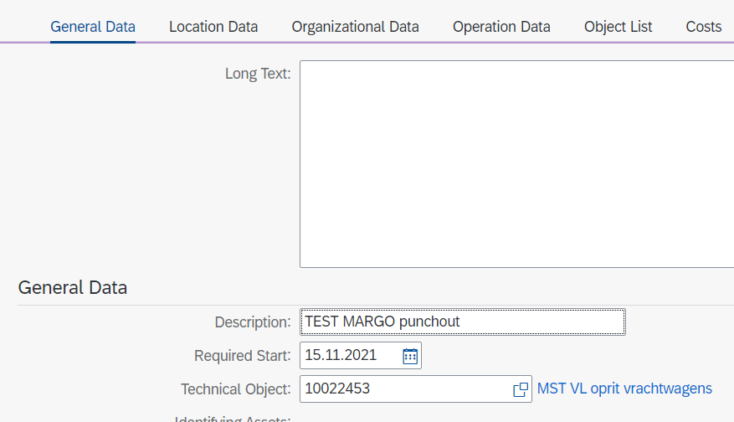

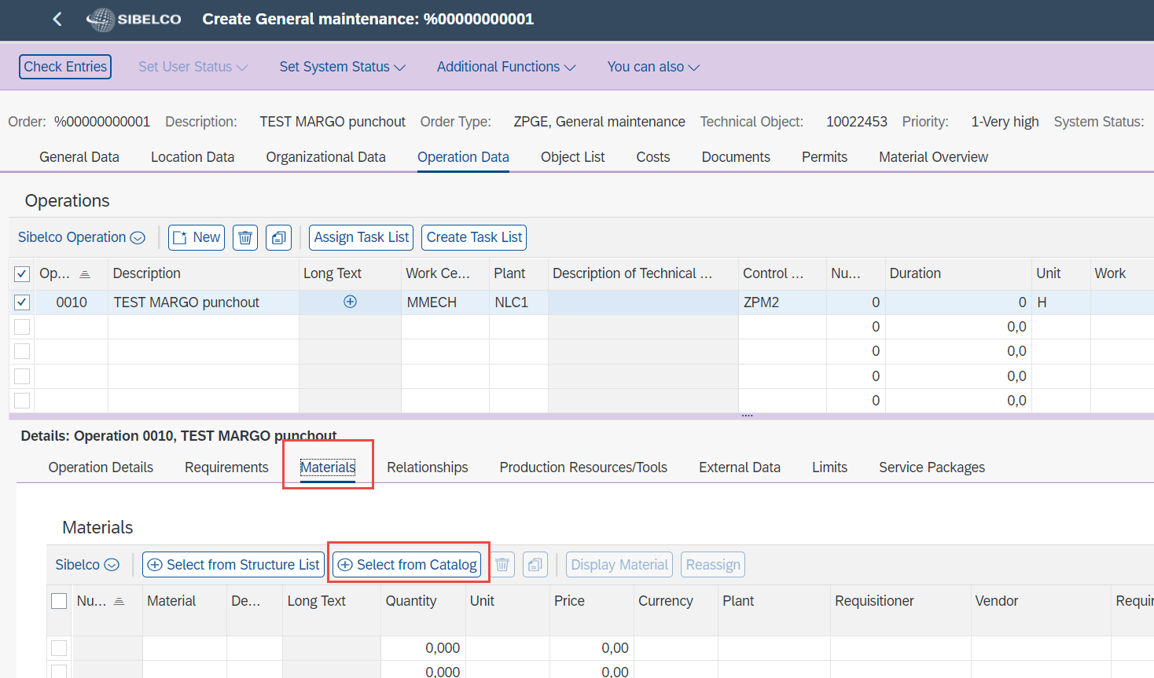

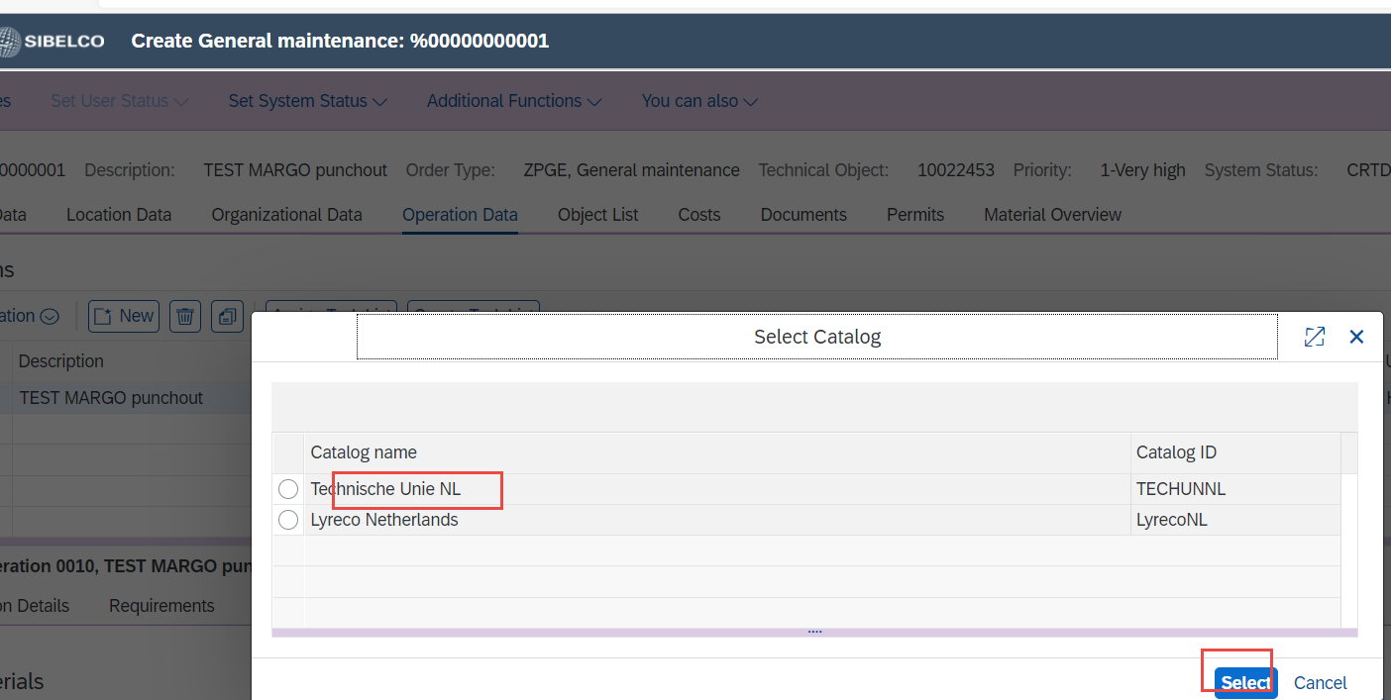

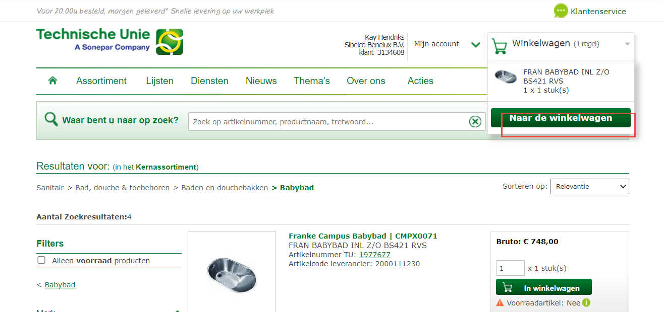
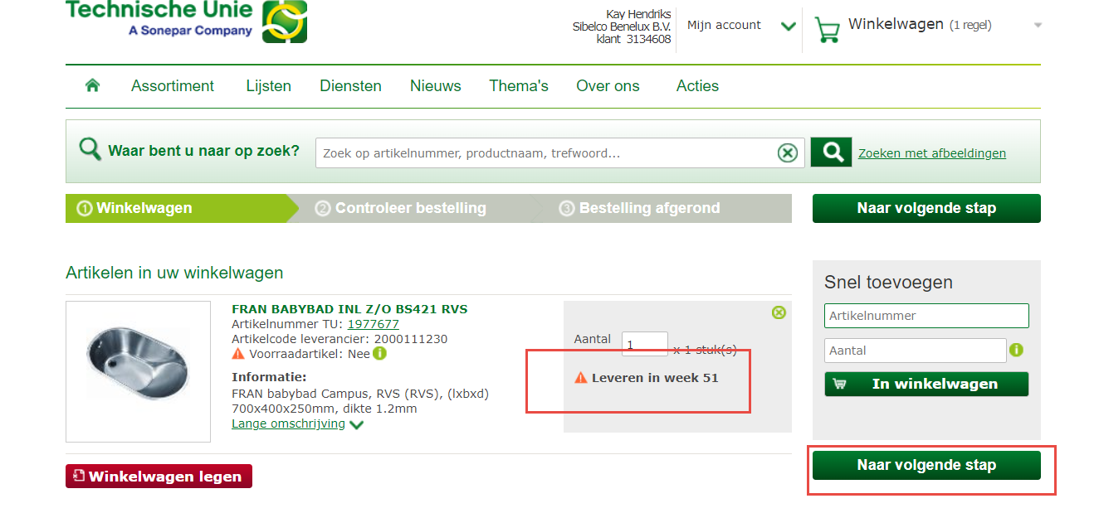
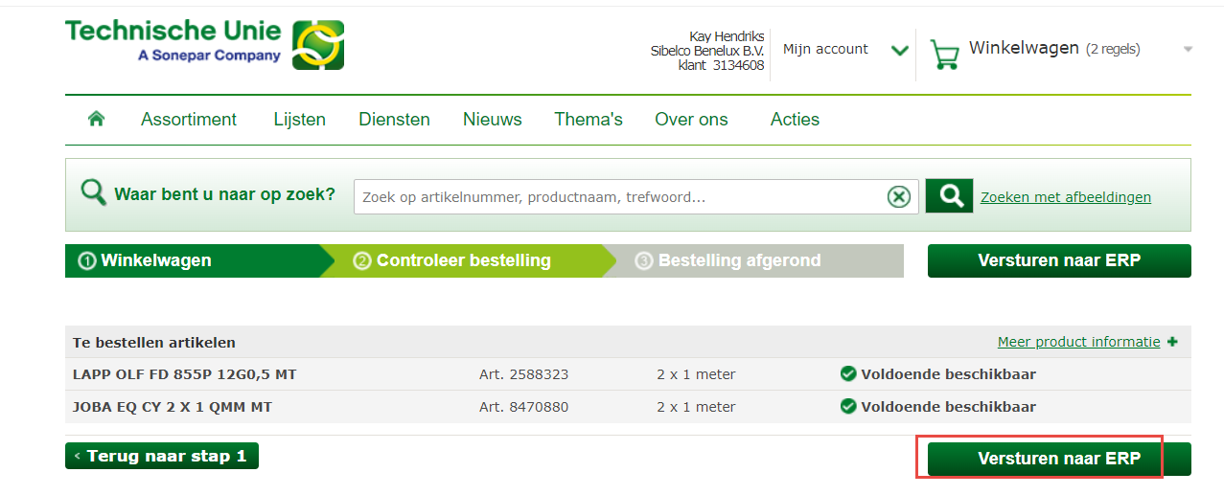

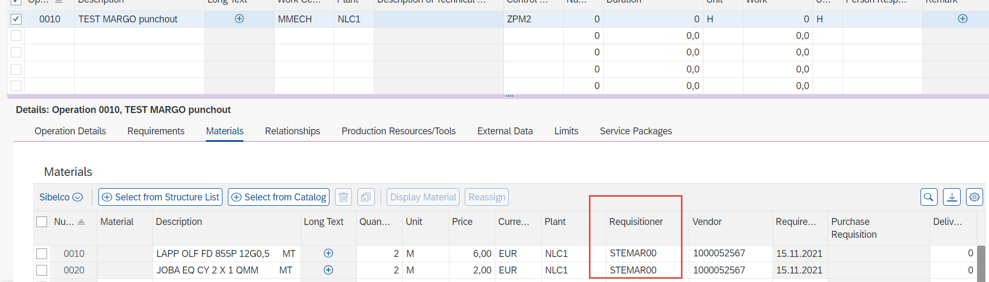

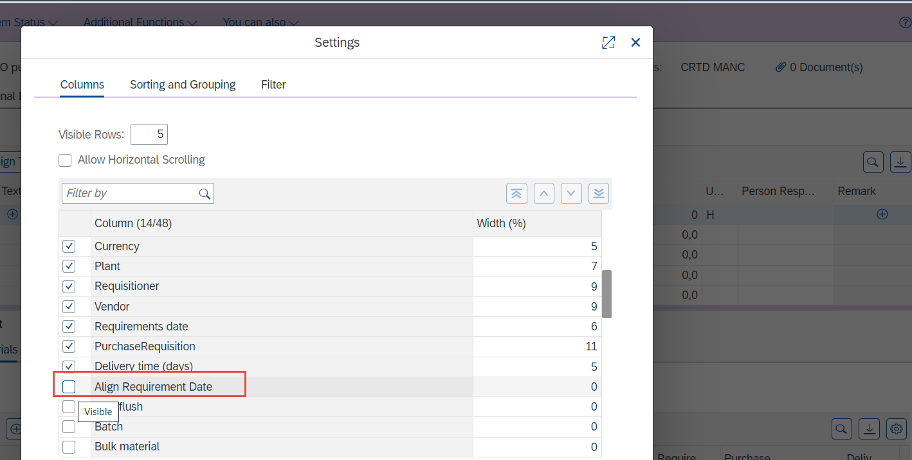

Release + SAVE
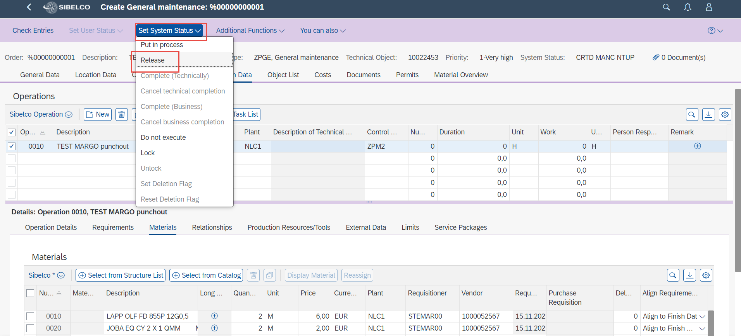

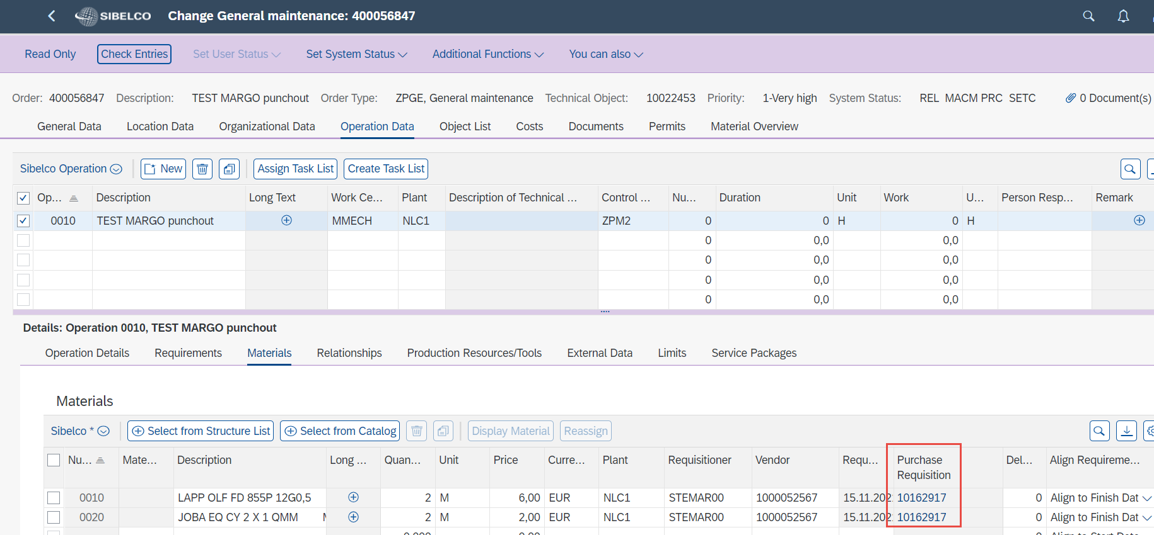

PR will go into approval.

For Procurement only:
- Do not convert manually – wait for the batch job or run batch job manually
– Exclude agreements in your variant (where you create PR – PO)
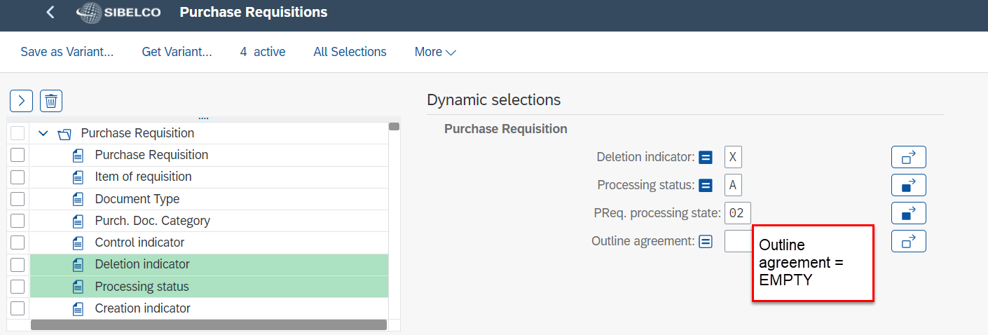
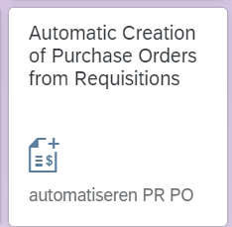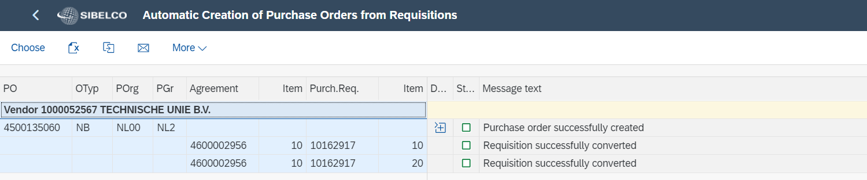

- For a punchout there is also an agreement created (take into account VAT tax code)
